Intelligent Stacking Supported Automation System with Robotic Basket for Hygienic Shopping

Dr. Geeta Tripathi
Professor, Computer Science and Engineering,
Guru Nanak Institutions Technical Campus, RR Dist., India, 501506

geetatripathi.office@gmail.com
Received on: 10 April, 2024 Revised on: 15 May, 2024 Published on: 17 April, 2024

Abstract –It’s not long time we have witnessed Covid-19 pandemic. It has reemphasized on hygienic system wherever we are expecting lot many human interaction and intervention involved. Shopping is one such area. By introducing automation it can be assured with little intervention of human beings. Here is an idea of automated shopping system. Making use of proposed intelligent stacking and Robotic Basket. List of items available for shopping can be put on a display designed for the user to view the items available. User may enter the shopping list into the system, pay the bill and get the token. This data will be sent to the centralized management system. A queue of robotic baskets will make a free basket at that moment take the command and collect the said items and ensure quantity too. Robotic Basket will be able to perform certain specific functions. It will be able to move through the stacks of items and collect the products on its own. Once the product list along with quantity of each is given by the customer, the basket will join the Reception area flashing the token number. Human intervention in collecting the product from shopping center will not be there. The smart system will also tally whether the number of products given by the customer is equal to the products collected by the basket. When the job is executed by the basket, it may flash and announce the Token number and then they will receive the products and basket's job is done. The basket will contain pedal operated sanitizer dispenser. After customer collects the items shopped, the basket will enter the queue of waiting baskets. At the entrance of the queue, there will be sanitizer sprayer that will sanitize the newly coming basket after customer has collected items from it. This will be very beneficial for hands free shopping experiences, especially for elderly people, pregnant women and specially-able people.

Keywords- Shop Management system, Robotic basket, Intelligent stacking, Hygienic system.

I -INTRODUCTION
The technological advancements should be used wisely to cater situations as we have seen in COVID-19, to prevent rather than controlling after effects is need of the hour. Otherwise, with huge population in a country like India, the things may exponentially take severe turns. Shopping is one such system where in lot many people get involved in closed vicinity for communication in person and interaction too. Shopping management systems in variety of flavors are available. Shopping is not only necessity for buying the items, it has rather became much needed survival to status quo as per the studies. Some of the psychological studies have also shown that it is one of the activities responsible to produce the happiness. Though numerous ways of online shopping have emerged and the convenience of shopping from sitting anywhere purchasing anything is just a button click away, the feel of shopping with looking for products and bringing it personally has a different level of satisfaction. During lockdown, it was realized that a safe and hygienic shopping system is what people are looking for. Design of one such system is presented in this paper that can provide a hygienic system for shopping with added functionality of smooth maintenance of the overall system.
II- RELATED WORK
Automation in bill generation or providing the platform online shopping is the goal of most of the research done in this line. Few of the works are done in the line are either robotic trolleys that follows the owner’s instructions as in paper [5, 6]. But it doesn’t give any idea for its use in shopping. It is basically for the travelers to avoid the carrying of heavy baggage for even smaller distances. In paper [1], the authors have given an idea where the buyers are moving their trolleys in the shopping mall and as they select the product, a scanner on the trolley reads the code on the product and adds it to the bill. So the buyers can avoid the long queue at the checking out counter for scanning products and paying the bill then. In the papers[2,3], authors are presented the idea of enlisting the important constituents of product after reading its code and can suggest if it is to be added in the cart or not, along with automated billing. In most of all these papers, the shopping trolleys are moved around by the buyers and even the products are picked up by the buyers and placed in the trolleys. While in some other cases, the total shopping system is online where the customers can buy online and products are delivered to the mentioned address.
III- METHOLOGY
The detailed design and methodology of the overall idea is as follows:
The customer has to place the order for shopping looking at the items and their details displayed on a screen, pay bills and get a token. An alert at end will be given with flashing token number as the basket is ready with the order. There is no need for the customer to pick up the items and place it in the basket. The basket will automatically do it. After successful payment, all baskets in the queue will receive the list and token number. The basket will check if it is the first basket in the queue. If yes, it will move for shopping and other baskets will delete the recently received shopping list and token. The basket while moving automatically will collect all the listed items. A dashboard unit on the basket will display the token number and have a scanner to scan the token with the customer. The circuitry of push buttons to open/close drawers will start working if the scanned customer token matches with the stored token in the basket. This ensures the basket is handed over to proper customer.
The items will be placed in the proper compartments of the basket in an organized way. Like grains, milk/oil or any other liquid material packets, bottles of different varieties, chips/biscuits or any other items that may get crushed, small sized miscellaneous items like chocolates, eraser, pencil, etc and a section for toiletries etc. This will make it easier to collect the shopped items. The drawers 1,2,3 of the basket can be opened by pressing corresponding buttons 1,2,3 on the dashboard of the basket
A pair of hooks on the basket will help to hold the bag for placing the shopped items. A pedal operated sanitizer dispenser will be attached to the basket for the customer to sanitize hands before collecting the shopped items.
The customer will press a button labeled ‘Done!’ after collecting all the items from the basket. This will be acting as a command for the basket to join the basket queue at the rear end automatically. So, there will be no need to manually get the basket and put it in queue. Before the empty basket joins the queue, it will be sanitized with the automatic spraying system. This will ensure the hygiene.
A counter to count quantity for each item will be initiated in the basket after receiving the shopping list. Every item will be given a unique code. This will make the basket easy to track the item and its quantity as per shopping list.
Similar category of items can be placed in a group of stack as shown in the figure. Each group will have a number for identification. Each stack will have number matching to the unique code given to the item and a mechanism to make single quantity of item to slide in the basket.
The line follower mechanism in the basket will make the it move on the proper track.

Fig. 1- Flow of actions
If the shopping list has some quantity of one or more items from a stack group, it will stop in front of the stack group and open the particular drawer of the basket. It will send a message to corresponding stack to activate the mechanism of the stack to slide out item in required quantity. With every slide out, the counter will be reduced by one. The process will continue until the counter becomes zero. This will continue for the stacks in sequence in the group. After completing receiving of items from a stack group, the drawer will be closed and the basket will move to the next group.
If any of the items on the stack are below a threshold value, an alert with the unique item code will be send to the saved mobile number of the shopkeeper using the concept of IoT.
This will also update data on the display board near the order placing unit to make the customer aware of the availability of the item. This will continue for all the stack groups until all the initialized counters as per shopping list are zero.
Once the list is completed, an alert will be flashed through the dashboard of the basket as the basket will move to the collection counter for the customer.
This system won’t require even the shopkeeper to remain present all the time.
The mechanism on the basket will require power to drive the corresponding electronic circuitry. This may be done with the help of DC batteries of requisite power or an arrangement for solar panels and charging units can be done. If solar panels and charging units are used then the baskets maybe charged in off time and made available in the working time.
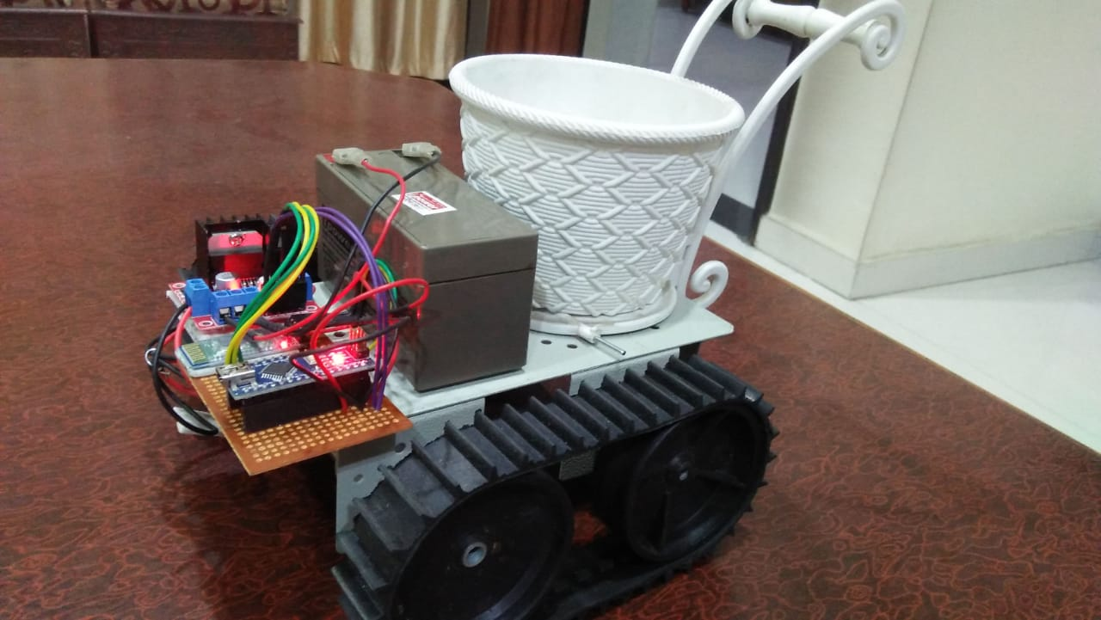
Fig. 2- Prototype of the trolley
The communication between different units installed on the basket, the stack groups, the stacks, automated sanitizer spraying system, the shopping list order placing unit will all can be done using either Bluetooth or WiFi or similar.
A display containing the list of items available and their details will be there near the order placing units to help the customers prepare a proper shopping list.
Improvements in this system can be incorporated by analyzing the data, if it is saved, over a period like daily basis or quarterly or yearly, using various techniques of AI, Machine Learning and data analytics.
IV-CONCLUSION
The proposed idea has multifold benefits if implemented in practical. Though the system seems complex and costly to implement as compared to the un-automated regular shopping system, but it has several added benefits worth investment. It is not only making use of technology for the service of people but also ensuring well being of the society by taking proper precautions.
REFERENCES
- P. Chandrasekhar et al, “Smart Shopping Cart with Billing System Through RFID and ZigBee” International Conference on Information Communication and Embedded Systems ICICES 2014, IEEE explorer.
- Ankush Yewatkar et.al, “Smart Cart with Automatic Billing, Product Information, Product Recommendation Using RFID and ZigBee with Anti-theft”, 7th International Conference on Communication, Computing and Virtualization, 2016. Available on www.sciencedirect.com
- Sudhir Rao Rupanagudi, Fathima Jabeen, et.al, “Novel Video Processing Based Cost Effective Smart Trolley System For Supermarkets Using FPGA”, Communication, Information & Computing Technology (ICCICT), 2015, International Conference on 1-6-2015.
- You-Chiun Wang, Chang-Chen Yang, “3S-Cart: A Lightweight, Interactive Sensor Based Cart for Smart Shopping In Super Markets”, IEEE Sensors Journal 16(17), 6774-6781, 2016.
- Eka Dodi Suryanto et al, “Design of automatic mobile trolley using ultrasonic sensors”, 2018 J. Phys.: Conf. Ser. 1007 012058
- S D Novalina, A Panjaitan, R P Simanjuntak and B Y Tamba, “Design of automatization of trolley cover based on microcontroller AT Mega 8535 as a learning media at ATKP Medan”, IOP Conference Series: Materials Science and Engineering, Volume 648, The 2019 International Conference on Information Technology and Engineering Management 27–29 June 2019,

