Embedded Transmission Cost Allocation Based On
Relative Electrical Distance In Restructured
Electricity Market

Dr. SANJAY B. WARKAD¹
P. R. Pote (Patil) College of Engineering & Management Amravati, India
sbwarkad@gmail.com
PRACHIKA B. GEDAM²
P. R. Pote (Patil) College of Engineering & Management Amravati, India
Prachikagedam.511@gmail.com

Abstract-Electricity Power sector around the world is witnessed reforms from traditional regulated regime to a deregulated system. Under such environment electricity transmission sector is separated from Generation and Distribution. This natural monopoly further allow public and private sector to use existing transmission facility under “Open Access”. Under such structure, it is essential to system owner and operator to form a rational and transparent costing mechanism for independent transactions by the third party. This costing mechanism in terms of price should provide the correct economic signals to each market participants, to ensure market investment, reliability and secure and reliable operation of power system. Several methods and approaches have been investigated for allocation of transaction to recover embedded cost with varying degree of success. This study demonstrates relative electrical distance approach to allocate embedded cost of transmission. The approach is numerically evaluated on Real power system for Maharashtra State Electricity Transmission Company Limited, India. The purpose of study is to recover and share transmission cost in term of tariff subject to system security and reliability of the power system. The results are computed. This study concludes that the proposed methodology is suitable to recover embedded cost, ensures the economic advantages, system security and reliability of the power system and suitable for practical power system.

Keywords—Electricity Reforms, Transmission embedded cost, Relative Electrical Distance, Power flow

I. Introduction
Electricity Power sector around the world is witnessed reforms from traditional regulated regime to a deregulated system. Under such environment electricity transmission sector is separated from Generation and Distribution. This natural monopoly further allow public and private sector to use existing transmission facility under “Open Access”. Under such structure, it is essential to system owner and operator to form a rational and transparent costing mechanism for independent transactions by the third party. Earlier electric power systems have traditionally been operated as regulated monopolies, partly to cope with the complexity of their operation and planning. In recent years under deregulation/restructured regime, the desired objective is to achieve a more efficient power system facilitated by competition. A good and sustainable pricing scheme becomes a key issue in order to achieve efficient competition. Electricity deregulation brings competition power generation and
distribution of electricity services throughout the world, it is now recognized that electricity transport services is identified as a natural monopoly which should going to control transmission company and Independent System Operator. In recent decades electricity transmission and distribution systems provide the crucial physical connections that makes wholesale and retail competitions feasible. So, Open Access in regulated electricity transmission system and use pricing of services i.e. rent to pay by user of services is necessary to enhance competition in bulk power market.
Few transmission pricing methods have been developed in order to meet the various pricing objectives. The transmission pricing schemes can be classified into two basic paradigms: Rolled-in and Marginal. The marginal cost pricing, which is implemented in most of the new electricity markets, does not allow recovering of the total cost of transmission investments, mainly because transmission marginal costs are lower than average costs. In order to enhance return on investment in transmission infrastructure, it is needed to design feasible pricing options that suits both seller and Buyer. The way to allocate this pricing among system’s users has been a challenge and debate amongst academician, electricity business entity and policy owners. Under the decentralized market environment, two commonly employed philosophies for transmission pricing are: transaction based tariff and the point-of-connection tariff so as to recover the embedded transmission cost. Various versions of MW-mile, Postage Stamp and Contract Path methods essentially represent the class of point-to-point ex-ante transmission pricing schemes. The objective of electricity transmission pricing is to recover all or part of the existing and new cost of transmission system [1]. Also, well designed electricity pricing of transmission services ensures wheeling participants and transmission companies economic benefits, system security and reliability. While electricity transmission network acts as a interconnection between the generation and distribution, it is quite difficult to know the component of electricity prices to each wheeling transaction participant [2],[3].
In the embedded electricity pricing method, all the costs i.e. fixed and variable components are ncluded
in a single cost that makes it impossible to distinguish between costs and its decomposition. However, electricity costs computed are shared between users of transmission services [6]. The various roll-in methods are Postage Stamp Pricing, Contract Path Pricing, MW-Mile and MVA-Mile Methods. Postage stamp pricing based on uniform pricing that all transmission users would pay a single rate, which covers the transmission transaction that occurs within a defined region, not minding the contractual origin or destination of transmitted electricity. The same rate applies to all customers [7]. Postage Stamp method to calculate pricing is the simpler among all embedded cost method and quite easy to implement on the system. This method usually avoid load flow studies and is no more concern with the transmission distance and network configuration of wheeling utility. The price is calculated by adding all transmission network costs and dividing it with the system peak demand. The seller and buyer’s power transmission charge is the product of the Annual fixed charged rate and the system peak load of that customer. This method is easy to calculate price so more popular amongst other embedded cost methods used by wheeling utilities. However this method has a shortcoming that it fails to give correct economic knowledge to electricity transmission sellers and buyers, also does not motivate wheeling utility about anticipated future augmentation for the efficient use of the transmission infrastructure [8] - [9]. The MW-Mile method which is also known as line-by-line method allocate embedded cost on the basis of magnitude of the real power transaction and the physical distance in miles between the seller bus where power transaction is inserted and buyer bus where transacted power is drawal. It is basically is the product of the transacted power and the physical distance this electricity flows through the transmission network [1]. Another method named “MVA-Mile method” is an extension of the previously discussed method having advantages that it considered both real and reactive power flows during additional transactions through wheeling utility. Additional power transaction leads more reactive power loading and increases transmission losses which need to be recovered from either buyer or seller through pricing
[7]. The other transmission pricing method is the Incremental Transmission Pricing Method composed of Short-Run Marginal Cost (SRMC), Long-Run Marginal Cost, Short-Run Incremental Cost and Long-Run Incremental Cost. Electricity transmission infrastructures mainly include both fixed cost and variable cost of operations. The incremental cost approach deals with the variable costs. It does not include the past investment annual revenue costs of energy transactions. The role of the SRMC [12] is to reduce the inefficiencies of fixed prices which failed in providing any financial benefits for efficient energy usage with the assumption that all capacity is fixed. [17] Transmission fixed cost is computed with security constrained optimal power flow. Also transmission service use for MW-mile method is determined by generalized distribution factors for pricing counterflows. [18] Transmission fixed cost is allocated using game-theoretic solutions. Circuit-theory-based equivalent bilateral exchange is introduced to for fair allocation of tariffs. This method estimates the relative locations of demand nodes with reference to the generator nodes. Transmission tariffs or charges are allocated based on the relative electrical distance and power transactions. The advantage of this method is optimal allocation of transmission tariff.

Electricity Transmission Pricing: Principles and objectives:
The transmission prices should:
i. Promote the efficient day-to-day operation of the bulk power market: All the participating generators on the power system must be coordinated to ensure the generation is able to cope with the demand. It also signals economic efficiency and will be required to perform an economic dispatch to meet the demand at the lowest possible cost.
ii. Give signal to locational advantages for investment in generation and demand: Short term scheduling decisions can affect the cost of transmission, but the most important factor is the location of generation and demand. The cost of transmission can be lowered down by locating the generation closer to demand.
iii. Give signal to need for investment in the transmission system: The transmission losses and congestion directly affect the transmission cost. Additional investment into the network could reduce such losses and congestions.
iv. Compensate the owners of existing transmission assets: Future revenue is the major concern for the investors who are involved in the design of a new transmission system.
v. Be simple and transparent: The pricing methodology
is about its simplicity to understand and transparency in implementation.

An efficient pricing scheme for electricity transmission
can be summarised as follows:
i. Economic Efficiency: Transmission pricing should give correct incentives and motivation to the market participants. It should encourage an efficient use of the existing network; encourage an efficient location of new generation and customers.
ii. Non-discrimination: Transmission pricing/tariff should be identical to each customers/clients.
iii. Price Transparency: Transparent pricing/tariff is an important consideration and practices in marketplace.
iv. Cost Coverage: Transmission pricing should be designed to fully recover the transmission owner's costs (including a profit), efficient allocation of scarce (congested) transmission capacity, efficient allocation of the costs of transmission losses etc.

II. Relative Electrical Distance Based
approach
This method estimates the relative locations of demand nodes with reference to the generator nodes.
Transmission tariffs or charges are allocated based on the relative electrical distance and power transactions. The advantage of this method is optimal allocation of
transmission tariff [19].

2.1: Problem formulation

(i) A network performance equations
Consider a power system where NB is the number of buses with (1, 2, .....,N ) g where Ng is the number of generating buses, and Ng +1, 2, .....,N, remaining (NB- Ng) buses. For a given power system, current equations can be written as,
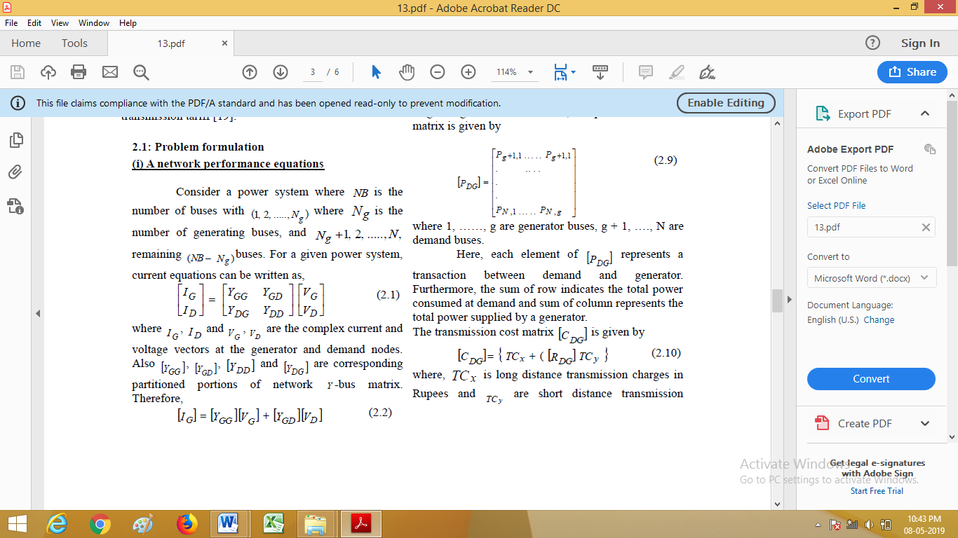
where IG , I D and VG , VD are the complex current and voltage vectors at the generator and demand nodes.
Also [YGG], [YGD], [YDD], and [YDG] are corresponding partitioned portions of network Y -bus matrix.
Therefore,
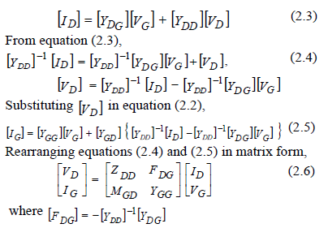
The elements of [FDG] matrix are complex and its columns correspond to the generator bus numbers and rows correspond to the demand bus numbers. This matrix indicates the relation between demand bus voltages and source bus voltages. This matrix also shares information about the location of demand nodes
with reference to generator nodes.
Matrix [FDG] gives the information for each consumer, about the amount of power that should be taken from each generator under normal and network contingencies. This matrix is used as the basis for the desired load sharing/generation scheduling. The relative electrical distances, i.e. the relative locations of demand nodes with reference to the generator nodes are obtained from the [FDG] matrix and given by
[RDG] = 1-abs {[FDG]} (2.7)
The desired proportions of generation for the desired
demand sharing/generation scheduling is also obtained
from the [FDG] matrix and is given by
[DDG]= abs {[FDG]} (2.8)

(ii) Evaluation of Transmission Tariffs/charges
Neglecting transmission losses, the power transaction
matrix is given by
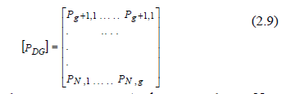
where 1, ……, g are generator buses, g + 1, …., N are demand buses. Here, each element of [PDG] represents a transaction between demand and generator.
Furthermore, the sum of row indicates the total power consumed at demand and sum of column represents the total power supplied by a generator.
The transmission cost matrix [CDG] is given by
[CDG] ={TCx + ([RDG]TCy} ( (2.10)
where, TCx is long distance transmission charges in Rupees and TCy are short distance transmission charges. The total transmission tariffs/charges =
[CDG] X [PDG] (2.11)

III. Simulation and Result
This method estimates the relative locations of demand bus with respect to generator bus and transmission tariffs are allocated based on relative electrical distance.
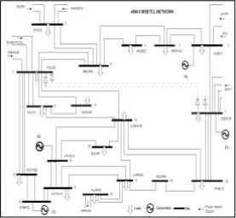
Figure 1 : A 400kV MSETCL system

Fig.1. The relative electrical distance based transmission tariff methodology is programmed in MATLAB. The evaluation and simulation is as follows. The [FDG] matrix corresponding to the demand/generator buses for the said practical network
is computed.
These values which are taken as relative electrical distances are used for the evaluation of transmission tariffs in open access. The desired proportions of generation for the desired demand sharing or generation scheduling defined as [DDG], are computed as shown below. The relative electrical distances i.e. the relative locations of demand buses with respect to the generators buses are obtained from [RDG] matrix
. 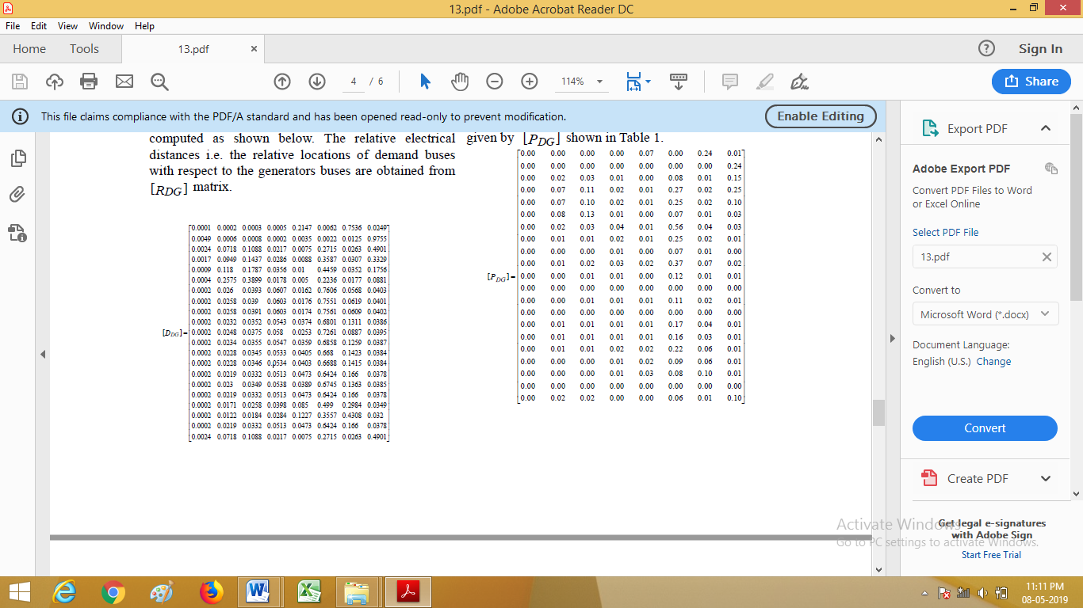
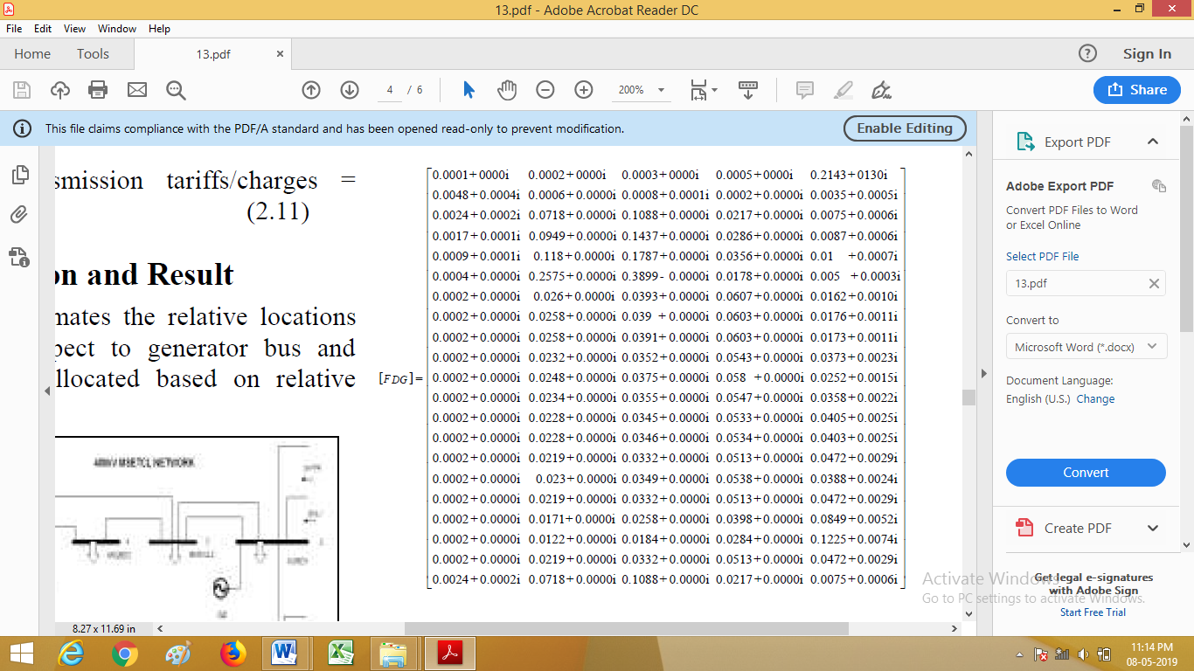
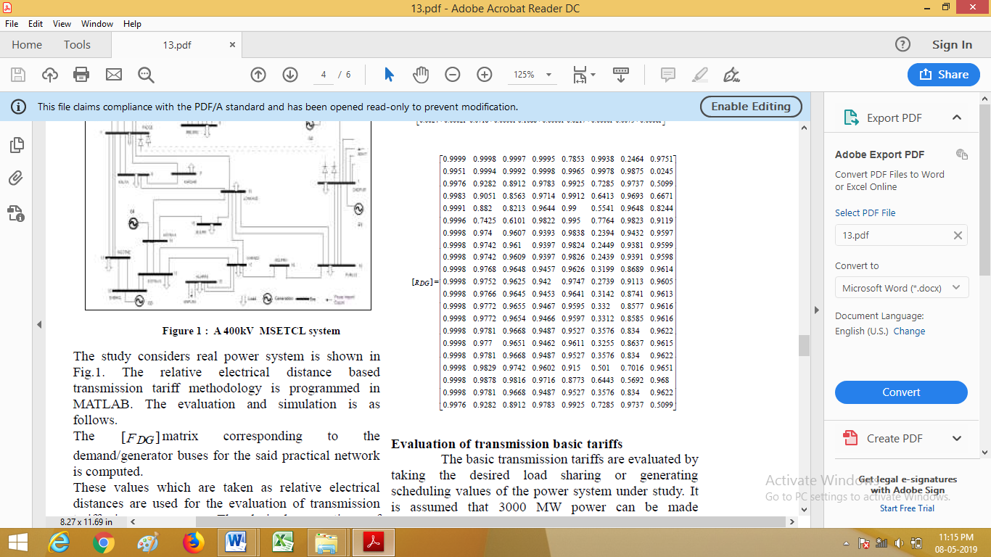

Evaluation of transmission basic tariffs
The basic transmission tariffs are evaluated by taking the desired load sharing or generating scheduling values of the power system under study. It is assumed that 3000 MW power can be made available at bus 26 to fulfill the demand in western part of Maharashtra in case of non availability of HVDC link. The base desired power transaction matrix is given by [PDG] shown in Table 1.
.
Table 1: A 400 kV MSETCL system: Desired power
Transactions
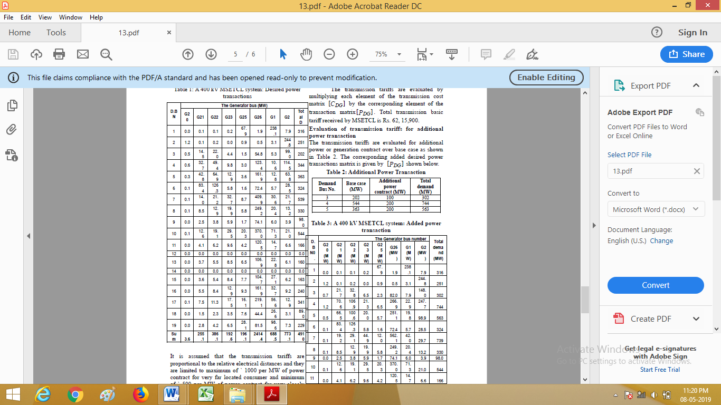
It is assumed that the transmission tariffs are proportional to the relative electrical distances and they are limited to maximum of ` 1000 per MW of power contract for very far located consumer and minimum of ` 500 per MW of power contract for very closely located consumer. The transmission tariff or cost matrix [CDG] of the real power system is given by

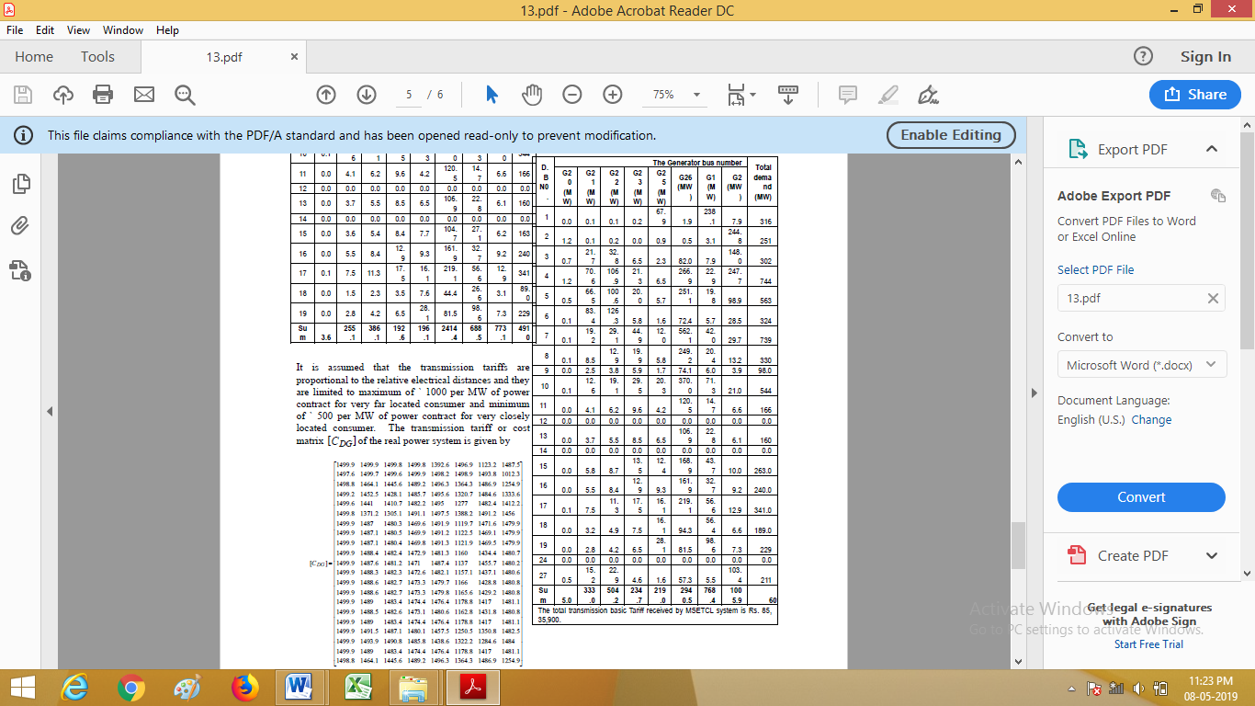
The transmission tariffs are evaluated by multiplying each element of the transmission cost matrix [CDG] by the corresponding element of the transaction matrix[PDG] . Total transmission basic tariff received by MSETCL is Rs. 62, 15,900.

Evaluation of transmission tariffs for additional power transaction
The transmission tariffs are evaluated for additional power or generation contract over base case as shown in Table 2. The corresponding added desired power transactions matrix is given by [PDG] shown below.

Table 2: Additional Power Transaction
- For increased transactions over base case, the cost of transmission tariffs also goes on increasing.
- This method is more suitable to allocate the transmission cost and generation sharing based on relative electrical distance. However it does not provide any information about generation maximum and minimum limits, merit order dispatch of generator. It presumes that the demand will be served by the nearest generator.
At present the embedded costs of transmission transactions to be recovered by the MSETCL from users of transmission services are calculated in transmission Annual Revenue Requirement form, which is of fixed amount. This method assumes maximum and minimum amount of transmission cost
based on location of consumers from generators.

VI. CONCLUSION

This paper reviewed transmission pricing philosophy and widely used methods. This study also presented and implemented the relative electrical distance based allocation methodology of transmission tariff for a real 400 kV MSETCL system of Maharashtra. Besides method’s inherent advantages, it has fairly allocated power transactions based on relative electrical distance between injection node and drawal node. The numerical results indicate that drawal node (Buyer) is served by nearest injection node (Seller). The proposed methodology can be useful to ensure the economic advantages, system security and reliability for the transmission companies and help in achieving transmission tariff objective.

Table 3: A 400 kV MSETCL system: Added power
Transaction

REFERENCES

[1] M. Murali, M. S. Kumari & M. Sydulu,“A comparison of fixed cost based transmission pricing methods”, Journal of electrical and electronic engineering, Scientific and Academic Publishing Vol. 1, Issue 1, 2011, pp. 33-41.
[2] R. Abhyankar, S. A. Soman, S. A. Khaparde, “Optimization approach to real power tracing: an application to transmission fixed cost allocation”, IEEE Trans. on Power Systems, Vol. 21, Issue 3, 2006, pp. 1350-1361.
[3] O. Pop, M. Nemeş, “Power transmission allocation with network matrices”, 7th International Power Systems Conference, Timişoara, Romania, 2007, pp. 527-534.
[4] T. Krause, “Evaluation of transmission pricing methods for liberalized markets: A literature survey”, Internal report from ETH Zurich, 2003, pp. 1-24.
[5] S. Matetic, “Intelligent trading agent for power trading through tariff market”, M. Sc Thesis, University of Zagreb, 2013, pp. 19-22.
[6] L. Similia, G. Koreneff & V. Kekkonen, “Network tariff structures in smart grid environment”, VTT technical report, Finland, 2011.
[7] A. T. Haral & M. F. Aslam, “Analysis of spot prices Arrangements in deregulated electricity”, International Conference on Electrical Engineering, ICEE’07, 1, 2007, pp. 1-6.
[8] A. K. Singh, C. Singh, S. Kumar, & Y. R Sood, “Electricity pricing in deregulated power sector”, International Journal of Advanced Research in Electrical Electronic and Instrumentation Engineering, vol. 3, Issue 5, 2014.
[9] M. Shalini, & K. V. Kishore, “Comparison of mbedded type transmission cost allocation methods”, International Journal of Scientific Engineering and Technology Research, vol. 3, Issue. 37, 2014, pp. 7526-7529.
[10] D. Shirmohammadi, X. Vieira, B. Gorenstin, M. Pereira, “Some fundamental technical concepts about cost based transmission pricing”, IEEE Trans. on Power Systems, vol. 11, Issue 2, 1996.
[11] I. Leevongwat, & P. Rostgoufard, “Forecasting locational marginal pricing in deregulated power markets”, Power Systems Conference and Exposition, PSCE ’09. IEEE/PES, vol. 1, 2009.
[12] B. J. Ring, “Dispatch based pricing in decentralized power systems”, Doctoral Dissertation, University of Canterbury, Christchurch, New Zealand, 1995, pp. 15.
[13] Happ., “Cost of Wheeling Methodologies”, IEEE Transactions on Power System, vol 9, no 1, February 1994.
[14] P Lewis, “Wheeling and Dealing [Power Transmission],”IEEE Review, vol 42, no 5, September 1996, p 196.
[15] D.P. Kothari and J.S. Dhillon, “Power System Optimization”, Prentice Hall of India Private Limited, New Delhi, 2004, p 214.
[16] S. B. Warkad, Dr. M.K. Khedkar, Dr. G. M. Dhole, “Transmission Tariff under Open Access: A Case Study of 400kV Maharashtra State Electricity Transmission Company Limited”, Journal of The Institution of Engineers (India); vol. 89, pp. 31-37, Sept.19, 2008.
[17] George A. Orfanos, Pavlos S. Georgilakis, Nikos D. Hatziargyriou, A More Fair Power Flow Based Transmission Cost Allocation Scheme Considering Maximum Line Loading for N-1 Security”, IEEE Trans. on Power Systems, Vol. 28, No. 3, Aug. 2013, pp. 3344-3351.
[18] Saeid POUYAFAR, Mehrdad TARAFDAR HAGH, Kazem ZARE, “Circuit-theory-based method for transmission fixed cost allocation based on game-theory rationalized sharing of mutual-terms”, Journal of Modern Power System and Clean Energy, Springer Publications, pp 1-16, 2019.
[19] K. Visakha, D. Thukaram, and Lawrence Jenkins,
“Transmission Charges of Power Contracts based on Relative Electrical Distances in Open Access”, Electric Power Systems Research, no. 70, pp. 153-161, 2004.

