Misinformation Mitigation

Ahilya Bhute Aditya Kharde
Department of Computer Engineering Department of Computer Engineering
St.Vincent Pallotti College of Engg & Tech St.Vincent Pallotti College of Engg & Tech
Nagpur, Maharashtra Nagpur, Maharashtra

Dewashish Andankar Kunal Nikhade
Department of Computer Engineering Department of Computer Engineering
St.Vincent Pallotti College of Engg & Tech St.Vincent Pallotti College of Engg & Tech
Nagpur, Maharashtra Nagpur, Maharashtra

Prof. Yogita Nikhare
Assistant professor
Department of Computer Engineering
St.Vincent Pallotti College of Engg & Tech
Nagpur , Maharashtra

Abstract
Strategies and Tools for Addressing Online Disinformation Abstract: The proliferation of misinformation on the internet poses a significant challenge to society, affecting various domains including public health, politics, and social cohesion. This project aims to develop effective strategies and tools for mitigating the spread and impact of misinformation online. Through a combination of data analysis, machine learning algorithms, and behavioural psychology principles, the project seeks to identify patterns of misinformation dissemination, understand the motivations behind its creation and sharing, and design interventions to counteract its effects. The research will also explore the role of social media platforms, fact-checking organizations, and community-driven initiatives in combating misinformation. By leveraging interdisciplinary approaches, this project strives to contribute to the development of robust solutions for addressing the complex and evolving landscape of online misinformation.
Keywords: RNN, LSTM.

Introduction
These days, false news is causing a variety of problems, ranging from satirical articles to manufactured news and planned government propaganda in some media. Our society is facing serious issues with fake news and a declining level of trust in the media. While intentionally false information is obviously "fake news," the scope of the term has been evolving recently due to blathering in the social media debate. These days, some of them ignore the evidence that contradicts their favoured theories with this word. Considerable attention was paid to the significance of misinformation in American political discourse, especially in the wake of the country's presidential election. The phrase "fake news" became widely used to refer to the problem, especially when referring to factually inaccurate and deceptive stories that are primarily published in order to generate revenue through page views. A model that can precisely forecast the possibility that a certain article is fake news is sought for. After receiving media exposure, Facebook has been the target of a lot of criticism. They have already included a function that allows users to report fake news on the website, and they have said openly that they are working on developing an automated system to identify bogus stories. It is undoubtedly a difficult task. Given that fake news may be found on both extremes of the political spectrum, an algorithm must be politically neutral while maintaining equal weight for both types of credible news sources.

Furthermore, it is a challenging question to determine validity. But to address this issue, one is required to comprehend what is Fake New.

Objective
This project's main objective is to create and put into use a sophisticated system for detecting fake news that can recognize fake news articles, photos, and videos using computer vision algorithms, advanced natural language processing (NLP) techniques, and machine learning models. Given the difficulties presented by the ways that disinformation is disseminated and its ever-changing nature, the system ought to be able to analyze data in real time. The solution should also be morally sound, guaranteeing a conscientious approach to speech freedom and content moderation.
Literature review
Previous works done in the field
Pioneering studies, such as , have laid the groundwork by categorizing truth evaluation techniques into network analysis and linguistic cue approaches. These typologies serve as a foundation, guiding subsequent research endeavours. By understanding the diverse techniques available, researchers can explore novel avenues for improving detection accuracy.
Machine Learning Algorithms and Classifiers: Using machine learning algorithms is one well-liked tactic. The authors of [6] introduced a straightforward technique using a Naive Bayesian classifier to show how effective this conventional algorithm is at identifying false news. Moreover, studies such a [5] s have investigated advanced classifiers such as Linear Support Vector Machines (LSVM) and have achieved remarkable accuracy rates. These algorithms, which form the basis of many fake news detection systems, enable the automatic analysis of large volumes of textual data.
Feature Extraction and Multimodal Integration: As shown in [5], feature extraction techniques, in particular Term Frequency Inverse Document Frequency (TF-IDF), have been essential in identifying linguistic patterns suggestive of fake news. Additionally, scholars have begun investigating the amalgamation of various modalities, encompassing text, images, and data from social media platforms [2]. By taking a comprehensive approach, the analysis is deeper and systems are able to identify fake news in a variety of content formats.

Datasets as Catalysts for Progress: The field's advancement has accelerated significantly since the introduction of datasets such as LIAR [7]. Given its wealth of political data, LIAR has established itself as the benchmark for assessing algorithms designed to identify false news. It is crucial to have high-quality datasets because they serve as standards for developing and accessing machine learning models. They encourage healthy competition in the field and allow researchers to thoroughly evaluate the effectiveness of their methods.

Methodology and model specifications

The suggested system uses cutting-edge technologies to tackle the growing threat of fake news. The system provides an all-encompassing method for precisely identifying and classifying misinformation by combining machine learning algorithms, natural language processing methods, and contextual analysis. The complexity of fake news disseminated across various media platforms is addressed by this multipronged approach.
- Software Requirement
Programming Language- Python
Libraries-Tensorflow ,Pandas ,Matplotlib
Seaborn, Nltk, Gensim, WordCloud, Numpy

- General architecture of the proposed system

A dataset of comments and the associated data, including the date, source, and author, will be fed into the suggested system. After that, it will convert them into a feature dataset that can be utilized for learning. Preprocessing is the process of carrying out various tasks like cleaning, filtering, and encoding. There are two sections to the pre-processed dataset: one for training and the other for testing. The training module creates a decision model that can be used with the test dataset by utilizing the support vector machine algorithm and the training dataset.
- Data Collection and Preprocessing

Data Sources: We will compile information from a range of online forums, news websites, and social media platforms. Data Preprocessing: We will use tokenization, stemming, and noise reduction techniques to clean up and prepare the data also transform multimedia files into formats that can be analyzed.

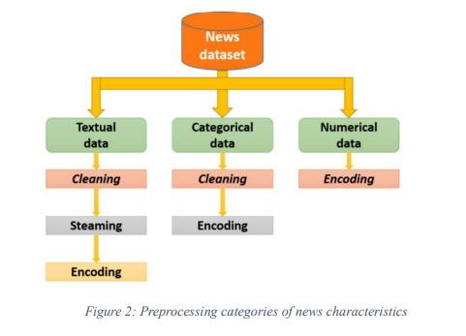

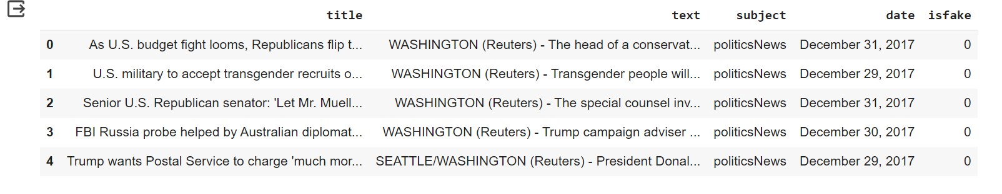
True.csv

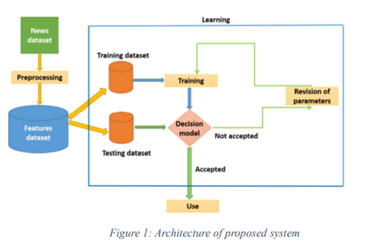

False.csv
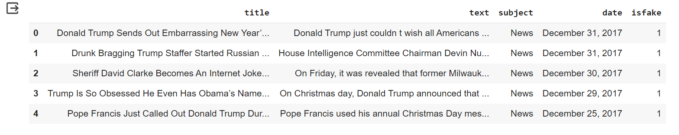

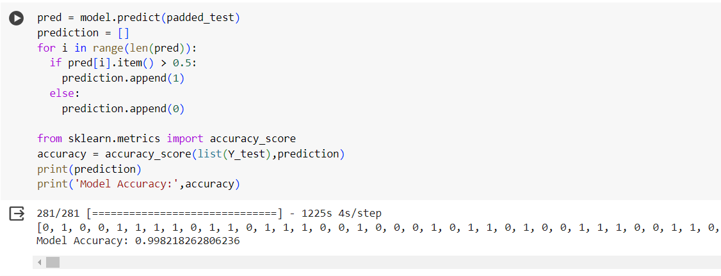
Output

Confusion Matrix


Conclusion
The proposed system is designed to classify news articles with high accuracy, aiming for a target accuracy rate of over 90%. This level of accuracy is required to ensure that the system can differentiate between authentic and fraudulent news. To make the system simple for users to access and use, it will feature an intuitive user interface. This interface makes it simple for users to view the system's classification results and submit news articles for analysis. An as user-friendly system as possible is necessary to encourage system adoption and usage.It will actively scan incoming news articles to promptly detect and alert users to potentially fraudulent news. This real-time monitoring and alerting system will help users stay informed and vigilant in the face of false information. To maintain the system's effectiveness over time, the machine learning model at the center of the system will be updated and modified frequently. Through the use of an ongoing process of improvement, the model will always remain current and be able to adjust to new trends and methods related to false information. The main objective of the system is to provide a robust and trustworthy means of identifying and avoiding false news.

References

[1] Afroz, S. (2019). A benchmark study on machine learning methods for fake news detection.

[2] Cédric Maigrot, E. K. (2018). Fusion par apprentissage pour la detection de fusses informations dans les reseaux sociaux. Document numerique.

[3] Conroy, N. J. (2015). Automatic Deception Detection: Methods for Finding Fake News.

[4] Dasgupta, D. V. (n.d.). Automated fake news detection using linguistic analysis and machine learning.

[5] Hadeer Ahmed, I. T. (2017). Detection of online fake news using n-gram analysis and machine learning techniques.

[6] Mykhailo Granik, V. M. (2017). Fake news detection using naive bayes classifier. IEEE First Ukraine Conference on Electrical and Computer Engineering (UKRCON).

[7] Wang., W. Y. (2017). liar, liar pants on fire.
[8] M. Gahirwal, “Fake News Detection,” International Journal of Advance Research, Ideas and Innovations in Technology.
[9] Fake News Detection- Z Khanam , B N Alwasel ,
H Sirafi and M Rashid

