Discrimination of Inrush Current and fault currents in Transformer by Prony Analysis Method
Nitin Mahadeo Khandare¹, Prashant J. Gaidhane²
¹Research Scholar,
Government College of Engineering, Jalgaon, India, 425001.
²Associate Professor, Dr.
Government College of Engineering, Jalgaon, India, 425001.

khandarenitin3@gmail.com

Received on: xxxx,20xx, Revised on: xxxx,20xx, Published on: xxxx,20xx

Abstract – The Power transformers are backbone of electrical transmission and distribution system and it plays an important role in it. It changes voltages and current levels of the supply at every stages of power system according to requirement for smooth operation. The most important issue for transformer protection is to differentiate the inrush from fault currents. Distinguishing internal currents associated with faults from inrush currents in transformers is a vital component of a transformer protection method. Therefore, ensuring its protection is crucial to ensuring the power system operates steadily and consistently. One of the main reasons why the protection system malfunctions is the inrush current occurrence. Therefore, accurate and timely fault current and inrush current discrimination is essential for the power system to operate consistently and satisfactorily.
Keywords- Inrush and Fault Currents, Transformer Protection, Electrical Machine, Discrimination, Power System.
INTRODUCTION
Power transformer is important equipment in power system and it assumes a key part in power supply dependability and security. Nonetheless, the exact activity rate isn't exceptionally great. In actuality, the exact activity pace of transmission lines is practically 100 percent. So the assurance execution of transformer needs to get to the next level. The differential assurance has forever been the primary insurance for power transformer. It has quick reaction speed and high awareness, so it has been generally utilized in power framework. The rule of differential assurance depends on Kirchhoff regulation. Be that as it may, the presence of charging branch makes the power transformer at this point not meet the Kirchhoff's regulation rigorously. In typical condition, the excitation current is little, so the transformer can get away from the impact of excitation current by the setting esteem. Be that as it may, inrush current is probably going to happen when the transformer is shut with no heap. The inrush current is enormous to such an extent that it might arrive at around 6-8 times of appraised current. The huge current can cause the malfunction of differential protection.
Up to 10 times the total current may be flowing through the transformer when it is energized due to magnetizing inrush current. When designing and operating differential protection relays that use power transmission and distribution systems, the phenomena of magnetizing inrush current in a transformer during energisation has long been an issue.
Therefore, there is a chance that magnetizing inrush current will create a false trip during energisation. Only fault conditions require the specified relay to function not inrush conditions. To ensure dependable protection, it is essential to differentiate between inrush and fault currents. It has long been recognized that distinguishing between fault current and magnetizing inrush current is a difficult challenge for transformer protection.
Conventional transformer protection systems detect a second harmonic in order to restrain during inrush transient phenomena because a magnetizing current often has a higher second harmonic current than an internal fault. Nevertheless, transformer defects can also result in the generation of second harmonic components.
This could be caused by CT saturation, the presence of distributive or shunt capacitors along the EHV transmission line that the transformer might be connected to, or both. The second harmonic in fault current may occasionally have a magnitude that is equal to or higher than the magnetizing inrush current.
LITERATURE REVIEW
In their paper titled Discrimination of magnetic inrush current from fault current in transformer-A new approach, the authors propose a novel method for quickly and precisely distinguishing inrush current from fault current. In view of the unevenness of inrush current waveform, a remarkable standard for segregation is laid out. MATLAB coding is created to demonstrate a transformer for the investigation. At intervals of 90⁰ from 0⁰ to 360⁰, distinct switching instants on the supply voltage waveform have been examined with varying residual flux in the magnetic core. For inrush current case, its extent is in every case not exactly polarizing current pinnacle esteem (for example 0.452 A) in one of the half or in both of the parts for initial not many cycles. In the event of through issue current, its extent will be dependably more prominent than polarizing current pinnacle esteem in both of the parts for initial not many cycles. If there should be an occurrence of an inside shortcoming it takes 3 to 4 cycles for surpassing charging current in the two cycles. [1]
The characterization of internal fault currents and magnetic inrush currents in the transformer is performed by utilizing a lengthy Kalman channel (EKF) calculation by creators in their paper entitled Separation of Transformer Inrush Flows and Inside Shortcoming Flows Utilizing Broadened Kalman Channel Calculation (EKF). The transformer's primary winding current was estimated utilizing the two-step predictive-corrective mechanism of the EKF algorithm. The EKF was used to predict the transformer primary winding current for a range of switching angles and faults. The severity of an internal defect affects how long it takes to identify it. As a result, this technique offers quick transformer protection against serious defects. [2]
This paper introduces a new, straightforward, yet effective power transformer protection method. This method for locating internal fault conditions and magnetizing inrush in power transformers is based on prony analysis. Additionally, it has the ability to distinguish between secondary winding and primary winding problems. Using prony analysis as a tool to fit the current waveform, it discovers that the aperiodic component of asymmetrical inrush current has two attenuation factors, the aperiodic component of fault current has one attenuation factor, and the aperiodic component of symmetrical inrush current has zero attenuation factor. It is important to note that the value of the two attenuation factors in asymmetrical inrush current varies significantly. Thus, by counting the attenuation of the aperiodic component, the inrush current can be identified. The strategy is validated by numerous MATLAB simulation results. Since the suggested method has nothing to do with second harmonics, it can avoid the issues related to second harmonic restraint. In addition, it can detect symmetrical inrush currents, which the dead angle constraint cannot. It also runs fast since it only requires one cycle to adapt to the current waveform. [3]
In order to differentiate internal faults from switching conditions in power transformers, a structured method of doing so is presented in the paper "Discrimination between Inrush Current from Interturn Fault Current in Transformers based on the Non-Saturation Zone." This technique can improve the efficiency of the electrical power system and address problems with internal fault current and inrush current. Large inrush current and current transformer saturation are the most common causes of discrimination algorithm failures. [4]
In their paper titled "Discrimination between Inrush and Fault in Transformer: ANN Approach", the authors present a novel online detection method that uses discrete wavelet transform and artificial neural-nets (ANNs) to discriminate the magnetizing inrush current and inter-turn fault, as well as even the location of fault, i.e. whether the interturn fault lies in primary winding or secondary winding. By staging these occurrences on the specially designed transformer, the algorithm has been successfully tested online. Less than a cycle after their inception, these events are recognized. Situations where the inception angle, fault resistance, and other parameters deviate significantly from those utilized during the ANN's learning process may result in this classification. In such a scenario, retraining the ANN and adding the incorrectly categorized fault record to the learning database are required. [5]
The authors of the paper "Discrimination between Inrush and Short Circuit Currents in Differential Protection of Power Transformer Based on Correlation Method Using the Wavelet Transform" propose a novel algorithm that uses the DWT to distinguish between internal fault currents and inrush currents. A power system model is used to test their suggested algorithm. Numerous instances of internal faults, inrush currents, and concurrent inrush and fault currents are simulated. Their simulation findings demonstrate the suggested algorithm's quick and dependable ability to distinguish between the various current types flowing in a power transformer under varied circumstances. [6]
In their study titled "A Novel Approach for Discrimination between Inrush Current and Internal Faults in Power Transformers," the authors propose a pattern recognition technique that uses the HS transform to distinguish between inrush current and internal faults in power transformers. According to their findings, the HS-transform clearly displays the normalized frequency contours for internal faults and inrush current. The second harmonic is more prominent in the case of inrush current than it is in the case of faults. Fuzzy C-means clustering is utilized to differentiate internal defects from inrush currents, and the spectral energy and standard deviation are also computed. For large power transformers, the HS-transform provides effective protection since it is less susceptible to noise than the Wavelet transform. [7]
The core flux and related exciting current experience a transient upon transformer energisation before stabilizing at their steady state values. There is a relationship between the switching instant and the switching transient's severity. The instantaneous value of common flux in the core (without residual flux) varies from –φ_{maximum} to +φ_{maximum} in half cycle to balance the applied voltage and lag its voltage by 90⁰ under steady state conditions if the applied voltage is sinusoidal. The flux grows from zero when the transformer is turned on at its positive peak, and the transformer turns on with regular magnetizing current. The same thing would happen if the applied voltage was at its negative peak when the transformer was turned on. On the other hand, for a flux-less core, the flux must change from zero to 2φ_{maximum} in half a cycle if the applied voltage is at zero at the time of switching and is rising toward positive. If the flux contains residual flux, the influence of residual flux will cause this value to grow. This creates a massive magnetizing inrush in the primary current and results in a nearly twofold increase in flux, also referred to as the "doubling effect." A similar circumstance would occur if the applied voltage was moving in the direction of negative. Inrush current is approximately 100 times higher than the typical no load current because it can reach five times the transformer's full load current. [8]
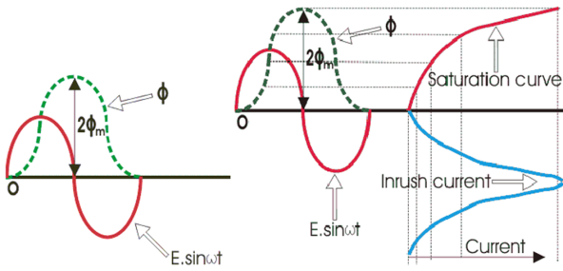
Fig. 1 – Transformer inrush current generation
The flux in the transformer core is zero prior to energisation. The steady-state will not be quickly reached by the flux. According to Faraday's rule of electromagnetic induction, the flux in the transformer core will grow from its zero value at the time of energisation. This rate of change in flux which causes the induction of voltage in the windings, and it can be found using the formula e = dφ/dt. The integral of the voltage wave will represent the entire flux, which is provided by,
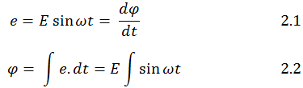
The flux wave will begin at the same origin as the voltage waveform if the transformer is powered at the voltage zero instant. The value of flux following the voltage waveform's first half cycle is determined by,
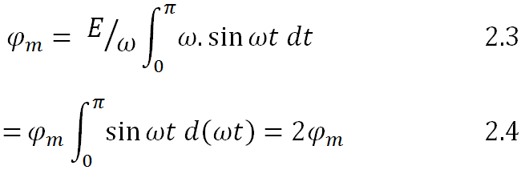
The maximal flux is represented by φ_{m}.
When the flux exceeds the maximum steady-state flux, the transformer core typically becomes saturated. The transformer's maximum flux value will increase to twice its steady-state maximum value during energisation. When the flux value surpasses the steady-state maximum, the transformer's core becomes saturated, causing the transformer to draw a large current in order to generate the remaining flux. During energisation, the transformer draws a large current known as the magnetizing inrush current. This current's magnitude could be ten times more than the transformer's rated current.
The interference of inrush current in a power transformer affects the differential relay's operation.
In addition to affecting the fuses or breakers' rating, high magnetizing inrush current causes noise and distortion to return to the supply mains. Therefore, it is crucial to distinguish between internal fault current and inrush current in order to enhance the transformer's protective system. Figure 2 shows the applied voltage and the transformer's magnetizing inrush current. [9]

Fig. 2- Transformer's Magnetizing Inrush Current
METHOLOGY
Prony analysis is a workable approach to modeling a linear sum of damped complex exponentials to uniformly sampled signals. In 1795, Prony introduced the Prony analysis. Its basic idea is to use a linear combination of exponential functions to express the equal interval sampling data. With the transitory signal, it functions nicely. It is possible to extract the harmonic components despite the frequency similarity. Prony analysis is also used to find the attenuation factor, phase, and amplitude of the signal. Since these numbers don't need to be computed in the frequency domain, the computing complexity is minimal. For this reason, proxy analysis has been widely used in power systems. Prony analysis is not only a signal analysis approach but also a means of system identification, and it is frequently used in the domains of power system electromechanical oscillation, radar, biomedical monitoring, sonar, geophysical sensing, radioactive decay and speech processing.
The linear combination of exponential functions serves as the Prony analysis's mathematical paradigm. The formula for it is Equation 3.1.
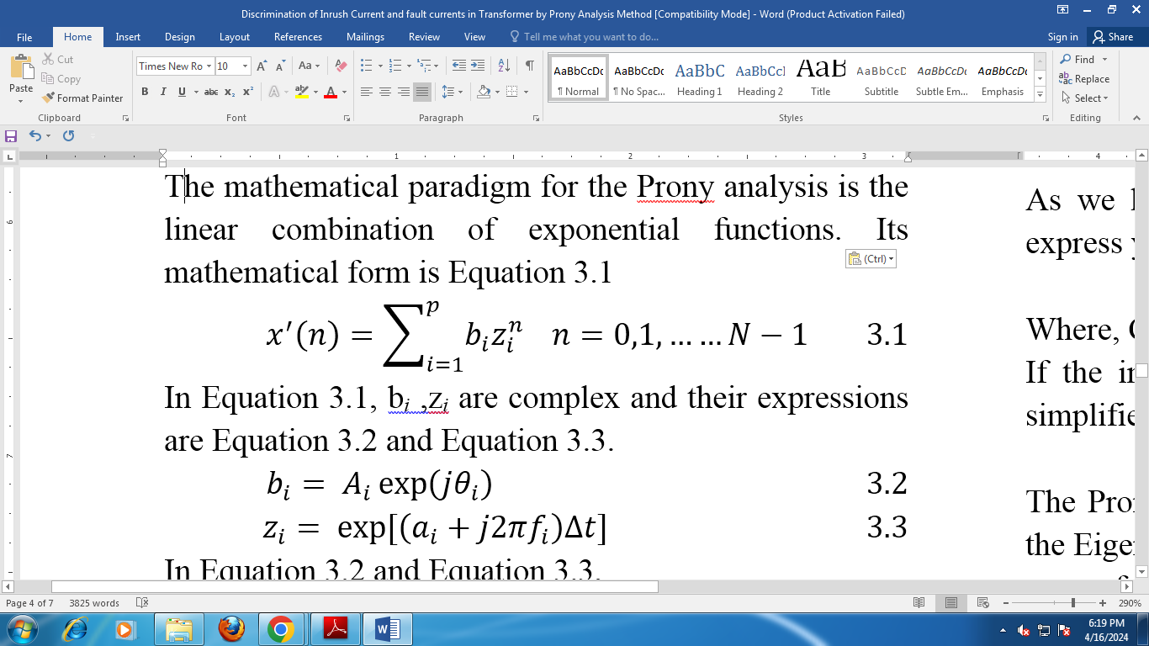
Equation 3.1's complex variables, z_{i} and b_{i}, can be expressed using equations 3.2 and 3.3.
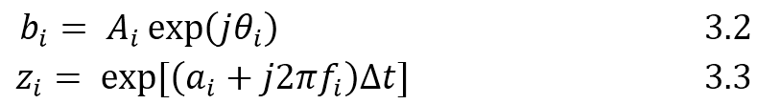
Equations 3.2 and 3.3 show that,
f_{i} = Frequency of Signal
A_{i}, θ_{i}, and a_{i} represent the signal's phase, attenuation factor, and amplitude. It is clear from Eq. 3.3 that every component in the Prony analysis is attenuated. With the exception of the aperiodic component, all the components in the full wave Fourier algorithm are observed to be stationary. As of right now, the full wave Fourier approach is less accurate than the Prony analysis. A specific algorithm can be used to calculate f_{i}, A_{i}, θ_{i}, and a_{i}.
Mathematical Analysis
To derive the mathematical formulation for the original Prony analysis, let us consider a Pulsed Corona Reactor (PCR) as a linear time-invariant (LTI) dynamic system as shown in Figure 3.
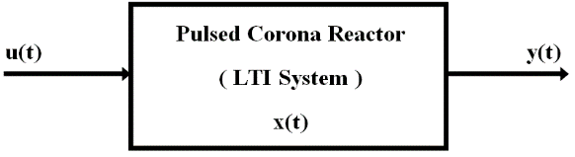
Fig. 3 - LTI system with a pulsed Corona reactor
The signals in Figure are denoted by the following names:
y(t) is the PCR system's response,
x(t) is the PCR system's state and
u(t) is the PCR system's input.
Equation represents the evolution of the PCR system's state.
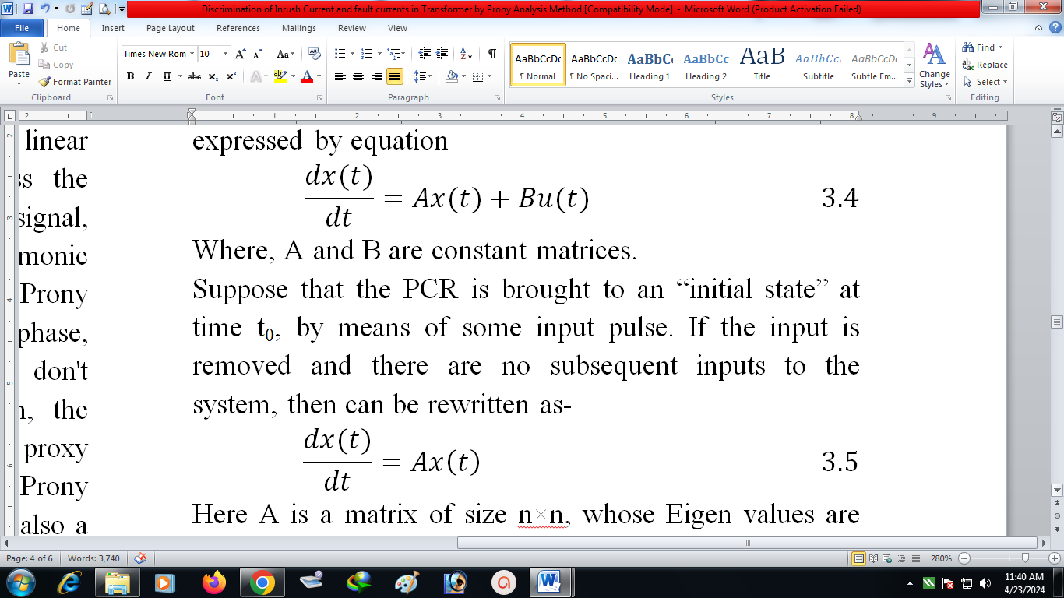
where A and B are matrices that are constants.
Assume that an input pulse is used to bring the PCR to its "initial state" at time t₀. It can be phrased as follows, if the input is eliminated and the system receives no more inputs:
In this case, A is an n×n matrix with eigenvalues of λ_{i}, left eigenvectors of q_{i}, and right eigenvectors of p_{i}. The system order is represented by n in the equation above. The sum of n components represents the answer to the problem mentioned before :
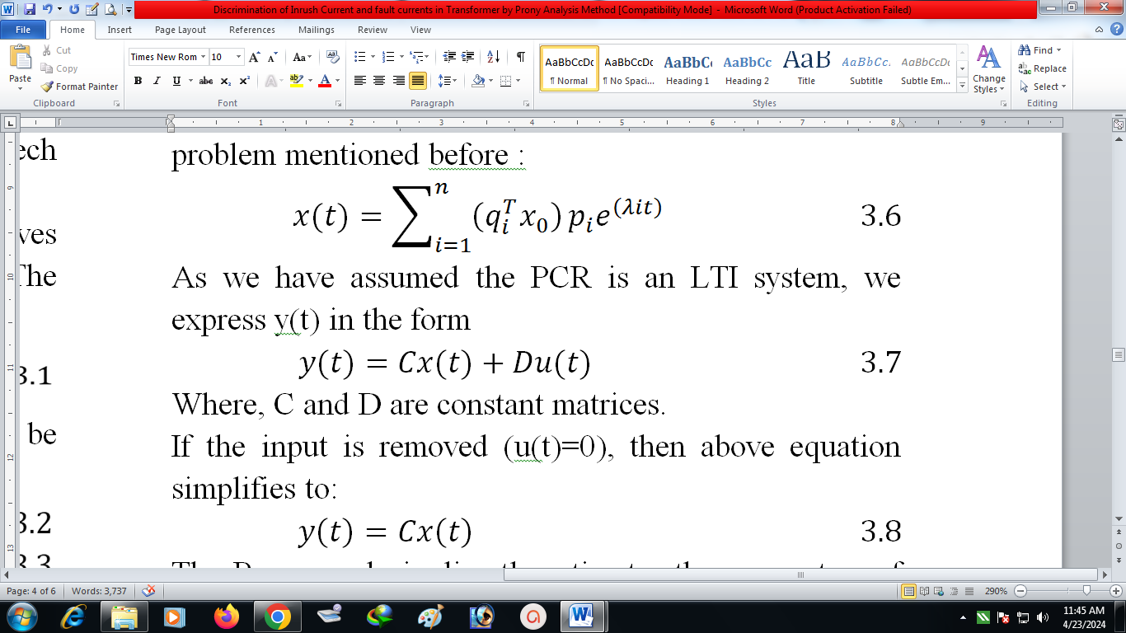
We express y(t) in the form since we believe the PCR to be an LTI system.
W here C and D are matrices that are constants.
The preceding equation becomes simpler to solve if the input is eliminated (u(t)=0):
By fitting a sum of complex damped sinusoids to evenly spaced sample (in time) values of the output, the Prony analysis directly calculates the parameters of the Eigen structure given in the third equation:
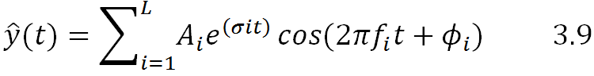
In Equation 3.9,
A_{i} represents the component's amplitude,
$σ$_{i} its damping coefficient,
f_{i} its frequency,
$\hat{y}L$= Estimated observed data for y(t) made up of N samples,
$\hat{y}\left(t\right)$= Estimated observed data for y(t)
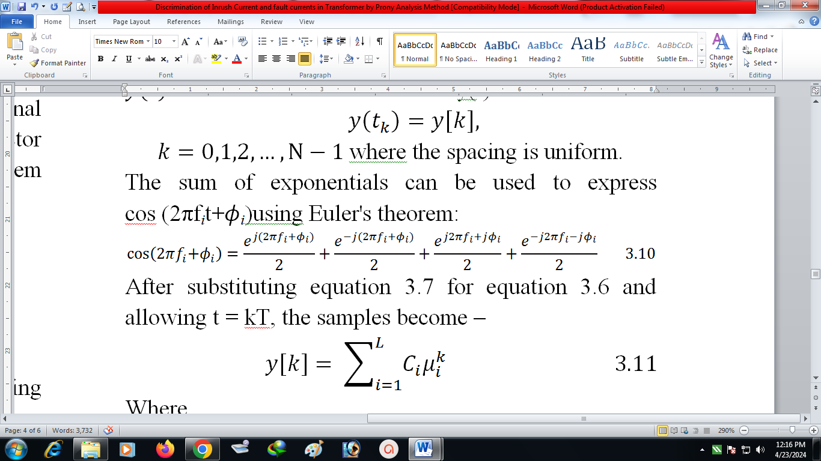
$k=0,1,2,…,N-1$where the spacing is uniform.
The sum of exponentials can be used to express cos (2πf_{i}t+$ϕ$_{i})using Euler's theorem:
After substituting equation 3.7 for equation 3.6 and allowing t = kT, the samples become –
Where,
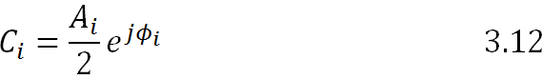

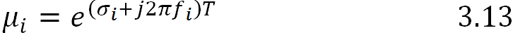

Which we refer to as “poles”
In equation 3.13,
T is the sampling period.
The original Prony analysis computes C_{i} and µ_{i} in three basic steps.
Study of Signal to noise ratio (SNR)
Two indexes—SNR (Signal-to-Noise Ratio) and DVR (Dynamic Change Rate) must be introduced in order to demonstrate the fitting waveform accuracy.
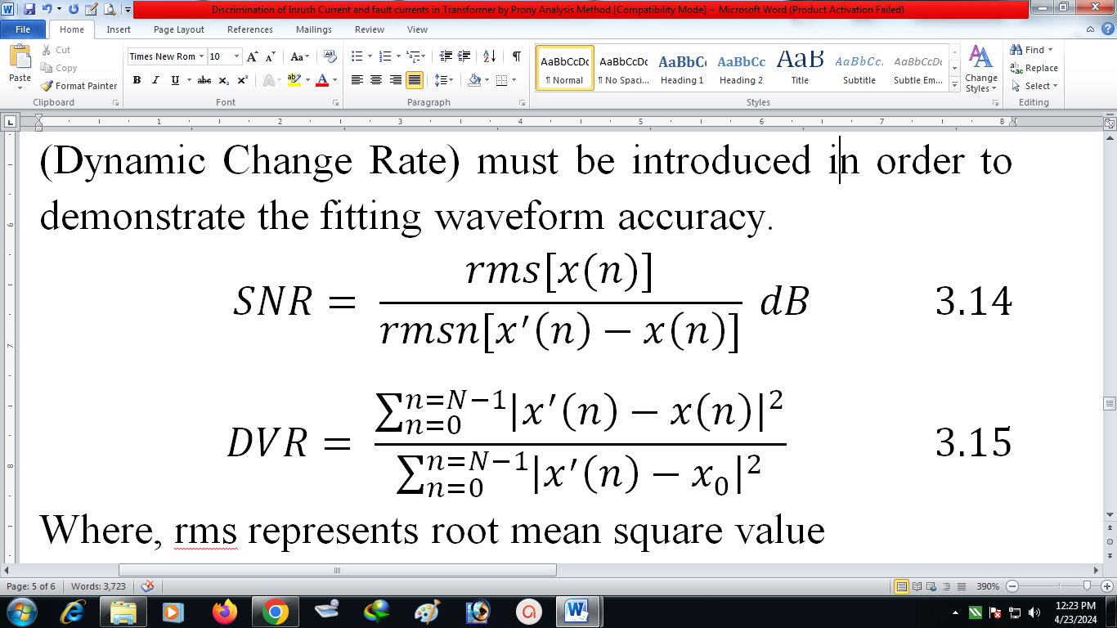

Where, r.m.s. stands for "root mean square" value.
x(n) sample data of the original signal.
x'(n) represents Data from the fitted.
A metric used in science and engineering to compare the strength of a desired signal to the strength of background noise is called the signal-to-noise ratio, or SNR or S/N. It is defined as the signal-to-noise power ratio, which is commonly given in decibels. More signal than noise is indicated by a ratio larger than 1:1 (more than 0 dB). SNR can be used to any type of signal, even though it is frequently used to describe electrical signals (such as isotope levels in an ice core or biochemical signaling between cells).
The ratio of accurate to inaccurate or irrelevant data in a discussion or interaction is commonly referred to as the signal-to-noise ratio.
In general, the proper result can be accepted when SNR is about 20 dB. In cases where SNR is higher than 40 dB, the fitting result is optimal. The smaller the DVR, the better the fitting result. An acceptable predicted result is one where DVR is less than 0.01.
Circuit Diagram
The transformer used is 1-phase, 2 KVA, 230/230 V, multi winding transformer, with number of winding on left side of it is as well as on right side is 1. The numbers of tapings are 10. Winding resistance of transformer is 0.825 pu and the winding leakage inductance 0.00396 pu, magnetization resistance 2850 pu.
1. Inrush Current:
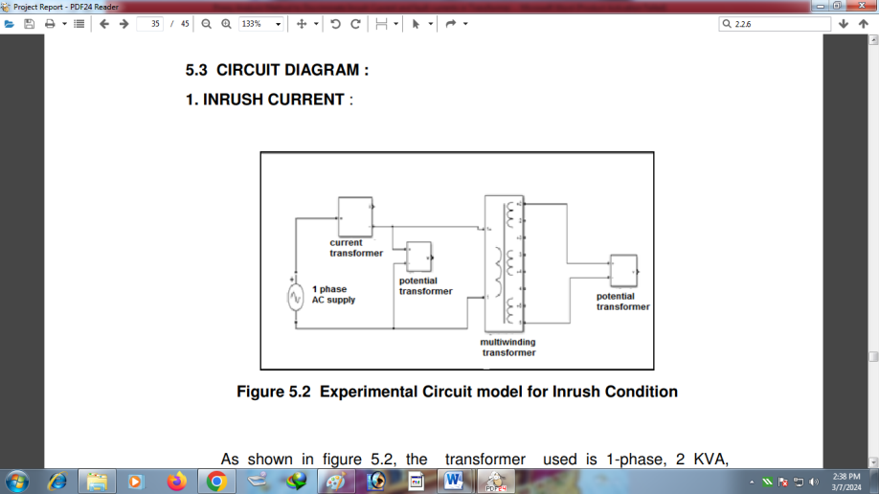
Fig. 4-Experimental Circuit model for Inrush Condition
The transformer's secondary is left open, power is applied to the primary side, and an attached ADC is used to obtain measurements for the inrush current computation. These readings are given as an input to the MATLAB program and graph of time vs I_{p} obtained. Using these graphs we can fit curve using Prony Analysis.
2. Inter-Turn Current
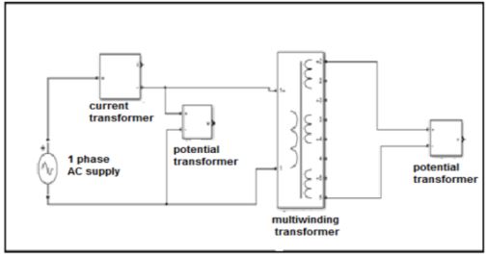
Fig. 5-Experimental Circuit Model for Fault Condition of 2 KVA
Supply is applied to the transformer's primary side, one of its secondary windings is shorted, and measurements are obtained from the attached ADC in order to calculate the fault current. These readings are given as input to MATLAB program and graph of time Vs I_{p} obtained. Using these graphs we can fit curve using Prony Analysis

Flow Chart
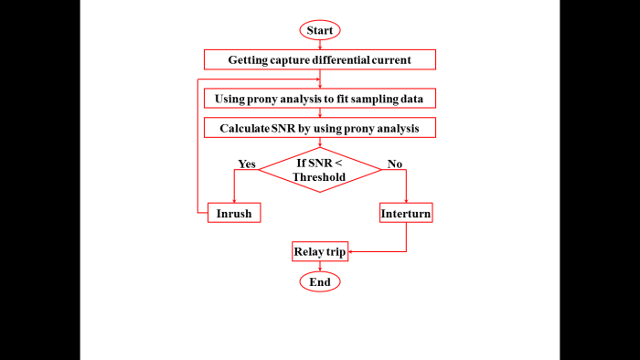
Fig. 6-Flowchart of Prony analysis
Procedure
1. Make the circuit connections.
2. Take the reading of Ip with the help of ADC of 1000 samples and makes it’s excel file.
3. Load the excel file in MATLAB.
4. By using the MATLAB algorithms for Prony Analysis, create a graph showing the relationship between the transformer's current signal and time.
5. Find the parameters like SNR, DVR and Attenuation factor from fitted curve.
RESULT AND DISCUSSION
Fig. 6-Fitted inrush current waveform
The above current waveform shown in figure and is obtained at modal point 700 for Inrush current. Basically, one cycle contains 20 samples. Here, two cycles are considered i.e. 40 samples. Now, by using Prony Algorithm the parameters like SNR and DVR can be calculated. So, here obtained values are: SNR = 25.9843, DVR = 0.0087.
Fig. 7- Fitted inter-turn current waveform
The above current waveform shown in above figure and can be obtained at modal point 560 for Inter-turn fault. Basically, one cycle contains 20 samples. Here, two cycles are considered i.e. 40 samples. Now, by using Prony Algorithm the parameters like SNR and DVR can be calculated. So, here obtained values are: SNR = 23.8154, DVR = 0.0008412.
CONCLUSION
This work elaborates a novel technique for distinguishing magnetizing inrush current from interturn faults in a transformer. To obtain distinguishing characteristics from the differential current, proxy analysis is utilized. By fitting the wave derived from inrush and fault current, this technique is accomplished. The conclusion is that the inter-turn fault current's SNR is higher than the inrush current's. To distinguish between inrush current and fault current, take the SNR threshold value into consideration.
The acquired result conclusively demonstrates that the system is capable of distinguishing between defective and inrush scenarios. This will reduce the chance of relay malfunction.
REFERENCES
- Yashasvi Tripathi, Kushagra Mathur, Dr. S. V. N. L. Lalitha, Dr. M. Ramamoorty, Discrimination of magnetic inrush current from fault current in transformer-A new approach, International Journal of Pure and Applied Mathematics, http://www.ijpam.eu, ISSN: 1311-8080 (printed version); ISSN: 1314-3395 (on-line version), Volume 114 No. 12 2017, pp. 615-625.
- Sunil Kumar Gunda, and Venkata Samba Sesha Siva Sarma Dhanikonda, Discrimination of Transformer Inrush Currents and Internal Fault Currents Using Extended Kalman Filter Algorithm (EKF), https://www.mdpi.com/journal/energies,https://doi.org/10.3390/en14196020, Energies 2021, 14, 6020, pp. 1-2.0
- Shao-feng Huang, Hong-ming Shen, Jia Wang, “A New Method to Discriminate the Inrush Current Based on Prony Analysis”, Advanced Materials Research Vols 516-517 (2012) pp 1671-1677 © (2012) Trans Tech Publications, Switzerland.
- Prof. P. R. Bharambe, Mr. V. S. Karale, Shivani Manatkar, Komal Tayade, Abhishek Patil, Adarsh Moon, Sumit Mahajan, Ashwini Rajagur, Discrimination Between Inrush Current from Interturn Fault Current in Transformers based on the Non-Saturation Zone, International Journal of Advanced Research in Science, Communication and Technology (IJARSCT), www.ijarsct.co.in, DOI: 10.48175/IJARSCT-4354, ISSN (Online) 2581-9429, Volume 2, Issue 7, May 2022, pp. 312.
- S. R. Paraskar, M. A. Beg, G. M. Dhole, Discrimination between Inrush and Fault in Transformer: ANN Approach, International Journal of Advancements in Technology http://ijict.org/, ISSN 0976-4860, Vol 2, No 2, April 2011, pp. 306-318.
- M. Rasoulpoor, M. Banejad and A. Ahmadyfard, Discrimination Between Inrush and Short Circuit Currents in Differential Protection of Power Transformer Based on Correlation Method Using the Wavelet Transform, Iranica Journal of Energy & Environment, IJEE an Official Peer Reviewed Journal of Babol Noshirvani University of Technology, 2 (4), ISSN 2079-2115, DOI: 10.5829/idosi.ijee.2011.02.04.3139, pp. 302-312.
- J. P. Patra, A New Approach for Discrimination between Inrush Current and Internal Faults in Power Transformers, International Journal of Electronics and Communication Engineering, http://www.irphouse.com, ISSN 0974-2166 Volume 4, Number 4 (2011), pp. 409-414.
- Anupam Sinha, Sarpreet Kaur, Different Methods of Differentiating Inrush Current from Internal Fault Current in Transformer, International Journal of Computer Applications (0975–8887), International Conference on Advances in Emerging Technology (ICAET 2016), www.ijcaonline.org, pp. 35-41.
- Purushottam R. Bharambe, Sudhir R. Paraskar, Saurabh S. Jadhao, A Review of Techniques Used For Discrimination of Inrush Current and Internal Fault Current of A Power Transformer, Online International Conference on Multidisciplinary Research and Development, ICMRD-21, www.iejrd.com, SJIF: 7.169, http://mkct.org.in/icmrd/, pp. 1-14.

