Comprehensive Literature Survey on Vehicle Speed Control

Priya Gupta ¹, Vijay D. Chaudhari². Hemraj V. Dhande³, Maheshkumar N. Patil⁴, Hemant T. Ingale⁵
¹PG student, ^{232,4,5} Assistant Professor
^{1,2,3,4,5} E&TC dept, MTech (VLSI & ES), GF’s Godavari College of Engg, Jalgaon - 425003, Maharashtra, India.
prgpt75@gmail.com¹, vinuda.chaudhari@gmail.com², maheshninupatil@gmail.com⁴
Received on: xxxx,20xx Revised on: xxxx,20xx Published on: xxxx,20xx

Abstract – Now a day’s people are facing further problems about road accident in all over world, currently accident is the most essential issue far and wide in the world; utmost of accident are due to rush driving of vehicle by motorist on public road indeed in confined areas. In recent study million of people failed in India due to road accident. Main reason of road accident is people one who driving vehicle veritably presto, drive vehicle by drinking alcohol, some people doesn't use Seatbelt, frazzle of motorist. Hence business operation is important in big megacity. Then in this paper, trying to reproduce the comprehensive literature study related to the colorful vehicle speed control fashion, accident discovery that are necessary to reduce accident to save precious life of one. In once days, the exploration is gone on colorful vehicle speed control fashion like traditional automotive mechanical system systems. Due to the advancement in recent ways, some vehicle speed control systems are grounded on microcontroller, GSM, GPS, numerous different detector like alcohol discovery, close eye discovery, RFID, Sigsbee, Wi-Fi, CAN machine protocol and radio frequencies system, etc. Each system has their own advantages and disadvantages. In utmost of systems, SMS fashion is used for communication so the system will come cost effective, more dependable and it'll take lower time to deliver communication. As accident becomes major problem currently, the speed covering systems moment needs to make use of the rearmost technology. In some papers, the authors have presented different vehicle speed monitoring system is bedded in vehicle or on road to control speed of vehicle automatically. Occasionally system will check whether condition like motorist frazzle, alcohol discovery, seat belt etc. Also the enhanced security systems are available grounded on android platform, wireless ways and bedded systems. A number of modifications take places in colorful vehicle speed control fashion from the last many times, in coming coming times numerous changes will takes place.
Keywords: Vehicle speed, GSM, GPS, Wi-Fi, CAN

- INTRODUCTION

Speed control of vehicle is need of hours due to increase in accident in our day to day life. People are driving veritably presto, hence accident passed constantly and we've to lose our precious life. mortal error is also causes utmost of road accident Hence for help this accident motorist should warn about the speed of vehicle. To break this problem related to accident Main end of this paper is to control speed of vehicle automatically in confined areas similar as academy zone, demesne, Hospital. Now days colorful placard are place on road but numerous time motorist ignore this placard and drive vehicle at unhappy speed and beget for accident. Some intelligent motorist system bear to control the different parameter of vehicle similar as speed of vehicle, position of vehicle also it should cover the motorist geste
like heart beat, alcohol, discovery, eye blink etc. Different detector are use to cover theses parameter. For vehicle shadowing GPS system is used for chancing position of vehicle.

II. LITERATURE SURVEY
Vehicle Speed Control systems are categorized based on technology 1) GSM based, 2) GPS based, 3) Radio Frequency based, 4) RFID based, 5) Wi-Fi based, 5) ) Motion detector based, 6) Zigbee based, 7) Advance speed advisory system based, 8) Microcontroller based, 9) Motion detector based,10)Biometry sensor 11) Color Sensor based Combined system.
- GSM AND GPS BASED SYSTEMS :
To know the position of vehicle, speed, exertion of motorist( 1) achieve the real time information of vehicle. GSM and GPS system allow object shadowing. For Accident forestallment we should know geste of motorist( 2) or condition of motorist similar as eye blink, drunk situation different detector are use. In GSM and GPS system if accident passed any where accident information will actuated and massage is transmitted to third party( 3). GPS system use for tracking vehicle and give global position of vehicle this information is passed to GSM modem. Because of GPS system it give secure travelling, GSM is used for communication purpose GSM module which gets actuated by a regulator GSM digitalize data and shoot massage to authority to apprehensive. If GSM system is place in auto we can communicate automatically to thirdparty.In ultramodern road monitoring system to control movement of vehicle over entire transport network for safe operation using GSM- road radio communication( 25). In order to make sure that injured person delivering, for that purpose delivering commerce information system is developed.

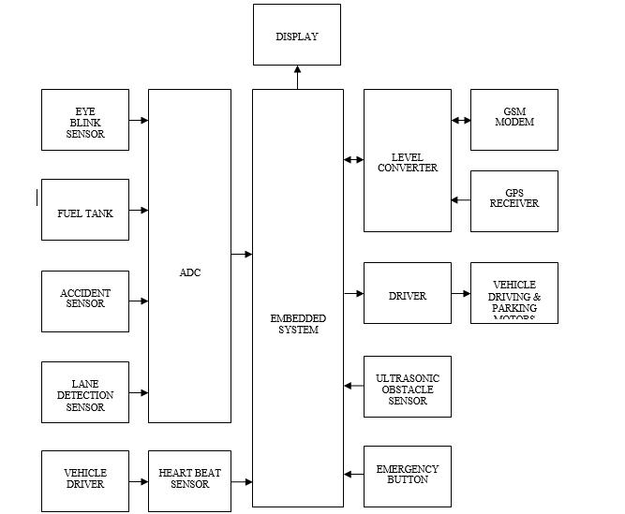

Fig. 2: diagram of Vehicle tracking [3]
- Sensor Based Detector based system:
Different detector are use to descry different condition like handicap discovery, speed discovery, alcohol discovery, eye blink detection, motorist heart beat discovery. In some system to collect business data in civic megacity use mobile detector (23). In network detector base system it enables to collect real time data of business in big metropolises. Speed detector observed speed of vehicle at regular interval (22). For collision discovery, used camera to cover image to suffer discovery process and distance computation.
  - Biometric Based System:
Numerous accident are passed due to geste Of driver .For that purpose nonstop assessment of different condition like alcohol, eye blink, frazzle, seatbelt, heart beat rate etc. In vibration detector system detector are use to descry vibration if climate increases above certain limit it indicate abnormal condition( 3). These different sensors spark microcontroller and massages shoot to affiliated authority like police station, sanitarium by using GSM system, Massage contain all information about position, number plate of vehicle. numerous accident are passed due to motorist fatigue, detector base system can anatomized eye movement of motorist( 22).
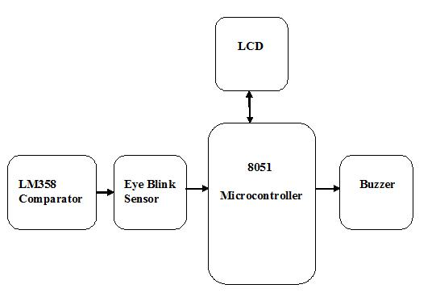

Fig.3. Eye blink detector

  - Color Sensor Based Detector system:
In color detector system( 5) different color strip painted on the road, trace, color detector sensor descry color strip which is painted on road and limit speed of vehicle at particular limit. Color detector sensor are located below cushion lattice of vehicle which can descry the color of color strip painted on trace and spark system by transferring signal to MCU, MCU control position of throttle stopcock to control speed of machine to given limit( 4). Programmable MCU can reuse signal from different element and shoot to garrote stopcock, speedometer, vehicle. In this way we can control speed of vehicle using color detector approach

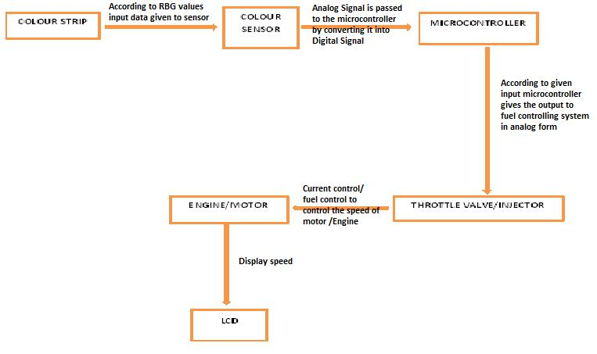

Fig.4: Layout of speed control using color strip[5].
3. MICROCONTROLLER Grounded SYSTEMS: Speed control of vehicle using microcontroller grounded system collect data of vehicle parameter using RF communication. Transmitted data from RF transmitter analyses by microcontroller and it take applicable action to control speed of vehicle in this particular zone where speed of vehicle is confined( 8). Microcontroller is programmed to drop speed of vehicle in separate zone( 9). In some microcontroller system use Electronic Controller and Display which is bedded in machine( 6). In this system display use to indicate the zone and other fresh information to motorist. In some ways speed is control by ARM and information is shoot by Zigbee.. In case of RF transmitter admit signal and spark the microcontroller to take applicable action. Microcontroller programming can do using bedded C( 7)
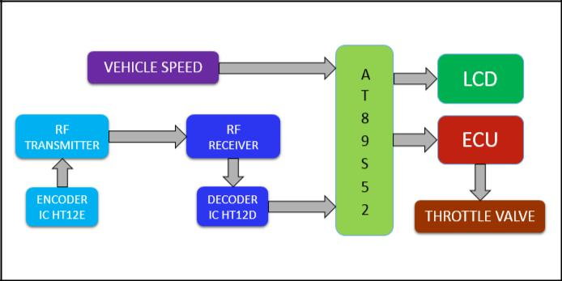
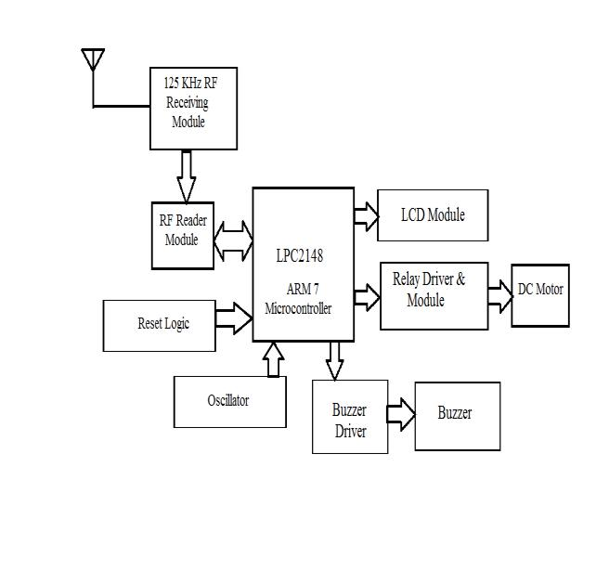

Fig 5: Electronic Controller and Display unit [6]
- RF BASED SYSTEMS :
To insinuate the motorist about zone, speed limit, can done by using RF technology( 20). Smart Display and Controller used to cover zone and controlled speed( 11). It correspond of two part 1) transmitter( to cover status of zone) 2) Receiver( display and control). Radio frequence is frequence electromagnetic diapason associated with radio surge propagation when RF current inventories to antenna electromagnetic field is created It can propagated through space( 15). RF receiver get signal from RF transmitter and actuated microcontroller, microcontroller compared the parameter and controlled speed of vehicle( 12). RF grounded system use Encoder and Decoder IC is with RF transmitter and receiver independently( 13).

- RFID Grounded SYSTEMS
Another system for Speed control of vehicle is by using RFID label( 10). RFID tagged placed in zone and RFID anthology is placed along vehicle. RFID label programmed to shoot law signal to receiver. When Vehicle enters into zone it s law signal to admit by receiver and it control speed of vehicle. Label placed at launch and end of zone where speed of vehicle is confined. RFID label can control speed of vehicle using propinquitysensor.RFID label also use to indicate dangerous portion of road. RFID tagged of auto give indispensable information about business( 14).
6. INTELLIGENT SPEED ADVISORY SYSTEMS
Intelligent speed Advisory systems in which all advance function are available for controlling all parameter of vehicle. correspond of zone warning system, speed warning system( active), speed premonitory system( unresistant).

Fig 6: Intelligent Speed Advisory System
Passive make allow choice for motorist what action should taken. Range of advising signal is in two form audio and visual warning signal( flashing of light or beep signal). Some advance ISA system capability to descry temporary speed zone( similar as accident, roadwork). Knowledge of premonitory system also descry sharp wind, stop signetc. violation operation provides effective monitoring and reporting system of speed of the vehicle which exceeds the limit( 16). To manage business inflow on road use intelligent business light system which use customer garçon communication that an give the information about direction and speed of vehicle( 24).
7. ZIGBEE Grounded SYSTEMS
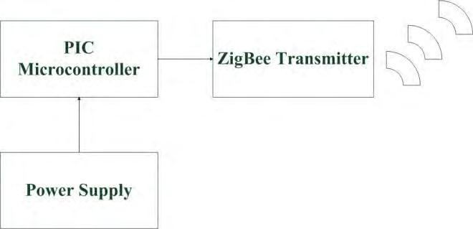
Vehicle speed information is transmitted using Zigbee system which is wireless mode of communication, whichactivated by rush driving( 31). It salutary at exigency condition( 30), it proves as effective. It correspond of two corridor transmitter and receiver transmitter is place at predetermine road. Information is shoot using wireless Zigbeemodel( 17). In addition to this business lights status collected by the transmission units will be transmitted via ZigBee( 29). ZigBee wireless technology is considered as a largely promising seeker forintra-vehicular wireless networks( 28). This system is also useful for business operation( 31). This model experimented for six zone( i) School zone( ii) Hospital Zone( iii) Steep Angles Ahead( iv) Bridge Works Ahead( v) Hair Leg Bend Ahead( vi) Accident Prone Area Ahead. Receiver containingZigbee, Microcontroller, CAN regulator. entered signal by Zigbee and shoot to microcontroller and also it shoot to CAN regulator. Speed information is attained from speedometer through CAN regulator. CAN machine protocol is enforced using a single board computer( SBC) and penetrated the vehicle parameters ever( 27).

Fig 7: Block Diagram of transmitter section[17].
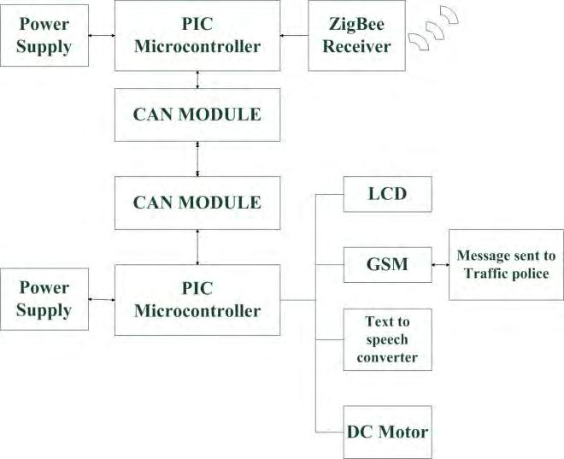

Fig 8: Block Diagram of Receiver section [17].
8. WI- FI BASED SYSTEMS
Intelligent Transportation system is advance system to minimize accident. This System focus on use of Global positioning system using bedded wireless Fidelity this is new approach for intelligent vehicle control( 18). In propose work system tackle can cover signal using GPS if there's normal state speed is normal else signal shoot to ARM processor to reduce speed of vehicle at certainlimit.ARM processor collect data from GPS and it shoot to Device motorist for operate vehicle at safe limit.
9. ADVANCE motorist ASSISTANT SYSTEMS
At present vehicles, auto, truck are drive by mortal but in unborn vehicle will be drive by robot, they can descry handicap on the way, speed of vehicle, zone of where speed limitation, accident prone area, stop sign, position ofroad.In ADAS it's set of system to help motorist for stay in comfort( 19). This system correspond of three mainsub-system i) motorist, ii) Road side terrain, iii) Vehicle. In propose work to increase or drop speed of vehicle PWM fashion is use.
III. DISCUSSION
From all study we got knowledge about each different wireless technology for controlling speed ofvehicle.Because vehicle speed control is important issue for like academy zone, sanitarium zones, hilly areas, accident zones, rambler crossing and so on. Different technology use for control speed of vehicle without convenience the motorist, we can got automatically control on vehicle. For this purpose we can use different technologies similar as RFID, GPS, GSM, Zigbee, RF Module, different microcontrollers. Each Technology has its own operation and downsides like range, circuitry, cost, operation, complexity, power demand, data rate etc. relative analysis of different wireless technology which used in vehicle speed control( 34)
1. Infrared – It allow to communicate at short range. Data can shoot bidirectional.
2. Wireless Fidelity( Wi- Fi) – Wi- Fi relate to as IEEE802.11 communication standard for wireless original area network( WLANs). Different Security styles available from unauthorized access.
3. Zigbee – Zigbee is suite of specification for high positioncommunication.Zigbee network use to transmit data over larger distance.
Table 1 lately Proposed Different Vehicle speed control Systems using colorful ways and their comparison( 35)-( 36
Specification | RFID | IR Wireless | Wi-Fi  (802.11) | Zigbee
Power Consumption | Medium | low | High | Very Low
Security | 64 and 128 bit encryption |  |  | 128 AES plus application layer security
Typical Applications | Tracking items | Remote control, PC, PDA, Laptop | WLAN connectivity,  Broadband Internet access | Industrial control and monitoring,  Sensor networks, building automation,  Home control and automation
Complexity | Low | Low | High | Low
Data Rate | varies | 20-40Kbits/sec | 11 and 54 Mbps | 20, 40 and 250 Kbps
Range | 3 meters | <10 meter line of sight | 50-100 meters | 10-100 meters
Operating frequency | varies | 800 -900 nm | 2.4 and 5 GHz | 2.4 GHz

CONCLUSION :
From all we conclude that different wireless technology are used in vehicle speed control as per operation. Then some sensor are used for alcohol discovery, closed eyes, crash discovery, automatic discovery of zone like sanitarium zone for automatic disable cornucopia, academy zone academy zone, hills area, and roadways. This innovative fashion was developed substantially in a motive of reducing the death rates that are lost during accidents. This Survey Paper creates a satisfactory result for the long lasted problem.
ACKNOWLEDGMENT
Acknowledgment to person or the organization supported to the author for the research work. This is not mandatory for all.
REFERENCES
- [1]B.Devikiruba, “Vehicle Speed Control System Using GSM/GPRS”,(IJCSIT) International Journal of Computer Science and Information Technologies, Vol. 4 (6), 2013, 983-987.
- [2]M.abinanya, R. Uthira Devi Intelligent “Vehicle Control Using Wireless Embedded System in Transportation System Based On GSM and GPS Technology”International Journal of Computer Science and Mobile Computing, Vol.3 Issue.9, September- 2014, pg. 244-258
- [3]R. Rathinakumar and D. Manivannan“Wireless Accident Information System Using GSM and GPS” Research Journal of Applied Sciences, Engineering and Technology 4(18): 3323-3326, 2012 ISSN: 2040-7467
- [4]Srinivasan.J,“ Intelligent Vehicle Monitoring System using Wireless Communication”, International Journal of Innovative Research in Advanced Engineering (IJIRAE)ISSN: 2349-2163 Volume 1 Issue 10 (November 2014)
- [5]Sunil R. Kewate, S.V. Karmare, NehalSayankar and SiddharthGavhale“Automatic Speed Control System by the Color Sensor for Automobiles” -An Innovative Model Based Approach International Journal of Advanced Mechanical Engineering. ISSN 2250-3234 Volume 4, Number 2 (2014), pp. 223-230
- [6]GummarekulaSattibabu,B.V.V.Satyanarayan, VV Satyanarayana Kona, “Automatic Vehicle Speed Control With Wireless In-Vehicle Road Sign Delivery System Using ARM 7” international journal of technology enhancements and emerging engineering research, vol 2, issue 8 issn 2347-4289
- [7] Pratik Mhatre and Ketan Thakur, “Automatic vehicle speed control with wireless In-vehicle road sign delivery system using ARM 7,” International Journal of Scientific and Technical Advancements, Volume 2, Issue 2, pp. 111-112, 2016.
- [8] Kashyap A R, MohankrishnaK ,“Vehicle Collision Avoidance with Dynamic Speed Governor”International Journal of Innovations in Engineering and Technology (IJIET) Volume 5 Issue 4 August 2015 ISSN: 2319 – 1058
- [9] Imran Ahmed Khan, PragyaJaitly, Ram Krishna Gupta, SakshiKishor“Design of Zonewise Vehicle Parameter Control System” International Journal of Advanced Research in Computer Science and Software Engineering 5(3), March - 2015, pp. 132-136
- [10]Leena Thomas, SwethaAnnu James, Seril Joseph, Arya K B, TedikNarah, ObangPangu“ Automatic Speed Control of Vehicles Using RFID” International Journal of Engineering and Innovative Technology (IJEIT) Volume 3, Issue 11, May 2014 ISSN: 2277-3754
- [11] Ankita Mishra, JyotiSolanki , HarshalaBakshi, PriyankaSaxenaPranavParanjpe“ Design of RF based speed control system for vehicles”International Journal of Advanced Research in Computer and Communication Engineering Vol. 1, Issue 8, October 2012 ISSN (Print) : 2319-5940
- Mr.R.ManojkumarM.Suresh, M.Siva, S.Nanthakumar, “Speed Reducer for Two Wheelers Using Radio Frequency Sensors” Quest Journals Journal of Research in Mechanical Engineering Volume 2 , Issue 8 (2015) pp: 01-05 ISSN(Online) : 2321-8185
- [13] AnaghaChikate, BhushanKamble, ShraddhaBurrewar, NehaTiwari, JaveriyaShaikh“Radio Frequency Based Automatic Speed Control of Over Speeding Vehicles by Controlling Throttle Valve” International Journal of Engineering Science and Computing, May 2016 DOI 10.4010/2016.1421 ISSN 2321 3361
- [14] ManjunathChincholi, DrK.Chandrashekara“Design & Analysis of Vehicle Speed Control Unit Using RF Technology”International Advanced Research Journal in Science, Engineering and Technology Vol. 2, Issue 8, August 2015 ISSN (Print) 2394-1588
- [15]Deepa B Chavan, Abdul Rahim Makandar, Faizul Hakeem Khan, Syed AzimuddinInamdar“Automatic Vehicle Speed Reduction System Using Rf Technology” International Journal of Engineering Research and Applications ISSN : 2248-9622, Vol. 4, Issue 4( Version 9), April 2014, pp.13-16
- [16] Michael Paine David Paine “In-Vehicle Intelligent Speed Advisory Systems”
- [17] Rubini.R and Uma Makeswari.A“Over Speed Violation Management Of A Vehicle Through Zigbee” International Journal of Engineering and Technology (IJET) Vol 5 No 1 Feb-Mar 2013 ISSN : 0975-4024
- [18]P. SaiChaitanya, V. Vikram, B. Kalesh, “Automatic Vehicle Speed Control System Using Wireless fidelity” International Journal of Advance Electrical and Electronics Engineering (IJAEEE) ISSN (Print): 2278-8948, Volume-3 Issue-4, 2014
- [19] Sudhirkumar Singh W, Philomina S “Advanced Driver Assistance Systems For Automobiles Using Wpan” Unique Journal of Engineering and Advanced Sciences 02 (02), April-June 2014 Page 108-111
- [20]A.Vengadesh ,K.Sekar , “ Automatic Speed Control Of Vehicle In Restricted Areas Using Rf And Gsm” International Research Journal of Engineering and Technology (IRJET) Volume: 02 Issue: 09 | Dec-2015
- [21] D.Narendar Singh Ravi tejach.v. “Vehicle Speed Limit Alerting and Crash Detection System at Various Zones”International Journal of Latest Trends in Engineering and Technology (IJLTET) Vol. 2 Issue 1 January 2013 ISSN: 2278-621X
- [22]AthiraVijayaraman, Athiramol K Thampi, K U Anjali“Real-time nonintrusive monitoring and detection of eye blinking in view of accident prevention due to drowsiness”Circuit, Power and Computing Technologies (ICCPCT), 2016 International Conference on 18-19 March 2016
- [23] PimwadeeChaovalit, SooksanPanichpapiboon, ChaiyaphumSiripanpornchana “Effective variables for urban traffic incident detection” Vehicular Networking Conference (VNC), 2015 IEEE 16-18 Dec. 2015

. [24]Min-You Wu, Wei Shu, Mustafa Al-Mashhadani, “Enhancing Traffic Flow Using Vehicle Dashboard Traffic Lights with V2I Networks”
Vehicular Technology Conference (VTC Fall), 2015 IEEE 82nd6-9 Sept. 2015
[25]Kevin Chetty, Karl Woodbridge, Qingchao Chen“Train monitoring using GSM-R based passive radar” Radar Conference (RadarConf), 2016 IEEE2-6 May 2016
[26]Mihaela van der Schaar, UgurDemiryurek, Luca Canzian“Collision detection by network sensor” IEEE Transactions on Signal and Information Processing over Networks ( Volume: 2, Issue: 1, March 2016 )
[27] A. A. Salunkhe; Pravin P Kamble; RohitJadhav“Design And Implementation Of CAN Bus Protocol For Monitoring Vehicle parameters”Recent Trends in Electronics, Information & Communication Technology (RTEICT), IEEE International Conference on20-21 May 2016DOI: 10.1109/RTEICT.2016.7807831
[28]A.V. Durga Ganesh Reddy, BarathramRamkumar“Simulation studies on ZigBee network for in-vehicle wireless communications”Computer Communication and Informatics (ICCCI), 2014 International Conference on3-5 Jan. 2014
[29]Wei ZhaoJiyu JinDesign of “voice reminder system for intelligent transportation based on Wireless Sensor” Network Communication Technology and Application (ICCTA 2011), IET International Conference on 14-16 Oct. 2011 DOI: 10.1049/cp.2011.0706
[30] Shubham Vijay Vargiya, VikramLodhi, PrasunShrivastava“Vehicle To Vehicle Safety Device - An Ease For Safe Driving”Computing for Sustainable Global Development (INDIACom), 2015 2nd International Conference on 11-13 March 2015
[31] A. SowmiyaN. Prabhu Ram“An intelligent approach for effective road traffic management” Innovations in Information, Embedded and Communication Systems (ICIIECS), 2015 International Conference on 19-20 March 2015 DOI: 10.1109/ICIIECS.2015.7193251
[32] Madhumathi RajeshD.Muruganandam“On Proposing Automobile Accident Prevention System (A2PS) Using Wireless Sensors And Zigbee Technology”Computing Communication & Networking Technologies (ICCCNT), 2012 Third International Conference on 26-28 July 2012 DOI: 10.1109/ICCCNT.2012.6396066

