A review on “Design and Analysis of 3D printed parts developed through fusion of composite materials.”
Pratik Gulande¹, Dipali Bhoyar² , Ritesh Banpurkar³
¹M.Tech. Student, Abha Gaikwad Patil College of Engineering, Nagpur
²Asst. Prof. Abha Gaikwad Patil College of Engineering, Nagpur
³Asst. Prof. Abha Gaikwad Patil College of Engineering, Nagpur
Abstract:
This paper presents the development of a new composite material for use in injection molding machine. The material consists of iron powder filled in and to find out which type of composite material is best and to conduct tensile testing and fluctuation testing from a scientific point of view and to make a specimen and test it according to which type of composite material will give good 3D printing and find out the result and give a conclusion. FDM is one of the most widely used 3D printing technologies because of its reliability and simple process. FDM requires only a heating process to extrude the materials. Furthermore, FDM 3D printers have competitive prices when compared to other 3D printing machines. This is the primary reason why the FDM 3D printer is the most commercialized in the additive manufacturing industry today. Composites are becoming increasingly popular among business professionals as a way to provide high-quality materials for desired products, particularly in the aerospace and automotive industries, medical industries. Users can print lighter, stronger – sometimes even stronger than some metals – objects. The combination of two substances with different physical and chemical properties is called a compound. The most common materials for FDM 3D printing are Metal/Nylon, Metal/ABS and their various fusions. FDM printers can also print with other special materials with properties such as higher temperature, impact resistance, resistance and stiffness. In addition to commonly used materials, there are new and more effective materials that can be used in many combinations.
As a result of this study, it was confirmed that the tensile strength of the composite decreased with the increase of metal content. In addition, the thermal conductivity of metal/polymer filaments is improved by increasing the metal content. It is believed that metal/polymer filaments can be used to print metal and large 3D (3D) models without deformation due to thermal expansion of thermoplastics.
Keywords: Additive Manufacturing, FDM, Metal / Nylon, Metal / ABS

Introduction:
3D printing, also known as rapid prototypig, is a computercontrolled piecing process that uses a variety of materials and techniques to build objects layer by layer on a machine. 3D printing can create physical models directly from the computer. This invention came about at the same time as CNC technology in the late 80's. While 3D printing isn't as popular as CNC, it has changed the way we think about design. This ability has great power for production.
In addition, 3D printing has special advantages in design, internal flow channel design, cavity design, thin walls, ribs and other things that are difficult to do with other methods. A new metal/polymer composite filament was developed for the Fused Deposition Modeling (FDM) process to evaluate the thermomechanical properties of the new filament. Acrylonitrile butadiene styrene (ABS) thermoplastic mixed with copper and iron particles. The percentage of metal powder loaded was different to confirm the effect of metal on the thermomechanical properties of the fiber such as tensile strength and thermal conductivity. Compression parameters such as temperature and volume were also modified to understand the effect of strain parameters on the final product made with the FDM process.

SR.NO. | VARIOUS PROCESS | VARIOUS 3-D PRINTIG  ADVANTAGES
1 | FDM | Inexpensive, resistant components are possible
2 | SLA | Less material waste, Part with high precision as well as smooth finish can be produced
3 | MSLA | High resolution, resulting in parts with a smooth surface finish
4 | SLS | SLS is an excellent printing technology, but it has high barriers to entry
5 | DMLS | Great for producing unique shapes and designs with stable mechanical and material properties
6 | SLM | Slightly larger available build volume
7 | EBM | Precise and distortion free
8 | MATERIAL JETTING | Very low levels of material wastage and low energy use compared to conventional manufacturing methods
9 | DOD | Reducing costs, less waste, reduce time, get an competitive advantage, reduce errors, confidentiality, production on demand
11 | BINDER JETTING | Very low levels of material wastage and low energy use compared to conventional manufacturing methods
As a result of this study, it was confirmed that the tensile strength of the composite decreased with the increase of metal content. In addition, the thermal conductivity of metal/polymer filaments is improved by increasing the metal content. It is believed that metal/polymer filaments can be used to print metal and large 3D (3D) models without deformation due to thermal expansion of thermoplastics. [1] FDM is one of the most widely used 3D printing technologies due to its reliability and simple operation. FDM simply uses a heat treatment to extrude the material.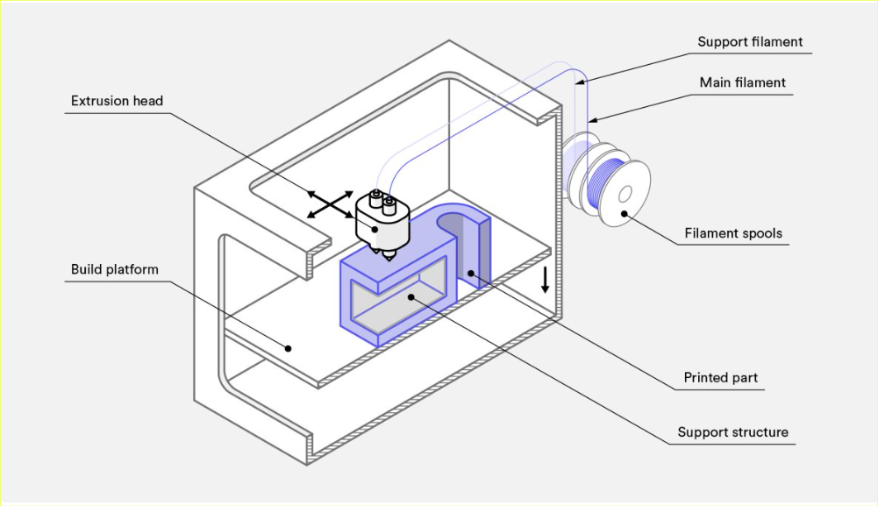
Furthermore, FDM 3D printers have competitive prices when compared to other 3D printing machines. This is the primary reason why the FDM 3D printer is the commercialized in the additive most manufacturing industry today.
2. Literature Survey
[1] SEYEON HWANG,1 EDGAR I. REYES,1 KYOUNG-SIK MOON, RAYMOND C. RUMPF,3 and NAM SOO KIM1,4 “Thermo-mechanical Characterization of Metal/Polymer Composite Filaments and Printing Parameter Study for Fused Deposition Modeling in the 3D Printing Process”. Journal of ELECTRONIC MATERIALS, Vol. 44, No. 3,2015 A new metal/polymer composite filament was developed for the Fused Deposition Modeling (FDM) process to evaluate the thermomechanical properties of the new filament. Acrylonitrile butadiene styrene (ABS) thermoplastic mixed with copper and iron particles. The percentage of metal powder loaded was different to confirm the effect of metal on the thermomechanical properties of the fiber such as tensile strength and thermal conductivity. Compression parameters such as temperature and volume were also modified to understand the effect of strain parameters on the final product made with the FDM process. As a result of this study, it was confirmed that the tensile strength of the composite decreased with the increase of metal content.
In addition, the thermal conductivity of metal/polymer filaments is improved by increasing the metal content. It is believed that metal/polymer filaments can be used to print metal and large 3D (3D) models without deformation due to thermal expansion of thermoplastics. The material can also be used in 3D printed circuits and electronic models for defense and other applications.[4] Anoop K. Sood a, Raj K. Ohdar b, Siba S. Mahapatra c, “Experimental investigation and empirical modellingof FDM process for compressive strength improvement”. Received 11 October 2010; revised 18 April 2011; accepted 2 May 2011Available online 2 June 2011 Fused Deposition Modeling (FDM) has gained popularity in manufacturing as it has the ability to create products with complex shapes without a tool and human-machine interface. The characteristics of the FDM design environment are highly dependent on the failure process, which can be improved by adjusting the parameters at the appropriate level. The anisotropic and fragile nature of the product makes it important to examine the results of the unloading process in order to improve the service life of the workplace. Therefore, the current study focuses on extensive research to understand the impact of the compressive stress of the structure on five important factors such as layer thickness, component design direction, grid angle, grid width and air difference. This study not only gives an idea about the success of the stress of the process, but also creates the equation of the prediction accuracy.
This equation is used to find parameters with the quantum best behavior method (QPSO). Since the FDM process is a very complex process and the failure process affects the nonlinear response, the compression stress is estimated using an artificial neural network (ANN) and compared with the predicted equation. [6] C.S. Ramesha , C.K. Srinivas “Friction and wear behavior of laser-sintered iron– silicon carbide composite” Received 19 December 2008 Received in revised form 10 April 2009 Accepted 17 April 2009 Due to its ability to produce complex products in a short time, laser sintering is currently one of the most popular methods for creating new materials for many high-tech industrial applications. Therefore, research papers have focused on advanced metal matrix fabrication, choosing the laser sintering method to create a component that eliminates slow machining time. Based on the above, the current work is focused on the production of iron-silicon carbide (nickel-plated) direct metal laser sintering equipment. Laser speeds of 50, 75, 100 and 125 mm/s were used. Metallographic studies, friction and wear tests were carried out on base metals and their alloys.
The load ranged from 10 to 80 N, while the slip speed ranged from 0.42 to 3.36 m/s for a period of 30 minutes. By laser sintering, up to 7% by weight of SiC was successfully dispersed in the metal matrix.[7] 7. Kurganova Yuliya, Lopatina Yuliya, Yijin Chen “Evaluation of Filler Distribution in Particulate Reinforced Composites” Journal of Materials Science and Chemical Engineering Vol.3 No.7, July 2015. xii Aluminum-based particle-reinforced composites are important in the industry, but maintaining the performance of such materials is difficult. The mechanical properties of metal matrix composites are greatly affected by the energy dissipation in the matrix. In this study, the homogeneity of SiC particle distribution in Al matrix composites made by stirred casting and powder metallurgy techniques was evaluated. Analysis is done by classical and computerized quantitative metallographic image analysis methods. In addition, we want to adjust the hardness distribution of the cross-sections of the sample as an indicator of the uniformity of the artificial material in the matrix.
Mechanical Properties of Highly Filled Iron-ABS Composites in Injection
Molding for FDM wire Filament
N. Sa’ude
1, a
, M. Ibrahim
2,b
and M. H. I. Ibrahim
3,c
[14] M. Nikzad 1 , S.H. Masood 2 , I. Sbarski3 , A. Groth45 th Australasian Congress on Applied Mechanics, Brisbane, Australia Thermo-Mechanical Properties of a Metal-filled Polymer Composite for Fused Deposition Modelling Applications , ACAM 2007 10-12 December 2007, Brisbane, Australia
The product contains metal powder and surfactant powder containing acrylonitrile butadiene styrene (ABS). In this study, the effect of metal powder in the polymer matrix was investigated and ABS was chosen as the matrix material. Detailed formulations of volume percent (%v) compound ratios of various combinations of novel PMCs were evaluated experimentally. According to the results, skin.
Effect of metal filler increments on hardness, tensile and flexural strength. The high filler metal content in the ABS composite increases the hardness and tensile strength of the PMC product through the injection molding process.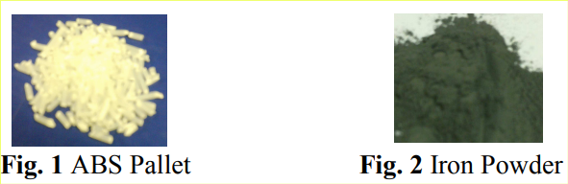
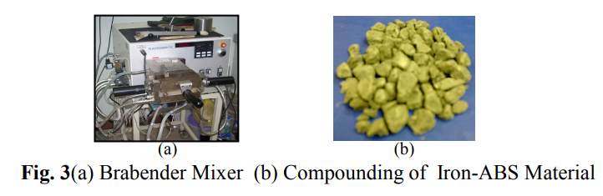
Table I. Characteristic of compounding material

Sr. No. | Components | Melt Temperature (°C) | Density (g/cm3 )
1 | Iron | 1539 | 7.86
2 | ABS | 266 | 1.1
3 | Nylon | 256 | 1.14-1.15
4 | Copper | 1085 | 9
6 | PP | 327 | 0.90-0.92
7 | SrTiO3 | 105-125 | 5.09
8 | Al2O3 | 2072 | 3.987
9 | Jute Fiber | 105-125 | 0.935

3. Problem Identification
Less availability which new and more efficient composite materials can be used in various blends in addition to those in common use various blends. The main purpose of research is more advanced FDM printers can also print with other specialized materials that offer properties like higher heat resistance, impact resistance, chemical resistance, and rigidity. The most common FDM 3D printing materials are Iron/Nylon, Iron/ABS and their various blends more advanced FDM printers can also print with other specialized materials that offer properties like higher heat resistance, impact resistance, chemical resistance, and rigidity. The strength of the product develop through various 3D printing processes with filaments material (Iron/Nylon, Iron/ABS etc.) is less this study focus on to improve the tensile strength of the product.
OBJECTIVE: - 1) Improve strength of material.
2)3D printing material various process parameter 1) Nozzle size
2) Filament size
3) Melting temperature
4) Bed temperature
5) Printing speed
6) Layer thickness
7) Infill geometry
8) Infill density
3) Fix process parameters for development of 3D printed product using composite material.
4) Identification of tensile strength of product
4) Fluctuation strength

4. Methodology
FDM is one of the most widely used 3D printing technologies due to its reliability and simple operation. FDM simply uses a heat treatment to extrude the material. Also, FDM 3D printers are competitively priced compared to other 3D printers. This is the main reason why FDM 3D printers are the most popular in the additive manufacturing industry today. Research data analysis, find out which materials are best, perform tensile and wave tests from research findings, samples and tests based on composite materials to provide effective 3D printing results and explore and draw conclusions.
3D printers are now widely used in many research and development areas. However, the narrow nature of 3D printing materials with limited power sources still limits the true potential of this disruptive technology. There is an interest in improving and differentiating the product of general printed materials by introducing the material with specific
products and/or combining materials with differet products to produce high performance composites. 3D printing composites are used in many applications such as biomedical, mechanical, electrical, thermal and optically enhanced products. The growth of 3D-printed composites can be attributed to the ability to create complex geometries, lower costs, and other advantages associated with rapid design.
5. Conclusions
After studying the literature review, to find out which type of composite material is best and to conduct tensile testing and fluctuation testing from a scientific point of view and to make a specimen and test it according to which type of composite material will give good 3D printing and find out the result and give a conclusion. FDM is one of the most widely used 3D printing technologies because of its reliability and simple process. FDM requires only a heating process to extrude the materials. Furthermore, FDM 3D printers have competitive prices when compared to other 3D printing machines. This is the primary reason why the FDM 3D printer is the most commercialized in the additive manufacturing industry today. To compare and to analyses less availability which new and more efficient composite materials can be used in various blends in addition to those in common use various blends. The main purpose of research is more advanced FDM printers can also print with other specialized materials that offer properties like higher heat resistance, impact resistance, chemical resistance, and rigidity. References
- SEYEON HWANG,1 EDGAR I. REYES,1 KYOUNG-SIK MOON, RAYMOND C. RUMPF,3 and NAM SOO KIM1,4 “Thermo-mechanical Characterization of xxii Metal/Polymer Composite Filaments and Printing Parameter Study for Fused Deposition Modeling in the 3D Printing Process”. Journal of ELECTRONIC MATERIALS, Vol. 44, No. 3, 2015
- Ralf Lacha, Andrea Monamia, b Sören Grie ß bachc, Volker Grießbachd “Lifetime assessment of additive manufactured polymer materials by means of the rolling ring test using cyclically loaded notched ring specimens”. Integrity Procedia 13 (2018)
- V. Juechter , T. Scharowsky, R.F. Singer, C. Ko¨rner, “Processing window and evaporation phenomena forTi–6Al–4V produced by selective electron beam melting”. Received 21 February 2014; received in revised form 15 May 2014; accepted 16 May 2014 Available online 12 June 2014
- Anoop K. Sood a, Raj K. Ohdar b, Siba S. Mahapatra c, “Experimental investigation and empirical modellingof FDM process for compressive strength improvement”. Received 11 October 2010; revised 18 April 2011; accepted 2 May 2011Available online 2 June 2011
- A Equbal1, A K Sood1,V Toppo1, R K Ohdar2, and S S Mahapatra3 “Prediction and analysis of sliding wear performance of fused deposition modelling-processed ABS plastic parts” The manuscript was received on 22 May 2010 and was accepted after revision for publication on 27 July 2010
- C.S. Ramesha , C.K. Srinivas “Friction and wear behavior of laser-sintered iron– silicon carbide composite” Received 19 December 2008 Received in revised form 10 April 2009 Accepted 17 April 2009
- Kurganova Yuliya, Lopatina Yuliya, Yijin Chen “Evaluation of Filler Distribution in Particulate Reinforced Composites” Journal of Materials Science and Chemical Engineering Vol.3 No.7, July 2015
- Klaus DOPPLER, Carl WIJTING, Tero HENTTONEN, Kimmo VALKEALAHTI “Multiband Scheduler for Future Communication Systems” JOURNAL NAME: xxiii International Journal of Communications, Network and System Sciences, Vol.1 No.1, June 4, 2008
- C.S. Ramesha, C.K. Srinivas “Friction and wear behavior of laser-sintered iron– silicon carbide composites” Received 19 December 2008 Received in revised form 10 April 2009 Accepted 17 April 2009
- Mehmet Akgu “Suitability of stinging nettle (Urtica dioica L.) stalks for medium density fiberboards production” Received 26 March 2012Received in revised form 1 June 2012Accepted 10 September 2012
- Armin Thumm,1 Damien Even,2 Pierre-Yves Gini,3 and Mathias Sorieul “Processing and Properties of MDF Fibre-Reinforced Biopolyesters with Chain Extender Additives” Received 23 May 2018; Revised 24 September 2018; Accepted 5 November 2018; Published 16 December 2018 .
- Yanhong Jin,1,2 Jiaxian Lin,1,2 Yu Cheng,1,2 and Chunhong Lu1,2 “Lignin-Based High-Performance Fibers by Textile Spinning Techniques” Materials (Basel). 2021 Jun; 14
- Daniele Nuvoli, Valeria Alzari, Roberta Sanna, Sergio Scognamillo, Massimo Piccinini, Laura Peponi, Josè Maria Kenny & Alberto Mariani “The production of concentrated dispersions of few-layer graphene by the direct exfoliation of graphite in organosilanes” Published: 13 December 2012
- M. Nikzad 1 , S.H. Masood 2 , I. Sbarski3 , A. Groth45 th Australasian Congress on Applied Mechanics, Brisbane, Australia Thermo-Mechanical Properties of a Metal-filled Polymer Composite for Fused Deposition Modelling Applications , ACAM 2007 10-12 December 2007, Brisbane, Australia

