Smart Irrigation System

Ishwarlal Rathod¹, Anuprita P Linge², Rohit Manna³, Swapndeep Tomar⁴, Kartikay Sharma⁵
Assistant Professor
Symbiosis University Of Applied Sciences, Indore, India, 452006
Assistant Professor
Shri Shankarprasad Agnihotri College of Engineering, Wardha (Maharashtra), India, 442001
Student
Symbiosis University Of Applied Sciences, Indore, India, 452006
Student
Symbiosis University Of Applied Sciences, Indore, India, 452006
Student
Symbiosis University Of Applied Sciences, Indore, India, 452006
ishwarlal.rathod@suas.ac.in, anupritalinge@gmail.com,, Rohitmanna55@gmail.com,
2022btcs054@student.suas.ac.in, 2022btcs026@student.suas.ac.in,

Received on: xxxx,20xx, Revised on: xxxx,20xx, Published on: xxxx,20xx

Abstract – Over the past decade, significant advancements have not only enhanced and matured technology but have also paved the way for numerous new applications in agriculture and related fields. Presently, a wide range of sensors finds application in various contexts, including moisture sensors, ultrasonic sensors, etc [1] [2]. In this research, we have developed a smart irrigation system. Our prototype incorporates a soil moisture sensor capable of detecting soil moisture levels [3]. It effectively communicates with a watering system or water pump, enabling automatic activation or deactivation as per the soil's moisture condition [4]. Additionally, the system's status is conveniently displayed on an LCD screen. The microcontroller at the heart of this irrigation system is the Arduino Uno board [5].
Keywords- Soil Moisture System, Soil Moisture Sensor, Arduino UNO, LCD, Smart Irrigation

INTRODUCTION

In this innovative Smart Irrigation System, a Soil Moisture Sensor diligently assesses soil moisture levels. When the sensor detects low moisture levels, the Arduino, serving as the microcontroller, activates a water pump to supply the necessary water to the plants [6]. This system operates autonomously, turning off the water pump as soon as it detects sufficient soil moisture. Real-time status updates for the water pump and soil moisture are displayed on an integrated LCD screen, ensuring users are well-informed [7] [8].
This system proves invaluable in various settings, including farms, gardens, and homes, offering automated, efficient plant care without the need for constant human intervention. By intelligently managing water resources, this Smart Irrigation System represents a significant advancement in modern agricultural and horticultural practices, promoting both sustainability and convenience [9].

LITERATURE REVIEW
This research aims to carry out a systematic review about the smart irrigation systems we have developed.
Components Used in the Research Project
2.1 Arduino UNO R3
Arduino UNO is a microcontroller board based on the ATmega328P. It has 14 digital input/output pins (of which 6 can be used as PWM outputs), 6 analog inputs, a 16 MHz ceramic resonator, a USB connection, a power jack, an ICSP header, and a reset button. It contains everything needed to support the microcontroller; simply connect it to a computer with a USB cable or power it with an AC-to-DC adapter or battery to get started.

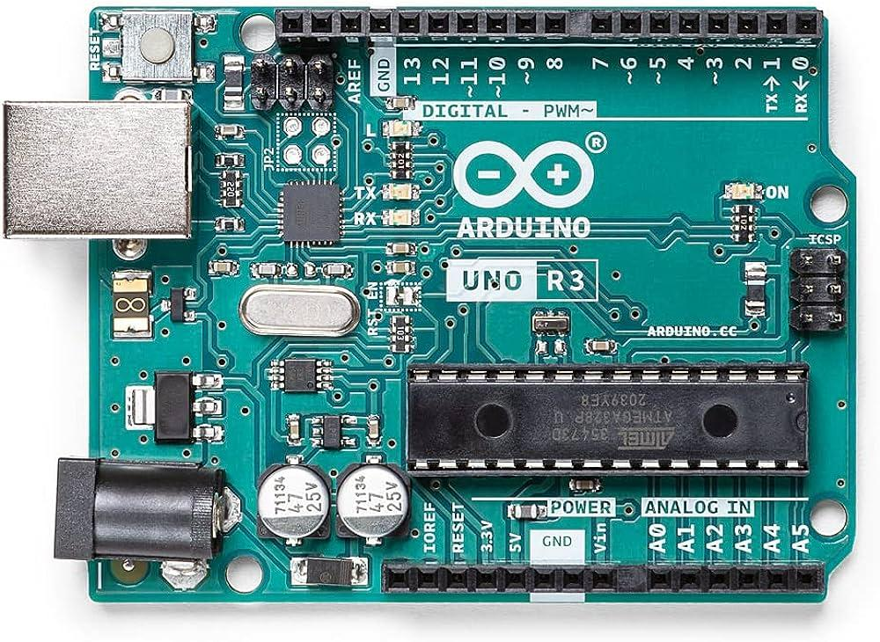
Figure 1: Arduino UNO R3
  - 16x2 LCD Display
The abbreviation LCD stands for "Liquid Crystal Display," a type of electronic display module widely employed across a diverse spectrum of applications, including electronic circuits and devices such as mobile phones, calculators, computers, and television sets.
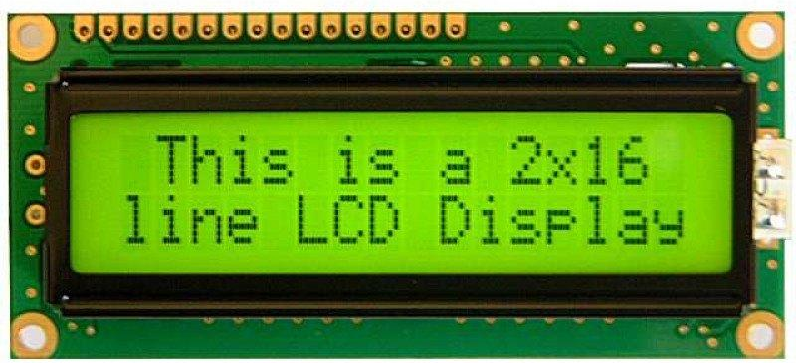
Figure 2: LCD Display
  - . Soil Moisture Module
The soil moisture sensor is used to measure the moisture content present in the soil. It consists of 4 pins. Vcc and Gnd pins, responsible for connecting to the power supply, while the other two pins serve as digital and analog output interfaces. Specifically, the digital pin produces a low output signal when the soil's moisture content surpasses a predetermined threshold level.
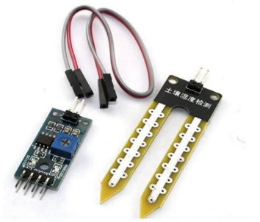
Figure 3: Soil Moisture Module
  - Relay Module
Relay modules are essentially circuit boards that host one or more relays. These modules are available in various sizes and shapes, with rectangular configurations being the most common. They typically accommodate 2, 4, 8, or sometimes even up to 16 relays on a single board.
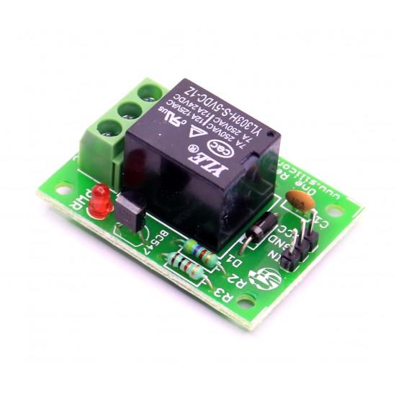
Figure 4: Relay Module
  - USB Cable
USB bus has a voltage range of 4.75 to 5.25 volts. The official Uno boards have a USB-B connector, but 3rd party Uno boards may have a miniUSB or microUSB connector. This cable is used to interface any of the Arduino board with your computer, you can also connect your USB printer, scanner, and more to your computer. These cables Transmits data at high speeds with the error-free, high-performance transmission.
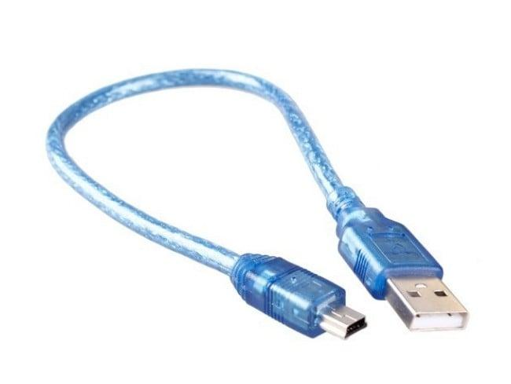
Figure 5: USB Cable
METHOLOGY
The smart irrigation system can be explained with the help of a block as shown in Figure 7 and the circuit diagram mentioned in Figure 6. Smart irrigation systems employ soil moisture sensors to estimate and monitor the current moisture levels of plants. Based on these measurements, the water system or pump is automatically engaged or disengaged to meet the specific water requirements. This seamless operation is made possible through the utilization of an Arduino UNO as a microcontroller, complemented by a relay module that functions as a switch. When the system detects low soil moisture levels, it triggers the watering system, and when moisture levels stabilize, the system deactivates itself automatically.
This innovative prototype serves as a valuable tool for managing irrigation systems, ensuring that water is supplied when necessary while concurrently reducing excess water consumption. Precisely controlling the volume of irrigation water applied, the frequency of irrigation cycles, and overall water utilization efficiency are pivotal factors in optimizing plant health and conserving this vital resource.
DESIGN
Schematic Diagram
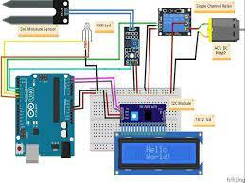
Figure 6: Smart Irrigation System
Block Diagram
The block diagram visually presents the step-by-step functioning of the smart irrigation system.
It commences by detecting the soil moisture level, subsequently triggering the activation or deactivation of the watering system or pump through a microprocessor.
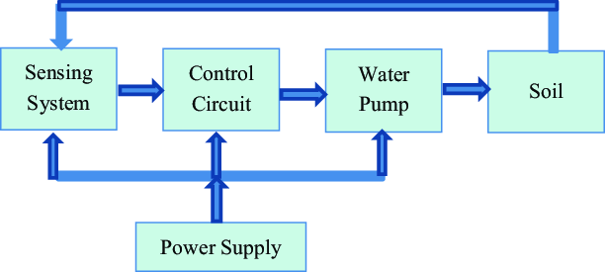
Figure 7: Smart Irrigation System Block Diagram

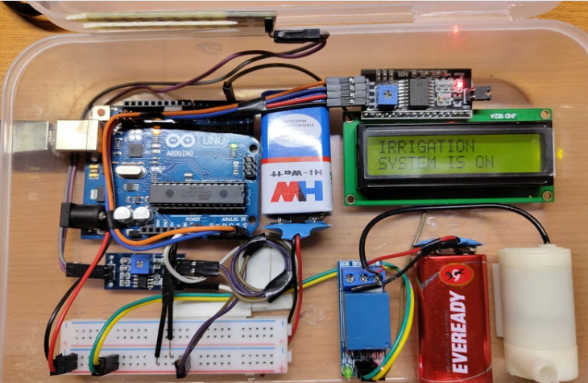
Implementation

Figure 8: Implementation of Smart Irrigation System

CONCLUSION
As the availability of water diminishes and concerns about water quality increase, there is a growing imperative to enhance irrigation efficiency, thereby minimizing both water consumption and the leaching of chemicals.
The proposed system proves highly effective in addressing these challenges within the agricultural sector, representing a significant advancement. By substantially reducing the reliance on manual labor for field irrigation, it not only conserves water but also optimizes time management, offering a dual benefit to agriculture.
The future scope for smart irrigation systems involves integrating technologies like Raspberry Pi for advanced data processing, IoT connectivity, and AI-driven optimization. This enhances water conservation, remote monitoring, energy efficiency, and user-friendly interfaces, making them adaptable to various scales of agriculture and landscaping.

REFERENCES
- Ning Wanga, Naiqian Zhangb and Maohua Wangc, "Wireless sensors in agriculture and food industry-Recent development and future perspective", science direct, 2006
- Morais Raul, A. Valente and C. Serodio, "A Wireless Sensor Network for Smart Irrigation and Environmental Monitoring: A Position Article", EFITA, 2005.
- Sankar, P., Norman, S.R,(2009) “Embedded System for Monitoring Atmosphere is Weather Conditions Using Weather Balloon”, International Conference on Control and Automation.
- R. N. Rao and B. Sridhar, "IoT based smart crop-field monitoring and automation irrigation system", 2018 2nd International Conference on Inventive Systems and Control (ICISC), pp. 478-483, 2018.
- S. B. Saraf and D. H. Gawali, "IoT based smart irrigation monitoring and controlling system", 2017 2nd IEEE International Conference on Recent Trends in Electronics Information Communication Technology (RTEICT), pp. 815-819, 2017.
- R. Khan, S. U. Khan, R. Zaheer and S. Khan, "Future internet: The internet of things architecture, possible applications, and key challenges," Proc. - 10th Int. Conf. Front. Inf. Technol, p. 257–260, 2012.
- Techatronics. "Welcome to Techatronics - Electronic Automation Controls." Techatronics. Available: https://www.techatronics.com/ Accessed on: Apr. 9, 2023..
- Arduino. "Arduino IDE." Arduino. Available: https://www.arduino.cc/en/software Accessed on: Apr. 5, 2023.
- Samy Sadeky, Ayoub Al-Hamadiy, Bernd Michaelisy, Usama Sayedz,“ An Acoustic Method for Soil Moisture Measurement”,IEEE20.

