Smart Dustbin
Ishwarlal Rathod¹; Anuprita P Linge²; Rohit Manna³; Akshat Thakkar⁴; Kartik Raghuwanshi⁵

Assistant Professor
Symbiosis University Of Applied Sciences, Indore, India, 452006
Assistant Professor
Shri Shankarprasad Agnihotri College of Engineering, Wardha (Maharashtra), India, 442001
Student
Symbiosis University Of Applied Sciences, Indore, India, 452006
Student
Symbiosis University Of Applied Sciences, Indore, India, 452006
Student
Symbiosis University Of Applied Sciences, Indore, India, 452006
ishwarlal.rathod@suas.ac.in, anupritalinge@gmail.com, Rohitmanna55@gmail.com,
2022btcs008@student.suas.ac.in, 2022btcs025@student.suas.ac.in

Received on: xxxx,20xx, Revised on: xxxx,20xx, Published on: xxxx,20xx

Abstract- In the last decade, substantial technological advancements have not only improved technology but have also ushered in new applications, particularly in the domain of environmental cleanliness. Nowadays, individuals are employing various types of waste bins to segregate wet and dry waste. In this study, we introduce a smart dustbin equipped with an ultrasonic sensor for object detection. This paper harnesses ultrasonic technology for non-contact object detection [1] [2]. Moreover, the lid's motion in the dustbin is governed by a compact servo motor. This intelligent waste bin system is underpinned by the Arduino Uno board, serving as the microcontroller [3].

Keywords: Ultrasonic sensor, Non-contact technology, Arduino UNO, Microcontroller.

- INTRODUCTION
In the present era, governments are increasingly focused on enhancing cleanliness at the city, state, and national levels. To promote this objective, governments have launched initiatives such as "Swachh Bharat" to raise awareness about maintaining a clean India. In support of these efforts, we propose the implementation of a smart dustbin system designed to facilitate efficient garbage collection. In this prototype, an ultrasonic sensor is employed to detect the presence of individuals near the dustbin.

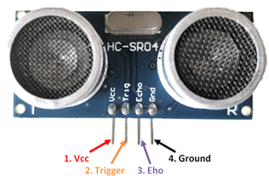
Technically, the project utilizes an Ultrasonic Sensor to ascertain the presence of objects within a specific range [4]. The Ultrasonic transmitter emits ultrasonic waves, which travel through the air. When these waves encounter an object, they are reflected back toward the

sensor [5] [6]. The Ultrasonic receiver module then observes these reflected waves [9].
Figure SEQ Figure \* ARABIC 1-Arduino uno

When the sensor detects the presence of a person, it automatically triggers the opening of the dustbin's lid, a function made possible with the assistance of a servo motor. To orchestrate this entire operation, the ultrasonic sensor and servo motor are connected to the Arduino Uno, which serves as the microcontroller [7] [8].

- COMPONENTS USED
2.1 Arduino UNO
The Arduino UNO is a microcontroller board centered around the ATmega328P. Equipped with 14 digital input/output pins (with 6 available for PWM outputs), 6 analog inputs, a 16 MHz ceramic resonator, a USB connection, a power jack, an ICSP header, and a reset button, it encompasses all the necessary components to sustain the microcontroller. To initiate operation, one can easily connect it to a computer using a USB cable or power it through an AC-to-DC adapter or battery.
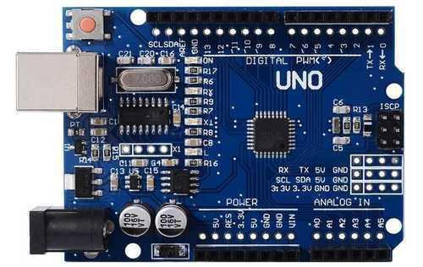
Figure 1-Arduino UNO
  - HC-SR04 Ultrasonic Sensor
The HC-SR04 ultrasonic sensor is a widely employed component compatible with various microcontroller and microprocessor platforms such as Arduino, ARM, PIC, Raspberry Pi, and others. This cost-effective sensor delivers non-contact measurement capabilities within a range of 2cm to 400cm, boasting a ranging accuracy of up to 3mm.

Table 1 – HC-SR04 Ultrasonic Sensor Pin Description
Pin Number | Pin Name | Description
1 | V_{cc} | The V_{cc} pin powers the sensor, typically 5V.
2  Figure 2-HC-SR04 Ultrasonic Sensor | Trigger | The trigger pin is an input pin. This pin has to be kept high for 10µs to initialize measurement by the ultrasonic wave.
3 | Echo | The echo pin is an Output pin. This pin goes high for a period of time which will be equal to the time taken for the ultrasonic wave to return to the sensor.
4 | Ground | This pin is connected to the Ground of the Arduino.

HC-SR04 Sensor SG-90 Features:

- Operating voltage: +5V
- Theoretical Measuring Distance: 2cm to 450cm
- Practical Measuring Distance: 2cm to 80cm
- Accuracy: 3mm
- Measuring angle covered: <15°
- Operating Current: <15mA
- Operating Frequency: 40Hz

  - Tower Pro SG-90 Servo Motor
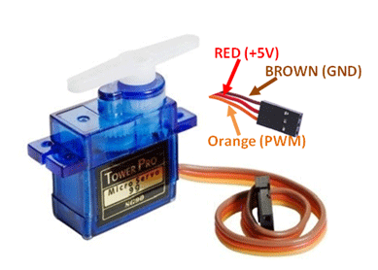
A servo motor is an electrical device designed to exert precise force or rotation on an object. It is employed for the accurate control of angles or distances, making it suitable for applications where precise positioning is essential.
Figure 3-SG90 Servo Motor
Figure 3-Servo motor
Table 2 – SG90 Servo Motor Wire Description
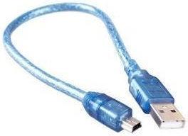
Wire Number | Wire Color | Description
1 | Brown | Ground wire to be connected to the ground of Arduino.
2 | Red | Powers the motor, typically +5V is used.
3 | Orange | PWM signal is given in through this wire to drive the motor.

SG-90 Servo Motor Features:

- Operating Voltage is +5V typically
- Torque: 2.5kg/cm
- Operating speed is 0.1s/60°
- Gear Type: Plastic
- Rotation: 0°-180°
- Weight of motor: 9gm
- Package includes gear horns and screws

2.4 USB Cable
The USB bus operates within a voltage range of 4.75 to 5.25 volts. While official Uno boards typically use a USB-B connector, third-party Uno boards may feature a miniUSB or microUSB connector. These cables serve as the interface between an Arduino board and a computer, enabling connections with devices such as USB printers and scanners. They support high-speed data transmission, ensuring reliable and efficient communication.
Figure 4-USB Cable
- PROPOSED METHODOLOGY
The operational concept of the smart dustbin is elucidated through a block diagram, illustrated in Figure 6, accompanied by a corresponding circuit diagram detailed in Figure 5. Key components include the SG90 Servo Motor and the HC-SR04 ultrasonic sensor, both interfaced with the microcontroller via data pins. The Arduino platform is chosen for its user-friendliness and versatility, offering multiple digital pins to concurrently connect the Servo motor and ultrasonic sensor. The HC-SR04 distance sensor is a widely adopted choice across microcontroller and microprocessor platforms like Arduino.
Figure 6-Ultrasonic Radar System Block Diagram
A dedicated battery source powers the servo motor, ultrasonic sensor, and the microcontroller board, providing a stable electrical supply. The servo motor is connected to the microcontroller and is activated exclusively when it receives a signal from the microcontroller.

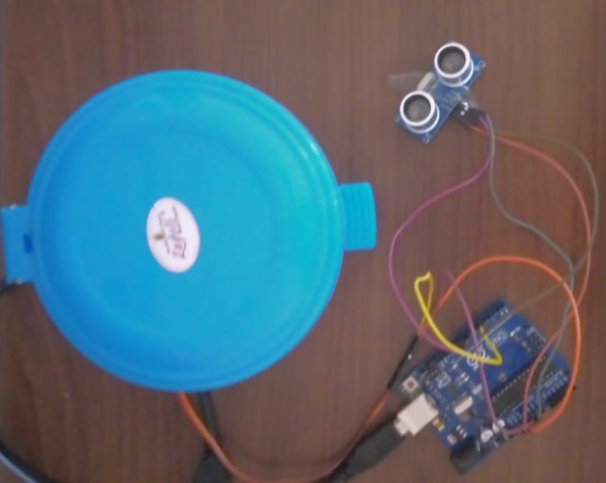
Upon detecting the presence of an object, the sensor triggers a signal transmission to the microcontroller. Subsequently, the servo motor, linked to the controller, initiates rotation to open the dustbin's lid. The system's program orchestrates this action, ensuring that the servo motor responds promptly whenever the sensor identifies an object in proximity.

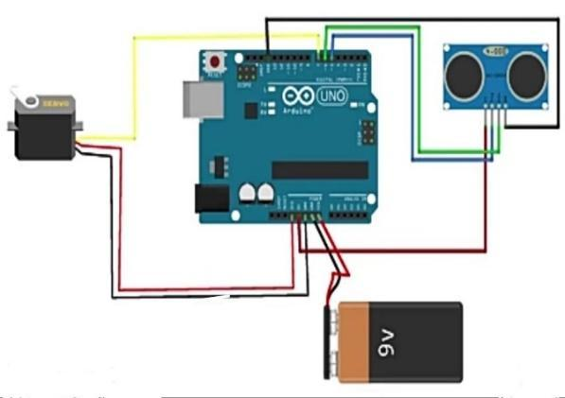
SCHEMATIC DIAGRAM
Figure 7-Implementation of Smart Dustbin

Figure 5-Smart Dustbin
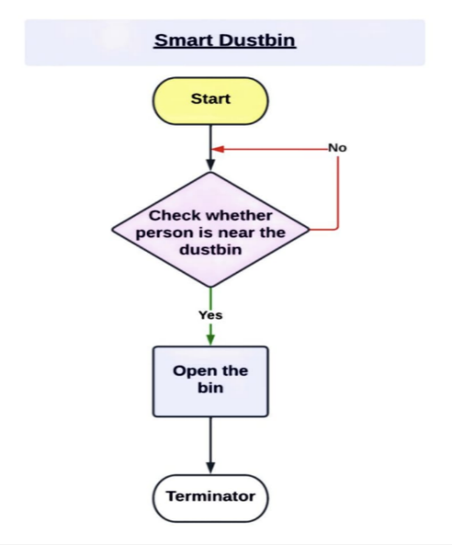
- Block Diagram
Figure 6-Block Diagram of Smart Dustbin
- RESULT

- CONCLUSION
The suggested system holds significant promise for efficient garbage collection. Should municipal corporations across our nation choose to implement smart dustbins, the potential to curtail pollution stemming from garbage becomes evident.
Such an initiative can substantially simplify the task of waste collection for sanitation workers while providing a more convenient and hygienic disposal method for the public. Consequently, this approach diminishes the risk of diseases associated with garbage or waste exposure when individuals interact with the dustbins.

- FUTURE SCOPE
Expanding our research can involve the integration of an HC-SR04 ultrasonic range sensor, which directly connects to the Raspberry Pi's GPIO port, enabling us to effectively monitor the garbage level in the dustbin. To enhance waste segregation, we can incorporate various sensors, such as weight sensors and infrared sensors, into the smart dustbins. These sensors are capable of detecting both the type and quantity of waste being deposited. By leveraging this technology, we can precisely measure waste levels and classify the materials as recyclable, organic, or general waste.

References

[1] | G. Bhor, P. Bhandari, R. Ghodekar and S. Deshmukh, "Mini Radar," International Journal of Technical Research and Applications, pp. 68-71, 2016.
[2] | A. Flora, "Towards a clean environment: A proposal on sustainable and integrated solid waste management system for university Kebangsaan Malaysia", Report from Alam Flora., 2009..
[3] | P. Messerli and E. Muminingtyas, "The future is now: Science for achieving sustainable development", United Nations, vol. 1, pp. 27, 2019.
[4] | S.A. Mahajan, A. Kokane, A. Shewale, M. Shinde and S. Ingale, "Smart Waste Management System Using IoT", International Journal of Advanced Engineering Research and Science (IJAERS), vol. 4, Mar 2017.
[5] | M. Pandey, A. Gowala, M. Goswami and C. Saikia, "Smart dustbin using Arduino", International Journal of Scientific Research in Engineering and Management (IJSREM), vol. 04, no. 08, Aug 2020.
[6] | R. Khan, S. U. Khan, R. Zaheer and S. Khan, "Future internet: The internet of things architecture, possible applications, and key challenges," Proc. - 10th Int. Conf. Front. Inf. Technol, p. 257–260, 2012.
[7] | F. Samann, "The Design and Implementation of Smart Trash Bin", Academic Journal of Nawroz University (AJNU), vol. 6, no. 3, pp. 141-148, Jan 2017..
[8] | E. Likotiko, D. Petrov, J. Mwangoka and U. Hilleringmann, "Real time solid waste monitoring using cloud and sensors technologies", The Online Journal of Science and Technology, vol. 8, no. 1, pp. 106-116, Jan 2018.
[9] | D. Jayakumar, A. Pravalika and K. P. Rao, "Model Radar Implementation Using Ultrasonic Sensor," 2014.

