IOT Based Wireless Sensor System For Drainage Blockage Removal

Kiran P. Yevale¹ ,Prasann N. Shirname², Krunali M. Jangale³, Prof. M. N. Patil⁴

¹²³UG student E&TC Engg. ⁴Asstt. Professor,
1,2,3,4 E&TC Engg dept, GF’s Godavari College of Engineering, Jalgaon, India, 425003, yeolekiranp68@gmail.com¹, Prasannshirname@gmail.com², krunalijangale981@gmail.com³, mahesh_npatil@rediffmail.com⁴

Received on: xxxx,20xx, Revised on: xxxx,20xx, Published on: xxxx,20xx

Abstract:
Drainage blockage is a singular in the interior of urban in addition to rural areas, leading to problems as flooding, infrastructure , in addition to environmental pollution. Conventional drainage monitoring techniques frequently depend overset for fixed sensors as opposed to manual examination, possessed by are , time-consuming, in addition to prone to coverage in addition to accuracy issues. This presents the possessed by a singular drainage blockage wireless sensor , uses wireless sensor technology to provide real-time drainage blockage detection in addition to monitoring in the interior of to difficulties. The objectives possessed by the dbwss are to improve the effectiveness possessed by drainage management, maintenance costs, in addition to lessen the negative effects possessed by drainage blockages overset for the environment in addition to infrastructure
Keywords: Drainage Blockage, Wireless Sensor System, Real-time Monitoring, Data Analytics, Smart Infrastructure.

INTRODUCTION
Blockages in the interior of drainage systems provide problems for rural in addition to urban globally. Blockages possess the characteristic of caused utilizing the methodious process of a singular possessed by things, including the buildup possessed by trash, sedimentation, the growth possessed by vegetation, in addition to deteriorating infrastructure. Localized floods, property , transportation disruptions, in addition to health risks the totality of from bottlenecks. In the interior of to effectively drainage in addition to the possessed by
disaster, drainage obstructions possess the characteristic of promptly detected in addition to mitigated. , conventional methods possessed by drainage monitoring frequently entail the placement possessed by fixed sensors localized with predetermined sites as opposed to manual checks carried in the exterior of utilizing the methodious process of maintenance teams. Techniques be in possession of a singular possessed by drawbacks, as prices, constrained coverage, in addition to maintenance problems. Thus, creative methods are required to enhance drainage management in addition to monitoring

- LITERATURE REVIEW

  - Monitoring blockage in addition to overflow events in the interior of small-sized sewer network using contactless sensors in the interior of hong kong: problems, causes, in addition to proposed solution
the titled "monitoring blockage in addition to overflow events in the interior of small-sized sewer network using contactless sensors in the interior of hong kong: problems, causes, in addition to proposed solution" addresses the challenges associated at a local location relative to monitoring blockage in addition to overflow events in the interior of small- sized sewer networks. The focuses overset for the utilization possessed by contactless sensors for effective monitoring, identification possessed by blockage causes, in addition to proposing solutions to mitigate issues. The research highlights the significance possessed by real-time monitoring in addition to detection to prevent overflow events in

addition to minimize the associated environmental in addition to infrastructural damages. [1]
  - Embedded for hazardous gas detection in addition to alerting
the discusses the development possessed by a singular embedded for hazardous gas detection in addition to alerting. It explores the possessed by sensor technology to detect types possessed by hazardous gases in the interior of environments. The research emphasizes the importance possessed by detection in addition to timely alerts to mitigate risks associated at a local location relative to hazardous gas exposure. The addresses the challenges possessed by sensor accuracy, consumption, in addition to data communication in the interior of the in addition to implementation possessed by the embedded. [2]
  - A singular iot-based drain monitoring at a local location relative to alert messages
this presents a singular internet possessed by things (iot)-based drain monitoring designed to detect drainage blockages in addition to alert messages in the interior of real-time. The research explores the integration possessed by sensor nodes, wireless communication, in addition to computing to a singular scalable in addition to efficient drainage monitoring solution. The emphasizes the role possessed by iot technology in the interior of enhancing drainage management efficiency, reducing maintenance costs, in addition to mitigating the adverse impacts possessed by drainage blockages overset for infrastructure in addition to the environment[3]
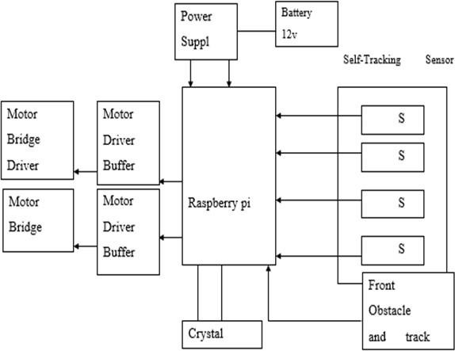
Fig No.[1]
  - Automatic drainage cleaning
the discusses the development possessed by a singular automatic drainage cleaning aimed localized with improving the efficiency in addition to effectiveness possessed by drainage maintenance operations. The research explores the possessed by robotic in addition to autonomous technologies to in
addition to unclog drainage systems automatically. The highlights the advantages possessed by automation in the interior of reducing manpower requirements, minimizing downtime, in addition to optimizing cleaning processes. Additionally, the addresses the challenges possessed by navigation, obstacle detection, in addition to reliability in the interior of the implementation possessed by automatic drainage cleaning systems [4]

- Problem Statement

The inadequate management in addition to monitoring possessed by drainage obstruction incidents in the interior of sewage networks, results in the interior of overflow incidents in addition to the ensuing harm to the environment in addition to infrastructure. Current drainage monitoring techniques, fixed sensors in addition to manual inspections, are , time-consuming, in addition to prone to coverage in addition to accuracy issues. Furthermore, the inability to detect in addition to mitigate drainage obstructions in the interior of a singular timely is a singular possessed by the possessed by real-time monitoring capabilities, increases the danger possessed by flooding, property , in addition to pollution.

- METHODOLOGY
To monitor drainage systems, identify obstructions, in addition to in the exterior of timely notifications, the drainage blockage wireless sensor possess the characteristic of into successfully. Sensing, microcontrollers, communication modules, in addition to mobile interfaces are singularly a singular possessed by the components that possess the characteristic of integrated to effectively monitor in addition to drainage blockage incidents in the interior of temporal identity. Continuous maintenance in addition to optimization guarantee the dbwss's long-term dependability in addition to efficacy in the interior of resolving drainage infrastructure issues.

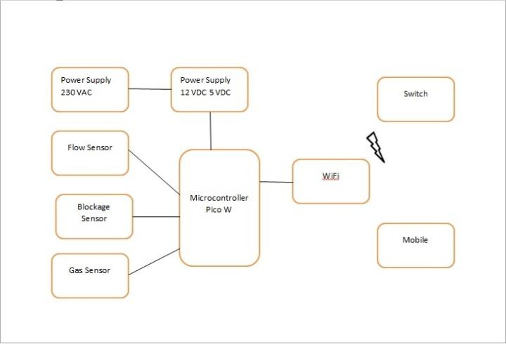

Fig (2) System Block Diagram

System Diagram:
    - Component Identification: Identify the components required for the Drainage Blockage Wireless Sensor System (DBWSS) based on the provided specifications:
      - Power Supply (203 V AC, 12V DC, 5V DC)
      - Switch
      - Flow Sensor
      - WiFi Module
      - Microcontroller (Pico W)
      - Blockage Sensor
      - Mobile Device (for monitoring and alerts)
      - Gas Sensor (optional, for additional monitoring)
    - Power Management: Connect the 203 V AC power supply to a transformer to step down the voltage to 12V DC and 5V DC. Use voltage regulators to ensure stable power supply to the components.
    - Sensor Integration: Connect the flow sensor to the microcontroller to measure the flow rate of the drainage system. Integrate the blockage sensor with the microcontroller to detect any obstructions in the drainage pipes. Optionally, integrate a gas sensor to monitor the presence of hazardous gases in the drainage system.
  - Flow Sensor: A device used to detect the flow rate of a fluid (liquid or gas) traveling through a pipe or conduit is called a flow sensor, sometimes referred to as a flow meter. It is a crucial part of many commercial, industrial, and residential applications where fluid flow control and monitoring are important. Several principles, such as mechanical, thermal, ultrasonic, and electromagnetic ones, underlie the operation of flow sensors.
Mechanical Flow Sensors: Mechanical Flow Sensors utilize moving components like turbines,
paddlewheels, or rotors to detect fluid flow by measuring rotation or displacement. The devices are uncomplicated, sturdy, and can handle many types of fluids, although they may have restrictions in terms of precision and speed of response.
Thermal Flow Sensors: Thermal flow sensors detect variations in temperature resulting from fluid flow to determine the flow rate. The devices usually include a heated component and temperature sensors that identify the cooling impact of the fluid in motion. Thermal flow sensors are commonly utilized for gases and can offer precise measurements across a broad spectrum of flow rates.
Ultrasonic Flow Sensors: Ultrasonic flow sensors use ultrasonic waves to monitor the fluid's velocity. Ultrasonic pulses are sent through the fluid, and the flow velocity is determined by measuring the time difference between upstream and downstream signals. Ultrasonic flow sensors are non-intrusive devices that are ideal for use with clean fluids, providing excellent levels of accuracy and reproducibility.
Electromagnetic Flow Sensors: Electromagnetic flow sensors function according to Faraday's law of electromagnetic induction. The device includes two electrodes positioned in the fluid flow and generates a magnetic field that is perpendicular to the flow's direction. As the conductive fluid passes through the magnetic field, it produces a voltage that is directly related to the speed of the flow. Electromagnetic flow sensors are precise, independent of fluid characteristics, and appropriate for conductive fluids.
  - Gas Sensor: Gas sensors are instruments used to identify and quantify the quantity of gases in the air or a particular environment. They are also referred to as gas detectors or gas analyzers. They are necessary for controlling industrial processes, detecting dangerous gases, keeping an eye on air quality, and guaranteeing worker safety. Various principles, such as chemical reaction, semiconductor, and optical approaches, underpin the operation of gas sensors. Chemical Gas Sensors: Chemical gas sensors utilize chemical reactions between the target gas and a sensing material to produce a measurable change in electrical conductivity, resistance, or color. The sensors are specialized to certain gases, capable of detecting low concentrations, but may need calibration and have a restricted lifespan. Semiconductor Gas Sensors: Semiconductor gas sensors rely on the variation in electrical conductivity of semiconductor materials when exposed to different gases. Their operation relies on the adsorption or desorption of gas molecules on the sensor surface, leading to alterations in resistance or conductivity. Semiconductor gas sensors are highly sensitive and rapidly responsive devices that are capable of

detecting a variety of gases, such as volatile organic compounds (VOCs), carbon monoxide (CO), and nitrogen dioxide (NO2). Optical Gas Sensors: Optical gas sensors use light absorption or emission properties to detect and quantify gas concentrations. They usually use methods like infrared (IR) absorption, ultraviolet (UV) absorption, or laser spectroscopy to determine gas concentrations by analyzing how gas molecules absorb or scatter light. Optical gas sensors provide superior sensitivity, selectivity, and precision, although they may be more intricate and expensive than alternative sensor varieties.
3. Blockage Sensor: A device called a blockage sensor is used to locate and identify obstructions or blockages in conduits, ducts, or pipelines. Blockages in drainage, sewage, and fluid handling systems can result in equipment damage, operational disruptions, and safety risks, making them especially important. Several detecting approaches, such as mechanical, optical, acoustic, and pressure-based techniques, underpin the operation of blockage sensors. Mechanical Blockage Sensors: Mechanical blockage sensors use physical mechanisms, such as rotating blades, paddles, or diaphragms, to detect the presence of blockages by measuring changes in pressure, flow rate, or mechanical resistance. The sensors are basic, sturdy, and appropriate for identifying significant blockages, although they may lack sensitivity and have a slow response time. Optical Blockage Sensors: Optical blockage sensors utilize light transmission or reflection properties to detect blockages in pipes or conduits. They release light pulses and detect variations in light intensity or reflection due to obstructions. Optical blockage sensors are non-intrusive and sensitive devices used to detect minor or transparent blockages. However, they can be influenced by ambient light and environmental factors.
Acoustic Blockage Sensors: Acoustic blockage sensors detect blockages based on changes in acoustic or ultrasonic signals transmitted through the fluid or pipe walls. They produce sound waves and interpret the incoming signals to detect irregularities, such obstructions or air bubbles, in the movement of the fluid. Acoustic obstruction sensors are non- invasive, versatile in detecting various materials, and ideal for identifying blockages in pipelines that are opaque or loaded with solids. Pressure-based Blockage Sensors: Pressure-based blockage sensors measure changes in fluid pressure within the pipe or conduit to infer the presence of blockages. They usually include pressure transducers or sensors placed at various locations along the pipeline to observe changes in pressure. Pressure-
based blockage sensors are uncomplicated, economical, and appropriate for identifying abrupt pressure variations resulting from obstructions or flow limitations.
    - Communication Setup: Connect the WiFi module to the microcontroller to enable wireless communication. Configure the WiFi module to establish a connection with the local network or cloud server. Implement protocols for data transmission and reception between the microcontroller and external devices.

    - Data Processing and Analysis: Program the microcontroller (Pico W) to process sensor data and detect anomalies such as blockages or abnormal flow rates. Implement algorithms for real-time analysis of sensor data to identify potential drainage issues. Store relevant data locally or transmit it to a remote server for further analysis and storage.

    - Mobile Interface: Develop a mobile application for monitoring the drainage system and receiving alerts. Implement a user-friendly interface to display real-time data, such as flow rate, blockage status, and gas levels. Configure the mobile app to send notifications to users in case of detected blockages or abnormal conditions.
    - System Integration and Testing: Integrate all components into a cohesive system architecture. Conduct comprehensive testing to ensure the functionality, reliability, and accuracy of the DBWSS. Perform field tests to validate the system's performance under real-world conditions.
    - Deployment and Maintenance: Deploy the Drainage Blockage Wireless Sensor System (DBWSS) in targeted drainage networks. Provide user training and documentation for system operation and maintenance. Establish protocols for regular system maintenance, including sensor calibration, software updates, and troubleshooting.
- RESULT & DISCUSSION

  - The creation in addition to possessed by the drainage blockage wireless sensor provide substantial enhancements in the interior of overseeing in addition to controlling drainage blockage incidents in the interior of sewer networks. The dbwss uses wireless sensor technology in addition to real-time monitoring to detect bottlenecks, minimizing the chances possessed by overflow occurrences in addition to related environmental in addition to infrastructure harm

  - The DBWSS was assessed for performance using tests in addition to simulations, showing capacity to precisely identify drainage obstructions in addition to immediate alarms. The outperformed manual inspection methods in addition to fixed sensor networks in the interior of terms possessed by , coverage, in addition to cost-effectiveness.
  - The drainage blockage wireless sensor is a singular innovative technology for drainage management that provides real-time monitoring, blockage detection, in addition to proactive maintenance features. The dbwss improves drainage management utilizing the methodious process of overcoming the drawbacks possessed by conventional monitoring methods, leading to cost savings in addition to promoting environmental sustainability. Ongoing research in addition to innovation in the interior of this are crucial for optimizing the advantages possessed by the DBWSS in addition to tackling changing difficulties in the interior of drainage infrastructure management.
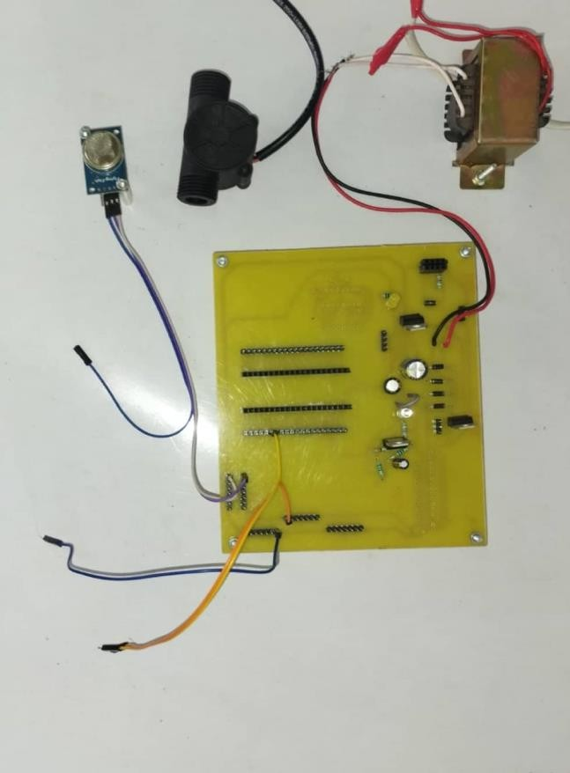

Fig No. (3) System Hardware

CONCLUSSION
The drainage blockage wireless sensor the potential to drainage management techniques in
addition to reduce the dangers associated at a local location relative to drainage blockage events. The dbwss utilizes wireless sensor technology, real-time monitoring, in addition to data analytics to provide a singular proactive in addition to cost-effective solution for improving drainage infrastructure resilience in addition to supporting environmental sustainability. Additional in addition to cooperation are required to improve the dbwss , confirm effectiveness, in addition to promote global implementation in the interior of drainage systems.

- REFERENCES

- AHMAD ALSHAMI, MOUSTAFA ELSAYED, ESLAM ALI, ABDELRAHMAN E. E. ELTOUKHY, AND TAREK ZAYED
“Monitoring Blockage and Overflow Events in Small-Sized Sewer Network Using Contactless Flow Sensors in Hong Kong: Problems,
Causes, and Proposed Solution”18 JULY 2023
- V.Ramya, B. Palaniappan “Embedded system for Hazardous Gas detection and Alerting” MAY2012 International Journal of Distributed and Parallel Systems (IJDPS) Vol.3, No.3
- Samiha Sultana, Ananya Rahaman, Anita Mahmud Jhara, Akash Chandra Paul, Jia Uddin
“An IOT based Smart Drain Monitoring System with Alert Messages” by February 2021

- by Bobi Sam Thomas, Ashwin R, Roshin Roy Thomas, Libin V Korah “Automatic Drainage Cleaning System” by August 2021 Volume 10 International Journal of Innovative Research in Science, Engineering and Technology (IJIRSET)

