Securing Safety: A Comprehensive Review of Helmet Locking and Handling Systems

Harshraj K Wani¹, Rishabh R Sharnagat ², Ayush N Chaudhari ³, Ganesh K Badgujar ⁴
¹UG student, BTech, Mechanical Engineering Department
Government College of Engineering Jalgaon, Maharashtra, India, 425002, waniharsh25@gmail.com
²UG student, BTech, Mechanical Engineering Department
Government College of Engineering Jalgaon, Maharashtra, India, 425002, rishabhsharnagat@gmail.com
³UG student, BTech, Mechanical Engineering Department
Government College of Engineering Jalgaon, Maharashtra, India, 425002, ayush.c2911@gmail.com
⁴Research Scholar, MTech Mechanical Engineering.
Khandesh Engineering Services, Jalgaon, India, 425001, ganesh.badgujar03@gmail.com

Received on: xxxx,20xx, Revised on: xxxx,20xx, Published on: xxxx,20xx

Abstract – This research paper presents a thorough examination of various helmet locking and handling systems with the objective of identifying the optimal solution for ensuring rider safety and convenience. Helmets are crucial components of motorcycle safety, and the effectiveness of their storage and handling systems directly impacts their functionality. The study explores a spectrum of existing mechanisms, encompassing traditional lock-and-key systems, innovative combination locks, proximity sensors, and emerging technologies. Through an in-depth analysis of factors such as security, ease of use, and durability, the paper aims to pinpoint the most efficient and user-friendly helmet locking and handling system. The findings of this research provide valuable insights for both manufacturers and consumers, contributing to the ongoing efforts to enhance motorcycle safety measures.
Keywords- Helmet, Driver safety, Helmet Locking, Leg guard, head gear.
I. INTRODUCTION
In the dynamic world of two-wheeled travel, the helmet stands as an emblem of safety, a crucial guardian for riders navigating the open road. As the cornerstone of protective gear, helmets serve as the primary defense against unforeseen accidents, offering a shield that can make the difference between a minor mishap and a life-altering event. However, the efficacy of helmets extends beyond their inherent protective qualities; the manner in which they are secured and handled, plays a pivotal role in ensuring their functionality and, ultimately, the safety of the rider. Helmets, designed to absorb impact forces and shield the head from injury thus the process of securing and handling these protective headpieces is not merely a practical consideration but a critical aspect of fostering a safety-conscious riding culture.
In this exploration, we embark on a journey through the evolution of helmet locking systems, from traditional lock-and-key mechanisms to cutting-edge technologies. The review encompasses a spectrum of considerations, including ease of use, security, durability, and market availability. By scrutinizing the various types of helmet locking and handling systems, our goal is to identify the optimal solution that not only fortifies the protective capabilities of helmets but also seamlessly integrates into the rider's routine, promoting a harmonious balance between safety and convenience. As we navigate this intricate terrain, we aim to provide valuable insights for riders, manufacturers, and safety advocates alike, contributing to the ongoing dialogue on enhancing the safety measures in the world of motorcycle riding.
II. LITERATURE REVIEW
Road traffic accidents represent a significant challenge, particularly in developing nations where factors such as modernization have exacerbated their impact. Alarmingly, the majority—approximately 85%—of fatalities and injuries resulting from these accidents occur in these regions [1]. Projections by the World Health Organization suggest that by 2030, road traffic accidents will rank among the top causes of mortality and morbidity in developing countries [1].
In these contexts, inadequacies in medical facilities, including referral centers, modern equipment availability, and skilled personnel, pose substantial challenges [1,2]. Moreover, the financial and emotional burdens on individuals and families affected by these accidents are considerable [1,2]. Despite their popularity as a means of transportation in various communities, motorcycles are disproportionately involved in accidents, resulting in a significant number of injuries and fatalities [5]. This trend persists even in developed countries, where the prevalence of private cars is higher [6].
Motorcyclists are particularly vulnerable to severe injuries, notably to the head and brain, in traffic accidents [7,8]. The prevalence of such injuries and associated mortality rates varies widely across different regions, with motorcycle accidents often yielding more severe outcomes compared to those involving other vehicles [5]. Mortality rates stemming from motorcycle accidents range from 6.8% to 80.6% [9-11].
Encouragingly, the use of helmets has demonstrated substantial efficacy in reducing the severity of injuries and preventing fatalities, particularly those resulting from head impacts [5,15]. Moreover, helmet usage has been linked to significant cost savings and broader societal benefits. For instance, in jurisdictions where helmet laws are enforced, substantial financial savings have been observed, underscoring the importance of promoting helmet use [18]. Studies showed that wearing a helmet prevented traumas by 69% and decreased the odds of deaths by up to 42% and estimate of effectiveness ranges from OR 0.23 to 0.35 [7, 19]. Therefore, acknowledging the significance of helmet use for safety against fatalities increased the implementation of helmet laws in different countries [5, 20-22]. Although there is a unique relationship between mortality rate of bike riders and brain traumas on one hand and not wearing a helmet on the other, factors affecting wearing or not wearing a helmet by riders have not been evaluated precisely [23]. In spite of the obvious benefits of helmet use by motorcyclists, unfortunately they have no interest in wearing a helmet.
III. METHOLOGY
This study aims to investigate the effectiveness and user preferences among various motorcycle helmet locking systems. To achieve this, a mixed-methods research approach was adopted, integrating both quantitative and qualitative research methodologies to provide a comprehensive understanding of the subject matter. The study was divided into several phases, as outlined below:
A thorough review of existing literature on motorcycle helmet locks was conducted to understand the current state of knowledge, identify gaps, and refine the research questions. This review encompassed academic journals, industry reports, and product reviews. A survey was developed to gather data on user preferences, experiences, and perceptions regarding different helmet locking systems. The survey included both closed and open-ended questions, allowing for quantitative analysis of preferences and qualitative insights into user experiences. The survey was distributed online through motorcycle enthusiast forums, social media groups, and email listservs targeting a diverse population of motorcycle riders.
Data from the surveys were collected and analyzed to identify patterns, preferences, and significant differences in user satisfaction among the different types of helmet locks, for improvement. Semi-structured interviews were conducted with a select group of respondents who had indicated willingness to participate in further research. These interviews aimed to explore in-depth the reasons behind their preferences, experiences with theft or attempted theft, and any additional measures they take to secure their helmets and motorcycles. All participants were provided with an information sheet detailing the study's purpose and assured of their anonymity and confidentiality. Consent was obtained prior to participation.
Table 1. Questionnaire used for finding out rider’s Reasons for not Using a Helmet
Sr. No. | Question details
1 | The helmet is quite heavy and so don’t use it
2 | The helmet causes discomfort & neck pain
3 | Feels hot on my head when wearing the helmet
4 | Feel of suffocation when wearing the helmet
5 | While riding slowly there is no need to wear a helmet
6 | It restricts neck and head movement
7 | In case of accident, I can maintain my balance so there is no need to wear a helmet
8 | In summers, I cannot use a helmet due to excessive warmth
9 | The winter season is suitable for wearing a helmet
10 | Helmet leads to limitation to field of vision
11 | Carrying the helmet before and after use is difficult

Responses to the questionnaire were numeric from 1 to 5. Where 1 means weakly related and 5 means strongly related to question. Only scores above 3, were used for further calculation.
By employing this methodology, the study aims to contribute valuable insights into the effectiveness and user satisfaction of motorcycle helmet locking systems, with the ultimate goal of enhancing motorcycle-helmet safety and security.
IV. TYPES OF HELMET AND PRIOR AVAILABLE LOCKING SYSTEMS
This classification system categorizes motorcycle helmets into six distinct types based on their intended application and specific features.
Full-face helmets provide the highest level of protection by covering the entire head, including the face and chin, and often come equipped with features such as face shields and aerodynamic designs. Open-face helmets, on the other hand, offer less coverage but provide increased visibility and airflow as they leave the face exposed. Half helmets, as the name suggests, cover only the top of the head, making them lightweight and popular for certain riding styles. Modular helmets combine the features of both full-face and open-face helmets, allowing riders to flip up the front section for increased airflow without removing the entire helmet. Off-road helmets are specifically designed for off-road riding, featuring angular chin bars and enhanced ventilation to accommodate goggles.
Lastly, adventure/touring helmets are tailored for long-distance touring, striking a balance between comfort and protection with extended face shields and aerodynamic designs. This classification provides riders with a clear understanding of the available helmet options, enabling them to make informed decisions based on their individual needs and preferences.

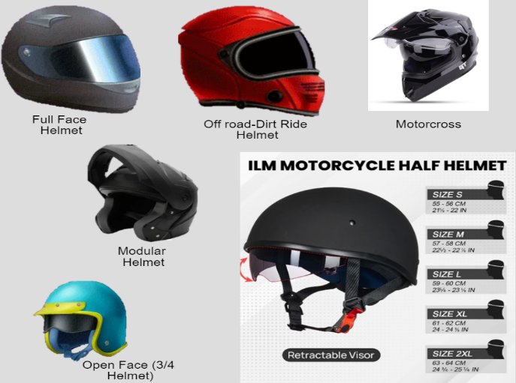
Fig 1. Available Helmets & market trends
It’s been a hot pick of debate regarding making the ISI mark mandatory for two-wheeler helmets. Now, MoRTH or the Ministry of Road Transport & Highways has issued a new notification, which states that all bike/two-wheeler helmets sold from 1 June 2020, should have the ISI mark. As per the latest notification, all bike/two-wheeler helmets must have the ISI mark under the license from Bureau of Indian Standards. This move will kick out the sale of low-quality helmets, which compromise the ride safety of the motorcyclists. Now, it will be interesting to see what happens with the imported helmets which come with different quality test marks such as ECE, DOT.
Some of the top manufacturers who provide helmets meeting these requirements and key players in Indian Motorcycle Helmets Market
- Paras Industries India
- M S A [India] Ltd
- Studds
- Steelbird Hi-Tech India Ltd.
- LS2 Helmets
- Royal Enfield Helmets
- Mallcom [India] Ltd.
- Vega Auto Accessories Pvt. Ltd.
- Wrangler Helmets
- Aerostar Helmets Pvt. Ltd.
- Armex Auto Industries
Current Helmet Locking Techniques
For earlier mentioned helmets there are variety of locking techniques available but some of the key players are listed below
- Bolt Helmet Locks: Traditional keyed locks with small shackles, either bracket-mounted onto the frame or clamped onto the handlebars. Examples include Guami Anti-Theft Motorcycle Helmet Lock and Biker’s Choice helmet lock.
- Carabiner Helmet Locks: Climbing-inspired combination locks made of heavy-duty metal shackles with minimal points of failure. Versatile and lightweight options include Rocky Creek HelmetLok and its rubberized universal motorcycle helmet lock.
- Cable Helmet Locks: Threaded steel cable loops with padlocks, offering simple and reliable solutions for securing helmets and other gear. Examples include the Master Lock Motorcycle Helmet Lock and its combination lock variants.
- Keyed Cable Locks: Cable locks with keys, offering increased reliability against vandalism. Thicker cables provide more safety, as seen in products like the BigPantha Motorcycle Helmet Lock & Cable.
- Combination Helmet Locks: Keyless security with multiple combinations, providing a deterrent against theft. Optimal security is achieved with locks featuring four combinations, such as the HelmetLok 4104 Carabiner Style Lock.
- Motorcycle Chain Locks: Versatile protection using motorcycle anchor chains, serving as a last resort due to their bulkiness and potential damage to helmet integrity.
- Gun or Bicycle Locks: Flexible vinyl-coated steel cable locks with padlocks, offering weather resistance and compatibility with helmets. Examples include gun locks and bicycle locks, suitable for helmet security.
- Padlock or U-Lock: Hardened steel protection with padlocks or U-locks, offering reliable security for helmets with double D retention mechanisms. Examples include the OnGuard Double-Team PITBULL U-Lock and Cable.
- Built-In Helmet Locks: Convenient integrated security systems found on motorcycles, such as hooks under seats or tail-mounted locks like those on the Honda CRF250L Rally.
- Electronic helmet locking: This being a prototype system, seeks to improve road safety for motorcyclists by implementing an effortless helmet locking mechanism integrated with the motorcycle module. This ensures that the motorcycle functions only when the rider wears a helmet. Otherwise, the vehicle's speed is capped at 40 kmph, accompanied by beep sounds and a 10-second delay to reduce speed. Non-compliance triggers automatic ignition shutdown. Furthermore, an LCD display offers speed readings and rider instructions, while a carbon sensor in the exhaust system monitors emissions to assess engine health.
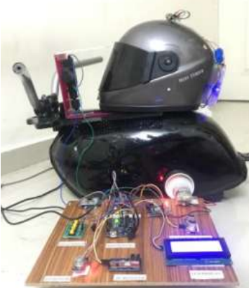
Fig 2. Photograph of the electronic Helmet lock after complete Installation
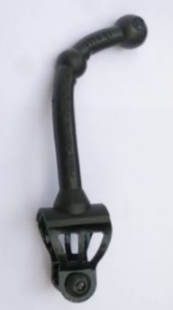
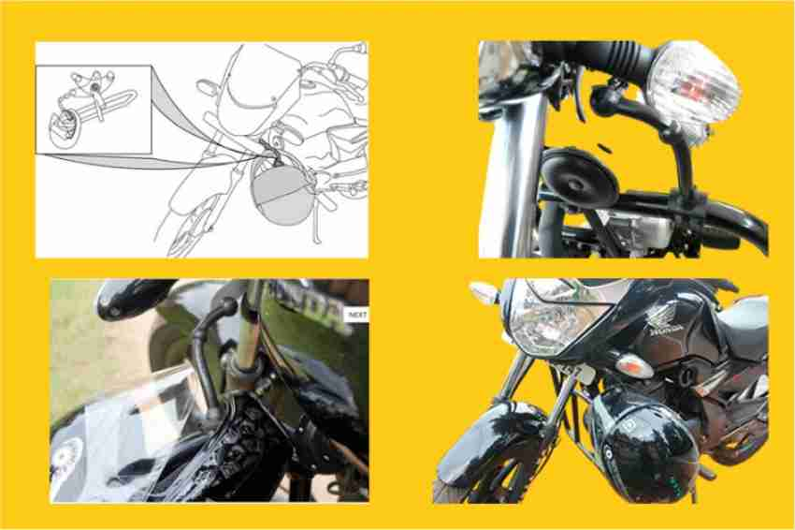
- Fitaki:
Detachable clip
FITAKI Link

Fig 3. FITAKI link attached to motorcycle leg guard
FITAKI is world’s first automatic helmet lock cum Multiduty carrier that secures the helmet on the bike without much time and effort. It is cool, comfortable, and convenient than any of the existing helmet lock systems as it requires neither a lock nor a key. Mileage saving, reduction of pollution and accidents, carrier facility are the core features of FITAKI and these factors make the cost you met to purchase FITAKI is a wise investment. FITAKI is a long-life product and will not get rust or get damaged like the existing locks. The registered design of FITAKI has applied for its worldwide patent.
V. RESULT & DISCUSSION
The survey was conducted amongst 100 motorcyclists in local area of Jalgaon, Maharashtra, India. The motorcyclists’ reasons for not wearing a helmet during the motorcycle ride were the heavy weight of the helmet in 75%; neck pain after wearing a helmet, in 79.4%; limitation of movements of the head and neck, in 59.6%; visual limitation during wearing a helmet in 57%; feeling of heat in 61.4%; feeling of suffocation in 68%; unfavorable appearance of the helmet in 53%; difficulty of preserving or holding the helmet before and after the ride in 72 % and being ridiculed by others due to the use of a helmet in 53.9%. In addition, 64.8% of motorcyclists believed that summer was not a suitable season for wearing a helmet due to excessive heat and 66.3% believed that winter was a suitable season for wearing a helmet. Furthermore, 53.4% of the cases believed that if they obeyed the rules and rode at low speed, there would be no need to use a helmet. In addition, 41.6% of the subjects believed that they did not need a helmet because they were sure that they could keep their balance if an accident occurred.
This survey says that almost 72 % of the people believe in the fact, that “Carrying the helmet before and after use is difficult” and hence they do not use it.
With reference to the survey, we concluded that helmet handling and security was one of the major reasons for not wearing helmets in participating motorcyclists. So here are some needs, we concluded which make helmet handling so important for riders.
- Theft Prevention: Robust locking systems deter theft, safeguarding valuable helmets.
- Safety Enhancement: Securely locked helmets stay in place, ensuring optimal protection during rides.
- Promotion of Responsible Riding: Encourages compliance with safety regulations, fostering a culture of responsible riding.
- Convenience: Provides a hassle-free solution for storing helmets, freeing up hands and simplifying transportation.
- Damage Prevention: Minimizes the risk of helmet damage, preserving structural integrity and protective capabilities.
- Versatility: Adaptable to various environments and user preferences, ensuring suitability in different situations.
- Regulatory Compliance: Facilitates adherence to helmet usage regulations, promoting legal compliance.
- Peace of Mind: Assures riders that their helmets are securely attached, allowing them to focus on other activities with peace of mind.

V. CONCLUSION
With all mentioned types of locking, Fitaki is the most efficient system that everyone can employ. Also, we came to know about following main problems or disadvantages of other systems.

- Most systems were costly.
- Most were to be purchased separately after purchase of bike and its accessories.
- Systems were not as sturdy as they were priced.
- Complex installations.
- Failing to accommodate universal application.
- Need of separate triggering mechanism or password system.
- Separate key required.
- Bulky structure, unpleasant appearance.

So, we came up with a rather hybrid model of bike crash guard and the Fitaki link. Together they form a sturdy mechanical system. When installed in a motorcycle, it automatically locks the helmet in the extended link with the suspension studs, when handle lock is activated.

This type of configuration can be used effectively for helmets with chin guard.
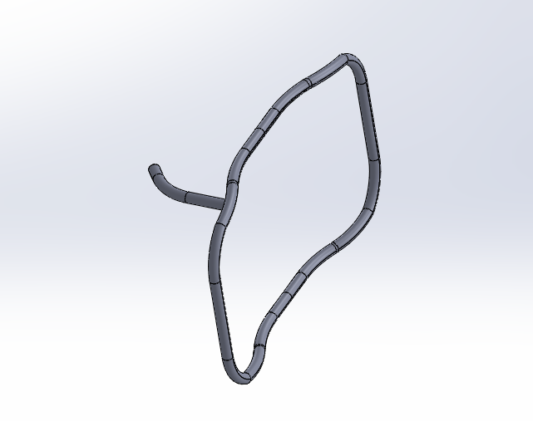
Extended Link for locking of helmet
Bike Crash guard or Leg guard
Fig 3. Extra-link attached to a crash guard. (Target-system, compatible with majority popular motorcycle models)
ACKNOWLEDGMENT
We extend our sincerest gratitude to those who have contributed to the completion of this research paper. Firstly, we express our appreciation to Dr. Shashikant T. Wagge sir from Govt College of Engineering Jalgaon, our supervisor, whose guidance and support have been invaluable throughout the research process. Their expertise has shaped this work significantly.
We also extend our thanks to Mr. Ganesh K Badgujar, Khandesh Engineering Services, for their assistance in data analysis and interpretation, enhancing the depth and accuracy of our findings. Additionally, we acknowledge the contributions of Mr. Ayush N Chaudhari, Mr. Akash G Bhalerao, Mr. Rishabh R Sharnagat, Mr. Aman N Bisen for their valuable input and feedback.
Lastly, we are grateful to the participants who generously shared their time and insights, and to our families and friends for their unwavering support. Without each of these contributions, this research would not have been possible.
Thank you all for your indispensable roles in this endeavor.
REFERENCES
- Peden M, Scurfield R, Sleet D, Mohan D, Hyder AA, Jarawan E. World Report On Road Traffic Injury Prevention. Geneva : WHO, 2004.
- Arch Trauma Res. Ebrahimzadeh MH. National Trauma Registry center, as a backbone of trauma management & research. 1[3], 2012. 10.5812/atr.8487.
- World Health Organization. In: Global status report on road safety 2013 supporting a decade of action. Department of Violence and Injury Prevention and Disability., editor. Geneva: 2013. [Google Scholar]
- Ebrahimzadeh MH. National trauma registry center, as a backbone of trauma management and research. Arch Trauma Res. 2012;1[3]:87–8. doi: 10.5812/atr.8487. [PMC free article] [PubMed] [CrossRef] [Google Scholar]
- Rowland J, Rivara F, Salzberg P, Soderberg R, Maier R, Koepsell T. Motorcycle helmet use and injury outcome and hospitalization costs from crashes in Washington State. Am J Public Health. 1996;86[1]:41–5. [PMC free article] [PubMed] [Google Scholar]
- Mohan D. Road safety in less-motorized environments: future concerns. Int J Epidemiol. 2002;31[3]:527–32. [PubMed] [Google Scholar]
- Liu BC, Ivers R, Norton R, Boufous S, Blows S, Lo SK. Helmets for preventing injury in motorcycle riders. Cochrane Database Syst Rev. 2008;[1]:CD004333. doi: 10.1002/14651858.CD004333.pub3. [PubMed] [CrossRef] [Google Scholar]
- Servadei F, Begliomini C, Gardini E, Giustini M, Taggi F, Kraus J. Effect of Italy's motorcycle helmet law on traumatic brain injuries. Inj Prev. 2003;9[3]:257–60. [PMC free article] [PubMed] [Google Scholar]
- Nakahara S, Chadbunchachai W, Ichikawa M, Tipsuntornsak N, Wakai S. Temporal distribution of motorcyclist injuries and risk of fatalities in relation to age, helmet use, and riding while intoxicated in Khon Kaen, Thailand. Accid Anal Prev. 2005;37[5]:833–42. doi: 10.1016/j.aap.2005.04.001. [PubMed] [CrossRef] [Google Scholar]
- Oginni FO, Ugboko VI, Ogundipe O, Adegbehingbe BO. Motorcycle-related maxillofacial injuries among Nigerian intracity road users. J Oral Maxillofac Surg. 2006;64[1]:56–62. doi: 10.1016/j.joms.2005.09.027. [PubMed] [CrossRef] [Google Scholar]
- Tsai MC, Hemenway D. Effect of the mandatory helmet law in Taiwan. Inj Prev. 1999;5[4]:290–1. [PMC free article] [PubMed] [Google Scholar]
- Hyder AA, Waters H, Phillips T, Rehwinkel J. Exploring the economics of motorcycle helmet laws--implications for low and middle-income countries. Asia Pac J Public Health. 2007;19[2]:16–22. [PubMed] [Google Scholar]
- Heydari ST, Maharlouei N, Foroutan A, Sarikhani Y, Ghaffarpasand F, Hedjazi A, et al. Fatal motorcycle accidents in Fars Province, Iran: a community-based survey. Chin J Traumatol. 2012;15[4]:222–7. [PubMed] [Google Scholar]
- Janmohammadi N, Pourhossein M, Hashemi SR. Pattern of motorcyclist's mortality in Mazandran province, Northern Iran. Iran Red Crescent Med J. 2009;11[1]:81–4. [Google Scholar]
- Rutledge R, Stutts J. The association of helmet use with the outcome of motorcycle crash injury when controlling for crash/injury severity. Accid Anal Prev. 1993;25[3]:347–53. [PubMed] [Google Scholar]
- Paravar M, Hosseinpour M, Salehi S, Mohammadzadeh M, Shojaee A, Akbari H, et al. Pre-hospital trauma care in road traffic accidents in kashan, iran. Arch Trauma Res. 2013;1[4]:166–71. doi: 10.5812/atr.8780. [PMC free article] [PubMed] [CrossRef] [Google Scholar]
- Gennarelli TA, Champion HR, Sacco WJ, Copes WS, Alves WM. Mortality of patients with head injury and extracranial injury treated in trauma centers. J Trauma. 1989;29[9]:1193–201. discussion 1201-2. [PubMed] [Google Scholar]
- Centers for Disease C, Prevention. Helmet use among motorcyclists who died in crashes and economic cost savings associated with state motorcycle helmet laws--United States, 2008-2010. MMWR Morb Mortal Wkly Rep. 2012;61[23]:425–30. [PubMed] [Google Scholar]
- Pervin A, Passmore J, Sidik M, McKinley T, Nguyen TH, Nguyen PN. Viet Nam's mandatory motorcycle helmet law and its impact on children. Bull World Health Organ. 2009;87[5]:369–73. [PMC free article] [PubMed] [Google Scholar]
- Keng SH. Helmet use and motorcycle fatalities in Taiwan. Accid Anal Prev. 2005;37[2]:349–55. doi: 10.1016/j.aap.2004.09.006. [PubMed] [CrossRef] [Google Scholar]
- Lardelli-Claret P, Jimenez-Moleon JJ, de Dios Luna-del-Castillo J, Garcia-Martin M, Bueno-Cavanillas A, Galvez-Vargas R. Driver dependent factors and the risk of causing a collision for two wheeled motor vehicles. Inj Prev. 2005;11[4]:225–31. doi: 10.1136/ip.2004.006957. [PMC free article] [PubMed] [CrossRef] [Google Scholar]
- MacLeod JB, Digiacomo JC, Tinkoff G. An evidence-based review: helmet efficacy to reduce head injury and mortality in motorcycle crashes: EAST practice management guidelines. J Trauma. 2010;69[5]:1101–11. doi: 10.1097/TA.0b013e3181f8a9cc. [PubMed] [CrossRef] [Google Scholar]
- Gkritza K. Modeling motorcycle helmet use in Iowa: evidence from six roadside observational surveys. Accid Anal Prev. 2009;41[3]:479–84. doi: 10.1016/j.aap.2009.01.009. [PubMed] [CrossRef] [Google Scholar]

