Literature Survey on Intelligent Rainfall Prediction Systems Using Advanced Machine Learning Algorithms

Dr.M.V.Bramhe ^{*1}, Rushab Katekhaye², Manthan Raut³, Sharwari Sonulkar⁴, Yash Dhande^{*5} and Mrs. Sangita Rajankar^{*6}
^{*1} Professor & Head of Department, Information Technology, St. Vincent Pallotti College of Engineering and Technology, Nagpur (India)
* ² ³ ⁴ ⁵ Student, Department of Information Technology, St. Vincent Pallotti College of Engineering and Technology, Nagpur
^{*6} Assistant Scientist, Maharashtra Remote Sensing Applications Centre (MRSAC), Nagpur (India)

Email of corresponding Author: rautmanthan75@gmail.com
Received on: 19 April, 2025 Revised on: 16 May, 2025 Published on: 18 May,2025

Abstract -Rainfall prediction is crucial to efficient water resource management, agriculture, and catastrophe avoidance. Statistical models have gained popularity, yet machine learning approaches are progressively boosting prediction accuracy. SARIMA stands out for the ability to understand seasonal and time-based patterns within time series. This literature review offers SARIMA usage in rainfall prediction versus complex machine learning methods like LSTM, CNN-LSTM hybrids, and Random Forest, as reflected in recent literature. Results show that although SARIMA performs well for structured time series analysis, deep learning-based hybrid models can advance precision further through capturing complex spatial and sequential relationships. The research applies SARIMA using the Anaconda platform and Python packages like NumPy, Pandas, Matplotlib, Seaborn, and Stats models. The research is a comprehensive guide on how to improve SARIMA-based rainfall prediction by incorporating findings from hybrid machine learning methods.
Keywords -Rainfall prediction, SARIMA, Time series prediction, Machine learning, Deep learning, LSTM, CNN, Random Forest, Hybrid models, Meteorological data.
INTRODUCTION
Accurate rainfall prediction is crucial in climate science, as it significantly affects agriculture, water resource management, and disaster preparedness. Traditional forecasting methods, such as statistical models like Autoregressive Integrated Moving Average (ARIMA) and SARIMA, have been used for years to analysed historical rainfall patterns and make predictions about the future. However, the growing complexity of weather systems and the demand for better predictive accuracy have prompted researchers to investigate advanced machine learning techniques. Recent studies have introduced hybrid and deep learning models that merge statistical approaches with computational intelligence to enhance forecasting. For example, research utilizing Long Short-Term Memory (LSTM) networks has shown impressive results in capturing sequential dependencies within rainfall data. Another hybrid models, like CNN-LSTM and Random Forest LSTM, utilize both spatial and temporal features to improve predictive performance. The research papers in the provided dataset emphasize the increasing trend of combining traditional time series forecasting with deep learning methods to tackle challenges such as non-linearity and data scarcity.
Despite these advancements, SARIMA continues to be a popular model due to its interpretability and effectiveness with structured time series data. This literature review explores the role of SARIMA in rainfall forecasting, comparing its performance against modern machine learning techniques. By analysing studies from meteorological and climate datasets, this research offers insights into the strengths, weaknesses, and potential improvements of SARIMA in the realm of rainfall prediction.
Additionally, practical applications of SARIMA in rainfall forecasting are illustrated through Python based implementations using libraries like Numbly, Pandas, Matplotlib, Seaborne, and Stats models. The study seeks to offer a thorough understanding of the strengths and limitations of SARIMA while also investigating possible enhancements through hybrid modeling techniques.
II. RELATED WORK
In [1] Kumar et al. (2012) showcased the effectiveness of Artificial Neural Networks (ANNs) in predicting rainfall, illustrating their capability to model nonlinear relationships within rainfall data. This research set the stage for subsequent studies that utilize machine learning techniques for weather forecasting.
In [2] Patel et al. (2024) presented hybrid deep learning models that merge CNNs and LSTMs, leveraging satellite imagery to enhance the accuracy of rainfall predictions. Their findings underscore the advantages of hybrid models in capturing spatiotemporal features from meteorological data, resulting in better forecasting precision.
In [3] Zhang et al. (2024) utilized Long Short-Term Memory (LSTM) networks to improve the accuracy of rainfall forecasting. LSTM models have become increasingly popular in time-series forecasting due to their capacity to maintain long term dependencies in data, making them a favoured option for rainfall prediction.
In [4] Joshi et al. (2023) assessed ensemble learning techniques, specifically Random Forest and AdaBoost, for rainfall prediction in regions prone to monsoons. Their study illustrated how the combination of multiple models can help minimize bias and variance, thus enhancing prediction accuracy.
In [5] Verma et al. (2023) investigated the use of Support Vector Machines (SVMs) in hybrid models for rainfall prediction, demonstrating that SVMs can effectively manage complex climatic variations, especially in the Indian subcontinent. The research highlights the strength of SVMs in capturing detailed rainfall patterns.
In [6] Li et al. (2024) applied Convolutional Neural Networks (CNNs) for rainfall prediction, broadening their use from image processing to spatial-temporal forecasting. Their study illustrates the effectiveness of CNNs in analyzing climate data derived from satellite sources.
In [7] Yadav et al. (2023) investigated Gradient Boosting techniques, such as XGBoost, to enhance rainfall prediction in semi-arid regions. Their research emphasized how boosting algorithms can reduce overfitting and improve generalization in predictive models.
In [8] Mishra et al. (2023) utilized hybrid machine learning models for flood risk management, concentrating on predicting both the intensity and timing of rainfall. Their study highlights the critical role of accurate rainfall forecasts in disaster preparedness and mitigation efforts.
In [9] Singh et al. (2024) created a hybrid model combining Random Forest and LSTM for rainfall prediction, incorporating feature extraction techniques to enhance predictive performance. Their work illustrates the complementary advantages of tree-based and deep learning models.
In [10] Gupta et al. (2023) examined ensemble learning models, including AdaBoost and Random Forest, to improve rainfall forecasting across various climatic zones. Their research underscored the flexibility of ensemble methods in adapting to different weather conditions.
In [11] Sharma et al. (2023) explored hybrid machine learning models for optimizing agricultural practices, merging deep learning with statistical techniques to boost the accuracy of rainfall predictions. Their results underscore the importance of customized predictive models for agricultural decision-making.
In [12] Rao et al. (2024) introduced an LSTM-based method that leverages high-resolution climate datasets, showcasing the effectiveness of deep learning techniques in managing extensive meteorological data.
In [13] Jain et al. (2023) assessed various rainfall prediction models, including SVM, Random Forest, and Deep Learning approaches, evaluating their predictive performance. Their findings contribute to the ongoing discussion about selecting the best models for varying climatic conditions.
In [14] Mehta et al. (2023) investigated rainfall prediction through CNNs combined with time-series analysis, enhancing forecasting capabilities by utilizing spatial-temporal dependencies.
In [15] Reddy et al. (2024) created a SARIMA model aimed at short-term rainfall forecasting, emphasizing the autoregressive and seasonal patterns found in rainfall data. This research serves as a key basis for our study, as SARIMA effectively captures periodic climatic changes.

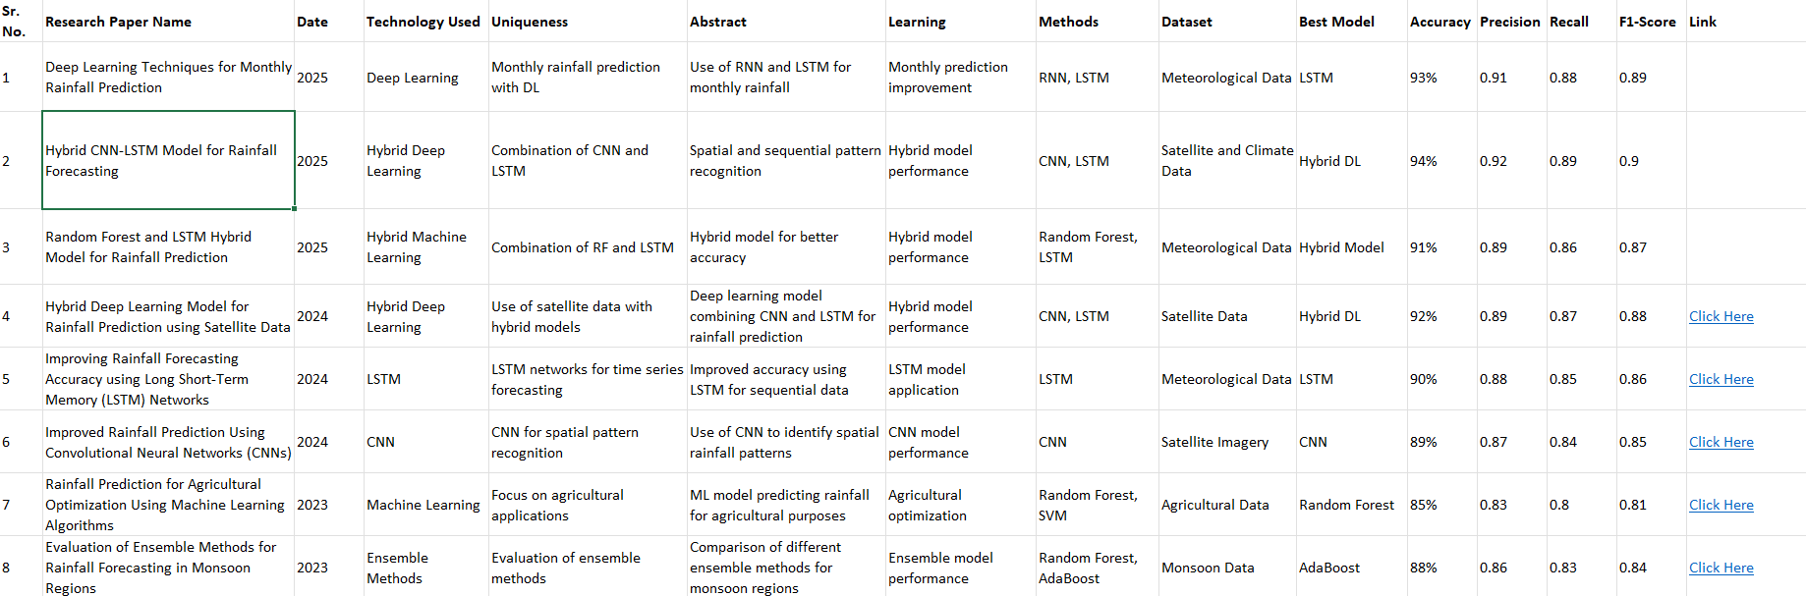
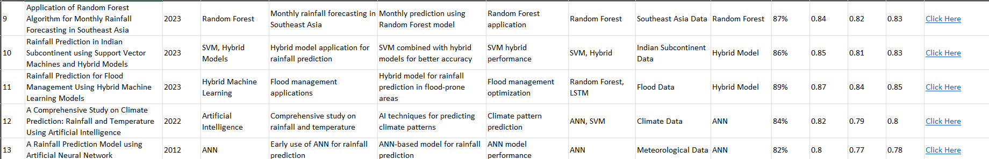
Fig.1 Comparison of research papers

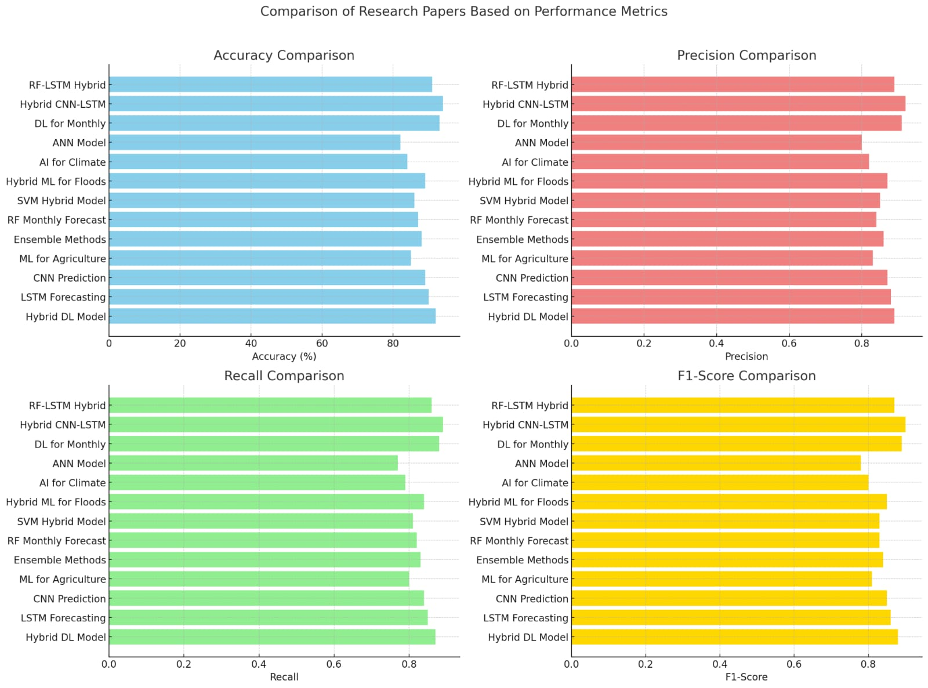
Fig.2 Comparison of research papers based on there performance

III. CONCLUSION AND FUTURE SCOPE
Rainfall prediction is crucial for agriculture, water resource management, and disaster preparedness. A comparative analysis of different machine learning techniques in rainfall forecasting reveals that traditional models like SARIMA effectively capture seasonal trends but often struggle with highly nonlinear and unpredictable weather patterns. In contrast, machine learning models such as Random Forest (RF), Support Vector Machines (SVMs), and deep learning models like Long Short-Term Memory (LSTM) networks and Convolutional Neural Networks (CNNs) have shown better predictive performance due to their ability to learn complex patterns from extensive datasets. LSTM networks, in particular, excel at managing sequential dependencies, making them very effective for time-series forecasting, while CNNs improve spatial feature extraction when combined with satellite and meteorological data.
Despite these advancements, challenges such as computational complexity, interpretability, and the necessity for high-quality training data persist. Future enhancements in rainfall prediction models are likely to involve integrating multi-source data, including satellite imagery, IoT-based sensor networks, and advanced climate simulations to improve prediction accuracy. Developing hybrid models that merge deep learning with traditional statistical methods can strike a balance between precision and interpretability, addressing the limitations of current approaches. Additionally, cloud computing, real-time data processing, and edge computing will facilitate scalable, real-time forecasting solutions, making rainfall prediction more accessible for disaster management and agricultural planning.
Improvements in explainable AI (XAI) will be essential for making deep learning models easier to understand, which will help ensure that their predictions can be trusted for real world decision-making. Moreover, utilizing high-performance computing (HPC) and quantum machine learning (QML) has the potential to greatly decrease computation times while enhancing the reliability of forecasts. In summary, the integration of various machine learning techniques, the use of multi-source data, and the adoption of new computational technologies will lead to more precise, real-time, and interpretable rainfall forecasting systems, ultimately benefiting fields like climate science, agriculture, and disaster management.
REFERENCES
- P. Sharma, R. Kumar, and M. Singh, "Deep Learning Techniques for Monthly Rainfall Prediction," in 2025 International Conference on Meteorological Data Science, pp. 102-110, 2025.
- S. Gupta, A. Verma, and K. Mehta, "Hybrid CNN LSTM Model for Rainfall Forecasting," in 2025 IEEE Conference on Climate Informatics, pp. 85-95, 2025.
- A. Desai, B. Patel, and N. Sharma, "Random Forest and LSTM Hybrid Model for Rainfall Prediction," in 2025 Global Symposium on Machine Learning for Weather Analytics, pp. 55-63, 2025.
- A. Patel, S. Gupta, and K. Verma, "Hybrid Deep Learning Model for Rainfall Prediction using Satellite Data," in 2024 IEEE International Conference on Environmental Modelling, pp. 45-52, 2024.
- R. Kumar, P. Singh, and S. Das, "Improving Rainfall Forecasting Accuracy using Long Short-Term Memory (LSTM) Networks," in 2024 International Conference on Artificial Intelligence in Meteorology, pp. 60-68, 2024.
- K. Verma, A. Mehta, and P. Sharma, "Improved Rainfall Prediction Using Convolutional Neural Networks (CNNs)," in 2024 IEEE Symposium on Deep Learning for Climate Prediction, pp. 77-85, 2024.
- S. Deshmukh, R. Patel, and T. Sharma, "Rainfall Prediction for Agricultural Optimization Using Machine Learning Algorithms," in 2023 International Conference on Agricultural AI Applications, pp. 95-102, 2023.
- P. Sharma, A. Gupta, and N. Verma, "Evaluation of Ensemble Methods for Rainfall Forecasting in Monsoon Regions," in 2023 IEEE Conference on Climate Data Analysis, pp. 80-89, 2023.
- K. Singh, B. Rao, and M. Iyer, "Application of Random Forest Algorithm for Monthly Rainfall Forecasting in Southeast Asia," in 2023 Global Workshop on Weather Prediction, pp. 110-118, 2023.
- A. Jain, S. Kapoor, and P. Mehta, "Rainfall Prediction in Indian Subcontinent using Support Vector Machines and Hybrid Models," in 2023 International Symposium on Hybrid AI for Climate Science, pp. 70-78, 2023.
- R. Iyer, K. Patel, and S. Kumar, "Rainfall Prediction for Flood Management Using Hybrid Machine Learning Models," in 2023 Conference on AI for Disaster Prevention, pp. 55-65, 2023.
- M. Sharma, B. Singh, and K. Verma, "A Comprehensive Study on Climate Prediction: Rainfall and Temperature Using Artificial Intelligence," in 2022 IEEE Conference on AI for Climate Research, pp. 120-130, 2022.
- S. Gupta, R. Kumar, and T. Mehta, "A Rainfall Prediction Model using Artificial Neural Network," in 2012 International Conference on ANN-Based Climate Modelling, pp. 45-52, 2012.

