A Review on Various Industrial Material Handling Systems

Riyaz Ahmed
ahmad_riaz.ghrceme@raisoni.net
Department of Mechanical Engineering
G H Raisoni College of Engineering, Nagpur, India.

Laukik Raut
laukik.raut@raisoni.net
Assistant Professor
G.H.Raisoni College of Engineering, Nagpur, India.

A.S.Sharma
asinfo.chpl@gmail.com
Consolidated Hoists Private Limited, Pune, India

ABSTRACT

The main aim of this paper is to study various material handling equipments & systems used in an industry for various material handling, and study various modern techniques. Material handling is required by many safety regulations, national consensus standards and manufacturers. It is the purpose of the daily condition usage to ensure that the overall equipment mechanical and electric components of the equipment have been maintained in a safe and serviceable condition and are functioning properly according to the original equipment manufacturer’s specifications. It is the purpose of the inspection test to ensure by actual test that the equipment is capable of safely lifting and moving the rated load through all designed motions. The inspection and load test do not take into account the duty factor of the equipment.

Keywords: Material handling system, safety, AGV, Industrial robot

INTRODUCTION
Material handling involves short-distance movement within the confines of a building or between a building and a transportation vehicle. It uses a wide range of manual, semi-automated, and automated equipment and includes consideration of the protection, storage, and control of materials throughout their manufacturing, warehousing, distribution, consumption, and disposal. Material handling can be used to create time and place utility through the handling, storage, and control of material, as distinct from manufacturing, which creates form utility by changing the shape, form, and makeup of material For the safety and ease in productivity of your employees and workplace, it’s of critical importance to know that new or newly repaired or modernized material handling equipment is in proper working order—before you put it into service. This section defines required pre-service operational testing and load testing.

PRINCIPLES OF MATERIAL HANDLING

Although there are no definite “rules” that can be followed when designing an effective MHS, the following “Ten Principles of Material Handling” as compiled by the College-Industry Council on Material Handling Education (CIC-MHE) in cooperation with the Material Handling Institute (MHI), represent the distillation of many years of accumulated experience and knowledge of many practitioners and students of material handling:

Planning Principle. All MH should be the result of a deliberate plan where the needs, performance objectives, and functional specification of the proposed methods are completely defined at the outset.

Standardization Principle. MH methods, equipment, controls and software should be standardized within the limits of achieving overall performance objectives and without sacrificing needed flexibility, modularity, and throughput.

Work Principle. MH work (defined as material flow multiplied by the distance moved) should be minimized without sacrificing productivity or the level of service required of the operation.

Ergonomic Principle. Human capabilities and limitations must be recognized and respected in the design of MH tasks and equipment to ensure safe and effective operations.

Unit Load Principle. Unit loads shall be appropriately sized and configured in a way that achieves the material flow and inventory objectives at each stage in the supply chain.

Space Utilization Principle. Effective and efficient use must be made of all available (cubic) space.

System Principle. Material movement and storage activities should be fully integrated to form a coordinated, operational system which spans receiving, inspection, storage, production, assembly, packaging, unitizing, order selection, shipping, and transportation, and the handling of returns.

Automation Principle. MH operations should be mechanized and/or automated where feasible to improve operational efficiency, increase responsiveness, improve consistency and predictability, decrease operating costs, and to eliminate repetitive or potentially unsafe manual labor.

Environmental Principle. Environmental impact and energy consumption should be considered as criteria when designing or selecting alternative equipment and MHS.

Life Cycle Cost Principle. A thorough economic analysis should account for the entire life cycle of all MHE and resulting systems.

CLASSIFICATION OF MATERIAL HANDLING SYSTEM

[A] Equipment Oriented System
[1]. Convey system
[2]. Tractor transfer system
[3]. Fork lift truck
[4]. Industrial truck system
[5]. Underground system

[B]. Material Oriented System
[1]. Unit handling system
[2]. Bulk handling system
[3]. Liquid handling system

[C]. Method Oriented System
[1]. Manual systems
[2]. Automated system
[3]. Job shop handling system
[4]. Mass production system

[D]. Function Oriented System
[1]. Transportation systems
[2]. Conveying systems
[3]. Transferring systems
[4]. Elevating system

MATERIAL TRANSPORT EQUIPMENT

International Materials Management Society has classified equipment as (1) conveyor, (2) cranes, elevators, and hoists, (3) positioning, weighing, and control equipment, (4) industrial vehicles, (5) motor vehicles, (6) railroad cars, (7) marine carriers, (8) aircraft, and (9) containers and supports. The following provides the details of material transport equipments.

OBJECTIVE OF MATERIAL HANDLING

To increase efficiency of material flow by ensuring availability of materials when & where they needed | To reduce MH cost
To improve facilities utilization | To improve safety & working conditions
To facilitate mfg processes | To increase productivity

CONVEYOR SYSTEMS

A Conveyor is used when a material is moved very frequently between specific points and the path between points is fixed. Conveyors combined with modern identification and recognition systems like bar code technologies have played a significant role in the transportation and sorting of a large variety of products in modern warehouses. Some of the common types of conveyors are:
Roller conveyor
Skate- wheel conveyor
Belt conveyor
In- floor towline conveyor
Overhead trolley conveyor

CRANES AND HOISTS

Cranes are normally used for transferring materials with some considerable size and weight and for intermittent flow of material. In general, loads handled by cranes are more varied with respect to their shape and weight than those handled by a conveyor. Hoists are frequently attached to cranes for vertical translation that is, lifting and lowering of loads.
They can be operated manually, electrically, or pneumatically. Cranes usually include hoists so that the crane-and-hoist combination provides

Horizontal transport

Vertical lifting and lowering

This class of material handling equipments can typically lift & move a material up to 100 tons. A hoist consists of one or more fixed pulley & one or more rotatable pulley & a hook to attach load with it. The number of pulleys in hoist determines its mechanical advantage which is the ratio of load lifted & deriving force.

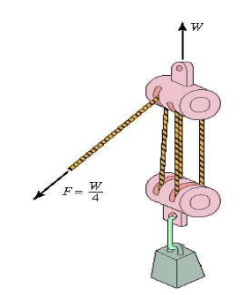 | 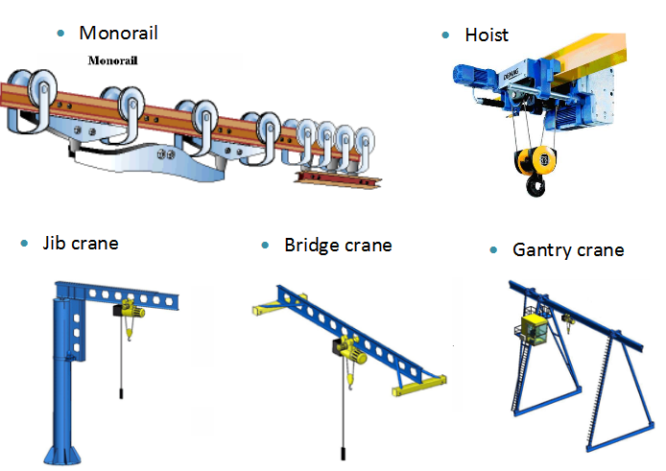
Figure 7: Hoist

AUTOMATED RETRIEVAL AND STORAGE EQUIPMENTS

Storage equipments can be in the form of racks, shelves, bins and drawers. Among these, storage rack is probably the most common form of storage equipment. There are numerous variants and configurations of storage racks, which include single-deep, double-deep rack, cantilever rack etc. and configurations that are designed to facilitate specific storage and retrieval operations drive-through, flow-through etc. More sophisticated re trieval and storage system combine the use of storage equipment, storing and retrieval machines and control that are manifested in a modern automated storage/ retrieval system.

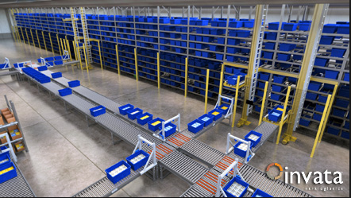 | 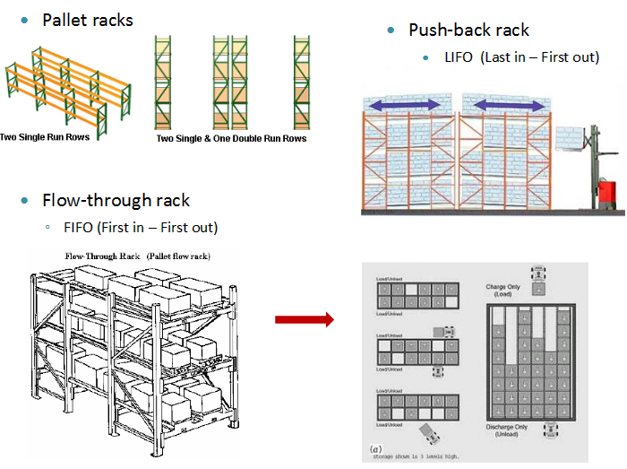

AUTOMATED STORAGE AND RETRIEVAL SYSTEM

AUTOMATED GUIDED VEHICLES

An Automated Guided Vehicle System (AGVS) is a material handling system that uses independently operated, self-propelled vehicles guided along defined pathways in the facility floor. It is an automated material handling system which moves along predefined and preprogrammed path along an aisle from one station to another. The main parts of an AGV include structure, drive system, steering mechanism, power source (battery) and onboard computer for control.
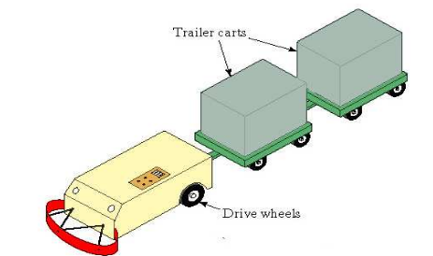
DRIVERLESS AUTOMATED GUIDED VEHICLE

INDUSTRIAL ROBOTS

Industrial robots are very useful material handling devices in an automated environment. An industrial robot is a reprogrammable
multifunctional manipulator designed to move materials, parts, tools, or other devices by means of variable programmed motions and to perform a variety of other tasks. It is also defined as a machine formed by a mechanism including several degrees of freedom often having the appearance of one or several arms ending in a wrist capable of holding a job, tool and inspection device. It is automatically controlled, reprogrammable, multipurpose manipulative machine with several reprogrammable axes which is either fixed in place or mobile for use in industrial automation applications.

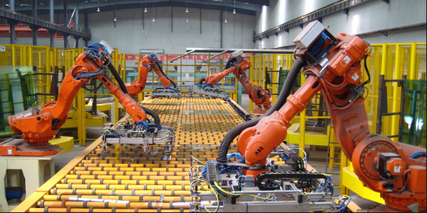
INDUSTRIAL ROBOT

DEGREE OF MACHANIZATION IN MH

A Material Handling system can be completely manual or fully automated; Different degrees of mechanization also exist between these two extremes. Level of Mechanization in MH System is classified with respect of Source of power for handling, degree of human involvement & computers in operating the equipment.

Level of Mechanization can be classified as:

MANUAL & DEPENDENT ON PHYSICAL EFFORT:

This level also includes manually driven equipment such as hand truck.

MECHANIZED:

Power instead of physical effort is used for driving the eqpt. Some trucks, conveyors, & cranes fall into this level. Here operators are needed for operating the eqpt as opposed providing the power

MECHANIZED COMPLEMENTED WITH COMPUTERS:

It is an extension of 2nd level. The function of the computers is to generate documents specifying the Moves & Operations

AUTOMATED:

Minimum human intervention is used for driving & operating the equipment, & most of these functions are performed by computers. Examples includes Conveyors, AGVs, & AS/RS. The equipment usually receives instructions form key boards, pushbuttons, & tape or card readers.

FULLY AUTOMATED:

This level is similar to the 4th level, but computers perform the additional task of on-line control, thus eliminating the need for human intervention.

The cost & complexity of designing the system increases as the degree of mechanization increases. However, efficiency of operations & labor savings can result.

LIMITATIONS OF AUTOMATED MATERIAL HANDLING SYSTEMS
A good management practice is to weigh benefits against the limitations or disadvantages before contemplating any change. Material handling systems also have consequences that may be distinctly negative.

THESE ARE:

Additional investment

Lack of flexibility
Vulnerability to downtime whenever there is breakdown Additional maintenance staff and cost
Cost of auxiliary equipment.
Space and other requirements:
The above limitations or drawbacks of adopting mechanized handling equipment have been identified not to discourage the use of modern handling equipment but to emphasize that a judicious balance of the total benefits and limitations is required before an economically sound decision is made.
CONCLUSION

From the above study it has been analyzed that observed that the material handling is an important task in the industry and involves a lot of total product cost. The selection of the most appropriate MH equipment for any particular application is very important and affects productivity and efficiency of an industry. Types of material handling systems are outlined and discussed. Transportation, position and storage material handling equipment are discussed briefly with the few examples. Further some guidelines are provided to select the best material handling equipment for a particular task. Thus the paper concludes that selection of material handling equipment plays an important role increasing productivity and efficiency of the industry and ensures safety of labor and quality of product.

REFERENCES:
- Material Handling and Logistics U.S. Roadmap" (PDF). MHI. January 2014. Retrieved 2015-05-08.
- Sameet Dandawate, Laukik P. Raut, “Implementing ‘5-S Methodology’ as Tool for Improving Efficiency & Performance of Delivery and Production Operations at Bajaj Steels”, IJSRD - International Journal for Scientific Research & Development| Vol. 3, Issue 03, 2015 | ISSN (online): 2321-0613.
- Rajat P. Kale, Laukik P. Raut, “Kaizen & Its Applications – A Japanese Terminology Referred to Continuous Improvement”, IJSRD - International Journal for Scientific Research & Development| Vol. 3, Issue 02, 2015 | ISSN (online): 2321-0613
- Rajat B. Wakode, Laukik P. Raut, “Overview on Kanban Methodology and its Implementation”, IJSRD - International Journal for Scientific Research & Development| Vol. 3, Issue 02, 2015 |

