Automatic Security Light Control System Using Real Time Clock
Zacchaeus Adetona¹ and Samson Ameh²
¹Senior Lecturer, ²Formerly Student
Department of Electrical Electronics Engineering, Federal Polytechnic, Ilaro, Nigeria

Email of corresponding Author: zacchaeus.adetona@federalpolyilaro.edu.ng

Received on: 19 April, 2025 Revised on: 16 May, 2025 Published on: 18 May,2025

Abstract – The energy consumption of manually operated security lights is high, wasting money since the operator cannot be precise when turning on/off the system. Insufficient lighting in the environment at night encourages criminal activity and makes the environment unsafe for people. There is a need for a system that saves energy while ensuring safety by providing constant lighting in the environment at the required time. In this work, a microcontroller, a relay, and a DS1307 Serial Real Time Clock (RTC) were utilized to develop a system that allows a user to set the on/off time for the security lighting system. The power section comprises of a stepped- down and rectified mains backed up by a lithium-ion battery. The RTC, basically set to work on a 24-hour clock, was utilized to provide the user the opportunity to set a specific on/off time. The PIC16F877A Microcontroller programmed using MikroC language serves as the heart of the design. It monitors the time status of the RTC in real time to determine when to energize the switching circuit to turn on or off the AC lamps. Three tests were performed to validate the system's functionality using different time intervals between real time, ON time and OFF time, and these yielded the desired and accurate results. The AC lamps connected were automatically turned on an off during the tests. An automatic control circuit switching was implemented which was extremely efficient, consumed minimal energy and has low maintenance cost.
Keywords- Energy consumption, Microcontroller, Real Time Clock (RTC), Security light.
INTRODUCTION
Energy wastage is one of the concerns of in day-to-day life in the world of today. The energy consumption of security lights that are manually operated is really high. Poor lighting in residences, workplaces, walkways, or surrounding area encourages criminal activity and makes the environment unsafe for people. Security lighting illuminates objects or people and creates a psychological deterrent to criminal activity (Wilson et al. 2015). They are an essential part of any city because they improve night vision, provide security in the house and roads, and provide exposure to public areas but they consume a significant amount of electricity, hence, there is need to effectively control the system. This is the reason why automatic control of such a system is needed. The term "smart/automatic control" is meaningless without automation. The main goal of automation is to eliminate human intervention, one of which is to make daily life more comfortable.
Over the years, many automatic security light control system have been developed. There are lots of approaches made to provide a control system for security lights, some of which include using Complex Programmable Logic Device (CPLD) and automatic controller (Saad et al, 2013), embedded system (Yusuf et al., 2020) and energy saving based on intelligent security light control system (Popa & Cepisca, 2011). Hillebrand (2013) proposed a security light control system that allowed interaction between the mobile phone and the receiver placed in the house. The command actions of either ON/OFF can be done on phone. Any electronic or electrical device which includes lighting bulb, etc., can be controlled from far distance.
According to Santhi et al. (2019), another system uses AT89S52 microcontroller which was used to control the automatic switching of the security light. It consists of various technologies such as LCD, timer, digital clocks etc., and is based on a 3D printed circuit board (PCB) with an Arduino microcontroller. Also, a system that uses wireless sensor network framework was developed (Xudan et al, 2010). This system also utilises humidity sensor and to increase its efficiency, solar powered road light with automatic function was proposed by Kalaiarasan et al. (2013). Rajput et al, (2013) came up with a way to reduce the amount of power wastage in the security light. The system comprises of different sensors such as noise sensor, light sensor, etc., and GSM module which was utilized to receive and send data between the system and the operator.
The objective of this study is to construct a security lighting control system using RTC and capable of switching on and off security lights based on a preset time by the user. To enable automatic switching, an RTC module is integrated into the system. Some of the previous systems have their automation done using sensors (e.g. proximity sensor, light dependent resistor) but sensors get damaged easily, hence the use of Real Time Clock (RTC). An RTC has a timer produced by a crystal oscillator that provides the time of day and as well as the date (Alias et al, 2019).
MATERIALS AND METHOD
The materials used for the design of Automatic Security Light Control system includes PIC16F877A microcontroller, DS1307 serial RTC, T73-S-106-C relay, 220VAC/9VAC stepdown transformer, 1000µF capacitor, 3VDC-28VDC boost strap, 3V CMOS battery, a voltage regulator, 20×4 LCD and a 3.7V lithium battery. Figure 1 depicts the pin out of the PIC16F877A microcontroller that was selected.
The automatic security light control system was designed using an RTC. An RTC allows the operator to determine the time to ON/OFF the security light and a microcontroller to carry out a set of instructions. The system automatically powers the security light either to ON/OFF when it reaches the set time.
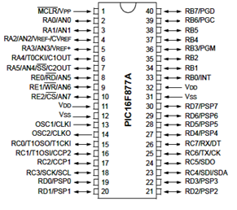
Fig. 1- PIC16F877A Microcontroller Pin layout (Ghayas, et al., 2016)
Design Method
The overall system was divided into various sections, as shown in the block diagram in Figure 2, with each section contributing significant value and distinct functions to the overall system. The sections are power input, RTC and microcontroller operation, and the output section. The power input section serves as the system's input. A step-down transformer and a rectification circuit are included. This section also includes a backup means for the microcontroller, allowing it to retain a set instruction for an extended period of time when there is power outage from the mains.
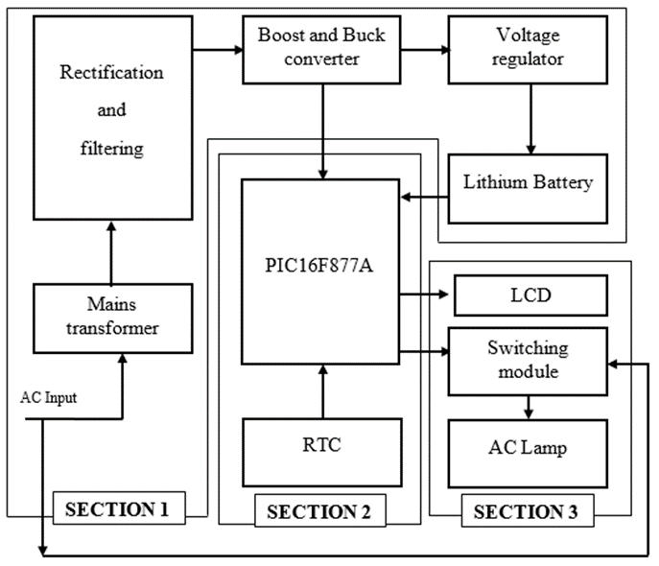
Fig. 2- System block diagram
The LM8050 voltage regulator was selected and the specifications are:
current rating = 1A
input voltage range = 7V – 35V
output voltage range = 4.80 - 5.2V.

From the data sheet of LM8050, the recommended smoothening capacitor is 1000µF but this was confirmed after selecting the transformer. A boost and buck converter that has a voltage rating of 3V – 28V was selected and this was used to power the microcontroller. The selected voltage regulator was used in charging the backup battery.
The step down transformer selection was done using the following calculations. The minimum input voltage of the regulator is 7V. After rectification, voltage drop usually occurs between the four diodes (usually 1.4V for DC and 1.21 for AC).
Using the expression,
V_{rms} = V_{regulator} + V_{drop} (Mohammad, 2017) (i)
V_{rms} = 7 + 1.4 = 8.4V
The result above was approximated to 9V, hence, a stepdown transformer of 220/9V was selected for the design.
The filter capacitor for the design was determined as follows:
Using the equation:
$C=\frac{I}{2xfxV_{pp}}$ (AbdRazak, et al., 2016) (ii)
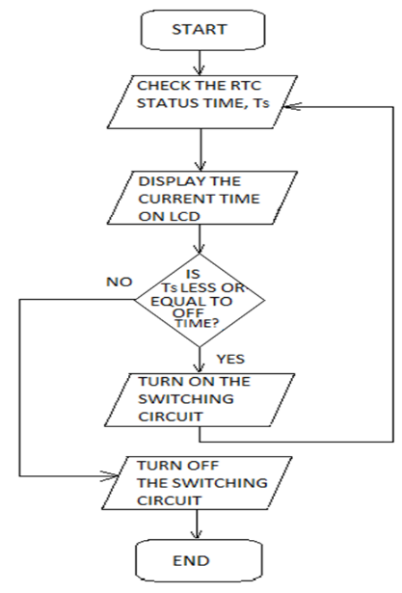
Where, C = capacitance of the capacitor
I = maximum output current
f = period that it takes to charge or discharge the capacitor
V_{pp} = Peak to peak voltage.
The stepdown transformer selected has a maximum current of 300mA.
To get the period T, T = $\frac{1}{f}$.
Where f = operating frequency (when oscillation increases, the operating frequency becomes double). Thus,
f = 2 × 50 = 100Hz
Peak Voltage, V_{p} = V_{rms} × $\sqrt{2}$ (iv)
V_{p} = 8.4 × $\sqrt{2}$ = 11.879V
V_{pp} = Peak voltage x 2
V = 11.879 x 2
= 23.76 V.
Therefore, $C=\frac{I}{2xfxV_{pp}}$
With the transformer having a maximum current capacity of 300 mA,
$C=\frac{300 x {10}^{-3} }{2x100x23.76}$
C = 0.00006313
C = 63.13 µF.
1000µF capacitor was used and this matches with the recommended smoothening capacitor for LM8050.
RTC and Microcontroller Operation
The second section comprises of the instruction input channel to the system through an RTC and the microcontroller that carries out the instructions. The PIC16F877A Microcontroller programmed using MikroC language serves as the heart of the design. The control program follows the flowchart shown in Figure 3. The PIC monitors the time status of the RTC in real time to

Fig. 3- Program flowchart for the microcontroller
determine when to energize the switching circuit to turn on or off the AC lamps. DS1307 Serial RTC shown in Figure 4 was used for setting the ON and OFF time. An oscillator helps the RTC to retain the time setting and the time is set with the help of three resistors which were set to pull-up.
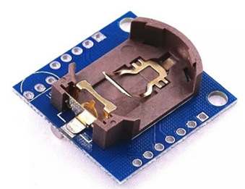
Figure 4: RTC module
For the microcontroller to be able to sense if it is a pull up when the button is pressed, the typical recommended resistor value is 1kΩ -5kΩ but in cases of switches and resistive sensor applications, it is usually 1kΩ -10kΩ resistor.
From Ohm’s law,
V = IR (v)
V_{cc} = Current through R × R
By limiting the current to 1mA when the button is pressed, R = $\frac{5}{0.001}$ = 5k$Ω$.
Therefore, a resistor of 5kΩ can be selected but the available resistor was 10kΩ and since it matches with the recommended value of resistor for pull up, it was chosen.
Output Section
The third section comprises of a transistor, relay, LED light and 20×4 LCD. The relay acts as a link between the controller and the Security Light. Its primary function is to provide isolation. Since the devices to be controlled are AC lamps and the output from the microcontroller is DC, a means to control a large voltage or current with a small electrical signal is needed. Therefore, a relay cannot be left out. The LCD displays the real time and the set time while inputting the command, it also shows the ON and OFF time.
Simulation method
Before implementation, the security light control system circuit was simulated. The simulation was designed with the help of Proteus ISP professional software to test the operation of the components, analyse their performance, and make any necessary changes before proceeding with construction. Figure 5 shows the schematic circuit of the security light control system. The diagram includes the various sections used for the implementation of the design.
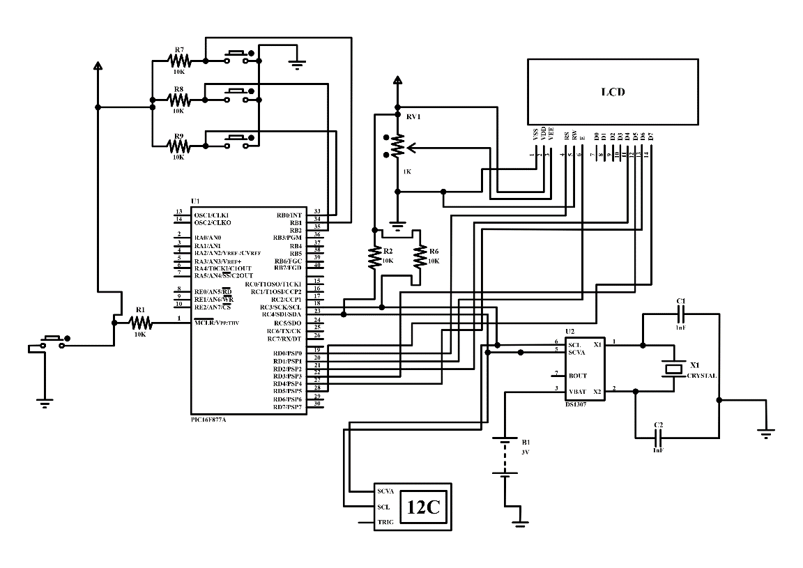
Fig. 5- Schematic Circuit of the Security Light Control System
CONSTRUCTION
The design and construction of Automatic Security Light was achieved by understanding the existing designs based on research work and taking decision on the available materials to select from. Based on the block diagram in Fig. 2 and the schematic diagram in Fig. 4, each section of the design was properly followed in order to solder the selected materials effectively. The circuit was first implemented on the breadboard for workability before final soldering onto Veroboard. After soldering, it was finally installed in a casing as shown in Fig. 6.
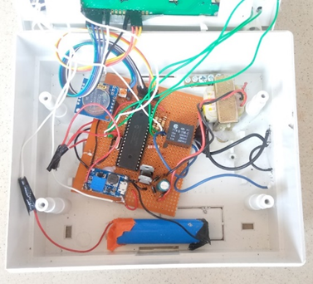
Figure 6: Automatic security light control system setup
RESULTS AND DISCUSSION
The system was left for days without power supply and it kept the real time whether there is power supply from the mains or not. Also, since there is a backup for the system (that is, the lithium battery), the system switched to its ON state before being powered up. With the power button turned OFF and the system connected to the mains, the system became ON which means the power circuit connected with the bridge rectifier and filter circuit was in good state.
Using RTC, an automatic security light control system was designed and tested. The ON time and the OFF time of the system was set to confirm if the system will perform its designed function. When the system reached the set ON time, the LED lamp which was connected to the output turned ON and when it reached the OFF time, it went off. The RTC was basically set to work in 24 hours clock settings. The first test was carried out with 10-minute interval between the real time and the second with 30 minutes difference. The result also ascertained that even if the system is used for a longer time, it will still give the expected results. The real time on the system was 13:00, then the ON time was set to 13:30 and OFF time 14:00; this implies that it was tested with 30 minutes interval. When the ON time was reached, the AC lamp automatically switched ON and switched OFF when the set OFF time was reached.
All the test gave the desired results. Table 1 represents the result after the test and Figure 6 shows the result as captured in pictures.
Table 1- Results
REAL TIME | ON TIME | OFF TIME | COMMENT
11:50 | 12.00 | 12.10 | The lamp switched ON when it was 12:00 and OFF when it was 12:00.
13:00 | 13:30 | 14.00 | The output lamp was in its OFF state until the time reached the set ON time and automatically switched OFF when it reached the set OFF time.

CONCLUSION
An automatic security light control system capable of switching on and off automatically was constructed. It helps to significantly reduce the amount of electricity wasted by conventional security light systems. This system is a highly cost-effective, practical, and secure way to save energy. The system practically allows users to determine when the security light will be ON/OFF automatically.
To maintain the longevity of the automatic security light control system it should be cleaned on a monthly basis because dirt can impose harm on the system. Since the security light provides illumination and also exposes the presence of intruders, a PIR sensor can be incorporated into the system to further save energy. The problem of sudden darkness can also be addressed by incorporating an LDR to the system. The LDR will send signal to the microcontroller in cases of sudden darkness then turns on the security light.
REFERENCES
- AbdRazak, I. S. Hashima, Zarina, R. I., Hashima, R. Z. & Soid, S. N. M. (2016). A Design of Single Phase Bridge Full-wave Rectifier, Conference on Language, Education, Engineering and Technology, 2016, vol. 2.
- Alias, M. N., Mohyar, S.N., Isa, M.N., Harun, A., Jambik, A.B. & Murad, S.A. (2019). Design and analysis of dedicated Real-time Clock for customized microcontroller unit. Indonesian Journal of Electrical Engineering and Computer Science. 14, 796-801.
- Ghayas, S. M., Fazil, A., & Amrish, D. (2016). Automatic Street Light Control System Using Microcontroller. International Journal of Electrical and Electronics Engineers. 8(1), 55-61.
- Hillebrand, F. (2013). The creation of standards for global mobile communication GSM and UMTS standardization from 1982 to 2000. IEEE wireless communication. 20(5), 24-33.
- Kalaiarasan, C., Bhuvaneswari, C., & Rajaswari, R. (2013). Analysis of Solar Energy Based Streetlight with Auto Tracking System, 2(7), 1-7.
- Mohammad, A. A. (2017). Important material for Engineering Students. National University of Sciences and Technology, 1-5. Retrieved from https://www.studocu.com/row/document/national-university-of-sciences-and-technology/engineering-circuit/1623566216428-ena-project/15778523
- Popa, M., & Cepisca, C. (2011). Energy Consumption Saving Solutions Based on Intelligent Street Lighting Control System. 73(4), 297-308.
- Rajput, K.Y., Gargeyee, K., Monica, P., & Priyanka, Y. (2013). Intelligent Street Lighting System using GSM, 2(3), 60-69.
- Saad M., Farij A., Salah, A., & Abdaljalil, A. (2013). Automatic Streetlight control system using microcontroller. International Conference on machine Design and Automation, 92-96.
- Santhi, S., Rajesh, V., Hari, K., & Varun, C. (2019). Automatic Street Lighting System. International Journal of Innovative Technology and Exploring Engineering. 8(7), 2920-2924.
- Wilson, C., Hargreaves, T., & Hauxwell-Balwin, R. (2015). Smart homes and their users. A systematic analysis a key challenge. Personal and Ubiquitous Computing, 19(2), 463-476. DOI: 10.1007/S00779-014-0813-0.
- Xudan, S., Sun, L., & Gong, S. (2010). A new streetlight monitoring system based on wireless sensor networks. The 2nd International Conference Information Science and Engineering, pp. 6394-6397. DOI: 10.1109/ICISE.2010.5691530.
- Yusuf, S.D., Nmezi, S.N., Loko, A.Z., & Lumbi, W.L. (2020). Design and Construction of an Automatic Streetlight Controller using microcontroller and LDR. International Journal of Academic Research and Development. 5(3), 50-56Everett, H.R. (1995). Sensors for Mobile Robots: Theory and Application. A K Peters, Ltd, MA, USA.

