WEATHER MONITORING SYSTEM USING IOT AND CLOUD COMPUTING

Vaibhav Bele
UG Research Scholar Electronics & Telecommunication Department
Wainganganga College of Engineering And Management Nagpur
Vaibhavbele1@gmail.com

Kunal Bohre
UG Research Scholar Electronics & Telecommunication Department
Wainganganga College of Engineering And Management Nagpur
Kbohare028@gmail.com

Bramhadeo Wadibhasme
Assistant Professor Electronics & Telecommunication Department
Wainganganga College of Engineering And Management Nagpur
Bramhadeo12@gmail.com

Abstract –
The weather is a dynamic phenomenon. It may alter in a matter of seconds or milliseconds. In the past, when technology was still in its infancy, monitoring the weather was fairly difficult. But because to modern sensors and processing methods, it is now simple to not only monitor the weather but also anticipate it accurately. IOT (Internet of Things) is used in the project to streamline the detecting procedure. Arduino (Microcontroller), NodeMCU ESP8266 and other weather-monitoring sensors are added to the project as IOT is employed. A web server with an open source is used to host the sensor's data. The open server can be used to retrieve the data needed for the prediction process as well as to obtain real-time data. Additionally, a webpage is created that shows the data and shows it to users.
Keywords- Cloud Computing,, Environmental Monitoring, Internet of Things, Weather Monitoring.
INTRODUCTION
The term "weather reporting system" refers to a monitoring system that relays and displays weather information on a server. The server also serves as a repository for datasets, from which users can download data to feed the machine learning algorithm. Both monitoring and forecasting functions are performed by this system. IOT, or the Internet of Things, is the monitoring technology. This combines sensors, Arduino UNO and the ESP8266 Wi-Fi module from Node MCU. The Node MCU is used as a module to connect to the server and show the output after the sensors' ability to detect climatic changes is provided as data to the Node MCU. It is anticipated that the internet of things will change the world by deploying sensors and devices that can record, process, and send meteorological parameters to monitor and control environmental phenomena.
The term "cloud" refers to the accessibility of computer system resources like data storage and computational power without user direct active supervision. The data that is collected is sent to the cloud so that it can be further presented. The system also includes parts like microcontroller board with digital pins, a USB connector, and everything else needed to support microcontrollers; the DHT11 temperature and humidity sensor, which is used to detect the aforementioned parameters; and other components. The information gathered from the sensors is converted and sent to the web server using a WIFI module. As a result, weather conditions at any area can be checked remotely from anywhere in the world. A website is developed that can access the cloud, display, and arrange the desired outcomes.
METHOLOGY
A setup for reading and displaying data in a server is included in the proposed system, together with a number of sensors, Arduino UNO and Node MCU. The results are also quite exact because the sensors' precision is so great. By connecting Node MCU to the server, the results are shown there. The server is open source and offers a number of ways to present the information either separately in feeds or collectively in dashboards. The server also gives users the choice of downloading the data or immediately importing it into other applications.
1. Data of weather are gathered form the sensors.
2. Sensors send the value to Microcontroller like Arduino UNO and Node MCU 8266 Wi-Fi Module.
3. The next phase in the procedure microcontroller send the data on cloud.
4. Cloud data display to all users, User can see all Weather Report.
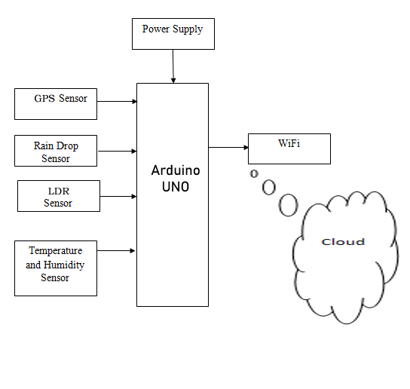
Fig. Block Diagram of Weather Monitoring System
DESIGN

ARDUINO UNO (MICRO-CONTROLLER):
A microcontroller board called Arduino UNO is based on the ATmega328P. It contains 6 analog inputs, a 16 MHz ceramic resonator, 14 digital input/output pins (six of which can be used as PWM outputs), a USB port, a power jack, an ICSP header, and a reset button. It comes with everything needed to support the microcontroller; to get started, just plug in a USB cable, an AC-to-DC adapter, or a battery. You can experiment with your UNO without being overly concerned that you'll make a mistake; in the worst case, you can replace the chip for a few dollars and start over.
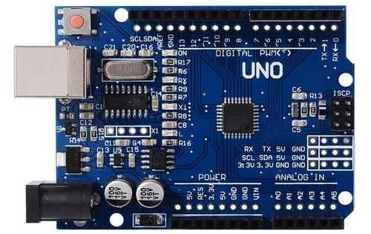

WIFI MODULE:
The Arduino Uno Wi-Fi module that we utilized is built within the Arduino Uno that we used. The board's ATmega328P processor and ESP8266 Wi-Fi module combine with a TCP/IP protocol stack. The microcontroller must utilize a few AT commands in order to connect to the ESP8266 Wi-Fi module and begin communicating.
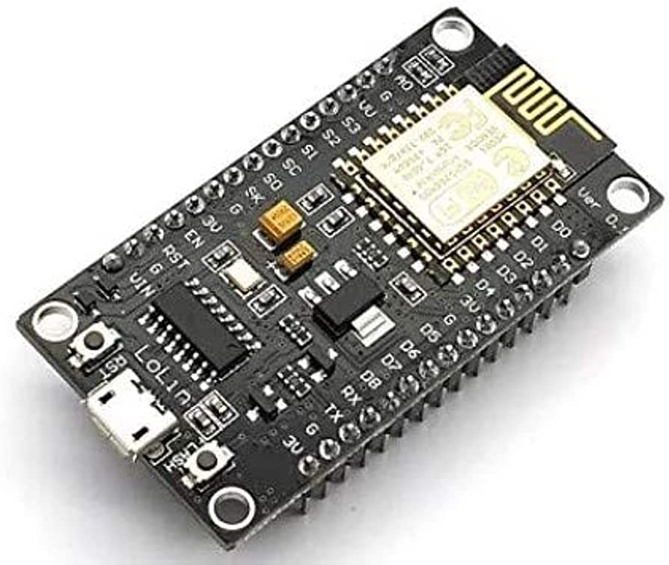
SENSORS:
A barometric pressure sensor (BMP180) and temperature and humidity sensors (DHT 11) make up the system. The key environmental variables including temperature, humidity, and CO levels will be measured by these 2 sensors. Due to the fact that each analog voltage provided by these sensors corresponds to a different weather factor, the microcontroller board will receive the analog voltage as an input and turn it into digital data.
TEMPERATURE AND HUMIDITY SENSOR:
The DHT11 is a sensor that measures temperature and humidity. Temperature and humidity are output as serial data. It can operate between 3.5 and 5.5 volts for temperature readings, it can have an accuracy of 2°C and a 5% accuracy for humidity readings. It has 4 pins and is factory calibrated, making setup quite simple. It is also a cheap sensor. It has a 5% accuracy range for measurements between 20 and 80 percent humidity. It determines the environment's temperature. It has four pins. Between pins 1 and 2, a 10k resistor connection is required. The 3.3V is connected to Pin 1.GND is the connection for Pin 4.Pin 2 is the output pin that feeds data to nodemcu pin D4 next.P3 is not in use.
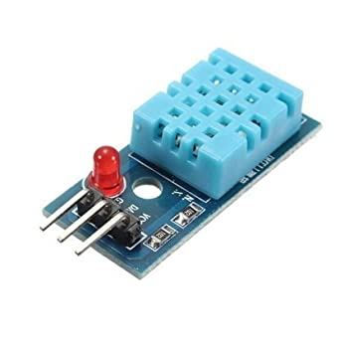

LDR (Light-Dependent Resistor):
An LDR, or light dependent resistor, operates on the theory that it contains a variable resistor that alters its resistance in response to the brightness of the light. It is frequently utilized in various light sensing or light detecting circuits, such as the camera attached to some smartphones that allow the camera to modify its shutter speed in accordance with the brightness of the light. As light intensity rises, it becomes less resistant. High resistance semiconductor is used in its construction.
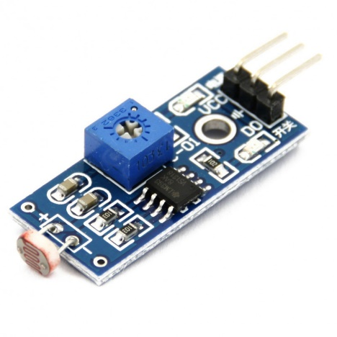
Raindrop Module:
It is utilized to detect rain. It can also be used to gauge the force of a downpour. It features both analog and digital outputs. It also features a control board and a rain board as subassemblies. The sensitivity can be changed with a potentiometer. This module uses an analog output pin to measure the moisture, and when the moisture threshold is exceeded too far, a digital output is sent.5V is the operational voltage. Its key benefits are that it is simple to use and plug in, and it also has excellent accuracy.
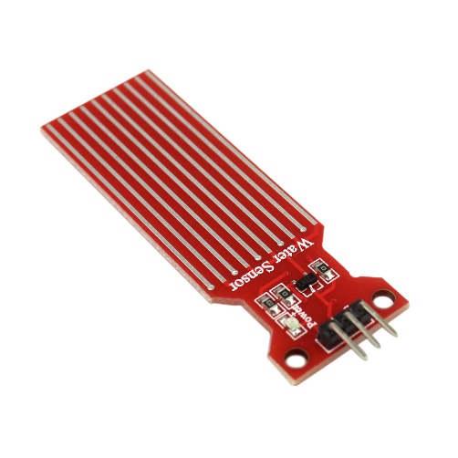

RESULT

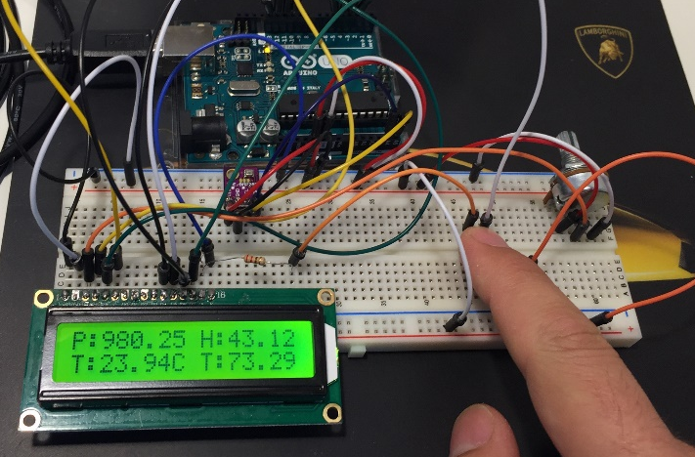
Fig. System Design of Weather Monitoring System

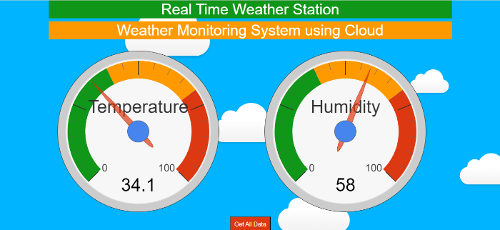
Fig. Website View

CONCLUSION
You may monitor weather conditions in real-time by building a weather monitoring system with NodeMCU. An inexpensive and simple-to-use development board called NodeMCU is ideal for Internet of Things (IoT) projects. You can quickly gather information on temperature, humidity, and atmospheric pressure with a NodeMCU and a few sensors. Then, for analysis and visualization, you can send this data to a web server or a mobile application.
NodeMCU's Wi-Fi connectivity, which enables you to connect to the internet and send data to a cloud-based platform for storage and analysis, is one of the main advantages of utilizing it for a weather monitoring system. In addition, NodeMCU is an open-source platform with a sizable developer community that may offer assistance and direction.
Overall, everyone interested in IoT and weather monitoring should build a weather monitoring system using NodeMCU. It offers a useful and enjoyable approach to learn about sensors, data gathering, and IoT connection.

REFERENCES
Mohit Tiwari, Deepak Narang et al, Weather monitoring system using IOT and cloud computing.,
International journal of advanced science and technology ,June-2020.
[2] Moulana Mohammed, Prediction Of Rainfall Using Machine Learning Techniques , International
Journal of Scientific & Technology Research Volume 9, Issue 01, January 2020.
[3] Girija C, Hashnalathan, et al, IOT based weather monitoring system, International Journal of
engineering research and technology,Apr-2018
[4] Devesh Kumar Srivastava ,IOT Based Weather Reporting System , International Journal of
Engineering and Advanced Technology (IJEAT),Volume-9 Issue-5, June 2020.
[5] Ferdian Joe John Joseph, IOT based weather monitoring system for effective analytics., International
journal of engineering of and advanced technology APRIL-2019
[6] Yashaswi rahut, Smart weather monitoring and real time alert system using IoT, International
Research Journal of Engineering and Technology (IRJET) Volume: 05 Issue: 10 | Oct 2018.
[7 ] Prathap N Kashyap, Intelligent Weather Forecasting using Machine Learning Techniques,
International Research Journal of Engineering and Technology (IRJET )Volume: 07 Issue: 03 | Mar
2020.
[8] Ramya,T.,Dr.Malathi,S.,ratheeksha,G.R. and Dr.V.D.Ambeth Kumar (2014)" Personalized
authentication procedure for restricted web service access in mobile phones", Applications of Digital
Information and Web Technologies (ICADIWT), 2014, Page(s):69 - 74, Bangalore, India (ISBN:978-
1-4799-2258-1)
[9] Ambeth Kumar.V.D (2018). Novel Wireless Sensing System For The Welfare Of Sewer Laborers.
Healthcare Technology Letters (IET) Volume 5, Issue 4, p. 107 –112.
[10] Ambeth Kumar.V.D, G.Saranya , D.Elangovan, V.RahulChiranjeevi, V.D.Ashok Kumar, “IOT Based
Smart Museum Using Wearable Device”, Lecture Notes in Networks and Systems, Vol.55, pp: 33-42,
2018
[11] Ambeth Kumar.V.D and Dr.M.Ramakrishan(2011).Footprint Based Recognition System. in the month
of April for the International Journal Communication in Computer and Information System (CCIS)
Journal (Springer) Volume 147, Part 3, 358-367, DOI: 10.1007/978-3-642-20573-6_63, April 2011.
[12] Ambeth KumarV.D (2017), “Efficient Routing for Low Rate Wireless Network a Novel Approach”,
International Journal of Image Mining, Vol. 2, Nos. 3/4, 2017, 2017
[13] Ambeth Kumar.V.D, V.D.Ashok Kumar, Dr.S.Malathi and P.Jagaeedesh, (2014) .Intruder Identification
using Footprint Recognition with PCA and SVM Classifiers. for the International Journal of Advanced
Materials Research Vols.1345, PP 984-985 (2014) pp 1345-1349.
[DOI:10.4028/www.scientific.net/AMR.984-985.1345]
[14] Ambeth Kumar.V.D, G.Gokul, S.Malathi, K.Vengatesan, D.Elangovan, B.Chitra .Implementation Of
The Pulse Rhythemic Rate For The Efficient Diagonising Of The Heart Beat. Healthcare Technology
Letters (IET) 2019 Apr 17;6(2):48-52.
[15] Ruphitha.S.V et.al. Management of Major Postpartum Haemorrhage by using Zigbee protocol - A
Review . 2021 6th International Conference on Inventive Computation Technologies (ICICT) (DOI:
10.1109/ICICT50816.2021.9358757 )
Mohit Tiwari, Deepak Narang et al, Weather monitoring system using IOT and cloud computing.,
International journal of advanced science and technology ,June-2020.
[2] Moulana Mohammed, Prediction Of Rainfall Using Machine Learning Techniques , International
Journal of Scientific & Technology Research Volume 9, Issue 01, January 2020.
[3] Girija C, Hashnalathan, et al, IOT based weather monitoring system, International Journal of
engineering research and technology,Apr-2018
[4] Devesh Kumar Srivastava ,IOT Based Weather Reporting System , International Journal of
Engineering and Advanced Technology (IJEAT),Volume-9 Issue-5, June 2020.
[5] Ferdian Joe John Joseph, IOT based weather monitoring system for effective analytics., International
journal of engineering of and advanced technology APRIL-2019
[6] Yashaswi rahut, Smart weather monitoring and real time alert system using IoT, International
Research Journal of Engineering and Technology (IRJET) Volume: 05 Issue: 10 | Oct 2018.
[7 ] Prathap N Kashyap, Intelligent Weather Forecasting using Machine Learning Techniques,
International Research Journal of Engineering and Technology (IRJET )Volume: 07 Issue: 03 | Mar
2020.
[8] Ramya,T.,Dr.Malathi,S.,ratheeksha,G.R. and Dr.V.D.Ambeth Kumar (2014)" Personalized
authentication procedure for restricted web service access in mobile phones", Applications of Digital
Information and Web Technologies (ICADIWT), 2014, Page(s):69 - 74, Bangalore, India (ISBN:978-
1-4799-2258-1)
[9] Ambeth Kumar.V.D (2018). Novel Wireless Sensing System For The Welfare Of Sewer Laborers.
Healthcare Technology Letters (IET) Volume 5, Issue 4, p. 107 –112.
[10] Ambeth Kumar.V.D, G.Saranya , D.Elangovan, V.RahulChiranjeevi, V.D.Ashok Kumar, “IOT Based
Smart Museum Using Wearable Device”, Lecture Notes in Networks and Systems, Vol.55, pp: 33-42,
2018
[11] Ambeth Kumar.V.D and Dr.M.Ramakrishan(2011).Footprint Based Recognition System. in the month
of April for the International Journal Communication in Computer and Information System (CCIS)
Journal (Springer) Volume 147, Part 3, 358-367, DOI: 10.1007/978-3-642-20573-6_63, April 2011.
[12] Ambeth KumarV.D (2017), “Efficient Routing for Low Rate Wireless Network a Novel Approach”,
International Journal of Image Mining, Vol. 2, Nos. 3/4, 2017, 2017
[13] Ambeth Kumar.V.D, V.D.Ashok Kumar, Dr.S.Malathi and P.Jagaeedesh, (2014) .Intruder Identification
using Footprint Recognition with PCA and SVM Classifiers. for the International Journal of Advanced
Materials Research Vols.1345, PP 984-985 (2014) pp 1345-1349.
[DOI:10.4028/www.scientific.net/AMR.984-985.1345]
[14] Ambeth Kumar.V.D, G.Gokul, S.Malathi, K.Vengatesan, D.Elangovan, B.Chitra .Implementation Of
The Pulse Rhythemic Rate For The Efficient Diagonising Of The Heart Beat. Healthcare Technology
Letters (IET) 2019 Apr 17;6(2):48-52.
[15] Ruphitha.S.V et.al. Management of Major Postpartum Haemorrhage by using Zigbee protocol - A
Review . 2021 6th International Conference on Inventive Computation Technologies (ICICT) (DOI:
10.1109/ICICT50816.2021.9358757 )
[1] Mohit Tiwari, Deepak Narang et al, Weather monitoring system using IOT and cloud computing., International journal of advanced science and technology ,June-2020.
[2] Moulana Mohammed, Prediction Of Rainfall Using Machine Learning Techniques , International Journal of Scientific & Technology Research Volume 9, Issue 01, January 2020.
[3] Girija C, Hashnalathan, et al, IOT based weather monitoring system, International Journal of engineering research and technology,Apr-2018
[4] Devesh Kumar Srivastava ,IOT Based Weather Reporting System , International Journal of Engineering and Advanced Technology (IJEAT),Volume-9 Issue-5, June 2020.
[5] Ferdian Joe John Joseph, IOT based weather monitoring system for effective analytics., International journal of engineering of and advanced technology APRIL-2019
[6 ] Prathap N Kashyap, Intelligent Weather Forecasting using Machine Learning Techniques, International Research Journal of Engineering and Technology (IRJET )Volume: 07 Issue: 03 | Mar 2020.
[7] Ambeth Kumar.V.D (2018). Novel Wireless Sensing System For The Welfare Of Sewer Laborers. Healthcare Technology Letters (IET) Volume 5, Issue 4, p. 107 –112.
[8] Ambeth Kumar.V.D, G.Saranya , D.Elangovan, V.RahulChiranjeevi, V.D.Ashok Kumar, “IOT Based Smart Museum Using Wearable Device”, Lecture Notes in Networks and Systems, Vol.55, pp: 33-42, 2018
[9] Ambeth Kumar.V.D and Dr.M.Ramakrishan(2011).Footprint Based Recognition System. in the month of April for the International Journal Communication in Computer and Information System (CCIS) Journal (Springer) Volume 147, Part 3, 358-367, DOI: 10.1007/978-3-642-20573-6_63, April 2011.
[10] Ambeth KumarV.D (2017), “Efficient Routing for Low Rate Wireless Network a Novel Approach”, International Journal of Image Mining, Vol. 2, Nos. 3/4, 2017, 201
[11] Ambeth Kumar.V.D, G.Gokul, S.Malathi, K.Vengatesan, D.Elangovan, B.Chitra .Implementation Of The Pulse Rhythemic Rate For The Efficient Diagonising Of The Heart Beat. Healthcare Technology Letters (IET) 2019 Apr 17;6(2):48-52.
[12] Ruphitha.S.V et.al. Management of Major Postpartum Haemorrhage by using Zigbee protocol - A Review . 2021 6th International Conference on Inventive Computation Technologies (ICICT) (DOI: 10.1109/ICICT50816.2021.9358757 )

