Physical Properties of Soybean and Chickpea Seeds for Designing an Efficient Seed Planter

Ankita Shinde¹, S. H. Thakare², D. S. Karale³, Mrudulata Deshmukh⁴, A.K. Kamble⁵

^{1,2,3,4,5} Department of Farm Power and Machinery, Dr. PDKV, Akola, Maharashtra

shindeankita213@gmail.com

Received on: 12 November, 2023 Revised on: 02 December, 2023 Published on: 04 December, 2023

Abstract-- Design and development of seed box and other components of an inclined plate broad bed furrow planter has been done from the physical properties of hundred seeds of soybean and chickpea seeds viz., size (length, width, and thickness), geometric mean diameter, sphericity, thousand seed mass, bulk density, roundness, angle of repose. Popular varieties of soybean and chickpea seeds were used in this study namely AMS-MB-5-18 and AKG-1109 respectively which are suitable for high density planting system. Cell size of the seed metering plate was selected with reference to maximum breadth, width and length of seeds. Sphericity of soybean and chickpea seed ranged from 0.83 ± 0.007 to 0.74 ± 0.012 and thousand seed mass from 106.68± 2.061 to 211.93 ± 3.233 g respectively. Capacity of seed hopper depends on the bulk density of seeds. The bulk density for soybean & chickpea seeds varied from 748 to 779 kg m⁻³ and angle of repose varied from 30.96 to 31.25 degree respectively. To ensure free flow of soybean seeds, slope of the seed hopper was taken as 35⁰ which is higher than the average angle of repose of seeds.
Keywords: Planter, Design, Physical properties, Soybean, Chickpea.
I-INTRODUCTION
Soybean and chickpea are two versatile and nutritionally-rich legumes that have been cultivated and consumed for thousands of years, playing essential roles in various cuisines and agricultural practices around the world. Soybean (Glycine max (L) Merr.) is one of the most widely cultivated crops in the world. The major soybean growing states are Madhya Pradesh, Maharashtra, Rajasthan, Karnataka, and Telangana. Chickpea (Cicer arientimum L.) also known a ‘chana’ or ‘bengal gram’ belongs to leguminous family. To design the hopper, selection of seed metering plate for planting soybean and chickpea, it is necessary to determine the physical properties of seeds as a function of moisture content. The movement of seeds through a planter is dependent on size, shape, sphericity, bulk density and angle of repose of seeds. Therefore attempts were made to find the optimum design parameters of a planter by determining the relevant physical properties of soybean and chickpea seeds for varieties of AMS-MB-5-18 and AKG-1109 respectively. Kibar and Ozturk (2008) studied the physical and mechanical properties of soybean. The physical and mechanical properties of soybean were determined at 8 to 16% moisture content. In this moisture range, grain length, width, thickness, arithmetic average diameter and geometric average diameter increased from 7.24 to 8.19, 6.79 to 7.12, 5.78 to 6.23, 6.60 to 7.18, 6.57 to 7.14 mm, respectively. The sphericity and bulk density decreased linearly from 0.91 to 0.87 and 766.12 to 719.00, kg m⁻³ respectively. The angle of internal friction increased linearly from 27.37 to 31.81 degrees with the increase of moisture content. Pradhan and Verma (2018) studied the physical properties namely, length, width, sphericity, seed weight, angle of repose and bulk density of soybean, pigeonpea and chickpea seeds were evaluated as design parameters for a planter. There was a specific variety was selected and 20 seeds were taken randomly for the study which most popular in Chhattisgarh for measuring the physical property for designing the planter. Bulk density, moisture content and angle of repose which are major affect the drooping of seeds through metering plate. The average length, width, thickness, sphericity and geometric mean diameter were 2.71 mm, 1.65 mm, 0.88 mm, 0.57 and 1.55 mm respectively for soybean while 2.06 mm, 2.96 mm, 4.18 mm, 1.44 and 2.93 mm respectively for pigeonpea and 8.48 mm, 6.45 mm, 6.03 mm, 0.81 and 6.90 mm respectively for chickpea. Maximum angle of repose was 28.03º for chickpea while 28.21º and 26.10 º for soybean and pigeonpea, respectively. Bulk density of soybean, pigeonpea and chickpea were evaluated by mass per unit volume where the averagely 709.53 kg m⁻³ for chickpea which was maximum than the soybean (694.30 kg m⁻³) and pigeon pea (666.64 kg m⁻³) due the heavy weight and large size.

II- MATERIALS AND METHODS
Size is defined as the equivalent diameter of a seed. The size of seeds was determined in terms of length (L), width (W) and thickness (T). To determine the average size of the seed, the three linear dimensions namely, length (L), width (W) and thickness (T) were measured using a vernier caliper having an accuracy of 0.01 mm for randomly selected 100 seeds of each variety (Ozarslan, 2002) as shown in fig. 1. The size and shape of the seeds were useful in deciding the size and shape of orifice of metering mechanism for the selected seeds used for this study.
$$D_{e}{=(L×W×T)}^{\frac{1}{3}}$$
Where,
D_{e} = equivalent diameter
L = length of seed
W = width of seed
T = thickness of seed
For determination of average weight of 1000 seeds, a random sample of thousand seeds was selected and weighed on the electronic weighing balance having sensitivity of 0.01g. The experiment was replicated five times to determine average value of 1000 seeds weight (Mohsenin, 1986). The sphericity of seed (φ) was calculated by using the following relationship (Mohsenin, 1970) from the measured length (L), width (W) and thickness (T) of the seeds.
$$Φ={\frac{(L×W×T)}{L}}^{1/3}$$
As the seeds flow due to gravity, the angle of repose influences the design of inclination of seed hopper. Angle of repose is angle between the base and the slope of the cone formed on a free vertical fall of a granular material to a horizontal plane. Five replications were carried out for each seed variety of soybean and chickpea as shown in fig.2. (Nimkar and Chattopadhyay, 2001)

$θ=\tan^{-1 }( \frac{2h}{D}$)
Where,
$θ$ = angle of repose, degree.
h = height of heap, cm
D = Diameter of base plate, cm
This procedure was replicated thrice and the mean value was recorded for the selected varieties of soybean and chickpea seed separately.
Bulk density influences the design of volume of seed hopper and is affected by the moisture content and degree of packing. The bulk density of selected verities of soybean and chickpea seeds were computed by standard method. A cubical container (100 ml) was filled with seeds and the weights of seeds were measured with 5 replications of soybean and chickpea seed. Bulk density will be calculated as the ratio of weight of seeds in the container to the volume of container expressed as kg/m³ (Varnamkhasti et al., 2008)
$$Bulk density = \frac{M}{V}$$
Where,
M = mass of the seed sample, kg
V = volume of sampler, m³
Roundness of grain seed was calculated by using the formula (Gautam et al. 2016)
Roundness = $\frac{\left[\left(\frac{W}{L}\right)+\left(\frac{T}{L}\right)+\left(\frac{T}{W}\right)\right]}{3}$
Where,
W = Width of grain seed, mm
L= Length of grain seed, mm
T = Thickness of seed, mm

III -RESULT AND DISCUSSION
Length, width, thickness, geometric mean diameter, thousand seed weight, sphericity, bulk density, angle of repose, roundness of soybean and chickpea seeds of varieties AMS-MB-5-18 and AKG-1109 are shown in Table 1.
The average length, width and thickness of soybean and chickpea seeds ranged from 6.72 ± 0.075 to 7.38 ± 0.141m,

5.62 ± 0.054 to 4.86 ± 0.106 mm and 4.56 ± 0.051 to 4.50 ± 0.095 mm as the moisture content increased from 8.15 to 13.45 percent (d. b.) respectively. When the seed metering plate rotates inside the seed hopper, each seed may position itself with respect to length or width. The configuration of the cell should accommodate the seed in any position without causing external injury. From the measured values, the maximum value of length was selected for the selection of seed metering plate for both seed variety.
Movement of spherical seed is usually higher under gravity than non-spherical seeds. Sphericity of soybean and chickpea seeds in natural rest position were 0.83 ± 0.007 and 0.74± 0.012 respectively. Since the lower sphericity value of seeds were taken into consideration for designing the slope of the seed transfer unit (seed tube). The mean angle of repose for soybean and chickpea seeds was 30.96 and 31.25 degrees respectively. To ensure the free flow of seeds in a hopper, the slope of the seed hopper should be higher than the angle of repose of seeds. Hence the slope of the seed hopper was fixed at 35 degrees. Roundness for soybean and chickpea varied from 0.70 to 0.87 and 0.60 to 0.83 respectively.
IV-
CONCLUSION
In this study, the physical properties of soybean and chickpea seeds were analysed to determine their suitability for designing a seed planter hopper, selection of metering plate. Based on the physical properties of the seeds, including size, thousand grain weight, sphericity, bulk density, roundness and angle of repose, the design parameters for the seed planter were determined. In conclusion, the study provided valuable insights into the physical properties of soybean and chickpea seeds, which are crucial for designing an efficient and effective seed planter. The findings will contribute to optimizing the planter's performance and enhancing seed sowing practices, ultimately benefiting agricultural practices and crop production. Thickness and cell diameters of the seed metering plate were selected in reference to the maximum breadth and length of seeds. Both roundness and sphericity affect seed flow through the various components of the planter. Seed weight affects seed flow from seed metering device to the furrow opener, and in turn, influences the design of seed hopper.
ACKNOWLEDGEMENTS
This paper is a part of the PhD thesis of the first author of Dr. Panjabrao Deshmukh Krishi Vidyapeeth, Akola. The facilities provided by the College of Agricultural Engineering, Dr. PDKV, Akola for carrying out this study are acknowledged.
REFERENCES
- Mohsenin, N. N. 1970. Physical Properties of Plant and Animal Materials. New York: Gordon and Breach Science Publishers.
- Mohsenin NN. 1986 . Physical properties of plant and animal materials (2nd edition). Gordon and Breach science Publication, New York, 152-176.
- Nimkar P. M.and P. K. Chattopadhyay, 2001. PH-Postharvest Technology: some physical properties of green gram. J of Agric. Engg. Res, 80(2):183-189.
- Ozarslan, C. 2002. Physical Properties of Cotton Seed. Biosystems Engineering, 83(2), 169–174.
- Kibar H. and T. Öztürk, 2008. Physical and mechanical properties of soybean. Int. Agrophysics, 22, 239-244.
- Varnamkhasti M. G. , H. Mobli, A. Jafari, A.R. Keyhani, M.H. Soltanabadi, S. Rafiee,2008. Some physical properties of rough rice (Oryza Sativa L.) grain. J Cereal Sci., 47(3):496-501.
- Gautam A, Manes GS, Dixit A, Verma A. 2016. Development and Evaluation of Inclined Plate Metering Mechanism for Onion Pelleted Seeds. Vegetos-An Int. J of Plant Res. 29(3):95-99.
- Pradhan P. and A. Verma, 2018. Physical properties of soybean, pigeonpea and chickpea seeds. Bulletin of Environment, Pharmacology and Life Sciences, 7 (8): 01-08.
Appendices
Table 1: Physical Properties of Soybean and Chickpea Seeds at 95 % Confidence Limit
Parameters | Soybean | Chickpea
Length, mm | 6.71 ± 0.075 | 7.55 ± 0.141
Width, mm | 5.61 ± 0.054 | 4.93 ± 0.106
Thickness, mm | 4.56 ± 0.051 | 4.51± 0.095
Geometric mean dia. ,mm | 5.56 ± 0.046 | 5.51± 0.098
Sphericity | 0.83 ± 0.006 | 0.73 ± 0.009
Thousand seed weight, g | 106.68 ± 2.061 | 211.93 ± 3.233
Bulk density, kg/m³ | 748 | 779
Roundness | 0.78 ± 0.006 | 0.72 ± 0.009
Angle of repose, degrees | 30.96 | 31.25

(95% confidence limit = mean ±1.645 SD)
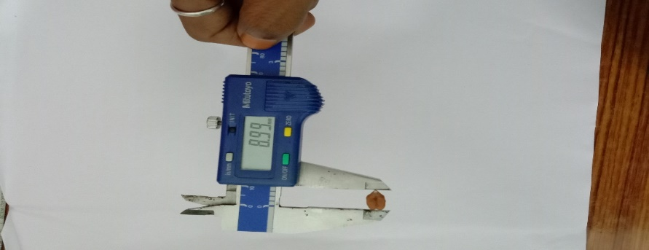
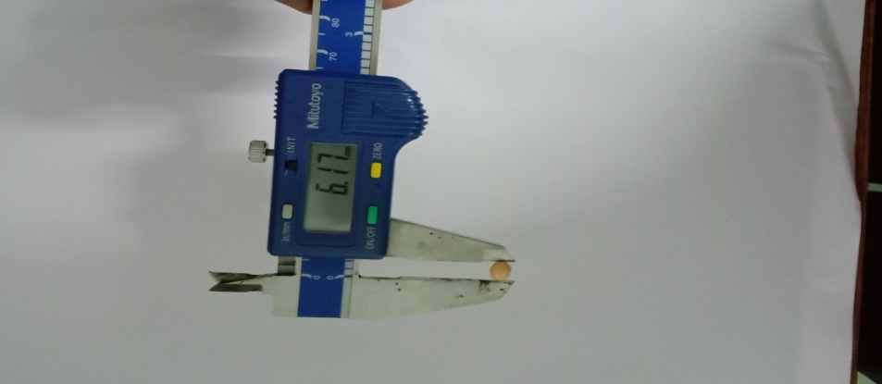
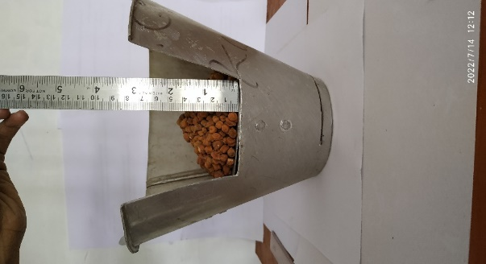
Fig.1. Measurement of size of soybean & chickpea seeds
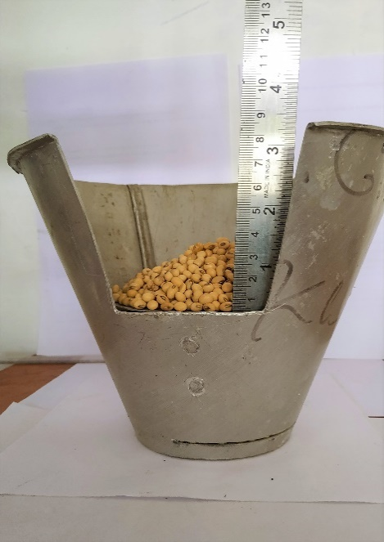
Fig.2 Measurement of angle of repose of soybean and chickpea seed

