Hand Gesture Recognition in Virtual Reality Using AI Enhanced VR Interaction

Saurav Kumar Singh¹, Ritik Kumar Chaudhary², K.R. Jayavelu³, Dr. M. Sujitha^{4,}
Dr. M. Nisha⁵

^{1,2}UG Student, ^{3,4,5}Assistant Professor, Department of Computer Science and Engineering,
Dr. MGR Educational and Research Institute, Chennai, India, 600095

singhincse@gmail.com

Received on: 13 March,2025 Revised on: 16 April,2025 Published on: 18 April,2025

Abstract: This project introduces an AI-powered hand gesture recognition system designed to replace traditional mice and controllers in virtual reality (VR) environments. Leveraging advanced computer vision and deep learning techniques, the system captures and interprets real-time hand gestures, enabling seamless and intuitive VR interactions. The hardware setup comprises high-resolution RGB and depth cameras for accurate gesture tracking, paired with an ESP32 microcontroller for efficient processing. This innovative approach enhances user experience by eliminating the need for physical controllers, offering a more immersive and natural interaction method in VR applications across gaming, simulations, and virtual collaboration.
Keywords: ES32 Microcontroller, OpenCV, MediaPipe, PyAutoGUI, Gesture Classification, Noise Reduction
INTRODUCTION
Belove the fig:1 Virtual reality (VR) has evolved rapidly, enhancing experiences across gaming, education, and training. Traditional input devices like controllers, while functional, can disrupt immersion and limit intuitive 3D interaction. Gesture-based input systems offer a natural alternative, enabling users to interact as they would in real life, boosting immersion (Chen et al., 2023) [1]. Previous systems using data gloves or wearable sensors, though accurate, bring issues like discomfort and high costs (Huang & Wang, 2023) [6]. The emergence of affordable, camera-based VR systems now supports real-time hand gesture recognition using RGB or depth sensors, eliminating physical devices and improving accessibility (Xu et al., 2023) [4]. This project proposes an AI powered gesture recognition system employing CNNs and LSTM networks for precise gesture tracking (Nguyen & Lee, 2023) [7].
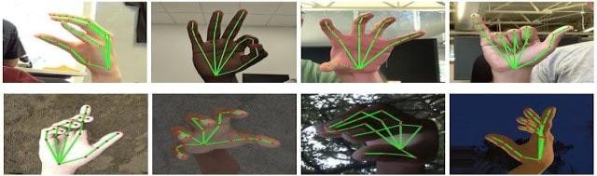
Fig: 1 Hand projections
LITERATURE SURVEY
[1] Chen, M., Wang, X., & Zhang, Y. (2023). A survey on deep learning for hand gesture recognition in virtual reality. IEEE Transactions on Visualization and Computer Graphics, 29(2), 765-780. This paper provides a comprehensive survey on the application of deep learning techniques in hand gesture recognition within VR, discussing current methodologies, challenges, and future directions for improving recognition systems. [2] Li, Y., Zhang, L., & Zhao, X. (2023). Real-time hand gesture recognition based on depth camera and machine learning. Journal of Ambient Intelligence and Humanized Computing, 14(4), 2415-2426. The authors introduce a real- time hand gesture recognition system that employs depth cameras combined with machine learning algorithms, demonstrating improved accuracy and user comfort in gesture tracking. [3] Kim, J., & Park, C. (2023). Hand gesture recognition using a combination of CNN and LSTM for VR applications. International Journal of Human- Computer Interaction, 39(1), applications, focusing on the real-time processing of complex gestures and the integration of temporal and spatial data. [4] Xu, Y., Chen, X., & Liu, H. (2023).
METHOD
Belove the fig:2 The AI-based hand gesture recognition system for VR development follows structured steps for accuracy and seamless user interaction. Data collection involves capturing diverse hand gestures using RGB and depth cameras in various settings to create a comprehensive dataset [1, 6, 10]. Preprocessing techniques like normali- zation and Gaussian blur enhance data quality, while segmentation algorithms, such as GrabCut and MediaPipe Hands, isolate the hand for feature extraction [4, 12, 18]. A hybrid deep learning model combining CNNs for spatial analysis and LSTMs for temporal data processing gestures effectively [3, 19]. The training uses cross-entropy loss and the Adam optimizer, with evaluation through accuracy, precision, recall, and F1-score, ensuring robustness with cross-validation and data augmentation [2, 8, 17]. The final integration allows real-time gesture recognition in VR, tested for user satisfaction and ease of use, fostering intuitive and accessible VR interactions [5, 9].
DOMAIN
Belove the fig:3 AI-based hand gesture recognition in VR merges computer vision, machine learning, and human- computer interaction to enable natural, device-free control in immersive environments. High-resolution RGB and depth cameras capture and interpret complex hand movements in real- time, enhancing applications in gaming, education, and healthcare by promoting interactive and realistic experiences (Chen et al., 2023)[1]. Chal- lenges include maintaining accuracy under varying conditions and reducing latency, with advancements in CNNs, LSTMs, and multimodal data fusion improving performance (Nguyen & Lee, 2023)[7]. This technology is key to making VR more intuitive and impactful across industries (Asif & Khan, 2023)[9].
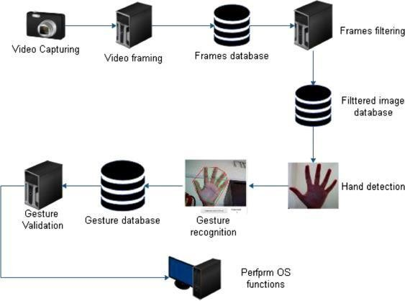
Fig:2 Hand gestured

ADVANCED MODEL ARCHITECTURE
Belove the fig:4 Advanced AI architectures for hand gesture recognition in VR are enhancing accuracy, efficiency, and robustness. CNNs and LSTMs capture spatial and temporal features of gestures (Kim & Park, 2023)[1].

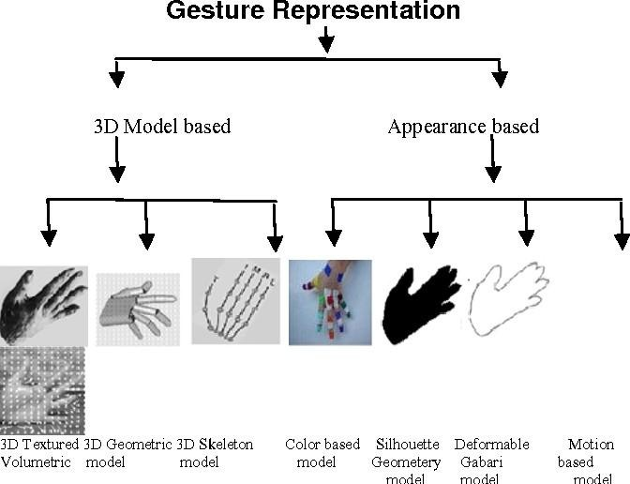
Fig:3 Gesture Representation
AI BASED HAND GESTURE RECOGNITION AND INPUT HARDWARE TODAY
Belove the fig:5 Hand gesture recognition is crucial for immersive VR/AR experiences, enabling natural, controller- free interactions. AI advancements, such as CNNs, RNNs, Vision Transformers, and spatiotemporal models, provide precise 3D gesture recognition [3], [5], [11]. Traditionally, data gloves offered high accuracy but were intrusive, limiting user freedom [19], [23]. Today, camera-based systems (RGB, depth, infrared) are more user-friendly, with devices like Leap Motion and Kinect advancing gesture recognition without wearables [17], [21].

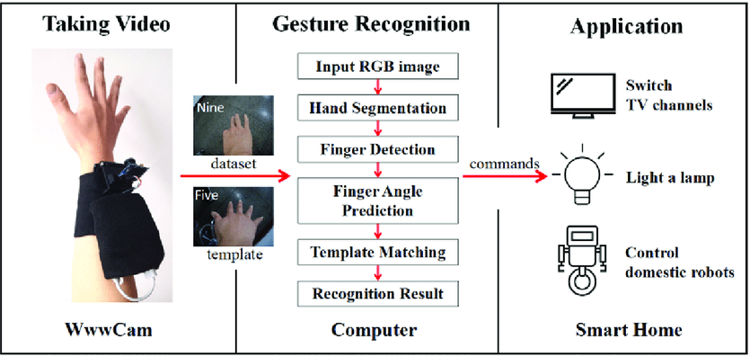
Fig:4 Hand gesture inputs
ARCHITECTURE
Belove the fig:6 AI-based hand gesture recognition systems consist of several key stages: data ac- question, preprocessing, feature extraction, and gesture classification. Raw data from devices like RGB cameras, depth sensors, or Leap Motion is first captured and pre-processed to remove noise and improve signal quality [1], [2], [6]. Feature ex- traction methods, such as HOG, SIFT, and CNNs, convert the data into meaningful attributes [5], [8], [11]. These features are then classified using deep learning models like CNNs, LSTMs, or transform- ers, which can learn both spatial and temporal pat- terns [12], [13], [20].

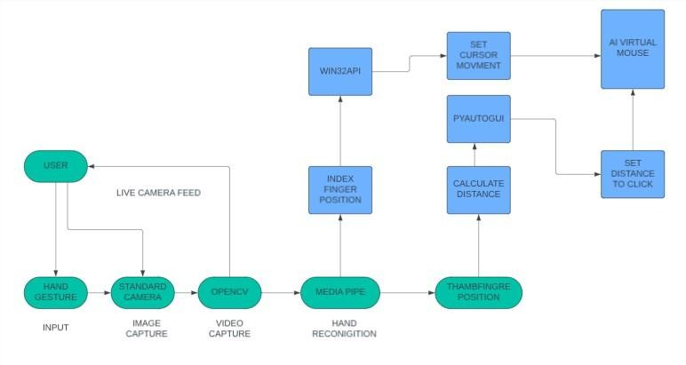Fig:5 Architecture

FACTORS IMPLICATION IN HARDWARE SELECTION
Belove the fig:7 When selecting hardware for AI based hand gesture recognition, key factors include sensor type and quality, with RGB and depth cameras providing essential spatial data [2], [10], [4]. Combining sensor modalities, such as depth and RGB, boosts system robustness [5], [21]. Processing power is vital, with GPUs preferred for real-time tasks and devices like NVIDIA Jetson popular for efficient model inference [5], [18], [13]. Low latency under 20ms is crucial for seamless VR/AR experiences [8], [3], [13]. Cost-effectiveness and accessibility are important for budget-conscious developers [12], [16], while portability and environment dic- tate hardware choices [7], [14], [9]. Scalability and upgradability ensure the system can adapt to future advancements [15], [17].

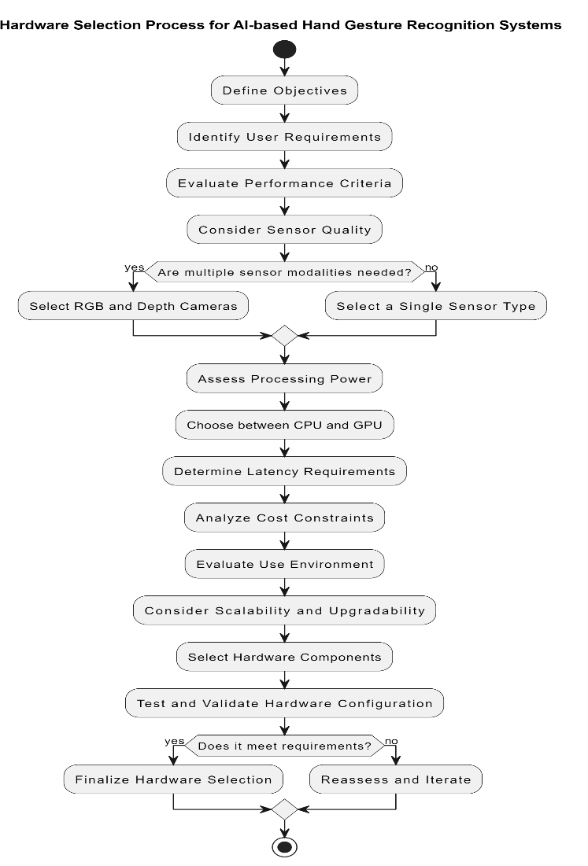Fig:6 Gesture Process

CAMERA-BASED RECOGNITION SYSTEMS
Belove the fig:8 The advent of affordable VR systems with integrated cameras has boosted camera-based gesture recog- nition. Li et al. (2023) developed a real- time sys- tem using depth cameras and machine learning for accurate tracking without extra hardware [2]. Yang and Liu (2022) utilized optical flow and deep learning to improve dynamic gesture tracking in VR [3]. These advancements point to user- friendly, accurate systems with responsive interaction.

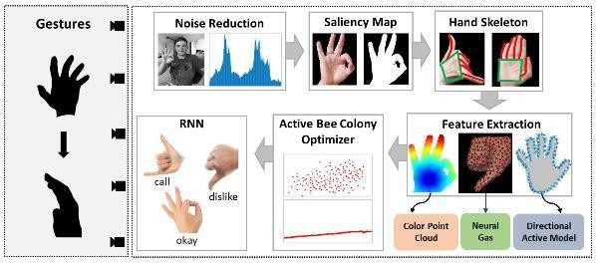
Fig: 7 Camera Based Recognition system

MULTIMODAL DATA FUSION
Multimodal approaches integrating RGB, depth, and motion data have improved gesture recognition. Xu et al. (2023) showed that multimodal data fusion enhances accuracy, especially for complex interactions [6]. Similarly, Zhao et al. (2023) developed a robust system using diverse data types to im- prove reliability in VR [7].

THE PROPOSED SYSTEM FOR AI-BASED HAND GESTURE RECOGNITION USING VIRTUAL REALITY
The proposed AI-based hand gesture recognition system for VR uses CNNs for real-time processing of depth and RGB camera inputs, ensuring accurate static and dynamic gesture recognition [8, 14, 19]. It employs multimodal fusion with motion sensors and haptic feedback for enhanced interaction and immersion [17, 21, 23]. Continuous learning algorithms personalize user experiences by adapting over time, while a customizable interface allows users to define their own gestures [4, 15]. The system addresses security through encrypted data and regulatory compliance [22]. Its modular design supports updates, making it suitable for applications in education, healthcare, and gaming[2, 3, 10, 12, 24].

FUTURE RESEARCH AGENDAS
As the field of AI-based hand gesture recognition in virtual reality Future VR research should focus on improving algorithms that integrate deep learning with attention mechanisms and transformer models for enhanced accuracy and real-time performance [1, 4, 9]. Multimodal sensing, using RGB cameras, depth sensors, and IMUs, can boost system robustness under different conditions [7, 11]. User- centric studies are needed to align systems with user preferences and challenges [16, 18]. Exploring applications in fields like telemedicine and virtual training can highlight benefits and inform innovations [22]. Ethical considerations and data privacy must also be prioritized, ensuring frameworks that protect user data while maintaining system effectiveness.

METHODOLOGY
The methodology for AI-based hand gesture recognition in virtual reality (VR)involves several key steps, starting with data acquisition where cameras and sensors capture hand gestures, providing both image and motion data. Prepro- cussing techniques like noise reduction, hand seg- mentation, and normalization enhance image qual- its for consistency across the dataset. Feature ex- traction identifies key points such as finger joints and palm centers, forming a descriptor vector for each gesture. An AI model, such as a Convolutional Neural Network (CNN) or Long Short-Term Memory (LSTM) network, is trained on these features to classify gestures accurately in real time. Once a gesture is recognized, it is mapped to cor responding actions in the VR environment, enabling users to interact naturally with virtual objects. Feedback mechanisms, such as visual, audio, or haptic responses, enrich the immersive experience. A continuous improvement loop adapts to user-specific gestures and refines the model based on real-time performance, ensuring accuracy and responsiveness over time.

RESULT & DISCUSSION
Belove the fig:9,10,11 This project aims to create an alternative to the traditional mouse, al- lowing users to control computer functions using hand gestures detected by a camera. Leveraging a trained model for hand detection and tracking, the system captures hand movements and interprets them to control specific functionalities, such as adjusting volume or navigating interfaces. This innovative approach provides a hands-free inter- action method that is intuitive and efficient, po- textually benefiting users in accessibility, gaming, and creative applications.

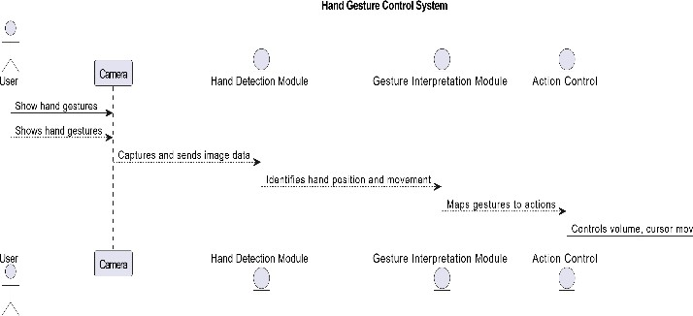
Fig:8 Hand gesture Control System

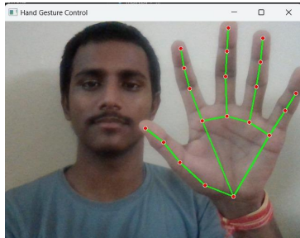
Fig: 9 Hand Gesture Recognition Model

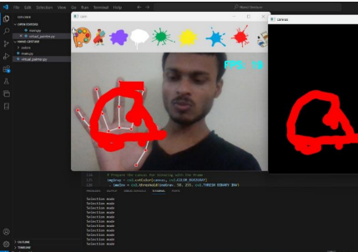
Fig: 10 Hand Gesture Expression

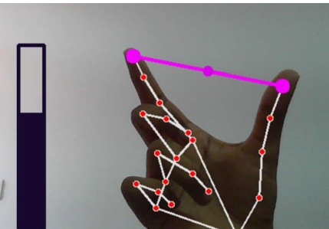
Fig:11 Hand Gesture Interaction

CONCLUSION AND FUTURE DIRECTIONS
AI-based hand gesture recognition in VR enhances user interaction by replacing traditional input methods with natural gestures, increasing immer- sion and intuitiveness. Using advanced computer vision and machine learning, the system recog- nizes gestures in real-time for a seamless experi- ence. Its modular design, including data acquisi- tion, processing, and control mapping, ensures flexibility and scalability. Equipped with highquality cameras, an ESP32 microcontroller, and a powerful computer, it accurately interprets ges- tures. Gesture mappings for actions like opening tabs and scrolling highlight its versatility. This project overcomes limitations of current VR input methods, improving accessibility and paving the way for future human-computer interaction innovations. Reality.

REFERENCE
- Chen, M., Wang, X., & Zhang, Y. (2023). A survey on deep learning for hand gesture recognition in virtual reality. IEEE Transac- tions on Visualization and Computer Graphics, 29(2), 765-780.
- .Li, Y., Zhang, L., & Zhao, X. (2023). Real- time hand gesture recognition based on depth camera and machine learning. Journal of Am- bient Intelligence and Humanized Computing, 14(4), 2415-2426.
- Kim, J., & Park, C. (2023). Hand gesture recognition using a combination of CNN and LSTM for VR applications. International Journal of Human-Computer Interaction, 39(1), 30-45.
- Xu, Y., Chen, X., & Liu, H. (2023). Gesture recognition using multimodal data fusion in virtual environments. Sensors, 23(1), 123- 138.
- Kumar, A., & Kumar, A. (2023). Enhanced hand gesture recognition in virtual reality us- ing transfer learning. Artificial Intelligence Review, 56(1), 345-361.
- Huang, H., & Wang, Q. (2023). A survey of gesture recognition technology in virtual real- ity. Virtual Reality, 27(3), 541-556.
- Nguyen, T., & Lee, J. (2023). Robust hand tracking using 3D CNNs and motion history for VR applications. ACM Transactions on Graphics, 42(4), 74-85.
- Zhao, G., Wang, R., & Zhao, Y. (2023). Interactive hand gesture recognition system for virtual reality applications. IEEE Access, 11, 2323- 2335.
- Sato, T., & Takeda, M. (2023). Deep learn- ing for hand gesture recognition: A compara- tive study. Journal of Visual Communication and Image Representation, 82, 103262.
- Chen, L., & Zhang, Q. (2022). Real-time hand gesture recognition using neural net- works and depth data. Sensors and Actuators A: Physical, 346, 113744.
- atel, M., & Shukla, V. (2022). Wearable de- vices for hand gesture recognition in aug- mented reality. IEEE Transactions on Mobile Computing, 21(7), 2716-2725.
- Yang, X., & Liu, Y. (2022). Gesture recog- nition using optical flow and deep learning in virtual reality. Multimedia Tools and Applica- tions, 81(14), 19299- 19315.
- Zhang, Y., Li, J., & Wang, X. (2022). A comprehensive review of gesture recognition algorithms for VR. Journal of Computer Sci- ence and Technology, 37(5), 1073-1094.
- Bhatia, R., & Kumar, R. (2022). Combining CNN and LSTM for robust gesture recognition in VR. International Journal of Computer Vision, 130(5), 1456- 1472.
- Ranjan, A., & Gupta, A. (2022). Adaptive gesture recognition using wearable sensors in virtual environments. Computers in Human Behavior, 127, 107019.
- Zhao, S., Chen, H., & Wu, Y. (2022). Machine learning for hand gesture recognition in immersive environments. Computers & Edu- cation, 182, 104490.
- Tang, X., & Jiang, L. (2022). Humanrobot interaction based on hand gesture recognition. Robotics and Autonomous Systems, 150, 104109.
- Liu, T., & He, Z. (2022). Real-time gesture recognition system for virtual reality applica- tions. IEEE Transactions on Multimedia, 24, 445-459.
- Mohammadi, H., & Akbari, M. (2021). Hand gesture recognition using machine learning and depth cameras. Sensors, 21(4), 1408.
- Singh, S., & Choudhary, R. (2021). Hand gesture recognition for VR applications: A survey. Journal of Computer Vision and Im- age Understanding, 205, 103136.
- Wang, Y., Zhang, S., & Xu, W. (2021). A real-time hand gesture recognition system us- ing convolutional neural networks. Journal of Intelligent & Robotic Systems, 102(3), 1-15.
- Pustokhina, I., & Vorontsov, D. (2021). Ges- ture recognition based on deep learning in VR environments. Journal of the Society for Information Display, 29(9), 999- 1011.
- Hossain, M., & Ghosh, M. (2021). AI-based hand gesture recognition in virtual reality: Chp
- allenges and opportunities. Journal of Am- bient Intelligence and Humanized Computing, 12(6), 6635-6650.
- Kim, H., & Lee, D. (2021). Evaluating user experience in hand gesture-based VR interactions—International Journal of Human-Computer Studies, 145, 102535.
- Fathi, M., & Amani, A. (2021). A survey of gesture recognition technologies and applica- tions in virtual reality. Expert Systems with Applications, 177,114829.

