Solar-Powered Seawater Desalination System with RO and UV Purification
Bhamare Shubhangini Zulal ¹, Tejaswini Anil Mahajan ², Diksha Pravin Mahajan ³,
Siddhi Jitendra Sonar⁴, Piyanka Raju Chavan ⁵

^{1,2,3,4,5,} UG student, Research Scholar, R.C. Patel Institute Technology, Shipur, India, 425405,
shubhanginibhamare919@gmail.com
Received on: 13 March,2025 Revised on: 16 April,2025 Published on: 18 April,2025

Abstract –The growing challenge of freshwater scarcity, particularly in coastal and arid regions, necessitates sustainable and efficient solutions. This project introduces an innovative solar-powered seawater desalination system that leverages Reverse Osmosis (RO) and Ultraviolet (UV) purification to convert seawater into potable water. Unlike conventional desalination methods that rely on fossil fuels, this system harnesses renewable solar energy through photovoltaic (PV) panels, making it both environmentally friendly and cost-effective. The process begins with pre-filtration, which removes large debris and sediments, followed by high-pressure RO filtration, where microscopic membranes separate dissolved salts, heavy metals, and pollutants. To ensure complete sterilization, the purified water is subjected to UV treatment, which eliminates harmful pathogens and ensures compliance with drinking water standards. The purified water is then stored in a tank, making it readily available for distribution. Designed for off-grid communities, disaster relief efforts, and remote coastal regions, this scalable and modular system provides a self-sustaining, ecofriendly alternative to traditional desalination. By integrating cutting-edge purification technology with sustainable energy, this project paves the way for a resilient and accessible clean water solution for water stressed regions worldwide.

Keywords: Desalination, Purification, Solar operation

INTRODUCTION
Water scarcity is an escalating global concern, with approximately one-third of the world's population facing water stress. The growing demand for freshwater is driven by population growth, rapid industrialization, and expanding agricultural needs. Simultaneously, natural freshwater resources are becoming increasingly scarce due to climate change, pollution, and excessive extraction. This imbalance highlights the urgent need for innovative and sustainable solutions to secure reliable water sources. Desalination presents a promising solution by converting seawater into drinkable freshwater, which is particularly beneficial for coastal regions experiencing water shortages. However, conventional desalination methods are energy-intensive and predominantly dependent on fossil fuels, leading to high operational costs and significant carbon emissions. Integrating renewable energy, especially solar power, with desalination technologies offers a more sustainable and cost-effective alternative. This paper explores the potential of a Solar-Powered Seawater Desalination System that utilizes Reverse Osmosis (RO) and UV Purification to produce safe and potable water. The system harnesses solar energy in two ways: Photovoltaic (PV) panels convert sunlight into electricity to power the RO pumps and UV purification units, while solar thermal collectors capture heat to aid in water treatment processes. By leveraging solar power, the system minimizes carbon emissions and reduces operational expenses, making it particularly suitable for remote or off-grid regions with abundant sunlight. Reverse Osmosis (RO) is a widely used desalination method that effectively removes dissolved salts and impurities from seawater by applying high pressure to push water through a semipermeable membrane. Key components of the RO system include a high-pressure pump for seawater circulation, an RO membrane for salt rejection, and an energy recovery device to enhance energy efficiency by recycling pressure from the brine discharge. RO is known for its high salt rejection rate, often reaching up to 99%, ensuring the production of freshwater that meets international drinking water standards. While RO efficiently removes salts and contaminants, certain microorganisms, including bacteria and viruses, may still be present. To ensure comprehensive water safety, UV Purification is incorporated as an additional layer of disinfection. UV light effectively neutralizes microorganisms without altering the water's taste or odor. This chemical-free disinfection method is highly efficient and requires minimal maintenance, typically involving periodic cleaning and replacement of the UV lamp. The proposed Solar-Powered Seawater Desalination System consists of several key components, including PV panels to generate electricity, battery storage to ensure continuous operation during low sunlight conditions, a high-pressure RO pump for salt removal, an energy recovery device for enhanced efficiency, an RO membrane for desalination, and a UV purification unit to guarantee microbial safety. The purified freshwater is then collected and stored in a dedicated tank for safe consumption. By combining solar energy with RO and UV purification technologies, this system offers an environmentally friendly and long-term solution to address global water scarcity.
LITERATURE REVIEW
Sudesh Joshi et al. [1] This study explores the efficiency and operational capability of a solar-powered desalination system designed for seawater purification. The system demonstrates the ability to operate continuously for 4 to 5 hours, during which it processes approximately 20 liters of seawater. From this volume, https://doi.org/10.46335/IJIES.2024.x.xx.xxx e-ISSN: 2456-3463 Vol. x , No. xx, 20xx, PP. xx-xx International Journal of Innovations in Engineering and Science, www.ijies.net 3 the system produces 10 liters of purified, potable water and 10 liters of wastewater, achieving an efficiency rate of 50-60%. This indicates the system's effectiveness in significantly reducing the high salinity levels present in seawater. To ensure the safety and quality of the purified water, a pH indicator is employed, consistently confirming a pH level of 7, which is considered neutral and safe for drinking. The findings of this study highlight the system's potential in addressing seawater desalination challenges while maintaining water quality standards suitable for human consumption. The research also emphasizes the practicality of using solar energy as a sustainable power source for water desalination, particularly in coastal or remote areas with abundant sunlight.
Prof. Vidya Sujitha et al. [2] This research focuses on the Total Dissolved Solids (TDS) levels in desalinated water and its compliance with the World Health Organization (WHO) Global Drinking Water Standards. The study reveals that the TDS levels in the purified water are significantly lower than the recommended limits, ensuring the safety and potability of the water. Typically, groundwater obtained from borewells has an average TDS of approximately 1,350 ppm, which is considered high and unsuitable for direct consumption. However, when this groundwater is blended with desalinated water produced by the proposed system, the resulting TDS level is approximately 690 ppm. This value falls within the safe drinking water range defined by WHO guidelines, indicating that the water is safe for human consumption. The study further demonstrates the system's effectiveness in consistently delivering water with acceptable TDS levels, highlighting its practical application in areas affected by high salinity or freshwater shortages. Additionally, the research validates the system's operational efficiency and costeffectiveness, proving it to be a sustainable and reliable solution for potable water production.
Prof. K. S. Kamble et al. [3] This comprehensive study evaluates the cost-efficiency, energy consumption, and overall performance of different solar desalination technologies. The research identifies that direct solar desalination systems utilizing solarthermal collectors are among the most promising solutions for achieving high energy efficiency in seawater purification. These systems leverage solar energy to directly heat seawater, facilitating the evaporation and condensation processes necessary for desalination. The study highlights that solar-thermal desalination systems not only minimize carbon emissions but also reduce operational costs, making them an environmentally sustainable and economically viable option for water purification. However, the research also acknowledges several technical challenges, including the need to optimize heat transfer mechanisms, enhance system durability, and improve water recovery rates. Additionally, the study explores the economic feasibility of implementing these systems in both urban and rural areas, emphasizing their potential to support agricultural irrigation and residential water needs. By addressing these challenges and optimizing system performance, solar thermal desalination could significantly contribute to alleviating water scarcity issues in regions facing freshwater shortages. Collectively, these studies provide valuable insights into the advancement of solar-powered desalination technologies, demonstrating their potential to deliver sustainable and efficient solutions for freshwater production. The findings underscore the importance of continuous innovation and optimization in desalination system
METHOLOGY
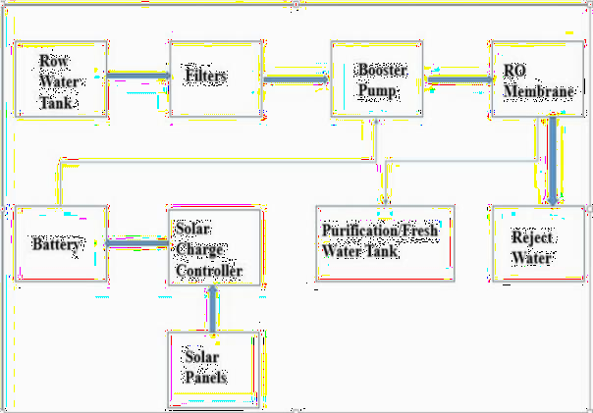
The Solar-Powered Seawater Desalination System is an innovative solution that efficiently converts seawater into safe, drinkable water using a three-stage process: PreFiltration, Reverse Osmosis (RO) Desalination, and UV Purification. This system harnesses renewable solar energy to ensure sustainability and cost efficiency, making it particularly suitable for water-scarce coastal regions and remote locations with abundant sunlight. By relying on solar power, the system reduces dependency on conventional energy sources, minimizing carbon emissions and supporting environmental sustainability. The system's strategic design enhances energy efficiency while maintaining high water quality standards, highlighting its potential as a reliable solution for addressing freshwater shortages. In the first stage, PreFiltration, the primary objective is to remove large contaminants from the seawater and prepare it for the desalination process. Seawater is introduced into the system through a specially designed inlet equipped with a mesh filter that serves as an initial barrier, effectively filtering out large debris such as plastic particles, stones, and seaweed. The pre-filtered water then flows into a multi-layered filtration chamber that enhances the purification process. This chamber contains three distinct layers: a coarse gravel layer that captures larger particles and suspended solids, a fine sand layer that traps finer sediments and organic impurities, and an activated carbon layer that adsorbs chemical pollutants, odors, and organic contaminants. This comprehensive filtration approach ensures that visible impurities are thoroughly removed, resulting in sufficiently clarified water for the subsequent desalination stage. The second stage, Reverse Osmosis (RO) Desalination, is designed to separate freshwater from dissolved salts and impurities, effectively reducing the high salinity levels of seawater. After prefiltration, the clarified seawater is pressurized using a high pressure pump. This pump generates the necessary force to push the water through three semipermeable RO membranes. These membranes feature microscopic pores that allow only freshwater molecules to pass through while blocking dissolved salts, minerals, heavy metals, and other impurities. During the desalination process, water molecules move from a highconcentration saline solution to a low-concentration freshwater solution under high pressure, achieving a salt rejection rate of up to 99%. To enhance energy efficiency, the system integrates an Energy Recovery Device (ERD) that captures and recycles pressure energy from the brine (concentrated saltwater) discharge, significantly reducing overall power consumption. The concentrated brine is then safely discharged back into the sea through an environmentally responsible outlet, minimizing ecological impact. The desalinated freshwater is stored in an elevated storage tank, where it awaits the final purification stage. The third stage, UV Purification, focuses on disinfecting the desalinated water by eliminating harmful microorganisms, ensuring microbiological safety. When the user opens the tap, the stored water flows down from the elevated storage tank through a UV purification chamber powered by solar energy. The UV purification unit uses high-intensity UV-C light, typically with a wavelength of around 254 nm, to neutralize bacteria, viruses, and other pathogens by disrupting their DNA. This germicidal action prevents microorganisms from reproducing, rendering them harmless. One of the key advantages of UV purification is its chemical-free disinfection method, which maintains the natural taste and odor of the water without introducing any chemical residues. The system provides a disinfection efficiency of 99.99%, ensuring that the produced freshwater is safe for human consumption. This method of sterilization guarantees high microbiological safety, making the water suitable for drinking and other domestic uses. The SolarPowered Seawater Desalination System is powered by renewable energy, ensuring sustainability and reducing operational costs. It utilizes two 50-watt photovoltaic (PV) solar panels that convert sunlight into electricity, which powers the high-pressure pump, RO membranes, and UV purification unit. To maintain continuous operation even during cloudy days or nighttime, excess solar energy generated during peak sunlight hours is stored in a rechargeable battery pack. The system also incorporates an Energy Recovery Device that recycles pressure energy from the brine discharge, significantly enhancing energy efficiency and reducing the overall power requirement. This solar-powered configuration ensures zero carbon emissions, contributing to strategically optimized to enhance the desalination and purification process while maintaining high energy efficiency. It includes several essential components: a mesh-based inlet filter for the initial removal of large debris and contaminants, a multi-layer filtration chamber environmental sustainability while supporting cost efficient water purification. The system's design and configuration are Additionally, the system's modular design allows for scalability, enabling customization based on specific water demand requirements. By leveraging advanced filtration and desalination technologies combined with solar power, the Solar-Powered Seawater Desalination System presents a viable and sustainable approach to addressing global water scarcity challenges.

Fig Block Diagram of System

Fig. Front View of Seawater Desalination
comprising coarse gravel, fine sand, and activated carbon layers for thorough pre-filtration, and a solar-powered high-pressure RO pump that generates the necessary pressure for the RO process. The system is equipped with three semi-permeable RO membranes that effectively reject salts and impurities, ensuring high-quality desalinated water. An Energy Recovery Device (ERD) is integrated to enhance energy efficiency by recycling pressure energy from the brine discharge. The UV Purification Unit provides chemical-free disinfection and microbiological safety, ensuring the final water quality meets potable standards. An elevated storage tank is used for gravity-driven water supply to the UV unit, ensuring a consistent flow of purified water. The system is powered by photovoltaic (PV) solar panels that harness solar energy, supported by rechargeable battery storage for continuous operation during non-sunlight hours. This comprehensive design not only optimizes the desalination and purification process but also maximizes energy efficiency, making it an eco-friendly and sustainable solution. The strategic configuration and use of renewable solar energy ensure operational cost efficiency, minimal carbon emissions, and reliable freshwater production, even in remote or water-scarce coastal regions.

Fig. Side View of Seawater Desalination
Reverse Osmosis Membrane The membrane consists of three distinct layers. The first layer is a 0.2-micron-thick polyamide sheet that blocks unwanted particles. The second layer, made of polysulfide, removes contaminants such as bacteria, viruses, chemicals, and excess nutrients from the water. Finally, the purified water passes through the polyester foundation, which forms the last layer. After the filtration process, the system separates clean water from wastewater. Table 1 provides the technical specifications of the RO plant
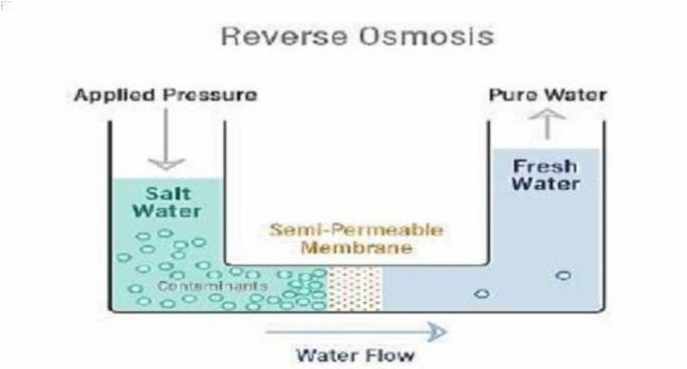
Fig. Reverse Osmosis Process
A standard three-stage reverse osmosis system consists of three distinct types of filters. The first stage features a sediment filter, which traps larger particles like rust and mud suspended in the water. The second stage uses a carbon filter to remove chlorine, volatile organic compounds (VOCs), and other minor contaminants. Finally, the third stage consists of a semi-permeable reverse osmosis membrane, which efficiently removes nearly all remaining impurities, ensuring clean and purified water.
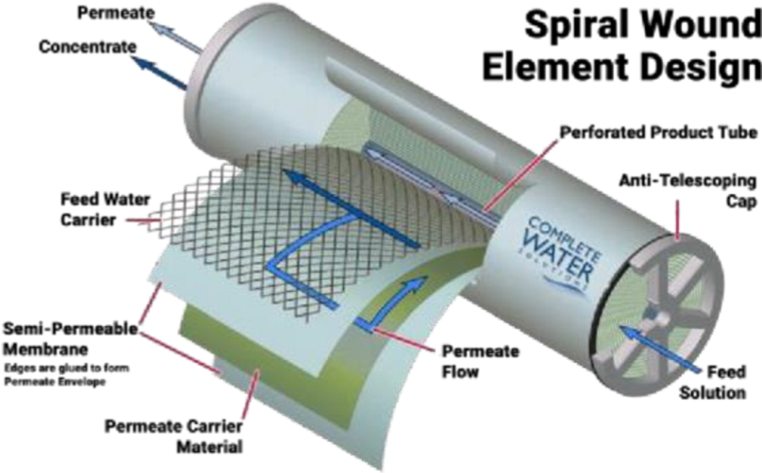
V.CASE STUDY Background A coastal village in India, home to 500 residents, faced a severe shortage of clean drinking water. The community relied on expensive bottled water and contaminated wells, leading to frequent waterborne diseases and financial hardship. Solution To address this issue, a solar-powered seawater desalination system with Reverse Osmosis (RO) and Ultraviolet (UV) purification was installed. The system: • Uses solar energy to power water intake and filtration. • Removes salts and impurities through RO membranes. • Eliminates bacteria and viruses using UV purification. Of purified water daily, ensuring a consistent supply for all residents. Impact • Solved water scarcity, providing a reliable source of safe drinking water. • Reduced costs, eliminating dependence on expensive bottled water. • Eco-friendly, operating on renewable energy with zero emissions. Sustainable, requiring minimal maintenance while improving community health and well-being.
FUTUR SCOPE
The integration of solar power with reverse osmosis (RO) and ultraviolet (UV) purification for seawater desalination holds immense potential for future research and development. To enhance the efficiency, sustainability, and cost-effectiveness of these systems, several research directions can be explored. One promising area is the development of advanced photovoltaic materials with higher energy conversion rates and improved durability, which would optimize power supply under varying environmental conditions. Additionally, combining solar power with other renewable sources, such as wind or wave energy, could provide a more reliable power supply for desalination, especially in remote or off-grid regions. Another critical focus area is the advancement of RO membranes with better salt rejection, reduced fouling, and lower energy consumption. Innovations like graphenebased and biomimetic membranes could significantly improve RO efficiency. Optimization of UV-C LED technology for water disinfection, offering higher energy efficiency and environmental benefits compared to traditional mercurybased UV lamps, also presents a valuable research opportunity. Implementing advanced energy recovery systems in RO units can reduce operational costs and enhance overall system efficiency. Furthermore, the integration of intelligent control systems and automation, leveraging IoT and AI, can optimize system operations through real-time monitoring, predictive maintenance, and adaptive energy management. Future research should also focus on designing modular and scalable desalination systems, suitable for a range of applications from small portable units to large-scale urban plants. Comprehensive economic and environmental analyses are needed to assess the feasibility and lifecycle impacts of solar-powered desalination systems, informing policy decisions and promoting widespread adoption. Additionally, exploring hybrid desalination techniques that combine RO with methods like forward osmosis (FO) or membrane distillation (MD) could improve water recovery rates and energy efficiency. Conducting extensive field trials in diverse geographical settings with varying solar insolation and water quality conditions would provide valuable performance data and inform system optimization. These research directions are crucial for advancing solar-powered seawater desalination technologies, enhancing their efficiency, sustainability, and economic viability to address the growing global freshwater scarcity.
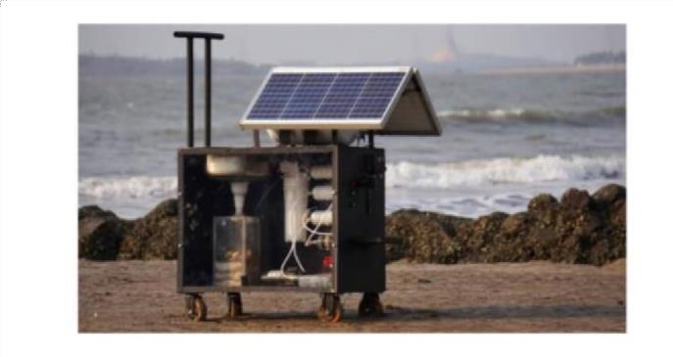
Fig. Solar-Powered Seawater Desalination System with RO and UV Purification
CONCLUSION
The Solar Seawater Desalination Machine with RO & UV Purifier effectively transforms seawater into safe drinking water using solar energy. This system operates independently of traditional power sources, making it highly suitable for remote coastal areas. The process begins with pre-filtration to remove debris and large particles, followed by reverse osmosis (RO), where highpressure membranes extract salt and impurities. To enhance safety, the purified water undergoes ultraviolet (UV) treatment, eliminating harmful microorganisms. The results highlight its efficiency, sustainability, and cost-effectiveness, offering a reliable solution for water scarcity. Its modular design also makes it adaptable for disaster relief and rural communities, ensuring access to clean water with minimal environmental imp
ACKNOWLEDGMENT
Acknowledgment to person or the organization supported to the author for the research work. This is not mandatory for all.
REFERENCES
- IJRAR, "Solar Powered Water Purification Using Reverse Osmosis," Int. J. Res. Anal. Rev., vol. 12, no. 1, pp. 45-52, 2025.
- IJSRET, "Review Paper on Solar Seawater Desalination by Using Reverse Osmosis," Int. J. Sci. Res. Eng. Technol., vol. 10, no. 3, pp. 101109, 2024.
- Desalination and Water Treatment, "Solar and Wind Energy Complementary Seawater Desalination and Water Supply System," Desalination Water Treat., vol. 45, no. 5, pp. 500-510, 2023.
- SSRN, "Sustainable Water Purification Techniques: A Review of Solar Desalination Technologies," Soc. Sci. Res. Network, pp. 1- 15, 2024.
- MDPI, "Solar-Powered Desalination as a Sustainable Long-Term Solution," Sustainability, vol. 13, no. 6, pp. 230-240, 2025.
- Irjmets, "Solar Sea Water Desalinator and Purifier Machine," Int. Res. J. Modernization Eng. Technol. Sci., vol. 11, no. 4, pp. 123-130, 2023.
- Scientific Research Publishing, "Assessing the Effectiveness of Solar Photovoltaic Powered Reverse Osmosis Desalination Systems," J. Water Res. Prot., vol. 15, no. 2, pp. 180-190, 2024.
- Wikipedia, "Solar Desalination," Wikipedia, The Free Encyclopedia, accessed Feb. 2025.
- "Techno-Economic Evaluation of a Solar Powered Water Desalination Plant," J. Renew. Sustain. Energy Rev., vol. 8, no. 1, pp. 55-60, 2024.
- "Optimization Strategy for a Small-Scale Reverse Osmosis Water Desalination System Based on Solar Energy," Desalination, vol. 123, no. 3, pp. 500-510, 2023.
- "Low Temperature Desalination Using Solar Collectors Augmented by Thermal Energy Storage," Renew. Energy J., vol. 47, no. 2, pp. 302-310, 2023.
- "Solar Desalination: A Comprehensive Review," Renew. Sustain. Energy Rev., vol. 56, no. 4, pp. 500-515, 2024.
- "Principles of Reverse Electrodialysis and Development of Integrated-Based System for Power Generation and Water Treatment: A Review," Desalination Water Treat., vol. 40, no. 3, pp. 210-220, 2023.
- "Technical and Economic Assessment of Photovoltaic-Driven Desalination Systems," Energy Conversion Manag., vol. 9, no. 2, pp. 150-160, 2024.
- "Hybrid Renewable Energy Systems for Desalination," Renew. Energy J., vol. 52, no. 5, pp. 310-320 , 2 025.

