IoT Based Energy Meter and Theft Detection

¹Mamata N. Bonde, ²Roshni K.Patil, ³Utkarsh T. Mahajan, Shafiq Ansari⁴ , Hemraj V. Dhande⁵
^{1,2,3} B.E. Students, 4, Asstt. Prof..
^{1,2,3,4,5} E&TC Engg dept., GF’s Godavari CoE,, Jalgaon-425003, Maharashtra, India.
umahajan386@gmail.com ³

Abstract- In this paper, we propose a new system to update energy consumption of electricity on cloud by wi-fi module these system design using existing energy meter. In the present billing system the distribution companies are unable to keep track of the changing maximum demand of consumers. The consumer is facing problems like receiving due bills for bills that have already been paid as well as poor reliability of electricity supply and quality even if bills are paid regularly. The remedy for all these problems is to keep track of the consumers load on timely basis, which will held to assure accurate billing, track maximum demand and to detect threshold value. These are all the features to be taken into account for designing an efficient energy billing system in EB.

Keywords – Automatic Meter Reading (AMR), Electricity Board (EB), Wi-Fi, Liquid crystal display (LCD)
- INTRODUCTION
The electricity also contains some issues like power theft. Power theft is a measure crime and it also directly affects the economy of our country. Transmission, generation and distribution of electricity include the loss of electricity. To avoid the losses we need to monitor the power consumption and losses, so that we can efficiently utilize the generated power. Meter tempering is part of power theft and also illegal crime which we can minimize. Billing is a process in general the human operator goes to every consumer’s home then providing bill it will take lot of time. To resolve these issues we developed system on the base of IOT energy meter reading.
In this paper we offered new system to update energy consumption of electricity on cloud by using Wi-Fi module. Now a day theft of electricity is increased and easily energy meter hacked by using remote control and magnet due to digitization of electronic energy meter can be easily. This theft prevention is design and implements this project.
In these project we used existing energy meter to get reading to upload to cloud using aurdino uno via Wi-Fi module for examine the consumption of energy day by day and also show on display and prevent to reduce excess use of electricity. And also prevent theft of electricity and also inform to MSEB and cut electricity connection due to theft. Then show massage on display “ contact to MSEB”.
- LITERATURE SURVEY
In India, bill is issued only once in a month or two months. So the consumers will be in dark during this period of time about their energy usage. In this era of complete digitalization, no one will take the pain to go and check their electricity meter reading and compare it with the previous reading so as to get an idea about their consumption.
According to the maximum demand, the consumer will purchase a cash-card of amount depending on the consumption of energy and after the full consumption, the consumer again has to purchase another cash-card or recharge the same and thus the hassle related to go to the billing office, to stand in a long queue and to submit the bill, can be avoided. Also this system helps to eliminate the draw backs of billing management system, such as to take the reading from the meter, to create the bill, to print the bill, to send the bill to the proper address and to collect the amount for the bill .[1]
The Internet of Things (IoT) might have the capacity to consolidate transparently and flawlessly an expansive number of various and heterogeneous end frameworks, while giving open access to chose subsets of information for the improvement of a plenty of computerized administrations. Building a general design for the IoT is consequently an exceptionally complex undertaking, for the most part due to the to a great degree extensive assortment of devices, interface layer advances, and administrations that might be engaged with such a most advanced communication technologies to help involve esteem administrations for the organization of the city and for the natives. Subsequently gave exhaustive study of the empowering advancements, conventions, and engineering for an urban IoT [2][6].
2.1 PROBLEM STATEMENT
In these project we design the concept of stop theft electric energy and show consumption of energy on display as well as cloud using Internet of Things ( IoT). But due to implementation the system to connect electronic energy meter to aurdino uno and also does not compatible to upload data to cloud using Wi-Fi module ,Theft detection and prevention also not detected due to system run on existing energy meter.
2.2 PROPOSED SYSTEM
To overcome these problem to connect electronic energy meter to aurdino uno system we used optocoupler to prevent our system damage by excess power and we used relay module to connect load and connect to system and for overcome theft detection implementation problem use current sensor and used input from calibration LED on energy meter then we successfully upload energy consumption data and detect theft also on existing energy meter used by customer
- METHODOLOGY
3.1 SYSTEM HARDWARE
The main objective of the project is to develop an IOT (internet of things) based energy meter reading displayed for units consumed and cost thereupon over the internet in chart and gauge format.
For this innovative work we had taken a digital energy meter whose blinking LED signal is interfaced to a microcontroller through an Optocoupler (4N35). The blinking LED flashes 3200 times for 1 unit.But for demonstration one blink of LED for 1 unit.
The rate of this flashing is proportional to the amount of power passing through the meter, and so useful information is there to be collected.
This type of meter will always be labelled in this way with a certain number of Imp/kWh. Imp/kWh is short for Impressions per kWh (unit) of electricity which passes through the meter where one ‘impression’ is a brief flash of an LED.
The optocoupler gives reading each time the meter LED flashes to the programmed microcontroller. The microcontroller takes this reading and sends it to cloud using ESP 8266. ESP 8266 is a Wi-Fi module, which provides internet facility for microcontroller. Here Arduino is used as a microcontroller. ESP 8266 transmits the data serially to the ThingSpeak web page for display that can be viewed from anywhere in the world in multi level graphical format.[3]
The consumed power reading is displayed on ThingSpeak website along with cost to be paid for consumption in graphical and gauge format respectively.
The ACS712-05B can measure current up to ±5A and provides output sensitivity of 185mV/A (at +5V power supply), which means for every 1A increase in the current through the conduction terminals in positive direction, the output voltage also rises by 185 mV. The sensitivities of 20A and 30A versions are 100 mV/A and 66 mV/A, respectively. At zero current, the output voltage is half of the supply voltage (Vcc/2).
The ACS712 with an analog-to-digital converter. The precision of any A/D conversion depends upon the stability of the reference voltage used in the ADC operation. In most microcontroller circuits, the reference voltage for A/D conversion is the supply voltage itself.
The curve below shows the nominal sensitivity and transfer characteristics of the ACS712-05B sensor powered with a 5.0V supply. The drift in the output is minimum for a varying consuming energy , which is attributed to an innovative chopper stabilization technique implemented on the chip for theft detection.
When the current is switched off, the contacts open again, switching the circuit off. A useful property of relays is that the circuit powering the coil is completely separate from the circuit switched on by the relay. For this reason relays are used where a safe low-voltage circuit controls a high-voltage circuit.

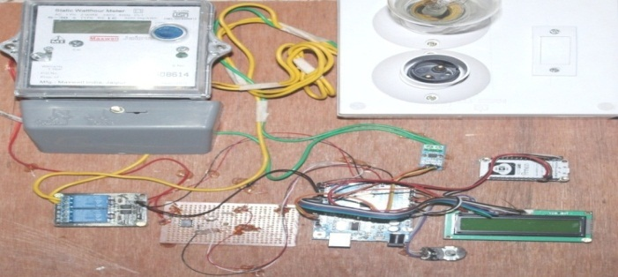
Fig 1 - Implementation of board
  - SYSTEM SOFTWARE
IoT is the main method of communication between the energy meter and web server. The sensor collects data from load and energy meter. This is then sent to Arduino through UART communication. The controller then performs logically and automatically operation using MQTT protocol. This data is then stored on the cloud such that we can monitor the data any time. This stored data displayed on the web page where the user and utility can monitor the data and perform the action they desire. Then the data is updated with the real time status of the connected devices. This updated data is send to the controller to takes the appropriate action.

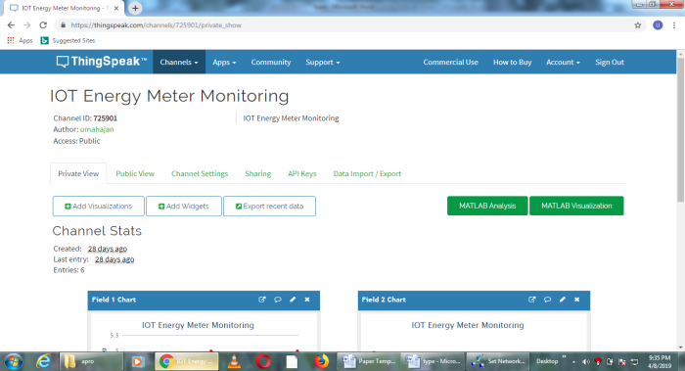

Fig 2 - Online Data Visualization On Thingspeak

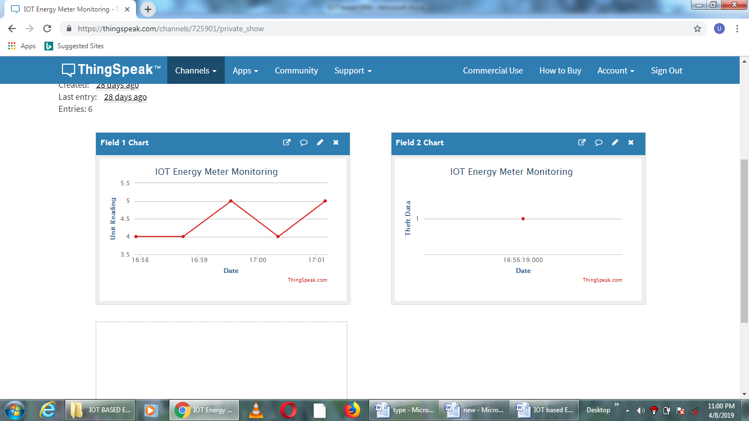
Fig 3 - Online Data Visualization of unit reading On Thingspeak
Fig 4 - Online Data Visualization of theft data On Thingspeak
- FUTURE SCOPE
Energy crisis is one of the major problems that the world faces today. The best remedy for this is not the increase in energy production, but the effective use of available energy. By properly monitoring our energy consumption and avoiding energy wastage, energy crisis can be reduced to a certain extent. But energy monitoring cannot be done efficiently mainly because consumers are not aware of their energy consumption. They will get an idea about their consumption only when the electricity bills are issued. This whole procedure has to be repeated several times in a month to efficiently control the energy usage. If consumers can check their energy consumption using their mobile phone or laptop instead of checking energy meter, it will be a great leap in the area of energy management. Since most of the people are today 24*7 online, it will be really a boon if they can monitor their energy consumption online from anywhere on the globe. In this paper, we are describing a method of electricity energy meter reading using IoT concept
- CONCLUSION
We are doing automatic reading and also connection and disconnection of meters using WIFI module. Then meter reading has come faster. It is publically available for the customers as well as for the KPTCL. Both the peoples will be using the information as per their requirements and they will be having freedom to check the bill, tampering, when the meter has been connected and disconnected before the due date. All the information will be displayed by using smart app. Finally concluding our project that we are successfully monitored the tampering i.e. seal tampering and we have read the meter bills which also be uploaded on the website using IOT concept. Overall the new things we are worked with in our project are ARM controller coupled with Arduino controller and the IOT model.
The IOT based Energy meter for calculating cost and displayed in LCD has been achieved using MPLAB and PIC 16F877A. The power cost is send through serial communication to the Virtual terminal constructed in PROTEUS.
An attempt has been made to make a practical model of‘IoT Based Smart Energy Meter used to calculate the energy consumption of thehousehold, and even make the energy unit reading to be handy.
Hence it reduces the wastage of energy and bring awareness among all. Even it will deduct the manual intervention.
REFERENCES
[1] Giri Prasad. S1, Akesh .R2, BalaPravin .C3, Gokila Devi .S4, Gowri DeviD5 Iot Based Energy Meter And Theft Prevention.International Journal of Recent Trends in Engineering & Research (IJRTER)Conference on Electronics, Information and Communication Systems (CELICS’17)Special Issue; March - 2017 [ISSN: 2455-1457]
[2] “IoT Based Energy Metering And Theft Detection” Srujana Uddanti, Christeena Joseph,P.C.Kishoreraja “Saveetha School of Engineering, Saveetha University Chennai, India” Volume 117 No. 9 2017, 47-51, ISSN: 1311-8080 (printed version); ISSN: 1314-3395 (on-line version) url: http://www.ijpam.eu
[3] “Iot Based Energy Meter Reading” Pooja D Talwar, Prof. S B Kulkarni , pg Student, Department Of Vlsi Design And Embedded Systems, K.L.E. Dr.M.S.Sheshgiri College Of Engineering And Technology, Belagavi, rnataka,India.
[4] Darshan Iyer N and Dr. K A Radhakroshna Rao, IoT Based Energy Meter Reading, Theft Detection and Disconnection using PLC modem and Power Optimization, Proc of IJAREEIE, Vol 4, Issue 7, July 2015
[5] G. L. Prashanti and K .V.Prasad, Wireless power meter monitoring with power theft detection and intimation system using GSM and Zigbee networks, Proc of IOSR-JECE, Vol 9, Issue 6, Ves.I (Nov-Dec, 2014), PP 04-08.
[6] Thingspeak (www.Thingspeak.co.in)

[7] Internet of things (http://en.wikipedia.org/wiki/Internet-of-Things)

