Effect of Mechanical Vibration on Zinc Sulphate Nanopowder Based Fluidized Bed
Khwaja Izhar Ahmad¹, A. M. Langde²
¹Research Scholar, Anjuman College of Engineering and Technology, Nagpur, India,440001
²Professor, Anjuman College of Engineering and Technology, Nagpur, India,440001

kiahmad@anjumanengg.edu.in
Received on: 10 June, 2024 Revised on: 23 July, 2024 Published on: 25 July,2024

Abstract – The fluidization of zinc sulphate nano powder was discussed in this section. The zinc sulphate nano powder material column of 10cm was prepared in the tower of 80cm height. The mechanical vibrational system was attached at the bottom end of the tower while bottom end is also used for the aeriation purpose. In this paper effect of different mechanical vibration on fluidization of bed were discussed
Keywords- Fluidization, Fluidized Bed, Vibration, minimum fluidization velocity.
INTRODUCTION
Fluidization of granular material is the process of converting static solid like state to dynamic fluid like state. A fluidized bed technology generally uses small size particles for better heat transfer rate. Fluidized beds have variety of applications in manufacturing and process industries. Because of effectiveness of fluidized bed, their applications are increases day by day. In recent years, researchers suggested many techniques to improve the fluidization. This article review developments and advancements done in fluidized bed technology using different techniques. Extensive review is done on the basis of performance characteristics of fluidized bed and external assisted mediums to enhance output from fluidized bed.
The advantage of using fluidization technique is to access large amount of fluidizing medium which is normally air. It allows good combustion of bed particles even with low grade quality fuel in a fluidized bed boiler. The fluidized beds are widely used in a variety of industries where heat transfer properties of the fluidized system become important for successful operation [1]. Fluidized beds having advantages such as high heat transfer coefficient between bed and immersed surface or wall, uniform bed temperature with low bed pressure drop. Geldart [7] was the first who suggested the classification of particulate solids according to density and size of particles and this classification divides particulate solids into four groups. Group A, B C and D. Group A particles have good fluidization characteristics with small mean size and low particle density Group B particles have good bubbling characteristics at minimum fluidization velocity. Group C powders are considered as cohesive and hard to fluidize due to intermolecular forces. Small particle sizes between 40-1000 μm have strong movement. Comparing gas convection with particle convection, particle convection is the main mechanism of heat transfer. When the particle size is larger than 800 μm, the gas convection plays an important role, due to low particle movement and high interstitial gas velocity. Group D particles are large or very dense particles which show stable spouted bed. In 1995, Experimental results was presented by Pidwerbecki and Welty[8] on horizontal tube bubbling fluidized bed which helps to know the effect of particle size on the heat transfer in flash zone of high temperature region. Investigation was done on the basis of specific operating parameters like, particle size, bed temperature and the tube locations. Convective and blackbody radiative heat transfer coefficient variations were presented as functions of the non dimensionalized velocity ratio and of the particle size. Results show that largest convective heat transfer coefficients were found in the dense phase of the fluidized bed.
Sunderesan and nigel [9] carried out an experimentation to know the local heat transfer coefficient on the circumference of the fluidized bed tube. Results show variation in heat transfer coefficient at different angular positions along the circumference of the tube. It occurs because of because the contact characteristics of the emulsion phase with the tube wall are not the same at all angular positions along the tube. It was seen that, by increasing gas superficial velocity, bubble frequency increases due to greater availability of excess free gas to rise through the bed as bubbles. High gas velocity resulted high heat transfer rate. Numerical simulation analysis on optical He-Ne laser was done by Yamada et al. [10] which find heat exchange characteristics between heated surface and fluidized bed. A theoretical model was proposed to find the thermal boundary layer near the heated surface. The radiative heat exchange between a fluidized bed and a heated surface was investigated via an optical experiment employing a He-Ne laser and numerical simulation analysis. Also, proposed a theory which predicts the radiative heat transfer by considering the thermal boundary layer near the heated surface. Experiments were performed at various fluidization velocities and static bed heights. Good correlation was obtained which shows qualitative dependence of fluidized pattern and particle diameter. Another paper of same authors [11] on characterization amongst fluidizing partials and remotely heated heat transfer surface by means of radiation. Thermal imager was used to find the time-averaged radiation energy emitted from the heated fluidizing particles. This study concluded that, by using fluidizing particles of large diameter and operating the fluidizing bed under high fluidizing velocities, reduces the radiation energy toward the heat transfer surface which effectively enhance the net radiative heat exchange of fluidized bed.
The heat transfer augmentation of particles which was in contact with heat transferring surface inside the fluidized bed was studied by Miyamoto et al. [12]. The instantaneous local heat transfer coefficient and particle packing around the tube were simultaneously measured at the same locations. The measured results were analyzed by the conditional averaging method, distinguishing between particle contact and no particle contact. The average local heat transfer coefficient in the periods during particle contact was closely correlated by exponential function of average local particle packing. Similar study was carried out by Hamidipour et al. [13]. Effect of contact time of particles at walls of gas fluidized beds was studied by using a radioactive particle tracking technique. The solids used were sand or FCC particles, fluidized by air at room temperature and atmospheric pressure at various superficial velocities, covering both bubbling and turbulent regimes of fluidization. Based on the analysis of tracer positions, the motion of individual particles near the walls of the fluidized bed was studied. It was found that in a bed of sand particles, the mean wall contact time of the fluidized bed of sand particles decreases by increasing the gas velocity in the bubbling and increases in the turbulent fluidization.
The effect of gas velocity on local and average heat transfer coefficient between a submerged horizontal tube and a fluidized bed was determined by Busoul et al. [14]. The relationship between the bubble or emulsion properties and the heat transfer coefficients was determined from the simultaneous measurements using a heat transfer tube with an optical probe. It was found that the bubble frequency increases with the increase in gas superficial velocity due to greater availability of excess gas free to rise through the bed as bubbles. Yao et al. [15] Investigated Fluidization characteristics of six kinds of SiO2 powders having particle sizes from 7 to 16 nm. These powders were fairly similar in primary particle sizes and bulk densities. They all are homogeneously fluidized as agglomerates but their bed developments are quantitatively dissimilar at certain gas velocities. From the results in Figure 3, particles with surface modification shows much higher bed expansions as compared with those which are not modified. Also, the structure, size, apparent weight and the interactive forces between agglomerates considerably influence the hydrodynamic behavior of agglomerating fluidization. Similar analysis was done by Zhu et al. [16] in which sound frequencies were added in fluidization tube and obtain better fluidization at minimum fluidization velocity. Liang [17] performed experimentation of agglomerating fluidization behavior in vibro-fluidized bed for different binary mixtures of SiO2/TiO2, SiO2/ZnO and TiO2/ZnO nanoparticles. It was observed from Fig. 4 that there is a reduction in agglomerates size of binary mixture of nanoparticles by increasing intensity of vibrations.
RESULTS AND DISCUSSIONS
Minimum Fluidization Velocity
During the experimentation, the mechanical vibration is assisted for the fluidization purpose. The 10cm bed of Zinc Sulphate nano material is used for the testing of fluidization. The air with varying velocity is passing through the bed. The mechanical vibration system is attached at the bottom of the fluidization column. The vibration has given the fluidized column. The minimum fluidization velocity was studied for the different intensity of sound. The below figure 1 shows the effect of different intensity on mechanical vibration. The figure 1 shows, the testing was conducted at a frequency of 15Hz, 25Hz and 35Hz. The minimum fluidization velocity also tested at different mechanical vibrational frequency. The varying intensity was tested under four different vibrations. From the graph it has been observed that, for all the vibrational frequency, the minimum fluidization velocity obtained for the 25Hz frequency i.e 0.42cm/sec.
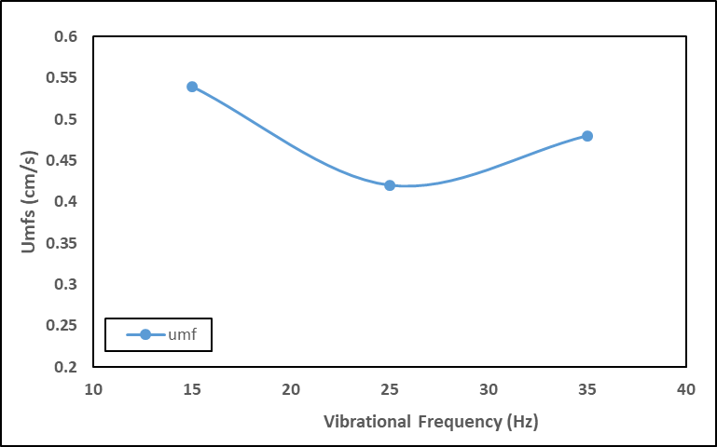
Fig. 1 Effect of Mechanical Vibration on Minimum Fluidization Velocity
Fractional Reduction
The fractional reduction was studied for the different mechanical vibrational frequency. The below figure 2 shows the effect of different intensity on fractional reduction. The figure 2 shows, the testing was conducted at a frequency of 15Hz, 25Hz and 35Hz. The fractional reduction also tested at different mechanical vibration. The varying intensity was tested under three different mechanical vibration frequency. From the graph it has been observed that, for all the mechanical vibration frequency, the maximum fractional reduction obtained for the 25Hz frequency is 0.506.
Bed Expansion
The bed expansion was studied for the different mechanical vibrational frequency. The below figure 3 shows the effect of different mechanical vibrational frequency on bed expansion. The figure 3 shows, the testing was conducted at a mechanical vibrational frequency of 15Hz, 25Hz and 35Hz. The bed expansion also tested at different mechanical vibrational frequency. The varying intensity was tested under three different mechanical vibrational frequencies. From the graph it has been observed that, for all the mechanical vibrational frequency, the maximum bed expansion obtained for the 25Hz frequency is 17.7.
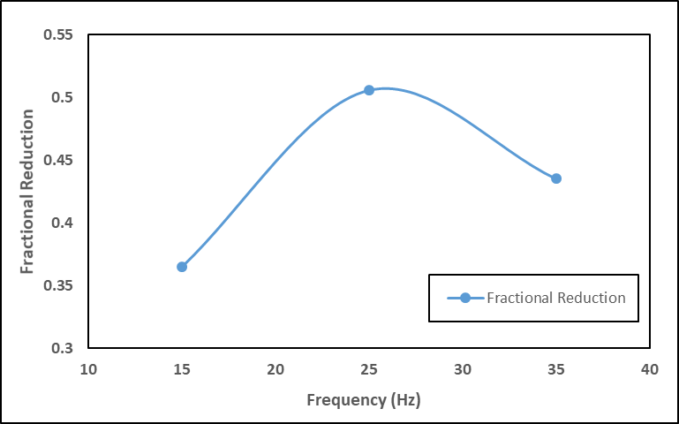
Fig. 2 Effect of Mechanical Vibration on Fractional Reduction
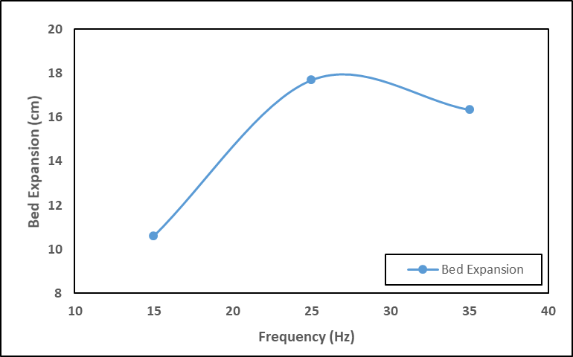
Fig. 3 Effect of Mechanical Vibration on Bed Expansion (H) (cm)
Bed Expansion Ratio
The bed expansion ratio was studied for the different mechanical vibrational frequency. The below figure 4 shows the effect of different mechanical vibrational frequency on bed expansion ratio. The figure 4 shows, the testing was conducted at a mechanical vibrational frequency of 15Hz, 25Hz and 35Hz. The bed expansion ratio also tested at different mechanical vibrational frequency. The varying intensity was tested under three different mechanical vibrational frequencies. From the graph it has been observed that, for all the mechanical vibrational frequency, the maximum bed expansion ratio obtained for the 25Hz frequency is 1.77.
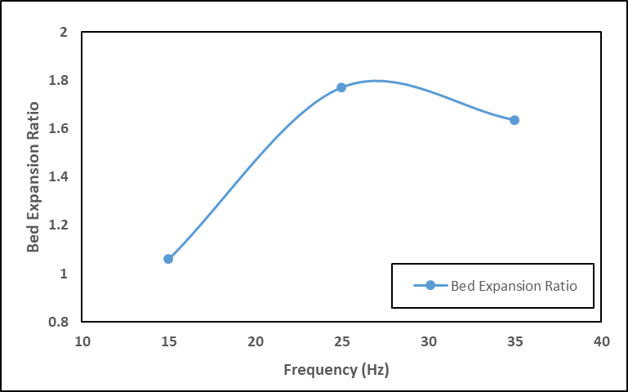
Fig. 4 Effect of Mechanical Vibration on Bed Expansion Ratio
Bed Voidage
The bed voidage ratio was studied for the different mechanical vibrational frequency. The below figure 5 shows the effect of different mechanical vibrational frequency on bed voidage. The figure 5 shows, the testing was conducted at a mechanical vibrational frequency of 15Hz, 25Hz, and35Hz. The bed voidage also tested at different mechanical vibrational frequency. The varying intensity was tested under four different sound frequency. From the graph it has been observed that, for all the mechanical vibration, the maximum voidage obtained for the 25Hz i.e. 0.435.
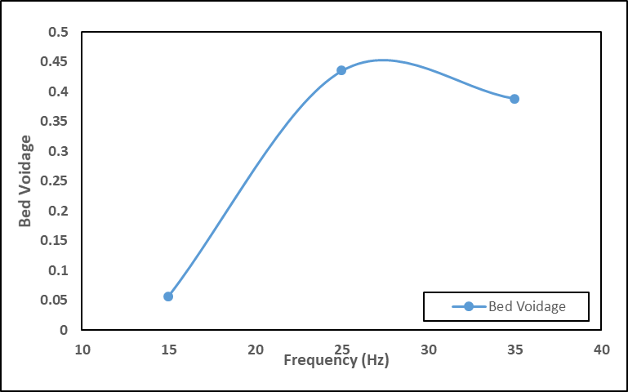
Fig. 5 Effect of Mechanical Vibration on Bed Voidage
CONCLUSION
The experimentation was conducted to study the effect mechanical vibration on the fluidized bed made up of zinc sulphate nano particle. In experimentation was conducted to study the minimum fluidization velocity, bed expansion, fractional reduction, and bed expansion ratio. It has been observed that, out of three vibrations the 25Hz mechanical vibrations gives minimum fluidization velocity, maximum bed expansion, bed expansion ratio and fractional reduction.
REFERENCES
- Cocco, R. F., et al., “Particle Clusters in and above Fluidized Beds,” Powder Technology, 203, pp. 3–11 (2010).
- A.. S. Meshram., U. S. Wankhede. (2017.). Fluidized Bed Drying of Food Materials- A Review. Int J. of Mech. Engg. Research. [Online]. 7(1), pp. 35-44 https://www.ripublication.com/ijmer17/ijmerv7n1_0 4.pdf
- A. Langde., R. L. Sonolikar., D. J. Tidke. (2012). Effect of variable acoustic field and frequency on gas-solid suspension of fine powder: a review. Chemical Engineering Communications. [Online]. 199(3), pp. 384-398
- J. Shabanian., R. Jafari., J. Chaouki. (2012, Jan.). Fluidization of Ultrafine Powders. International Review of Chemical Engineering. [Online]. 4(1), pp. 16-50. Available: http://www.pra iseworthyprize. org/jsm/?journal=ireche
- S. K. Gaikwad., U S. Wankhede. (2016, Mar.). Heat transfer in sound assisted fluidized bed of fine powders: a review. International Journal of Research in Engineering and Technology [Online]. 05(03), pp 307-304. Available: https://www.slideshare.net/ esatjournals/heat-transfer-insound-assisted-fluidized-bed-of-fine-powders-a-review
- D. Geldart. Types of gas fluidization. (1973, May). Powder Technology. [Online]. 7(5), pp. 285-292 Available: https://d oi.org/10.1016/0032- 5910(73)80037-3
- A. B. Silva., F. Costa., J. T. Freire., M. C. Ferreira. (2016, May). Modelling drying pastes in vibrofluidized bed with inert particles. Chemical Engineering and Processing [Online], 103, pp 1-11. Available: https://doi.org/10.1016/ j.cep.2015.09.012
- U. S. Wankhede. (2009). fluidization and surface to bed heat transfer in a sound assisted bubbling fluidized bed of fine powders. Journal of applied engineering research’. [Online]. 4(4), pp. 619-625.
- U. S. Wankhede. (2009, Apr.). Heat transfer characteristics and partial behavior around a horizontal heating surface immersed in a sound assisted fluidized bed powders. International journal of dynamics of fluid, [Online]. 5(2) pp 1-10
- U. S. Wankhede. (2009, Nov.). Effect of Increase in surface temperature on heat transfer in a sound assisted fluidized bed of fine powders. International journal of engineering studies. [Online]. 1(1). pp. 64-68.
- R. R. Yawalkar., U. S. Wankhede . (2012, Jun.). Analysis of rectangular fluidized bed dryer with rectangular wavy walls. International Journal Of Advance Research In Science And Engineering. [Online] 2(6). pp. 64- 68. Available: http://www.ijarse.com
- U. Wankhede., ,R. Sonolikar. (2015. Sept.). Experimental analysis and CFD simulation for heat transfer in sound assisted fluidized bed powder. Thermal science [Online] 00, Available: https://doi.org/10.2298/T SCI150208124W
- Bi, HT 2007, ‘A critical review of the complex pressure fluctuation phenomenon in gas–solids fluidized beds’, Chemical Engineering Science, vol. 62, no. 13, pp. 3473-3493.
- Boskovic-Vragolovic, N, Brzic, D & Grbavcic, Z 2005, ‘Mass transfer between a fluid and an immersed object in liquid-solid packed and fluidized beds’, Journal of the Serbian Chemical Society, vol. 70, no. 11, pp. 1373-1379.
- Buffiere, P & Moletta, R 1999, ‘Some hydrodynamic characteristics of inverse three phase fluidized-bed reactors’, Chemical Engineering Science, vol. 54, no. 9, pp. 1233-1242. 118
- Busciglio, A, Vella, G, Micale, G & Rizzuti, L 2008, ‘Analysis of the bubbling behaviour of 2D gas solid fluidized beds: Part I. digital image analysis technique’, Chemical Engineering Journal, vol. 140, no. 1-3, pp. 398-413.
- Cano-Pleite, E, Hernandez-Jimenez, F, de Vega, M & Acosta-Iborra, A 2014, ‘Experimental study on the motion of isolated bubbles in a vertically vibrated fluidized bed’, Chemical Engineering Journal, vol. 255, pp. 114-125.

