Wireless Blockage Detection Using Sensor Network With Iot Devices

Mrs. Swati Ajay Gandhi¹, Dr. Deepak P. Patil ²
¹ Research Scholar, Sandip Foundation , Sandip Institute of Engineering Research and Management ,Nasik,Maharashrta,India,swati.gandhi25@gmail.com
²Research Guide &, Professor , Sandip Foundation ,Sandip Institute of Engineering Research and Management ,Nasik,Maharashrta,India,dipakpatil25@gmail.com

Received on: 04 May,2024 Revised on: 04 June,2024, Published on: 07June ,2024

Abstract – The Internet of Things (IoT) is a system of physical items connected through communication devices to sensor networks that enables communication and automated operations between the natural and digital worlds. IoT was born because of the ability of computers to retrieve data from objects and devices without requiring human contact. Nonetheless, it sought to transcend the limitations of manually input data to attain cost, precision, and generality. The sensor system is critical to the IoT paradigm's success. This article discusses the deployment and design of an Internet of Things (IoT)-enabled Underground Drainage and Manhole Monitoring System (UDMS). This design prioritizes cheap cost, minimal maintenance, rapid deployment, many optical communication sensors, a long service life, and a high level of service quality. The suggested model includes a system for observing the water level, air temperature, and pressure within a manhole and determining if there is an increase in water level and tension between two manholes.
Keywords- IoT, Sensor, WSN, Blockages, optical
- INTRODUCTION
A vital component of urban infrastructure is the subsurface drainage system. It is regarded as a lifeline for the city. Because most subterranean drainage maintenance is manual, having a clean and functional subsurface system is inefficient. Additionally, government employees may have difficulty locating the same manhole causing the Issue in large cities. The majority of cities have implemented an underground drainage structure, and it is the management station's (Community Corporation's) responsibility to keep the city clean. If drainage is not appropriately maintained, clean water becomes polluted by drainage water, resulting in infectious illnesses. During the rainy season, the drainage system becomes clogged, posing problems for daily living, such as traffic congestion, contamination of the environment, and public outrage. Assume a facility inside the Municipal Corporation (management station) that notifies authorities immediately after a drainage system is blocked in which region and at which location. The Issue that develops in these drainage systems might significantly impact the city's everyday operations. If suitable cleaning measures are not conducted regularly, problems such as obstruction due to left-over material and numerous dangerous gases might occur. Because today's drainage systems are not computerized, it is difficult to determine if a blockage happened in a specific spot.
Additionally, waste in such drainage systems may sometimes release different gases such as methane (CH4), carbon monoxide (CO), and others that are hazardous and can cause severe problems if breathed in significant numbers by people. They are encountered by drainage workers, resulting in fatalities. Additionally, we do not get early warnings about the blocking of increasing gases or rising water levels.
As a result, detecting and correcting the obstruction becomes time-consuming and stressful. There are several real-world instances of the drainage system's deficiency.
The drainage system serves as the foundation for preventing excess and unneeded water, rains, and wastewater from accumulating. The drainage system is critical in a large metropolis with millions of residents. It is not feasible to monitor drainage manually, and inadequate monitoring adds to drainage blockage, which results in floods across the area. Manual tracking is also ineffective, and it requires a large number of devoted individuals capable of recording just a limited number of reports with a poor degree of accuracy [4].
Bangalore's unprecedented expansion, which a lack of required infrastructure has accompanied, has exacerbated a significant issue. In 2019, roads, sewers, and even residences in several regions of Bangalore were inundated, bringing enormous hardship to the city's significant expansion. The city's drainage system is comprised of main drains, roadways, side drains, and berm drains, all of which get clogged during the rainy season. Intelligent solutions are necessary to avert such situations. Smart city infrastructure may include intelligent traffic automation, military, logistics, and environmental monitoring. As a result, it is critical to build a system capable of autonomously managing subterranean three drainage systems. Underground drainage consists of a sewage system, a network of gas pipelines, a water pipeline, and manholes.
Pressure transients and acoustic wave methods, on the other hand, are more cost-effective. They are global techniques for observing the influence of a fault on a pipeline system by monitoring the pipe response. As a result, the time and frequency domains of acoustic wave propagation are employed in this study to identify leakage and obstruction. On the other hand, the wandering mass approach has already been applied in the frequency domain.
  - The Importance of Intelligent Drainage Systems
Urban regions are disproportionately impacted by artificial floods, such as dwindling open places with non-recycled pliable drains that are not checked frequently, resulting in excessive water collection after heavy rainfall.
Bellundur Lake (Bangalore) was covered with mud and foul-smelling froth in 2017 due to high rains and a lack of an adequate drainage structure. Seventy-six polluting industries were shut down in the aftermath of the Bellandur lake catastrophe.
Delhi was inundated with water during an extended period of severe rains, resulting in gridlock [8].
In 2015, Chennai saw catastrophic flooding, while Mumbai's floods claimed 500 lives.
These catastrophes occur as a consequence of a deficiency in sophisticated drainage systems. Manual surveillance is inefficient and sometimes dangerous to human life.
In Agra, an inquiry into the building of drainage was ordered in 2019. The drainage was to be built within a 50-meter radius. However, up to 0.2 kilometers of the existing drainage system has been compromised. This was done to benefit select individuals via creative civic programs.
Following the exposure of this fraud, extreme action was intended. Numerous unscrupulous schemes are concealed, crooked individuals profit, and ordinary citizens suffer.

1.2 Existing system

Drainage monitoring systems in the modern day are not fully automated. As a result, determining the precise site of a blockage is not always straightforward. Additionally, there are no early warnings of a jam. As a result, detecting and correcting the obstruction becomes laborious. It becomes pretty challenging to deal with the problem when all pipes are stopped. People confront several issues as a result of such drainage line failures.
An intelligent drainage system that can be monitored remotely and risk-free.

II. LITERATURE REVIEW
Muragesh S. K1 and SanthoshaRao [1] created a prototype that incorporates monitoring the water level, ambient temperature, and pressure within a manhole and determining if the manhole cover is open. Additionally, it monitors electrical power cables constructed underneath. This design prioritizes cheap cost, minimal maintenance, rapid deployment, many sensors, a long service life, and a high level of facility quality.
The Internet of Things (IoT) comprises natural life items and communication strategies connected to sensor systems to facilitate communication and computerized operations between the natural and data worlds. IoT was born because of the ability of computers to retrieve data from objects and devices without requiring human contact. Nonetheless, the goal was to transcend the constraints of manually input data and attain cost, precision, and generality. The sensor system is critical to the IoT paradigm's success, and it embodies the implementation and design functions of an Internet of Things-enabled Underground Drainage and Manhole Observing System (UDMS).
Prof. S A. Shaikh and Suvarna A. Sonawane [2] planned a scheme for smart cities to monitor the quality of properties in the town to expand good supervision and accelerate the city's development. The critical need is to promote healthy and harmless cities that provide real-time facilities and the latest technology to improve intelligent city perception. Data are gathered through optical communication sensors and sent to the Raspberry Pi3 controller. The controller's yield is directed to the control room and displayed on a private computer in the control room.
Yash Narale, Apurva Jogal, Himani Chaudhari, and S.P Bhosale [3] established an underground drainage observing system that would assist in not only preserving the city's appropriate well-being and safety and in lowering the workload of administrative officials. Many optical communication sensors (flow, level, temperature, and gas sensors) are interfaced with the ARM7 microprocessor to construct the scheme intelligently. Once the different sensors hit the threshold value, the microcontroller receives an indicator of the matter and the sensor in question. Additionally, ARM7 transmits the signal and position of the manhole to the civic corporation through GSM and GPS, enabling authorities to immediately determine which manhole is experiencing issues and take necessary action.
G. Gowthaman and K. Hari Haran presented [4] a simple technique for level monitoring. Before overflow, it creates alert signals by sending complaints through mail and SMS to the appropriate authorities.
MS T.Deepiga [5] demonstrated a wireless sensor network-based intelligent water monitoring system. The system is comprised of a sensor device that detects and regulates the household electrical appliances that are utilized daily based on various tariff charges.
Retno Tri Wahyuni et al. [6] stated that sensible gadgets if linked into the city's substructure with appropriate ICT research, would significantly simplify living in any municipality. We will design a practical period drain monitoring system in this work by using a variety of optical communication sensors such as water level, obstruction, and gas detectors. Wirawam et al. [7] established an analytical flood warning scheme based on the Internet of Things and implemented it in a stream such as Central America's country and other rivers.
Water flow is a proxy for cleanliness and energy. Gunasekaran, M.Pavitra, S.Priyanka, and R. Reeva [8] presented a scheme consisting of subsurface aquifers and aboveground rivers, lakes, streams, and marshes that would account for just 65 percent of the world's water. The preceding water should be cleansed and renewed regularly.

- TECHNIQUES USED FOR SMART DARNING & BLOCKAGE DETECTION

The development of nonintrusive procedures for defect identification is desired [12]; non-destructive testing techniques like radiographic testing are often utilized as nonintrusive tests. Over the last two eras, investigators have attempted to progress flow analysis-based systems for detecting blockages; methods established used fluid transients to detect, locate, and size blockages based on the system's response to an injected transient; these nonintrusive methods have shown promising development. The time-domain or frequency-domain analysis of flow transients is possible.
To solve governing partial differential equations in the time sphere, the method of characteristics (MOC) is utilized [13], [14]. Frequency domain analysis may be performed in two ways: impedance analysis or transfer matrix analysis [15].
Adewumi, Eltohami, and Ahmed [17], Adewumi, Eltohami, and Solaja [18] suggested a time replication approach and carried out mathematical tests to identify discrete extended type partial blockage in a single conduit for both single and manifold jams.
Vitovsky et al.[19] developed an impulse reply approach for detecting discrete leaks and fractional blockages in a single conduit, and the system was statistically validated. Wang, Lambert, and Simpson [20] noticed a partial single discrete obstruction in a single pipeline using the hindering of fluid transients based on a diagnostic solution and investigational verifications. Several other studies employed the Frequency Response Method to discover discrete bottlenecks in single channels using numerical experiments [10], [11], and [2], as well as to detect discrete bottlenecks in branching media via [5]. Sattar, Chaudry, and Kassem [11] linked numerical findings to laboratory studies and discovered that the position of the blockage could be determined with nearly no mistake, but the size recognition had minor problems.
Duan, Lee, Ghidaoui, and Tung [21] projected another method based on Frequency Response Investigation for detecting single and manifold extended type blockages in a single conduit; later that year, Duan et al.[21] simplified their previous work analytically and validated the numerical results using laboratory experiments.
The authors suggested a combined frequency and time–domain examination to detect single and many extended type blockages in a single pipeline, with the two techniques empirically validated. The findings indicate that the time-domain approach (pressure signal investigation) is the most precise way of identifying the obstruction. The frequency-domain process (frequency response examination) is the most accurate method for estimating the radius of contraction and the length of the obstacle. Stephens, Lambert, Simpson, Vitkovsky, and Nixon and Stephens, Simpson, and Lambert [19] [20] directed field transient flow tests to determine the accuracy of detecting and locating single discrete blockages in a single conduit. The outcomes indicated a high degree of precision for sensing and locating blockages, but with the restriction that the suggested model failed to see the backup for jams with a decrease in pipe cross-section less than 67 percent.
Wang et al. [20] devised and validated an approach for separate obstruction recognition in gas conduits based on the replication of an injected acoustic signal.

III.1 Some pipeline monitoring methods

Existing pipeline observing approaches may be classified into two types according to the location of the optical communication sensors, i.e., within or outside the conduit.
Sensors outside conduits

III.1.1. Visual inspection

Traditionally, aboveground pipeline observing solutions use image/video devices to monitor the region around the channels. When the visibility is excellent, the image/video sensors have a wide sensing range. The image/video sensors may detect and locate any obstruction or other abnormal condition along the pipes. This technology, however, cannot be utilized to monitor pipes that are buried underground.

III.1.2. Ground-penetrating radar (GPR)
[18] makes use of ground-penetrating radar (GPR) to identify pipeline obstruction. Without the need for digging, GPR can precisely locate subsurface pipeline leaks. GPRS may be incorporated into portable devices that maintenance personnel can carry. While this approach can cover many miles of pipeline every day, it needs considerable human effort. Additionally, there is no real-time monitoring. As a result, an obstruction may be undetected for an extended time.

III.1.3. Soil properties sensors
The sensors to be used are dictated by the fluid delivered through the pipes being monitored. Because the blocked fluid may create changes in the soil characteristics around the underground channels, the blockage may be identified by determining the abnormal value of the soil properties. Temperature sensors, for example, can locate blocked hot liquid when the surrounding temperature rises after the formation of a block. Water blockages may be detected using soil humidity sensors [8]. Hydrocarbon vapor sensors can identify pipes carrying liquefied natural gas that has become clogged.

III.2. Monitoring methods
using sensors located underground pipes Intensive confidential dimensions are not advantageous for subterranean conduits because sensor positioning necessitates connecting two nearby pipes. The density of connections in subterranean pipes increases the probability of a blockage. As a result, the inside sensors may be put only at checkpoints or pump stations inside the channel. As a result, the sensor density within the device cannot be excessive. The following describes the current internal blockage detecting sensors.

III.2.1. Acoustic devices Small
As a result of the fluid escaping from the channel, pipeline leakage may cause high-frequency fluctuations in the pipe wall. Acoustic transducers are often used to track shaking data back to its foundation to locate and pinpoint blockages [18]. Due to the detection range constraint, installing a dense network of acoustic devices within the conduit is often required to protect the whole system, which is not feasible for underground pipes due to positioning and maintenance challenges. The hearing devices are impervious to massive obstructions since they do not emit distinctive high-frequency vibrations [19]. As a result, acoustic sensors are only helpful in identifying minor obstacles in underground pipes at checkpoints or pump stations.

III.2.2. Mass balance approaches
A blockage may result in an unexpected shift in the differential flow rate between upstream and downstream flows. As a result, the backup may be identified by measuring the flow differential across the pipes through flow sensors [22,24]. The mass balancing technique is relatively inexpensive. Additionally, this approach can detect minor breaches that do not cause a rapid change in inflow pressure. Though, the recognition of false alarm rate is significant since the variation in flow rate might be produced by a variety of other variables, including pipe blockage/roughness and temperature/density of the conveyed fluid. Additionally, the mass balance approach cannot precisely localize the blockage's site.

III.2.3. Transient-based approaches
Transient-based approaches have recently been subjected to extensive analysis by the scholarly community [21]. Four stages are necessary to complete the transient-based leakage detection methods:
An artificial transient event is initiated in the pipeline network, such as the opening/closing of a valve or the starting/stopping of a pump.
Pressure sensors installed at pipeline network checkpoints monitor the pressure variation caused by the transient occurrence. The data is forwarded to a processing facility for analysis.
The observations are used to calibrate a pipeline network transient simulation model.
Calibration allows for detecting the obstruction's existence, size, and position.
Due to the restricted number of sites where pressure sensors can be installed, transient-based approaches cannot offer sufficient precision in detecting and localizing blockages [20].

- CHALLENGES AND ISSUES RELATED TO MONITORING INSIDE THE PIPE

Sewage is used to indicate the liquid waste from the community and industries. The significant challenges for sewage monitoring inside the pipes are as follows:
1. The uniformity of the liquid characteristics inside the pipes.
2. Customized to the pipeline structure, making the solution inappropriate for other types of pipeline technologies.
3. Threshold level or peak discharge of sewage inside the pipe.
4. Generation of hazardous gases inside the pipe.

- PROPOSED WORK

Due to abrupt changes in the atmosphere and climatic fluctuations over the seasons, drainage systems get clogged or flooded, resulting in an unpleasant environment and disrupting the healthy routines of everyday people. Cleaning companies in India continue the Underground Drainage Structure to provide a clean, vigorous environment and a healthy ecosystem. However, due to inadequate maintenance of the subsurface drainage system, filthy water often mixes with clean water—the ingestion of this contaminated water results in the transmission of water-borne illnesses.

As seen in Figure 01, our project entails installing two flow devices, one for each drain, nodemcu. The primary objective is to locate any obstructions in the drainage system. As a result, we are using flow devices to monitor the regular movement of sewage liquid and, if any unexpected flows occur, nodemcu will be notified. The nodemcu is linked by Wi-Fi, and data from the flow sensor is transferred to the cloud via an API. The fluid flow may be monitored, and when a blockage develops, an alert is transmitted to the mobile device.

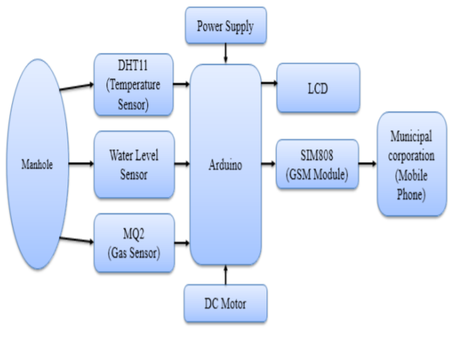
Figure 01: Block Diagram of Underground Drainage Monitoring System

To address all of these concerns about the underground drainage structure, we developed the innovative drainage structure, which will have the following formats:
- Senses the clear drain where the blockage arises.
- Primary data of the jam.
- The scheme directs the movement of sewage from the pipes.
- Use of flow devices to distinguish the differences in the flow.
- Get the prior warnings of blockages and trace them using IoT.
- This whole information packet will be transferred by the gateway node and kept in the cloud across the scheme, allowing us to quickly display, change, and resolve problems in real-time. We may witness the Smart Drainage System's operation via the block diagram [21].
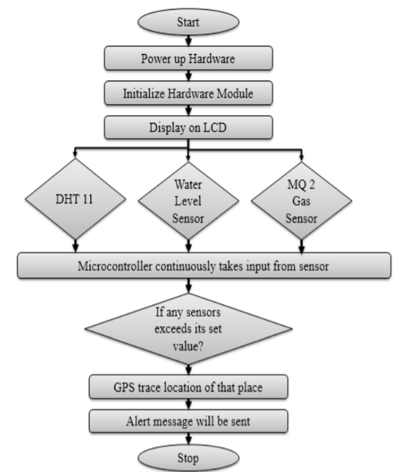
Figure 02: Block Diagram

V.1 System Design
A wireless sensor network's topology and structure might vary considerably. The confining environment of an underground pipeline imposes several constraints on an underground wireless sensor network (UWSN). Due to the much smaller RF transmission choice in soil than in air. As a result, routing methods and the UWSN's general structure are constrained. Additionally, the pipeline's topology limits the network's architecture—the suggested UWSN for pipeline monitoring in available schematics in Figure 2.
Each node in the proposed WSN interacts through RF signals with the nodes ahead and behind it. A primary node communicates with the device nodes through RF transmission for every 4–5 nodes (up to a maximum of 10 nodes with intervals of 20–40 meters between two manholes). Additionally, these primary nodes should join the internet and transport data from the nodes to the cloud through the internet. The cloud-based information may then be accessible from any device with an internet connection.

Individual sensor nodes s1 typically consist of four distinct components: data acquisition and dispensation unit, a transmission unit, a power supervision unit, and devices. Each of these parts has a significant impact on the overall presentation of the device nodes and system in terms of power consumption and consistency. Figure 3 depicts a simplified design of the planned sensor node's several components for communication between the sender and receiver located between two manholes.

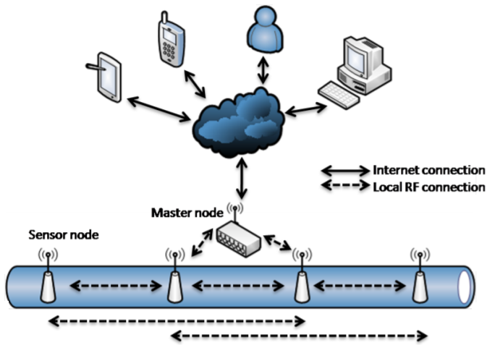
Figure 03: A general schematic of the Underground Radio Sensor Network (UWSN) proposed for pipeline monitoring systems.

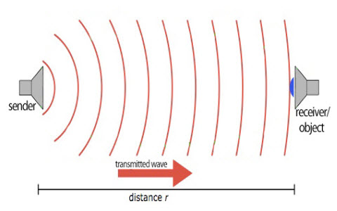
Figure 04: Transmitter and receiver functions between two shafts

V.2 Working:
A monitoring system for underground drainage will ensure the city's health and safety and lessen government staff's workload. Various devices (flow, level, temperature, and gas) are interfaced with Arduino Uno's microcontroller to make the scheme intelligent. When the multiple devices hit the threshold value, a signal is delivered to the microcontroller indicating the importance and sensor. Additionally, Arduino Uno transmits the movement and the position of the manhole to the civic corporation through GSM and GPS, allowing authorities to quickly determine which manhole is experiencing issues and take necessary action. Additionally, Arduino Uno utilizes IoT to continuously update the live values of all devices in the manholes within the designated region. Additionally, an LCD notice will show.

- RESULT & DISCUSSION
Analyses of domains of frequency If there is a partial blockage inside the pipe, the pressure signal will exhibit a diverse pattern from that of an ordinary line due to the pressure waves reflected by the fractional obstruction.

Table 01: System Specification
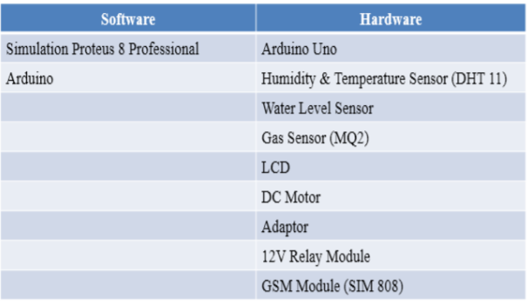

However, since pressure signals are often high in frequency and polluted by measurement noise, pressure variations between regular and partly obstructed pipes are tough to identify in the time domain. As a result, the time domain information is translated to signal in the frequency domain. This research makes use of the parameter F, which is calculated as the average of the average distances between left and right neighbors of 50mm (1)
Eq (1)
Assume that X is a vector of the frequency domain amplitudes of a pressure signal. The quick Fourier transform converted X from a time-domain pressure signal. Assume that xi is the ith element in X. In Eq., the mean of the variances between xi and k-left nearby points (left-differences average) and the mean of the differences between xi and k-right neighboring points (right difference mean) are utilized to assess whether or not xi is a meaningful peak (1).
The response spectra for the two occurrences are shown in Figure 05 a,b, where the system's fundamental frequency normalizes the frequency axis, ωth = a/4L. (amplitude and length). The spectral response is normalized to the valve's steady-state head and displayed as the non-dimensional hD. While the time domain responses exhibit significant differences, their spectra are comparable, comprising uniformly spaced resonant peak replies at odd multiples of the scheme fundamental frequency. The energy distribution between these resonant frequencies directly narrates to the signal's time-domain form. The first resonant peak is the transient signal constituent that repeats throughout the system's 4L/a period. The brief suggestions in time demonstrate that both temporary signals recur at this scheme period regardless of their form. The reply in the spectrum for this frequency is most substantial for both movements. The breadth of the higher-order resonant peaks provides data on the shape variations that occur throughout each period of the transient signal. System reflections or frequency-dependent effects might generate these shape changes.

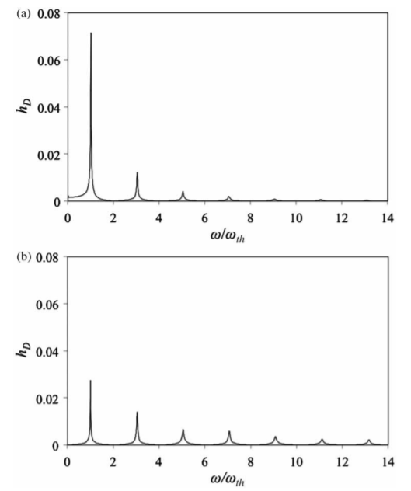
Figure 05: Frequency spectrum of (a) valve closure and (b) pulse disturbance.

Notably, regardless of the origin of the transient disorder, the scheme reaction is most significant at resonant frequencies, implying that characterizing the system's behavior at these resonant frequencies yields the system's dominant behavior.
Figure 06 (a) shows two pulses: the first pulse is the first reflection from the blockage, and the second pulse is the reflection of the first pulse from the pipe inlet or between two manholes. These two pulses appear to be combined because the first pressure monitoring point (𝑠1) is close to the manhole. Therefore, the reflected wave from the blockage and the following reflection from the manhole was monitored almost (a) (b) (c) (d) (e) (f) 25 simultaneously at the first pressure monitoring point. Figure 6(b) shows the first reflection from the pipe outlet (trough) and its reflection from the pipe inlet (peak). Figure (b) marks the peak of the reflection of the transmitted wave in the intact flawless pipe (i.e., without blockage) between two manholes. Figure (a) marks the peak of the reflection of the transmitted wave from the blockage and the manhole, while the letter "C" in Figure (b) marks the peak of the reflection of the transmitted wave from the second manhole and first manhole. It can be observed that there is a change in amplitude in the propagating pulse because the acoustic energy of the initial pulse has been split into two. Figure (b) shows that the acoustic wave doubly reflected between two manholes in the flawless pipe has amplitude marked “A” of magnitude 𝑝𝐴 = 0.20. Similarly, Figure (a) shows that the acoustic wave doubly reflected by the blockage and manhole in the pipe with 10 mm diameter blockage has amplitude marked “B” of magnitude 𝑝𝐵 = 0.18, while Figure (b) shows that the acoustic wave doubly reflected between two manholes has amplitude marked “C” of magnitude 𝑝𝐶 = 0.12. It is expected that the splitting of the acoustic energy at the blockage should result in the energy balance given by 𝐸𝐴 = 𝐸𝐵 + 𝐸𝐶.
.
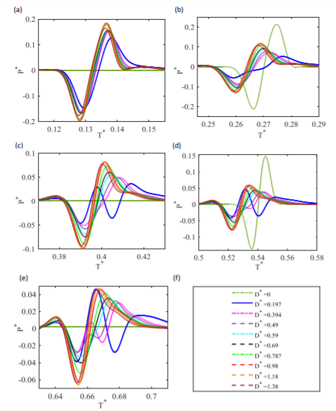
Figure 06: The magnified waveforms labeled (a) to (e) in Figure (a) are the first reflection from the blockage and the reflection from the entrance, (b) the first reflection from the exit and the reflection from the entrance, (c) Second reflex Reflex from obstruction and reflex from entrance, (d) Second reflex from exit and reflex from entrance, (e) Third reflex from obstruction and reflex from entrance, (f) Usage Guide

Thus, Reflection times and detachments from pressure observing locations to blockage for an air-filled pipe with 10 to 20 mm diameter blockage (D) hear we consider sewage pipe for 50 cm diameter (ts is the time it earns the wave to run from the inlet to pressure observing location from sensor s1, tp is the time it deserves the wave to travel from the channel to the sensor then to the pipe exit and back to pressure observing location and td is the time it encounters the outflow and was moderately reflected backward.
Since the energy in a wave is proportional to the square of its amplitude, this implies that the following relationship should hold: 𝑝𝐴 2 = 𝑝𝐵 2 + 𝑝𝐶. Indeed, the sum of squares of the amplitudes of the doubly reflected waves “B” and “C” in the pipe with 10 mm diameter blockage (D*=0.98) is equal to the square of the amplitude of the doubly reflected waves “A” in the flawless line.
Also, it is surprising to see in Figure (b) that the acoustic waves that are doubly reflected by the pipe outlet and pipe inlet for the leakage cases arrive earlier than the acoustic wave that is reflected by the pipe outlet and pipe inlet intact (flawless) case. This suggests that the wavefront for the doubly reflected waves for the blockage in pipes travels at higher velocity. It seems that the blockage in the pipe is behaving like a notch filter suppressing the low-frequency wavefront and only passing the high-frequency wavefront. This is akin to Helmholtz resonator. However, figure (b) shows that as the size of the blockage decreases, the arrival times of the reflected waves increase and approach that of the flawless pipe.
When the blockage size becomes 5 to 25 mm (D*=0.197), the combined doubly reflected waves begin to acquire a different trend from the other combined doubly reflected waves. Following the second set of reflections from the blockage and manhole, Figure (c) shows that this combined doubly reflected waves for the pipe with the 5 to 25mm diameter blockage (D*=0.197) with sewage pipe for 50 cm diameter, now have two peaks and two troughs instead of 1 rise and 1 through which the other combined doubly reflected waves have. 26 As the blockage size increases, Figure (d) and (e) show that the combined doubly reflected waves of other pipes with blockage also start developing extra wavefronts. As mentioned earlier, this transformation is believed to be due to the blockage acting like a Helmholtz resonator. The jam behaves like a notch filter; the low-frequency components of the incident pulse are suppressed and prevented from propagating along the pipe. As the reflected wavefront propagates back and forth, the blockage suppresses the low-frequency components more and more. It begins to eat up into the high-frequency components of the wavefronts.

- CONCLUSION
Thus, our effort strives to provide a safe and healthy environment via developing an intelligent drainage monitoring system. By observing the obstruction between two manholes, this study targets intelligent and real-time drainage monitoring and detection systems for metropolitan cities through IoT applications. We can monitor the drainage system's real-time situation by identifying drainage system issues using a variety of sensors, including gas detection, ultrasonic obstruction detection, and many more. As a result of receiving early warnings of obstruction and rise, we may take specific action on the issues. This document may be used to create an innovative and real-time drainage blockage detecting scheme and resolve the Issue. This technology enables the sensor nodes to be easily installed on pipes without compromising the structural integrity of the lines.

REFERENCES
- Li Xiaoman, Lu Xia, Design of a ZigBee Wireless Sensor Network Node for Aquaculture Monitoring, 2016 2nd IEEE International Conference on Computer and Communications (ICCC), Chengdu, China, 14-17 Oct. 2016.
- Prof. S A.Shaikh , Suvarna A. Sonawane. ” Implementing Smart City Concept with Various Application Using IOT Based Technique”June 2017
- Yash Narale, Apurva Jogal, Himani Chowdhary,S.P Bhosale "Underground Drainage Monitoring System Using IOT" . International Journal of Advance Research Ideas And Innovations In Technology, Volume 4 Issue 1, January 2018.
- G. Gowthaman, K. Hari Haran "Automated Internet of Things for Underground Drainage and Manhole Monitoring System for Metropolitan Cities"ISSN 0974- 2239 Volume 4, Number 12 (2014), pp. 1211-1220
- Deepiga, T, SivasankariA, “Smart Water Monitoring System Using Wireless Sensor Network at Home/Office”, International Research Journal of Engineering and Technology, vol.02, no.04, July 2015
- Retno Tri Wahyuni1* Yusmar Palapa Wijaya2 Dini Nurmalasari “Design of Wireless Sensor Network for Drainage.
- Wirawam, S., Pratoma, I., and Mita, Nagahisa. “Design of Low Cost Wireless Sensor Network-Based Environmental Monitoring System for Developing Country”.Proceedings of APCC2008
- Dr. Gunasekaran M,Pavithra S,Priyanka R,Reeva M ”IoT enables Underground Drainage Monitoring System using Water Flow Sensor” May 2019.
- C. Jihoon, S. Joonho, S. Choonggeun, H. Suyong, and P. Doo Il, “Leak Detection and Location of Water Pipes Using Vibration Sensors and Modified ML Prefilter,” Sensors, pp. 1–17, 2017.
- N. F. Adnan, M. F. Ghazali, M. M. Amin, and A. M. A. Hamat, “Leak detection in gas pipeline by acoustic and signal processing - A review,” in IOP Conference Series: Materials Science and Engineering, 2015.
- P. Yin, X. Cao, Z. Qiu, and W. Liang, “Leak detection in gas pipeline by acoustic and signal processing - A review Leak detection in gas pipeline by acoustic and signal processing – A review,” 2015.
- N. F. Adnan, M. F. Ghazali, M. M. Amin, and A. M. A. Hamat, “Leak detection in gas pipeline by acoustic and signal processing - A review,” in IOP Conference Series: Materials Science and Engineering, 2015.
- P. Yin, X. Cao, Z. Qiu, and W. Liang, “Leak detection in gas pipeline by acoustic and signal processing - A review Leak detection in gas pipeline by acoustic and signal processing – A review,” 2015.
- B. Sumathy, G. Gowthaman, K. Hari Haran, G. KeertheeRajan, A. SweetoJeison, Sewage Level Maintenance using IoT, International Journal of Mechanical Engineering and Technology 9(2), 2018, pp. 389–397.
- Akhila C, Kowshik , Keerthana M & H.Shrinivas, “Implementation of IoT Based Sewage Water Purity Indicator”, International Research Journal of Engineering and Technology (IRJET), vol. 04, Issue. 05, May 2017.
- Christeena Joseph, Kishoreraja C, Reji & Radhika Baskar, “Design of Wireless Sensor Network Gateway for the Internet of Things”, International Journal of Pure and Applied Mathematics, vol.117, No. 9, 2017.
- Adewumi, M.A.; Eltohami, E.S.; Ahmed, W.H. Pressure Transients across Constrictions. J. Energy Resour. Technol. 2000, 122, 34–41.
- Adewumi, M.A.; Eltohami, E.S.; Solaja, A. Possible Detection of Multiple Blockages Using Transients. J. Energy Resour. Technol. 2003, 125, 154–159.
- Vitkovsky, J.P.; Lee, P.J.; Stephens, M.L.; Lambert, M.F.; Simpson, A.R.; Liggett, J.A. Leak and Blockage Detection in Pipelines Via an Impulse Response Method. Pumps, Electromechanical Devices and Systems Applied to Urban Water Management. In Proceedings of the International Conference, Valencia, Spain, 22–25 April 2003.
- Wang, X.J.; Lambert, M.F.; Simpson, A.R. Detection and Location of a Partial Blockage in a Pipeline Using Damping of Fluid Transients. J. Water Resour. Plan. Manag. 2005, 131, 244–249.
- Duan, H.F.; Lee, P.J.; Ghidaoui, M.S.; Tung, Y.K. Extended Blockage Detection in Pipelines by Using the System Frequency Response Analysis. J. Water Resour. Plan. Manag. 2012, 138, 55–62.

