Case Study: Rooftop Solar Power

Mitesh Sapkale¹, Dr. Ishwar S. Jadhav², Maheshkumar N. Patil³, Hemraj V. Dhande⁴, Vijay D. Chaudhari⁵

¹PG student, ² Assistant Professor
^{1,2,3,4,5} E&TC dept, MTech (VLSI & ES), GF’s Godavari College of Engg, Jalgaon - 425003, Maharashtra, India.

miteshsapkale24@gmail.com¹, ishwar.jadhav@rediffmail.com², maheshninupatil@gmail.com³

Received on: 04 May,2024 Revised on: 04 June,2024, Published on: 07June ,2024

Abstract - Rooftop solar power plants offer a number of advantages, including self-reliance in electricity at a low cost, protection against future price increases for electricity, reduced carbon footprint, and others. The sunlight that generates solar energy is an environmentally friendly and never-ending renewable source of energy. Applications such as residential, commercial, and industrial use this solar energy, which is easily derived from direct sunlight. Therefore, it is highly effective and environment-friendly. The design of low- and medium-voltage collector systems for large solar power plants is facing new difficulties as a result of the development of newer technologies in concentrating solar power (CSP) plants, particularly those that make use of dish Sterling systems, as well as changes in the design of photovoltaic (PV) inverters. Besides, interconnect prerequisites for responsive power, voltage, and incline rate control and the qualities of sun based power require special answers for ideal plant plan. The development of appropriate models for transient and dynamic simulation of these plants must be included in the design process to guarantee that large solar plants can be successfully connected to the grid without compromising grid stability or reliability. Renewable solar energy is a plentiful source. In India, solar energy is only used sparingly. The production of electricity from sunlight is known as solar power. Using the photovoltaic effect, photovoltaic (PV) converts light into electric current either directly or indirectly through the use of concentrated solar power (CSP). Business concentrated sunlight based power plant were first evolved during the 1980s.
Keywords - PV Module, Inverter, Roof top solar, Battery Off grid

Introduction

History of plants:

The power area in India has gone through huge advancement after Autonomy. At the point when India became free in 1947, the nation had a power producing limit of 1,362 MW. The primary means of producing electricity have been hydropower and thermal power generated from coal. Electricity generation and distribution were primarily the responsibility of private utility companies. Only a small number of urban centers had access to power; country regions and towns didn't have power. After 1947, all new power age, transmission and circulation in the rustic area and the metropolitan places (which was not served by confidential utilities) went under the domain of State and Focal government organizations. Atomic power improvement is at a more slow speed, which was presented in the last part of the sixties.

Need of solar power plant:
Solar Power Is Good for the Environment:
The most well-known aspect of solar energy is that it is a green and clean energy source. A great way to cut down on your carbon footprint is to use solar power.

Solar Power Causes Less Electricity Loss:
Through extensive networks, electricity must be transported from large power plants to end users. Given the short distance, rooftop solar power is helpful for increasing electricity efficiency. Your energy becomes homegrown and therefore you're in charge of your own bills and energy utilization. Besides, sun oriented power frameworks are solid, along these lines chances of administration interference are diminished.

Solar Power Is A Free Source of Energy:

Sun gives us more energy than we might at any point utilize, and nobody can consume the daylight. Your sun oriented influence framework will begin setting aside cash from the second it's turned on; However, the benefits of solar power are most evident over time. The more time you spend using your solar power system, the more you can take advantage of solar technology's advantages and help the environment. Beside sun based power, sun oriented energy has a subsequent application. We frequently partner sun based energy with power, which is gained through PV boards, but on the other hand it's feasible to utilize the energy produced by the sun for the purpose of warming. Solar thermal systems are used to accomplish this by simply converting sunlight into heating solutions. We can begin by making more use of solar panels as acceptance of solar technology grows.

Solar Power Improves Grid Security:

When there are many of us switching to solar power, we are less likely to experience blackouts or brownouts. Every household in the UK that has solar cells installed, functions as a small power plant.

Solar Power Can Use Underutilised Land:

You might keep on asking why sunlight based power. The majority of us now have easy access to solar energy because of the growing demand for it. There are vast areas across nations that are not used for anything and are far from major cities or capitals. We can actually make use of the land and generate a lot of value by using solar power; sunlight based energy gives a source .

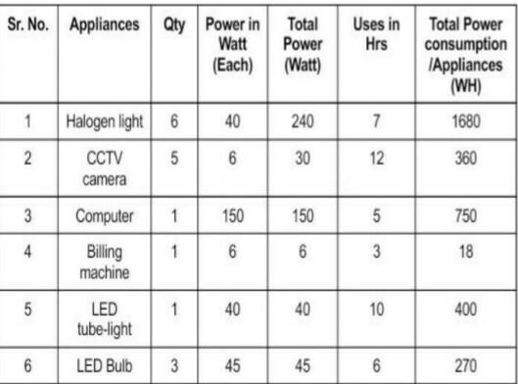
Actual site solar power plant block diagram

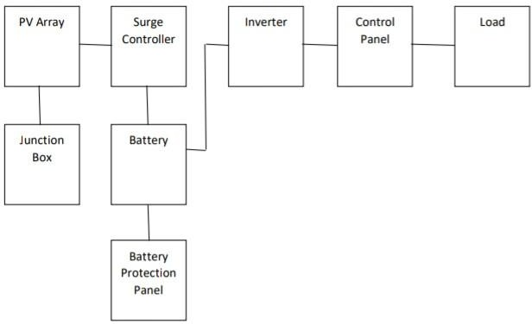
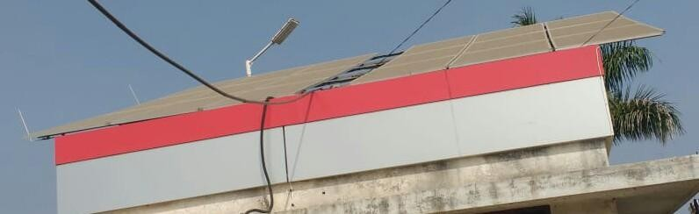
- Actual site photo and details

Site details

Plant Name - Jay Durga Petrol Pump Type of system - Off grid (Rooftop) Location of plant - Taharabad (Nashik)
Total wattage of solar power panels = 4500 W Size of inverter = 7.5 KW
Total battery backup calculation 1 battery = 12 V,
8 battery Total = 12 × 8 = 96 V.

Load Table

Total load calculation

Total load power consumption per day = 3478 wh kWh = 3478÷1000
= 3.478 kwh

Total panels = 18 install with 3 string

- 1st string (series) calculation (6 Plate)

Total watt = 1500 W
Total current = 48.96 A
Total Voltage = 184.2 V
- 2nd string (series) calculation (6 Plate)

Total watt = 1500 W Total current = 48.96 A Total Voltage = 184.2 V
- 3rd string (parallel) calculation (6 plates):

Total watt = 1500 W Total current = 48.96 A Total Voltage = 184.2 V
- Total watt of each string = 4500 W
- Total current of each string = 148.88 A
- Total voltage of each string = 552.6 V
- Total surge controller = 5964.8 W

kWh produce within a week
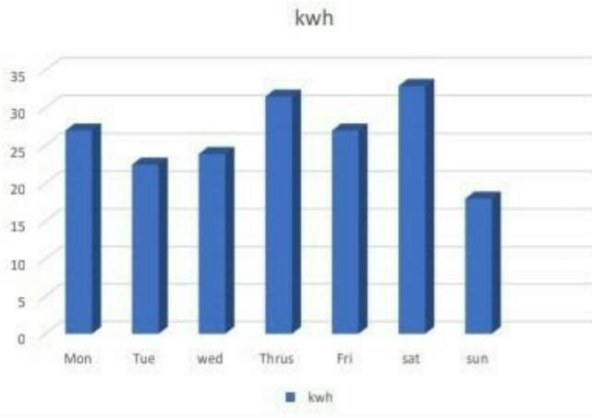
Total load of actual site is 4500w (4.5kw). Formula find for kWh are as follows

kWh = (Total watt × hrs)/ 1000 Weekly kWh are as follows
- Monday kwh ( Sunrise time is 6 hrs)

Total watt = 4500 w ,Hrs = 6 kWh =( 4500 × 6)/1000
= 27 kwh

- Tuesday kWh (sunrise time is 5 hrs) kWh =( 4500 × 5)/1000
= 22.5 kwh

- Wednesday kWh ( sunrise time is 5.30 hrs ) kWh =(4500 × 5.30)/1000
= 23.9 kWh

- Thursday kWh (sunrise time is 7 hrs) Kwh =( 4500 × 7)/1000
= 35.7 kWh

- Friday kWh ( sunrise time is 6 hrs ) kWh =( 4500×6)/1000
= 27 kWh

- Saturday kWh (sunrise time is 7.30 hrs) kWh =( 4500×7.30)/1000
= 32.9 kWh

- Sunday kWh (sunrise time is 4 hrs ) Kwh = (4500 × 4)/1000
= 18 kwh

Average of kWh = (mon + Tues + Wed +Thurs + Fri + sat + sun) / 7

=( 27+22.5+23.9+31.5+27+32.9+18) / 7

= (182.8) / 7

= 26.1 kwh Maximum kWh = 32.9 (Sat) Minimum kWh = 18 (Sun)

kWh produce within a week graph

  - kWh produce within a month
Monthly kWh ( month consider as "February 2021")

    - 1-2-2021 (sunrise time is 5 hrs) Total watt = 4500w and hrs = 5h Kwh = (Total watt × hrs)/ 1000 kWh =( 4500×5)/1000
= 22.5 kwh

    - 2-2-2021 (sunrise time is 7 hrs) kWh = 4500 × 7)/ 1000
= 31.5 kWh

    - 3-2-2021 (sunrise time is 6 hrs) kWh =( 4500×6)// 1000
= 27 kWh

    - 4-2-2021 ( sunrise time is 6.30hrs ) Kwh =( 4500×6.30) / 1000
= 28.4 kW

5-2-2021 ( sunrise time is 4 hrs ) Kwh = ( 4500×4) / 1000
= 18 kWh

    - 6- 2-2021 (sunrise time is 6 hrs ) kWh = (4500×6)/ 1000
= 27 kWh

    - 7-2-2021 (sunrise time is 8 hrs) kWh =( 4500×8) / 1000
= 36 kWh

    - 8-2-2021 (sunrise time is 5 hrs) kWh = (4500×5) / 1000
= 22.5 kwh

    - 9-2-2021 ( sunrise time is 3 hrs ) kWh = 4500×3) / 1000
= 13.5 kwh

    - 10-2-2021 (sunrise time is 8 hrs) kWh = (4500×8) / 1000
= 36 kWh

11-2-2021 ( sunrise time is 6.30hrs ) Kwh =( 4500×6.30) / 1000
= 28.4 kWh

    - 12-2-2021 ( sunrise time is 3.30hrs ) Kwh =( 4500×3.30) / 1000
= 14.9 kWh

    - 13-2-2021 ( sunrise time is 6 hrs ) Kwh =( 4500×6) / 1000
= 27 kWh

    - 14-2-2021 (sunrise time is 7 hrs) kWh = (4500 × 7) / 1000
= 31.5 kWh

    - 15-2-2021 (sunrise time is 7 hrs) kWh =( 4500 × 7) / 1000
= 31.5 kWh

    - 16-2-2021 ( sunrise time is 6.30hrs ) Kwh = (4500×6.30) / 1000
= 28.4 kWh

    - 17-2-2021 ( sunrise time is 8.30hrs ) Kwh = (4500×8.30) / 1000
= 37.4 kWh

    - 18-2-2021 (sunrise time is 6 hrs) kWh = (4500×6) / 1000
= 27 kWh

- 19-2-2021 ( sunrise time is 5hrs) kWh =( 4500×5) / 1000
= 22.5 kwh

- 20-2-2021 (sunrise time is 7 hrs) kWh =( 4500×7) / 1000
= 31.5 kwh

- 21-2-2021 (sunrise time is 7 hrs) kWh = (4500 × 7) / 1000
= 31.5 kwh

- 22-2-2021 ( sunrise time is 8.30hrs ) Kwh = (4500×8.30) / 1000
= 37.4 kWh

- 23-2-2021 (sunrise time is 8 hrs) kWh = (4500×8) / 1000
= 36 kWh

- 24-2-2021 (sunrise time is 6 hrs) kWh = (4500×6) / 1000
= 27 kwh

- 25-2-2021 ( sunrise time is 7 hrs ) Kwh = (4500×7) / 1000
= 31.5 kWh

- 26-2-2021 ( sunrise time is 4 hrs ) Kwh =( 4500 ×4) / 1000
= 18 kWh

- 27-2-2021 ( sunrise time is 4 hrs ) Kwh = (4500×4) / 1000

= 18 kWh

    - 28-2-2021 ( sunrise time is 3.30hrs ) Kwh = (4500×3.30) / 1000
= 14.9 kWh

Average of kWh Monthly (Feb ) = Addition of kWh (per day) ÷ 28
Addition of kWh per month = 22.5+31.5+27+28.4+18+27+36+22.5+13.5+36+28.
4+14.9+27+31.5+31.5+28.4+37.4+27+22.5+31.5+
31.5+37.4+36++27+31.5+18+18+14.9

= 756.8 kWh

Average of kWh per month =( 756.8) / 28

= 27 kwh

Maximum Kwh of Month = 37.4 (17-02-2021 22-02-2021)

Minimum kWh of month = 13.5 (09 -02-2021)

Average of kWh per month = 27 kwh

kWh produce within a month graph

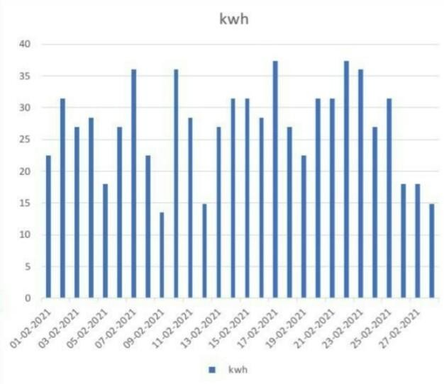
  - Payback period of 4.5 kW solar panel Payback period = Net investment / Net Earnings Net Investment = Total cost of solar system
= 4,00,000 Rs

Net earning = Annual energy production × tarrif ( per kWh ) Per day energy production = 27 kWh
Per month energy production = 27 × 30 = 810 kWh Annual energy production = 810 × 12 = 9720 kWh Tariff = 3.30 / kWh
Net earning = annual energy production × Tarrif

= 9720 × 3.30

= 32076

Pay back period = Net investment / Net Earnings

= 4,00,000 / 32076

= 12.5 years

Payback period = 12.5 years

Calculation for carbon save from 4.5 kW solar panel

4.5 kW solar panel carbon save monthly 1125 pounds 1 pounds = 0.454 tons
1 month carbon save = 1125 × 0.454

= 510 tons

1 kw solar panel carbon save = 3000 pounds 1 yearly carbon save = 3000×4.5
= 13500 pounds

= 13500 × 0.454

= 6129 tons

1 yearly carbon save = 6129 ton

Conclusion

By doing proper study of various components as per above work and by doing the load calculation the total load requirement can be found out. On the basis of that total solar panel required are calculated and the size of solar inverter can be found. All the components are calculated and this helps in designing of overall size of solar power plants as well as all the components required. Because of this, appropriately sized solar components can be gathered and a powered rooftop plant of appropriately sized can be installed. Consequently with the advantages of sun powered as free and Green wellspring of Energy bunches of fossil fuel byproduct as well as cash stick saved. Sun oriented energy is a spotless, contamination free and sustainable wellspring of energy. Advancement of this wellspring of energy requires exact definite long haul information on the possible considering occasional varieties.

References
- Energy Information Administration website, Available at http://www.eia.doe.gov.
- J.A. Duffle, W.A. Beckman, “Solar Engineering of Thermal Processes”, 3rd edition IEEE Recommended Practice for Utility Interface of Photovoltaic System, http://www.solarbuzz.com/Technologies.htm
- J. Wood, B. F. Wallenberg, “Power Generation Operation an Control,” Wiley Interstice
- A.A. Chowdhury, D.O. Kaval, “Impact of Photovoltaic Power Sources on a Power System’s Capacity Reliability Levels”,
- B.H. Chowdhury, S. Rahman, “ Is Central Power Station Photovoltaic Power Dispatch able?”Surface meteorology and Solar Energy: A renewable energy resource web site (Release 6.0), Available at: http://eosweb.larc.nasa.gov/sse/RETScreen/
- R. Ram Kumar, “Photovoltaic Systems”, in Proceedings of the IEEE,
- Puerto Rican Census website, Available at http://www.gobierno.pr/Censo/Accessed.

