Real-time Object Detection and Tracking Using Surveillance Video

Mr. Nitin Barsagde1, Adhish Pathak2, Kshama Rai3, Shreya Kunte4

¹Assistant Professor, ^{2,3,4,}Students ,

Department of Computer Science and Engineering, G H Raisoni Institute of Engineering and Technology, Nagpur

nitin.barsagde@raisoni.net

Received on: 11 June ,2022 Revised on: 31 July ,2022, Published on: 03 August ,2022

Abstract- Face detection is about finding or losing a face in a provided image and, if any, reestablishes the position of the image and the features of each face. Safety and security are two of the most significant human characteristics. In this article we have suggested face detection and a visual system that will be able to process images very quickly while achieving the highest level of face detection. Facial recognition is the process of identifying a person using a personal status to identify a person's personality. In this project, we propose a personal verification system that uses face recognition and generates an unauthorized person warning. The alert will be in the form of an unauthorized image that will be displayed in the application. The discovery was made with instantaneous video taken from a camera of mobile or laptop. People and things are being filmed in this video using Open CV, YOLO and Face Net. When a person is found, the system identifies the person. His identity will be transformed to audio and introduced to the user. Similarly, locally found objects will be presented in audio format to the user.

.

Keywords- Face detection, Object detection, Real-time, YOLO.

I – INTRODUCTION
Many face acknowledgment calculations planned in a product space having a high location rate, however normally require a couple of moments to get orperceiveda single picture, insufficient handling speed in real-time programs. The program is altered utilizing Python altering language. Both ongoing face location and face recognition in specific pictures, i.e., Object Detection, are

performed and the proposed framework is tried on all standard sites of different appearances, with sound and without obscuring impacts. Framework execution is surveyed by working out the face level of every site. The outcomes uncover that the proposed framework can be utilized to recognize faces even in low-goal pictures and to show astounding proficiency. The issue of security is vital in this day and age. Among the few strategies utilized for security purposes, face acknowledgment is a powerful method for guaranteeing wellbeing and security. Face acknowledgment is one of the most broadly concentrated on biometrics advances and has been created by specialists. Face identification is a critical connection for the accompanying facial related applications, for example, facial acknowledgment [l], facial acknowledgment [2], and facial acknowledgment [3], as its impact straightforwardly influences the exhibition of ensuing applications. In this way, face location has turned into an exploration region in the field of example acknowledgment and PC vision and has been broadly investigated throughout recent many years. Many face acknowledgment strategies have been proposed. Introductory exploration on facial acknowledgment zeroed in on the formation of a craftsmanship highlight and utilized normal AI calculations to prepare effective class dividers to find and distinguish. Such techniques are restricted in light of the fact that the plan of the functioning component is intricate and the precision of location is low.
The proposed framework will have clever PC includes that incorporate individual recognizable proof and individual information. Distinguishing proof will be finished by face acknowledgment and acknowledgment. As per our exploration up until this point we have discovered that facial acknowledgment should be possible utilizing Haar Cascade Fron Face to get xml. Accessible in the most famous library Open Cv.
For face acknowledgment we will use inside and out learning calculations to prepare our facial site model. In-depth learning strategies can utilize extremely huge facial informational collections and learn rich and incorporated facial portrayals, permitting current models to start to perform well and later outperform human facial acknowledgment abilities. Likewise we will see normal things, for example, PDA, wallet, key and so on to track and screen regardless of whether they are lost. Object securing will be finished utilizing open cv and YoloV3 or YoloV4 model. (Consequences be damned) is a cutting edge, ongoing system.

II – METHODOLOGY

Instruments and innovation utilized:
Python: Has an enormous number of libraries for applications, for example, Scikit AI, Open CV PC scanner, Tensor Flow for brain organizations, and so forth. Java: Android involves Java as one of its customizing dialects. Utilizing Java, Android applications for disclosure and underlying face acknowledgment.
Open CV: Used to perform continuous PC vision capacities.
Consequences be damned: Provides an edge that permits the obtaining of articles close to constant speed. Since versatile delivery utilizes Tiny YOLO, which is a straightforward YOLO structure for cell phones and edges.

Tensor Flow: An open source programming library and brain network structure and AI applications. It has an adaptable plan and can be circulated to waiters, workstations, cell phones, edge gadgets, and so forth.

Tensor Flow Lite: Tensor Flow for cell phones has a meager and lightweight PC utilizing low power PCs on cell phones and fringe gadgets called Tensor Flow Lite.

This little system takes into consideration simple utilization of little AI projects and low-power gadgets.

Keras: Keras is a profound brain network library that runs over different designs, for example,
TensorFlow. It is not difficult to utilize and considers the preparation of related learning models utilizing brain networks is simple. Keras contains some of extra highlights of a similar brain network layers, structures, opening capacities, and so forth which makes it a valuable library for some applications.

FaceNet: Used to extricate top notch facial highlights and train face acknowledgment framework.

Scikit-learn: Contains different calculations for gathering, taking away and partitioning into various classifications. AI projects can be utilized with other Python libraries, for example,

SciPy and NumPy. Scikit-advance additionally utilizes SVM (Vector support machines) and FaceNet among preparing projects to make precise face acknowledgment models.

Execution Phases :

Stage I : In this stage the entire framework is constructed utilizing Python. The proposed framework configuration is carried out utilizing Python scripts for every module. The fundamental justification for this approach was to guarantee that the entire framework worked appropriately. At the point when the total framework was assembled and tried, the code was moved to Java for use on Android.
Python is utilized on a Windows and Linux-based machine to fabricate and test proposed execution.
At this stage, the framework is based on a versatilePC, which gives admittance to better PC administrations like the CPU and GPU of the PC. All facial acknowledgment and obtaining models present were prepared in this segment.
At last, a straightforward client cooperation was made, remembering that the end client of the application needs to faces no troubles in utilizing the framework. The primary models utilized in the face acknowledgment application are prepared in the cloud involving the GPU in Google Colabs and Kaggle as well as unambiguous preparation in the nearby GPU on a compact PC. Afterward, because of the enrollment of another facial covering, the preparation element of the new face model was added to the portable application. This is to guarantee that new faces can be added straightforwardly to the cell phone without expecting to prepare the new model remotely and download the model to the cell phone. Pseudocode acquisition start process OpenCV import process import yolo weights, yolo-config, coco .names start line open web camera using Open CV real-time video capture on device using Open CV split video in its frames while input frames for processing take one frame while converting the frame to a gray image convert the image into identical NumPy members
(or Java matrix) make object discovery using the YOLO binding box around the object labeled item enter the words of objects found in the same audio line the conversion process when the line is empty remove the object at the head of the line convert the object name into an audio as output.
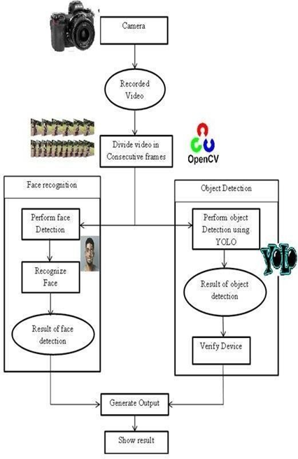

The proposed method is broadly divided into five parts of data collection, data processing, data classification, training and testing. The program uses a variety of image processing techniques to improve image quality and remove hidden pixels, as well as editing edges. The in- depth Convolution Neural Network (CNN) learning algorithm is used to classify images based on their characteristics. There are two main components of CNN architecture
•A convolution tool that separates and identifies various aspects of an image to be analyzed through a process called Feature Extraction.
•A fully integrated layer that uses the output from the conversion process and predicts the image phase based on the features extracted from previous sections.
Fully Convolution Connected
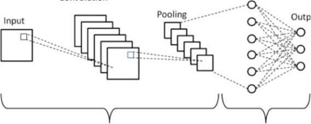
Fig.2 -Block Diagram

III -FEATURE EXTRACTION CLASSIFICATION

When the framework is completely assembled and tried for effectiveness, the code is then sent to Java.

Stage II : This was the second period of venture execution where the whole codewas composed

Python has been moved to Java for use on the Android application. Qualified models from class I are utilized straightforwardly in the Android application for visual and object acknowledgment.

Since the working framework was at that point constructed utilizing Python, the principal task at this stage was to incorporate library adjustment to help Android and Java, submit Python code and revamp it to Java to bring prepared models into the application. When the primary assignments are finished, the Android App is constructed and introduced on cell phones for texting. Android Voice API has likewise been added to guarantee that the outcomes are changed over completely to sound arrangement.

The figure below is the block diagram of proposed system :
Fig.3- Flow chart

The proposed program compares person- related items during the training period with the latest image provided by the program. If something is missing in the frame the system will highlight that and tell the user which objects is missing in the frame.
If you use human vision in your computer vision application, you can use a pre- trained model or give yourself a model yourself. If you give your model a lot of data, your device will be better able to see what you want and learn to improve it.
After receiving the photos, these results will be categorized. If it is personal based on a person's ID, it will display personal details and update the UI. In the case of objects then comparisons will be made in the previous and current image and it will be determined which object is not in the frame. Item will label and be given a UI to update the list and show missing items.

Computer literacy performs three different functions:

- Selects items from background images
- Promotes things as a class - people.
- Characterizes the socioeconomics of the proposed populace with x foundations and lengths and lengths and values
At the most elevated level, there are twovariables to think about while moving toward a photographic artist utilizing PC vision applications. To start with, there is the specialized side - how to track down individuals in a photograph or video. The subsequent part is how you can manage the outcomes, and it has to do with the nature of the advantages you get from your applicationimage. Yield: Old Label Location: Find the presence of items in a pictureRegularly, critical thinking in photograph or video information starts with formal picture characterization. In the first place, the instrument can involve the calculations in the establishment to distinguish the areas you are keen on. The machine will then think of a rundown of ideas in view of your settings. The last strides for reception are to sort objects in light of models, utilize potential and reestablish classes and areas in the system of your last supported recommendations.

The class you would like, for this situation, is individuals. The applications distinguish these human articles in the survey region by handling pretrained blocks by consolidating countless pictures with an inside and out Deep learning: man-made reasoning framework. These handling blocks are known as models, and can be prepared to see nearly anything individuals can see.
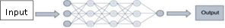
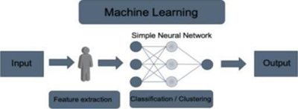
Feature extraction + Classification Code editor : Visual Studio
IV -RESUKT ANALYSIS

V- CONCLUSION

This project describes how to identify and identify a person and his or her belongings in real time. The project describes the system used to obtain items. By using precise CV cameras or drones with embedded counting functions, security companies can obtain accurate, updated demographics and aggregated data to inform employee decisions. The system operates in two basic steps; it sees a person and things, separates it and finally sees something that is not in the frame.
One of the major problems involving object detection is the classification of an object and the location of an object within an object. The use of deep neural networks has helped to address the topic of object acquisition. However, implementing such techniques on mobile devices requires high calibration and memory resources. So small deep neural network structures are used to find something like used to get real-time object when using mobile devices that can help the visually impaired.

REFERENCES

- OlegsNikisins, RihardsFuksis, Arturs Kadikis, ModrisGreitans "Face recognition system on Raspberry Pi" International Journal of Research in Advent Technology, Vol.3, No.5, May 2015.

- Harshal V. Khodaskar, Shashank Mane "Human Face Detection & Recognition Using Raspberry Pi" International Journal of Advanced Engineering, Management and Science (IJAEMS) jun 2014.

- Prof. Natali Almeida "Facial Recognition System applied to Multipurpose Assistance robot for Social Human-robot Interaction (MASHI)" International Journal of Engineering Trends and Technology (IJETT) - Volume 30; Number-I, December 2015

- David Gsponer "IOT: Building a Raspberry Pi security system with facial recognition" Bachelor's Thesis Degree Programme in Business Information Technology vol. 4, May 2018.

- Saurabh K. Patil, Narendra G. Narole " Smart Face Recognition Security Based On Raspberry Pi" International Journal of Engineering Science and Computing, Volume 8 Issue No.3 March 2018.

- Mr. Shamanth G S "Face Detection using Raspberry Pi and Python National Conference on Product Design (NCPD 2016),July 2016

- Mr. Shamanth G S "Face Detection using Raspberry Pi and Python National Conference on Product Design (NCPD 2016)", July 2016.

- Shrutika V. Deshmukh" Face Detection and Face Recognition Using Raspberry Pi" International Journal of Advanced Research in Computer and Communication Engineering Vol. 6, Issue 4, April 2017

- Swathi .VI, Steven Fernandes2 "Raspberry Pi Based Human Face Detection" International Journal of Advanced Research in Computer and Communication Engineering Vol. 4, Issue 9, September 2015

- Dahake, N. N. Mandaogade "Implementation of Raspberry Pi for Human Face Detection & Recognition Technical Research Paper Competition for Students (TRPCS-2K17)", 23 March 2017

- Ajeet Ram Pathak Manjusha Pandey Siddharth Rautaray Application of Deep Learning for Object Detection School of Computer Engineering, Kalinga Institute of Industrial Technology (KIIT) University, India,(2020)

- Shuo Yang, Ping Luo, Chen-Change Loy, Xiaoou Tang From Facial Parts Responses to Face Detection: A Deep Learning Approach ;Proceedings of the International Conference on Computer Vision (ICCV), pp. 3676-3684,(2021)

