EtherFund: A Decentralized Approach for Crowdfunding
Anuj J. Ghom¹, Atharv N. Phuse², Harish S. Chopade³, Mahesh A. Ghongade⁴
Prof. Sumit S. Sagane¹
P. R. Pote Patil College of Engineering and Management, Amravati, India, 444604

Abstract – Crowdfunding has emerged as a vital mechanism for raising funds, enabling startups, social causes, and creative projects to receive financial support from a broad audience. However, traditional crowdfunding platforms face challenges such as high transaction fees, lack of transparency, centralized control, and risks of fraud or fund mismanagement. To address these issues, we propose a Blockchain-Based Decentralized Crowdfunding Platform that leverages blockchain technology and smart contracts to enhance security, transparency, and trust in fundraising. By eliminating intermediaries, the system facilitates direct peer-to-peer transactions, ensuring immutability and automated fund distribution based on predefined conditions. This implementation utilizes the Ethereum blockchain to create an environment where fundraisers and backers can interact securely. The paper details the system architecture, smart contract design, security considerations, and a comparative analysis with traditional crowdfunding models. The results demonstrate improved transparency, reduced operational costs, and enhanced trust in the crowdfunding ecosystem.
Keywords- Crowdfunding, Blockchain, Decentralization, Smart Contracts, Ethereum, Transparency

INTRODUCTION
Crowdfunding has emerged as a powerful tool for raising funds for projects, startups, and social causes by connecting fundraisers with potential backers. However, traditional crowdfunding platforms are centralized, leading to several challenges, such as high transaction fees, lack of transparency, risk of fraud, and reliance on intermediaries for fund management. These limitations reduce trust among users and hinder the efficiency of crowdfunding campaigns.
Blockchain technology presents a transformative solution by enabling decentralized crowdfunding, where smart contracts automate transactions and ensure transparency without the need for third-party involvement. By leveraging blockchain, a crowdfunding platform can provide secure and immutable transactions, ensuring that funds are only released when predefined conditions are met.
This paper presents the design and implementation of a Blockchain-Based Decentralized Crowdfunding Platform that eliminates intermediaries and enhances security. The platform is built using the Ethereum blockchain and leverages smart contracts to manage fund transfers while ensuring campaigns meet their goals. This system is designed to enhance trust, streamline processes, and reduce costs compared to traditional crowdfunding methods.
LITERATURE SURVEY
The research paper highlights decentralization in Web 3.0, emphasizing its role in keeping the internet open and accessible. It explains how blockchains and decentralized P2P networks replace centralized servers, enabling DApps that enhance security and competition.[1] The research paper highlights the lack of fund control in traditional crowdfunding and the role of online platforms in enhancing public participation. It suggests that Ethereum Blockchain can improve transparency and traceability in charitable donations. [2]
The research paper highlights blockchain's role in making crowdfunding decentralized, secure, and transparent. It emphasizes how smart contracts and distributed ledgers improve fundraising efficiency and participant trust.[3] The research paper provides an overview of the crowdfunding sector, covering both investment-based platforms and those where funders do not receive monetary returns. It highlights key characteristics of this rapidly growing industry and examines the economic forces influencing platform design.[15] The study focuses on network effects, including cross-group and within-group externalities, as well as issues related to asymmetric information. These factors shape the interaction between funders and project creators, affecting platform efficiency and success. Overall, the paper offers insights into the fundamental mechanisms driving crowdfunding markets.[4]
This study explores the benefits of blockchain technology, including decentralization, persistency, anonymity, and auditability, while highlighting its wide range of applications across industries such as finance, IoT, and public services. Despite numerous studies on specific blockchain applications, a comprehensive survey covering both technological and application perspectives is lacking.[16] To address this gap, the paper provides a taxonomy of blockchain, reviews consensus algorithms, and examines key applications. It also discusses technical challenges and recent advancements in overcoming them. Additionally, the study identifies future research directions in blockchain technology.[5]
Blockchain technology enhances transparency in donation tracking, addressing donor concerns about fund utilization. A blockchain-based platform ensures secure and verifiable transactions, allowing donors to monitor fund allocation in real time.[12] By eliminating intermediaries, it improves trust between donors, charities, and recipients. The system ensures accountability and provides a clear donation route, increasing confidence in charitable contributions. This approach revolutionizes traditional donation processes by making them more efficient and transparent.[6]
Blockchain technology, initially developed for cryptocurrency, is now being widely adopted across various industries. It is expected to become a key component in secure online transactions. One promising application is in crowdfunding platforms, where issues such as lack of regulation, fraud, and project delays are prevalent.[13] Research highlights that integrating Ethereum smart contracts into crowdfunding can automate fund allocation, reducing fraud risks and ensuring timely project completion. This study explores how blockchain enhances trust and efficiency in crowdfunding by leveraging smart contracts for secure and transparent transactions.[7]
Blockchain technology enhances crowdfunding by addressing the limitations of traditional platforms, such as the lack of donor guarantee policies and control over funds. Existing crowdfunding systems rely on intermediaries, which can lead to security risks and inefficiencies.[14] By integrating blockchain, crowdfunding platforms can ensure transparency, security, and traceability of transactions. Donors can track fund utilization, and every transaction is recorded immutably on the blockchain. This decentralized approach minimizes risks associated with traditional crowdfunding, providing a more reliable and secure fundraising model.[8]
During the COVID-19 pandemic, many organizations raised funds to support local governments and those in need. Trust plays a crucial role in crowdfunding, involving funders, platform providers, and fundraisers.[17] This study analyses the implementation of blockchain and smart contracts in crowdfunding. The findings suggest that blockchain-based smart contracts can be effectively integrated into crowdfunding models, enhancing transparency, security, and trust in the fundraising process.[9]
Blockchain technology enhances crowdfunding by providing transparency, security, and trust between investors and stakeholders. Traditional crowdfunding relies on centralized platforms, raising concerns about credibility and fund management.[18] By integrating blockchain, crowdfunding platforms can ensure secure, tamper-proof transactions, increasing investor confidence. This approach reduces reliance on intermediaries, making the fundraising process more efficient. As a result, blockchain-based crowdfunding has the potential to attract more investors and revolutionize the way ventures secure funding.[10]
Blockchain-based crowdfunding addresses key issues in traditional fundraising, such as fraud and lack of transparency, by offering a decentralized and secure system.[19] This model leverages smart contracts to ensure trust, automate transactions, and enhance security. Existing blockchain crowdfunding platforms are reviewed, highlighting their benefits and limitations. Key challenges include compliance, scalability, and security, which require further research and innovation. Future advancements in blockchain technology can improve crowdfunding efficiency and investor confidence.[11]

METHOLOGY
The development of EtherFund, a Blockchain-Based Decentralized Crowdfunding Platform, follows a structured methodology consisting of the following phases:

Campaign Creation
Users can start a campaign by linking their MetaMask wallet to the web application. Once connected, they can set up a new campaign by providing details like the campaign title, a campaign image, a description, and the target fundraising amount. The smart contract for this process is written in Solidity and deployed on the blockchain. A new campaign is created through the Campaign Factory, which generates a new instance for each campaign. Every transaction requires a small gas fee to process, ensuring its validity. When a user clicks the "Create Campaign" button, a new campaign is generated with the necessary gas fee. Within a few seconds, the transaction is completed, and a new block is added to the blockchain with the contract address.
After creation, the campaign will be displayed on the homepage of the website for other users to view and interact with. Since the campaign exists on the blockchain, an E-Wallet like MetaMask is needed to manage all related transactions.

Contributors & Approvers
Contributors are users who donate funds to campaigns. After linking their MetaMask wallet, they can browse and select campaigns to support. The donated funds go directly to the campaign's address rather than the creator, ensuring transparency and reducing fraud risks. Approvers are contributors who have donated more than a set minimum amount. They have the right to approve withdrawal requests made by the campaign creator.

Withdrawal of Funds
Contributors who have donated to a campaign become approvers, giving them the power to approve or reject fund withdrawal requests. This ensures that funds are used as agreed upon by the investor community.
A withdrawal request requires approval from at least 50% of the approvers before funds can be released to a designated address. All transactions and approvals are securely recorded on the blockchain, making them transparent and tamper-proof. This system enhances trust and ensures that crowdfunding remains a secure and reliable way for startups to raise funds.
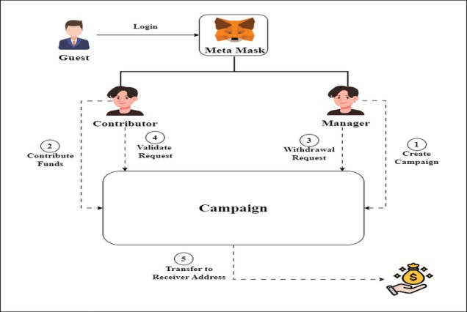

Fig. 1- System flow

RESULTS

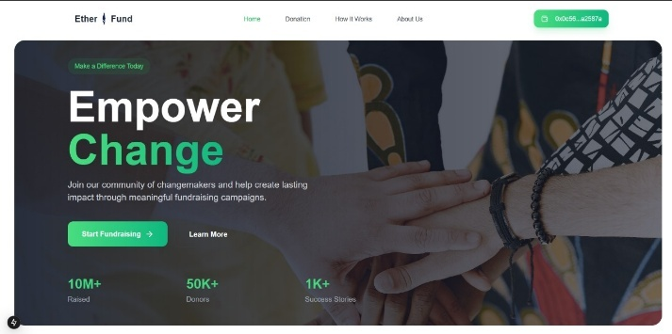
Fig. Home Page


Fig(b) Campaign Creation

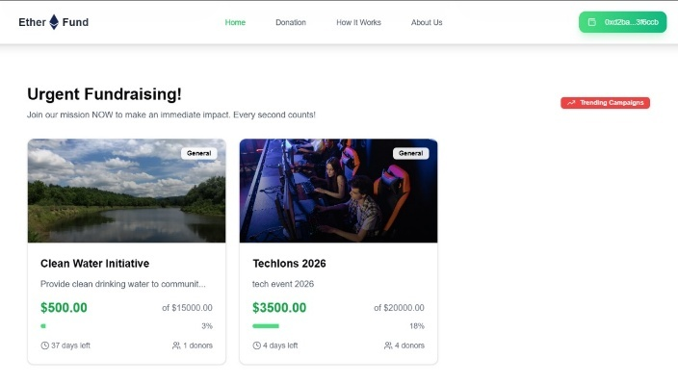
Fig(c) Campaign List

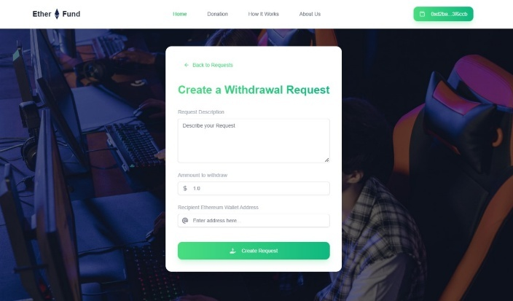
Fig(d) Withdrawal of amount from campaign


Fig(e) List of withdrawal requests

CONCLUSION
This paper presented the design and implementation of EtherFund, a Blockchain-Based Decentralized Crowdfunding Platform built on the Ethereum blockchain. By leveraging smart contracts, the platform ensures secure, transparent, and automated fund management, eliminating the need for intermediaries. The system architecture, development process, and deployment strategy demonstrate how blockchain technology enhances trust, efficiency, and cost-effectiveness in crowdfunding.
The results show that EtherFund improves transparency, reduces transaction costs, and prevents fraud by enforcing predefined funding conditions through smart contracts.

REFERENCES
- Goel, Amit & Bakshi, Rahul & Agrawal, Krishna. (2022). Web 3.0 and Decentralized Applications. 8. 10.3390/materproc2022010008.
- Dr. K. M. Anandkumar, Shravan Vignesh, M
Sivakumar and Syed Adnaan, “An approach for crowdfunding using blockchain”, 2024, E3S Web of Conferences 491, https://doi.org/10.1051/e3sconf/202449102021.
- Priyanka Gupta, Vedika Sangle, Rutuja Patil, Anjali Jadhav, Mayuri Aher, Shruti Khivansara,
“A Comparative Dive into Crowdfunding
Methods - Traditional vs Blockchain”, 2024.
- Belleflamme, Paul and Omrani, Nessrine and Peitz, Martin, The Economics of Crowdfunding
Platforms (March 20,
2015), http://dx.doi.org/10.2139/ssrn.2585611
- Zibin Zheng and Shaoan Xie, “Blockchain challenges and opportunities: A survey”, 2018, International Journal of Web and Grid Services 14(4):352 DOI:10.1504/IJWGS.2018.095647.
- Hadi Saleh, Sergey Avdoshin, Azamat Dzhonov,
“Platform for Tracking Donations of Charitable Foundations Based on Blockchain Technology”, Actual Problems of Systems and Software Engineering (APSSE), 2020
- Saadat, Md & Halim, Syed & Osman, Husna & Nassr, Rasheed & Zuhairi, Megat. (2019). Blockchain-based crowdfunding systems.
- Prof D. L. Falak, Soudagar Shanawaz, Jadhav Pranav, Katke Kajal, Shukla Utkarsh, “CrowdFunding Using Blockchain Technology”, 2022, International Journal of Research Publication and Reviews.
- Firmansyah Ashari, Tetuko Catonsukmoro, Wilyu Mahendra Bad, Sfenranto, Gunawan Wang,
“Smart Contract and Blockchain for
Crowdfunding Platform”, 2020, International Journal of Advanced Trends in Computer Science and Engineering, https://doi.org/10.30534/ijatcse/2020/83932020..
- "Crowd-Funding Using Blockchain technology", International Journal of Emerging Technologies and Innovative Research (www.jetir.org), ISSN:2349-5162, Vol.10, Issue 6, page no.g518g525, June-2023,
http://www.jetir.org/papers/JETIR2306662.pdf
- Rohan J Tilwani, Eshwar K U, Ms. Sindhu N, “Blockchain-Powered Crowdfunding”, Journal of Emerging Technology and Innovative Research, 2023.
- Vikas Hassija, Vinay Chamola, Sherali Zeadally, BitFund: A blockchain-based crowd funding platform for future smart and connected nation, Sustainable Cities and Society, Volume 60, 2020,
102145, ISSN 2210-6707,
https://doi.org/10.1016/j.scs.2020.102145
- Bogdan Tiganoaia, George-Madalin Alexandru”, Building a Blockchain-Based Decentralized Crowdfunding Platform for Social and Educational Causes in the Context of Sustainable Development, 2023
- Adwaith Viju, Aarushe Reddy, Thejas Nair, Levin Viji, Rohit Sharma,”Crowdfunding using
Blockchain”,International Journal for Research in
Applied Science and Engineering
Technology,2024, https://doi.org/10.22214/ijraset.2024.59996
- Chetan Dakhole, Prasad Tidke, Gaurav Dhok, Harshal Thakare, Samarth Khade, Prof. Sumit
Sagane “LAND REGISTRATION SYSTEM
USING BLOCKCHAIN TECHNOLOGY” in
International Research Journal of Modernization in Engineering Technology and Science (IRJMETS) on Volume:06, Issue:02, February2024.
- Arpita S. Mankar, Prathmesh S. Gorle, Sarthak R. Bhojane, Apurva R. Dandale , Prof S. S. Sagane “ E-Governance System For Property registration and Taxation Using Blockchain “ in international Journal of Scientific Research in Engineering & management (IJSREM) on Volume: 07 Issue: 04, April 2023.
- Pooja Sapate, Aasawari Mhalasane, Shriya Thakare, Tejaswini Lanjewar, Aditya Subugade , Prof. S. S. Sagane “Cloud Based Patient information Chatbot System” in International Journal of Scientific Research in Engineering and Management (IJSREM) Volume: 06 Issue: 05 | May - 2022, ISSN: 2582-3930.
- Prof. Sumit S. Sagane “A Review on Cloud computing virtualization” (CSE015) in International Conference on recent trends & research in Engineering and Science (ICRTRES 2K20), organized by Padm. Dr. V. B. Kolte College of Engineering, Malkapur - held on 02/05/2020 to 03/05/2020.
- Mr. Ravi V. Kute, Mr. Nilesh K. Bodkhe, Mrs. Tejaswini G. Ulemale, Mr. Sumit S. Sagane on Secure File Sharing With Intrusion Detection in Cloud Computing in International Journal for Scientific Research & Development (IJSRD) Vol. 6, Issue 02, on 2018, ISSN (online): 2321-0613
- Sumit S. Sagane, Dr. G. R. Bamnote “Study on Various Cloud Storage Systems” in International Journal of Advance and Innovative Research (IJAIR) volume 2 issued on 10th Oct. 2013.
21. Sumit S. Sagane, Dr. G. R. Bamnote “Flexible, trusted and Private Personal Storage System in Cloud Computing” In National Conference on Advance in Computing & Networking at PRMIT&R Badnera in March 2013.
22. Sumit S. Sagane, Dr. G. R. Bamnote “Secure Personal Storage System” in International Journal of Advanced Research in Computer Science and Software Engineering (IJARCSSE) in November 2013 volume- 3, Issue- 11.

