Food Supply Chain Optimization Using Block Chain Technology

MD Izhar¹, MD Aftab Raza², MD Tahseenuddin³, Dr. M.Anand⁴, Ms. G.Priyanka⁵,
Mrs. V.Jeeva⁶

^{1,2,3}UG Student, ⁴Professor, ^{5,6}Asst.Professor,,Department of Computer Science and Engineering, Dr. MGR Educational and Research Institute, Maduravoyal, Chennai 600095, TN, India
,

Received on: 14 March, 2025 Revised on: 18 April,2025 Published on: 22 April,2025

Abstract – Particularly blockchain, distributed Ledger technology (DLT) has transformed many industries; supply Chain management (SCM) is one of the fundamental benefactor. This paintings gives FARMSUPPLY, a brand new technique the use of blockchain to enhance traceability and openness in the food supply Chain (FSC). using Ethereum blockchain and smart contracts, FARMSUPPLY guarantees confirmation of important characteristics at every supply chain level—from farmer to merchant. FARMSUPPLY provides seamless preservation and retrieval of transaction data—including photos and locations—by means of immutable ledger recording and InterPlanetary file system (IPFS) integration. FARMSUPPLY solves important FSC problems via encouraging openness and traceability, therefore promoting informed decision-making and building confidence among the stakeholders. The FARMSUPPLY concept is thoroughly reviewed on this examine, with precise interest to its ability to transform FSC operations, raise consumer confidence, and assist the food zone to be normally green and sustainable.
Keywords - Distributed Ledger Technology (DLT), Supply Chain Management (SCM), Food Supply Chain (FSC), Block chain, Smart Contract, Verification and Validation”
INTRODUCTION
Emerging as a transforming device across several sectors, block chain technology presents a shared, unchangeable ledger that simplifies asset management and transaction recording [1]. Blockchain networks assist to song and alternate assets in corporate companies, where they might be both tangible and intangible, therefore reducing costs and risks related with conventional trading practices [2]. Blockchain's potential to exactly distribute data at high speeds—using its immutable ledger only available to authorised members—is key to its efficiency [3]. Adoption of blockchain in corporate operations presents several advantages, especially in improving responsibility and openness in numerous spheres of organisational activities [4]. Blockchain ensures a consistent and dependable view of transaction reality among all stakeholders through the registration and monitoring on an immutable ledger. This transparency fosters efficiency and assurance, enabling organisations to optimise resource allocation and mitigate risk [4].
In "Supply Chain Management (SCM)," blockchain delivers significant outcomes and enhances security measures [5]. Traditional supply chain management technology, often laborious and time-consuming, is poised for transformation with the implementation of blockchain technology [6]. Combining permissioned blockchains with standardised transaction encoding techniques and governance systems helps to simplify SCM processes and provide real-time view of important deliver chain characteristics [6]. among these are pricing, timestamps, product quality, region, certifications, and other pertinent data actually vital for efficient supply chain management [7]. Driven by its ability to transform food traceability and safety standards [8], blockchain integration into food supply chains has attracted more and more attention in lately. "food supply Chain (FSC)" management facilitated by blockchain improves traceability, hence accelerating the food origin tracking from farm to fork [9]. Blockchain reduces foodborne disease and counterfeit product hazards by guaranteeing adherence to meals safety and quality criteria [9]. Blockchain also gives food supply chain operations' stakeholders more responsibility, openness, and control [10].
2. LITERATURE SURVEY
The use of the blockchain era to "food supply chains (FSC)" and "supply chains management (SCM)" has drawn close attention from both researchers and practitioners. The purpose of this literature review is to provide an overview of important works in this field, emphasizing the advancements, strategies, and outcomes of blockchain adoption.
A preliminary study on blockchain technology in supply chain management was carried out by Yousuf and Svetinovic (2019), who emphasized its potential to enhance transparency, traceability, and efficiency [5]. In a similar vein, Cui (2021) examined the application of blockchain technology to supply chain financial risk management, emphasizing how it can lower financial risks and improve overall supply chain management operations [6]. The many benefits of blockchain technology for supply chain management will become more clear as a result of these investigations.
The nuances of blockchain adoption in the food supply chain and its effects on traceability, dependability, and privacy have been noted by scientists. The significance of blockchain technology in guaranteeing traceability and quality control in the food supply chain was emphasized by Satya et al. (2021) [14]. The goal of Malik et al. (2021) was to develop a trustworthy and traceable data protection chain for agri-foods. This study emphasizes how blockchain can be used to address inquiries about FSC members.
Blockchain-based solutions for knowledge integration, food supply chain regulation, and a focus on new trends and challenges were examined by Shweta and Prabodh (2021) [17]. Shahid et al. (2020) used blockchain technology to present a comprehensive system of the agricultural food supply chain. This covers quality control, transparency, and traceability [19].They offer a useful analysis of real- world blockchain uses in FSC research and its outcomes.
The literature review shows overall the increasing amount of studies on blockchain technology in food supply chains and supply chain management. Researchers have investigated several sides of blockchain adoption—including its possible advantages, drawbacks, and consequences for stakeholdersfrom exploratory studies to thorough evaluations. more study is required going ahead to handle new challenges and fully utilise blockchain capabilities in improving traceability, efficiency, and openness throughout supply chain systems.
3. METHODOLOGY
a) Proposed Work:
Using blockchain and smart contracts especially, the suggested system seeks to solve the shortcomings of current "supply chain management (SCM)" [5] systems by leveraging developing technologies.
Blockchain technology guarantees a tamper-proof and open ledger of transactions.
The distributed network of the proposed system lessens the dependence on a central authority. smart contracts help supply chain players to automatically and trustless cooperate, so simplifying procedures and lowering the demand for middlemen.
Smart contracts streamline operations for businesses by automating and enforcing agreements, reducing the need for extensive paperwork and manual processes. The cryptographic principles underpinning blockchain bolster the security of transactions and data. The transparent and verifiable nature of blockchain transactions enhances the credibility of supply chain enterprises.
b) System Architecture:
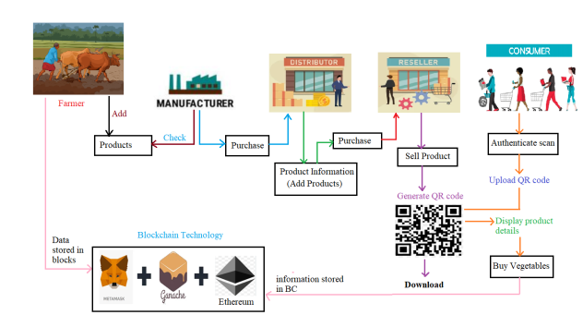
Fig1 Proposed Architecture
The system's architecture consists of five core elements: Grower, Producer, Supplier, Retailer, and end-user. For the purposes of data preservation and verification, every component interfaces with the blockchain technology framework, which includes Ethereum [20], Ganache, and Metamask.
Blockchain innovation allows agrarians to introduce fresh products into the network and store information in segments. Producers acquire from farmers, verify the merchandise, and then dispatch it to retailers. Distributors facilitate purchases from producers and oversee product details, moving items to sellers. Sellers generate QR codes for validation, promote products, and provide downloadable information on the items.
Shoppers generate fresh QR codes, upload scanned QR codes onto the blockchain, and verify products. They can buy veggies, access detailed product information, and ensure transaction data is securely stored on the Blockchain [1].
This framework ensures safety, accountability, and transparency across the entire food supply chain, thereby facilitating seamless collaboration among participants and boosting consumer trust in product genuineness and caliber.
c) Modules:
We utilized the modules of Farmer, Manufacturer, and Distributor to execute this project.
here are the descriptions of these modules:
I) Farmer Modules:
1. Farmer Registration:
Agricultural producers enroll by using their login details and providing the necessary information. This phase verifies their presence in the system, consequently enabling their involvement in the supply chain.
2. Farmer Login:
Entering their login information (password and username) allows enrolled farmers to access their accounts securely and with permission.
3. Add Product:
Producers enable the smooth incorporation of raw materials into the supply chain by adding subtleties to their agricultural products.
II) Manufacturer Modules:
1. Manufacturer Registration:
Manufacturers must provide the necessary information regarding registration and creation of login information for system participation. This stage means their origins and allows them to participate in supply chain sourcing.
2. Manufacturer Login:
In order to guarantee safe and approved access to accounts in your system, enter your identification, login credentials, and registered manufacturer password.
3. Check Product and Purchase:
Manufacturers check data, employ a range of items, and engage in trade when needed. In order to streamline operations, this function helps manufacturers acquire raw materials or intermediate products from farmers or wholesalers.
III) Distributor Modules:
1. Distributor Registration:
Manufacturers use a variety of products, review data and participate in trades when necessary. This feature supports manufacturers in obtaining intermediate products or raw materials from wholesalers or farmers to facilitate operations.
2. Distributor Login:
Distributors who are registered need to provide their login credentials (password and user). Here, you may be sure that the system will guarantee safe and approved access to your account.
3. Add Product:
By combining items into inventory and encouraging sales at their stores, retailers will help to create supply chains. This feature improves the distribution system's efficiency and guarantees a smooth product flow.
IV) Retailer Modules:
1. Retailer Registration:
By filling up the required forms, creating login credentials, and confirming its existence on the website, the dealer registers. This stage assists you in obtaining the resources required to perform memory inspections and handle transactions.
2. Retailer Login:
Enter your password and registered login details. Verified and safe access to your account is guaranteed by a certified business.

3. Sell Products and Generate QR code:
Retailers employ system features to increase sales and create QR codes to increase product visibility. This will facilitate the best possible customer transactions, encourage efficient inventory management, and propel overall performance.
V) Customer Modules:
1. Customer Registration:
By figuring out their login credentials and giving them the required information, customers start to commit to the system. Devices needed for authentication and purchase operations are accessible at this level.
2. Customer Login:
To verify safe and approved access to the system, enter the username and password of the registered user.
3. Authenticate Scan:
To increase supply chain trust and guarantee product efficacy, consumers use product scans to verify reliability.
4. Buy Vegetables:
Customers purchase vegetables in a transparent and safe manner by using a straightforward shopping strategy. This function enhances the purchasing experience and facilitates smooth system interaction.
d) Blockchain Integration:
Numerous supply chain businesses employ blockchain's distributed software architecture to translate information transactions. Data is stored in a network of nodes that are controlled by databases or central authority, guaranteeing enhanced security and decentralization. This lowers the possibility of a single point of error and strengthens the information change process.
Ethereum smart contracts ensure secure crop tracking and promote transparent and verifiable interactions. Smart contracts enforce the rules governing crop tracking by ensuring that the process is secure, transparent, and impenetrable. This increases the confidence of those involved in the food supply chain.
If you maintain the immutable ledger enabled by the blockchain, this means that you cannot change the data after input. Link to "Interplanetary File Systems & IPFS&#
1;" provides even more security and decentralization. The extended content mechanism allows you to store and retrieve data. The way to maintain this is block style. Each block in the blockchain is connected to a distinctive hash code. Some knots or servers hold these blocks that are held above them. Before storing clean entries, the blockchain checks the hash code for each block. If all block data needs to be changed, the hash code will also be changed, and data integrity and invariable due to the use of security alarms. Therefore, blockchain and IPF create operation-resistant communication files where IPF's distribution and content properties satisfy the immutability of the blockchain.
Blockchain technology eliminates middlemen, transaction records, and centralized authority from the food supply chain. The distributed nature of blockchain technology eliminates the need for a reliable middleman by enabling information to flow and transactions between relevant parties to occur directly between them. This reduces the chance of fraud, increases supply chain efficiency, and aids in cost control.
e) GANACHE:
Ganache is an intuitive user interface for tracking Ethereum blockchain activities. It facilitates the tracking of accounts, transactions, and smart contracts, enabling access even for individuals who are not very knowledgeable about blockchain. By offering complete transaction information, such as sender, recipient, amounts, gas consumption, and success status, Ganache ensures transaction accuracy and aids in debugging. Additionally, it monitors smart contract implementations to ensure appropriate deployment and use. This transparency simplifies validation and monitoring processes.
We can examine the details of each Ethereum blockchain block thanks to Ganache. We can find out what transactions took place inside a block, when it was introduced, and how much gas—the processing energy—was used up there. Additionally, Ganache allows data to be retrieved from stored blocks, which allows developers to access and examine specific block information.
f) METAMASK:
Metamask functions as an Ethereum wallet and a browser extension. It streamlines interactions with blockchain apps by providing direct access to DApps and assisting with bitcoin management.
By showing the ETH deduction as fees, Metamask promotes transparency and ensures safe Ethereum transactions within the project.
This transparency helps maintain accuracy and ensures secure, reliable financial transactions within the system.
4. EXPERIMENTAL RESULTS
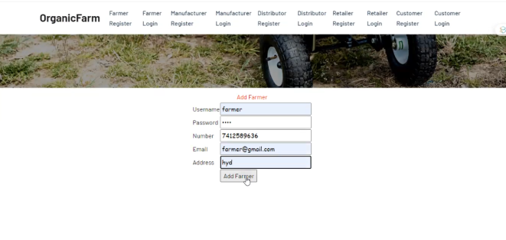
Fig 2 Registration Screen
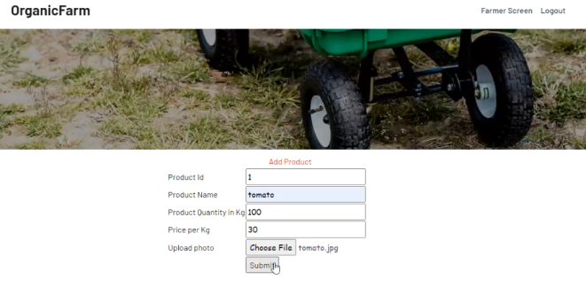
Fig 3 Add Product Screen
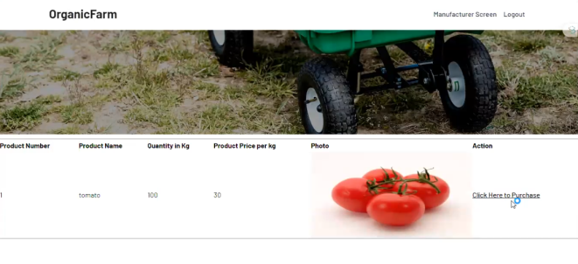
Fig 4 Click Here to Purchase
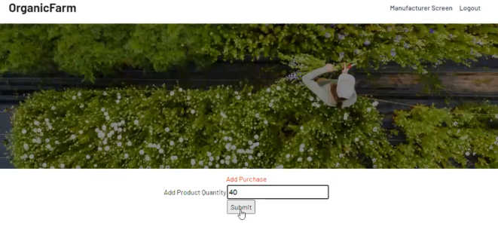
Fig 5 Add Product Quantity
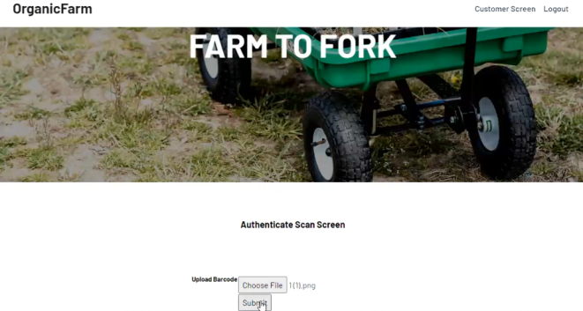
Fig 6 Authenticate Scan Screen
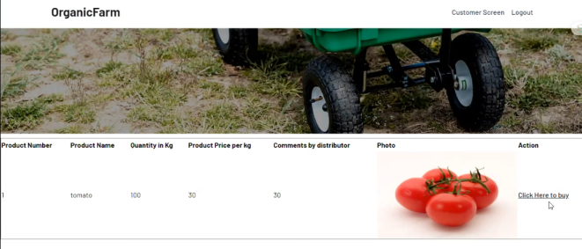
Fig 7 Click Here to Buy
5. CONCLUSION
In this paradigm, intelligent contracts and the Ethereum blockchain [20] changed the assessment of transactions in the food supply chain. The general truths created through the use of blockchain technology allow parties to take on supply chain transparency and responsibility. The proposed approach reduces fraud, ensures an unparalleled environment, while simultaneously providing consistency, efficiency and open data. Transaction records, stored securely in common books, allow for easy persecution and data access methods. The project will improve harvests, support open communication channels through Ethereum intelligent contracts and operation-resistant blockchains, improving supply chain safety and reliability. This initiative includes those assigned to blockchain [1]-ARA by removing interim traders, trading facts, and centralized governments. Additionally, a powerful record mechanism is created along with the interplanetary file system & IPFS & immutable main book. Each fact is explicitly recognized and connected to ensure permanent communication. This all-encompassing strategy not only improves the safety and efficiency of the food supply chain, but also paves the way for the next function of agricultural technology and supply chain management [5].
6. FUTURE SCOPE
Future scope of the proposed project includes progressive data analysis, predictive knowledge within the supply chain, and integration into development technologies such as "artificial intelligence (KI)" and "Internet of Things (IoT)" for automation. Systems can use IoT and artificial intelligence to improve decision-making, maximize resource allocation, and actively deal with supply chain difficulties. Standardized methods and regulatory systems must also be advanced to promote the general use of blockchain technology across all supply chains. The definition of common standards and ensuring interoperability and compatibility in many ecosystems in the supply chain relies on cooperative efforts between corporate takeholders, governments, and international organizations. These projects stimulate agricultural methods and inspire inventions by encouraging, promoting openness and efficiency throughout the supply chain.
REFERENCES

- P. Frauenthaler, M. Sigwart, C. Spanring, M. Sober and S. Schulte, "ETH Relay: A Cost-efficient Relay for Ethereum-based Blockchains," 2020 IEEE International Conference on Blockchain (Blockchain), 2020, pp. 204-213, doi: 10.1109/Blockchain50366.2020.00032.
- D. Li, Q. Guo, D. Bai and W. Zhang, "Research and Implementation on the Operation and Transaction System Based on Blockchain Technology for Virtual Power Plant," 2022 International Conference on Blockchain Technology and Information Security (ICBCTIS), 2022, pp. 165-170, doi: 10.1109/ICBCTIS55569.2022.00046.
- P. Shen et al., "A Survey on Safety Regulation Technology of Blockchain Application and Blockchain Ecology," 2022 IEEE International Conference on Blockchain (Blockchain), 2022, pp. 494- 499, doi: 10.1109/Blockchain55522.2022.00076.
- G. Wang and M. Nixon, "InterTrust: Towards an Efficient Blockchain Interoperability Architecture with Trusted Services," 2021 IEEE International Conference on Blockchain (Blockchain), 2021, pp. 150- 159, doi: 10.1109/Blockchain53845.2021.00029.
- S. Yousuf and D. Svetinovic, "Blockchain Technology in Supply Chain Management: Preliminary Study," 2019 Sixth International Conference on Internet of Things: Systems, Management and Security (IOTSMS), 2019, pp. 537-538, doi: 10.1109/IOTSMS48152.2019.8939222.
- H. Cui, "Blockchain Technology and Its application Research in Supply Chain Financial Risk Control," 2021 International Conference on Computer, Blockchain and Financial Development (CBFD), 2021, pp. 401-404, doi: 10.1109/CBFD52659.2021.00087.
- Z. Li, "Remolding of the Supply Chain Development Mode Based on the Block Chain Technology," 2021 International Conference on Computer, Blockchain and Financial Development (CBFD), 2021, pp. 392-395, doi: 10.1109/CBFD52659.2021.00085.
- L. Su and H. Wang, "Supply Chain Finance Research in Digital Bulk Commodities Service Platform Based on Blockchain," 2020 International Conference on E-Commerce and Internet Technology (ECIT), 2020, pp. 341-344, doi: 10.1109/ECIT50008.2020.00085.
- N. N. Ahamed, T. K. Thivakaran and P. Karthikeyan, "Perishable Food Products Contains Safe in Cold Supply Chain Management Using Blockchain Technology," 2021 7th International Conference on Advanced Computing and Communication Systems (ICACCS), 2021, pp. 167-172, doi: 10.1109/ICACCS51430.2021.9442057.
- N. Anjum and P. Dutta, "Identifying Counterfeit Products using Blockchain Technology in Supply Chain System," 2022 16th International Conference on Ubiquitous Information Management and Communication (IMCOM), 2022, pp. 1-5, doi: 10.1109/IMCOM53663.2022.9721789.
- https://www.globenewswire.com/newsrelease/2020/11/23/2131535/0/en/The-global-blockchain-inagriculture-and-food-supply-chain-market-size-is-estimated-to-beUSD-133-million-in-2020-and-is-projected-to-reach-USD-948- million-by-2025-at-a-CAGR-of-48-.html Last Accessed on 19 Nov 2022
- B. Subashini and D. Hemavathi, "Detecting the Traceability Issues in Supply chain Industries using Blockchain Technology," 2022 International Conference on Advances in Computing, Communication and Applied Informatics (ACCAI), 2022, pp. 1-8, doi: 10.1109/ACCAI53970.2022.9752478.
- M. C. Jayaprasanna, V. A. Soundharya, M. Suhana and S. Sujatha, "A Block Chain based Management System for Detecting Counterfeit Product in Supply Chain," 2021 Third International Conference on Intelligent Communication Technologies and Virtual Mobile Networks (ICICV), 2021, pp. 253-257, doi: 10.1109/ICICV50876.2021.9388568.
- D. Sathya, S. Nithyaroopa, D. Jagadeesan and I. J. Jacob, "Block-chain Technology for Food supply chains," 2021 Third International Conference on Intelligent Communication Technologies and Virtual Mobile Networks (ICICV), 2021, pp. 212-219, doi: 10.1109/ICICV50876.2021.9388478.
- A. K. Hadi and S. Salem, "A proposed methodology to use a Blockchain in Supply Chain Traceability," 2021 4th International Iraqi Conference on Engineering Technology and Their Applications (IICETA), 2021, pp. 313-317, doi: 10.1109/IICETA51758.2021.9717543.
- S. Malik, V. Dedeoglu, S. S. Kanhere, R. Jurdak and H. -Y. Paik, "Traceable, trustworthy and privacy preserving agri-food supply chains," 2021 Third IEEE International Conference on Trust, Privacy and Security in Intelligent Systems and Applications (TPS-ISA), 2021, pp. 313-320, doi: 10.1109/TPSISA52974.2021.00034.
- A. N. Shwetha and C. P. Prabodh, "A Comprehensive Review of Blockchain based Solutions in Food Supply Chain Management," 2021 5th International Conference on Computing Methodologies and Communication (ICCMC), 2021, pp. 519-525, doi: 10.1109/ICCMC51019.2021.9418305.
- G. S.B., H. V., S. P. Gokarnkar and B. Ravishankar, "Adoption of blockchain in the supply chain to improve quality of product and customer service in manufacturing sectors," 2020 International Conference on Mainstreaming Block Chain Implementation (ICOMBI), 2020, pp. 1-8, doi: 10.23919/ICOMBI48604.2020.9203060.
- A. Shahid, A. Almogren, N. Javaid, F. A. Al-Zahrani, M. Zuair and M. Alam, "Blockchain-Based Agri-Food Supply Chain: A Complete Solution," in IEEE Access, vol. 8, pp. 69230-69243, 2020, doi: 10.1109/ACCESS.2020.2986257.
- Ozturan, C. (2020) “Barter machine: An Autonomous, distributed barter exchange on the ethereum blockchain,” Ledger, 5. Available at: https://doi.org/10.5195/ledger.2020.148.

