•

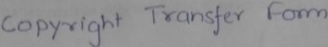

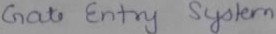

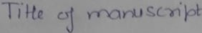I >"' c Y 'IS'll.J (nor l 1 f<D1Jet l4 1<t ,..,. ia
Nc\ n- ie (j
Al Llt •Ol
1'-YAI.')' I t- t.i'io..U ( 'V'.\.(.lhl Y) ' ) ,, l

( "'t{l L )Y('I<; j ('



