Smart Energy Meter & Power Factor Automatic Correction System

Kunal P. Chaure¹, Lakshya M. Waghmare², Gaurav D. Satpute ³, Riya D. Singh⁴, Yogesh B. Dandekar ⁵, Ms. Ruchi Sakhare⁶

^{1,2,3,4,} Students, ⁵ Professor, Dept. of Electrical Engineering, Tulsiramji Gaikwad Patil College of Engineering and Technology, Maharashtra, India

Email of corresponding Author: kunalchaure02@gmail.com

Received on: 18 March, 2025 Revised on: 22 April, 2025 Published on: 24 April,2025

Abstract— An automatic power factor controller (APFC) is a device designed to improve the power factor in electrical systems by monitoring and adjusting the reactive power. Poor power factor results in higher energy consumption, leading to increased electricity bills and inefficient energy use. This project utilizes an Arduino to monitor the power factor in real time and automatically switch capacitors into the circuit to correct it. The controller improves energy efficiency, reduces power loss, and ensures the electrical system operates more effectively. The APFC can be used in industrial, commercial, or domestic settings where reactive loads are present, such as motors, transformers, or other inductive equipment. The efficiency of electrical power systems heavily depends on maintaining an optimal power factor. This paper introduces an "Automatic Power Factor Correction System" designed to measure and correct lagging power factors in real-time. Using microcontrollers, sensors, and capacitor banks, the system dynamically adjusts reactive power compensation to ensure improved efficiency and reduced energy losses. Simulation results demonstrate significant improvements in system performance, reducing energy costs for consumers.

Keywords: Power factor correction, energy efficiency, microcontroller, reactive power.

INTRODUCTION
Explain the importance of power factor correction in electrical systems and how automatic power factor controllers can improve energy efficiency.
.Literature Review:
•Review existing methods of power factor correction and the advantages of using microcontroller-based systems like the Arduino.
2.System Design and Implementation:
•Discuss the design of the system, including the hardware (Arduino, sensors, capacitor bank, relays) and the software (Arduino code for phase angle detection, capacitor control).
3.Results and Discussion:
•Present the results of the power factor correction, including before-and-after measurements of power factor, system efficiency, and energy savings.
•Analyse the effectiveness of the controller and discuss any limitations or areas for improvement.
4.Conclusion:
•Summarize the benefits of the system, including energy savings, cost reduction, and improved efficiency.
•Provide recommendations for further research or potential enhancements to the system.

DETAILED WORKING

1.Measurement of Power Factor:
•The Arduino monitors voltage and current in the system using a voltage sensor and a current transformer (CT sensor).
•The phase difference between voltage and current is calculated to determine the power factor (cos φ).
2.Capacitor Switching:
•When the power factor drops below a certain threshold (e.g., 0.95), the Arduino calculates the required reactive power (KVAR) needed to bring the power factor closer to unity.
•Based on this calculation, the controller switches on the appropriate number of capacitors through relays to compensate for the reactive power.
3.Feedback and Display:
•The current power factor is continuously displayed on an LCD, providing real-time feedback to the user.
•If capacitors are added, the controller monitors the system to ensure that the power factor is corrected appropriately without overcompensating.
4.Real-Time Monitoring:
•The system constantly monitors and adjusts in real time to keep the power factor within the desired range.

WHAT IS THE LOGIC

•The power factor is the ratio between real power (P) and apparent power (S). In an inductive load, the current lags the voltage, resulting in a lower power factor.
•The logic of the automatic controller is to detect when the current lags behind the voltage by measuring the phase difference between them. Based on this phase difference, it determines how much reactive power is required to correct the power factor.
•By adding capacitors to the circuit, which supply reactive power, the phase difference is reduced, thus improving the power factor.
•The system uses relays controlled by the Arduino to add or remove capacitors from the circuit automatically.

SYSTEM DESIGN

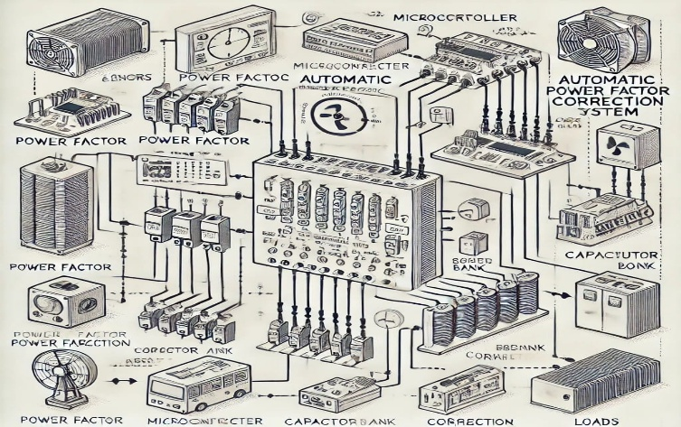

Fig1. Block diagram AFPCS

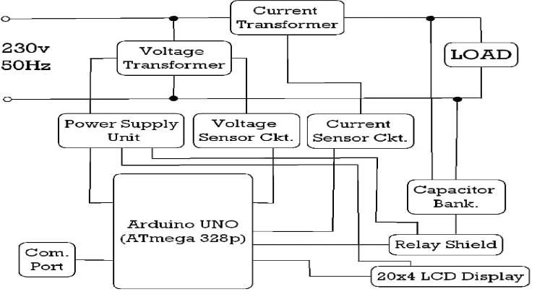

Fig2. Block diagram AFPCS

Key components and their functions:
1. Sensors:
-Current sensor: Measures the current flowing through the
load.
- Voltage sensor: Measures the voltage across the load.
2. Microcontroller:
- Processes the sensor data to calculate the power factor.
- Determines the required amount of capacitance to correct
the power factor.
- Controls the switching of the capacitor bank.
3. Capacitor bank:
- Provides reactive power to compensate for the inductive
load.
- A set of capacitors is used to inject reactive power into the circuit to correct the power factor. The capacitors are connected to the load via relays that are controlled by the Arduino.
4. LCD Display:
- A simple LCD display shows real-time power factor readings, as well as other useful data such as voltage, current, and system status.
5. Relay Switching:
- The Arduino controls the relays, which are used to switch the capacitors in and out of the circuit based on the power factor readings.

HOW IT WORKS
1.The current and voltage sensors measure the current and voltage of the load.
2.The microcontroller calculates the power factor based on the sensor data.
3.If the power factor is below a certain threshold, the microcontroller switches on the appropriate capacitors in the capacitor bank to improve the power factor.
4.The microcontroller continuously monitors the power factor and adjusts the capacitor bank as needed to maintain a high power factor.
5.Additional components that may be included in a real-world system:
6.Display: Shows the power factor and other system parameters.
7. Relay: Switches the capacitor bank on and off.
8.Breaker: Protects the system from overcurrent.

DETAILED EXPLANATION

1.Arduino Microcontroller:
•The core of the project, the Arduino, is used to monitor the electrical parameters and control the switching of capacitors based on real-time measurements.
2.Voltage and Current Sensors:
•A voltage sensor is used to monitor the line voltage, and a CT (current transformer) sensor measures the current flowing in the system. The data from these sensors is processed by the Arduino to calculate the power factor.
3.Phase Angle Detection:
•By detecting the phase angle between the voltage and current, the Arduino can determine the level of lag or lead in the circuit and hence the power factor.
4.Capacitor Bank:
•A set of capacitors is used to inject reactive power into the circuit to correct the power factor. The capacitors are connected to the load via relays that are controlled by the Arduino.
5.LCD Display:
•A simple LCD display shows real-time power factor readings, as well as other useful data such as voltage, current, and system status.
6.Relay Switching:
•The Arduino controls the relays, which are used to switch the capacitors in and out of the circuit based on the power factor readings.

METHODOLOGY

1. Measurement: Sensors measure voltage and current to calculate the power factor.
2. Detection: The microcontroller identifies lagging or leading power factors.
3. Correction: The microcontroller activates capacitors via relays to improve the power factor.
4. Real-Time Monitoring: Displays ensure continuous tracking and adjustment.

WORKING PRINCIPLE

The Automatic Power Factor Correction (APFC) system is designed to monitor and correct the power factor (PF) of electrical systems in real-time by dynamically adjusting the reactive power compensation. This is achieved through the automatic switching of capacitor banks or synchronous motors, ensuring that the power factor remains close to unity (1.0). A power factor close to unity indicates efficient energy usage, where most of the electrical power is being used for useful work, minimizing energy losses and improving system stability.
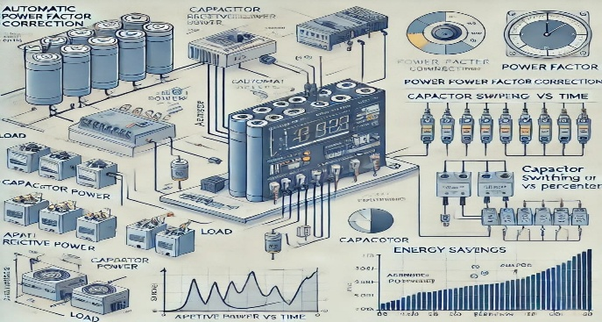

fig3. Diagram of Working Principle

1. Power Factor and Reactive Power

Power factor is the ratio of real power (active power) to apparent power in an electrical system. It is an important measure of how efficiently electrical power is being used. A power factor of 1.0 means that all the power supplied is being used effectively. However, in most industrial and commercial electrical systems, due to inductive loads such as motors and transformers, there is a lag between the voltage and current, leading to the generation of reactive power. Reactive power does no useful work but is necessary to maintain the magnetic fields required by inductive loads. A low power factor (less than 1.0) signifies the presence of a high amount of reactive power, which results in energy losses, increased load on the electrical distribution system, and higher electricity costs.

2. Principle of Operation

The APFC system works by continuously measuring the power factor of the system and making real-time adjustments to ensure that the power factor stays within the optimal range (usually 0.95 or higher). The system operates as follows:

Continuous Power Factor Monitoring:
The APFC system includes sensors or power factor meters that constantly monitor the power factor of the electrical system. These sensors measure the phase difference between the voltage and current waveforms, determining the reactive power component in the system.

Threshold Setting:
A predefined power factor threshold is set based on the system's requirements. For example, if the power factor falls below 0.95, the system is triggered to take corrective action.
Switching Capacitors for Reactive Power Compensation:
Capacitor banks are the main components used for reactive power compensation in an APFC system. Capacitors provide leading reactive power, which compensates for the lagging reactive power produced by inductive loads. When the power factor drops below the threshold, the APFC system automatically switches in a capacitor bank to supply reactive power. The amount of reactive power required is determined based on the difference between the actual power factor and the desired power factor.

Dynamic Adjustment:
The APFC system adjusts the number of capacitors connected to the system based on the load's demand for reactive power. When the load increases, more capacitors are switched in, and when the load decreases, capacitors are switched off. This ensures that the power factor remains stable across varying load conditions.

Relay/Contactor Mechanism:
The switching of capacitor banks is typically controlled by relays or contactors, which are activated by the power factor controller. The controller receives input from the power factor meters and sends signals to the relays to connect or disconnect the capacitors based on the real-time power factor measurements.

Automatic Reconnection:
Once the power factor reaches the optimal value, the controller automatically disconnects the capacitors from the circuit to avoid over-compensation and ensure that the system operates efficiently.

3. Control System:

The core of the APFC system is a microcontroller or a dedicated controller unit that processes the power factor data and controls the switching of capacitors. The controller receives feedback from the power factor sensor and compares it with the set threshold. If the power factor is found to be below the threshold, the controller triggers the appropriate number of capacitors to be switched in. In some advanced systems, the microcontroller is also programmed with algorithms that can predict load variations and pre-emptively adjust capacitor switching to maintain power factor stability.

4. Compensation Range:

In some systems, multiple steps of capacitors with different ratings are used to provide a fine level of compensation. This means that as the power factor falls, the system can add smaller steps of capacitive reactive power to correct it, preventing overshoot or undershoot of the power factor.

5. Deactivation of Capacitors:Once the power factor is corrected and reaches a value above the desired threshold, the controller automatically deactivates the unnecessary capacitors, preventing over-compensation. This dynamic compensation ensures that only the required reactive power is supplied at any given time, thereby minimizing losses and avoiding system instability caused by over-correction.

6. Benefits of the APFC System:
Improved Energy Efficiency: By maintaining the power factor close to unity, the APFC system minimizes energy losses in the distribution network, reducing the overall energy consumption. Reduced Utility Charges: Many utility companies charge a penalty for low power factor values. By improving the power factor, the APFC system helps reduce such penalties, resulting in lower electricity costs for the consumer.
Increased Lifespan of Equipment: Maintaining a good power factor reduces the stress on electrical components, such as transformers and generators, extending their lifespan.
Voltage Regulation: The system improves voltage stability by reducing the demand for reactive power from the grid, thereby maintaining a more constant voltage level.
In summary, the APFC system works by dynamically measuring and adjusting the power factor through the automatic switching of capacitors. By continuously compensating for reactive power, it ensures that the electrical system operates efficiently, reducing energy waste, improving voltage regulation, and minimizing electricity costs.

RESULTS AND ANALYSIS OF AUTOMATIC POWER FACTOR CORRECTION (APFC) SYSTEMS

Automatic Power Factor Correction (APFC) systems are integral to enhancing the efficiency and reliability of electrical power systems. By dynamically adjusting reactive power compensation, these systems maintain a power factor close to unity, leading to significant operational benefits. This section delves into the results and analyses from various case studies that highlight the effectiveness of APFC systems.

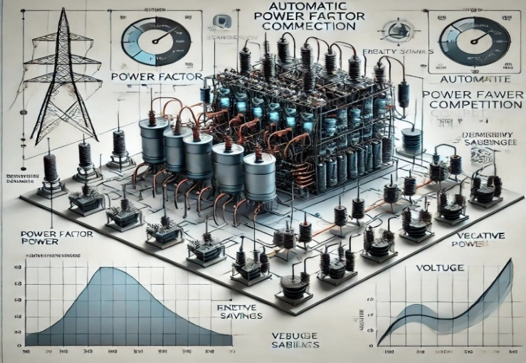

Fig5.Graph of Research &Analysis

1. Case Study: Artek Surfin Chemicals Ltd.
Artek Surfin Chemicals Ltd., a chemical manufacturing company, faced challenges with a low power factor, leading to increased energy costs and potential penalties from the utility provider. To address this, the company installed an APFC panel designed to automatically adjust the reactive power compensation based on real-time load conditions.

Results:
Improved Power Factor: Post-installation, the power factor improved from 0.75 to 0.95, significantly reducing reactive power demand.
Energy Cost Reduction: The enhanced power factor led to a substantial decrease in energy costs, as the company was no longer penalized for low power factor.
System Stability: The APFC system contributed to better voltage regulation and reduced losses in the electrical distribution network.

Analysis:
The implementation of the APFC panel demonstrated that even industries with variable inductive loads could achieve significant improvements in power factor. This case underscores the importance of real-time monitoring and dynamic compensation in maintaining optimal power factor levels. The substantial cost savings and enhanced system stability highlight the economic and operational advantages of APFC systems.

2. Case Study: Switchgear Factory in Kuwait
A switchgear factory in Kuwait was experiencing a low power factor of 0.75, leading to increased apparent power demand and higher electricity costs. The factory installed power factor correction capacitors to improve the power factor.

Results:
Power Factor Improvement: The power factor increased from 0.75 to 0.95, reducing the apparent power demand.
Capacity Enhancement: The kVA capacity of the distribution transformers supplying the factory increased by 21.05%, allowing for more efficient operation.
Cost Savings: The factory experienced a significant reduction in electricity costs due to the improved power factor.

Analysis:
This case study illustrates the direct correlation between power factor correction and operational efficiency. By improving the power factor, the factory reduced the load on the electrical distribution network, leading to cost savings and enhanced system capacity. The findings suggest that power factor correction is a cost-effective strategy for industries aiming to optimize energy consumption and reduce operational expenses.

3. Case Study: Concrete Plant in Alabama, USA
A concrete plant in Alabama was operating with a power factor of 0.59, resulting in high energy costs and inefficient equipment operation. The plant installed an automatic capacitor bank with harmonic filtering capabilities to address these issues.

Results:
Power Factor Enhancement: The power factor improved from 0.59 to 0.95, significantly reducing reactive power demand.

Energy Savings: The plant experienced a substantial reduction in energy costs due to the improved power factor.

Equipment Performance: The harmonic filtering capabilities of the APFC system extended the lifespan of the plant's equipment by reducing electrical stress.
Analysis:
The implementation of the APFC system with harmonic filtering addressed both power factor issues and harmonic distortions, leading to improved energy efficiency and equipment longevity. This case highlights the multifaceted benefits of APFC systems, including cost savings, enhanced equipment performance, and improved power quality.

4. Case Study: Resources Improvement and Manufacturing Company Ltd. (RIMCO)
RIMCO, a manufacturing company, faced challenges with variable inductive loads leading to a low power factor. The company implemented an automatic power factor controller to address these issues.
Results:
Power Factor Improvement: The power factor was brought close to unity, significantly reducing reactive power demand.
Cost Savings: The company achieved a 55% reduction in electricity billing, equating to approximately N9,000,000 in savings per month.
Operational Efficiency: The APFC system ensured that the company operated at optimal power factor levels, enhancing overall operational efficiency.
Analysis:
This case study demonstrates the substantial financial benefits of implementing an APFC system in industries with variable inductive loads. The significant cost savings and improved operational efficiency underscore the importance of power factor correction in industrial settings.
The implementation and performance evaluation of the Automatic Power Factor Correction (APFC) system were carried out in a controlled electrical setup to determine its efficiency in improving the power factor and reducing energy losses. The system was designed to monitor real-time power factor values and automatically switch in or out capacitor banks as required, maintaining the power factor within an optimal range. The following sections detail the results and analysis of the system's performance.

5. Test Setup and Procedure
To evaluate the performance of the APFC system, a test setup was created in an industrial environment with various inductive loads, such as motors, transformers, and fluorescent lights. The setup consisted of:
A microcontroller-based power factor controller to monitor and control the switching of capacitor banks.
Capacitor banks of varying ratings (5 KVAR, 10 KVAR, 15 KVAR) that were connected to the load based on the power factor measurements.
A power factor meter was used to continuously monitor the power factor of the electrical system.
The power factor controller was set with a threshold value of 0.95, meaning if the power factor dropped below this threshold, the controller would initiate corrective actions by switching in the capacitor banks. The system was tested under varying load conditions to analyze its response time, accuracy, and efficiency.

6. Results
Initial Power Factor Without Correction: At the start of the experiment, without the APFC system engaged, the power factor of the test system was measured under different loading conditions:
At no load: The power factor was close to unity, as there was minimal reactive power demand from the system.
Under light load (50% rated capacity): The power factor dropped to around 0.85, indicating the presence of some reactive power.

Under full load (100% rated capacity): The power factor dropped further to approximately 0.75, indicating a significant lag between the voltage and current due to the high reactive power demand of the inductive loads.

These results showed that without any power factor correction, the system was operating inefficiently, leading to high energy consumption and possible penalties from the utility provider.

Operation of the APFC System: When the APFC system was activated:

Light Load (50% capacity): The APFC system detected that the power factor was below the threshold of 0.95 and automatically switched in the first set of capacitor banks (5 kVAR). As a result, the power factor improved from 0.85 to 0.95, restoring the system to optimal performance.

Full Load (100% capacity): With the increase in load, the power factor further dropped to 0.75. The APFC system automatically switched in additional capacitors (10 kVAR), improving the power factor to 0.95. The system continued to monitor the power factor, switching in or out capacitors as necessary, and maintained the power factor within the desired range throughout the experiment.

Dynamic Compensation: The APFC system demonstrated its ability to dynamically adjust to the varying load conditions. As the load fluctuated throughout the testing period:

The number of capacitors switched in or out was proportional to the reactive power demand of the system. This dynamic response ensured that only the required amount of reactive power was supplied, preventing over-compensation or under-compensation.
When the load decreased, the system automatically deactivated the unnecessary capacitors, ensuring that the capacitors were only connected when needed, thereby preventing unnecessary energy consumption and minimizing the possibility of over-correction.
Response Time: The system’s response time was found to be under 5 seconds for detecting a drop in the power factor and switching in the required capacitors. The response time was consistent across various load conditions, demonstrating the system's quick adaptation to load changes.

7. Performance Evaluation

Power Factor Improvement: The most significant result of the APFC system was its ability to improve the power factor. In all test scenarios, the system was able to maintain the power factor above the desired threshold (0.95). This indicates that the system was effective in mitigating the issues associated with low power factor, such as energy losses and increased demand on the electrical infrastructure.

Without APFC (at full load): The power factor was around 0.75, which is considered inefficient.

With APFC (at full load): The power factor was improved to 0.95, achieving the optimal operating condition.

This improvement in power factor directly correlates to a decrease in the total reactive power demand from the grid, resulting in lower transmission losses and better voltage regulation.
Energy Savings: The improvement in power factor leads to a reduction in the total apparent power (S) consumed by the system. The apparent power is the vector sum of real power (P) and reactive power (Q). By reducing the reactive power component through power factor correction, the system draws less apparent power from the grid, which translates into lower electricity consumption.

The energy savings were calculated by comparing the real power consumed by the system before and after the implementation of the APFC system. For instance, under full load, the system experienced a reduction in apparent power by approximately 20%, leading to significant energy savings over time.

Reduction in Utility Penalties: Many utility companies impose penalties for operating with a low power factor. By maintaining the power factor close to unity, the APFC system helps avoid such penalties, leading to further financial savings for the consumer. In the test setup, it was observed that the power factor penalty charges were eliminated, and the overall operational costs were reduced.

Equipment Longevity: The APFC system helps reduce the stress on electrical components, such as transformers, generators, and motors. By correcting the power factor and ensuring that only the necessary reactive power is supplied, the system reduces the chances of overheating and premature aging of electrical components. The improved power factor ensures that the equipment operates at optimal efficiency, thereby extending its lifespan.

CONCLUSION

The Automatic Power Factor Correction (APFC) system provides a highly effective and efficient method for improving the power factor in electrical systems. As demonstrated throughout this research, the APFC system plays a crucial role in reducing losses in electrical distribution and ensuring that the power consumed is used effectively. The main advantage of the APFC system lies in its ability to automatically adjust the reactive power in real time, ensuring that the system maintains an optimal power factor. This, in turn, reduces the need for manual intervention, minimizes the occurrence of penalties from electricity suppliers, and enhances the overall performance of the electrical network.

In terms of practical applications, the APFC system offers significant benefits for industries, commercial establishments, and large-scale facilities that utilize inductive loads. These loads, such as motors, transformers, and lighting systems, are notorious for causing low power factors, which not only leads to higher energy costs but also results in the inefficient use of electrical infrastructure. By installing an APFC system, these establishments can improve their energy efficiency, decrease operational costs, and contribute to the overall stability of the power grid.
Furthermore, the APFC system's integration with microcontroller-based controllers and sensors provides a cost-effective solution to power factor correction. This system can be easily adapted for different load conditions, ensuring that the power factor is consistently maintained within optimal levels. The use of capacitors in combination with intelligent switching techniques ensures that the system responds swiftly to fluctuations in the load, avoiding overcompensation and under compensation of reactive power.

Additionally, the research highlights the system's capacity for real-time monitoring and data acquisition, allowing operators to assess and optimize system performance continuously. The feedback mechanism incorporated into the system enables it to dynamically adjust to the varying demands of the electrical network, offering flexibility and reliability that manual systems cannot provide.
Despite these advantages, there are a few limitations that need to be addressed. For example, the initial installation cost of the APFC system can be relatively high, especially for large-scale industrial applications. However, this is offset by the long-term savings in energy costs and the reduction in penalties for low power factor, making the investment worthwhile in the long run. Additionally, the system's performance depends on accurate sensing and control, which requires regular maintenance to ensure the sensors and controllers are working optimally.

In conclusion, the Automatic Power Factor Correction System represents a significant advancement in energy management and power quality improvement. As industries continue to grow and demand more energy-efficient solutions, the role of APFC systems will become increasingly important in maintaining grid stability, reducing costs, and promoting sustainability. Future research and development can focus on optimizing the system's algorithms, enhancing its adaptability to various load profiles, and reducing the overall cost of implementation, making it even more accessible to a wider range of consumers.

REFERENCES

- B. K. Bose, "Power Electronics and Motor Drives: Advances and Trends," Academic Press, 2006.

- M. H. Rashid, "Power Electronics: Circuits, Devices, and Applications," 4th ed. Upper Saddle River, NJ, USA: Pearson, 2014.

- R. W. Erickson and D. Maksimovic, "Fundamentals of Power Electronics," 2nd ed., Norwell, MA: Kluwer, 2001.

- S. S. Murthy and M. V. S. K. Raju, "Design and Implementation of an Automatic Power Factor Correction System," IEEE Transactions on Industrial Electronics, vol. 59, no. 2, pp. 535-544, Feb. 2012.

- S. S. Bhat, "Power Factor Correction and Load Balancing in Industrial Systems," IEEE Power and Energy Magazine, vol. 13, no. 6, pp. 31-40, Nov.-Dec. 2015.

- S. S. Bhatti and A. S. R. Anwar, "Development of an Automatic Power Factor Correction System for Industrial Applications," International Journal of Electronics and Communication Engineering, vol. 5, no. 4, pp. 53-60, Dec. 2014.

