Mini Solar Power Plant For Agriculture Dr. A.R.Kondelwar¹, Ujwal Munne², Ashish Badole³, Harshad Ingle⁴ ¹Assistant Professor, Department of Electronics & Telecommunication Engineering Priyadarshini college of engineering, Nagpur, India ^{2,3,4}Research Scholar, Department of Electronics & Telecommunication Engineering Priyadarshini college of engineering, Nagpur, India

Abstract
Solar mini power plant basically use for Agriculture purpose & also solar energy is clean and free to use. We are going to construct a mini solar power plant which produce the electricity through sun rays and used for the watering crops. One solar power plant will supply electricity to the 5-10 farms or more nearer to the plant. The solar power plant is a pollution free and it does not require more cost for its installation and maintenance this will be economical to the government of our country.

Keywords: Solar Panel, Microcontroller, Relays, Sun tracking system, Quota system, GSM, Motor, Battery charging unit, power supply.

- INTRODUCTION
India is an Agriculture country, many people do the farming in our country. But there is always a problem of load-shedding during day and night in rural areas this puts the farmer in trouble and this affects the production in the farm. In summer this causes a big issue. They are not able to supply water to the crops, plant in the farms. If the problem of load-shedding continue then how the plants will grow without water? This will reduce the production level in the farm. As we know that food, clothes and shelter are the basic needs of human beings and without food no one can survive and to fulfill the demand of food we have to supply regular water to the land and to supply the water we need electricity. So mini solar power plant is the best and unique solution for this problem to provide the supply to the farmers. This mini solar power plant solves the problem of load shedding and increases the production level. As the solar energy is pollution free and it also not require much cost for its installation and maintenance and it is a free gift of nature. This will proved to be economical for the government of India. One solar power plant will supply 1-04 farms nearer to the plant. During load-shedding periods farmers can take supply from these plan watered the crops in the farm. It's

Completely free of cost to the farmers. Here we allocate a small land for small power plant with small grid system and provide the supply to desired farms. Solar energy can be used for pumping of water in two ways. In direct conversion scheme, solar energy is directly converted into electricity using solar cells. This electricity either stored in batteries or used directly in D.C motors [1].

LITERATURE REVIEW
The author says that, “The replacement of diesel- or grid-powered water pumps with solar energy offers environmental, economic, and social benefits via climate change moderation, improved Alimentation, and greater quality of Life. As a result, India’s government is recommend solar Pumping technologies via direct capital alimony, financing schemes, and legal and administrative development. Despite such attention, and while solar pump systems have shown significant promise, challenges in implementation continue to anticipate the full realization of environmental, economic, and social gains. In this paper, we examine three small-scale system implementation models across India grant-funded pay-it
Forward systems for agricultural use in Uttar Pradesh, grid-tied sprinkling systems in Karnataka, and direct to customer financed systems for salt farming in Gujarat.[2]

The author says that, “Electrification by mini hybrid PV-solar energy system for rural, remote and mountainous/tribal areas” It is need to provide electricity for domiciliary use to each family in each locality including remote and tribal belt of each state. This paper present an analysis of power supply using Solar and Wind hybrid energy in south-west of Rajasthan. This area includes parts of Baswara, Sirohi, Pali, Jalore, Barmer and Jaisalmer. There are some mountainous/trible belts in south-west Rajasthan where the consistency of population is less than hundred persons per Sq. kilometer. Geographically this is hilly area where people live in scattered shelter in mountainry area where it is very costely to supply electricity to each and every shelter. To enlighten these huts in dark nights and to provide them Electricity for household use in each and every session is the goal. Hybrid wind-solar Energy may be a boon for this area [3].
The one of the author says that, “A. Ali Power Engineering and Optimization Conference (PEDCO) 2012 IEEE International,” mini-grid power system optimization formation and economic analysis of solar powered river water desalination plant for rural communities and emergency comfort conditions “This project develops a mini-grid hybrid power system to provide certain supply of clean water supply for rural areas and emergency comfort conditions. This formation process includes the mini-grid power system with desalination plant and economic analysis for the whole project life cycle. The mini-grid power supply introduces solar power as the sole power supply after considering the geographical conditions of rural areas that make it not applicable to build transmission line interconnection with the exiting national grid. Experimental prototype of mini-grid desalination plant are developed to verify the reliability of power and water supply [4].
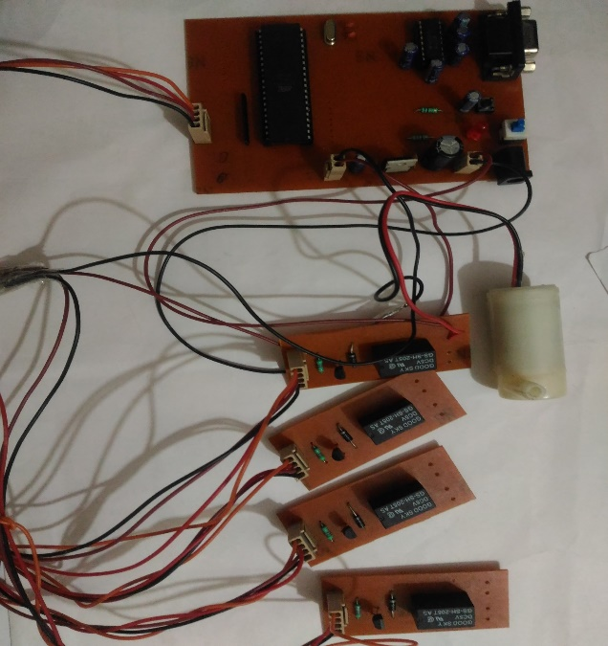
3. IMPLEMENTATION
3.1 Block Diagram
Battery banks
Solar panels
Battery charging unit
Motor
8 0 5 1
Distributer Relay
Relay Driver

Motor Driver
Buttons 1-4
1
Serial Driver IC
Relay 1-4

Sensor Ckt 1-4

GSM
Motor
1-4

Sun Tracking Ckt
Multiple water pump

Fig 1. Block diagram of mini solar power plant [5]

Solar Panel:
The fig. 1 shows the implementation of our mini solar
Power plant system. Firstly this device convert the light into electricity. This generate the electricity through light and gives it to the battery charging unit. Solar cell are the building block of Photovoltaic modules, otherwise known as solar panels.

II. Microcontroller Section:
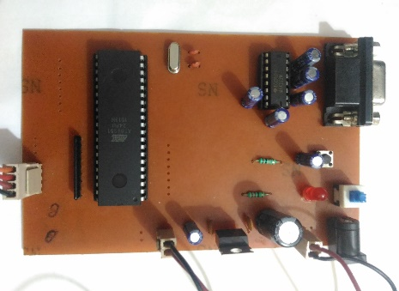

Fig 2. 3D View of Microcontroller section
Microcontroller is heart of computer on a chip which is include RAM, ROM and output pins, in the block diagram all process control the system. Serial driver is used to support serial communication. It convert the TTL logic to CMOS logic and vice versa between microcontroller and GSM. GSM is a device which is used for message sending and Calling [6].
III. Relay driver section:

Fig 3. 3D View of Relay section
It is used to drive relays. Microcontroller send signal to the relay driver circuit and relay driver makes the relay ON / OFF.
IV. Sun Tracking System:
This circuit checks the movement of sun from east to west to get the light on panel and this signal are send to microcontroller.
V. Quota System:
In the quota system through the sunlight battery gets charged upto a certain voltage level. Then the supply is distributed to the all farm nearer to the power plant equally with the help of quota system. If the battery
Storage is X volt and the 4 farm are connected to the power plant then X/4 supply voltage is given to the farm. If the usage exceed then the supply will be disconnected. And if any one of them not use then this will be stored for the use of next day.
VI. GSM:
GSM is a global system for module device which can be either a mobile or a modem device which can be used to for communication purpose. A GSM model require sim card to be operated and operate over a network range subscribed by the network operator. In this project we are using this device or modem for the sending a messages to a farmer and fault indication, if any problem are found in the system then GSM will send a message to a farmer. Also we are using serial driver IC for communication medium between the GSM and microcontroller [7].
VII. MOTOR
Motor it is used for the watering the farm. It is a dc motor which carrying a near about 1-2ampere current for pumping.
VII. BATTERY CHARGING UNIT:
It is a battery overcharging protection circuit. In this circuit we are use IC LM358 for to check continuously battery voltage level. This battery charging unit is used to charge the battery upto 12v as well as it protect battery from overcharging.
VIII. POWER SUPPLY:
In this project we are using two power supply one supply is used to drive the motor and another is used for controller section and other section. In this power supply we are used IC7805 means voltage regulator which convert 12V power supply to 5V because controller work on a 5V power supply and 12v power supply used for driving the motors.
4. RESULT
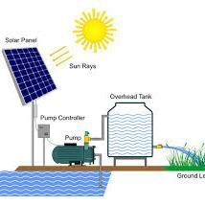
For this we have used the following machineries with the parameters shown below:-
DC motor (36W) Battery (12V, 8A) = 96W the duration of the battery i.e. Battery Watt/ motor power (Watt) 96/36 = 2.66 hrs. 2.66 hrs. The time for which the battery will supply the power. Also we have used 4 solar panels resulting in 500mA or 12V. Therefore the total solar power is 500ma*12V = 6W. Therefore, 6W is the total solar panel power. Battery Charging time can be concluded by Battery power/ solar power i.e. 96W/6W = 16hrs. Hence, 16hrs will be the time taken by the battery to fully charge one time. The following Table 1. Shows the parameter of actual and practical reading of mini solar power plant system.
Parameters | Actual Reading | Practical Reading
Motor output | 0.75kW (120-180V) | 36W
Battery output | 48V 60A | 12V 8A
Solar panel output | 400-500W | 6W
Battery time | 11 hrs. | 2.66 hrs
Battery charging time | 7.2hrs | 16hrs
TABLE 1. Actual & Practical Reading Parameter of Solar Power Plant System

5. APPLICATION Some of the application of this project: 1. The irrigation system in most of the arid agriculture areas is either dependent upon rain or water pump.
2. Solar mini power plant is used in Agriculture for water pumping.
3. The solar mini power plant it is use for Saving the Most of Electricity.
4. The project is used to conserve the wastage of water and to efficiency manage the amount of watering of the plant.
6.CONCLUSION With this Mini solar power plant integrating power generation system will be highly effective at all the places especially in rural areas where the commercial electricity has not reached or undelivered.

Fig 4. Practical Model of Mini solar power plant
So mini solar power plant is the best and unique solution for this problem to provide the supply to the farmers. This solves the problem of load shading and increases the production level. As the solar energy is pollution free, a free gift of nature, requires less cost for its installation and maintenance. This will proved to be economical for the government of India. The fault detection will become easy as we have introduced the GSM system. The messages will be sent about the maintenance.

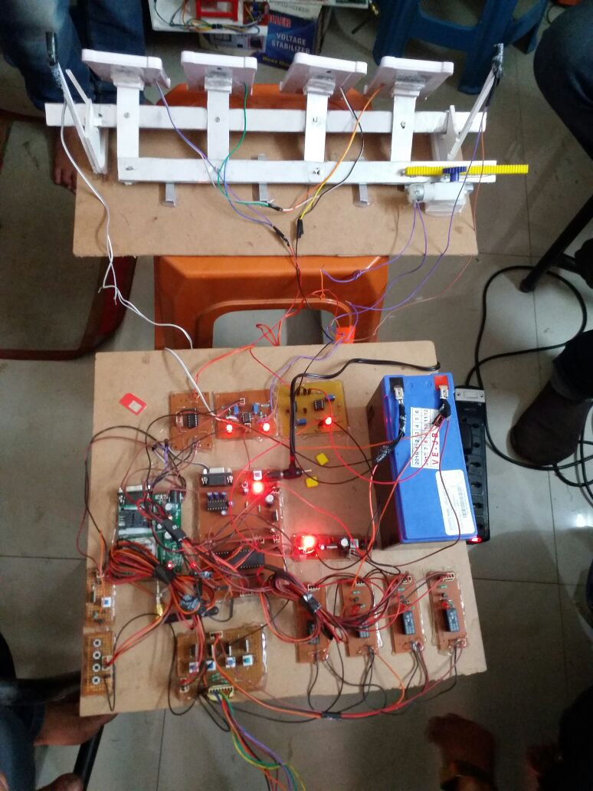
7. Overview Model of Mini Solar Power Plant System

Fig 5. Actual model of mini solar power plant system

REFERENCES
[1] H. P. Garg, J. Prakash “Textbook of solar energy Fundamental and application” Method of analyzing the actual status of Solar powered water thermal water pump Chapter Fifteen (page No 342-348) Association for Tata McGraw-Hill Publishing Company Limited. [2] Jonars B. Spielberg, Amit Gandhi, Sara Lynn Pesek, Jennifer L. Green, Vandana Pandya “Small Scale solar Pumping system in India” Published in Global Humanitarian Technology Conference (GHTC), 2016 International Conference on 13-16 Oct. 2016, Electronics ISBN: 978-1-5090-2432-2, USB ISBN: 978-1-5090-2431-5.
[3] Pradeep Anjana H. P. Tiwari “Electrification by mini hybrid PV-solar/wind energy system for rural, remote and Hilly/trible areas in Rajasthan(India)” Electric Utility Deregulation and Restructuring and Power Technologies (DRPT), 2011 4th International Conference on 6-9Jully 2011 Computational Intelligence and Computing Research (ICCIC), Electronic ISBN: 978-1-4577-0365-2 Print ISBN: 978-1-4577-0364-5
Jully 2011 IEEE.
[4] N. H. Baharudin; T. M. N. T. Mansur, R. B. Ali, A. A. A. Wahab, N. A. Rahman, E. A. R. E. Ariff, “Mini-Grid power system optimization design and economic analysis of solar powered sea water desalination plant for rural communities and emergency relief condition” Published in Power Engineering and Optimization Conference (PEDCO) Melaka, Malaysia, 6-7 June IEEE International, 2012, Print ISBN: 978-1-4673-0660-7.
[5] Binoy Seal, omkar Shirke, Siddesh Shewale, Abhilash Sirsikar, Prof. Priya Hankare ”Solar based automatic irrigation system” Published in International journal of research in advent technology, Vol 2, No.4, April 2014 E-ISSN: 2321-9637.
[6] Muhammad Ali Mazidi and Janice Gillispie Mazidi
“Textbook of the 8051 Microcontroller and Embedded System” The Method of analyzing the actual status of I/0 Port Programming Chapter four (page No 84-90) Copyright By Pearson Education, Inc.
[7]William C. Y. Lee “Textbook of mobile cellular Telecommunication analog and digital system” The Method of analyzing the actual status of Digital Cellular system chapter Fifteen (page No 463-465) Second edition Published By McGRAW–HILL INTERNATIONAL EDUCATION.

