Leveraging IoT for Detecting Power and Water Theft in Urban Environments: A Comprehensive Review

Rohit P. Bhoge¹, Janhavi Holey², Vidhan Rajput³ , Shardul Rathod ⁴, Yash Raut⁵,
Praful Nandankar⁶

Electrical Engineering Department, Government College of Engineering Nagpur, Maharashtra, India
pppful@gmail.com

Received on : 15 May 2024, Revised on: 23 May,2024 , Published on:25 May,2025

Abstract— Utilities such as power and water are the basic needs of today’s modern world, with increase in theft of such utilities serious challenges arises to urban environment. Economic losses, resource scarcity are some of the challenges. Advancement in Internet of Things (IoT) has introduced many innovative, scalable, and optimal solutions towards these problems. The designs of these solutions enable real time monitoring of data, automated detection of theft, alerting the users and analysis of consumer patterns. This review paper explores the various IoT-based technologies and methodologies developed to detect and mitigate power and water theft in urban infrastructure.
Keywords—Power theft, Water theft, IoT systems, Theft detection, Flow sensor, Smart meters, Voltage sensor, Current sensor, Raspberry pi, Cloud storage.

I-Introduction
In the urban environment across the globe, the problems related to power and water theft have emerged as a significant theft for utility companies and local authorities. We know the opulation in urban areas is increasing drastically, increasing the demand for essential resources such as electricity and water. This increasing demand is fulfilled by illegal connections or by tampering meters to manipulate the consumption. This not only affects social-economic growth and development of the country, but also set back other sectors[1].
Figure 1 Classification of different methods for power theft
Power theft includes illegal connections, tampering with meters, and avoiding billing systems, leading to major economic losses for utility companies. According to a report by the World Bank, electricity theft accounts for about $96 billion in losses annually, with urban areas being particularly affected due to higher population densities and greater infrastructure complexities[2]. Similarly, water theft happens through illegal tapping of water mains, and meter tampering. The International Water Association estimates that non-revenue water, which includes theft, accounts for 25-50% of total water production in many cities[3].
The consequences of utility theft is beyond economic losses. It damages sustainability and reliability of urban infrastructure, and disturbs resource management. Detection and prevention of such thefts is crucial for efficient and proper distribution of resources.
To tackle with such issues, utility companies are moving towards advanced technologies and innovative approaches to counter theft. Smart meters, Internet of Things (IoT), Artificial Intelligence and Machine Learning (AIML), and Geographic information systems are being used[4]. Smart meters, for example, allow for continuous monitoring of consumption patterns, making it easier to detect anomalies that may indicate theft[5].
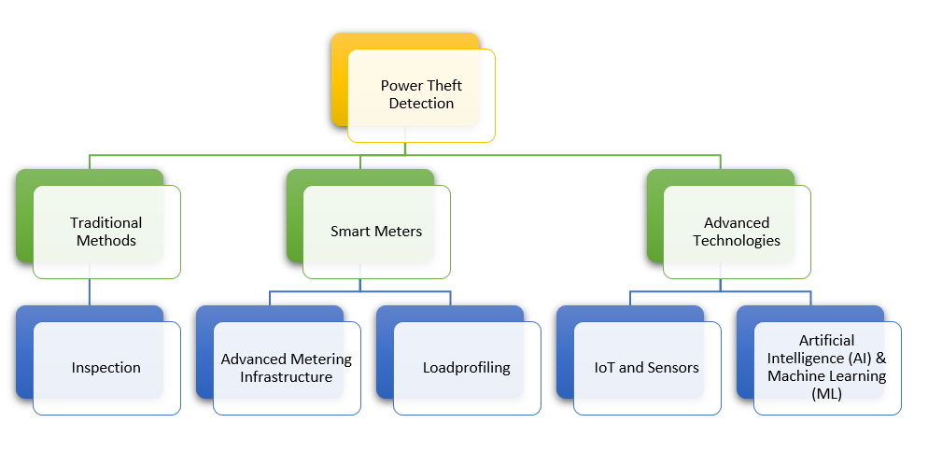
Further in this article, a review of existing technologies for power and water theft has been made along with the comparison of them and which you can prefer for power and water theft detection based on different parameters.

II-Methodologies

Power Theft Detection
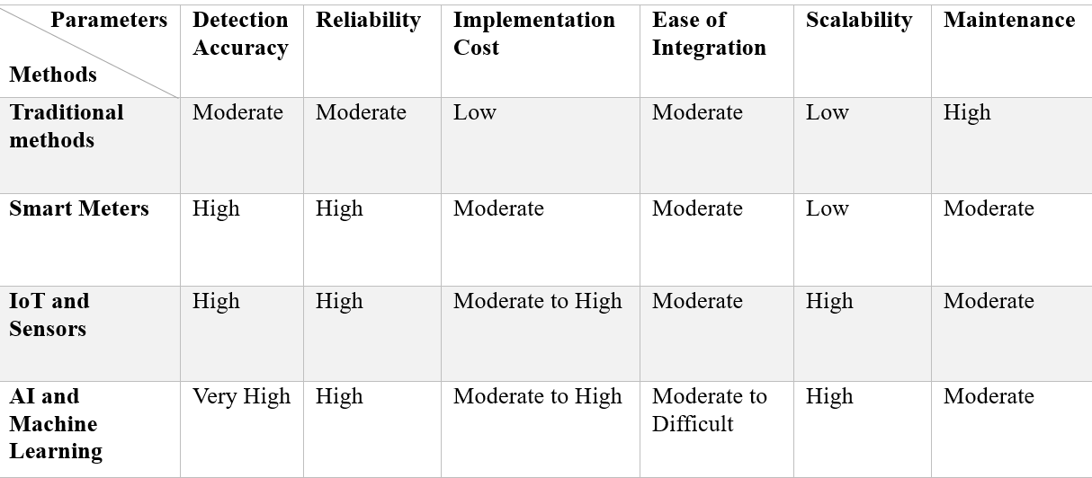
Power theft detection is a serious and significant issue for electric companies in India as it leads to major financial losses and affects the stability and reliability disturbing the frequency of the power grid and damaging the consumer end machines. Different methodologies have been developed in the recent years to identify and avert power theft. These methodologies can be mainly categorized into traditional, smart meter-based, and advanced technologies.
Table 1: Detailed comparison of power theft detection methods
Traditional Methods are the foundation for new modern day techniques and advanced technologies in finding and blocking illegal and tampered connections. The traditional methods are not as effective as latest advanced technologies as they are inspection based and they count deliberately on surrounding people for monitoring and systematic purpose. Below is the detailed elaboration on the key traditional method used:
a) Inspection - Electricity companies conduct frequent audit of meters and distribution lines for any possible fault and theft. Officers visit allotted areas to check for irregularities. They maintain a proper documentations to ensure strict inspection, ensuring the meter is securely installed, and checking for any signs of tampering. Officers look for visible signs of tampering, such as broken or missing seals, physical damage to the meter, or signs of forced entry into meter boxes. Checking for illegal connections, such as wires attached to the meter bypassing the measurement mechanism or direct tapping into power lines. Environmental clues like Observing surroundings for signs of illegal activity, like unusually high power usage in areas where consumption is expected to be low (e.g., residential areas at night).
Smart Meters is a remarkable and major technological escalation in the utility distribution sector. Wide range of functions enhances the monitoring, detection, and prevent electricity theft. Following section elaborates on the various smart meter-based methods, highlighting their features, capabilities, and impact on power theft detection.
a) Advanced Metering Infrastructure (AMI) - It is a system that includes collection and processing of the electricity usage data from the smart meters interlinked via a network. It also monitors and evaluates the real time data which play a significant role in indicating power theft. Smart meters transfers the user data about electricity consumption after every 15 minutes to the cloud storage. The flow of data received by the central system which is then monitored according to the user patterns in real time which helps in analysing abnormalities in the usage. The system is configures in such a way that when there is any unusual pattern of electricity consumption it detects and generates an alert for cases like zero consumption or sudden drop in expected usage. Smart meters have sensors to detect physical tampering like if the enclosure is opened or if there is some other type of tampering with the meter, the meter logs and sends such data with the usage data letting utility companies to locate when and where tampering has occurred.
b) Load Profiling - It involves study of consumption pattern of consumer to identify the difference from the normal usage, which can be considered as a theft. The load curves give us the graph for power usage over time, thus with load curves utility companies can spot strange consumption patterns. Detailed profiling also helps in understanding consumer behaviour, making it easier to identify inconsistencies and possibly unauthorized usage. Smart meters are capable of monitoring phase current of electrical distribution system, phase imbalances may suggest illegal connection or power diversion.
Advanced Technologies are the latest modern day methods used to identify and prevent the theft in electric distribution system, with the introduction of internet it has become a lot easier to tackle with theft detection for utility companies. Technologies such as Internet of Things (IoT), different sensors, Artificial Intelligence (AI) and Machine Learning (ML), and Blockchain technology are part of the advanced technologies, in below section we will discuss about them in briefly.
a) Internet of Things (IoT) and Sensors - IoT is a collection of interlinked devices equipped with various sensors that gathers data and transmit it over a network or sometimes between the devices. In the power theft detection, IoT devices are crucial in real time monitoring and finding illegal connections. Various sensors which are placed in the distribution network monitors the consumption pattern and transmit the collected data to some storage regularly, which is analysed by utility companies allowing them to access the real time data of consumer usage. These sensors can accurately detect the abnormal patterns of consumer usage indicating power theft. Thermal sensors and vibration detectors can be used to find physical tampering attempts, such as unauthorized connections or meter tampering. These sensors detect unusual changes in temperature or physical vibrations around meters or distribution equipment.
b) Artificial Intelligence (AI) and Machine Learning (ML)- AI and ML techniques are increasingly used for diagnostic study and abnormality detection in power consumption data. AI algorithms process historical consumption data along with external affecting factors (e.g., weather, time) to speculate expected usage patterns. On the basis of modulations from these predictions can indicate potential theft. ML models are trained to recognize patterns of normal electrical power consumption. They can identify abnormalities, such as steady low power consumption or irregularities in load profiles. This analysis helps in identifying undetectable patterns that may not be possible through manual inspection.

Types of IoT Based Power Theft Detection System
As per the observations based on Table 1, IoT is the most balanced and suitable approach in different aspects and terms. The initial cost for the system can be higher but the long term benefits of real time monitoring and automated process gives it an edge over these expenses. Thus on the basis of IoT we have some technologies or designs which is discussed below.
1] Raspberry Pi Theft Detector - It is a generalised IOT based design using raspberry pi to detect electricity theft by comparing the recorded values of current at the utility service intake to the recorded value of current at the energy meter intake. The result of the compared values is stored on the firebase server, which is accessible in real-time[6]. The utility service box (USB) is feed with the transmission line supply which is measured by a relay consisting of a current sensor, similarly the consumer end also a relay connected in series with the meter and load. Both the current sensors transmits the data to the raspberry pi which then process them and uploads

on a cloud server via NodeMCU. The utility company can monitor real time data for any suspicious connection.
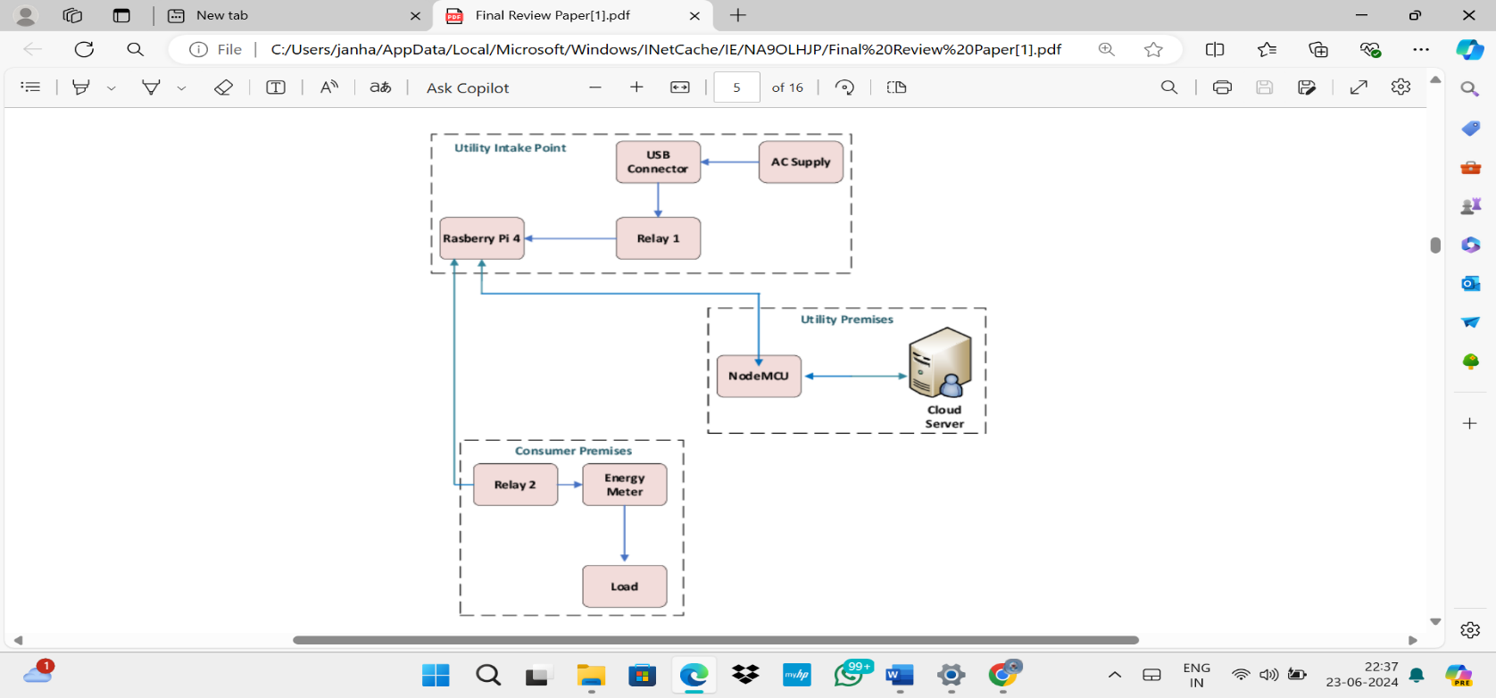
Figure 2:- Block Diagram of raspberry pi theft detector
2] SmartMeter Guardian - In this proposed design, the power supply is given to relay which controls the supply for load. If there is any theft found the Arduino is programmed in such a way that it will terminate the supply via web page which is operated by utility companies. For the interfacing between the Arduino and utility companies a GSM module is used which transmits the data to a cloud server, from where the operate can access the data[7]. The number of units usage is 9 units per day at home, as per the US government research. If the usage goes beyond 9 units then the consumer need to pay extra money than the normal payment. In the house the circuit is designed such the power goes automatically after the usage of 9 units, so that the theft can be detected.
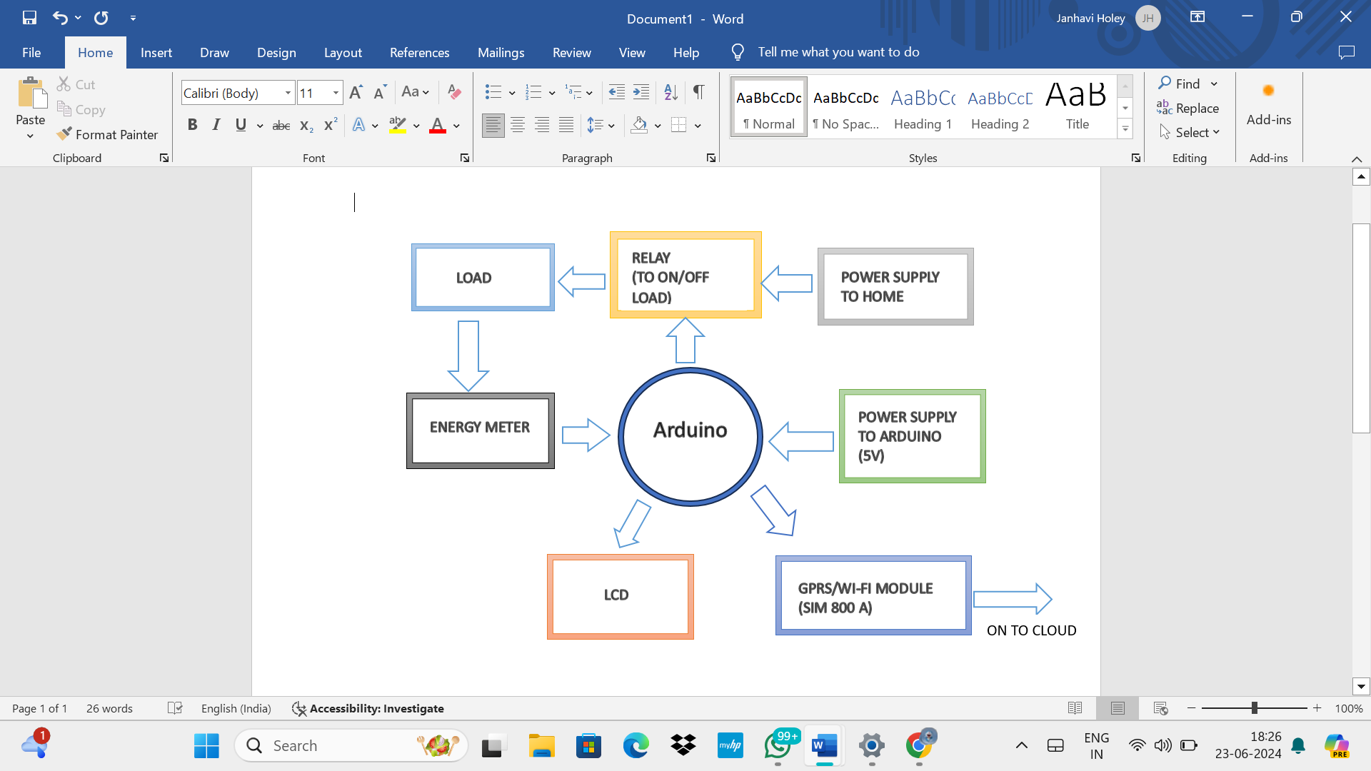
Figure 3: Block Diagram for Smart Meter Guardian
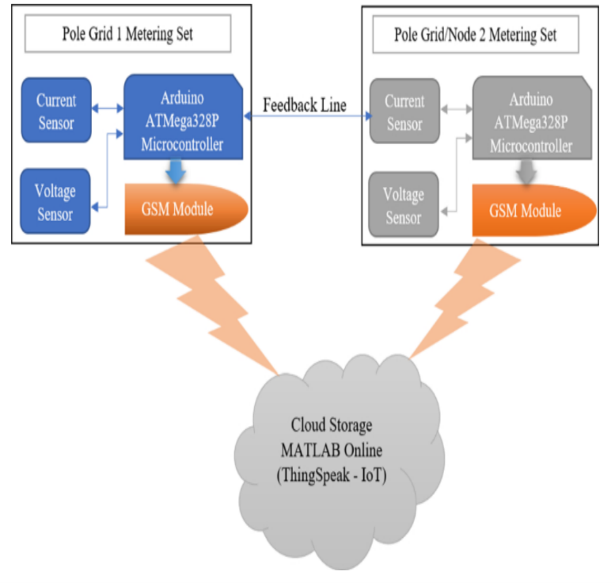
3] Smart Power Monitor - The objective of this proposed system is to alert the utility company about a possible theft with some difference in current[8]. The system works on the Principle of Conservation of Energy and Kirchhoff's Current Law (KCL). According to KCL, the total current leaving the transformer must be equal to the sum of individual currents entering the consumers' energy meters.
$$IT =\sum_{k=1}^{n}{I}K …(1)$$
where, n is the number of consumers energy meters.
However, in real life, transmission line losses account for the slight difference in current readings. Hence, a slight modification is proposed in equation 1
$$IT= \sum_{K=1 }^{n}{ IK} + 20 mA ...(2)$$
The supply from transformer is measured by PZEM004T sensor which provides voltage, current, power, and energy data to the raspberry pi, PZEM004T sensors are placed on both ends i.e. consumer and transformer. The raspberry pi will process the data and accordingly it will indicate the theft via email and a red LED will be on with a theft prompt on LCD screen.
4] IoT Theft Guard - The proposed system is based on alerting and switching the load off through Arduino or raspberry pi[9]. Supply power is provided to load is measured by current and voltage transformer connected across Arduino which reads the analog signals and converts them into digital values using ADC converter.
The analog signals are converted into digital values from following equation,

$Vrms= (\frac{230}{1024})×$Voltage …(3)
1024 = maximum mapping resolution for 10-bit ADC
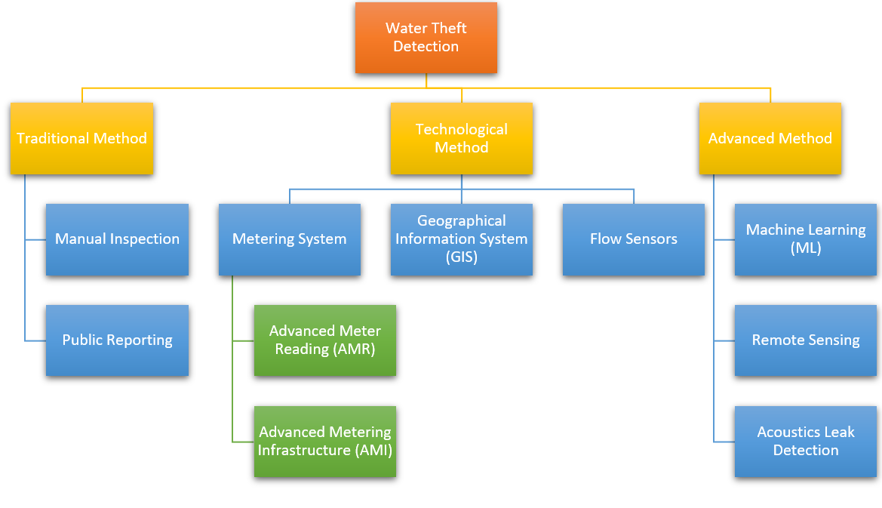
230 = rated voltage \newline
Power is calculated as,
Power = Vrms * Irms …(4)
These digital values are analysed to calculate the power consumption. If the power consumption exceeds the predefined values, the Arduino sends a signal to raspberry pi indicating a possible theft. Raspberry pi compares the power consumption with expected consumption patterns, if a theft is detected it initializes a theft alert via GSM module to utility company. If the utility company are reported for repeated pattern of theft, they can use IoT webpage to control the relay module and switch the power supply off for that particular load. To avoid meter tampering, a circuit with LDR and LED is provided, which is triggered if meter is opened. As LED will send a signal to LDR which will then send a signal to raspberry sending an alert to utility company.
Figure 5: Classification of different methods for water theft
Figure 4: Block diagram for dual data capture

5] Dual Capture Monitor - Here real time power theft monitoring and detection system is proposed[10]. Smart meters are installed in distribution system including places like distribution pole and consumer house. These smart meters are connected with current sensors, voltage sensors, Arduino, and a GSM module, which calculate the power distributed from transformer and power received at each distribution pole and consumer house with the help of current and voltage sensors placed in the smart meters. GSM modules transmits the data measured in terms of power for monitoring to cloud storage. Arduino compares the data of power distributed and power received, if power distributed is higher than power received it indicates a power theft and a SMS alert is send to utility company. Exact location and type of theft is identified from the data stored in the cloud storage.

A. Water Theft Detection
Water theft is a significant issue in many regions, particularly in areas with water scarcity. Various methods are employed to detect water theft, ranging from traditional manual inspections to advanced technological solutions.
Traditional Methods
a) Manual Inspections - Water utilities hire and rely on inspector to carry out physical routine inspection on site manually. These inspections include checking any form of tampering on water meters and other connection thoroughly. The tampering of water meters can be altered connections, illicit connections or any broken seals. The inspector will execute the corrective action to prevent their further recurrence.
However, manual inspection can be time consuming and require manpower. The efficiency of the work depends upon the availability and carefulness of the inspector as he/she are expected to carry out inspection thoroughly on every section and look for any signs of tampering by visibly spotting any issue. If the inspector is not cautious enough while executing the inspections, these can lead to further water theft, illicit connections and inaccurate water billing.
b) Public Reporting - Water utilities can also carry out water theft public awareness campaign to educate the residents and spread awareness among them about water theft like how to look for any unusual activity in water use and report the same with water utilities. This embolden community to monitor and report any doubtful activity regarding water theft like illicit connections to water mains, tampering with water meters or odd high water flow. Community can report the water theft by dialing customer service representative, through websites or mobile apps or directly to the water utilities offices. However, the efficiency can vary from person to person. The efficiency depend upon how involved and cautious the community is and how frequent they report any doubtful activity. Any hamper in reporting can cause water theft and in accurate billing. Hence, it is necessary for community and water utilities to keep them engage in monitoring these activities.
Technological Methods
a) Metering and Monitoring Systems -
i) Automated Meter Reading (AMR) - Automated Meter Reading (AMR) can automatically gather information regarding water consumption from meters introduced at customer location. This information is transmitted wirelessly to a central database managed by water utilities. This data is gathered and monitored by water utilities personnel. The information can be accessed without manually visiting the customer location. AMR provides precise and actual live information reducing the errors. AMR system hence reduces the cost of labour and increases the effectiveness of the system. The purchasing cost and set up of the system cost can be high. But it can help in long term saving, reducing the cost of manpower work. Hence the inspector can access and examine the water usage effortlessly without visiting the site saving time. As compared with the traditional system, this modem can help in increasing overall efficiency, reduces the water theft, avoiding error in the billing.
ii) Advanced Metering Infrastructure (AMI) - Advanced Metering Infrastructure (AMI) is more advanced than AMR modem as it allows networking between meters and utility central management system. This will not only allow inspector to check for any doubtful activity of meter but it also allow inspector to send the information back to the meter if required. This system will continuously check the pressure in the pipes, flow rate of water and provide live update to personnel working in water utility central management system. If there is any signs of leak, water theft, the system will send the alert signal to the utilities allowing them to further immediately take action and prevent any illicit water use. The purchasing cost for this system is quite high as it include installing hardware, software component and networking foundation. The AMI requires maintenance to make sure the systems runs correctly and reliably.
b) Geographical Information Systems (GIS) - Geographical Information Systems uses the combination of spatial data with attribute data that is maps and satellite images for information regarding water utilization. Water utilities use this system to monitor and analyse water utilization across different locations. This system helps inspector understand the different demand patterns, localise any unusual flow rate. Using this information, utilities can generate visual maps, helping them to locate different water usage patterns, locate the issues. The initial setup for this system need collecting and combining the geographical information with water utilization data. This works requires significant energy and resources. The utility inspector need to be trained for using this system. Regular maintenance is required for keeping the system accurate and effective.
c) Flow Sensors and Pressure Management - Flow Sensors and Pressure Management system uses flow sensors and pressure monitoring devices in order to continuously monitor and analyse the flow rate and pressure of water and therefore transmitting live and precise information to water utilities wirelessly. As the system give real time data about system performance. The water utilities can understand different flow rate patterns without visiting the site. This information is used to locate any doubtful condition. The system can distinguish any unusual abnormal patterns in flow and pressure of water, therefore allowing water utilities to quickly locate and take action which can significantly reduce any damage or illegal theft. The purchasing cost of this system require significant investment. For accurate and precise results calibration and maintenance of the system is needed.
Advanced Detection Methods
a) Machine Learning and Data Analytics - Machine Learning and Data Analytics are advanced detection techniques which uses advanced algorithms for collecting and monitoring large sets of information. This system uses AMI technology and other advanced technologies to gather the data. The gathered live information is collected and analyse with historical patterns to locate any doubtful condition like water thefts or unauthorised connection. The system accuracy can be increased by continuous monitoring and analysis. This system is able to locate any disputes which can be missed by personnel. Using this technology future needs are also be interpreted. However, for managing the advanced algorithms of machine learning and data analytics, the personnel is required to have expertise in the data science and machine learning. For setting up this technology large investment is required for setting advanced computers and infrastructure. The algorithms needs to be updated every now and then to enhance the reliability and accuracy of the system.
b) Remote Sensing and Satellite Imagery - Remote Sensing Technologies comprises of satellite imagery and aircraft containing cameras are used to analyse and monitor geographical area in order to locate for illegal water usage, unusual flow rate patterns. The high resolution image capture by satellite cameras can show different patterns in vegetation, plants and agricultural area. Aerial surveys are used capture images of specific areas. To analyse changes and patterns advanced software are used for processing this images. Advanced machine learning algorithms are used to locate any doubtful activity. Inspector use this information to carry out inspection and take necessary actions. This technology is very efficient as machine learning algorithms can easily detect any abnormal conditions which can be missed by human inspector. As the images are obtained from satellites the initial cost for this technology is expensive. Personnel working needs expertise knowledge in geographical data analysis.
c) Acoustic Leak Detection - The technology uses acoustic sensor which are responsible for converting a sound wave into electrical signal. These sensors are placed in water distribution system which can locate the abnormal condition by analysing the sounds of leaks, flow rate of water. These sensors recognise any unusual sounds like hissing, loud and rushing sound. By detecting the problems, the utilities can quickly resolve the issue by takings actions. The sensor can very useful as they can locate the exact location of problem making it easy for utilities for taking measures saving their time and energy. However, the sensors efficiency can reduce due to other environmental and traffic noise and size and material of pipe. Hence the personnel must be specialised training and experience so as to differentiate between normal sounds and abnormal sounds.
B. Types of IoT based water theft detection systems
1] Smart Anti-Theft Water Metering System (WTD1)- The proposed smart water metering system is designed to monitor consumer water consumption, detect water leakages, and provide accurate billing[11]. There is a water flow sensor installed in the water supply line which measures the flow rate of water, as water flows it generate pluses at a frequency (F) which correspond to volume of water which is calculated from below equations,
Water flow rate,
Q = A * v …(5)
Where, Q is the flow rate of water through pipe, \newline
A is the cross-sectional area of pipe given by $A = πr^{2}$, where r is the radius of pipe
v is the average velocity of flow.
Total volume of water consumed,
V = Q * t …(6)
where, Q is the flow rate of water through pipe,
t is the duration of water flow, given by 1/Frequency
Frequency,
Frequency = Q * k …(7)
where, k is the conversion factor of water flow sensor
The microcontroller receives data from water flow sensor and compares it with the calculated total volume of water consumed over a period of time. This data is transmitted to utility company to monitor real time data. Utility company use the stored data to generate accurate bills. To control the supply of water an inlet valve is present in the system which can be remotely operated by both consumers and utility companies in case of leakage or theft. In case of delayed bill payment, the inlet valve remotely closed by utility company can only be restored by them.
2] IoT Based Smart Water Leak Detection System for a Sustainable Future (WTD2) - The proposed system monitors and controls water distribution to prevent water loss due to leaks[12]. The microcontroller receives signals from water flow detector and resistance detector. Water flow detector measures the flow in litres per hour and sends a signal to microcontroller in case of any abnormality, similarly the resistance detector measure the resistance of cooper wire connected to pipe in case of leak the resistance changes and based on resistance value the exact location can be identified. When a leak is detected the solenoid valve is activated by a signal received from microcontroller. The microcontroller is linked to an ESP8266 module for sending real time data to user interface identifying exact location of water leak, alerting users about leakage. The microcontroller is linked to an ESP8266 module for sending real time data to user interface identifying exact location of water leak, alerting users about leakage. 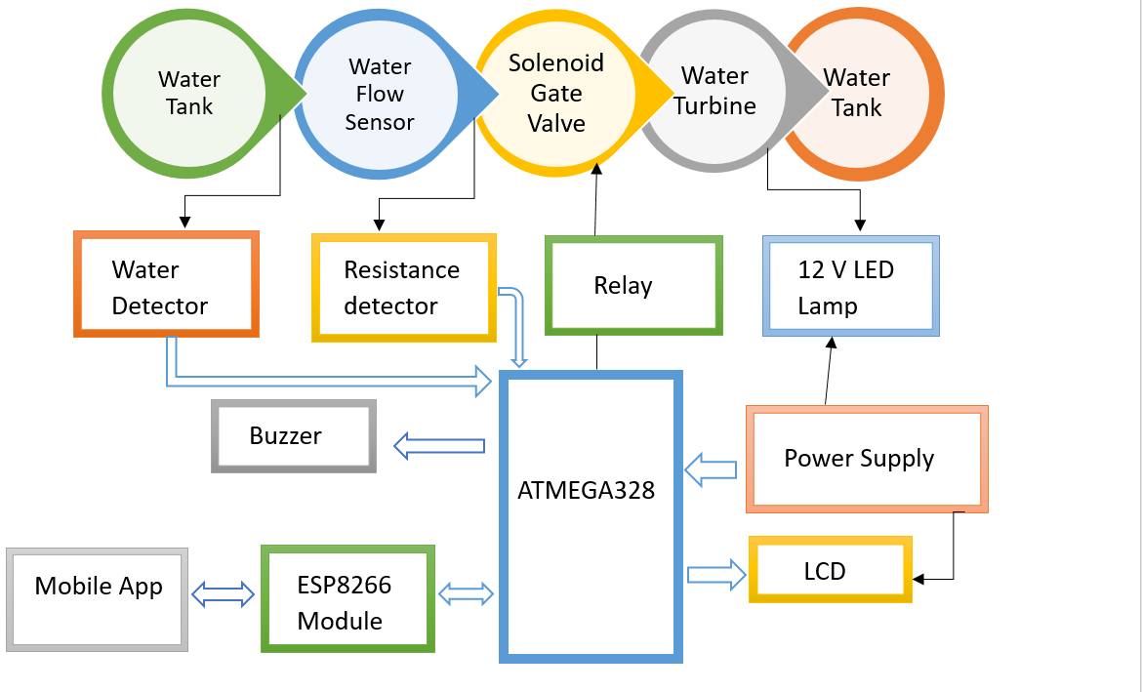
Figure 6: Block Diagram for IoT based smart water leak detection
3] Water Pipeline Leakage Detection and Monitoring System Using Smart Sensor with IoT (WTD3) - The system is based on two sensors for data collection, water flow sensor and turbidity [13]. Water flow sensor provides flow rate and volume of water through pipe, a turbidity sensor determines the purity of water by measuring the light scattered. This data in the form of pulses is sent to microcontroller which transmits it on a cloud server. Utility companies analyze the real time data and detect leaks by comparing with predefined thresholds. When a leak is detected an alert is send to users.
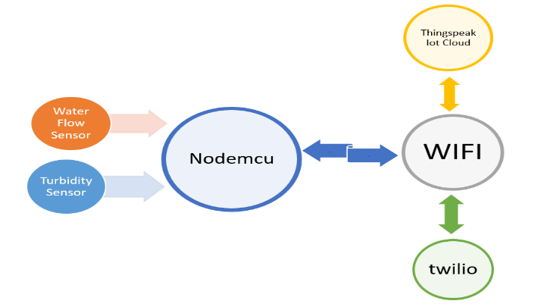
Figure 7: Block Diagram for IoT based Water Pipeline leakage system
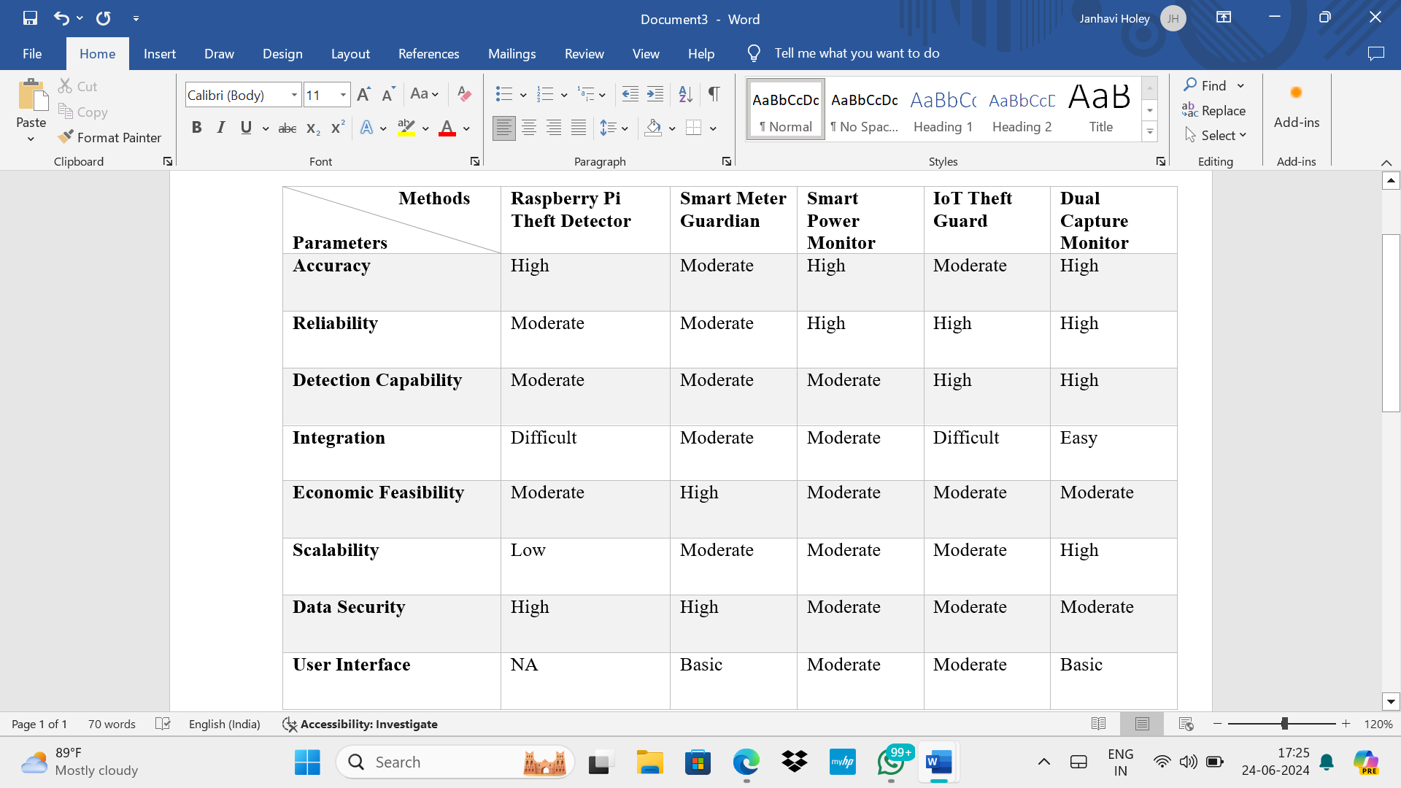
4] Automated Water Conservation and Theft Detection using IOT (WTD4) - The system proposed is a modification in communication between the microcontroller and cloud server as a Ethernet shield is used to connect the microcontroller to internet and use it as a server or client. The data will be feed to microcontroller in the form of signals. Water flow sensor is installed in each consumer house and in distribution line from main tank, the data is compared in microcontroller and after detection of theft it is transmitted on mobile app[14].
III- Comparisons
Table 2 Comparison of power theft based (PTD) IoT systems

Comparisons of different methods
$$Vtank =\sum_{k=1}^{ n}{Vk } …(8)$$
where, n is the number of water supply connections.
if the above equation (8) is not satisfied the microcontroller will detect a theft.
5] Water Leakage and Theft Detection Using IoT (WTD5) - The water supply is measured using flow sensors on inflow and outflow end for detection of leakage or theft. Microcontroller compares these value if the source and destination values are same then there is no leakage or theft. A solenoid valve is there to stop water supply in case of leak or theft. The readings of sensors are displayed on mobile app for monitoring purposes[15].
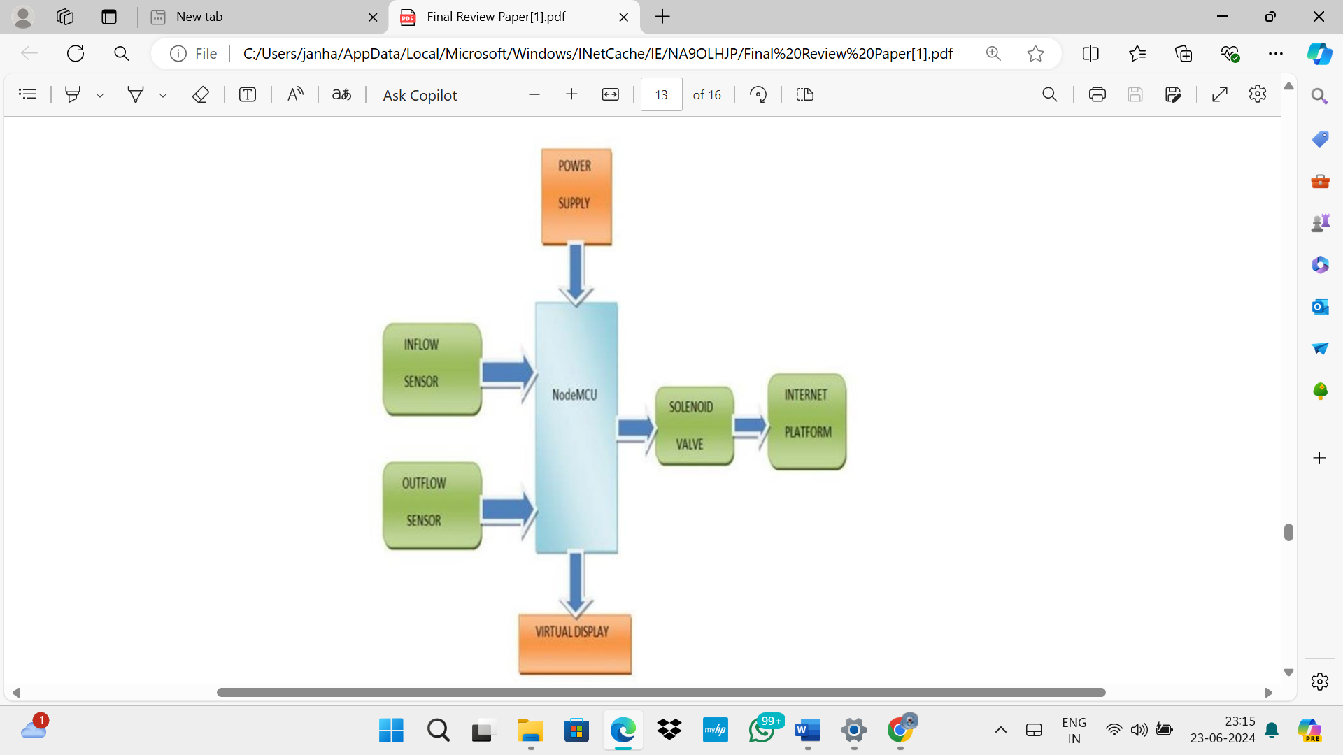

Figure 8: Block Diagram for IoT based water leakage and theft detection
- Power Theft Detection
Table 3 Comparison of power theft based (PTD) IoT systems

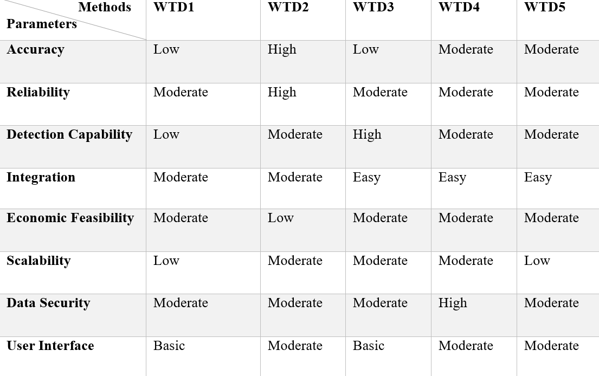
Table 4 Comparison of power theft based (PTD) IoT systems

- Water Theft Detection

iv-Conclusion
The detection and prevention of utility theft requires a complex and compact system that combines various methods like traditional with advanced technologies. Integrating Smart Meters, Internet of Things (IoT), Artificial Intelligence (AI) algorithms, and other technologies provides utility companies a solution that counters power theft effectively. In the comparison, we have included various parameters such as accuracy, reliability, detection capability, integration, economic feasibility, scalability, data security, and user interface for both water and power theft detection systems. After careful analysis of the comparisons, the double data capture system along with the flow and resistance sensor method will be the best optimal solution for power and water theft detection and prevention, the accuracy and reliability is increased if the new system is integrated with artificial intelligence and machine learning.

References
- Praful V Nandankar, GNR Prasad, M Lakshminarayana, G Satish, Ramya Maranan, et al. Iot-based power and water theft detection in urban cities. In 2023 International Conference on Sustainable Communication Networks and Ap- plication (ICSCNA), pages 316–322. IEEE, 2023.
- Thomas B Smith. Electricity theft: a comparative analysis. Energy policy, 32(18):2067–2076, 2004.
- Rudolf Frauendorfer and Roland Liemberger. The issues and challenges of reduc- ing non-revenue water. 2010.
- Patrick Glauner. Artificial intelligence for the detection of electricity theft and irregular power usage in emerging markets. PhD thesis, University of Luxembourg, Luxembourg, 2019.
- EEI-AEIC-UTC An. Smart meters and smart meter systems: A metering industry perspective. Washington, DC, USA, Edison Elect. Inst., White Paper, 2011
- Oscar Darteh, Charity Adjei, Samuel Amo, Raphael Anaadumba, Sajib Sarker, and T Goma. Design of internet of things based electricity theft detection using raspberry pi. International Journal of Engineering and Technical Research, 10:506–511, 03 2021.
- Srujana Uddanti, Christeena Joseph, and PC Kishoreraja. Iot based energy metering and theft detection. International Journal of Pure and Applied Mathematics, 117(9):47–51, 2017.
- Taimur Shahzad Gill, Durr E Shehwar, Hira Memon, Sobia Khanam, Ali Ahmed, Urooj Shaukat, Abdul Mateen, and Syed Sajjad Haider Zaidi. Iot based smart power quality monitoring and electricity theft detection system. In 2021 16th International Conference on Emerging Technologies (ICET), pages 1–4. IEEE, 2021
- R Meenal, Kevin M Kuruvilla, Adrin Denny, Rejin V Jose, and Renoy Roy. Power monitoring and theft detection system using iot. Journal of Physics: Conference Series, 1362(1):012027, nov 2019.
- Celimpilo Lindani Zulu and Oliver Dzobo. Real-time power theft monitoring and detection system with double connected data capture system. Electrical Engineering, 105(5):3065–3083, 2023.
- Emmanuel Effah, George Essah Yaw Okai, and Joshua Kweku Aidoo. Smart antitheft water metering system. In 2022 IEEE/IET International Utility Conference and Exposition (IUCE), pages 1–5. IEEE, 2022.
- Thenmozhi Sundaram, Sumathi Kumarasamy, Anju Asokan, Priyanka Balasubramaniam, Maheswar Rajagopal, and Jayarajan Parimanam. Iot based smart water leak detection system for a sustainable future. pages 359–362, 03 2021.
- D Mahesh Kumar and T Jagadeep. Water pipeline leakage detection and monitoring system using smart sensor with iot. Journal of Physics: Conference Series, 2267(1):012122, may 2022.
- B Sasikumar. Automated water conservation and theft detector using iot. International Research Journal of Engineering and Technology, 5(4), 2018.
- Sunilkumar Hattaraki and Achyut Yaragal. Water leakage and theft detection using iot. 10 2021.

