Mini Literature Review on Design and Analysis of Worm Gearing mechanism

Shweta Ramteke ¹, Dr. Subhash Waghmare²
¹M.Tech. Students in Mechanical Engineering Design, Priyadarshini College of Engineering Nagpur, India -440019 ²Assistant Professor, in Mechanical Engineering Dept., Priyadarshini College of Engineering Nagpur, India -440019
Received on: xxxx,20xx, Revised on: xxxx,20xx, Published on: xxxx,20xx

Abstract –This article describes in depth literature review on the design analysis and modification worm gear design for increases the life of the gear that is sued in the various gear train or gear box. The geometric features of the worm gear, the principle of operation and the theoretical basis for calculating the efficiency. The worm and worm wheel are utilized in the Winch machine's gear box to lift the sand bucket. The stress on the teeth causes the worm wheel to fail during operation. Stress concentration is to blame for the failure. The objective of this study was to develop an interactive package for the design and analyses of worm gearing mechanisms. The worm gears were designed based on full-depth involutes teeth. Mathematical models were developed to compute geometry factors for surface durability of single- enveloping worm gearing cases which were extracted from established American Gear Manufacturers Association (AGMA) standards.
Keywords- Worm gear, Analysis, Life, Worm wheel
INTRODUCTION
Originally, worm gearing was employed to achieve a substantial decrease in speed between the driving and driven shafts while increasing the torque of the driven shaft proportionately (save for frictional loss). Worm gearing is still employed for this, and the wheel is commonly driven by a single-thread worm with such a low helix angle that the drive cannot be reversed; that is, the wheel cannot drive the worm since the gearing locks against backward rotation. A worm gear, widely used in many industrial applications, can provide substantially increasing output torque due to its high gear ratio. It occupies small space due to its compactness. These advantages are very appealing to automotive manufacturers in particular, as they are moving from the HPS (Hydraulic Power Steering) to the EPS (Electric Power Steering) system to provide assistant torque to the driver. The use of worm gears is widespread in many areas of industry. Worm gear provides smooth and quiet operation, so it is used in hydraulic, lifting and transport machines, automotive, machine tools, etc.
The main geometric parameters of the worm and the worm wheel
The main parameters of the worm gear Figure 1,2 and 3 include: d1, d2 – dividing diameters of the worm and the worm wheel; the calculated pitch of the worm p is equal to the distance between the same side profiles of two adjacent turns of the worm; profile angle α (often equal to 20°).
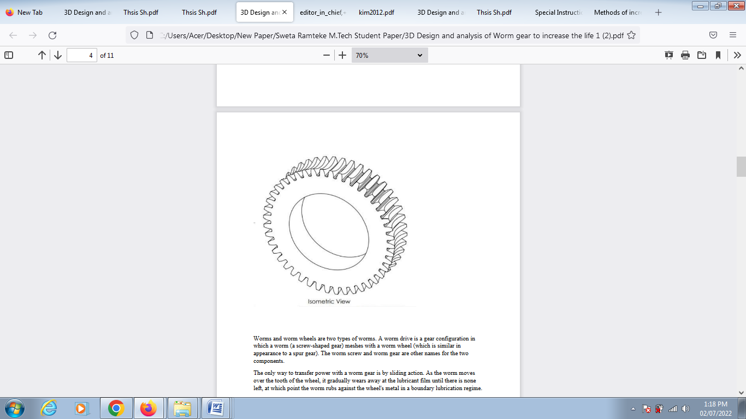
Fig. 1- Isometric view of design of worm gear

When designing and manufacturing a worm pair, it is necessary to correctly calculate the following geometric parameters: the diameter of the vertices of the turns da1 and the diameter of the vertices of the hollows of the worm df1; the diameter of the tops of the teeth da2, and the diameter of the tops of the teeth of the troughs of the teeth of the worm wheel; center distance aw, which is equal to half the sum of d1 and d2 (Fig. 1,2 and 3).
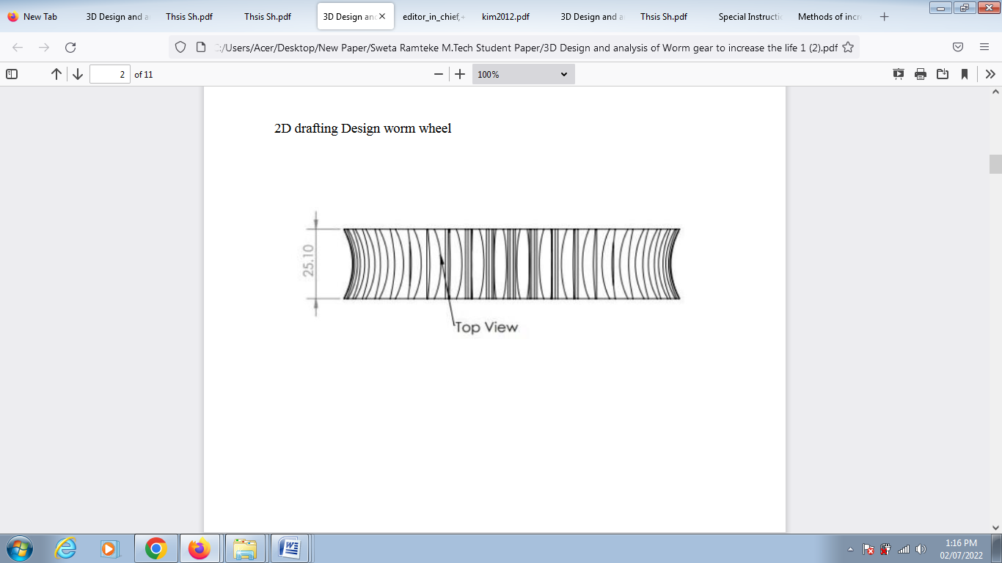
Fig. 2- 2 D drafting design of worm gear
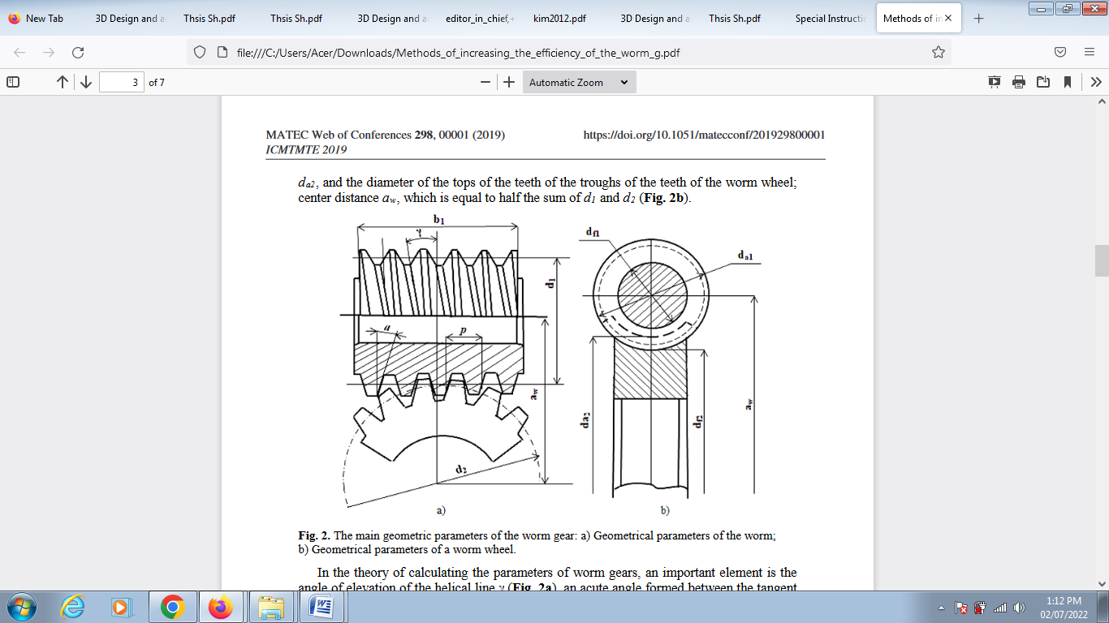
Fig. 3- The main geometric parameters of the worm gear: а) Geometrical parameters of the worm; b) Geometrical parameters of a worm wheel.
THEORETICAL BACKGROUND
Worm gears' primary drawback, which has an impact on their efficiency and advantages, is their poor coefficient of performance. The employment of such reducers is unproductive since a low indication of this coefficient (about 60%) involves large energy losses.[1]
B. Magyar and B. Sauer propose a physically based calculation approach for determining the efficiency of worm gear drives in their work «Calculation of the efficiency of worm gear drives». The authors' technique is based on the MEGT tribological simulation, which may be used to derive local tooth friction coefficients. The study's authors demonstrated the efficacy of the proposed strategy [2].
E. Mautner, W. Sigmund, J.-P. Stemplinger, and K. Stahl conducted experimental tests of large-sized worm gearboxes in order to evaluate knowledge regarding load-carrying capability and efficiency of their usage in a scholarly work titled Efficiency of Worm Gearboxes». During each trial, the study's authors assess the gearbox's efficiency. A novel approach for processing the components of a worm gear was developed as a result of this research endeavour [3]. Special attention is devoted to the topic of eliminating the major disadvantage - enhancing the efficiency of worm gear - in scientific works and publications [4-7].
The development of new techniques and procedures for producing the components of the worm gear is one of the most important and significant directions for resolving this problem. As a result, the focus of this paper is on the geometric characteristics of the worm gear. This is required in order to provide recommendations for current procedures in order to improve their mechanisms and attain the most effective results.[4-5].
The worm gear's functioning is dependent on the interaction of the worm's teeth with the worm wheel's teeth. The movement in the transmission is transformed using either a helical pair or an inclined plane concept. The worm's turn’s travel along the axis as it rotates, causing the worm wheel (its teeth) to rotate in the same direction [6].
The findings of investigations and experiments are reported in the researched research materials [7-8]. Author's approaches for refining the mechanism of a worm gear and its parts are offered based on these trials.[7-8].
The concept given in the scientific material «On one of the methods to boost the efficiency of a worm gear», published by L. Otkidach and B. Baikova, was evaluated and empirically proved by the writers of this article. The theory proposes that a specific clip be installed in the area of engagement between the worm and the worm wheel, resulting in an isolated area of excess oil flow from the worm in the engagement area. A specific clip is used to form a stable oil layer that helps to separate the friction surfaces (in the area of worm and worm wheel contact) and eliminates «dry» friction altogether [9].
With today's state-of-the-art creative engineering technologies, we may increase the quality of different mechanisms and components processing [10].
Suresh and Purushotham [11] used structural ANSYS to modify the initial design of mechanism to meet the requirement of various drooping intervals of goods such as food items, and cloths bags during cyclone. Sensitive analysis was also carried out to bring out the influence of design parameters on stress and natural frequency of worm gear mechanisms.
Litvin et al. [12] proposed methods for localization of bearing contact and reduction of transmission errors achieved by double-crowning of the worm of the drive with respect to the hob, the tool that generates the worm gear. A computer program for the simulation of meshing and contact was developed.
2.1 Optimal weight design of a gear train using particle swarm optimization and simulated annealing algorithms. Gear design entails empirical calculations, many graphs, and tables, resulting in a complex design. Furthermore, the growing need for small, efficient, and dependable gears compels the designer to employ the best design methods possible. [1]
2.2 A genetic approach to automate preliminary design of gear drives By using normal module, number of teeth, and face width as design factors and bending strength, contact stress as a constraint, the volume of a two-stage helical gear train was reduced.
2.3 A design method of gear trains using a genetic algorithm. A planetary gear train is a basic gear train that has a number of gears The volume of pitch diameter and face width is lowered by approximately 40%, and the error is reduced by about 40%.between the target and the result is around a reduction gear ratio by 3%
2.4 Optimization of module, shaft diameter and rolling bearing for spur gear through genetic algorithm. Gearbox volume has been improved. The gear volume obtained by GA was 1.47 percent lower than that obtained using the analytical approach.
2.5 Multidisciplinary optimization during gear design For cylindrical gears, a multidisciplinary optimization possibility for minimal noise (sound power level) was examined. When comparing the optimal geometry scenario to the simplest geometry situation, the results demonstrate that the highest reduction in acoustic power is 10%.
2.6 Optimization methods for spur gear dynamics. To determine adequate profile adjustments for a spur gear pair, researchers employed Genetic Algorithms in combination with a suitable goal function.
2.7 Core Vector Machines: Fast SVM Training on Very Large Data Sets. To minimize a product's lead time, extensive research has been conducted to forecast gear design performance parameters. Distributed support vector machines (SVM) algorithms are trained on pre-configured intranet/internet settings to obtain an effective classifier in the traditional approach. For huge data sets, these procedures are extremely difficult and costly
2.8 Optimal Weight Design of a Gear Train Using Particle Swarm Optimization and Simulated Annealing Algorithms. The purpose of this study is to offer a non-conventional technique, specifically the genetic algorithm, for minimizing the power loss of a worm gear mechanism under a set of restrictions
2.9 Design and technological features of a worm gear with a cylindrical worm Worm gears' primary drawback, which has an impact on their efficiency and advantages, is their poor coefficient of performance. The employment of such reducers is unproductive since a low indication of this coefficient (about 60%) involves large energy losses
2.10 Calculation of the efficiency of worm gear drives B. Magyar and B. Sauer proposes a physically based calculation approach for determining the efficiency of worm gear drives in their work.Calculation of the efficiency of worm gear drives». The authors' technique is based on the MEGT tribological simulation, which may be used to derive local tooth friction coefficients. The study's authors demonstrated the efficacy of the proposed strategy
2.11 Efficiency of worm gearboxes E. Mautner, W. Sigmund, J.-P. Stemplinger, and K. Stahl conducted experimental tests of large- sized worm gearboxes in order to evaluate knowledge regarding load-carrying capability and efficiency of their usage in a scholarly work titled «Efficiency of Worm Gearboxes». During each trial, the study's authors assess the gearbox's efficiency. A novel approach for processing the components of a worm gear was developed as a result of this research endeavor
2.12 The Theory and Practice of Worm Gear Drives. The Theory and Practice of Worm Gear Drives The worm gear's functioning is dependent on the interaction of the worm's teeth with the worm wheel's teeth. The movement in the transmission is transformed using either a helical pair or an inclined plane concept. The worm's turn’s travel along the axis as it rotates, causing the worm wheel (its teeth) to rotate in the same direction.
2.13 About one way to increase the efficiency of a worm gear. Engineering Herald. The concept given in the scientific material on one of the methods to boost the efficiency of a worm gear», published by L. Otkidach and B. Baikova, was evaluated and empirically proved by the writers of this article. The theory proposes that a specific clip be installed in the area of engagement between the worm and the worm wheel, resulting in an isolated area of excess oil flow from the worm in the engagement area. A specific clip is used to form a stable oil layer that helps to separate the friction surfaces (in the area of worm and worm wheel contact) and eliminates dry friction altogether.
2.14 Exploration of WEB resources in the domain of metal processing technologies with today's state-of-the-art creative engineering technologies, we may increase the quality of different mechanisms and components processing.
2.15 Measuring helical gears and worm wheels on a coordinate measuring machine, Efficiency Prediction of Worm Gear with Plastic Worm Wheel Special attention is devoted to the topic of eliminating the major disadvantage - enhancing the efficiency of worm gear - in scientific works and publications .
The development of new techniques and procedures for producing the components of the worm gear is one of the most important and significant directions for resolving this problem. As a result, the focus of this paper is on the geometric characteristics of the worm gear. This is required in order to provide recommendations for current procedures in order to improve their mechanisms and attain the most effective results.
PROBLEM STATEMENT
Failure of Gears Gear failure may be divided into four categories: 1. Excessive surface fatigue (pitting) 2. Plastic flow 3. Wear 4. Failure.
The look of various distress and failure scenarios varies depending on whether the gears have through hardened teeth or surface hardened teeth. These variances arise from the surface hardened gearing's varied physical traits and qualities, as well as residual stress characteristics. According to the literature review, the current work's problem statement is to optimize the worm and worm wheel while considering various objectives. These are the details:
1] Worm and worm wheel volume minimization.
2] Minimize the distance between the worm and the worm wheel's center.
3] Worm deflection is kept to a minimum.
The worm and worm wheel, which are used for crystallization in sugar factories and whose characteristics are listed in Table 1, were chosen for optimization.
CONCLUSION
This literature review study has presented a robust worm gear and worm wheel model for design and analysis of gearing mechanisms involving worm types. Putting into consideration factors causing on stresses on gear teeth, the model was developed as a design aid, allowing the analyst to quickly visualize the response of the system to a broad range of speed and torque inputs. The goal of this study was to optimize the worm and worm wheel with many objectives in mind, including minimizing volume, center distance between the worm and the worm wheel, and worm deflection. Gear ratio, face width, pitch circle diameters of worm and worm wheel are among the criteria evaluated. The results reveal that all of the objectives have been met.
REFERENCES
- Shadsky G.V., Feofiolova I.I. Design and technological features of a worm gear with a cylindrical worm. Izvestiya TulGu, 2017, no.8, pp. 316-322. (In Russian)
- Magyar, Balazs & Sauer, Bernd. (2014). Calculation of the efficiency of worm gear drives. 10.1533/9781782421955.15.
- Mautner, Eva & Sigmund, Werner & Stemplinger, J.-P & Stahl, Karsten. (2015). Efficiency of worm gearboxes. Proceedings of the Institution of Mechanical Engineers, Part C: Journal of Mechanical Engineering Science. 230. 10.1177/0954406215602286.
- Nikolaeva E.V., Nikolaev M.Yu., Molodtsov A.S., Pimneva N.E., Kazakov M.V. Measuring helical gears and worm wheels on a coordinate measuring machine. Omsk Scientific Herald, 2018, no.4, pp. 140-145. (In Russian)
- Kim, Seong & Shin, Min & Byun, Jung & O, Kwang & Chu, Chong. (2012). Efficiency Prediction of Worm Gear with Plastic Worm Wheel. International Journal of Precision Engineering and Manufacturing. 13. 10.1007/s12541-012-0021-7.
- Dudás, I.. (2004). The Theory and Practice of Worm Gear Drives. The Theory and Practice of Worm Gear Drives. 1-314.
- Shimizu, Y. & Watanabe, K.. (2009). Investigation into improving efficiency of worm gear with new tooth profile for EPS. 30. 151-158.
- Kim, Seong & Shin, Min & Byun, Jung & O, Kwang & Chu, Chong. (2012). Efficiency Prediction of Worm Gear with Plastic Worm Wheel. International Journal of Precision Engineering and Manufacturing. 13. 10.1007/s12541-012-0021-7
- Otkidach L.G., Baykov B.A. About one way to increase the efficiency of a worm gear. Engineering Herald, 2015 . no. 10, pp. 26-33. http://engsi.ru/doc/821787.html (In Russian)
- Wilk-Kołodziejczyk, Dorota & Opalinski, Andrzej & Nawarecki, E. & S., KluskaNawarecka. (2016). Exploration of WEB resources in the domain of metal processing technologies. Metalurgija. 55. 127-130.
- D. Suresh and A. Purushotham, “Design and analysis of a mechanical system for deployment of goods,” International Journal of Mechanical Engineering (IIJME), vol. 3, no. 8, pp. 9-14, 2015.
- F. L. Litvin, M. De Donno, A. Peng, A. Vorontsov and R. F. Handsc, “Integrated computer program for simulation of meshing and contact of gear drives,” Computer Methods Applied Mechanics and Engineering, vol. 181, pp. 71- 85, January 2000.

