Obstacle Avoidance & Surveillance Robot

Harshali Ragite1, Shubham Biradar2, Shubham Motghare3, Janhavi Hate4,
Rut Bijanpalliwar5

1Asst. Professor, ^{2,3,4,5} B.Tech Students,
Department of Artificial Intelligence and Data Science, Wainganga College of Engineering and Management,
Nagpur, Maharashtra, India

Shubhambiradar2712@gmail.com

Received on: 20 April, 2024 Revised on: 15 May, 2024 Published on: 17 May, 2024

Abstract – An obstacle avoidance and surveillance robot is an autonomous machine that is designed to navigate through an area of disaster ( environment ) while avoiding obstacles in its path. The robot typically uses sensors such as GPS for accurate location tracking with longitude and latitude coordinates, also ultrasonic, camera, or LIDAR to detect obstacles and sends signals to its control system to take appropriate actions to avoid them. This can include changing the robot's direction, slowing down, or stopping altogether In recent years, there has been a significant amount of research on obstacle avoidance robots, with various approaches being explored. These approaches include using computer vision techniques such as object detection and recognition, machine learning algorithms, and more traditional sensor-based methods

Keywords - GPS, GSM, Temperature Sensor, Ultrasonic Sensor, Camera.

I -INTRODUCTION
Interference analysis is the most important feature of this robot. The robot receives information from the

environment through sensors installed on it. Sensing devices used for obstacle detection include ultrasonic sensors, GPS, GSM, servo motors, etc. Ultrasonic sensors are best for detecting problems due to their low cost and powerful capabilities.
The robot is an intelligent robot that can understand the problems that come its way and overcome them. It has a microcontroller to process data and ultrasonic sensors to detect obstacles in its path. Anti-interference is one of the most important features of mobile robots. Without this, the robot's movement will be limited and difficult. This tutorial explains how to use ultrasonic sensors to avoid problems. The project also introduced a control system that allows the robot to avoid having to stop in front of obstacles, move smoothly in unknown places, and avoid accidents.
in front of obstacles, allowing it to navigate smoothly in an unknown environment and avoid accidents.

II. METHODS AND MATERIAL

- Block Diagram :
Power supply
Esp 32 (cam)

Aurdino uno
(Controller)
Display
Gsm / gps
Location
Buzzer
Motar driver

Gsm
Ultrasonic sensor
Servo motar

Figure 1: Block Diagram of Proposed System
- Components :
The prototype uses the following components:
1) Power Supply: Power Supply Electrical power is supplied to components by a power supply. The term usually refers to devices that are installed into the driven section. 3.7 *2 V rechargeable Li-ion battery is used to provide the power supply to the controller which in turn feeds the required power to all the sensors and modules connected to it.
2) OLED Display: OLED (Organic Light-Emitting Diode) displays use organic compounds that emit light when an electric current is applied. They offer high contrast ratios, wide viewing angles, and fast response times. OLED displays are used in smartphones, TVs, and wearable devices due to their thin and flexible nature, as well as their ability to produce deep blacks and vibrant colors.
‘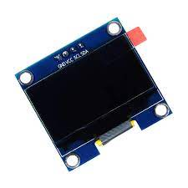
Figure 2: OLED Display
3) Temp Sensor: DHT 11 temperature sensor module is small sized, low cost sensor which is very sensitive to ambient temperature. This sensor helps in sensing the temperature and humidity of surrounding environment. The detection range of temperature is between 20 -80 degree Celsius.
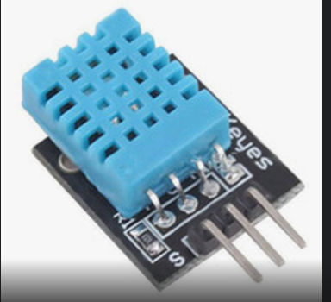

Figure 3: temperature Sensor( DHT 11)
4) GPS-GSM module: GPS and GSM are often connected in devices to enable various functionalities. GPS provides location information, while GSM allows for communication over cellular networks. When combined, these technologies enable features such as location tracking in smartphones, navigation systems in vehicles, and asset tracking in logistics. The GPS provides the location data, which can then be transmitted over the GSM network to a server or another device, enabling real-time tracking and communication.
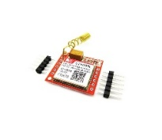
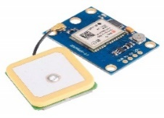

Figure 4: GPS-GSM Module
5) Buzzer: It is Small PCB Mountable 5V Passive Buzzer . It is used to add Audio Alert to electronic designs. An audible tone is generated using the coil element and works on 5v supply.
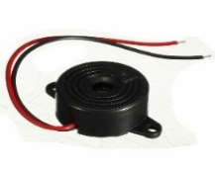

Figure 5: Buzzer
6) ESP32-CAM: The ESP32-CAM is a versatile development board featuring the ESP32-S chip. It combines Wi-Fi and Bluetooth connectivity with a camera module, making it ideal for IoT projects requiring image capture and transmission. The board supports OV2640 (2MP) and OV7670 (VGA) cameras, and features a microSD card slot for storing images or video footage. It also includes GPIO pins for connecting additional sensors or peripherals, and can be programmed using the Arduino IDE, making it accessible to beginners and experienced developers alike.
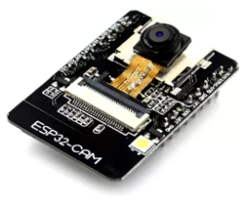
Figure 6: ESP32 cam
7) Arduino Uno: The Arduino Uno is a popular microcontroller board It is popular for its ease of use, low cost, and large community support. Ardui no boards can interact with sensors, lights, motors, and other devices, making them ideal for creating interactive objects or environments. They can be programmed to perform a wide range of tasks, from simple blinking lights to complex robotics projects.
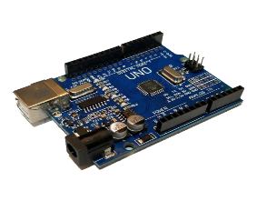
Figure 7: Arduino UNO
8) Bluetooth module (HC-05) : The HC-05 is a versatile and widely used Bluetooth module that facilitates wireless communication between devices. It operates on Bluetooth 2.0 specifications and can function both as a master and a slave device, making it ideal for various applications, from hobbyist projects to more complex IoT (Internet of Things) solutions. With its Serial Port Protocol (SPP), it allows microcontrollers, such as Arduino and Raspberry Pi, to communicate with smartphones, computers, and other Bluetooth-enabled devices over a short distance. The HC-05 is appreciated for its ease of use, affordability, and reliability in establishing Bluetooth connections for serial communication
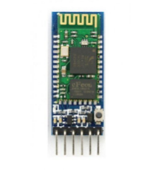
Figure 8 :- Bluetooth module (HC-05)
- Process Flow :
1.Manual mechanism
An RC (remote control) car with obstacle avoidance is a fun and challenging project combining the thrill of RC vehicles with help of bluetoth module. This requires programming the Arduino to read sensor data, process it to determine the best course of action, and then control the motors accordingly as shown in the fig 8.
Start

Connect with Bluetooth

Set manual mode

Press buttons according to requirement

Stop

Figure 8: Flowchart of Manual Mechanism
2. Automated mechanism
An obstacle avoidance robot typically uses sensors, such as ultrasonic or infrared sensors, to detect obstacles in its path. When an obstacle is detected, the robot's microcontroller, often an Arduino Uno, processes the sensor data to determine the appropriate action to avoid the obstacle. This action could involve stopping, moving backward, or turning to avoid the obstacle. The robot's motors are then controlled accordingly to execute the chosen action. This process is repeated continuously, allowing the robot to navigate its environment while avoiding obstacles autonomously.

Start

Connect with Bluetooth

Set auto mode

Stop

Figure 8: Flowchart of Auto Mechanism

3. Surveillance system
Creating a surveillance system using the ESP32-CAM module and OpenCV presents a powerful and cost-effective solution for real-time monitoring and security applications. The ESP32-CAM captures video footage which can then be processed using OpenCV, a leading open-source computer vision and machine learning software library. This combination allows for advanced image processing and analysis, such as motion detection, facial recognition, and object tracking, enhancing the surveillance system's capabilities beyond simple video streaming. With the ESP32-CAM's Wi-Fi connectivity, the video feed can be transmitted wirelessly to a server or computer where OpenCV algorithms analyze the footage in real-time. This setup enables the implementation of complex surveillance features like intruder alerts, activity logs, and automated responses to specific triggers, all while keeping the system's footprint and power consumption minimal. Leveraging the ESP32-CAM with OpenCV offers a scalable and efficient approach to building smart, responsive surveillance systems suited for both home and commercial settings.

Start

Connect with wifi

Open webpage

Start live streaming

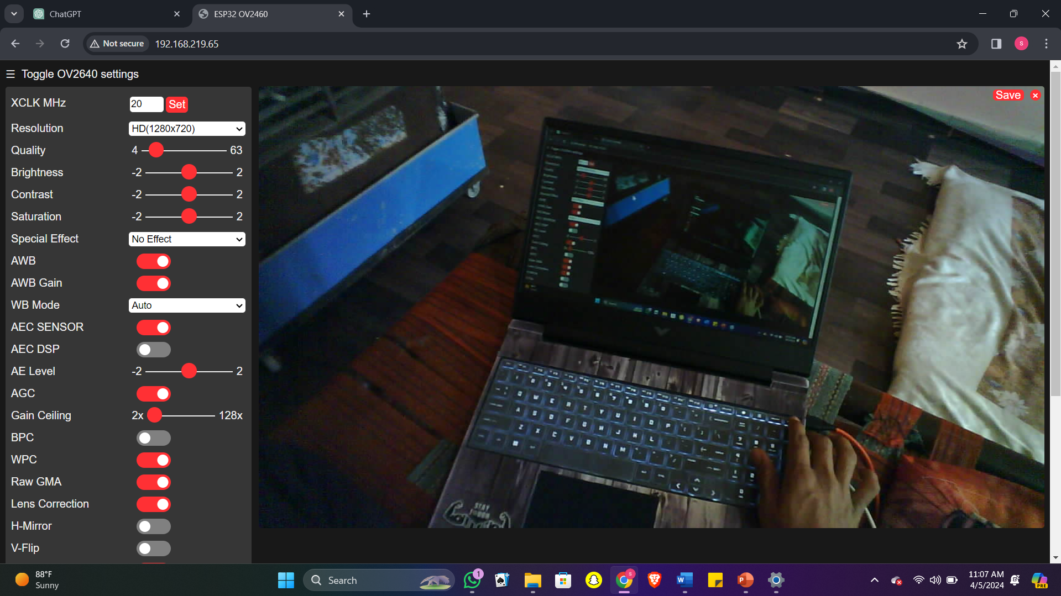
Fig : web page
- RESULTS AND DISCUSSION
In the obstacle avoidance surveillance robot project, utilizing an Arduino Uno as the main controller, a servo motor for navigation, an ultrasonic sensor for obstacle detection, a motor driver for locomotion control, and an ESP32-CAM for video capture and transmission, the results demonstrated the robot's effective capability in navigating through environments autonomously while avoiding obstacles. The integration of the ultrasonic sensor allowed the robot to detect objects in its path and make real-time adjustments to its course, showcasing a high degree of responsiveness and ccuracy in avoiding collisions. Meanwhile, the ESP32-CAM provided live video feedback, enabling remote monitoring and surveillance applications.
+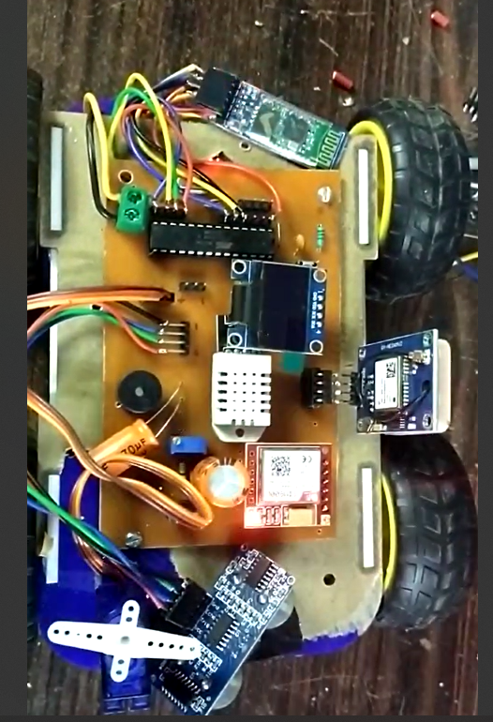

IV. CONCLUSION
The obstacle avoidance surveillance robot project, employing an Arduino Uno, servo motors, an ultrasonic sensor, an ESP32-CAM, and a motor driver, showcases a remarkable blend of robotics and wireless communication. This robot adeptly navigates through environments, steering clear of obstacles with its ultrasonic sensor, while the servo motors provide precise movement control. The integration of the ESP32-CAM adds a surveillance capability, allowing for real-time video streaming and image capture. This project not only demonstrates the practical application of microcontrollers and sensors in creating autonomous robots but also highlights the potential for such devices in security, monitoring, and IoT applications. The successful implementation of this project serves as a testament to the synergy between mechanical design and electronic innovation, paving the way for future advancements in robotic applications.
REFERENCES
- Diya Jaiswal, Priyanka Narad, Nisha Dukare, Jay Bhore, Rahul Bhandekar "Smart Wheelchair" International Journal of Innovations in Engineering and Science, www.ijies.net Vol. 8, No. 6, 2023, PP. 21-23
- KunalSuhanda, Tejas Kunder, MinalJadhav, Yashdeep Desai4, S.K. Gabhane " Obstacle Avoiding Robot ", IJIRT | Volume 8 Issue 11 | ISSN: 2349-6002.
- N. Senthil Kumar, M. Saravanan, S Jeebananthan, “Microprocessors & Microcontrollers”, Oxford University Press, 4th Edition, 2012,ISBN:978-0- 19- 806647-7
- B. Ram, “Fundamental of Microprocessors &Microcontrollers”, Dhanpat Rai Publication, Seventh Edition, ISBN:978-81-89928-60-5

