Evaluation and Modification of Rubber Mixing Process

Harsh G Chaudhary¹, Rohan M Thokal², Hemang A Tarmale³

¹Mrs. Nimisha Shirbhate, Professor in Department of Mechanical Engineering
Lokmanya Tilak College Of Engineering, Navi Mumbai, India, 400709

Email of Corresponding Author:harshgirishchaudhary@gmail.com

Received on: xxxx,20xx, Revised on: xxxx,20xx, Published on: xxxx,20xx

Abstract -The paper Studied the relationship between hardness of rubber ,its properties and compounding ingredients.Further it progressed towards enhancing the abrasion properties of same.Increasing the aesthetic appearance and minimising the losses during processing and post processing is also included the work .Rubber includes both natural and synthetic polymers.Compounding ingredients being the chemicals added to achieve the desired traits. Five steps are used to achieve the result of research.The first step,incorporates the observation and analysis of processed/manufactured products to understand defects and issue. The second step, inovoles findings from the observation done in first method.The third step is dedicated to solving the outcomes of previous step.The fourth step, is precise calculation of chemicals and materials to obtain the absolute proportion of all.The final step being the most vital one ,deals with instruments and techniques to test the product composition developed .The desired result reflected the success of research .

Additives altered the harness and chemical properties of rubber ,thus impacting the overall process time and characteristics of compound .Bound rubber dropped and molar masses of polymers were also reduced .The cross link density was relatively stable and stronger, achieved during vulcanising with the help of accelerator and sulphur .The strength was improved using carbo black at the beginning.There is a relationship between additives and their effect on hardness of compound.the speed of reaction is altered and losses are minimised which occurred due to external chemical and mechanical forces.

Keywords-vulcanised, masticated, fillers ,additives

I. INTRODUCTION

The manufacture of rubber and rubber goods is a significant and broad business. the rubber product manufacturing industry is essentially separated into two primary sectors:tyre and non tyre. The tyre industry produces all varieties of tyres for both automobiles and non-automobile applications, whereas the non-tire industry creates high-tech, sophisticated goods like conveyor belts and rubber seals. The vast array of rubber goods produced by the rubber business includes belts, footwear, vehicle parts, auto tyres, tubes, and heavy-duty earth moving tyres of all varieties.[1]

One method for determining the physical and chemical characteristics of vulcanised rubber is the rubber mixing procedure (RMP)[2]. RMP begins with rubber mastication and continues with the addition of rubber chemicals and/or fillers[3]. Binding rubber is created by rubber compound as an RMP product, and its vulcanizate comprises crosslink density. The physical joining of filler and rubber molecules results in bound rubber, the reinforcing level in rubber vulcanised.

In every case, a specific RMP is needed to make rubber with the desired physical and chemical qualities. The physical characteristics of vulcanised rubber, such as its resistance to abrasion, can be influenced by the order in which rubber chemicals and fillers are mixed.

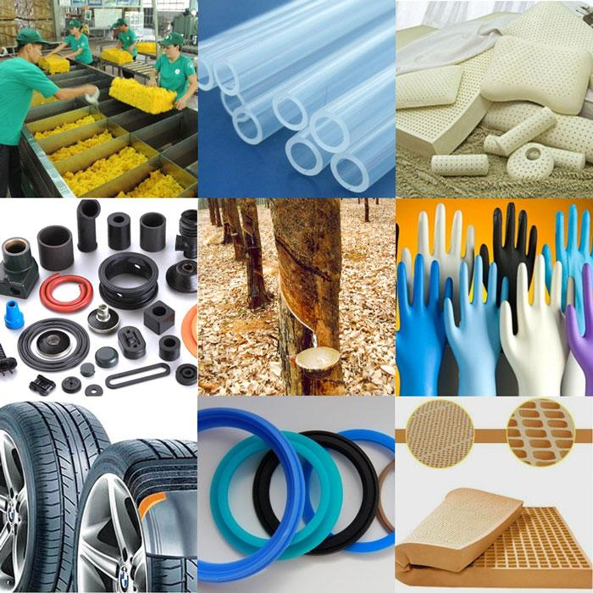
Fig. 1- Rubber Products [17 ]

II. LITERATURE REVIEW

Rubber compounding involves the science and engineering of rubbers and rubber additives, such as processing aids, fillers, and curing agents, in definite proportions to obtain a uniform mixture that will have desirable physical and chemical properties to meet processing at low cost and end use performance.

Several research studies have been conducted on the ,science ,properties, defects, additives and improvement of rubber compound and manufactured products.One study, published in the Science and technology of rubber 2005, focused on Vulcanization is a range of processes for hardening rubbers. It is the process of converting natural rubber to more strong and elastic form[4].

Another study, published in the The Complete Book on Rubber Chemicals 2009, The primary requirement of adding different compounding ingredients to develop the different grades of rubber compounds to meet various service needs at an economic price and to provide certain desired physical properties to a considerable extent. Some of the examples of rubber chemicals are waxes, amines, thiazoles, silicone resins, alcohol, sulphuric acids, dithiocarbamates, phosphoric acid etc. They are mostly applicable for white and coloured rubber[5].

The relationship between chemicals and compounds have been observed and studied in detail in the Rubber Chemistry and Technology 1982,Raw rubber is elastic and lacks the plasticity properties. The process of degrading the long-chain molecules of raw rubber to form plasticity . To adapt to various conditions of use.Process simulation.Revised and expanded single-source reference analyses all compounding material classes of dry rubber compounds, such as carbon blacks, plasticizers and age resisters, integrating detailed information on how elastomers are built up. The work provides practical compounding tips on how to avoid oil[6].

A more recent study, published in Basic Compounding and Processing of Rubber 2019, presented a comprehensive analysis on generally used curing agents are sulfur, peroxides, and metal oxides. These materials are used to cross-link the rubber matrix; these cross-links form different bonds, such as carbon–carbon, carbon–sulphur, and sulphur–sulphur linkages[7].

III. METHODOLOGY

Product Observation

Outcomes

Solutions

Design Calculation

Testing

Result

PRODUCT OBSERVATION

Problem 1: Abrasion of Rubber
Abrasion refers specifically to the wear which is caused to a material through friction when it comes into physical contact with something else. This wear can be caused by a wide variety of different processes. These can include repeated impacts, scuffing, scraping, sliding and grinding, among other motions.

Problem 2: UV Degradation
UV-light promotes free radical oxidation of the rubber surface which results in the formation of a film of oxidised rubber on the surface of the product

Problem 3: Temperature and Pressure Effect
Heat and pressure cause those chemical bonds to break, which results in lost elasticity. Overall, rubber seals that are exposed to thermal stress will lose their flexibility and elasticity over time.

Problem 4: Oil and Solvent Reaction
A liquid may cause the rubber to swell, it may extract chemicals from it, or it may chemically react with it.

Problem 5: Exposure to Ozone and Oxygen
Different rubber polymers will have greater or less resistance to ozone.A common effect includes cracking along the exposed, stretched, or stressed face — this is sometimes referred as dry rotting.

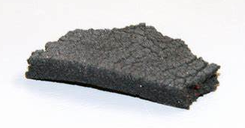
Fig. 2- Abrasion in rubber product[18 ]

OUTCOMES
1. Rubber Abrasion Resistance:
It is combated by the incorporation of fillers like carbon black and silica. These are the most common reinforcing agents. Typical fillers are clays, calcium carbonate and titanium dioxide.
Fillers are classified as Black fillers, white fillers, reinforcing fillers, semi reinforcing and non-reinforcing fillers.
2. UV Protection:
The table below contains an overview of the most common types of rubber compounds ability to withstand UV light, weathering and to hold up outdoors.
Table 1- Natural Polymers and their Resistance
Rubber Type | UV and Weather Resistance
Butyl Rubber | Excellent
EPDM Rubber | Excellent
Natural Rubber | Poor / Fair
Nitrile Rubber | Fair
Silicon Rubber | Excellent
Styrene Butadiene Rubber | Poor
Viton Rubber | Excellent
Neoprene Rubber | Good

3. Shielding Temperature and Pressure Effect:
Using Amorphous polymer due to it random molecular structure, Random molecular structure does not have sharp melting point.
4.Ozone Protection:
Can be conferred by antioxidants, anti-ozonates, ultraviolet light protector, waxes Paraffin wax is a useful ingredient to give protection against ozone cracking. It provides protective layer surrounding the surface of the elastomers through the diffusion process, commonly known as blooming, which prevent direct contact between ozone and the elastomers.

SOLUTIONS

CHARACTERISTICS AND PROPERTIES OF ADDITIVES
1.ZnO: Zinc oxide
2.Stearic Acid :
Zinc oxide and stearic acid together form zinc soap, improve the solubility of zinc oxide in the compound, and with the accelerator to form a complex, this complex is particularly lively, it reacts with sulphur to produce a very strong vulcanizing agent.
3.N550 carbon black :
N550 carbon black is a kind of rubber carbon black, suitable for natural rubber and various synthetic rubbers.
4.Sulphur :
Application- Natural rubber is soft, sticky and has less tensile strength. It is vulcanised to make it more strong, tough and elastic.
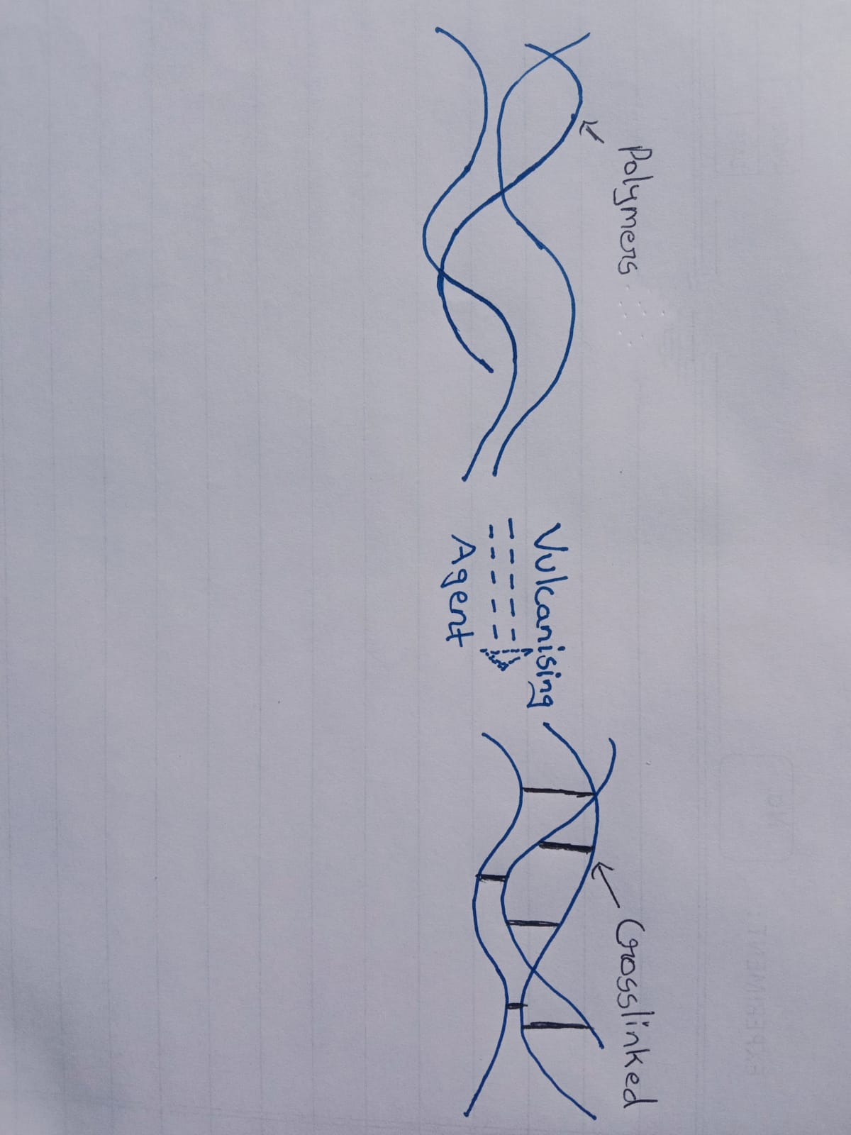
Fig.3- Vulcanisation of rubber
5.Antioxidant :
Ethylene oxide- inhibit the reaction of free radicals with rubber. They are referred to as Radical Scavengers, and they have been widely used in rubber compounds.
6.Processing Oil:
To ease processing and prevent scorching or burning of the rubber polymer when it is being ground. To improve general workability of the rubber compound to aid the dispersion of fillers, and to modify the physical properties of the vulcanised and/or finished rubber compound.
7.Filler :
These are used as substitutes of synthetic and natural rubber ,as they being expensive and have high molar masses.These are cheap and easily available chemical substances ,having similar properties like the rubber .
8.Softner :
The main effect of the softening agent is to soften the rubber molecules to reduce the friction between the molecules, thereby increasing the plasticity, or the raw rubber dripping agent, so that the agent easy to evenly dispersed in raw rubber.
9.Accelerator:
The accelerator is added to the rubber compound to promote the activation of the vulcanizing agent, thereby accelerating the cross-linking reaction between the vulcanizing agent and the rubber molecules, and achieving the practical effects of shortening the vulcanization time, lowering the vulcanization temperature, increasing the output, and reducing the production cost.
10.Wax:
Waxes (both natural and petroleum derived) have long been used as process aids in rubber. They provide economical internal lubrication, mill and mold release,and improved compound flow.
Table 2- Additives and Their hardness
MATERIAL | HARDNESS PER PHR
Carbon | +P/2
Processing Oil | -P/2
Filler | +P/7
Calcium carbonate | +P
ZnO | +1.5P
Wax | +P
Sulphur | +P
Softner | -P/2
Ester Plasticiser | +P/2

DESIGN CALCULATION
In the plastic/rubber industry, various additives are incorporated,under a process called compounding. The amount of these additives to be added is expressed in parts per hundred resin/rubber (PHR).PHR provides the weight of additives per 100 units of the base rubber.
Table 3- Existing Compounding Formulation
COMPOUND | FORMULATION
MATERIAL | QUANTITY PHR
Rubber | 100
White Filler | 50
ZnO | 5
Stearic acid | 1
Sulphur | 2
Accelerator | 4
Carbon Black N550 | 20
Oil Extender | 50
Wax | 5
Talcum Powder | 50
Chalk Dust | 200
Total | 487

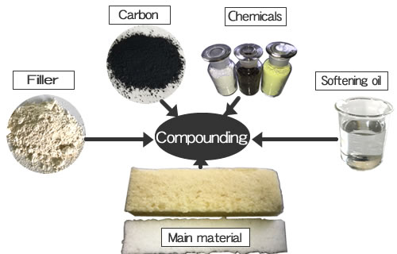
Fig. 4- Compounding of Rubber Products[19 ]

Table 4- Design Calculation Formulation
COMPOUND | FORMULATION
MATERIAL | QUANTITY PHR
Rubber | 100
Filler | 60
ZnO | 5
Stearic acid | 1
Calcium Carbonate | 2
Sulphur | 2
Antioxidant | 1
Accelerator (MBTS) | 1
Wax | 1
Processing Oil | 2
Carbon | 6
Total | 181

Material weight calculation for 10 KG Batch

- Calculation of filler:
60/181 x 10 = 3.3 kg

- Calculation of ZnO:
5/181 x 10 =0.2 kg

- Calculation of Stearic acid:
1/181 x 10 =0.095kg

- Calculation of Calcium Carbonate:
2/181 x 10 =0.11 kg

- Calculation of Sulphur:
2/181 x 10 =0.11 kg

- Calculation of Antioxidant:
1/181 x 10 =0.05 kg

- Calculation of Carbon:
6/181 x 10 =0.33 kg

- Calculation of Wax:
1/181 x 10 =0.05 kg

- Calculation of Processing Oil:
1/181 x 10 =0.05 kg

- Calculation of accelerator:
1/181 x 10 =0.05 kg

TESTING
The Hardness of the Manufactured product was tested using ‘Durometer of Shore A type’ .Result obtained were according to requirement ,has better aesthetic appearance,more resistive to environmental degradations and reactions.The various resistive properties were tested in artificial condition.The strength was improved.The material being soft was able to withstand uneven loads and thermal stresses.

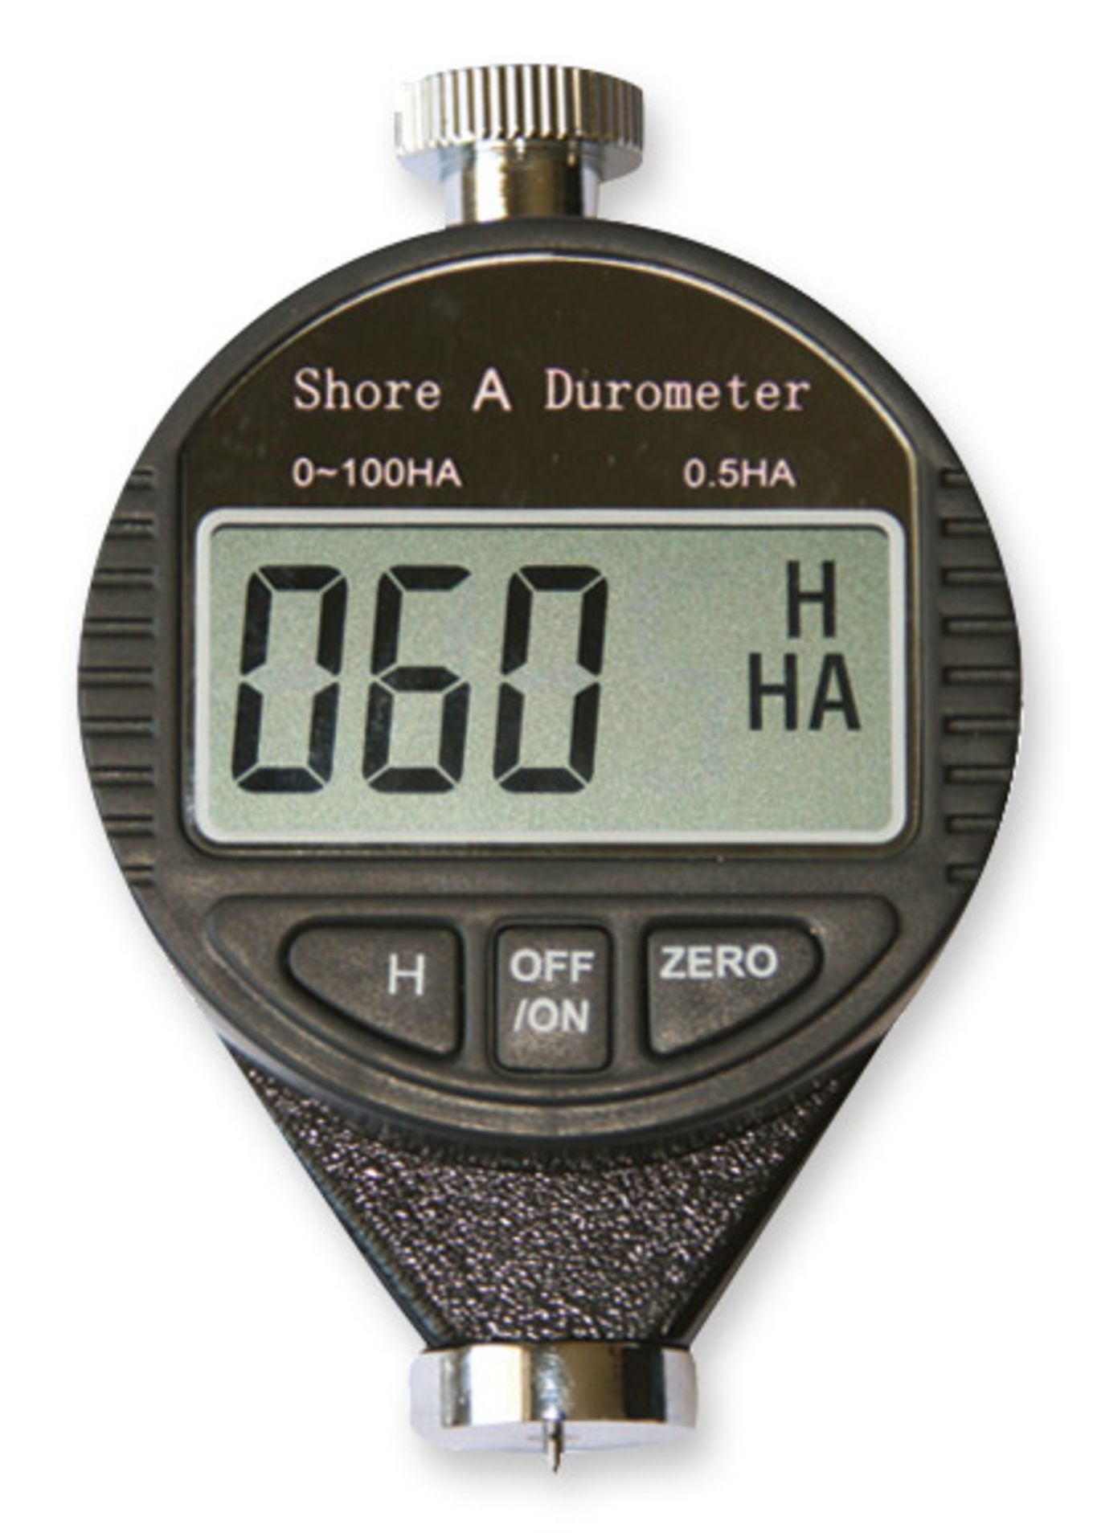
Fig. 5- Durometer to measure hardness[20]

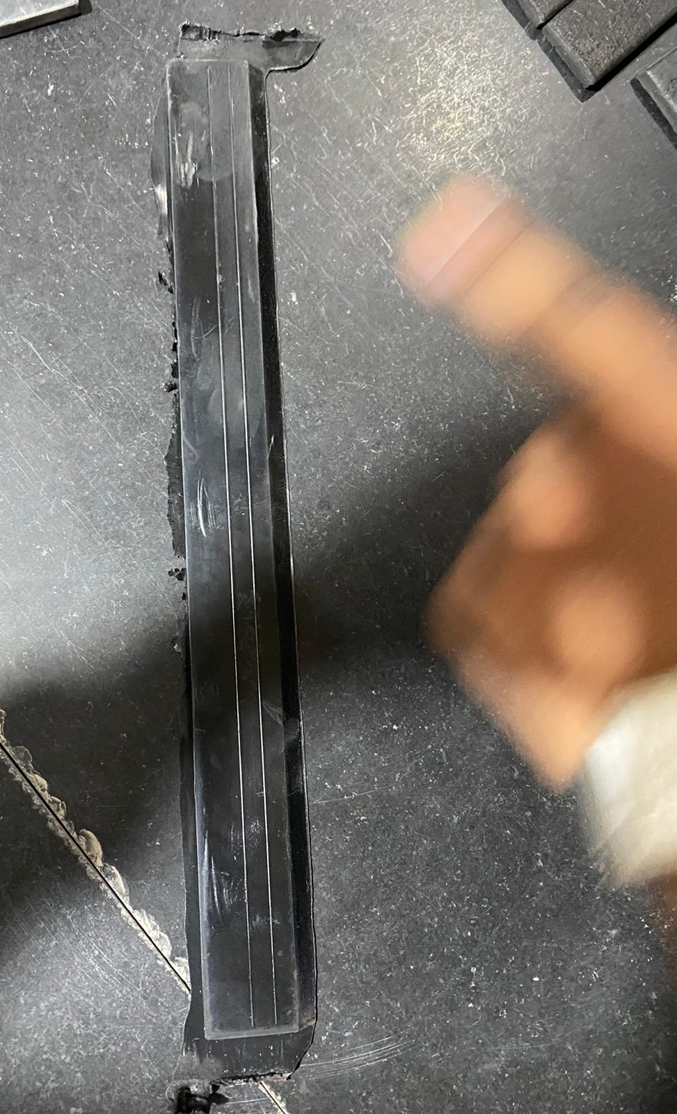
Fig. 6-Product Developed
IV. RESULT

The purpose of the research is to develop a product ,which can resolve the issues and defects occurring in the elastomer products being manufactured.

Fillers were incorporated to increase the abrasion resistance by adding reinforcing properties,moreover they improved hardness,tensile strength,tear strength and lowered the stickiness.
Analysis and research is done on the various properties and characteristics of compounding materials,filler,agents,quality of raw rubber etc. As per our study and findings,we are going to present the same analysis and observations to the staff of industry.
Accordingly we have to take adequate measures and steps to minimise the losses,optimise the production cost. Simultaneously we will be looking to increase the process efficiency.The testing was done for the designed product as per the calculations and results were favourable not only in terms of strength and properties but also durability and cost effective.

V. CONCLUSION

The rubber processing chemicals help in improving the resistance of rubber against effects of heat,oxidation, sunlight,ozone and mechanical stress.Rubber processing chemicals also improve the overall process of vulcanization.Rubber processing chemicals include a wide range of products such as antidegradants,accelerators and processing aids among others.

VI. ACKNOWLEDGEMENT

I acknowledge my deep gratitude to my course Prof. Nimisha Shirbhate for her inspiration, guidance and valuable suggestions for this Research paper

VII. REFERENCES

- H. Palmgren, Rubber Chemistry and Technology, 1975,
- Choi S S,J. Appl. Polym. Sci.1993
- F. S. Myers and S. W. Newell, Rubber Chemistry and Technology, 1978
- Hh
- James E. Mark,’The Science and technology of rubber’ Academic Press, New York,2005
- NPCS Board of Consultants & Engineers,The Complete Book on Rubber Chemicals, 2009
- H. Fries,R. R. Pandit,Rubber Chemistry and Technology ,1982
- Long, H,Basic Compounding and Processing of Rubber ,Lancaster Press2019
- Fig.1,https://www.researchgate.net/publication/327518819
- Fig.2,https://en.m.wikipedia.org/wiki /Elastomer
- Fig.4,https://www.sciencedirect.com/ topics/materials-science/vulcanization-agent
- Fig.5,https://www.salutron.de/fileadmin/_processed_/csm_haertepruefgeraet-shore-a-duromete

