Two Stage Converter Standalone PV Battery Based On VSG Control

P. Bhaskar prasad¹, P.Deepika², Y.Jahnavi³, D.Hajivali⁴, P.Lokeswar⁵
¹Assistant Professor, Department of EEE, Annamacharya Institute Of Technology and Sciences (AITS), Rajampet, Andhra Pradesh, 516126.
^{2,3,4,5}Students of Electrical And Electronics Engineering, Annamacharya Institute Of Technology And Sciences (AITS), Rajampet, Andhra Pradesh, 516126,

deepikaprodduturu@gmail.com

Received on: 03April,2023 Revised on: 28 April,2023 Published on: 30April,2023

Abstract –In photovoltaic (PV) systems, conventional energy conversion architectures are frequently compelled to choose between power generation and conversion efficiency. This work proposes an energy conversion scheme that, although converting just a small fraction of the total power generated, allows each PV element to function at its maximum power point (MPP). To achieve this, only the MPP current mismatch of a group of series-connected PV elements is supplied. Differential power processing improves overall conversion efficiency and provides solutions to issues caused by subpar MPPs (due to partial shading, damage, manufacturing tolerances, etc.). The analysis and comparison of different differential power processing architectures with Monte Carlo simulations. Distributed monitoring and protection are made possible by local control of the differential converters. System reliability has significantly increased overall, according to reliability analysis. simulations and experimental results exemplify the advantages of this strategy at the panel and subpanel levels, respectively, and are included.
Keywords- Local control, maximum power point tracking, and differential power processing (MPPT), solar energy, and renewable energy are some index terms.
- INTRODUCTION
Solar photovoltaic (PV) systems must continually generate as much electricity as possible over the duration of the system's lifespan in order to reach grid parity. This conclusion is reached by comparing the levelized cost of energy (LCOE) of PV systems with other resources. Panel lives are relatively lengthy, with warranties often lasting 25 years or longer, which strengthens the viability of PV. In the past, power electronics that converted and controlled the mean time to failure (MTTF) of energy from a PV installation is often much lower than that of PV panels, increasing the system's overall cost. Though inverter advancements have increased dependability, it is nevertheless crucial that the power processing architecture and components result in high efficiency, reliability, safety, and performance of the overall PV system.
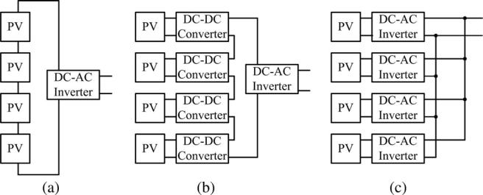

Fig. 1. A series PV with a central inverter, a modular cascaded dc-dc converter with a central inverter, and module-integrated inverters are only a few of the PV power processing architectures that are currently available (microinverters.)

II. LITERATURE REVIEW
K. A. Kim, B. B. Johnson, P. T. Krein, and P. S. Shenoy propose. In photovoltaic (PV) systems, conventional energy conversion architectures frequently have to choose between producing power and maximising conversion efficiency. In this study, an energy conversion strategy is presented that allows each PV element to function at its maximum power point (MPP) while only converting a small portion of the total power generated. The problems brought on by inferior MPPs are resolved by differential power processing, which boosts total conversion efficiency (due to partial shading, damage, manufacturing tolerances, etc.). Analyzed and contrasted with Monte Carlo simulations are a number of differential power processing architectures. Distributed protection and monitoring are made possible by local control of the differential converters. A considerable boost in total system dependability is revealed by reliability analysis. Results from experiments and simulations are included.
X. Lu, K. Sun, J. M. Guerrero, J. C. Vasquez, and L. Huang suggest in this study. A state-of-charge (SoC)-based adaptive droop control mechanism is suggested to balance the SoC of each energy storage unit (ESU). The droop coefficient for this decentralised control technique is inversely correlated with the SoC's nth order. ESUs with greater SoC deliver more power than those with lower SoC utilising a droop approach that is based on SoC. Because of this, the energy stored in the ESU with greater SoC degrades more quickly than that with lower SoC. Eventually, the load power is evenly distributed between each ESU's SoC differences, which have been steadily decreasing. M. Shayestegan. The literature is divided into categories based on the different kinds of PV systems, DC/DC boost converters, and DC/AC inverters, as well as the different kinds of controllers that regulate the circuit to guarantee maximum power tracking and input voltage and load stabilisation. The constraints and advantages of various topologies are also discussed in the study along with their fundamental functioning principles. The next generation of gridconnected PV systems is then offered using the suggested technology, which is then derived and its simulation results are described.
III. METHODOLOGY
LOCAL CONTROL
For local control, differential power processing works effectively. Differential converters can maximise each PV element's power output using only local information. The converters may benefit from additional security and oversight measures.
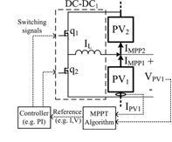

Fig. 2 Maximum power point tracking combined with regional data.
- Tracking of Maximum Power Point
Utilizing local data, a number of maximum power point tracking (MPPT) methods can be applied. Certain MPPT algorithms might not be as effective when applied to differential converters. For instance, since it must open the primary circuit channel, a fractional open-circuit voltage technique might not be preferable. When power conversion is managed at the submodule level, simple, low power overhead solutions may be appropriate. As depicted in Fig. 2, Extraction of maximum power from each PV element is the objective of the local controller. An elementary perturb-and-observe (P&O) algorithm is used in this work. At each PV element, local measurements of voltage and current are taken on a regular basis These measures allow the local controller to evaluate whether power has risen.
- Monitoring and Protection
One of the biggest problem in largescale installations, PV systems in particular, is the requirement for local protection and monitoring. When adopting the differential power approach, each local converter can be enhanced with protection, monitoring, and even active diagnostics. Local converters, for instance, can safely intervene in the event of an arc fault to avert fire or other dangers. Local information could be used by differential converters to decide if it is essential to open the circuit or shunt around the PV element. Local converters have the ability to report unusual activity, such as instances where a particular converter is processing more power than is desired. Costs associated with system operation and maintenance are projected to drop due to the improved safety performance and capacity to locate local problems.
- Simulated Example
Three PV panels in series with two buck-boost, PV-to-PV differential converters are designed and simulated in order to further study differential power processing. The system's structure is comparable to that seen in Fig. 3. (a). Three PV elements can be simulated to demonstrate the essential elements of differential converter functioning without being cumbersome. Standard modelling methods are used to simulate BP7185N panels, which have a nominal open-circuit voltage of 44.2 V. The first PV panel has a short-circuit current of 4.58 A and a 90% insolation, whereas the other two panels have a 5.09 A short-circuit current and 100% insolation.

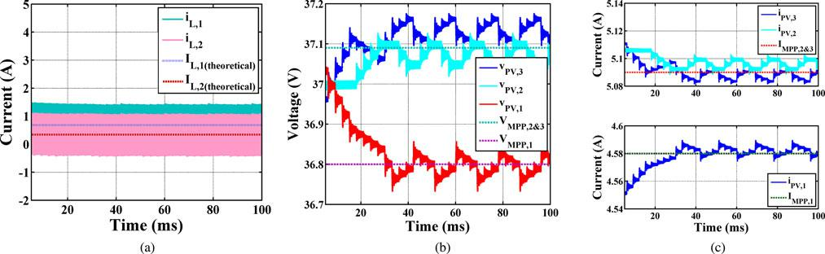

Figure 3. Using local differential converters to track the MPP of three series PV panels. Differential converters in (c) inject current so that each PV panel can run at its (a) MPP voltage and (b) MPP current.

A P&O algorithm employing local information determines the MPP of each PV panel. The duty cycle of the local P&O algorithm is updated every three milliseconds.
With a local 10% mismatch, MPP operation is accomplished when just a small portion of the total power is processed. Differential converters deliver a low average current [less than 1 A, as illustrated in Fig. 3(a)] in line with theoretical calculations. As illustrated in, coupling prevents the differential converters in this setup from merely providing the difference between the MPP currents of the PV elements (1). This indicates that, in contrast to the system's overall output power of almost 550 W, the differential converters process 25 W or less. As depicted in Fig. 3(b) and each PV panel achieves its local MPP (c). When compared to the predetermined settings, the power output of this system rises by around 16 W (a 3% increase).
IV. DESIGN
ASSESSMENT OF RELIABILITY

Comparing differential power processing to more traditional methods, system reliability is actually increased. Due to the fact that A local breakdown in the basic differential architecture won't have an impact on the transmission of conventional bulk power; instead, it will simply return to a typical series connection. The power components in the local converter can carry out additional tasks in dire situations. For instance, the related energy generation process can shift and eliminate substring if localised damage or severe shading happens within a panel. This improves and might even take the place to prevent local thermal runaway, PV panels currently use protection bypass diodes. We anticipate that strategy will allow for the replacement of bypass diodes and the avoidance of hotspots.
Three PV systems are modelled simply for the purpose of quantitative reliability effect study, and a matching closed form reliability function is then generated. To determine an MTTF for the system, the reliability functions are then contrasted. In this analysis, reliability is interpreted axiomatically and traditional modelling presumptions are used. Models for component defects show them as directly causing open or short circuits in order to make things more clear. Not all possible A component's failure modes or causes include addressed. Analytical tractability is promoted via a probabilistic framework. Think of T as the component's time to failure, and let it be a random variable. The consistency
R(t) = $P_{r}\{T>t)$ (1)
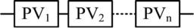

Fig. 4 Model for series PV elements reliability
The distribution of failures is thought to be exponential. This indicates that throughout the operating life, The lowest part of the "bathtub curve" represents the continuous failure rate [30]. With this model, a specific component's reliability is
R(t) = $e^{-\int{λ}dt} = e^{-λt}$ (2)
The component's final MTTF is
MTTF = $\int_{0}^{∞}{R\left(t\right)dt}= \frac{1}{λ}$ (3)
As a result, the failure rates of all the PV components are same (i.e., p,1 = p,2,n = p, and d,1 = d,2,2 = = d,n = d), and all the dc-dc converters, whether differential or cascaded, have identical failure rates.
- PV String Series
It is quite simple to create a dependability A series PV system model, like the one in Fig. 1, is presented (a). System failure results from the series string being recognised as open-circuited, whenever one of the PV panels develops a fault. From the standpoint of reliability, this system can be represented as n series PV elements. Fig. 9 displays the appropriate component-based dependability diagram. The overall system's dependability is
R(t) = $P_{r}\{T>t\}$
= $P_{r}\{T_{1}>t, T_{2}>t, . . . . T_{n}>t$}
= $P_{r}${$T_{1}>t$} . $P_{r}${$T_{2}>t$} . . . $P_{r}${$T_{n}>t$}
= $e^{-λ_{p,1}t}$ . $e^{-λ_{p,2}t}$ . . . $e^{-λ_{p,n}t}$
= $\prod_{i=1}^{n}{e^{-λ_{p,i}t}}$ (4)
Since each PV has the same failure rate, this product can be further simplified. As a result, the system's reliability
R(t) = $e^{-nλ_{p}t}$ (5)
- Stacking DC-DC Power Optimizers
The foundation of the dependability If one of the dc-dc converters in the series string of a PV system's cascaded dc-dc converters fails, the system collapses because it is unable to produce any power, according to the model, as depicted in Fig. 1(b). A string open circuit can be compared to the dc-dc converter failure. However, the system can continue function even if a PV panel fails, but possibly with reduced power.
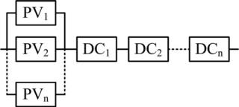
Fig. 5 Reliability model for a PV system with cascaded dc power optimizers.
By combining the series-connected dcdc converters having a component that combines the parallel PV components, the system's dependability is determined using the reliability model. Utilizing the unreliability QPV, the reliability RPV of the set of parallel PV components is calculated.
$R_{PV}(t)$ = 1 - $Q_{PV}(t)$
= 1 – (1 - $P_{r}\{T_{1}>t\}$) . . . (1 - $P_{r}\{T_{n}>t\})$
= 1 - $\prod_{i=1}^{n}{(1- R_{P,I}(t)})$
= 1 - $\prod_{i=1}^{n}{(1- e^{-λ_{P,i}t})}$ (6)
The system reliability indicated by this result can be determined by
R(t) = $R_{PV}(t)R_{dc,1}(t)$ . . . $R_{dc,n}(t)$
= (1 - $\prod_{i=1}^{n}{(1- e^{-λ_{p,i}t}}))\prod_{i=1}^{n}{e^{-λ_{d,i}t}}$ (7)
The reliability equation can be simplified to because Comparable components have similar failure rates.
R(t) = (1 – ${(1- e^{-λ_{p}t})}^{n})e^{-nλ_{d}t}$ (8)
- Processing of Differential Power
A differential converter and its neighboring PV element are connected in parallel from the perspective of reliability modelling. The simulation should show that the converters boost the system's overall performance dependability therefore, in contrast to a simpler series string, a differential converter failure does not endanger the system. The PV elements are modelled in series, much like in the case of a series PV system. Depending on where in the system they are located and the system architecture, Each PV element is represented by one or two differential converters operating in parallel. In the model, if a differential converter fails open, the system does not malfunction. Additionally, if a PV element breaks open, differential converters are used to bypass current around the element. In the event of a failure, only one circuit can bypass the initial and final PV components.
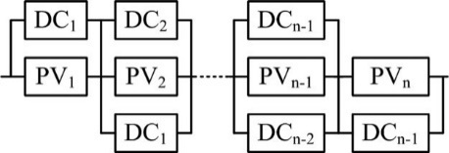

Fig. 6 A PV system with local differential converters is shown, as a reliability model.
Analyzing the system's component model yields the system reliability function. A string of parallel components create the component model in succession. The ability to aggregate each parallel segment into a single component and analyse it after the other segments is a possibility. The system reliability function is if R1 (t),..., Rn (t) denotes the reliability function for each parallel aggregation.
R(t) = $R_{1}(t)R_{2}(t)$ . . . $R_{n}(t)$. (9)
The failure rates for similar components are the same as they were in the prior two systems. Consequently, the first and last segments' dependability
$R_{1}$(t) = $R_{n}$(t) = 1 – (1 - $e^{-λ_{p}t})$(1 - $e^{-λ_{d}t})$
= $e^{-λ_{p}t}+ e^{-λ_{d}t}- e^{-(λ_{p}+ λ_{d}t)}$ (10)
All of the intermediate parts are consistently reliable.
$R_{2}$(t) = . . . = $R_{n-1}(t)$ = 1 – (1 - $e^{-λ_{p}t}){(1- e^{-λ_{d}t})}^{2}$
(11)

V. RESULT & DISCUSSION
To test experimentally the potential of differential power processing, hardware prototypes were created to function at the subpanel level. Figure 13 depicts a series string of PV modules with a single differential converter shown in its diagram (a). Switches, gate drivers, and the majority of the control are housed in the analogue integrated circuit (IC) is the central component of the prototypes. The LM20343 chip from TI was chosen because it had the required output voltage could be changed using an analogue reference value, and the device had synchronous switching to permit bidirectional current flow. The output reference voltage could be updated using this by an outside MPPT loop. The initial models used a 56-H inductor with 14.1 F of output capacitance and switched at 250 kHz.
The subpanel differential converter was built in two different designs. In the second iteration, a TI MSP430 microcontroller with a P&O MPPT algorithm was employed. while the first had no external MPPT loop and an LM20343 chip. The converter's voltage reference was initially set using a potentiometer to correspond to the PV's rated MPP voltage. a computer that also logged the results of the experiment managed the electronic load, which monitored each string's global MPP. The average one step was made every second for MPPT globally. Fig. 5 displays the power and energy produced by the two PV systems on a sunny day. Less than 5% of the PV panel's surface area was shadowed, which is a very modest amount. During the 5-min test period, the differential system produces approximately 50% more average power than the series system. As a result, by the end of the test time, energy production is around 50% higher. After roughly 25 s, each system reaches its global MPP. This is seen in Fig. 10's early power increase. Around 120 seconds, there was a power dip that was likely caused by a cloud.
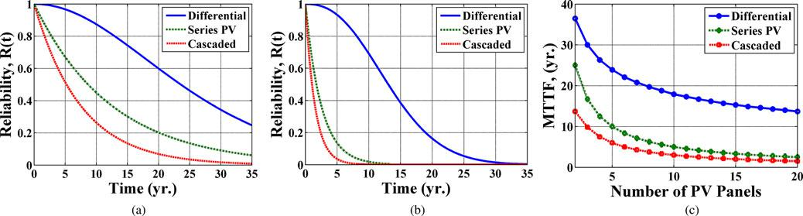

Figure 7 shows the dependability of a PV system with series panels, cascaded dc-dc converters, and local differential converters that uses (a) four PV panels and (b) 20 PV panels. The MTTF of each system for varied PV panel counts is shown in (c).
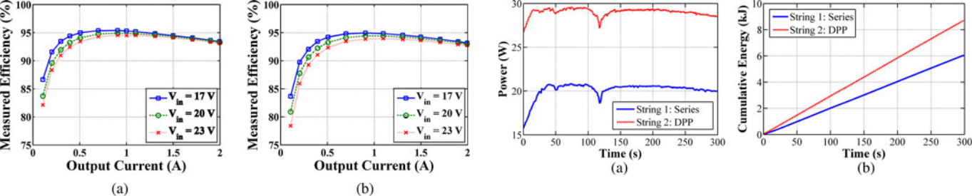

Fig. 8 depicts a diagram of the parts that make up a prototype subpanel differential converter (a). The respective PV element's MPP is tracked using local information. Prototypes of the hardware are displayed in (b).

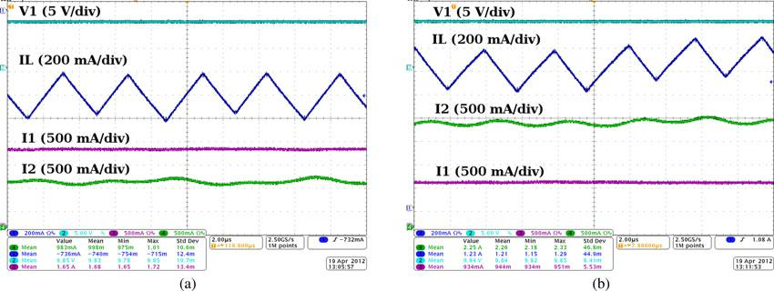

Figure 9 shows the measured efficiency of prototype subpanel differential converters with and without microcontrollers.
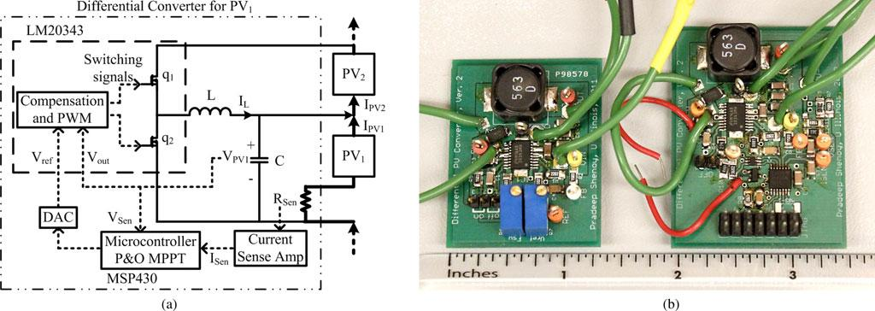

Figure 10 shows the measured power and energy produced by two series PV strings under 5% partial shade, both with and without differential power processing

Figure 11 shows the differential converter inductor current, PV voltage, and current under a shading condition that produces both positive and negative inductor current.

Fig. 11 illustrates the resultant negative inductor current (a). Due to partial shading of the lower PV substring, as depicted in Fig. 16, the differential converter injects cur
By attaining difference converters allow a the MPP of each series PV component, series PV system to properly maximise power generation. When there is an imbalance among the MPP currents, only a tiny portion of the entire output power is processed. Differential converters have a number of benefits that help to keep costs down, including: Since MPPT performance on time scales of a few milliseconds is at the cutting edge and differential converter requirements are easy and commonplace in the context of power conversion, There are no particular demands for dynamic performance. In addition, there are numerous scalable, local conversion solutions available. The LCOE of PV systems may be markedly enhanced by differential power processing. The architecture for differential power processing yields a longer MTTF than comparable dc topologies, according to a comparison of system reliability studies. Locally controlled differential converters are enhanced by security and monitoring features.
VI. CONCLUSION
In the paper, two-stage converter PV systems with a battery unit are suggested. The proposed control technique uses VSG control and MPPT algorithms. A bidirectional converter control is also provided. The rapid and responsive control capacity of the proposed approach enabled the combined control to successfully track under diverse irradiation circumstances. The bidirectional battery approach demonstrates that the control of battery modes also has greater control capacity, in addition to the positive effects on the entire system and the combined control performance tests. An investigation of the MPPT control's efficiency was performed. The control effectiveness of the MPPT system is 99%. The experiment demonstrated that the frequency dynamics are significantly enhanced by an increase in inertia. This indicates that VSG is able to accurately and faithfully simulate a synchronous generator.
ACKNOWLEDGMENT
The authors acknowledge the informative discussions about solar PV and reliability that they had with R. Pilawa, A. Dom'nguezGarc'a, and S. Dhople. R. Pilawa deserves special recognition for donating some of the hardware tools necessary for this study. The PLECS toolkit was used in the simulations, and Plexim is gratefully acknowledged by the writers for that. The information, data, or work offered here was partially financed by a US government agency. The accuracy, completeness, or usefulness of any information, apparatus, product, or process revealed is not guaranteed by any agency of the United States government, any of its personnel, and it is also not implied that its use will not violate the rights of third parties. any agency of the United States government does not necessarily represent or imply that any specific commercial product, technique, or service mentioned herein is endorsed, recommended, or given special treatment. The views and opinions of the authors are not necessarily representative of or aligned with those of the United States Government or any agency thereof.

REFERENCES
- “Power electronics needed for reaching grid-parity solar energy costs," Proc. IEEE Energy 2030 Conf., Nov. 2008; T. Esram, P. T. Krein, B. T. Kuhn, R. S. Balog, and P. L. Chapman
- National Renewable Energy Laboratory, Golden, CO, Tech. Rep. 462-5173, March 1995. W. Short, D. J. Packey, and T. Holt, "A guidebook for the economic evaluation of energy efficiency and renewable energy systems,"
- "20 years of life and more: where is the end of life of a PV module?" in Proc. IEEE Photovoltaic Spec. Conf., Jan. 2005, pp. 1593– 1596.
- N. G. Dhere, "Reliability of PV Modules and Balance-of-System Components," Proc. IEEE Photovoltaic Spec. Conf., January 2005, pp. 1570-1576.
- P. T. Krein and R. S. Balog, "Cost-effective hundred-year life for singlephase inverters and rectifiers in solar and LED lighting applications based on minimum capacitance requirements and a ripple power port," Proc. IEEE Appl.

