Design of Grid connected bidirectional Wireless Power Transfer System for Electrical Vehicle Application
Samruddhi Jadhav¹, Prof. Rajendra Bhombe², Prof. Saurabh Bagde³, Dr. Kishor Porate⁴
¹ M.Tech Student, ^{2,3}Assistant Professor, ⁴Professor,
Department of Electrical Engineering, Guru Nanak Institute of Engineering and Technology, Nagpur, Maharashtra,
India-441501

Abstract – Wireless Power Transfer (WPT) for Electric Vehicle (EV) battery charging application is one of the key upcoming technologies. The possibility of using EVs to transfer power back to the grid, utilizing the concept of Bidirectional Wireless Power Transfer (BD-WPT) is extensively being explored. The effect of integration of EV on grid is also of concern. This paper presents analysis of complete grid integrated BD-WPT system for controlling power transfer between grid and EV battery, along-with ensuring Unity Power Factor (UPF) at grid side. Mathematical model of each component in the system is presented which is then used to design vehicle and grid side controllers for achieving desired output. Concepts stated analytically are validated by simulation in MATLAB (Simulink).
Keywords- Bidirectional Wireless Power Transfer (BD-WPT), Electric Vehicles (EV), Grid Integration, Unity Power Factor (UPF), Controller Design, MATLAB, Simulink.
INTRODUCTION
The increasing global concern over depletion of fossil fuel reserves and their adverse effects on the environment have resulted in fast development in technologies like renewable energy generation and EVs. Conductive charging has been long introduced but is still not preferred due to tripping hazards, leakage from old, cracked cables (particularly in cold zones), risk of electric shock etc. Major drawback of present EVs is the power storage technology, usually battery, which has very unsatisfactory performance. Long charging time of EV batteries is the

main reason for its low popularity among consumers. Introduction of wireless power transfer for EV battery charging is thus being considered as a probable solution for aforementioned issues in conductive charging [1]. Wireless charging technique provides several advantages like galvanic isolation, convenient and safe usage in addition to low maintenance due to no physical contacts or moving parts [2]. Also, the battery capacity of EVs with wireless charging could be reduced to 20% or less compared to EVs with conductive charging [3][4]. Most of the developments in WPT technology have mainly been in applications requiring unidirectional power transfer [5]. In recent years, BD-WPT systems have become popular for implementing the concept of Vehicle to Grid (V2G) for grid integration of EVs [6]. To reduce the effects caused due to intermittent nature of renewable energy systems and facilitate dynamic demand management, V2G concept can be used as cost-effective alternate energy storage unit [7][8].
In this work, a complete system depicting V2G and G2V concept for controlling desired power transfer between grid and EV battery, along-with ensuring unity power factor at grid side has been analysed and simulated in MATLAB.
METHOLOGY
A block diagram broadly describing the elements of a bidirectional wireless power transfer system is shown in Fig. 1. It consists of two sides: primary and secondary. Primary side is connected to the utility grid via a dc link and is usually embedded under the road in places like traffic signals, bus stops, vehicle charging stations etc. The secondary side is connected with EV battery and is placed at the bottom of electric vehicle. As can be seen in Fig. 1. both sides consist of coupling coils, high frequency (HF) converters, compensation circuit and dedicated controllers. When power flows from grid to EV battery (forward direction), primary converter acts as an inverter (DC/AC) and secondary converter acts as a controlled rectifier (AC/DC). Similarly, when EV battery supplies power to the grid (reverse direction), the role of converters is reversed. As already mentioned, there are compensation networks on both primary and secondary sides.
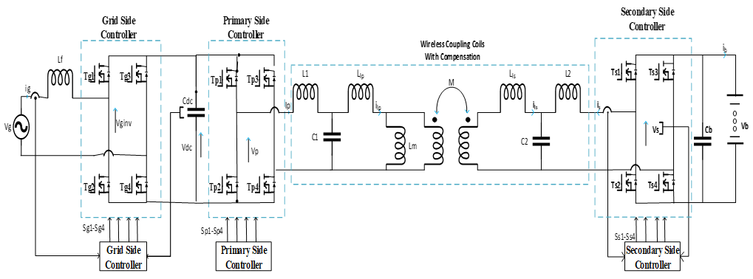
Fig 1: Grid Connected BD-WPT System
Wireless Power Transfer (WPT) for Electric Vehicle (EV) battery charging application is one of the key upcoming technologies. The possibility of using EVs to transfer power back to the grid, utilizing the concept of Bidirectional Wireless Power Transfer (BD-WPT) is extensively being explored. The effect of integration of EV on grid is also of concern. This paper presents analysis of complete grid integrated BD-WPT system for controlling power transfer between grid and EV battery, along-with ensuring Unity Power Factor (UPF) at grid side. Mathematical model of each component in the system is presented which is then used to design vehicle and grid side controllers for achieving desired output. Concepts stated analytically are validated by simulation in MATLAB (Simulink)

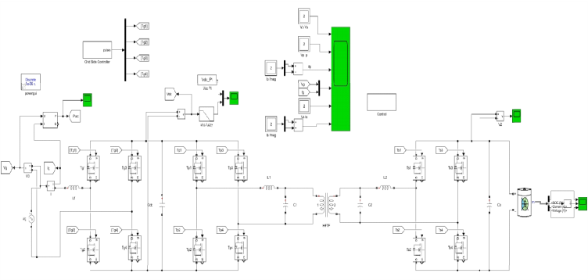
Fig 2: Modelling of proposed test system

The above is the modelling of proposed circuit topology connected to single phase grid source, output is connected to EV battery. The below is the single phase fully controlled rectifier controller with feedback from DC link voltage.

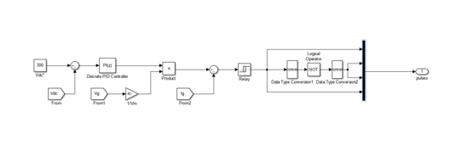
Fig 3: Grid side rectifier controller
The below is the phase shift PWM technique of the dual active bridge DC AC- AC DC- converter with grid power feedback selecting G2V or V2G modes. If Pref is positive the mode is G2V and if Pref is negative the mode is V2G.
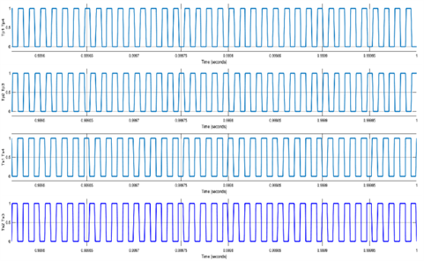

Fig.4-Phase shift pulse of Dual active full-bridge DC-DC converter

The simulation is run for 1 sec making the circuit work in G2V mode from 0-0.5sec and in V2G mode from 0.5-1sec.

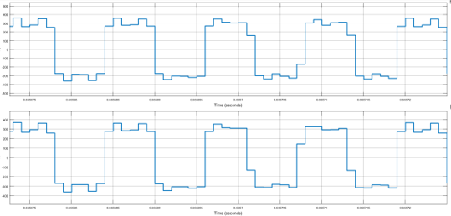

Fig 5: Primary and Secondary voltages of high frequency transformer
The simulation is run for 1 sec making the circuit to work in G2V mode from 0-0.5sec and in V2G mode from 0.5-1sec. The below is the direction of power of grid during both modes of operation.

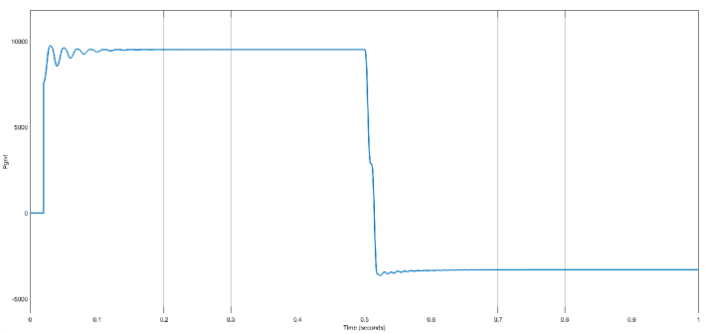

Fig 6: Grid active power

In any condition, the DC link voltage is always maintained at 300V, and the graph is shown below

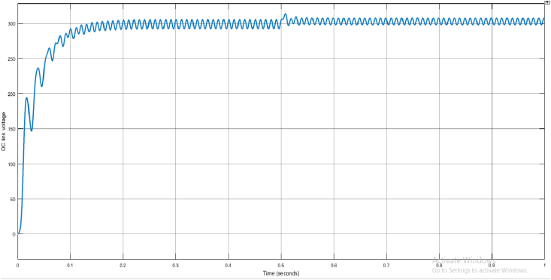

Fig 7: DC link voltage after controlled rectifier using a PI controller
For both the conditions the battery characteristics are shown below. As the it can be seen the battery is charged from 0-0.5sec with raising rate of SOC and negative

current. After 0.5sec the SOC is falling, and the current is shift to positive direction showing discharging condition.

CONCLUSION
The paper titled "Power Flow Study of Grid Connected Bidirectional WPT Systems for EV Application" presents significant findings regarding the implementation of bidirectional wireless power transfer (BD-WPT) systems for electric vehicles (EVs). Here are the key conclusions drawn from the study:
Bidirectional Power Transfer Scheme: The authors successfully derived a mathematical model for the bidirectional power transfer scheme, which operates in both Grid-to-Vehicle (G2V) and Vehicle-to-Grid (V2G) modes. This model encompasses various components of the system, including the Grid Connected Converter (GCC), primary and secondary inverters, and coupling coils. The simulation results align well with the analytical equations presented in the paper, confirming the validity of the model.
Operational Efficiency: The study demonstrates that V2G and G2V operations can be executed without interruptions in the functioning of the converters. This is crucial for maintaining a stable power flow between the grid and the EV battery, ensuring that the system can efficiently manage energy transfer in both directions.
Power Quality Assurance: The research emphasizes the importance of maintaining a sinusoidal grid-side current that is in phase with the grid voltage. This approach helps to avoid power quality issues, which are often a concern in power transfer systems. The authors highlight that their control strategies effectively ensure a unity power factor at the grid side.
In summary, the paper provides a comprehensive analysis of a grid-connected BD-WPT system, demonstrating its feasibility and effectiveness for EV applications. The findings pave the way for future research and development in this emerging technology, which holds promise for enhancing the integration of electric vehicles into the power grid.
REFERENCES
- [1] Y. Tang, Y. Chen, U. K. Madawala, D. J. Thrimawithana and H. Ma, “A New Controller for Bidirectional Wireless Power Transfer Systems,” in IEEE Transactions on Power Electronics, vol. 33, no. 10, pp. 9076-9087, Oct. 2018.
- [2] S. Li and C. C. Mi, “Wireless Power Transfer for Electric Vehicle Applications,” in IEEE Journal of Emerging and Selected Topics in Power Electronics, vol. 3, no. 1, pp. 4-17, March 2015.
- [3] A. A. S. Mohamed, A. Berzoy and O. A. Mohammed, “Experimental Validation of Comprehensive Steady-State Analytical Model of Bidirectional WPT System in EVs Applications,” in IEEE Transactions on Vehicular Technology, vol. 66, no. 7, pp. 5584-5594, July 2017.
- [4] D. J. Thrimawithana, U. K. Madawala and Yu Shi, “Design of a bi-directional inverter for a wireless V2G system,” 2010 IEEE International Conference on Sustainable Energy Technologies (IC-SET), Kandy, 2010, pp. 1-5.
- [5] Y. Hsieh, Z. Lin, M. Chen, H. Hsieh, Y. Liu and H. Chiu, “High-Efﬁciency Wireless Power Transfer System for Electric Vehicle Applications,” in IEEE Transactions on Circuits and Systems II: Express Briefs, vol. 64, no. 8, pp. 942-946, Aug. 2017.
- [6] M. L. G. Kissin, C. Huang, G. A. Covic and J. T. Boys, “Detection of the Tuned Point of a Fixed-Frequency LCL Resonant Power Supply,” in IEEE Transactions on Power Electronics, vol. 24, no. 4, pp. 1140-1143, April 2009.
- [7] M. K. Uddin, G. Ramasamy, S. Mekhilef, K. Ramar and Y. Lau, “A review on high frequency resonant inverter technologies for wireless power transfer using magnetic resonance coupling,” 2014 IEEE Conference on Energy Conversion (CENCON), Johor Bahru, 2014, pp. 412-417. doi: 10.1109/CENCON.2014.6967539
- [8] C. Mi and C.T. Rim, “Wireless power transfer for electric vehicles and mobile devices”, John Wiley & Sons Ltd., U.K., 1st edition, 2017.
- Dodke, R. Argelwar, B. S. Dani and S. P. Muley, "Comparison of cuk and buck converter fed electronically commuted motor drive," 2016 International Conference on Electrical, Electronics, and Optimization Techniques (ICEEOT), Chennai, India, 2016, pp. 4292-4297, doi: 10.1109/ICEEOT.2016.7755529.
- Design and CFD Simulation of Supersonic Nozzle by Komega turbulence model for Supersonic Wind TunnelRavi Shankar Raman, S. Vinod Kumar, Uma Reddy, Amit Dodke, Ashwani Kumar, Sonali Jayronia and Myasar Mundher Adnan E3S Web of Conf., 507 (2024) 01024DOI: https://doi.org/10.1051/e3sconf/202450701024.
- D. Raipure, D. Padole, S. Joshi, W. Patil, S. Patil and A. Dodke, "Design of Non Stop Solar Electric Vehicle Charging System Using Inductive Charging System-A Review," 2024 International Conference on IoT Based Control Networks and Intelligent Systems (ICICNIS), Bengaluru, India, 2024, pp. 744-751
- C. Xia, Z. Deng, and X. Zhang, "A Bidirectional Wireless Power Transfer System for an Electric Vehicle," IEEE Transactions on Industrial Electronics, vol. 62, no. 10, pp. 6041–6050, Oct. 2015.​

- S. Y. Choi, B. W. Gu, S. Y. Jeong, and C. T. Rim, "Advances in Wireless Power Transfer Systems for Roadway-Powered Electric Vehicles," IEEE Journal of Emerging and Selected Topics in Power Electronics, vol. 3, no. 1, pp. 18–36, Mar. 2015.​
Wikipedia

- J. A. Russer and P. Russer, "Design Considerations for a Moving Field Inductive Power Transfer System," in Proceedings of the 2018 IEEE Wireless Power Transfer Conference (WPTC), Montreal, QC, Canada, Jun. 2018, pp. 1–4.​
Wikipedia
[15] J. A. Russer, M. Dionigi, M. Mongiardo, and P. Russer, "A Moving Field Inductive Power Transfer System for Electric Vehicles," IEEE Transactions on Microwave Theory and Techniques, vol. 67, no.

