PNUEMOGUARD-Chemical Pneumonitis Detection

Mrs. Mrudula Gudadhe¹, Trushna Gandhare², Utkarsha Bhasarkar³, Pranav Madare⁴, Yash Moundekar⁵, Yash Bhatkure⁶

¹Assistant Professor, 23456 Students
Priyadarshini College of Engineering, Nagpur, India, 440019

Email of corresponding Author: gandharetrushna299@gmail.com
Received on: 06 March, 2025 Revised on: 03April ,2025 Published on: 05 April,2025

Abstract – An Innovative Chemical Pneumonitis Detection System for Enhanced Occupational Health and Safety. We present PNEUMOGUARD, a detection system designed to identify chemical pneumonitis, a life- threatening lung inflammation caused by toxic chemical inhalation, consumption. Our research highlights the importance of early detection, classification, and treatment of chemical pneumonitis, emphasizing the need for reliable detection tools. It provides timely and accurate alerts for healthcare professionals, enabling prompt treatment and improved patient outcomes. This innovative system integrates environmental and physiological data analysis to detect early warning signs of chemical pneumonitis, reducing mortality rates and preventing long-term lung damage. PNEUMOGUARD cutting-edge technology has the potential to revolutionize occupational health and safety, protecting vulnerable populations such as construction, manufacturing, and firefighting workers.
Keywords— Chemical pneumonitis, Detection system, PNEUMOGAURD, inhalation, healthcare technology, inflammation, Acute Respiratory distress syndrome (ARDS)

INTRODUCTION
Chemical pneumonitis is a type of lung inflammation caused by inhaling or consuming toxic chemicals, which can damage lung tissue and impair gas exchange. Chemical Pneumonitis can be classified as Acute (Sudden onset, usually after a single exposure to a high concentration of toxic chemicals), Chronic (long-term exposure to low concentrations of toxic chemicals, leading to gradual lung damage.), Irritant-Induced (Caused by inhaling irritant chemicals, such as chlorine or ammonia, which damage lung tissue.), Sensitizer-
Induced (Caused by inhaling sensitizing chemicals, such as isocyanate or anhydrides, which trigger an allergic response)
Chemical pneumonitis occurs through a complex process involving the inhalation of Toxic chemicals that enters the lungs, either through the nose or mouth. The chemicals deposit in the airways, including the trachea, bronchi, and bronchioles. Immune cells, such as macrophages and dendritic cells recognize the toxic chemicals as foreign substances. The immune cells become activated, releasing signaling molecules that attract other immune cells to the site. Activated immune cells release inflammatory mediators, such as cytokines, chemokines, and reactive oxygen species (ROS). Inflammatory mediators attract more immune cells, including neutrophils and lymphocytes, to the site. The inflammatory response causes damage to lung tissue, including the alveoli, airways, and blood vessels. Immune cells release pro-inflammatory cytokines, such as TNF-α, IL-1β, and IL-6. The cytokines activate immune cells, leading to the release of more inflammatory mediators. Immune cells and damaged tissue produce ROS, which cause oxidative stress. ROS damage lung tissue, including lipids, proteins, and DNA. The inflammation causes increased permeability of the alveoli-capillary membrane. Fluid accumulates in the lungs, impairing gas exchange. The inflammation and fluid accumulation cause respiratory distress, including coughing, shortness of breath, and chest pain. Prolonged exposure to toxic chemicals leads to chronic

inflammation. Chronic inflammation causes fibrosis, leading to scarring and permanent lung.
Majorly, Labors, miners, firefighters, that work at mines, chemical industries, and agriculture fields are the Prey to this disease and they are mostly adults aged from 25 to
64. According to National institute for occupational safety and health chemical can be fatal in 5-15% of cases (NIOSH, 2018). Another study published in European respiratory journal and journal of occupational and environmental medicine reported a mortality rate of 15- 30% for severe chemical pneumonitis (Mudoun et al., 2020), and 10-20% mortality rate for simple Chemical Pneumonitis (Kumar et al., 2018). A study published in the respiratory medicine journal found that the overall survival rate for chemical pneumonitis was 70-80%. (Liu et al., 2019) and also the journal of critical Care medicine reported it as 60-70% for patients with severe chemical Pneumonitis (Kim et al., 2017). [7]
According to a review of 145 cases by Kumar et al., (2018) cases of pneumonitis found that 80% of patients recovered fully. And here in 145 cases 12.4% (18 out of 145 cases) are death rates , 87.6%(127 out of 145 cases) survival rate, 21.4% (31 out of 145 cases) has long term lung damage and overall recovery rate was 71.7% (104 out of 145 cases). Some notable outbreaks and incident like Bhopal disaster (1984) a gas leak at pesticide plant in Bhopal India resulted in an estimated 3787 that and 100,000 people exposed to toxic chemicals including methyl isocyanate which can cause chemical pneumonitis and World Trade center (2001): exposure to toxic dust and chemicals during the 9/11 attacks resulted in humorous cases of chemical pneumonitis among first responders and survivor. [7]
Chemical pneumonitis occurs when toxic chemicals enter the lungs but it can also depend on individual factors such as respiratory pre-existing condition such as asthma or COPD, and smoking increase susceptibility to chemical pneumonitis, older adults and young children are more vulnerable and also people with weakened immune system are mostly affected. Chemical pneumonitis detection system can help to effective detection as it involves a multi-disciplinary approach combining medical expertise, data analysis and technology but for the treatment can be only done by medical expertise. Prompt recognition of these symptoms and immediate medical attention are crucial in treating chemical pneumonitis and preventing long-term damage. Diagnostic tests, including chest X-rays, CT
scans, pulmonary function tests, blood gas analysis, and complete blood counts, can help confirm the diagnosis.
Although chemical pneumonitis can be live threatening; early detection and treatment can improve the chances of successful outcome. The mortality or death rate can be reduced up to a certain limit if the chemical pneumonitis is detected before time. The prompt detection and treatment can prevent the progression of chemical pneumonitis to severe disease which can be life threatening, it results in reducing risk of complications such as respiratory failure, ARDS and multiple organ failure. It also prevents secondary infections which can exacerbate chemical pneumonitis and improves lung functioning, reducing the risk of long term lung damage and chronic respiratory problems. By detecting pneumonitis early we can improve quality of life. With the help of PNEUMOGUARD – CHEMICAL PNEUMONITIES DETECTION people can easily predict if the chemical pneumonitis disease is positive or negative with the help of the symptoms that they exhibit and lung X-ray image analysis.

METHOLOGY
As we are developing PNEUMOGAURD - Chemical Pneumonitis Detection system, we incorporate a variety of cutting-edge techniques in Artificial Intelligence (AI), Deep Learning, Data Augmentation, and Convolutional Neural Networks (CNNs) to ensure accurate and efficient detection of chemical pneumonitis.

Data Collection and Preprocessing
Before we could begin developing the AI models, we first needed a robust dataset to train and evaluate our system. This dataset is collected majorly from Kaggle, a certified website for medical data that includes X-ray images from patients diagnosed with chemical pneumonitis, healthy patients, and patients with other respiratory conditions. We also gathered additional data, including biomarkers and patient medical histories.
Data Preprocessing: The collected X-ray images will be preprocessed to ensure they are clean and standardized. This involves removing noise from images, normalizing pixel values, and resizing images to a consistent format for input into the model. The data also will undergo augmentation techniques to simulate different conditions and artificially expand the dataset.

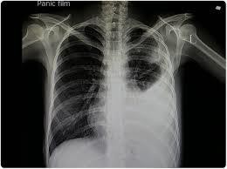

Data Augmentation
We came to know that medical imaging datasets, especially for specific diseases like chemical pneumonitis, are often limited. To overcome this challenge, we will be applying data augmentation to increase the diversity and volume of the training data. This will allow our AI models to generalize better, reduce over fitting, and improve performance on unseen data.
  - Augmentation Techniques:
    - Rotation: X-ray images will be rotated by small random angles (e.g., 45°, 90°) to simulate different orientations that a real-world imaging scenario might produce.
    - Flipping: Images will be horizontally or vertically to represent variations in how X-ray images may be captured from different angles.
    - Zooming and Cropping: Random zooming and cropping helps simulate different image qualities and focus on areas of the lungs that might exhibit early signs of chemical pneumonitis.
    - Brightness and Contrast Adjustments: These changes helps simulate the effect of different imaging equipment and exposure conditions, ensuring the model could handle a variety of real- world scenarios.
Through these techniques, we will be able to significantly enhance the robustness of the model, ensuring that it could handle a wide range of image variations and effectively detect chemical pneumonitis.

Building the Convolutional Neural Network (CNN) Model
Once the data gets prepared, we turn to Convolutional Neural Networks (CNNs) for image analysis. CNNs are particularly effective for image-related tasks like
classifying X-ray images because they automatically learn hierarchical features at different levels (edges, textures, shapes, etc.).
  - Feature Extraction: CNNs is used to automatically extract features from the X-ray images, such as the presence of lung consolidation, pleural effusion, or interstitial changes—all key indicators of chemical pneumonitis. This allows the model to learn the relevant patterns without manual feature engineering.
  - Layers of Convolution and Pooling: The CNN architecture designed uses multiple convolution layers followed by pooling layers. The convolutions helps identify local patterns in the X-rays, such as irregularities in lung tissue, while pooling reduced the image dimensions and retained only the most important features.
  - Fully Connected Layers: After feature extraction, fully connected layers will be used to interpret the extracted information and make a final classification—whether the X-ray showed signs of chemical pneumonitis, was normal, or exhibited other respiratory issues.
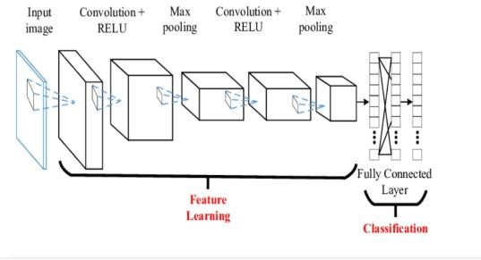
By training the CNN on our augmented dataset, a deep learning model that could effectively identify patterns indicative of chemical pneumonitis in X-ray images will be created.

Model Evaluation and Metrics
To assess the effectiveness of the training CNN model, we evaluate its performance using several key metrics that are critical in medical diagnostics: precision, recall, confusion matrix, and ROC curve.

Precision vs. Recall:
    - Precision is particularly important in this context because we want to minimize the number of false positives—i.e., healthy patients being incorrectly diagnosed with chemical pneumonitis. We aimed for a high precision to ensure that any patient

flagged by the system for further evaluation truly had the disease.
    - Recall is equally important because we wanted to ensure that most patients with chemical pneumonitis were correctly identified. High recall reduces the risk of false negatives, where patients with the disease might be missed.
By adjusting the decision threshold (i.e., the level of confidence required for the model to classify a patient as positive), we can find a balance between precision and recall that best suits the system. The model achieves optimal results when the threshold is calibrated to identify most cases of pneumonitis (high recall) while ensuring that the majority of identified cases are indeed true positives (high precision).
  - Confusion Matrix: We are using the confusion matrix to provide a comprehensive evaluation of the model’s performance. The matrix helps identify:
    - True Positives (TP): Correctly identified cases of chemical pneumonitis.
    - True Negatives (TN): Correctly identified healthy patients.
    - False Positives (FP): Healthy patients mistakenly diagnosed with chemical pneumonitis.
    - False Negatives (FN): Patients with chemical pneumonitis missed by the system.
The confusion matrix allows us to calculate additional metrics like the F1-score, which is the harmonic mean of precision and recall, helping us further optimize the system’s diagnostic capability.
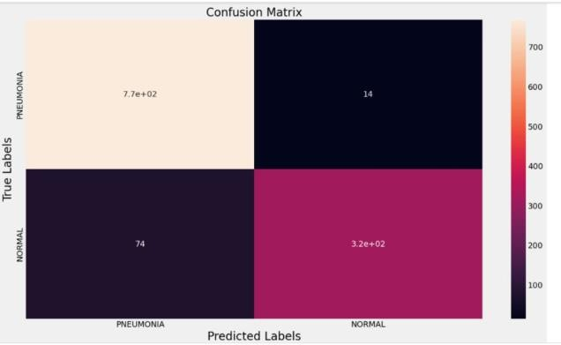

  - ROC Curve: We are also generating ROC curves to visualize the model's ability to differentiate between patients with and without chemical pneumonitis. The area under the curve
(AUC) was a key indicator of the model’s performance. A higher AUC indicates better performance in distinguishing between the two classes (positive and negative).
The ROC curve allowed us to test the model at various thresholds to determine the best cutoff point for classifying patients. This optimization helps us select the threshold that balanced sensitivity and specificity to ensure early detection of chemical pneumonitis while avoiding false positives.

- Real-Time Clinical Application and Monitoring Once we develop and validate the CNN-based model, we will be integrated it into the PNEUMOGAURD system for real-time clinical use. The application processes incoming patient data (e.g., chest X-rays) and outputs a prediction on whether the patient has chemical pneumonitis, accompanied by an explanation of the detected features.
  - Automatic Analysis of X-ray Images: Upon receiving an X-ray image from the healthcare provider, the system will automatically process it using the trained CNN. The system will then classify the image as showing normal lungs, lungs affected by chemical pneumonitis, or other conditions.
  - Clinical Decision Support: If the model detects signs of chemical pneumonitis, it provides recommendations for further diagnostic tests, potential treatments, or refers to specialists. The AI also presents the clinician with a confidence score for its prediction, based on its analysis of the X-ray image and other relevant patient data.

Continuous Learning and Improvement
In the PNEUMOGAURD system, the AI model will be designed for continuous learning. As more patient data is collected, the system can be retrained and fine-tuned, incorporating new cases and improving its diagnostic accuracy over time.
  - Retraining: With feedback from healthcare professionals and additional labeled data, the system can undergo periodic retraining, improving its ability to recognize chemical pneumonitis and differentiate it from other lung conditions.
  - Adaptive Algorithms: The system adjusts its diagnostic thresholds and adapts its decision- making based on real-world performance, ensuring that it remains up-to-date with evolving clinical practices.

DESIGN

The figure below shows the flow of the application from start to end and each activity to be performed on the system by the user and the administrator ends.

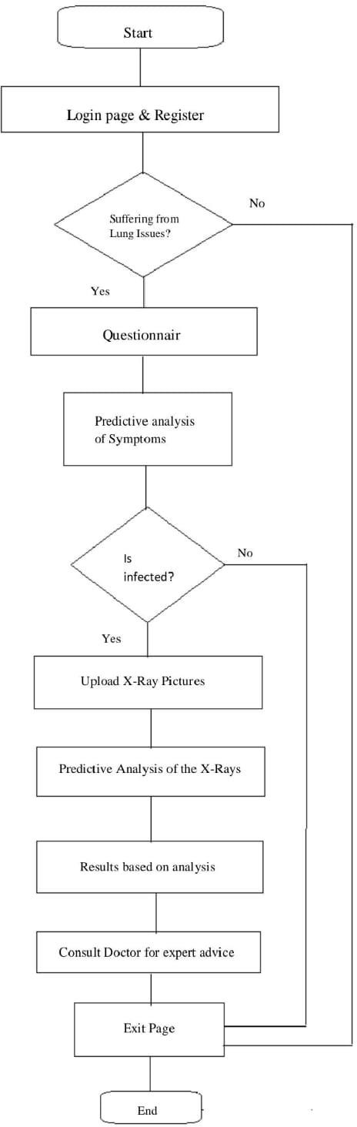

CONCLUSION
Based on the current progress of the system, it provides the predictive analysis of symptoms entered by the user, the basic symptoms of chemical pneumonitis as provided by the literature survey are framed as questions to obtain the current health condition of the patient thus getting an overview of the illness and further to add the X-ray image for analysis based on Lab reports. The contemporary accuracy of the system goes to 70% proper results on the basis of the victim’s symptoms.
The Technique that is being suggested for the chemical pneumonitis detection system focuses on developing a cutting edge effective system that makes it easier for medical experts and researchers for better chemical pneumonitis detection. The project plans to use image processing for a major area when analyzing the X-ray images so as the user of the system can get a proper result of the cause of illness and presence of chemical pneumonitis in the body thus to detect early and get medically treated suitably.

ACKNOWLEDGMENT
We have a great honor to acknowledge Dr. S. A. Dhale, Principal, Priyadarshini College of Engineering, Rashtrasant Tukdoji Maharaj Nagpur University, and Nagpur, who had given us his consent to carry out this paper. We are very much delighted to voice my gratitude and indebtedness to Prof. P. S. Prasad, Head of Department of Information Technology, Rashtrasant Tukdoji Maharaj Nagpur University, Nagpur, who had given us his consent to carry out this Paper. We feel immense pleasure and privilege in expressing my deep sense of gratitude towards our Guide Prof. Mrudula M. Gudadhe and Project Incharge Mrs. Mrudula Gudadhe, whose valuable guidance and critical analysis of my result has led to successful study and research for this paper

. REFERENCES
- James R. Bennion, Alfred Franzblau, American Journal of Industrial Medicine 31:474-478(1997).
- Young Jin Lee, In Beom Jeong, Respiratory Medicine Case Reports 32(2021) 101338, ScienceDirect.
- Euu-Woo Cha, Doosoo Jeon, Dongmug Kang, Young-Ki Kim, Se- Yeong Kim, International Journal of Environmental Research and Public Health 2022, 19, 7954.
- Vivekanand Paul, Rakesh Kumar, N P Gupta, International Journal of Pharmaceutical and Clinical Research 2024; 16(4); 1432-1435.
- Allen Kraut, Ruth Lilis, Division of Environmental and Occupational Medicine, ScienceDirect.

- Ashwin Kailash, Ghanshyam Verma, Raja Amarnath, Sushma Kalmodia, Mahitha Reddy, Aiswarya Ravichandran, Discovery Journal, Medical Science, plSSN 2321-7359; elSSN 2321-7367
- National Institute of Occupational Safety and Health’s Guide to Chemical Hazards (2005).
- Brain Tumor Segmentation on MRI images, International Conference on Emerging Trends in Engineering and Technology, 10.1109/ICETET-SIP143.2023.10151519
- Sourabh Pahuja, Arjun Khanna, Pallavi Periwal, Ankit Kumar Sinha, Dhruv Talwar, Satyam Agarwal, Pradeep Bajad, Deepak Talwar, Journal of Pulmonology Research & Reports, ISSN: 2754-4761.
- Keyur Saboo, Rinkle R Gemnani, Soumya Sharma, Sunil Kumar, Sourya Acharya, Cureus, 10.7759/cureus.42939.
- Jad Zeitouni, Genesy Aickarenth, Alan Pang, Deepak Bha radia, John A Griswold, Chest, 10.1016/j.chest.2022.08.1501.

