Raspberry pi based Assistive System for Bedridden Persons

Leena Patil¹, Hemraj V. Dhande², V. D. Chaudhari³, A. D. Vishwakarma⁴, H. T. Ingale⁵
¹PG student, VLSI & Embedded system, ^{2,3,5}Asstt.Prof.⁴Asso.Prof.
^{1,2,3,4,5}E&TC Engg dept, GF’S Godavari College of Engineering, Jalgaon
leenapatil5247@gmail.comr¹ hemrajd99@gmail.com²

Received on: xxxx,20xx, Revised on: xxxx,20xx, Published on: xxxx,20xx

Abstract- In recent year many assistive systems for disabled have been developed. In this paper we present a unique assistive system for bedridden persons they cannot move anywhere which work on Human machine interface using raspberry pi. Tetraplegia and quadriplegia is a paralysis condition where a patient cannot move parts below neck. Such persons may face some problem like dumb, deaf etc.The proposed assistive system is to enable communication between tetraplegic patient and caretaker.The proposed system work on voice based command and perform the action against the input. The patient can also use this system for device automation, for controlling fan, light and other devices.HMIs to monitor and configure set points,controlalgorithm,send commands and adjust and establish parameters in the controller.Used python programming language.

Keywords: Raspberry pi, Human Machine Interface, Voice Command Algorithms.

1. INTRODUCTION

Tetraplegia or Quadriplegia is a paralysis condition caused by illness or injury that results in the partial or total loss of body.the patient may also lose some difficulties like deaf, dumb,blindnessetc.Because of this persons cannot perform voluntary action and becomes a bedridden.The persons has to be taken care of somone always like familiy members. It is difficult for the patients to make caretaker or somone who take care of patient understand what they need. And even the patient face major problem like they won’t be able to communicate with the world. There are many systems developed and introduced for the tetraplegic patients to communicate with the outside world. Such as Brain wave technique and Electro-oculography as well as eye waver technology . In these techniques, electrodes are pierced through the epidermis of skin and in eye detection system incorporate with different technologies such as eye blink detection, eye center localization and conversion of the eye blink to speech, That system uses an efficient method which is depends on image processing techniques for detecting human eye blinks and generating inter-eye-blink intervals.

The proposed system works on voice based command and perform the action against the input command,this is done by using Human machine interface module through raspberry pi kit.To monitor and configure set points, control algorithms, send commands, and adjust and given parameters in the controller for these action use HMIs (Human Machine Interface) module. We are trying to design a standalone speaker dependent speech recognition circuit that may be interfaced to control just about anything electrical, such as; appliances, robots, test instruments, VCR's TV's, etc.
The output of the system is displayed by the microprocessor on the sevensegment display. The recognized voice is stored as the code of word.Have you ever talked to your computer? (And no, yelling at it when yourInternet connection goes down or making polite chit-chat with it as you wait for all25MB of that very important file to download doesn&#39;t count).

2. LITERATURE SURVEY

The Literature survey was conducted for the dissertation in all possible means through the media of Text Books, Reference books, and Data books,Technical magazines and of course the powerful Information media of Internet.
In this topic of Speech based command control of Computer applicationcontrol, we collected the information from all the above sources and compared thesame with each other and also with our approach of communication and foundthat the method suggested in the Project is relatively with new concept and more accurate and automated with less manual intervention and hence easy to accept
than the other conventional methods[1].
We need to improve the usage and the utility of the same in the best
possible manner. We need to analyses the problems faced by the customer andwe should try to minimize the same so as to improve the total efficiency of thesystem[2]. We are trying to build a standalone speaker dependent speech recognitioncircuit that may be interfaced to control just about anything electrical, such as;appliances, robots, test instruments, VCR&#39;s TV&#39;s, etc[3]. A Haar Cascade Classifier methodology is used for getting eye and facial axis information based on eye movement of the patient[4]. The system will be recorded by the eye movement and blink of patient and it is processed and converted into corresponding voice output, and this system also used for bedridden or paralysed condition persons. The paralysis or bedridden persons can also use this system for device automation, for controlling fan, light and other devices[5].
Image capturing and processing using eye blink detection is a demanding project. There are number of ways to implement this project and each system implementation involves many functional components. The easiest as well as best method to detect eye blinks is using infrared LEDs. Such system makes the best use of technology and improves the accuracy [6]. Hashim N A et al. proposed a system that can assist paralyzed or Tetraplegia or Quadriplegia patients by tracking person’s eye and counting the blinks, and employs this count to control various appliances and play pre-recorded audio messages[7]. In Voice Based Home Automation System using Raspberry Pi is the project which will be very helpful for old age people and disabled persons, basically for one’s who cannot perform basic activities efficiently[8].

3.BLOCK DIAGRAM

AC Supply
Transfor -mer
Rectifier
Regulator
DC Supply

Raspberry pi3 Kit
LCD
Display
Speaker
Camera

Fig. 3.1 Block diagram
The device consists of a Raspberry Pi 3B, speaker or earphones, Raspberry pi camera, Transformer,LCDdisplay,power offer (230V AC) and a rectifier converts ac to pulsating dc. The voltage regulator regulates the voltage to a fixed level to power the Raspberry Pi. The camera should manually be pointed towards the text and an image is captured. This image is then processed by the Raspberry Pi and therefore the audio output is giventhrough the speaker.
It helps in research work and use programing language like python. It does everything what a computer does like, playing live games and videos, databases and word processing. It helps to interface with the external world and used in digital processing, music equipment, sensors and weather stations. Raspberry Pi 3 board is used in this device.

3.1] Raspberry Pi 3 ModelB

Fig3.2: Raspberry Pi 3 ModelB
The Raspberry Pi 3 Model B+ is the latest product in the Raspberry Pi 3 range, boasting a 64-bit quad core processor running at 1.4GHz, dual-band 2.4GHz and 5GHz wireless LAN, Bluetooth 4.2/BLE, faster Ethernet, and PoE capability via a separate PoEHAT The dual-band wireless LAN comes with modular compliance certification, allowing the board to be designed into end products with significantly reduced wireless LAN compliance testing, improving both cost and time to market.
The device consist of Raspberri pi 3B, speaker or earphones, Raspberry pi camera,power offer (230VAC) and a rectifier convert ac to pulsetting dc. To power the raspberry pi voltage regulator regulate the voltage to fixed level. The camera should manually be pointed towards the text and image is captured. The raspberry pi has small peripheral devices like USB, ABC, Bluetooth, WIFI and SPI. Raspberry pi 3B+Linux operating system name Raspbianstretch.In this system the printed text is placed under the camera view by the blind person to ensure the image of good quality and fever distortions. Then an apllicable assistive blind system a localization algorithm might prefer higher recall by the sacrificing some precision.

Hardware Specification
5MP Raspberry Pi 3 Model B Camera
- Raspberry Pi 3 ModelB
- LCDDisplay
- Capacitors
- Transistors
- Cables &Connectors
- Diode
- PCB

Sofware Specification

Operating system: Raspbian(Stretch)
Language:Python3
Platform: Tesseract, OpenCV
Library: OCR engine, TTS engine
The proposed project is executed under the operating system rasbian which is derived from Debian operating system. The language used as the python language that may be a script language. The camera should manually be pointed towards the text and image is captured. The raspberry pi has small peripheral devices like USB, ABC, Bluetooth, WIFI and SPI. Raspberry pi 3B+Linux operating system name Raspbian stretch.

4. METHODOLOGY

4.1] HMI module

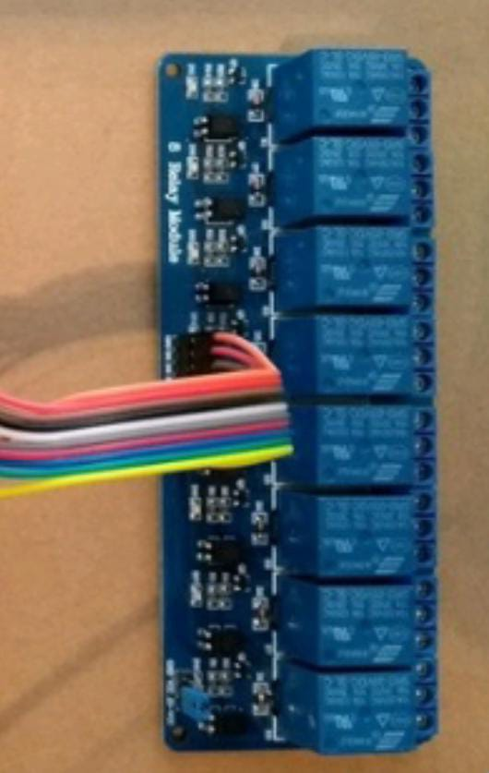
Fig 4.1: HMI module

An HMI work with a human users to interact with a system's machinery using graphical interface. As new technology develops, HMIs are becoming more use in everyday tasks for consumers. petrol pumps, self-service system, vendor machines, all use HMIs to process user inputs, translate into machine readable code, and perform tasks without the need for a workman,mechanic ,labourer or other employee. In the referance of production and process control systems, a visual representation of the control system provided by HMI, and also provides real time data acquisition. An use of HMI is to increase productivity by providing a centralized display of the control process that is relatively user-friendly and tremendously.
HMI can check and control the process so that users may update system processes without changing any of the hardware.HMIintegreted with manufacturing line, it must first be working with a Programmable Logic Controller (PLC) which acts as the central processing unit. The input information from input devices first collect PLC (physical sensors or commands from the HMI) and convert it to processes for manufacturing. thsese process is being performed ,and the HMI provides a display of received inputs, control process outputs, and defined user command to perform the tasks.

4.2] Using voice_command
Now by using 1st voice command turn LED ON, and then system stay for until the another voice command turns it off again.

defrun(self, voice_command):
self.say("LED Turns on")
led.on()
sleep(4)
self.say("LED Turns off")
led.off()

Above voice_command that is automatically passed to your run program methodology is a string translation of Google Assistant API .
Here’s what you’re going to do:
Within our run system, translate the voice_command string into all lower case Search through the string.
If it contains voice command the word “on”, turn the LED on
If it contains voice command the word “off”, turn the LED off
In a program python language is used.

4.3] Microphone
This is the device which converts the sound signal to the electrical signal. The two plates are mounting apart at very low distance forms as a capacitor. The moving plate is connected to diaphragm. The diaphragm moves according to the sound waves which are strike on the diaphragm which result to change in current flow of the condenser mike. This output is applied to the amplifier section which is amplified by selective gain. The output current is a proportional to the sound signal striking on the diaphragm

4.4] Flowchart

5. Design And Implementation

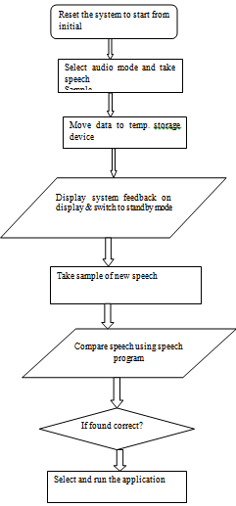

Setup Rapsbserry Pi:

For the raspberry pi to able to perform all the functions properly we need to define all the input and output pins of devices connected to it and to which no. of pin of raspberry pi it is connected to.

pwmPin = 18 # Broadcom pin 18 (P1 pin 12)
ledPin = 23 # Broadcom pin 23 (P1 pin 16)
butPin = 17 # Broadcom pin 17 (P1 pin 11)
dc = 95 # duty cycle (0-100) for PWM pin
# Pin Setup:
GPIO.setmode(GPIO.BCM) # Broadcom pin-numbering scheme
GPIO.setup(ledPin, GPIO.OUT) # LED pin set as output
GPIO.setup(pwmPin, GPIO.OUT) # PWM pin set as output
pwm = GPIO.PWM(pwmPin, 50) # Initialize PWM on pwmPin 100Hz frequency
GPIO.setup(butPin, GPIO.IN, pull_up_down=GPIO.PUD_UP) # Button pin set as input w/ pull-up
# Initial state for LEDs:
GPIO.output(ledPin, GPIO.LOW)
pwm.start(dc)
print("Here we go! Press CTRL+C to exit")
try:
while 1:
if GPIO.input(butPin): # button is released
pwm.ChangeDutyCycle(dc)
GPIO.output(ledPin, GPIO.LOW)
else: # button is pressed:
pwm.ChangeDutyCycle(100-dc)
GPIO.output(ledPin, GPIO.HIGH)
time.sleep(0.075)
GPIO.output(ledPin, GPIO.LOW)
time.sleep(0.075)
except KeyboardInterrupt: # If CTRL+C is pressed, exit cleanly:
pwm.stop() # stop PWM
GPIO.cleanup() # cleanup all GPIO

Conversion of image to text using OCR tool
DEFAULT_CHECK_COMMAND = "which"
WINDOWS_CHECK_COMMAND = "where"
TESSERACT_DATA_PATH_VAR = 'TESSDATA_PREFIX'
VALID_IMAGE_EXTENSIONS = [".jpg", ".jpeg", ".gif", ".png", ".tga", ".tif", ".bmp"]
import argparse
import logging
import os
import shutil
import subprocess
import sys
import tempfile
from constants import VALID_IMAGE_EXTENSIONS, WINDOWS_CHECK_COMMAND, DEFAULT_CHECK_COMMAND, TESSERACT_DATA_PATH_VAR
defcreate_directory(path):
"""
Create directory at given path if directory does not exist
:param path:
:return:
"""
if not os.path.exists(path):
os.makedirs(path)
defcheck_path(path):
"""
Check if file path exists or not
:param path:

6]. Result
The program coded for detecting the voice using HMI are compiled using OpenCV platform that supports python code, and OpenCV library. The image processing libraries like numpy, scipy, dilb, and shape predictor are used to import the code.

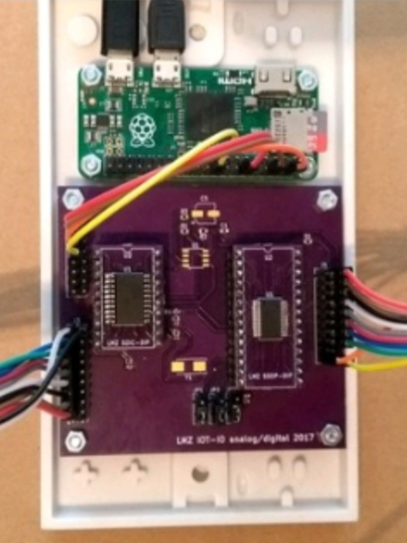

Within our run system, translate the voice_command string into all lower case Search through the string.
If it contains voice command the word “on”, turn the LED on If it contains voice command the word “off”, turn the LED off In a program python language is used.

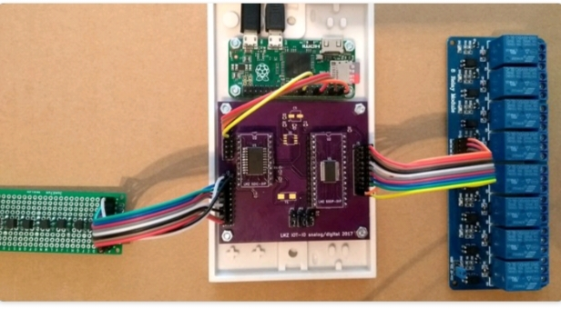

Table 1: Combinations of input and its corresponding voice outputs

No of input | Voice output
1 | Light
2 | Fan
3 | Nurse
4 | Water

7] ADVANTAGES AND DISADVANTAGES

Advantages:
- As the main intension of the project is to help people who is in paralysed condition
- User friendly (easy touse).
- It is very compact to theuser.
- High rate of translation:
- The speed of translation is much higher than the human translation it takes more than an hour for translating 10,000 words for human whereas, few seconds are enough for the device to translation
- Cost efficient

.8] CONCLUSION AND FUTURE WORK

The proposed system enables people suffering from Tetraplegia and quadriplegia,is a paralysis condition. This system is intended to assist the paralyzed and bedridden person to lead a normal life by controlling things and communicating their needs with less effort. According to physically challenge person the code convert the input voice into predefined voice command.

REFERENCES

[1]World Report on Disability, Word Health Organization (WHO) http://www.inthttps://www.who.int/disabiliti es/world_report/2011/report.pdf

[2]J.M. Noyes, R. Haigh, A.F. Starr, "Automatic Speech Recognition For Disabled People", Applied Ergonomics, Volume 20, Issue 4, 1989, Pages 293- 298,ISSN 0003-6870,

[3]ChinnawatDevahasdin Na Ayudhya, ThitiwanSrinark, “A Method for Real-Time Eye Blink Detection and its Application”.

[4] KevalLakhani , AnushaChaudhari, Kena Kothari , Harish Narula, “Image Capturing using Blink Detection”, KevalLakhani et al, / (IJCSIT) International Journal of Computer Science and Information Technology, Vol. 6 (6), 2015, 4965-4968.

[5]Milan Pandey; KushalChaudhari; Rajnish Kumar; AnoopShinde; DivyanshuTotla; Prof. N.D. Mali (2018). “Assistance for Paralysed Patients Using Eye Motion Detection” IEEE International Conference.

[6]McCreery, R. W., Walker, E. A., Spratford, M., Lewis, D., &Brennan, M. (2019). "Auditory, Cognitive, and Linguistic Factors Predict Speech Recognition In Adverse Listening Conditions For Children With Hearing Loss, Frontiers In Neuroscience", 13, 1093.

[7]Helander, M.G., Moody, T.S., &Joost, M. (1988), "Systems Design For Automated Speech Recognition, Handbook Of HumanComputer Interaction", 1988, Pages 301-319Chapter14.

[8]AnushGoel, AkashSehrawat, AnkushPatil, PrashantChougule, SupriyaKhatavkar,” Raspberry Pi Based Reader for Blind People”, International Research Journal of Engineering and Technology (IRJET),

