Modelling and Control of a Multi-input Converter Based EV Charging Station

Durgesh Munne¹, Harsh Jiwankar², Himanshu Dhote³, Vivek Dongare⁴ , Dr. Rajesh Surjuse⁵
^{1,2,3,4} Student, ⁵ Associate Professor
Government college of Engineering Nagpur, Nagpur, India, 441108

dongarevivek81@gmail.com

Received on: 27 April, 2023 Revised on: 23 May, 2023 Published on: 25 May, 2023

Abstract – Due to their limited on-board battery capacity and status as environmentally friendly vehicles, the rising popularity of electrical vehicles (EVs) creates a pressing demand for widely dispersed charging stations. Fast charging stations, especially super-fast charging stations, can put a strain on the electrical grid by potentially overloading it during peak hours, creating an abrupt power gap, and causing voltage sags. Due to the daily charging demand being met by adequate daytime PV generation, the impact on the power system is decreased. Simulation outcomes are shown to support the advantages of this suggested multiport EV charging circuits with the PV-BES configuration in various modes. To further increase efficiency, SiC devices are added to the EV charging station. Power losses and efficiency are examined for various modes and functions and compared in simulation with customary Si device-based charging circuits
Keywords- PV, BES,EV
I – INTRODUCTION
Electric vehicles (EVs) have become a viable alternative to traditional gas-powered vehicles due to the growing interest in reducing the consumption and pollution of fossil fuels. Due to the limited EV battery capacity, the development and growing use of EVs requires widely dispersed charging stations . However, a large number of charging stations that are directly connected to the grid, especially fast and superfast charging stations, put a strain on the stability and dependability of the power grid due to issues with peak demand overload, voltage sag, and power gaps. A few

researchers have combined photovoltaic (PV) generation with infrastructure for EV charging ; they also compared this with charging circuits based on traditional Si devices in simulation. However, researches still view the PV integration as a small portion of the power source for EV charging stations. Regarding the greater demand for fast charging during the day, PV generation's quick development optimizes power consumption at peak times with its sufficient daytime generation. Battery energy storage (BES) can be used to control the DC bus or load voltage, balance power gaps, and smooth PV power in light of the intermittent nature of solar energy.
Given the benefits of multiport power converters' high efficiency and power density, a multiport DC/DC converter is used for the EV charging station as opposed to three separate ones. According to the aforementioned research, there are two topologies for charging station architectures: AC bus and DC bus. The DC bus charging station is chosen in this case to increase the utilization efficiency of solar energy and reduce the price and losses of converters because PV output and BES can both be thought of as DC current sources. Non isolated multiport converters, which are typically derived from buck or boost converters, may have a smaller overall footprint, a higher power density, and a higher efficiency when compared to isolated multiport converters.
II -METHOLOGY
System Identification: Learn about the multi-input converter, batteries, power electronics, control system, and communication interfaces that make up the EV charging station. Determine how these elements interact and behave dynamically. Develop mathematical models for each component in accordance with its electrical and control properties. This entails modelling any necessary communication protocols as well as the converters, batteries, and power electronics. Take into account elements like energy management, voltage regulation, current control, and power flow. Design of the controller Create the charging station's control system. You may need to create controllers for voltage regulation, current control, power factor correction, and energy management depending on the precise needs. Choose the best control strategies, such as model predictive control (MPC), proportional-integral-derivative (PID), or other cutting-edge control methods.
Table 1- The EV Charging Operating Modes
S_{pv} | S_{b1} | S_{b2} | S_{EV} | Power Flow
OFF | OFF | OFF | ON | PV to EV
OFF | OFF | ON | OFF | PV to BES
ON | OFF | OFF | ON | BES to EV
- | ON/OFF | OFF/ON | ON | Grid to EV
OFF | OFF | OFF | OFF | PV to Grid

III -CIRCUIT DESIGN
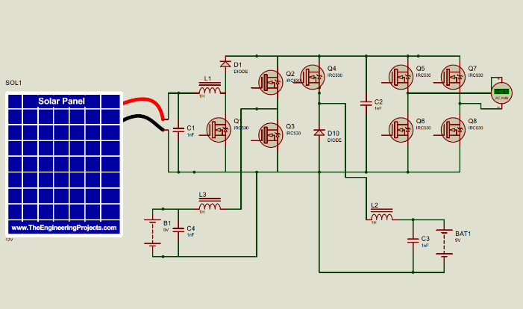

IV- SIMULATION RESULT
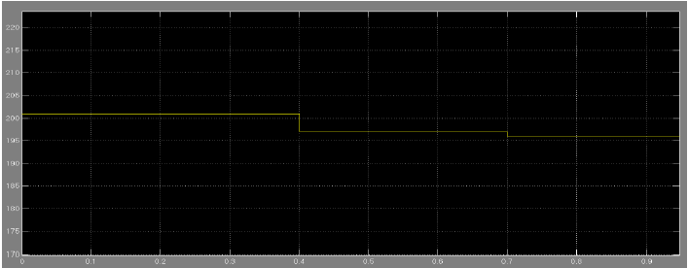
Fig.3(a) the terminal voltage of Battery energy storage
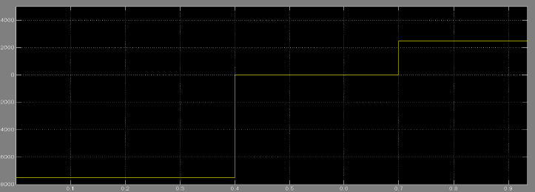
Fig.3(b) the output power of Battery energy storage
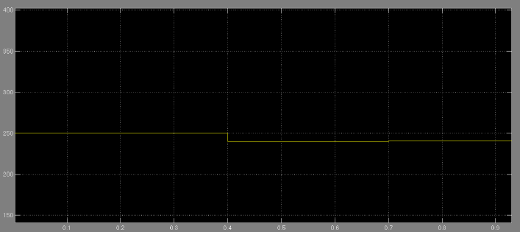
Fig.4(a) the output power of Battery energy storage
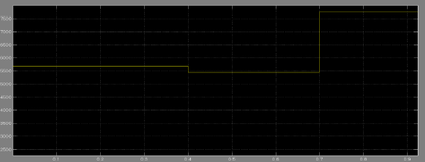
Fig.4(b) The simulation result EV charging station with consumed power of EV charging

V- CONCLUSION
A multiport converter-based EV charging station with PV and BES is suggested in this study. The suggested control scheme uses a BES controller; BES begins to discharge when PV is inadequate for local EV charging and begins to charge when PV is sufficient generation is in excess or the electricity system is experiencing a trough in demand, such as at night. As a result, the addition of PV production, BES, and EV charging improves the stability and dependability of the power grid. In ANSYS Twin Builder, simulation and thermal models of the multiport converter-based EV charging stations and the suggested SiC equivalent are created after various operating modes and their advantages are examined. The efficiency may be increased by 5.67%, 4.46%, and 6.00%, according to simulation results, respectively, compared to Si-based EV charging stations under the same operating parameters for PV-to-EV mode, PV-to-BES mode, and BES-to-EV mode at normal operating condition.
REFERENCES
- J. Guerrero, J. Matas, L. de Vicuña, M. Castilla, and J. Miret, "Wireless-Control Strategy for EV Charging Stations with Photovoltaic Panels and Energy Storage Systems," IEEE Transactions on Industrial Electronics, vol. 56, no. 10, pp. 4399-4409, October 2009.
- .H. Huang, Y. Li, P. C. Loh, and F. Blaabjerg, "Control and Operation of a Three-Port Converter for PV-Battery Systems in Stand-Alone DC Microgrids," IEEE Transactions on Power Electronics, vol. 29, no. 1, pp. 105-118, January 2014.
- .P. Rodriguez, A. V. Timbus, and J. Pontt, "Modeling and Control of a Multiport Converter for Integration of Photovoltaic Systems and Batteries," IEEE Transactions on Industrial Electronics, vol. 58, no. 10, pp. 4595-4605, October 2011.
- .A. Bazzi, A. D. Reis, and D. Dujic, "Control of a Multiport Bidirectional DC-DC Converter for a Battery Energy Storage System in an EV Charging Station," IEEE Transactions on Transportation Electrification, vol. 5, no. 1, pp. 182-194, March 2019.
- .A. El Khateb, K. Nagrial, and P. Wolfs, "A Review of Battery Charging Algorithms for Electric Vehicles with Photovoltaic Panels," Renewable and Sustainable Energy Reviews, vol. 31, pp. 237-246, November 2013.
- .S. P. Jayasinghe, M. Lehtonen, and J. Pyrhönen, "A Review on Multiport DC–DC Converters for Renewable Energy Applications," IEEE Journal of Emerging and Selected Topics in Power Electronics, vol. 5, no. 3, pp. 1150-1165, September 2017.
- .J. W. Jung, H. J. Kim, and J. W. Kim, "A Review of Three-Port Converters for Photovoltaic Module Application," Energies, vol. 13, no. 8, Article 1919, April 2020.

