Smart Stick for the Blind Person

Rupali Dasarwar *1, Sakshi Dhoble *2, Akash Chachere*3, Raj Bhosle*4, Junaid Pathan*5
*1Assi. Professor, Department of Artificial Intelligence & Data Science, Wainganga College of Engineering & Management , Nagpur, Maharashtra, India.rupalidasarwar20@gmail.com
*2BTech Student, Department of Artificial Intelligence & Data Science, Wainganga College of Engineering & Management, Nagpur, Maharashtra, India. Sakshidhoble627@gmail.com
*3BTech Student, Department of Artificial Intelligence & Data Science, Wainganga College of Engineering & Management, Nagpur, Maharashtra, India. akashchachere8@gmail.com
*4BTech Student, Department of Artificial Intelligence & Data Science, Wainganga College of Engineering & Management , Nagpur, Maharashtra, India. bhosleraj252@g
mail.com
*5BTech Student, Department of Artificial Intelligence & Data Science, Wainganga College of Engineering & Management , Nagpur, Maharashtra, India. junaidpathan83696@gmail.com

ABSTRACT:
There are millions of blind people in this world who always need some help. These visually impaired people find it challenging to travel outside their homes independently. The Smart Blind Stick that we will design helps the blind society by providing a better and more convenient means of life by moving around independently. The stick consists of web camera, one camera, and an earphone/speaker. Using a of web camp, this system can detect obstacles around the users up to 400 cm in their direction, i.e., forward, left, and right. For further processing of data these ultrasonic sensors are attached to the raspberry pi. The camera is used for object recognition, and the image obtained through the camera will be captioned and presented to the user in the form of audio. This audio will tell what that image is and what should be done if it is an obstacle thus, working as a virtual eye for blind people. The GPS module continuously tracks the user's location and movement in real-time, enabling turn-by-turn navigation to predefined destinations. Obstacle detection sensors help in identifying obstacles in the user's path, providing feedback through vibrations or auditory cues.
Keywords: Smart stick, Blind People, Object Detection, Raspberry Pi, GSM module, YOLOv4.

INTRODUCTION

Smart Blind Stick is an interactive device which mainly aims at helping the blind to navigate easily and in a safer manner. The Smart Blind Stick that we build can support the blind community by providing a better and simpler way of life by moving independently. So, the idea is simple, unlike the traditional stick, they need to carry a smart blind stick, which will help them to some extent by avoiding the obstacles around their way while walking or going out, which may be caused by accident. The stick will be having sensors and cameras to find the objects and give feedback alert messages to the user to avoid unnecessary accidents. The stick is very similar to those of the traditional, but it can save them from accidents as well as save their lives. The smart stick helps them in this by detecting if any obstacle is blocking the path being taken by the subject.

The device detects the obstacle with the help of a camera attached to the front of the stick. On detection of the obstacle, it is identified and appropriate instructions are provided to the user. The stick vibrates on approaching an obstacle. This adds to the safety of the blind person. The appropriate instructions to the blind person is given over Bluetooth earphones. Thus using the various technology, the stick provides a safer and a better navigation experience for the visually challenged.

In this paper, we are tackling the real world problems. Our aim is to provide the technical solution to all kinds of problems. The purpose of this project would be to make the lives of blind people much easier. The project aim to just provide obstacle free path to Blind person so that they can become self-independent as well. Whenever blind person feels any discomfort while navigating then he/she press the panic button mobile phone to give the SMS with the message “I am in trouble. Sending my location along with his/her GPS location”. This app is the best answer to unravel the issues. Android application also shows the GPS location of the blind person to his/her family members.

- METHODOLOGY

Block Diagram

Earphone

Controller
(Raspberry Pi)
Camera Module

Power Supply
Ultrasonic Sensor

GSM Module
Buzzer

SD Card

Figure 1: Block Diagram of Proposed System.
kj

Components:
The prototype uses the following components:

Raspberry Pi:

It acts as the heart of the system as it controls, processes and generates all the inputs and outputs. The Raspberry Pi used in this system will be running on Raspbian Lite OS. It receives an echo signal from the ultrasonic sensors which trigger it to take further actions, which is to check whether the obstacle is there or not. It generates an immediate alert using the buzzer. It also generates a caption for the image captured by the camera and later converts that caption into a speech that is played through an audio device.
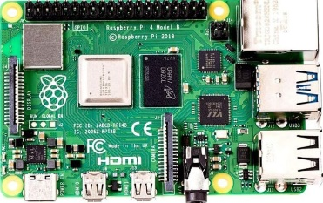

Figure 2: Raspberry Pi

Camera Module:

The camera module used in this system can act as an eye for the visually impaired person. Each time the ultrasonic sensor detects an obstacle it captures the picture. The picture is sent to Raspberry Pi, so that it can process the image and generate the caption for that image

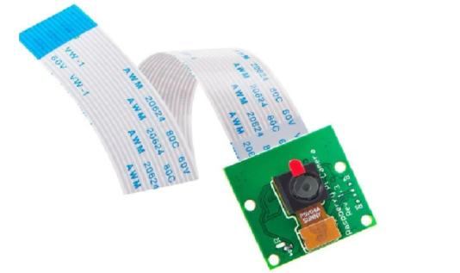

Figure 3: Camera Module.

Ultrasonic Sensor:

The ultrasonic sensor is one of the main components of the system. It is used to detect the obstacles that come in front of the user. This system will be using three ultrasonic sensors for center, left and right directions, respectively. It sends an echo signal to the Raspberry Pi so that it can decide further actions.
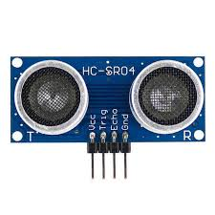
Figure 3: Ultrasonic Sensor.

GSM Sensor:
The SIM800L is a popular GSM/GPRS module commonly used in embedded systems for communication purposes. The SIM800L module supports GSM (Global System for Mobile communications) and GPRS (General Packet Radio Service) technologies. This enables it to establish communication over cellular networks.
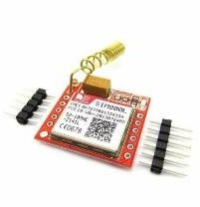
Figure 4: SIM800L.

Push Button:

A push-button or simply button is a simple switch mechanism to control some aspect of a machine or a process. Buttons are typically made out of hard material, usually plastic or metal. The surface is usually flat or shaped to accommodate the human finger or hand, so as to be easily depressed or pushed.

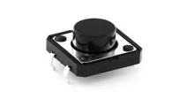

Figure 4: Push Button

  - Buzzer:
A buzzer or beeper is an audio signaling device, which may be mechanical, electromechanical, or piezoelectric. Typical uses of buzzers and beepers include alarm devices, timers, train and confirmation of user input such as a mouse click or keystroke.
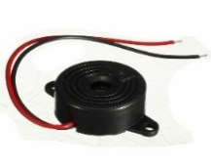

Figure 5: Buzzer

  - Power Supply:

Power Supply Electrical power is supplied to components by a power supply. The term usually refers to devices that are installed into the driven section. A 3.7 V rechargeable Li-ion battery is used to provide the power supply to the controller which in turn feeds the required power to all the sensors and modules connected to it. A power supply is an electrical device that supplies electric power to an electrical load. The main purpose of a power supply is to convert electric current from a source to the correct voltage, current, and frequency to power the load.

- Process Flow:

  - Automated mechanism

Understand user needs and research existing solutions.
Design the smart stick's features and interface. Choose and integrate sensors for object detection. Develop physical enclosure and feedback mechanisms. Write firmware/software to collect sensor data and implement object detection. Design feedback mechanisms and IoT connectivity. Combine hardware and software components. Test for accuracy, reliability, and usability. Gather feedback from users and refine the design accordingly. Finalize design for mass production. Manufacture and distribute smart sticks. Provide user training and ongoing support.This streamlined process ensures the creation of an effective IoT-based smart stick for blind individuals, aiding in their navigation and enhancing their independence.

No

Object

Detection
“chair”

Object Detected

Stop

Hardware Integration

Camera Module

Yes

Start

Send alert to user with vibration and buzzer

Figure 6: Flowchart of Automated Mechanism.

III. RESULTS AND DISCUSSION

The integration of capabilities allowed for remote monitoring and customization of the smart stick's features, enhancing its versatility and adaptability. User feedback played a crucial role in refining the design and functionality of the smart stick, emphasizing the importance of user- centered design in assistive technology development. Further research is warranted to explore enhancements such as voice-controlled interface, advanced obstacle recognition, and seamless integration with navigation aids

- Object Detection Accuracy:

The YOLO algorithm demonstrated high accuracy in detecting common obstacles such as walls, furniture, and pedestrians. Real-time processing enabled prompt detection and timely alerts to the user.

- Feedback Mechanisms:

Audio alerts provided clear and informative feedback about the presence and location of detected objects. Tactile feedback through vibration motors enhanced situational awareness and complemented audio cues effectively.

- User Experience:
Participants expressed satisfaction with the smart stick's performance, noting improvements in navigation confidence and safety. Ease of use and intuitive feedback mechanisms were highlighted as key strengths of the device.

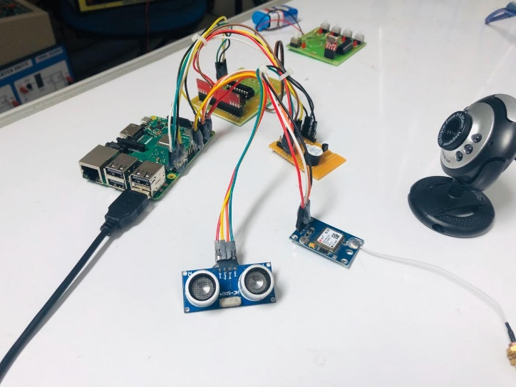
Figure 7: Result

IV. CONCLUSION

The implementation of the YOLO algorithm has proven to be effective in accurately identifying common obstacles and objects encountered in indoor and outdoor environments. The real-time processing capabilities enable timely alerts to the user, enhancing situational awareness and navigation safety. User testing has revealed a positive reception to the smart stick among blind individuals, highlighting improvements in navigation confidence and independence. The intuitive feedback mechanisms, including audio alerts and tactile vibrations, contribute to a seamless user experience and facilitate ease of use.

Moving forward, further research and development efforts should focus on refining the smart stick's design, optimizing object detection algorithms, and incorporating additional features to enhance functionality and accessibility. Additionally, continued collaboration with blind individuals and stakeholders is essential to ensure that the smart stick meets the evolving needs and preferences of its users.

The IoT-based smart stick offers a promising solution to address the mobility challenges faced by blind individuals, leveraging object detection technology to improve navigation and foster greater independence in daily life. With ongoing innovation and refinement, assistive devices like the smart stick have the potential to significantly enhance the quality of life for the visually impaired community.

V. REFERENCES

- Chaurasia, S., & Kavitha, K. V. N. (2014, February). An electronic walking stick for blinds. In Information Communication and Embedded Systems (ICICES), 2014 International Conference on (pp. 1-5). IEEE.

- Menikdiwela , M. P., Dharmasena, K. M. I. S., & Abeykoon, A. H. S. (2013, December). Haptic based walking stick for visually impaired people. In Circuits, Controls and Communications (CCUBE), 2013 International conference on (pp. 1-6). IEEE.

- Harsur, A., & Chitra, M. (2017). Voice Based Navigation System for Blind People Using Ultrasonic Sensor. IJRITCC, 3, 4117-4122.

- “An Electronic Walking Stick For Blinds” Shashank chaurasia and K.V.M.Kavitha, School of Electronics Engineering,VIT University Vellor (2014).

- Smart Cane: Assistive Cane for Visually-impaired People” Mohd Helmy Abd Wahab , Amirul A. Talib, Herdawatie A. Kadir , Ayob Johari , A.Noraziah , Roslina M. Sidek, Ariffin A. Mutalib ,Faculty of Electrical and Electronic Engineering, Universiti Tun Hussein Onn Malaysia 86400 Batu Pahat, Johor, Malaysia(2011).

- “Ultrasonic Blind Walking Stick” Abhishek Bhokare, Amruta Amberkar, Anvesh Gawde,Pratham Kale, Abhijeet Pasi,Department of Information Technology(2016).

- ”An Intelligent Walking Stick for the Blind” Kher Chaitrali , Dabhade Yogita , Kadam Snehal, Dhamdhere Swati , Deshpande Aarti , JSPM’s Jayawantrao Sawant College of Engineering(2015).

- ”Ultrasonic Stick for Blind” Ankit Agarwal , Deepak Kumar, Abhishek Bhardwaj, IP University, Sirifort College of Computer Technology and Management , Institutional Area, Rohini Sector-25, New Delhi(2015)

- ” Smart Walking Stick for Visually Impaired People Using Ultrasonic Sensors and Arduino “Dada Emmanuel Gbenga , Arhyel Ibrahim Shani , Adebimpe Lateef Adekunle Department of Computer Engineering, Department of Computer Science, University of Maiduguri, Maiduguri, Borno State, Nigeria(2017)

