Smart Wearable Device for Women Safety

Monika Ingole*1, Pranay Chide*2, Ajit Ukey*3 , Araju Chamlate^{*4} , Aarti Ukey*5
*1Assi. Professor, Department of Artificial Intelligence & Data Science, Wainganga College of Engineering & Management , Nagpur, Maharashtra, India.
*2BTech Student, Department of Artificial Intelligence & Data Science, Wainganga College of Engineering & Management, Nagpur, Maharashtra, India.
*3BTech Student, Department of Artificial Intelligence & Data Science, Wainganga College of Engineering & Management, Nagpur, Maharashtra, India.
*4BTech Student, Department of Artificial Intelligence & Data Science, Wainganga College of Engineering & Management , Nagpur, Maharashtra, India.
*5BTech Student, Department of Artificial Intelligence & Data Science, Wainganga College of Engineering & Management , Nagpur, Maharashtra, India.

ABSTRACT:
This study introduces a comprehensive smart wearable device designed specifically for enhancing women's safety. The device incorporates a temperature sensor for measuring ambient temperature, an accelerometer for tracking user positions and movements, GPS for accurate location tracking with longitude and latitude coordinates, GSM technology for making emergency calls and sending messages, and a dedicated push button for immediate activation of a built-in buzzer alert system. The integration of these features aims to provide women with a versatile and reliable safety solution, enabling real-time monitoring, rapid response in emergencies, and an added layer of security in various situations. The device's multifunctionality caters to the diverse safety needs of women, promoting a sense of security and empowerment. This system also provides the mechanism that user can use this by manually as well as the automatically.
Keywords: GPS, GSM, Temperature Sensor, Arduino UNO, Women Safety System, Smart Wearable Device, Internet Of Things(IOT), SMS Alert.

- INTRODUCTION

Women safety has always been an issue even in these modern times with so much advancement in technology. Women face challenges in the workplace and safety become a major issue in most of the countries. Increase of issues like sexual harassment is one of the common offense happening frequently and the thought haunting in women mind is how to move freely in streets during the odd hours. In such critical situations to help women, we proposed an idea of using Internet of things (IoT) for Women Safety with Alarm system. Proper precautions should be taken to build the best solution to this problem. This paper proposes an IoT based smart wearable for the safety of women. The device is used to automatically detect such situations and inform the related persons. It not only helps women escape critical situations but also ensures to provide justice to the women by helping them in times of need. The device leverages advanced technology, primarily a temperature sensor, to automate an emergency alert system. By incorporating GPS and GSM technologies, the device aims to detect potential threats automatically, send alerts to predefined contacts, and relay the user's location coordinates to facilitate swift and targeted responses from dear ones and law enforcement. The task includes the utilization of Arduino, movement sensor, signal, and a straightforward program. At the point when switch is on that will triggers the alert. The device can be worn on a hand as a watch. It is completely a light-weighted band with a wide range of features and functionality. The basic approach is too intimate the instant location and to send an alert message and ring to the registered number like parents, friends, media and police etc. So that unfortunate incident would be avoided.

- METHODS AND MATERIAL

- Block Diagram :
Power Supply Regulator
Battery

Micro-
Controller
Temperature Sensor
Buzzer

Accelero-meter

GSM Modem
Button
LCD Display

GPS

Figure 1: Block Diagram of Proposed System

- Components :

The prototype uses the following components:
1)OLED Display: The LCD term refers to the display of liquid crystal. It's one type of electronic display module used in many applications, such as mobile phones, computers, computers, TV set and so on. It is an extensive range of applications. These displays are chosen mainly for light emitting diode in multisegment and for 7 segments. The main advantages of using this module are low-cost; simply programmable, animations and custom characters, animations and so on are not limitations on displaying them.
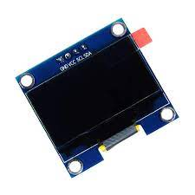
Figure 2: OLED Display
2) Power Supply: Power Supply Electrical power is supplied to components by a power supply. The term usually refers to devices that are installed into the driven section. A 3.7 V rechargeable Li-ion battery is used to provide the power supply to the controller which in turn feeds the required power to all the sensors and modules connected to it.
3) Temperature Sensor: NTC Thermistor temperature sensor module is small sized, low cost sensor which is very sensitive to ambient temperature. This sensor helps in sensing the temperature of surrounding environment. The detection range of temperature is between 20 -80 degree Celsius.
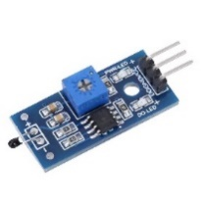
Figure 3: Temperature Sensor
4) Push Button: The mechanism of the push button is that two points are touched when the button is pressed which activates the alert mechanism.
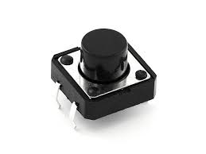
Figure 4: Push Button
5) GPS-GSM module: The location of the person in real-time is obtained using SIM808 module Both GPS and GSM are implemented as a two-way function in this module. Quad-Band is supported for GSM . Satellite navigation is supported with the help of GPS technology. A cheaper solution of two-way communication is achieved using a GSM modem compared with the two-way GPS communication satellite.
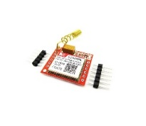
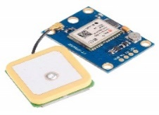

Figure 5: GPS-GSM Module
6) Buzzer: It is Small PCB Mountable 5V Passive Buzzer . It is used to add Audio Alert to electronic designs. An audible tone is generated using the coil element and works on 5v supply.
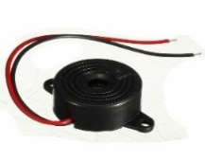

Figure6: Buzzer
7) Microcontroller: For communicating different sensors, switches, modules, the Arduino Uno microcontroller is used. It works as a decision-making controller by obtaining various signals from the different sensors and triggering output sensors appropriately.
Figure 7: Arduino UNO

- Process Flow :
1.Manual mechanism
Manual mechanism (see Fig.8) is the process flow which occurs when the women are in a situation to respond. It contains a button which can be pressed by the woman when she feels unsafe. When the button is pressed, the buzzer is activated to make a loud noise to alert the people around who can help her. Then the alert mechanism is triggered.
Start

Check if button is pressed

Activate Buzzer

Activate alert mechanism

Stop

Figure 8: Flowchart of Manual Mechanism
2. Automated mechanism
In most of the situations, the woman may not be able to react and use the manual mechanism. So, automate the mechanism using pressure, temperature and pulse-rate sensor (see Fig.2 ) and use a conjunction of the readings of these sensors to avoid false positives. When any of the two sensors detect an abnormality, the alert mechanism is activated The pressure sensor is a force sensing resistor sensor (FSR). With a small increase in force the resistance decreases exponentially. The resistance value is converted to analog voltage which ranges between 0-5V.
A trial and error method to find the thresholds of the sensors after taking the normal and abnormal values for all the three sensors. Whenever the sensors readings cross the thresholds values then they become HIGH. The voltage output of pressure sensor for various types of activities such as a normal touch, pushing etc. were observed during this process. The temperature sensor is used to measure the temperature of the surroundings. As a person comes closer to the personal space of the victim, the temperature surrounding her increases. So, a temperature sensor is integrated in such a way that it goes high when there is a sudden increase in the temperature around the woman.
The woman may not be able to respond and use the manual mechanism in the majority of cases. As a result, use friction, temperature, and pulse-rate sensors to automate the mechanism. In order to eliminate false positives, combine the readings of these sensors. The alarm system is triggered when one of the two sensors detects an abnormality. A force sensing resistor sensor is used as a pressure sensor (FSR). The resistance decreases exponentially with a slight increase in force. The resistance value is transformed to an analogue voltage between 0 and 5 volts.
Start

Take temperature readings

Temperature == HIGH

Activate Alert Mechanism

Stop

Figure 9: Flowchart of Automated Mechanism
3. Alert mechanism
The alert mechanism is triggered through one of the above mechanisms during a hazardous event. When the alert mechanism is triggered, GPS and GSM are used to send the message containing the location of the victim to relatives and officials. The location is sent as a Google Maps link for easy access. The system architecture of the alert mechanism is shown in Fig. The location coordinates are received from the GPS module whenever the alert mechanism is triggered. The GPS gets the location coordinates from the satellite. As these coordinates are difficult to interpret, the location coordinates is converted into a google maps link for easy access. After the coordinates being received a google link is formed which contains the victim's location. This link is sent to the registered numbers with the help of GSM.

GPS
GSM
Message Sent
Alert Triggered



Figure 10: Flowchart of Alert Mechanism

- RESULTS AND DISCUSSION

The components and modules used to construct the module are the sensor for the automatic mechanism, names as temperature sensors is shown on the top of the device, along with the other hardware needed, such as GPS, GSM, buzzer, and Arduino, which are all present inside the model. Some real-time scenario was created where the user might feel insecure to see the efficiency of the system. These scenarios can be easily differentiated from any normal stress-causing activity using the disabling tactile switch; at the same time emergency switch can be used to make the system forcefully work. When the switch in the sensor kit is pressed, it generates a message as shown in figure consists of location link , when the link is clicked it shows te current location of the victim in the google map as shown in figure, this message, will be sent to the preprogrammed number. It will also send the message automatically. When the buzzer starts to beep, the GSM module sends message to all in case of emergency (ICE) numbers along with the latitude and longitude values which is taken from the GPS module.

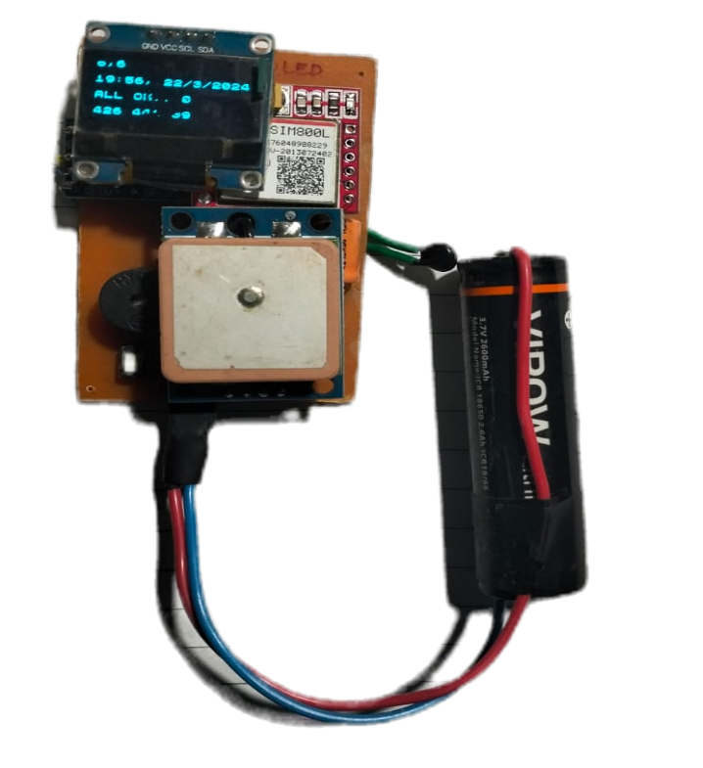

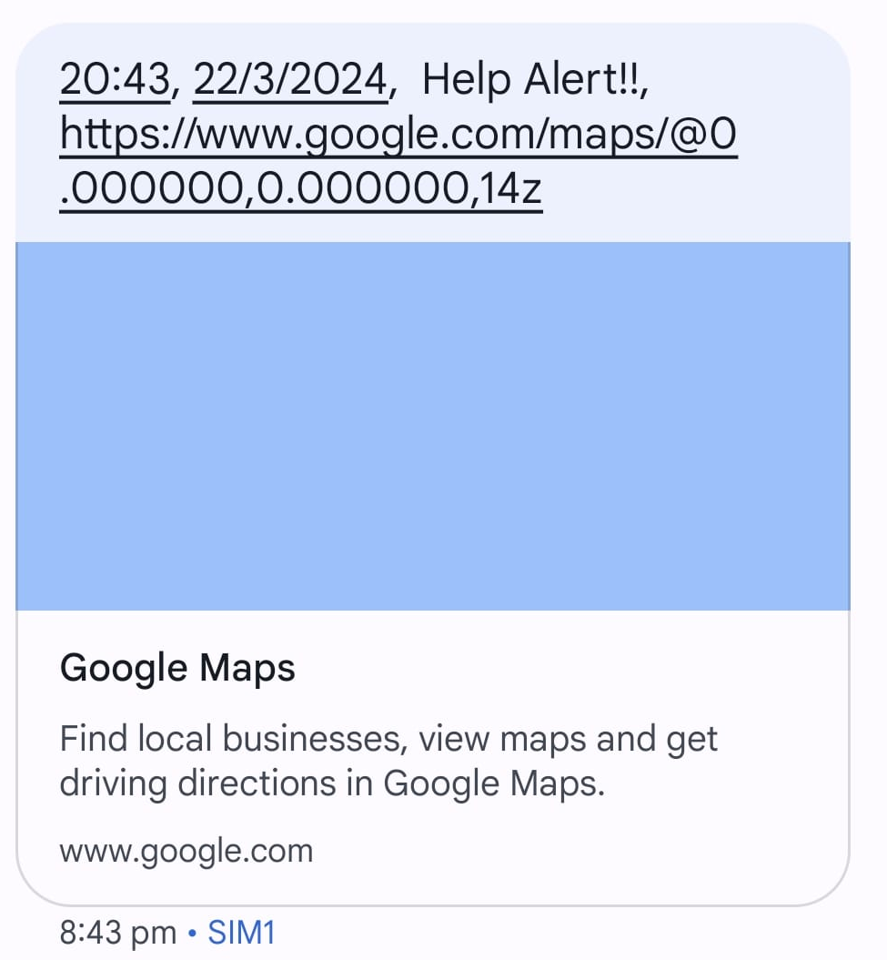
Figure 11: Prototype

Figure 12: Message send through the system

- CONCLUSION
The main aim of creating a woman protection device is to act as a rescue and avoid any harm to women in the event of a hazard. Through the proposed system a smart device for women’s safety which automates the emergency alert system is designed. This system detects and sends the alerts for the dear ones with the location coordinates of the women without the requirement of her interaction in critical times. It immediately sends an emergency alert to the family members and the nearest police station. The prototype can be carried in a variety of bags, including handbags and laptop bags. The proposed system involves Arduino UNO, GSM, GPS and various sensors. The GSM and GPS helps to send the message and location of the victim to the authorized network at the time of critical situation, Hence it becomes easy to find the appropriate location. The proposed design is making safe environment for women in the society, and allows them to go anywhere fear free. The objective of this women safety device is to prove complete protection to women in the present scenario. The main advantage of our proposed system is that both automatic and manual mechanism is implemented. It is also cost-efficient and easy to use.
- REFERENCES

- V. Hyndavi, N. Sai Nikhita , S. Rakesh, “Smart Wearable Device for Women Safety Using IoT”, Proceedings of the Fifth International Conference on Communication and Electronics Systems (ICCES 2020), IEEE Xplore ISBN: 978-1-7281-5371-1.

- N. Penchalaiah, M. Susmitha, C. Vinay Kumar Reddy, D. V. Pavan Kalyan Rao, D. Sreelekha, “An IoT Based Smart Wearable Device for Women Safety”, Special Issue of First International Conference on Information Technology, Computing & Applications (ICITCA 2021), Volume 03 Issue 05S May 2021.

- Dhruvil Parikh, Pallavi Kapoor, Shital Karnani, “IoT based Wearable Safety Device for Women”, International Journal of Engineering Research & Technology (IJERT) ISSN: 2278-0181 IJERTV9IS050697, Vol. 9 Issue 05, May-2020.

- R.Aarthi , M.Chitra , Aishwarys.E , Abinaya.K, “Smart Wearable Device for Women Safety using Internet of things”, International Journal of Innovative Research in Science, Engineering and Technology(2020), Vol. 9, Issue 3, March 2020.

- S Pradeep, Kanikannan, M Meedunganesh , A. Anny Leema "Implementation of Women Safety System using Internet of Things" Published in International Journal of Trend in Scientific Research and Development (ijtsrd), ISSN: 2456- 6470, Vol.4,Issue-4, June 2020.

- Tejonidhi M.R, Aishwarya, Chaithra K.S, Dayana M.K, Nagamma H, “IOT based smart security gadget for women’s safety”, International Conference on Advances in Information Technology, 978-1-7281-3241-9/19/$31.00 © 2019 IEEE.

- Wasim Akram, Mohit Jain, C. Sweetlin Hemalatha*, “Design of a Smart Safety Device for Women using IoT”, International Conference On Recent Trends In Advanced Computing 2019, ICRTAC 2019.

- Pravin Pardhi, Chetna Dnyaneshwar Dhote, Riteshwari Ashok Pagote, Suwarna Sunil Somkuwar ,Minakshi Pundlikrao Dhanorkar, “Smart Wearable System for Women Security Using IOT”, International Journal of Advances in Engineering and Management (IJAEM) Volume 4, Issue 5 May 2022, pp: 2765-276, ISSN: 2395-5252.

- C. Pratheeba, K. R. Archana, E. Dharshana, M.K. Nandhini, B. Shalini, “A Smart Wearable Device Women Safety System Based On IOT”, International Research Journal of Modernization in Engineering Technology and Science, Volume:03/Issue:03/March-2021 ,e-ISSN: 2582-5208.

