IOT Based Fish Feeding and Water Monitoring System

Sujata Dake¹, Sunil Vishwakarma², Sumit Parate³, Lalita Rakshak⁴, Yadneshwar Patle⁵
1Assi. Professor, Department of Artificial Intelligence and Data Science, Wainganga College of Engineering and Management, Nagpur, Maharashtra, India. sujatanehare5@gmail.com
2B.Tech Student, Department of Artificial Intelligence and Data Science, Wainganga College of Engineering and Management, Nagpur, Maharashtra, India. sunilvish1437@gmail.com²
3B.Tech Student, Department of Artificial Intelligence and Data Science, Wainganga College of Engineering and Management, Nagpur, Maharashtra, India. sumitparate199@gmail.com
4B.Tech Student, Department of Artificial Intelligence and Data Science, Wainganga College of Engineering and Management, Nagpur, Maharashtra, India. lalitar572@gmail.com
5B.Tech Student, Department of Artificial Intelligence and Data Science, Wainganga College of Engineering and Management, Nagpur, Maharashtra, India.

ABSTRACT:
Feeding fish properly is very important for the health and growth of the fish in your aquarium. However, due to their busy lifestyles, many fish owners have problems with regular feeding. With the emergence of IoT technology, many smart solutions have been developed for aquariums. However, there is still no research or innovation on how fish should be fed in smart aquariums. The IoT-based automatic fish feeding solution is designed to feed fish in aquariums or fish farms. The system uses microcontrollers and sensors to track fish feeding times and food items. The solution is connected to the internet and can be accessed remotely via a web application. Users can adjust feeding parameters according to the fish's needs. The IoT-based fish feed system is designed to provide fish owners with a simple and practical way to feed and monitor their fish from anywhere. The solutions use a variety of devices and sensors such as lights, spiral screw gear motors, temperature and humidity sensors, relays, RTC modules, pH sensors, water temperature sensors, where the test device is connected to the microcontroller that controls the functionality of the drug. A fish feeder is an electrical or electronic device that provides food to fish in an aquarium or aquarium. The equipment ensures regular and clear feeding of fish, which helps promote their growth and reduce waste.

Keywords: Aquaculture, microcontroller, fish farm, internet of things, sensor, temperature, pH value, water quality monitoring.

INTRODUCTION

Aquaculture, the controlled cultivation of aquatic organisms, has become increasingly vital in addressing global food security challenges and meeting the growing demand for seafood. Effective management of aquaculture systems, particularly in fish farms, requires continuous monitoring of environmental parameters such as temperature, pH value, and water quality [1]. With the advent of Internet of Things (IoT) technology, there is immense potential to revolutionize aquaculture practices by integrating sensor-based monitoring systems with automated feeding mechanisms [1, 2].

By harnessing the capabilities of microcontrollers, sensors, and IoT technologies, this system aims to optimize fish feeding operations, enhance productivity, and improve overall fish health.

At the heart of the system lies the ESP32 microcontroller, a versatile and powerful platform that serves as the central hub for data acquisition, processing, and communication. Integrated with a myriad of sensors including temperature sensors,
pH sensors, and TDS sensors, the ESP32 enables real-time monitoring of crucial water parameters essential for maintaining optimal conditions within the fish feeding environment [2,4]. The inclusion of specialized sensors such as the DHT11 Humidity Sensor further enhances the system's ability to assess environmental conditions with precision and accuracy.

Moreover, the incorporation of auxiliary components such as the ESP Camera Module offers remote surveillance capabilities, allowing fish farmers to visually inspect tank conditions and fish behavior from anywhere with internet connectivity. Additionally, the integration of a Gear Motor with Auger Screw facilitates automated fish feeding, ensuring consistent and timely delivery of feed to the fish population.

Furthermore, the inclusion of a 5V DC Power Supply and RTC Module ensures reliable operation and precise timing of system functions [5]. These components collectively enable the system to automate feeding schedules, monitor water quality parameters, and provide timely alerts in the event of deviations from optimal conditions.

METHODS AND MATERIAL
- Block Diagram
x

Temperat- ure and Humidity sensor
PH
sensor

Control Oxygen pump & Fish Tank Light
2 Channel Relay
Water Pump

ESP32
Micro Controller
Fish Feeder using Gear
1 Channel Relay
LCD
Display
Web
Camera Module
RTC
Module

Buzzer

Power Supply

Figure 1: Block Diagram of Proposed System
kj
TDS
Sensor

Components:
The prototype uses the following components:

ESP32 Microcontroller:
The ESP32 Camera Module refers to a camera

ESP Camera Module:
The ESP32 Camera Module refers to a camera module that is compatible with the ESP32 microcontroller. It allows users to capture images, video, or perform tasks related to computer vision and image processing in conjunction with the ESP32 board. There are several popular camera modules compatible with the ESP32, and one of the most commonly used is the ESP32-CAM.

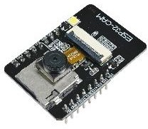
Figure 3: Camera Module

PH Sensor Module:
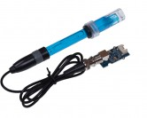
The pH sensor collect value from water and send that value to the server through the Wi-Fi module. A Web application was made to see values. pH level is important for fish. To grow a healthy fish, it’s essential to maintain the pH level [2]. So, a pH sensor was used. Freshwater ponds have a natural pH in the range of 6–8. When the pH level of water is low, it means the water is acidic, and high pH means it’s alkaline. If pond water becomes highly alkaline, it can damage the skin, eyes, and other outer surfaces of fish. Acidic water harms the reproduction of fish. Fish can die because of low pH levels.

module that is compatible with the ESP32 microcontroller. It allows users to capture images, video, or perform tasks related to computer vision and image processing in conjunction with the ESP32 board. There are several popular camera modules compatible with the ESP32, and one of the most commonly used is the ESP32-CAM [6].
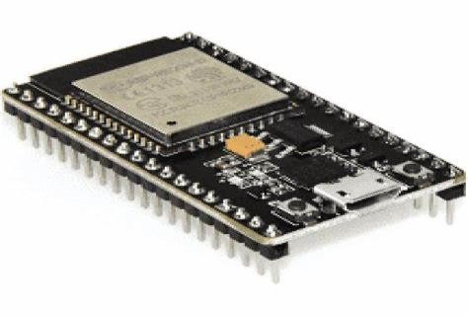
Figure 2: ESP32 Microcontroller

Figure 4: PH Sensor

TDS Sensor:
Total dissolved solids (TDS) represent the total concentration of dissolved substances in water. TDS is made up of inorganic salts, as well as a small amount of organic matter [2,7]. The TDS level is how much of the total dissolved solids are present in the water. The unit of TDS level is PPM, and 1 PPM TDS represents that it has 1 mg dissolved solids in 1L water.

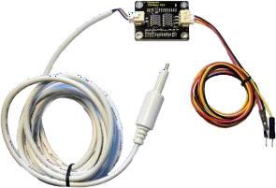

Figure 5: TDS Sensor

DHT11(Humidity Sensor):

The DHT11 is a basic and cost-effective digital sensor designed for measuring temperature and relative humidity levels in the environment [3]. It utilizes a capacitive humidity sensor and a thermistor to measure humidity and temperature, respectively. The operating temperature range for accurate measurements of the DHT11 is usually from 0°C to 50°C for temperature and 20% to 80% relative humidity for humidity readings.
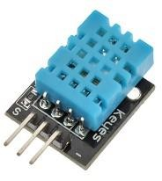
Figure 6: DHT11 (Temperature and Humidity Sensor)

RTC Module:
An RTC module, also known as a Real-Time Clock module, is a specialized electronic component used to keep track of time accurately in various electronic devices, even when the device is powered off [4].
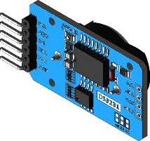

Figure 7: RTC Module

Water Pump Motor:

The water pump motor helps in maintaining the proper circulation of water within the fish tank. This is vital to ensure oxygenation, temperature regulation, and distribution of nutrients for the fish. In an IoT-based fish feeding system, the water pump motor might be linked or synchronized with the feeding mechanism.
Figure 8: TDS Sensor

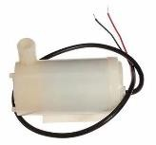
Gear Motor with Auger Screw:

A gear motor with an auger screw refers to a motorized mechanism that utilizes a gear motor to drive an auger (also known as a screw conveyor) [4]. This setup is commonly used in various applications, including industrial, agricultural, and automation systems, where controlled movement or transportation of materials is required [5].

Water Overflow Cut-off:

In an aquaculture system or fish tank, a water overflow cutoff mechanism is a safety feature designed to prevent potential flooding or overflow situations. This mechanism is essential in maintaining water levels within a safe range and avoiding damage to the surrounding environment or equipment.

GSM Module:

The SIM800L is a popular GSM/GPRS module commonly used in embedded systems for communication purposes. The SIM800L module supports GSM (Global System for Mobile communications) and GPRS (General Packet Radio Service) technologies. This enables it to establish communication over cellular networks [5].
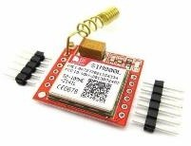
Figure 9: SIM800L

Process Flow:

- Automated mechanism
Users input or set predefined feeding schedules based on fish species, size, and nutritional requirements through the user interface. The feeding mechanism, controlled by a microcontroller, dispenses the feed into the fish tank [4]. The feeding mechanism, controlled by a microcontroller, dispenses the feed into the fish

tank. Sensors or cameras may verify the feed dispensing process for accuracy and monitor fish behavior during feeding. Based on feedback from sensors or user observations, adjustments to feeding schedules or feed quantities may be made through the user interface. Periodically synchronize the RTC module with an external time source (e.g., NTP server) to ensure accurate timekeeping.
Start
Web Application
No
4:00 AM
Yes
RTC Time

Figure 10: Flowchart of Automated Mechanism

Stop
Now Feeding

Integrating the RTC module ensures accurate timing for scheduled feeding events, enhancing the reliability and precision of the fish feeding process within the IoT-based system [4].

Remote mechanism

Establish a connection to a remote server or cloud platform for remote communication. Users input or set predefined feeding schedules based on fish species, size, and nutritional requirements through the user interface, which is hosted on the remote server. At scheduled feeding times determined by the RTC module, the microcontroller triggers the feeding mechanism to dispense feed. The microcontroller sends a signal or message to the remote server to notify users of the feeding event.

The feeding mechanism dispenses the appropriate
amount of feed into the fish tank as triggered by the microcontroller. Sensors or cameras verify the feed dispensing process for accuracy and monitor fish behavior during feeding. Data from these sensors may be transmitted to the remote server for monitoring by users. Users receive notifications of feeding events and can provide feedback or adjust feeding schedules or quantities through the remote user interface. Users can remotely access the system through the user interface hosted on the remote server. Remote access allows users to monitor system status, view sensor readings, adjust feeding schedules, and receive alerts or notifications.
Start
Web Application

Off | ON\OF  On
 | Now Feeding

Stop
Figure 11: Flowchart of Remote Mechanism
Button
Button

- Water Monitoring

Establish connections to the pH sensor and TDS sensor for water quality monitoring [2]. Users input or set predefined feeding schedules based on fish species, size, and nutritional requirements through the remote user interface. At scheduled feeding times determined by the RTC module, the microcontroller triggers the feeding mechanism to dispense feed. The microcontroller sends a signal or message to the remote server to notify users of the feeding event. The pH sensor and TDS sensor continuously monitor water quality parameters in the fish tank [7].
Sensor data is transmitted to the microcontroller for processing and analysis. The microcontroller

analyzes pH and TDS sensor data to detect deviations from optimal water quality conditions [2]. If abnormal readings are detected, the system generates alerts or notifications to inform users of potential issues. If water quality conditions are within acceptable ranges, the feeding mechanism dispenses the appropriate amount of feed into the fish tank.
Start
Web Application

Check Water Quality
No Change
Change
TDS and PH Sensor

Stop
Water Pump
Figure 12: Flowchart of Water Monitoring

Users can remotely monitor water quality parameters and feeding events through the remote user interface. Users receive alerts or notifications of water quality issues and can take corrective actions, such as adjusting feeding schedules or performing water exchanges, through the remote user interface [6].

RESULTS AND DISCUSSION
- Water Quality Management:
Continuous monitoring and timely intervention maintained optimal water conditions, minimizing risks to fish health.

Feeding Efficiency:
Automated feeding schedules optimized feed utilization, reducing wastage and ensuring proper
nutrition for fish.

Remote Monitoring:
Remote access to real-time data empowered users to oversee operations from anywhere, enabling proactive decision-making.

- Productivity and Sustainability: Improved water quality and feeding practices led to enhanced fish health, growth, and overall productivity.
Automation reduced resource consumption and promoted economic and environmental sustainability.

Scalability and Adaptability:
Modular design allowed for easy scalability and integration with external systems, ensuring versatility and adaptability to diverse aquaculture setups.
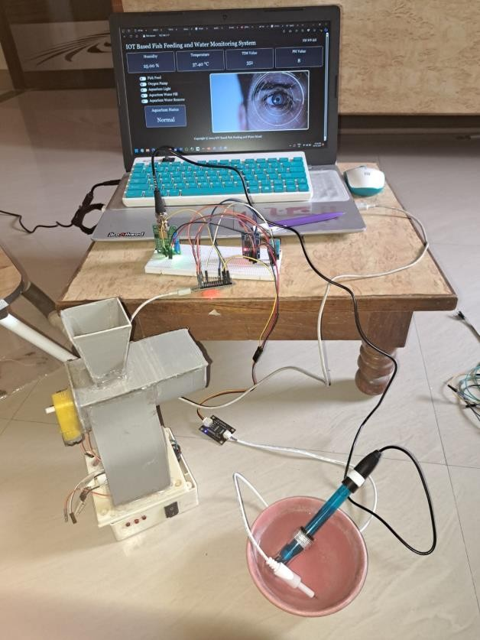

Figure 14: Result.

By presenting these results, we can effectively demonstrate the effectiveness and impact of IoT- based fish feeding and water monitoring system, showcasing its potential to transform aquaculture management practices for the better.

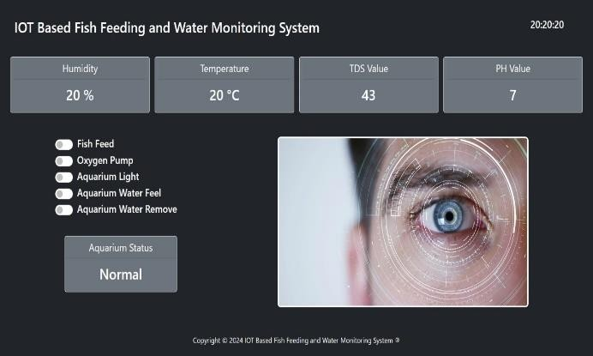

Figure 13: Webpage

CONCLUSION

The development and implementation of the IoT- based fish feeding and water monitoring system represent a significant advancement in aquaculture management. Through the integration of cutting- edge technologies, including real-time monitoring, automated control mechanisms, and remote access capabilities, the system has demonstrated its potential to revolutionize fish farming practices. The system's ability to continuously monitor water quality parameters and automate feeding schedules has significantly improved operational efficiency. By minimizing manual intervention and optimizing resource utilization, fish farmers can achieve higher productivity while reducing labor and feed costs. Real-time monitoring of water quality parameters such as pH and TDS levels has enabled proactive management of fish health. While the system has demonstrated promising results, there are opportunities for further refinement and expansion. Future research and development efforts could focus on improving data analytics algorithms, enhancing user interfaces, and integrating additional sensor technologies to broaden the scope of environmental monitoring. Collaboration with industry stakeholders and continued innovation will be key to unlocking the full potential of IoT-based solutions in aquaculture.

REFERENCES

- Fahad Aljehania, Ibrahima N’Doyeaand Taous Meriem Laleg-Kiratia, “Feeding control and water quality monitoring in aquaculture systems: Opportunities and challenges”, a Computer, Electrical and Mathematical Sciences and Engineering Division (CEMSE), King Abdullah University of Science and
Technology (KAUST), (arXiv:2306.09920v1 [eess.SY] 14 Jun 2023)

- Akbar Riansyah, Rina Mardiati, Mufid Ridlo Effendi, Nanang Ismail, “Fish Feeding Automation and Aquaponics Monitoring System Base on IoT”, Authorized licensed use limited to: Auckland University of Technology. (IEEE Xplore) (2020)

- Chiung-Hsing Chen, Yi-Chen Wu, Jia-Xiang Zhang and Ying-Hsiu Chen, “e IoT-Based Fish Farm Water Quality Monitoring System”, 2022 by the authors. Licensee MDPI, Basel, Switzerland. This article is an open access article distributed under the terms and conditions of the Creative Commons Attribution (CC BY) license (https:// creativecommons.org/licenses/by/ 4.0/).

- Donna T. San Antonio, Jairuz Ren A. Rivera, Alexander Carl N. Balid, Rica Ridgette P. Belaos, Annie I. Brizuela “IoT-Based Water Quality Monitoring and Automated Fish Feeder: Enhancing Aquaculture Productivity.” (n.d.) retrieved March 24, 2024, from ieeexplore.ieee.org/abstract/document/102236 36

- Md. Nasir Uddin, Mm Rashid, Mg Mostafa, Belayet H, Sm Salam, Na Nithe, Mw Rahman & A Aziz. “Development of Automatic Fish Feeder” 2016. International Islamic University Malaysia. https://globaljournals.org/GJRE_Volume16/3-
Development-of-Automatic-Fish.pdf

- Abinaya. M, Survenya. S, Shalini. R, Ms. P. Sharmila, Dr. J. Baskaran, “Desing and implemtation of aquaculture monitoring and controlling system”, 2019 International Conference on Computation of Power,Energy, Information and Communication (ICCPEIC) (IEEE Xplore).

- https://www.instructables.com/TDS- Measuring-in-Aquarium/

