BEHAVIOUR OF RC IRREGULAR STRUCTURE UNDER SEISMIC EFFECT
Ashwin R Dhabre¹, Dr. N. R. Dhamge²
¹M-Tech Scholar
KDK College of Engineering, Nandanvan, Nagpur 440009
²Professor, Civil Engineering Department,
KDK College of Engineering, Nandanvan, Nagpur 440009

----------------------------------------------------------------------------------------------------------------------------------------------------

ABSTRACT - During an earthquake, damage occurring from earthquake ground motion initiates at locations of structural weaknesses present in the lateral load resisting frames. This weakness increase due to discontinuity in mass, stiffness, geometry and setback. Such discontinuities between the storeys are often associated with immediate variation in the frame geometry along the height. Vertical irregularities are one of the main reasons of failures of structures during earthquakes. Vertical irregularity are building with soft stories. This can be affected by the earthquake ground motion and broken down into the different types of irregularities as well as their severity for a more refined assessment tool. Pushover analysis is an approximate analysis method available for evaluating building against earthquake loads subject to monotonically increasing lateral forces with an invariant height wise distribution unit a target displacement is reached. The structure is subjected to the load unit some structural member yield. A two or three dimensional model which includes bilinear or trilinear load deformation diagrams of all lateral forces resisting elements initially. The model is then modified to account for the reduced stiffness of the building and is once again applied with a lateral load unit addition member yield. A base shear vs. displacement capacity curve and plastic hinging model is produced as the end product of the analysis which give a general idea of the behavior of the building. Although it is acknowledge that other types of analysis such as the dynamic time history analysis. Time history analysis techniques involves the stepwise solution in the domain of the multidegree of freedom equations of motion which response of a building. It is the most sophisticated analysis available to a structural engineer. The present study is to evaluate the behavior of typical new R.C.C building were taken for analysis G+6 floor reinforced concrete frame structure subject to earthquake force in zone V. The paper gives investigation taken on pushover.

Keywords: Vertical irregularity; Pushover analysis; Discontinuity; R/C building; setbacks.
INTRODUCTION
Earthquake are considered to be one of the most unpredictable and devastating natural hazards. Earthquake pose multiple hazards to a community potential inflicting large economic, property and population loss. The damage in a structure generally initiates at location of the structures weak planes present in the building systems. These weaknesses often occur due to presence of the structural irregularities in stiffness, strength, mass, geometry in a building systems. The effect of vertically irregularities in the seismic performance of structure become really important. Height wise changes in stiffness and mass render the static and dynamic characteristic of these building different from the regular building. Vertical irregularities are basically building characteristic that may be due to irregular distribution in their mass, strength and stiffness along the height of building when such buildings are constructed in high seismic zones, the analysis and design becomes more completed. There are two methods to evaluate the seismic behaviour of RC building nonlinear static and nonlinear dynamic. The present study adopts building models with different type, magnitude and location of irregularity. The seismic responses of these building model have been compared with that of the regular building model. Pushover analysis is an appropriate analysis method available for evaluating building against earthquake loads. A structure is induced incrementally with a lateral forces with an invariant height wise distribution until a target displacement is reached. The structure is subject to the load unit some structural member is yield. A base shear vs. displacement capacity curve and a plastic hinging model is produced as the end product is analysis which give a general idea of the behavior of the building. The present study is to evaluate the behavior of typical new RCC building were taken for analysis G+6 floor reinforced concrete frame structure subject to earthquake force in zone V. In the building frame is designed as per Indian standard i.e. IS-456: 2000, IS-1893: 2002 and IS-1893: 2016. The main objective of this study the irregularities which we need to consider while analyzing it for the seismic loading given in IS- 1893: 2002 (Part-I) and to compare seismic behavior of RC structure by using IS code 1893: 2016 (Part 1).

Fig 1: Failure of buildings due to soft storey in turkey, bingol earthquake 2003
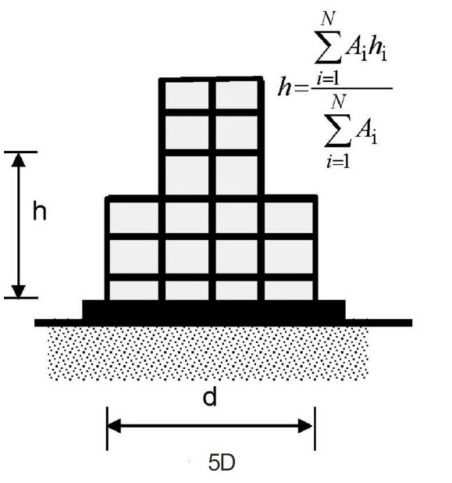
METHODOLOGY
A static pushover analysis using SAP2000 was utilized in the research. Using two codes provision such as IS 1893: 2002 and IS 1893: 2016 this method of analysis are considered the three model as per IS 1893: 2002 such as regular, irregular in x- direction and same models are considered according to the IS 1893: 2016 to their applied load combination. When earthquake forces are considered on structure these shall be combined as DL, IL and EL stand for response quantities earthquake load earthquake load respectively. So two codes provision of load combination shall be accounted for seismic analysis following load combinations are considered.
 | LOAD COMBINATION (IS 1893: 2002) |  | LOAD COMBINATION  (IS 1893: 2016)
1. | 1.5(DL+IL) | 1. | 1.2 [DL+IL+ (EL_{X} + 0.3 EL_{Y})] &
2. | 1.2 (DL+IL+EL) |  | 1.2 [DL+IL+ (EL_{Y} + 0.3 EL_{X})]
3. | 1.5 (DL+ EL) | 2. | 1.5[DL+ (EL_{X} + 0.3 EL_{Y})] &
4. | 0.9DL+ 1.5EL |  | 1.5[DL+ (EL_{Y} + 0.3 EL_{X})]
 |  | 3. | 0.9 DL+ 1.5 (EL_{X} + 0.3 EL_{Y}) &
 |  |  | 0.9 DL + 1.5 (EL_{Y} + 0.3 EL_{X})

As the provision of revised code IS 1893: 2016 for irregular structure are 7.6.2 the approximate fundamental translational natural period (T_{a}) of oscillation, in second shall be estimated by the following expression: 0.075h^{0.75} (for RC MRF building). According to the IS 1893: 2016 height of irregular structure are different because their irregularities. The analysis of model firstly defined by their vertical irregular structural height and calculate translational natural period of oscillation by the expression given in code.
Default SAP2000 hinges are used in the analysis. M3 hinges are assigned on beam ends P M2 M3 hinges are assigned on column end as per ATC-40 recommendations. The model is pushed to a target displacement determined automatically by SAP2000 using ATC-40 recommendations. This objective displacement is the displacement experienced by the building given the design earthquake.
Fig. 2 Vertical distribution of base shear to different floor level
DESIGN & ANALYSIS
This analysis, 7 story building was modelled. A concrete frame building with 5 bays in X- direction at 4 meters each is modelled and 4 bays in Y- direction at 5 meters each is modelled. Depth of foundation is 2 meters and a story height of 3.4 meters is kept constant throughout each story and model except when the irregularity is introduced. The model is also constructed considering code provision as well as guidelines given by the ATC-40 documents. Section sizes are determined so of model figure shows the geometry of the regular and irregular building model considered.
Beam size: 450 mm x 600 mm; Column: C₁ = 400 mm x 600 mm; C₂ = 600 mm x 600 mm; C₃ = 400 mm x 400 mm.

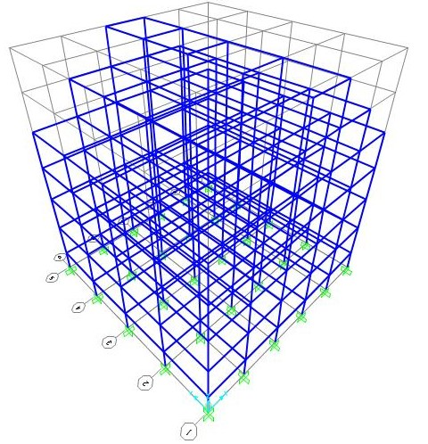
Fig 3 Plan of regular building frame
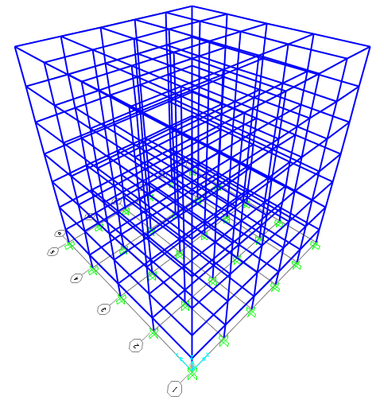
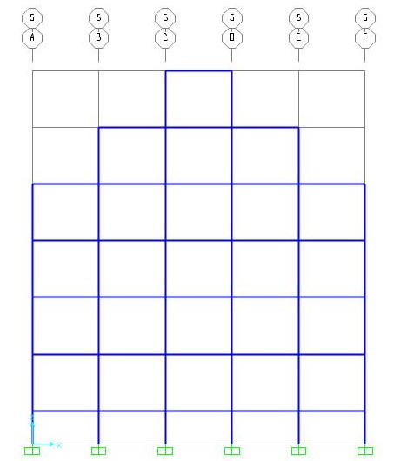
Fig.4 3D model regular building frame
Fig. 5 Section of Irregular Building (XZ Direction)
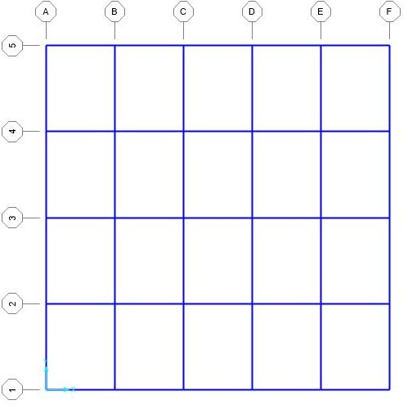
Fig. 6 3D Model Irregular Building Frame

RESULTS OF PUSHOVER ANALYSIS
Table – 1 Performance levels of G+6 structure Regular and Irregular as per IS code 1893: 2002.
REGULAR STRUCTURE
PERFORMANCE LEVEL | IO | LS | C
DISPLACEMENT  (mm) | 0.12760 | 0.29658 | 0.31056
BASE SHEAR  (kN) | 4836.53 | 5042.84 | 5057.97

IRREGULAR STRUCTURE
PERFORMANCE LEVEL | IO | LS | C
DISPLACEMENT  (mm) | 0.08197 | 0.1529 | 0.16140
BASE SHEAR  (kN) | 8063.76 | 8094.40 | 8083.97

Fig. 7 Comparison of base shear and displacement with regular and irregular structure (IS 1893:2002)

IRREGULAR STRUCTURE
PERFORMANCE LEVEL | IO | LS | C
DISPLACEMENT | 0.0800 | 0.14671 | 0.15460
BASE SHEAR | 8454.4 | 8809.19 | 8837.98
Table – 2 Performance levels of G+6 structure Regular and Irregular as per IS code 1893: 2016.

REGULAR STRUCTURE
PERFORMANCE LEVEL | IO | LS | C
DISPLACEMENT | 0.101985 | 0.178514 | 0.187219
BASE SHEAR | 8701.691 | 9074.048 | 9104.306

Fig. 8 Comparison of base shear and displacement with regular and irregular structure (IS 1893:2016)

DISCUSSION
The building frames analyzed go through various performance levels which describes a limiting damage condition for a building. As the displacement of the building increases, so does the damage as illustrated in figures. The performance levels are commonly defined as follows.
Immediate Occupancy IO: The post-earthquake damage state that remains safe to occupy, essentially retains the pre-earthquake design strength and stiffness of the structure and is in compliance with the acceptance criteria specified in the standard for the performance level.
Life Safety LS: The post-earthquake substantial damage to the structure and the structure may have lost large portion of its strength and stiffness.
Collapse Prevention CP: The post-earthquake severe damage and little strength and stiffness remains. Building is unstable and is near collapse.
Plastic Hinge Formation
Plastic hinge formation is one of the primary data analyzed by researchers to identify location of the building where large potential damage may occur. Assigned plastic hinges reach a specific hinges rotation limit and go through different damages states. ATC-40 recommends limit states but default SAP2000 hinge limits are adopted in the study. Figure shows the SAP2000 color legend indicating the increasing damage severity of the hinges.
CONCLUSION
1. Structure which is designed for seismic forces gives more ductility as compare to gravity designed structure. Some behavior is observed in both case regular and irregular structure.
2. Due to different behavior of structure the nonlinear performance of structure will be affects.
3. Irregular structure cannot sustain more force as compared to regular structure hence structure becomes damage.
4. Grade of concrete affects the strength capacity of building but there is no effect on deformation capacity.
5. Irregularities are harmful for the structures and it is important to have simpler and regular shapes of frames as well as uniform load distribution around the building.
6. As far as possible irregularities in a building must be avoided. But, if Irregularities have to be introducing for any reason, they must be designed properly.
Acknowledgements
The contribution and support of Dr. N. R. Dhamge, Professor at the Department of Civil Engineering, K.D.K College of Engineering, is gratefully acknowledged.
REFERENCES
1. Han Seon Lee, Dong Woo Ko, 2007, Seismic response characteristics of high-rise RC wall buildings having different irregularities in lower stories, Engineering Structures 29 (2007):3149–3167.
2. C.J Athanassiadou, 2008, Seismic performance of R/C plane frames irregular in elevation, Engineering Structures 30 (2008):1250–1261.
3. Ari Wibowo, John L. Wilson, Nelson T. K. Lam, Emad F. Gad, 2010, Collapse modelling analysis of a precast soft storey building in Australia, Engineering structure 32 (2010) 1925-1936.
4. Sarkar P, Prasad A Meher, Menon Devdas, 2010, “Vertical geometric irregularity in stepped building frames”, Engineering Structures 32 (2010) 2175–2182.
5. F. Hejazil S. Jilani, J. Noorzaei, C.Y Chiengi, M.S. Jaafar, A. A. Abang Ali 2011, “Effect of soft story on structure response of high rise buildings”, Materials Science and Engineering 17 (2011) 12043.
6. Nevzat Kirac, Mizam Dogan, Hakan Ozbasaran, “Failure of weak-storey during earthquakes”, Engineering Failure Analysis 18 (2011) 572- 581.
7. Ibrahim Serkan Misir, “Potential use of locked brick infill walls to decrease soft-story formation in frame buildings”, journal of performance of constructed facilities, 2015, 29(5).
8. Arlekar, J.N., Jain, S.K., and Murty C.V.R., “Seismic response of RC frame buildings with soft first storey,” In Proceedings of CBRI Golden Jubilee Conference on Natural Hazards in Urban Habitat, New Delhi, 1997.
9. Negro, P., and Verzeletti, G., “Effect of infill on the Global Behavior of RC Frame: Energy Considerations from Pseudodynamic Tests,” Earthquake engineering & structural dynamics 25 (8), 753-773, 1996.
10. Dipti Ranjan Sahoo, Durgesh C. Rai, “Design and evaluation of seismic strengthening techniques for reinforced concrete frames with soft ground story”, Engineering structures 56 (2013) 1933-1944

