Fruits Classification On The Basis of Different Diseases and Quality Using Deep Learning
Prof. Sujal Shelke¹, Monika Ingole² , Priyanka Yadav³, Minakshi Dobale^{4,}

^{1.2.4}Assistant Professor, ³Student
Wainganga College of Engineering and Technology, Nagpur, India.

prinkucool456@gmail.com

Received on: 10 April ,2022 Revised on: 16 May ,2022, Published on: 18 May,2022

Abstract- This paper includes an analysis of recent technological developments based on automatic detection of fruit classification. The use of computer vision technology is increasing in the agricultural and fruit industry. The automatic fruit quality monitoring system will be used to filter and sort various fruits. The main purpose of this program is to replace the manual testing program. This will help speed up the process, improve accuracy and reduce efficiency. In recent years, researchers have come up with innumerable contradictory ways of distinguishing fruits. Color, texture and morphological features are the most commonly used to identify the stage of fruit diseases. The proposed system will collect a camera image placed in front of a portable computer or mobile phone and after processing the images we will specify the type of fruit. The main emphasis in this work is the purchase of an analysis of the methods of diagnosing various fruit diseases. After that, these features are used to train the system module. In order to train the system we need a database of different fruits. We will therefore collect this fruit database from the data library. The database contains information and images of fruits that describe their quality and type. An in-depth reading module will read this database and learn the content / features of various fruits. The fruit element will be highlighted to show the type of fruit and the quality of the fruit will also stand out. The classification will be based on the shape, size and color of the fruit

Keywords: Fruits classification, Computer vision, Leaf disease, Features extraction, Convolution Neural Network (CNN).
- INTRODUCTION
Image processing has become increasingly popular in a variety of fields, including industrial, medical, real-time imaging, texture categorization, and beholding. Another rapidly growing evaluation field is image system and laptop computer imaginative and prescient. As a result, it is critical to strengthen the high-speed and low-cost fruit fine-scanning system. To discover fruits amazing and fruit malady, image strategy technology and laptop computer imaginative and prescient software Programme bundle will become more appealing. There are tens of millions of methods to well-known diseases in fruits in their early phases. The traditional technique of detecting illness in fruit is by observing fruits with the naked eye, which is no longer effective. The disease identification is more effective, correct, and timely when using a digital technology. fruit computerized partner diploma For sorting and grading various fruits, fine inspection devices will be used. For accurate fruit disease detection and identification, researchers have devised wholly unique photo method strategies and a large number of algorithms. A variety of plant diseases are wreaking havoc on fruits and vegetables. Diseases rectangular measure considered on the leaves and fruits of the plant, therefore disease detection plays an important role in agriculture. Pathogens, fungi, humans, microorganisms, and viruses are all patterns of fruit diseases, and unfavorable living conditions are to blame. Deep learning. Which is based on artificial neural network (ANN), is a set of machine learning algorithms that use a mix of techniques to extract desired information from a huge quantity of data. With the invention of the backpropagation method, which is an optimization method, ANN attained its pinnacle, but it reached a technological limit. As a result, machine learning was aided by the Kernel approach (Support Vector Machine, Gaussian Process, and so on). Many computing challenges, initialization problems, and local minima problems are among ANN's drawbacks. Pre-training employing unsupervised learning, computer development, parallel processing with GPGPU (General-Purpose Computing on Graphical Processing Units), and the introduction of Big Data are some of the causes that could overcome the problems. Many problems that have not been solved by standard machine learning approaches are solved by deep learning studies. Deep learning techniques such as DNN (Deep Neural Network), CNN (Convolutional Neural Network), and RNN (Recurrent Neural Network) are used in a variety of fields (Recurrent Neural Network). The CNN algorithm, in particular, performs well in image processing fields such as picture classification and recognition. As a result, several CNN models have been developed, and numerous experiments utilising them have been undertaken. Transfer learning using in-depth learning by introducing a pre-training model built in a well-positioned environment is also used. Models are created based on data features and fields, and transfer learning using in-depth learning by introducing a pre-training model built in a well-positioned environment is also used.
II -LITERATURE REVIEW
The presence of a flatoxin in fig samples has a strong link with fluorescence generation. There are certain machine vision systems that are used to inspect dried figs automatically; however their accuracy is still below 80% due to various unsolved technological issues. These issues are the driving force behind the use of manual inspection methods, either alone or in conjunction with automated inspection systems. Machine vision techniques, like any other approach, have distinct advantages and limitations. The goal of this research is to look at where machine vision stands right now in dried fig fruit sorting systems. It is also suggested that the issues of machine vision applications for fig fruit sorting be defined, as well as some ideas for improving the efficiency of these applications. [1].
Automatically sorting agricultural products is more efficient than the existing manual technique, which is sluggish, laborious, labour intensive, and prone to errors. However, an automated sorting system that can recognize agricultural items based on their features is required. In fruit grading systems, computer vision is commonly used. The shape, size, color, texture, and intensity of the fruits are use to grade them. Five different sorts of fruit photos were rated by Savakar (Apple, Chico, Orange, Mango and Sweet Lemon). A total 5000 sample pictures were taken, with 1000 images of each fruit species. 18 colors and 27 texture features were to extracted create the algorithm. Separating RGB (Red, Green, and Blue) components yielded the color characteristics. [2].
The objective of this research is to classify the specific agricultural land cover in the Tsagaannuur, which is a major agricultural producing region in Mongolia. We created an agricultural cadastral map and vector coverage of the study site using ARCMAP software. The vector field boundaries were produced and digitised from ground truth data. Maximum likelihood supervised classification was used to classify pictures recorded by Landsat TM and ETM in 1989 and 2000, respectively. With the help of ground-based agricultural monitoring data, supervised classification was performed on the six reflective bands for each of the two photos separately. [3].
Deep learning has been accustomed detect leaf or disease during a plethora of papers and articles. Convolutional Neural Networks have transformed the agricultural field by creating models that may reliably detect disease. However, recognizing the disease isn't enough; one must even be awake to the disease's symptoms within the leaf or plant image. Single Shot multi-box Detector (SSD), Faster Region-based Convolutional Neural Network (Faster RCNN), and Region-based Fully Convolutional Network (R-FCN) are wont to locate impacted areas within the plant via object detection. Furthermore, you merely look Once (YOLO) method is employed for real-time object detection. All of those algorithms may well be wont to diagnose disease and visualize the afflicted area. [4].
Plant diseases and pests have a big influence on plant output and quality. Using digital image processing, plant diseases and pests can be identified. Deep learning has achieved significant advancements in the field of digital image processing in recent years, outperforming traditional methods by a wide margin. Researchers are very interested in learning how to apply deep learning technology to study plant diseases and pest detection. This review defines the problem of detecting plant illnesses and pests and compares it to traditional ways of detecting plant diseases and pests. This report summarizes recent research on plant disease and pest detection using deep learning from three perspectives, based on the differences in network topology. The performance of existing studies is compared, and common datasets are introduced. This paper examines potential problems in practical applications of deep learning-based plant disease and pest detection. In addition, possible remedies and research ideas for the difficulties are presented, as well as many recommendations. Finally, based on deep learning, this study analyses and forecasts the future trend of plant disease and pest detection. [5].
This project aims to clarify the details of diseases and how artificial intelligence may be used to detect them quickly. They utilize machine learning and deep learning to automatically detect diseases in plants. In the last five years, machine learning approaches have shifted from traditional machine learning to deep learning. Furthermore, many data sets linked to plant diseases are thoroughly examined. The challenges and problems with the current systems are also discussed. [6].

Training:

Collect Dataset
Select Model
Train Model
Export Model
Create UI
Import Saved Model
Select Image
Show fruitname
Suggest fruit quality

Testing:

Fig.1 Block diagram of training and testing model

The data sets developed in this paper are used to identify healthy and sick leaves using Random Forest. The implementation aspects covered in this study are dataset construction, feature extraction, classifier training, and classification. To categorise the infected and healthy photos, the produced datasets of diseased and healthy leaves are combined and trained under Random Forest. Overall, employing machine learning to train huge publically available data sets provides a straightforward technique to detect plant disease. [7].
III -MATERIALS AND METHODS
Algorithm: Convolutional Neural Networks (CNN)
For picture classification, CNN was employed as a deep learning method. CNN, which is created of variety of

convolutional layers, a pooling layer, and a general neural network layer called a completely connected layer, performs well with 2-dimensional input file like images. Through the convolution procedure, the convolutional layer allows for feature extraction without being influenced by the dimensions or position of the target on the input image. within the process of reducing the info increased by convolutional progress, the pooling layer reduces the feature by subsampling it. The feature extraction performance is decided by repeating the convolutional and pooling operations. The classification problem is complicated by the actual fact that the features are collected via convolutional and pooling layers. Because the CNN approach requires lots of compute, it absolutely was employed for GPU capable data processing leveraging GPGPU (General-Purpose Computing on Graphics Processing Units) concept to train quickly.
Process:
Because all of the photos have varying dimensions, they should be down sampled to a fixed resolution of 256256 to produce a constant input dimension. After the image labeling, a classification was performed with the training model to classify the images to suit the categories, and then time was spent to achieve top-1 and top-2 accuracy. The top-5 with top-2 compression results were saved to text file format and visualized using a visualization approach. The highest categorization category is the top-1. It delivers a score on top1 if the image's actual label matches the classification label. Similarly, top-5 refers to data for the five highest-ranking categories.The whole flow is shown Fig. 2 below

Test of training model
Top 5 predictions
Image Resize
Test time and top-prediction
Data save and draw the result

Fig.2 Classification Process

- Before performing image classification using CNN, speed difference between CPU and GPU was checked about the training model. In general, when performing a deep learning algorithm, GPU is employed for computational efficiency, so it had been necessary to test to what extent the effect actually appeared. Following are the steps to coach and test model.
- To train a system we need database of different fruits. So we have collected these fruits database from data library like kaggle.
- The database contains information and images of fruits describing their quality condition and respective type name and plant diseases.
- Select deep learning model and train with dataset available.
- Deep learning module will read this database and learning the content/features of various fruits and plant leaves.
- After training the module we have designed a user interface (UI) on a python. User interface (UI) is software in which we process the image captured previously.
- Fruits feature will be extracted to identify the fruit type and quality of fruits will also highlight. And plant leaves feature also extracted to detect disease.
- Classification will do based on shape, size and color of fruits and plant leaves.
- Then we check for the better accuracy.
- Finally this model show the classification of fruits based on disease.

III- RESULT ANALYSIS
Fruit detection is done using YOLO object detection model. We used cvlib.
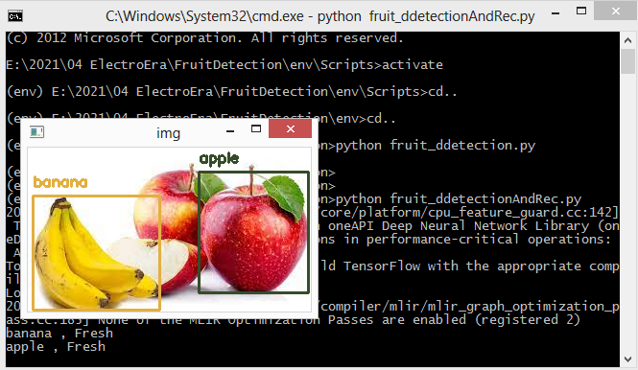
Fig.3 Fruit detection
After detecting fruit we need do classification on the basis of quality.
We used Google Colab for building and training model. Because Google colab provide free GPU for 24Hrs. We need gpu to train model in short time.
We build on classifier using CNN.
CNN model input image size is = 56 X 56
Number of classes = 6
Classes - ['freshapples', 'freshbanana', 'freshoranges', 'rottenapples', 'rottenbanana','rottenoranges']
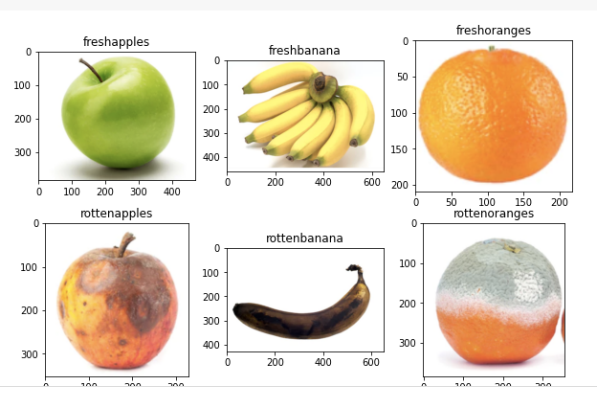
Fig 4.-Different fruits disease detection
Training Accuracy: 0.9975 Validation Accuracy: 0.8841
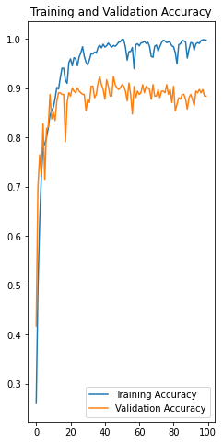
Fig.5 Training and validation accuracy
Testing trained model:
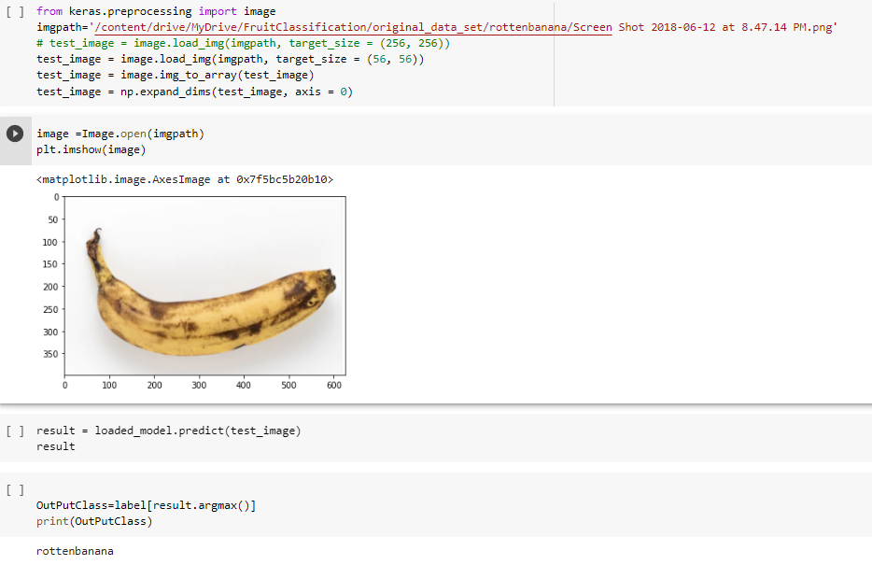
Fruit detection and classification.:
It is tested in local system with yolo object detection and downloaded pre-trained classification model.
We also added disease detection of plant using leaf dataset.
Plant leaf dataset is available on Kaggle dataset library named as PlantVillage Dataset.
We build on classifier using CNN.
CNN model input image size is = 56 X 56, Number of classes = 15
Classes - ['Tomato_Early_blight', 'Tomato_Bacterial_spot', 'Tomato_healthy', 'Tomato_Late_blight', 'Tomato_Leaf_Mold', 'Tomato_Septoria_leaf_spot', 'Tomato_Spider_mites_Two_spotted_spider_mite', 'Pepper__bell___Bacterial_spot', 'Pepper__bell___healthy', 'Potato__Early_blight', 'Potato__healthy', 'Potato___Late_blight', 'Tomato__Target_Spot', 'Tomato__Tomato_mosaic_virus', 'Tomato__Tomato_YellowLeaf__Curl_Virus']
Data
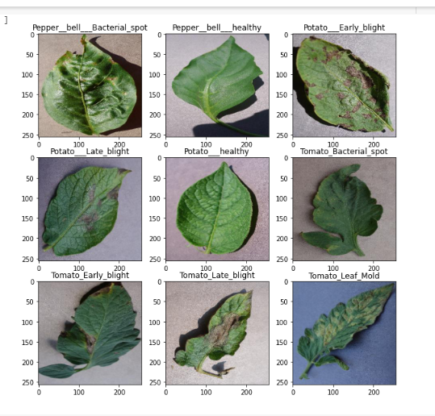
Fig 6: Plant disease detection by using different plants leafs
# View the summary of all layers

Training Accuracy: 0.9728
Validation Accuracy :0.9043
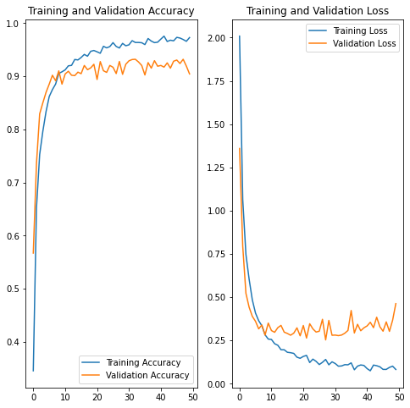
Fig 7:Training and Validation Accuracy
Testing trained model:
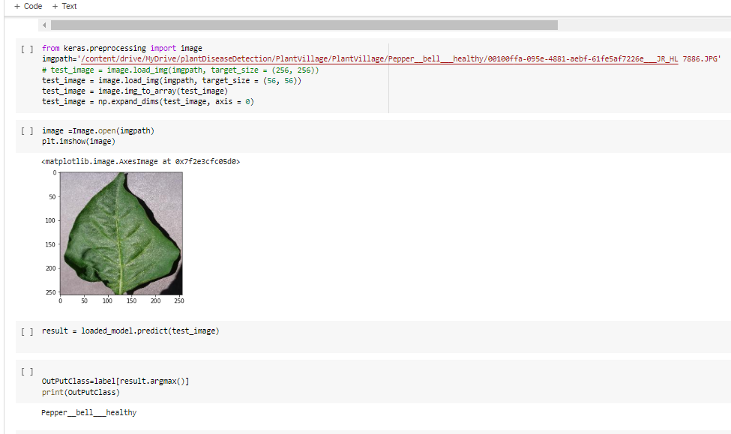
IV-CONCLUSION
This research proposes a new approach for identifying fruits based on the convolutional neural network algorithm. The above-mentioned results were obtained with seven test samples drawn from a total of 180 and 20 photos utilized for training and testing. Anaconda software was used to code and test the above algorithm. For training and testing, various fruit kinds with various backgrounds were used. The proposed method was found to be 98 percent accurate. This study investigates a CNN-based fruit classification. Using the fruits-360 dataset, accuracy and loss curves were created for five situations using various combinations of hidden layers. Based on a computer vision approach, this paper discusses numerous methods and algorithms for fruit detection and classification. CNN needs to improve its performance in order to achieve its goals.

REFERENCES

- Da-Wen Sun, “Computer Vision- an Objective, Rapid and Non-ContactQuality Evaluation Tool for the Food Industry,” In Journal of Food Engineering, vol.61, pp.1-2, 2014
- H. H. Wang, D. W. Sun, “Evaluation of the Functional Properties of Cheddar Cheese using a Computer Vision Method”, in Journal of Food Engineering, vol. 49(1), pp.47–51, 2002.
- N. B. A. Mustafa, K. Arumugam, S. K. Ahmed,Z. A. M. Sharrif, “Classification of Fruits using Probabilistic Neural Networks-Improvement using Color Features”, IEEE International Conference on TENCON, 2011.
- R. C. Gonzalez and R. E. Woods, Digital Image Processing. Prentice Hall, 2nd ed., 2002.
- M. W. Schwarz, W. B. Cowan, J. C. Beatty, “An Experimental Comparison of RGB, YIQ, LAB, HSV, and Opponent Color Models”, in ACM Transactions on Graphics, vol. 6(2), April 1987
- A. Hazra, K. Deb, S. Kundu, P. Hazra, “Shape Oriented Feature Selection for Tomato Plant Identification”, in International Journal of Computer Applications Technology and Research, vol 2(4), pp. 449 - 454, 2013.
- O.S. Al-Kadi, “Combined Statistical and Model based Texture Features for Improved Image Classification”, in Advances in Medical, Signal and Information Processing, MEDSIP, 4th International Conference, pp 1-4,2008
- D. Savakar, “Identification and Classification of Bulk Fruits Images using Artificial Neural Networks,” in International Journal of Engineering and Innovative Technology (IJEIT), vol. 1(3), March 2012.
- P. Deepa, “A Comparative Analysis of Feature Extraction Methods for Fruit Grading Classifications,” in International journal of emerging technologies in computational and applied sciences (IJETCAS) vol.13(138), 2013.
- M. Khojastehnazhand, M. Omid, A. Tabatabaeefar, “Development ofLemon Sorting System based on Color and Size,” in African Journal of Plant Science vol. 4(4), pp. 122-127, April 2010.
- P. Jackman, Da-Wen Sun, “Recent Advances in Image Processing using Image Texture Features for Food Quality assessment,” trends in Food Science & Technology vol. 29(1), pp. 35-43, 2013.
- Xu Liming and Zhao Yanchao, "Automated strawberry grading system based on image processing," in Computers and Electronics in Agriculture, vol. 71, no. Supplement 1, pp. S32-S39, April 2010.
- N. Alavi, "Date Grading using rule based Fuzzy Interference System,” in Journal of Agriculture Technology, vol.8 (4), pp. 1243-1254, 2012.
- M. Suresha, N.A. Shilpa, B. Soumaya, “Apples Grading based on SVM classifier,” in International Journal of Computer Applications on National Conference on Advanced Computing and Communication-NCACC, April 2012.
- V. Leemans, H. Mageinb, M.F. Destain, “On-line Fruit Grading according to their External Quality using Machine Vision”, Journal of Automation and Emerging Technologies, Belgium. Biosystems Engineering, pp. 397–404, 2002

