Next-Generation Fire Fighting Robot: Enhanced Autonomy And Efficiency

Assistant Professor,Dr.A.P.Khandait , Sanika Meshram, Saniya Rahate, Rashmi Warbhe, Laxmi Meshram
¹Assistant Professor, Dr.A.P.Khandait
Priyadarshini College of Engineering, Nagpur, India, Pin, 440019
²Sanika.A. Meshram
Priyadarshini College of Engineering, Nagpur, India, Pin, 440019
³ Saniya.S.Rahate
Priyadarshini College of Engineering, Nagpur, India, Pin, 440019
⁴ Rashmi.E. Warbhe
Priyadarshini College of Engineering, Nagpur, India, Pin, 440019
⁵ Laxmi.D.Meshram
Priyadarshini College of Engineering, Nagpur, India, Pin, 440019

Received on: xxxx,20xx, Revised on: xxxx,20xx, Published on: xxxx,20xx

Abstract – Fire safety is crucial in homes, offices, and industrial environments. Early detection and swift extinguishing of fires can prevent extensive damage and save lives. This paper presents the design and development of an autonomous fire-fighting robot capable of detecting and suppressing fires using water. The robot integrates multiple sensors, including flame sensors, and uses an Arduino Nano for control operations. It can navigate autonomously towards the fire source, activate a pump system, and extinguish the fire. The paper discusses literature review, methodology, hardware components, working principles, and expected outcomes.

Keywords- Fire-fighting robot, Flame detection, Arduino Nano, Autonomous navigation, Fire suppression.
INTRODUCTION
The increasing need for fire safety in residential and commercial environments calls for innovative solutions that minimize human intervention. Robotics is a rapidly evolving field that offers the potential for life-saving applications. One such application is the development of fire-fighting robots that can detect fires and autonomously extinguish them. Fires in hard-to-reach areas pose significant risks to both human lives and property. Manual fire suppression is often delayed by challenges in locating the fire source and accessing water. The proposed fire-fighting robot detects flames using sensors and extinguishes them, reducing damage and enhancing safety.
METHOLOGY
The development of the fire-fighting robot was based on systematic analysis and implementation:
- Initial research and analysis of existing fire suppression systems.
- Selection of components and technology through discussions with the project guide.
- Study of various sensors (flame, smoke, and heat) and control systems.
- Integration of sensors with an Arduino Nano controller.
- Design of the robot’s mechanical structure.
- Development of control algorithms.
- Assembly and testing of the robot.
Table 1- List of Hardware Components
Sr.No | Components | Function
1 | Arduino Nano | Main controller for processing inputs and controlling actuators.
2 | RF Module | Enables wireless control and communication.
3 | Flame Sensor | Detects the presence of fire.
4 | Motor Driver | Contols DC Motor for movement of Robot.
5 | Relay | Contol the pump and other high power devices.
6 | Water Pump | Spray water to extinguish fire.
7 | Voltage Regulator | Ensure stable Power Supply.
8 | Motors | Provide motion to the robot.
9 | Buzzer | Provide audible alert during fire detection.
10 | Red LED | Indicates Fire detection on emergency state.

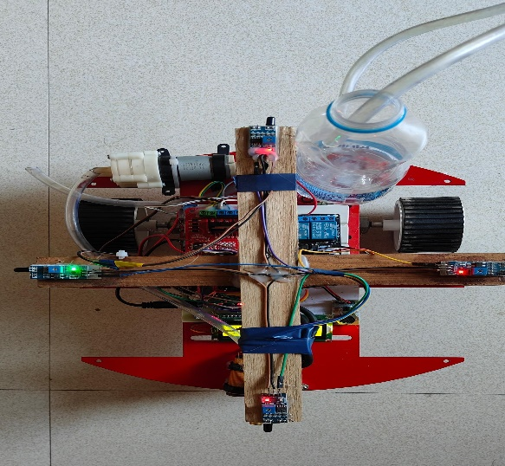

Fig. 1- Hardware Implementation of the Fire-Fighting Robot
DESIGN
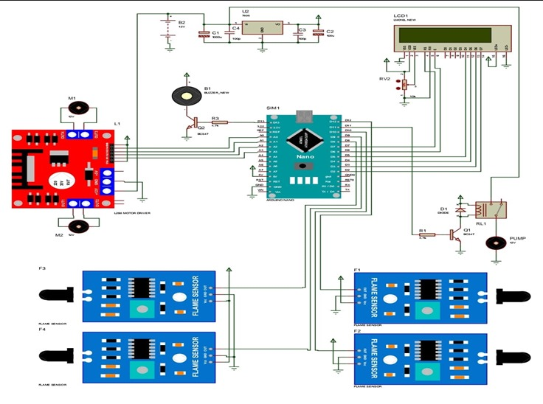
Fig. 2 – Circuit Diagram of Fire Fighting System.

The circuit design integrates the following components:
- Arduino Nano: Central microcontroller connecting to flame sensors, motor driver, buzzer, relay, RF module, LCD display, and water pump control.
- Flame Sensors: Four sensors connected to analog/digital input pins of Arduino to detect fire from multiple directions.
- Motor Driver (L298N): Connected to Arduino output pins; drives two DC motors for robot movement.
- DC Motors (Motor 1 and Motor 2): Receive signals from the motor driver and allow forward, backward, left, and right movement.
- Water Pump: Connected via relay; activated by Arduino to spray water.
- Relay Module: Controlled by Arduino to switch the pump on/off.
- RF Module (HC-12): Interfaces with Arduino for remote control and monitoring.
- LCD Display (16x2): Shows status messages like fire detection and pump activation.
- Buzzer and Red LED: Provide audio-visual alerts upon fire detection.
- Voltage Regulator (7805): Ensures stable voltage supply to all components.
- Power Supply: Battery pack or DC power jack providing energy to the robot.

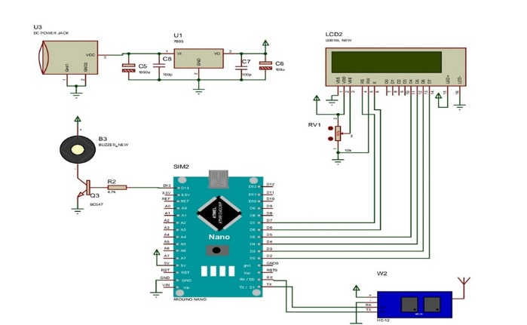
Fig. 3 – Circuit Diagram of Fire Alert System.
Integration of Components of Fig.3:
- Arduino Nano:
Acts as the central processing unit, controlling input and output operations.
- DC Power Jack (U3):
Supplies external power to the entire circuit.
- Voltage Regulator (7805):
Regulates and stabilizes voltage to 5V for sensitive components.
- LCD Display (16x2, LM016L):
Used for displaying real-time status messages.
- HC-12 RF Module (W2):
Facilitates wireless data communication for remote monitoring.
- Buzzer (B3):
Provides audible alerts during fire detection or system status changes.
- Transistor (Q3, BC547):
Used to drive the buzzer by switching current flow.
- Resistor (R2, 4.7kΩ):
Current-limiting resistor for transistor and buzzer control.
- Capacitors (C5, C6, C7, C8):
Used for filtering and smoothing the power supply.
- Potentiometer (RV1, 10kΩ):
Controls the contrast of the LCD display.
CONCLUSION
This paper presented the development of an autonomous fire-fighting robot with integrated flame detection and suppression capabilities. The robot effectively detects small fires in indoor environments and navigates autonomously to extinguish them using a water-based system. The implementation of this robot can significantly reduce response times and mitigate risks associated with fire incidents. Future enhancements could include the integration of advanced navigation algorithms, machine learning for fire recognition, and improved obstacle avoidance features.
ACKNOWLEDGMENT
We expresses gratitude to Priyadarshini College of Engineering, Nagpur, and the project guide for their valuable support and guidance throughout the project.

REFERENCES
- Smith, J., et al. (2020). "Advances in Firefighting Robotics." IEEE Robotics & Automation Magazine.
- Johnson, A. (2019). "Design and Development of a Firefighting Robot Prototype." Proceedings of the IEEE International Conference on Robotics and Automation.
- Kim, S., et al. (2018). "Autonomous Navigation of a Legged Robot for Firefighting in Complex Indoor Environments." IEEE Transactions on Robotics, 34(5), 1201-1214.
- Lee, H., et al. (2017). "Human-Robot Interaction for Firefighting Applications: A Review." IEEE/RSJ International Conference on Intelligent Robots and Systems (IROS), 456-463.
- Chen, L., et al. (2016). "A Survey of Sensing and Perception Methods in Firefighting Robotics." IEEE Sensors Journal, 16(10), 3795-3804.
- Wang, Y., et al. (2015). "Multi-Robot Systems for Firefighting Applications: Challenges and Opportunities." IEEE International Conference on Robotics and Automation (ICRA), 2987-2992.
- Li, Z., et al. (2014). "Development of a Firefighting Robot Prototype with Multi-Sensor Integration." IEEE/ASME Transactions on Mechatronics, 19(2), 536-545.
- Park, S., et al. (2013). "Safety Considerations for Human-Robot Interaction in Firefighting Scenarios." IEEE International Symposium on Safety, Security, and Rescue Robotics (SSRR), 1-6.

