Abstract - Internet of Things is an upcoming technology that transforms everyday physical objects into an ecosystem that would enrich our life and make it simpler. We formulate the problem in a leader-follower paradigm. Here, the leader is the person and the follower is the automaton. The automaton uses ultrasonic range detector along with Arduino to follow the expected leader. The ultrasonic range detector measures the distance by transmitting and receiving sound waves which is bounced back by the obstacle. The automaton recognises the person to be followed using ultrasonic sensors which detects the person through the ecolocation process.
Keywords-Internet of Things, Ultrasonic sensors, Arduino, Self Tracking, Object detection
I. INTRODUCTION
The Internet of things (IoT) is the network of physical devices, vehicles, home appliances and other items embedded with electronics, software, sensors, actuators, and connectivity which enables these objects to connect and exchange data.
The IoT allows objects to be sensed or controlled remotely across existing network infrastructure, creating opportunities for more direct integration of the physical world into computer-based systems, and resulting in improved efficiency, accuracy and economic benefit in addition to reduced human intervention. The term "the Internet of things" was coined by Kevin Ashton of Procter & Gamble, later MIT's Auto-ID Center, in 1999.
Robotics is a branch of engineering that involves the conception, design, manufacture, and operation of robots. This field overlaps with electronics, computer science, artificial intelligence.Robotics deals with the design, construction, operation, and use of robots, as well as computer systems for their control, sensory feedback, and information processing. Robots all have some kind of mechanical construction, a frame, form or shape designed to achieve a particular task. Robots have electrical components which power and control the machinery. All robots contain specific level of computer programming code. A program is how a robot decides when or how to do something. There are three different types of robotic programs: remote control, artificial intelligence and hybrid. A robot with remote control programing has a preexisting set of commands that it will only perform if and when it receives a signal from a control source, typically a human being with a remote control. It is perhaps more appropriate to view devices controlled primarily by human commands as falling in the discipline of automation rather than robotics. Robots that use artificial intelligence interact with their environment on their own without a control source, and can determine reactions to objects and problems they encounter using their preexisting programming.

II. RELATED WORK
There are many studies and underground works on real time robot tracking and following. Abhishek mishra et al., designed an algorithm based on clustering space-time events induced by a neuromorphic sensor followed by a classification procedure [1]. Ter-Feng Wu et al., ultrasonic sensors are adopted toimplement a real-time obstacle avoidance system for wheeledrobots, so that the robot can continually detect surroundings,avoid obstacles, and move toward the target area[2]. Takashi Yoshimi et al., Tracking people with stereo vision was robust algorithm that utilizes various characteristics of the idata realized by systematizing visual and motion control with a robust algorithm that utilizes various characteristics of the image data[3]. MohanadElshafie et al., A markerless multiple-camera vision-based 3D human tracking method for industrial environments andtrack humans in the vicinity of moving robots without using skincolor cues or articulated human models[4]. Nischay Gupta et al., A novel approach to obstacledetection and collision using ultrasonic sensors in indoor environment[5].

III. OBJECTIVES
We see many individual carrying the basic amenities like suitcases, duffle bags, cooler, water cans, golf kit bag, cricket kit bags and vendors towing their carts. Carrying these items along is a task. Hence, there is a tremendous need for an automation in our day to day activities to ease the life of commoners. The main objective is to cut down the efforts put by the people in carrying their items.
The proposed approach can be implemented in the field of sports where the players need not carry their kits along with them as our bot can carry their kits and follow them. Travellers can be relieved from the burden of carrying heavy luggage as this bot carries it for them. This tracking kit can be embedded into vendor's carts, as a result they don't have to put a lot of effort in towing their carts.

IV. IMPLEMENTATION

The core element of the model is the arduino board which controls and manages all the functions performed by the other components of the model. The instructions to the components are given through arduino programming language.
This model consists of the following hardware components:
•Arduino consists of both a physical programmable circuit board and a piece of software, or IDE that runs on a computer, which we are using to write and upload computer code to the physical board.
•The motor driver board along with the driver IC L293D is used to control the speed and direction of the wheels.
•The HC-SR04 ultrasonic sensors use sound waves to determine the distance to an object. The determination is done through the ecolocation process.
•The mini server motor is used for rotating the ultrasonic sensors to provide a wider range for object detection.
Along with these components switches and wires are used to develop the prototype.
The ultrasonic sensor determines the distance of the object from the bot through the ecolocation process. In this process sound waves which is transmitted by the sensor is bounced back by the obstacle and received by the sensor. The time difference between the transmission and reception of the sound waves is used to calculate the distance of the objects.
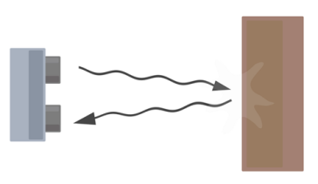
Fig. 1 Ecolocation process

INPUT FROM ULTRASONIC SENSOR

ARDUINO

DISTANCE WITHIN DEFAULT RANGE

DISTANCE ABOVE DEFAULT RANGE
DISTANCE BELOW DEFAULT RANGE

MOVE FORWARD
HALT
MOVE BACKWARD

Fig. 2 System Flowchart

The automaton receives the input from the ultrasonic sensor which is sent to the arduino board. The input is the distance of the object.
•If the distance is below the default range, the automaton moves backward.
•If the distance is within the default range, the automaton halts.
•If the distance is above the default range, the automaton moves forward.

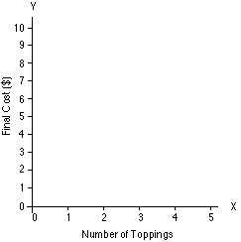

Below default range
Default range
Above default range

Fig. 3 Example for default ranges

V. HARDWARE DESCRIPTION

A. Ultrasonic Sensors
Ultrasonic sensors (model: HC-SR04), shown in Figure 4 have been used for detecting objects here. These are low cost ultrasonic sensors containing a receiver and a transmitter of ultrasonic waves. The sensors give a 4-pin interface for connecting with a microcontroller.
•Pin 1 is for providing the biasing voltage to the sensor(Vcc).
•Pin 2 is for Ground connection.
•Pin 3 is the “trigger” pin.
•Pin 4 is the “echo” pin.
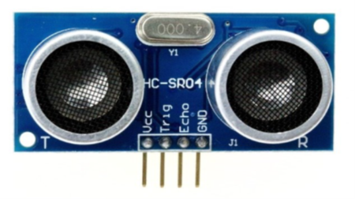
Fig. 4 Ultrasonic Sensor
The ‘trigger’ pin is supplied with logical high (5V) for approx.10us. During this time, the sensor gives away 8 pulses of ultrasonic waves (velocity approximately 340 m/s). If any obstacle is present within 4m distance (roughly), the sensor receives the waves reflected from the object. The distance of the object is proportional to the time for which ‘echo’ pin is high.
Distance of object from sensor = (high level time X velocity of sound (340m/s) / 2.
These sensors can detect objects kept at distances of up to 4m
and their field of vision is 15° on both sides of the line of sight.Using above described hardware along with a transmitter receiver pair, objects can be detected.

B. Arduino Board
Arduino is an open-source electronics platform based on easy-to-use hardware and software. Arduino boards are able to read inputs - light on a sensor, a finger on a button, or a Twitter message - and turn it into an output - activating a motor, turning on an LED, publishing something online.
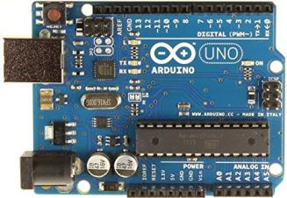
Fig. 5 Arduino board
VIII. FUTURE SCOPE
This model can be made more secure by providing an access key. This access key ensures that nobody else can access the tracking kits.
Solar cells can be embedded into this kit to make it cheaper and eco-friendly.
REFERENCES
[1] Abhishek Mishra, Rohan Ghosh, Ashish Goyal, Nitish V. Thakor, Fellow, IEEE and Sunil L. Kukreja, Senior Member, IEEE " Real-Time Robot Tracking and Following with Neuromorphic Vision Sensor " 6th IEEE RAS/EMBS International Conference on Biomedical Robotics and Biomechatronics (BioRob) June 26-29, 2016. UTown, Singapore.
[2] Ter-Feng Wu, Pu-Sheng Tsai, Nien-Tsu Hu, Jen-Yang Chen " Use of Ultrasonic Sensors to Enable Wheeled Mobile Robots to Avoid Obstacles" 2014 Tenth International Conference on Intelligent Information Hiding and Multimedia Signal Processing.
[3] Takashi Yoshimi, Manabu Nishiyama,TakafumiSonoura, Hideichi Nakamoto, Seiji Tokura,Hirokazu Sato, Fumio Ozaki and NobutoMatsuhira "Development of a Person Following Robot with Vision Based Target Detection" Proceedings of the 2006 IEEE/RSJ International Conference on Intelligent Robots and Systems October 9 - 15, 2006, Beijing, China.
[4] MohanadElshafie and Gary M. Bone"MARKERLESS HUMAN TRACKING FOR INDUSTRIAL ENVIRONMENTS"CCECE/CCGEI May 5-7 2008 Niagara Falls. Canada
978-1-4244-1643-1/08/$25.00 _ 2008 IEEE.
[5] Nischay Gupta, Jaspreet Singh Makkar , Piyush Pandey "OBSTACLE DETECTION AND COLLISIONAVOIDANCE USING ULTRASONIC SENSORS FORRC MULTIROTORS" 978-1-4799-6761-2/15/$31.00 ©2015 IEEE.

