Smart Breath Bag Unit and Evaluation of
Vital Signs Module

Mrs. K. Thivyabrabha¹, Deepak.K², Kavya.T³, Ponnaveen.R⁴
1-AssistantProfessor, Nandha Engineering College, Erode-638 052, India,thivyabrabha@nandhaengg.org
2-UG-Student, Nandha Engineering College, Erode-638 052, India, deepakdeebu273@gmail.com
3-UG-Student, Nandha Engineering College, Erode-638 052, India, kavyakayal18@gmail.com
4-UG-Student, Nandha Engineering College, Erode-638 052, India, ponnaveen38@gmail.com .
Received on: xxxx,20xx, Revised on: xxxx,20xx, Published on: xxxx,20xx

Abstract— Due to Contraction motion in the diaphragm, reverse pressure is produced. By using this reverse pressure, human lungs suck the air from the environment for breathing. Contradictory motion is used to inflate the lungs by pumping type motion. Normally, Ventilators can generate 10-12 breaths per minute. With the help of Ventilator, we can also be able to monitor patient monitoring parameters like Temperature, SPO2, Heartbeat, Electrocardiogram and Electroencephalogram. The setting to adjust thetime duration for inhalation to exhalation ratio is very important. We used a siliconventilator bag which is coupled driven by DC motors with one side push mechanism topush the ventilator bag. For switching, here we use a relay switch and a variable pot to adjustthe breath length and the BPM value for the patient.The vital signmodulesensor is mainly usedtomonitorthenecessityofthepatientmonitoringanddisplay the resultsonLCD screen. There are different types of existing systems which can be used for operating an artificial manual breathunitbag.SuchasRulerchainmechanism,CAMmechanism,RackandPinionmechanism, Lead screw mechanism but here using front and back mechanism with thehelp of wiper motor function. The ventilator we designed and improved by using Microcontroller and Wi-fi module helps us to develop a low-cost, portable, and reliable Emergency Ventilator.

Keywords – Ventilator, ECG, EEG, BPM Value, LCD Screen, CAM Mechanism, Wi-fi Module.

1.INTRODUCTION
Ventilators are machines that act as bellows to move air in and out of your lungs.Ventilatorsarecomputerizedmicroprocessor-controlled machines, but patientscan also be ventilated with a simple, hand-operated bag valve mask.Ventilatorsarechieflyusedinintensive-caremedicine,homecare,andemergencymedicine(asstandaloneunits)andinanesthesiology(asacomponentofananesthesiamachine).Initssimplestform,amodernpositivepressureventilatorconsistsofacompressibleairreservoiror turbine, air and oxygen supplies, a set of valves and tubes, and a disposable or reusablepatient circuit. The air reservoir is pneumatically compressed several times a minute todeliver room-air, or in most cases, an air/oxygen mixture to the patient. If a turbine is used,the turbine pushes air through the ventilator, with a flow valve adjusting pressure to meetpatient-specificparameters.Whenoverpressureisreleased,thepatientwillexhalepassivelydue to the lungs' elasticity, the exhaled air being released usually through a one-way valvewithinthepatient circuitcalledthepatientmanifold.

Ventilators may also be equipped with monitoring and alarm systems for patient- relatedparameters (e.g., pressure, volume, and flow) and ventilator function, backup batteries, oxygen tanks, and remote control. Thepneumaticsystemisnowadaysoftenreplacedbyacomputer-controlled turbopump.Assist-control(AC)modeisone of themostcommonmethodsofmechanicalventilation inthe intensive care unit. AC ventilation is a volume-cycled mode of ventilation. It works bysetting a fixed tidal volume (VT) that the ventilator will deliver at set intervals of time orwhenthepatient initiatesabreath.

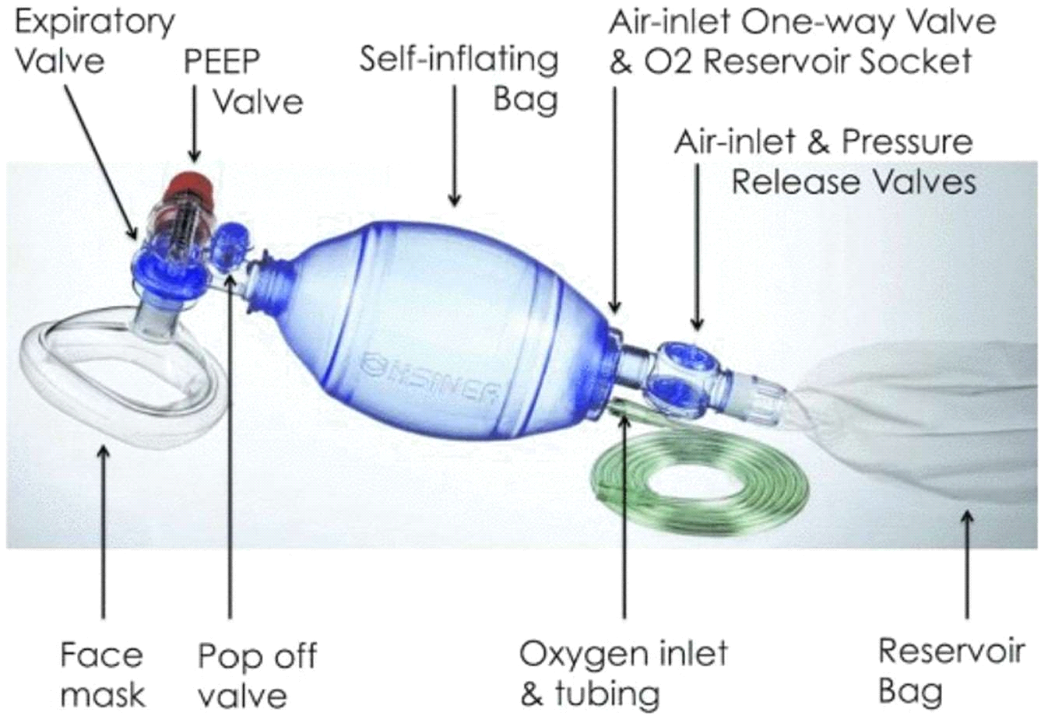
Figure1.1:ArtificialManualBreathBag unit

The Ambu (Air-Shields Manual Breathing Unit) Bag is a special type of Bag Valve Mask (or BVM) that is used to help a child or an adult who is either not breathing or having a hard time breathing on his own.

The utilization of manual resuscitators to provide ventilation to a patient is frequentlytermedas"bagging"thepatientandisroutinelyessentialformedicalemergencieswhenever the breathing of the patient is considered insufficient or has halted completely.They are used within the premises of the hospital for temporary ventilation of patients thatare dependent on mechanical ventilators whenever the mechanical ventilator is required tobeevaluatedforpossiblemalfunctionorwheneverventilator-dependentpatientsaremobilized within the hospital. It supplements air or oxygen directly into the lungs to expand them under controlledpressure,thusresultinginamethodtodeliverpositive pressure.

II. LITERATURE SURVEY
1.Ravinder Dahiya et al. (2020) has developed a method for the COVID-19 patients whofind it difficult to breathe as the virus infects the upper or lower parts of their respiratorytract.These DIY emergency ventilators address this issueby automating the squeezing of the bag.
2.Mr. Edwincalilung et al. (2020) has developed a mechanical ventilator to helptheshortagesofventilatorsinthepandemicranges.Manyofthesedesignsarebasedonautomating the manual operation of the Bag Valve Mask (BVM), a ubiquitous resuscitatordevice used for emergency ventilation or resuscitation of patients with breathing problems.
3.Mr. Navid bin Ahmed et al. (2021) has developed a system for the Pneumonia patientswithhighpulseandbreathingrates,andlowbloodoxygen.Pulserateandbloodoxygenare two parameters that doctors use to diagnose and measure Pneumonia and Bronchitis.
4.Mr. AbhishekPandeyetal.(2021),hasintroducedaLow-CostPortableVentilatorDesignin 2021.They developed and tested the performance of an Atmel ATmega328P MCU andMAX30100 sensor kit-based pulse rate and blood oxygen monitor.
5.Mr. Muhammad Jawad Ghafoor et al. (2017), has introduced a Prototyping of a cost effective and portable ventilator. This piece of prototype is cost effective as well as energy efficient as far as the present technology in ventilators is concerned.
III.METHODOLOGY
ATMEGA328PU is the main controlling unit of the proposed system. Temperature sensor, Pulse oximeter, ECG sensor and EEG sensor are connected in ATmega328PU 's ADC port. oxygen flow can be controlled through the solenoid valve by relay which is connected to the controller's digital I/O pin. Oxygen pump is controlled by DC motor using relay which is connected to the controller's digital I/O pin. Temperature value, SPO2 data, Heartbeat data, ECG value and EEG value are sent to IoT module through ATmega238PU serial port. The IoT module receives the data and sends it to the cloud. The cloud data publishes the values and status of the patient on our own designed App by MIT inverter app domain.
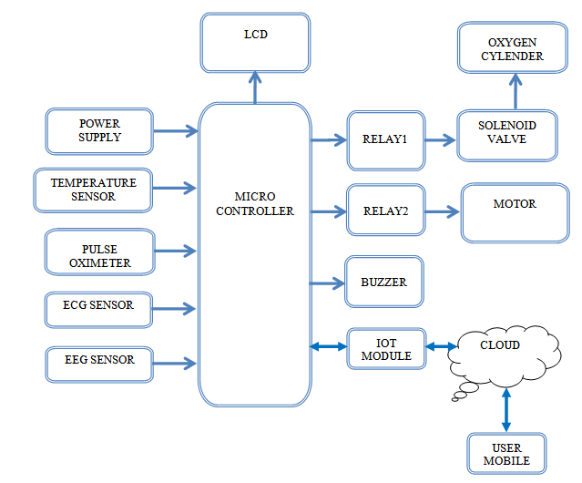
Figure 1.2: Block Diagram
IV.RESULT
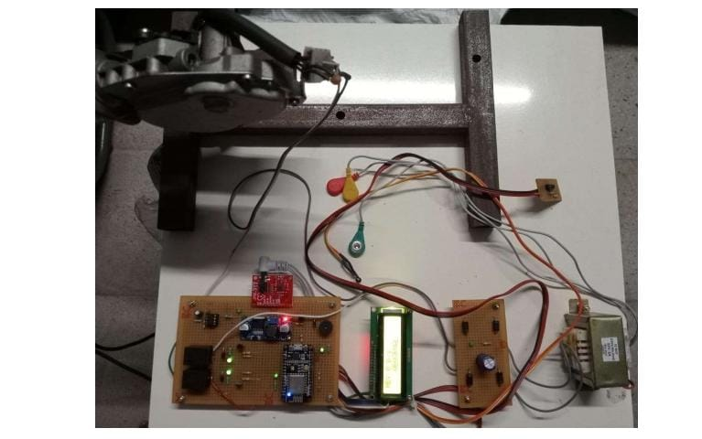
Figure1.3: Model
By using the IOT Module in our project, the results we get are all in digital values. With the help ofTemperature sensor, we will get an accurate body temperature in Celsius scale. The Heartbeat sensor helps us to sense the heartbeat and is measured in beats per minute (BPM).The pulse oximeter measures the percentage saturation of oxygen which ranges between 95% and 100% in the healthy body. ECG is a test mainly used to check the electrical activity of the heart. If the test done by ECG is normal, then the normal heart rate will be from 60 to 100 per minute. But if the test shows a slow or fast heart rate, then it maybe considered as abnormal heartbeat and it may lead to different heart conditions like a heart defect, coronary artery disease, heart valve disease, or an enlarged heart.EEG is a test used to measure the electrical activity of the brain. With the help of EEG, we can diagnose epilepsy, sleep disorders and brain tumours. With the help of this, doctors can easily identify the illness and can treat the patients for a better life.
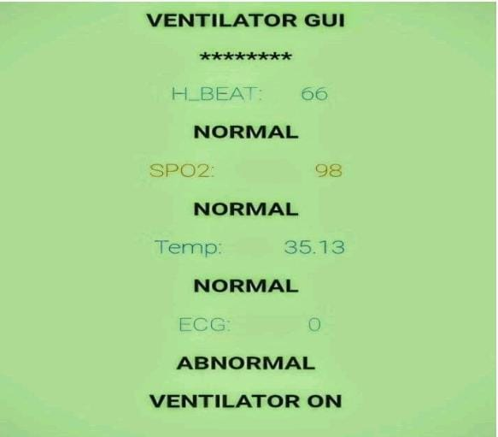
Figure 1.4: Result

V.CONCLUSION
Theproject is mainly discussed about thedevelopmentofArtificialManualunitbag-basedemergency ventilator and focused on two main mechanical design prototypes. Byusingamodifiedmechanismdrivenbyawiper motor helps us to design a low-cost ventilator.Thisprototypewas alsouncomplicatedandstabilized,didnotallowfullcontrolofventilation parameters. The ventilator provides oxygen to the patient’s body mechanically. The tube which is connected to the ventilator allows the air to flow through the patient’s mouth and to the windpipe.And, we also had added the extra medical parameters for bettertreatment.
VI.FUTURE WORK
The Artificial manual breath unit bag is the most efficient treatment for treating Covid andillness Patient at present. This device can be integrated with vital parameters for additionalmonitoring of pulse rate, temperature, ECG, EEG, SpO2. The therapy can be improvised andintegrated with otherwise breathing devices (Like we add mix of Oxygen Gas) using newhighly technological breathing systems for combined medication and treatment of not onlyemergency and covid pandemic but also various kind of Breathing disorders and lunginfections. The ventilator we designed and improved by using Microcontroller and Wi-fi module helps us to develop a low-cost, portable, and reliable Emergency Ventilator
VII.REFERENCES
[1] Ravinder Dahiya, Andrew Hart, (2020). DIY Ventilatorsfor COVID-19 Could Be aVitalStopgap. IEEEspectrumpaper.
[2] J. M. Pearce, “A review of open-sourceventilators for COVID-19 and future pandemics,” F1000 Research 2020, vol. 9, no. 218, 2020.
[3] Edwin Calilung, Jason Española, Elmer Dadios, et al (2020). Design and Developmentofan AutomatedCompressionMechanismforaBag-Valve-MaskBasedEmergencyVentilator.IEEE12thInternationalConferenceonHumanoid,Nanotechnology,InformationTechnology,CommunicationandControl,Environment,Management(HNICEM)|978-1-6654-1971-DOI: 10.1109/HNICEM51456.2020.9400150.
[4] Abhishek Pandey, Aradhya Juhi, Abhishek Pratap, Anupam Pratap Singh (2021). AnIntroduction to Low-Cost Portable Ventilator Design. International Conference on AdvanceComputingand InnovativeTechnologies inEngineering(ICACITE)|DOI:10.1109/ICACITE51222.2021.9404649.
[5] Navid bin Ahmed, Shahriar Khan, Nuzhat Arifa Haque, Md. Shazzzad Hossain (2021).Pulse RateandBloodOxygenMonitortoHelpDetectCovid-19:ImplementationandPerformance,IEEEInternationalIOT,ElectronicsandMechatronicsConference(IEMTRONICS)DOI:10.1109/IEMTRONICS52119.2021.9422520.
[6]Partially Reparable automated open-source bag valve mask-based ventilator Aliaksei Petsiuka, Nagendra G. Tanikellab, Samantha Dertinger, Adam Pringleb, Shane Oberloiera, Joshua M. Pearce a, b, d, e.
[7] Sudip Deb, Sheikh Md. Rabiul Islam, Jannatul Robaiat Mou, Md. Tariqul Islas (2017).Design and Implementation of Low-Cost ECG Monitoring System for the Patient usingSmartDevice.InternationalConferenceonElectrical,ComputerandCommunicationEngineering (ECCE).DOI:10.3991/ijoe. v15i15.11860.
[8] RidwanAlam, David B, Peden, Jiaqi Gong, John Lach (2019). Non-Invasive Inferenceof Minute Ventilation Using Wearable ECG and Gaussian Process Regression. IEEE EMBSInternationalConferenceonBiomedical&HealthInformatics (BHI).DOI:10.1109/BHI.2019.8834670.
[9] Dertinger, S.C., Gallup, N., Tanikella, N.G., Grasso, M., Vahid, S., Foot, P.J. andPearce, J.M., (2020). Technical pathways for distributed recycling of polymer compositesfordistributedmanufacturing:Windshieldwiperblades.Resources,ConservationandRecycling,157,p.104810.
[10] L. Brochard, A. Slutsky, and A. Pesenti, (2017). Mechanical Ventilation to MinimizeProgression of Lung Injury in Acute Respiratory Failure. American Journal of RespiratoryandCriticalCareMedicine, vol.195,no.4,pp. 438–442.

