Live Crime Reporter
Prashant Sisodiya
Student IMS Engineering College, Ghaziabad, India,
Dr. Pankaj Agrawal
Head Of Department, IMSEC
1.Abstract
Very often we come across a situation when we see some crime or accident being committed in front of our eyes and yet we are tentative to extend any help. This mindset is quite prevalent among Indians and one of the reasons for this is our lack of confidence in our legal system. We fear being harassed unnecessarily. Somehow criminals have gained lot of confidence that they will always find some way out even after committing any heinous crime.
Our project Live Crime Reporter enables a common man to report the live scene of any such incident to concerned authorities including police stations, near hospitals, social media and other relevant agencies.
Our proposed project is a mobile app that helps to record the live incident and send the details of the location, live broadcasting of the incident to all the nearby agencies so that timely help can be reached to the needy person.
Timely help can save the life of the person in case of accidents, criminals can be tracked and punished in time. Most importantly it will promote a healthy practice to help each other in need of the hour.

System, Global Adult Tobacco Survey, Health and QGIS.

2. INTRODUCTION
The Live Crime System has major components-
- Mobile Application (iOS, Android, Windows Phone)
- Web portal for police department
- Cloud for data storage and processing (AWS).

A] Mobile Application-
The users can send crime reports through mobile application. These reports will be sent to the nearest police stations, hospitals & NGOs. It will have following options-

Crime Report-
Users can send crime reports using following methods-

Live Report
They can live stream the crime scene to the police. They will also have an option to chat with police officers to explain the situation in detail.

Chat Report
This can be used when live streaming the crime scene is not possible such as in cases where one wants to avoid detection or internet speed is not good. Users will only have the option to send text messages to police to explain their situation.

Offline Report
If there is no internet connection, the victim or witnesses can capture and store videos, add description of the crime offline. This will be uploaded once the device becomes online and the reporter has signed in.

Emergency Shortcuts-
Since there are many emergency numbers in India and it is hard to remember them all, we provide the option to locate the nearest emergency help center (e.g. police station, hospitals etc.) and/or make emergency calls from within the app. The corresponding ‘locate’ feature will show the nearest police station, hospital etc. to the user in Google Maps. This will enable quick navigation in times of need.

B].Web Portal-
The police can view and respond to the incoming reports using this portal. A computer system will be installed in every police station (or police control room) and an operator will be in charge of viewing and responding to the crime reports. He can interact with the reporter using chat messages in case of chat reports and live reports or talk directly using voice chat in live report.

C] Cloud Services
All the data of the crimes and users will be stored on AWS cloud. Wowza Streaming Engine will manage the live streams and a separate Django based server will handle all other tasks. The system will use MySQL database 8.0 or above.
The mobile app will communicate with the webserver to get report ID and permission/credentials to access AWS cloud. The live stream video will be sent to the AWS S3 bucket directly. It will also send metadata of report and other information such as-
- Who created the report.
- When it was created.
- When it ended
The unique identifier of the live stream video sent to AWS chat messages.

3.Methodology
The Live Crime System has 3 parts-
- Mobile App (iOS, Android, Windows Phone)
- Web portal for police department
- Cloud for data storage and processing (AWS).

Mobile App-
The users can send crime reports through this mobile app. These reports will be sent to the nearest police station. It will have following options-

Crime Report-
Users can send crime reports using following methods-

Live Report
They can live stream the crime scene to the police. They will also have an option to chat with police officers to explain the situation in detail.

Chat Report
This can be used when live streaming the crime scene is not possible such as in cases where one wants to avoid detection or internet speed is not good. Users will only have the option to send text messages to police to explain their situation.

Offline Report
If there is no internet connection, the victim or witnesses can capture and store videos, add description of the crime offline. This will be uploaded once the device becomes online and the reporter has signed in.
In all above cases, the location of the user will be sent along with the report. However, in live report and chat report, the location (using GPS) will be send every 10 seconds to enable live tracking of user’s location, but in case of offline report, the user’s location will be fetched once and will be uploaded to the server. Hence, in case of offline report, tracking the user’s location is not possible. This is desirable as in case of offline report, the user must have moved to a different location than the crime spot therefore tracking his exact location will not serve any purpose.

Emergency Shortcuts-
Since there are many emergency numbers in India and it is hard to remember them all, we provide the option to locate the nearest emergency help center (e.g. police station, hospitals etc.) and/or make emergency calls from within the app. The corresponding ‘locate’ feature will show the nearest police station, hospital etc. to the user in Google Maps. This will enable quick navigation in times of need.
Mobile Application


Options for Report
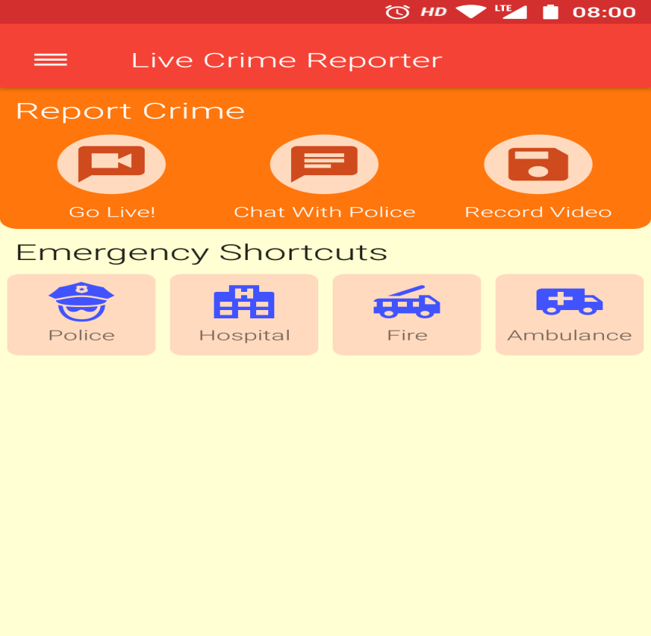

Live Streaming start
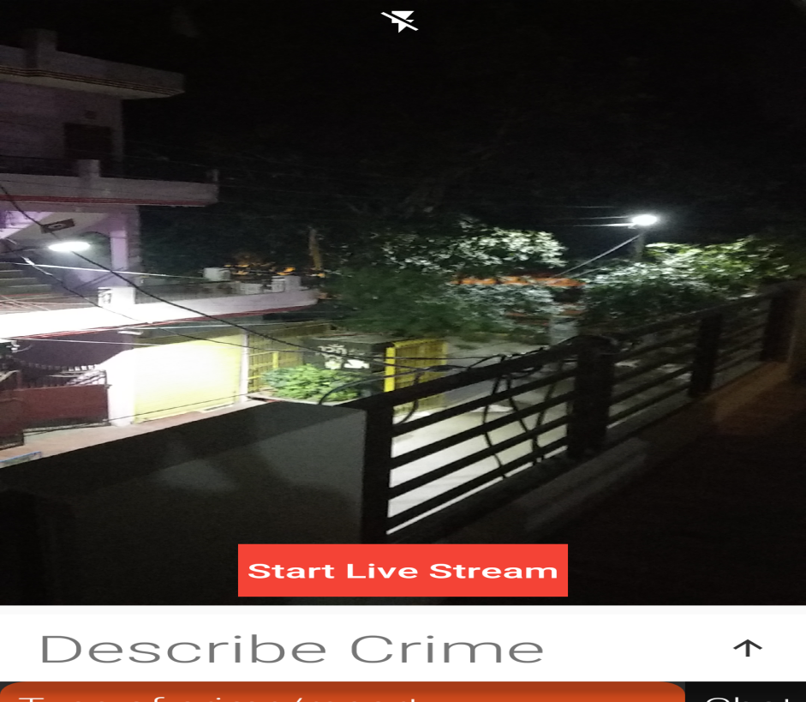

Crime Type
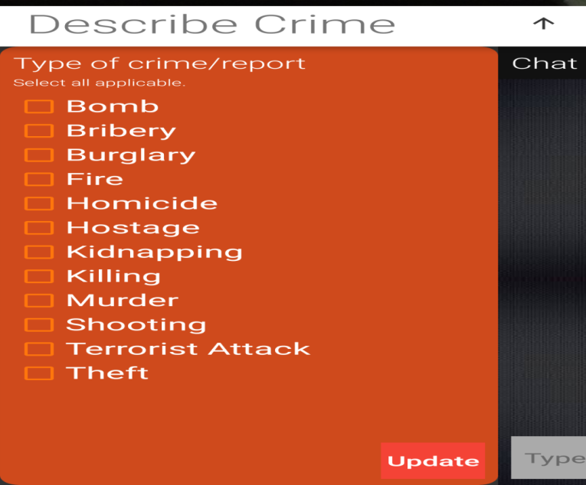

2- Police Portal-
The police can view and respond to the incoming reports using this portal. A computer system will be installed in every police station (or police control room) and an operator will be in charge of viewing and responding to the crime reports. He can interact with the reporter using chat messages in case of chat reports and live reports or talk directly using voice chat in live report.
He can also view the offline reports on a separate page. He must review all offline reports at the end of the day so that they are not left unserved.

Police Portal
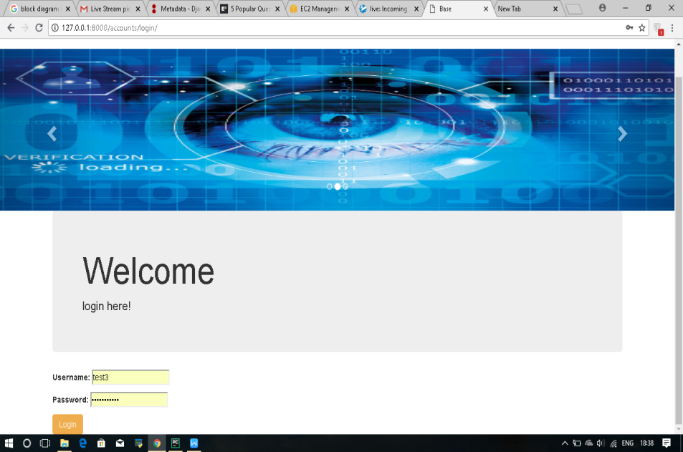

Live Streaming Portal Page
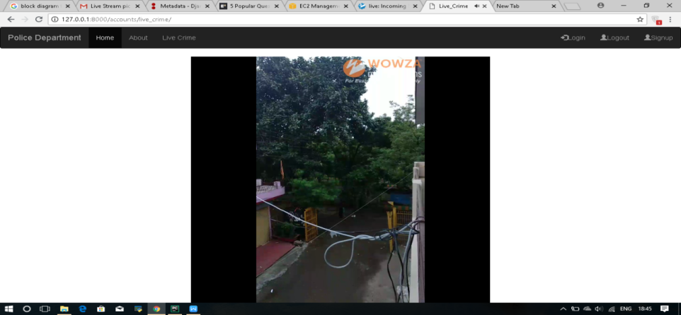
This portal will be hierarchy based i.e. the local operator can only access the reports within his/her assigned area. A higher authority officer can access the reports which are accessible to all his subordinates and so on.

Implementation
The implementation of this police portal will involve following steps-
  - A computer system will be installed in every police station or police control room. Existing computer systems can also be used.
  - Each person in the department will have his/her user account to access the portal. A user’s account shall contain the login credentials (username and password) and other information about a person to identify and verify the person. The details include the full name and employee ID/service no. of the user.
The enrollment of police officers will be done in following steps-
    - A system administrator will create user accounts for the highest authority (Commissioner) of police department of every state.
    - Each authority will create user accounts of his/her direct subordinates. A direct subordinate is one who reports to the higher authority without any intermediate authority. For example, if person C works under A such that there is no person B who works under A and is above C, then C is the direct subordinate of A. Conversely, A is also direct boss of C.
    - The lowest in the hierarchy will be the operator. He will be responsible to handle all the crime reports. The areas which fall under an operator will be decided by his/her direct boss. Since all the persons in the department are in well-defined hierarchy, defining working areas of the lowest in the hierarchy will implicitly define the areas which are assigned to the higher authorities.
  - The report of crimes handled or not handled by a subordinate will be sent to his/her higher authorities so that appropriate action can be taken and quick resolution of cases can be done.

3 Cloud Services
All the data of the crimes and users will be stored on AWS cloud. Wowza Streaming Engine will manage the live streams and a separate Django based server will handle all other tasks. The system will use MySQL database 8.0 or above.
The mobile app will communicate with the web Server to get report ID and permission/credentials to access AWS cloud. The live stream video will be sent to the AWS S3 bucket directly. It will also send metadata of report and other information such as-
      - Who created the report.
      - When it was created.
      - When it ended
      - The unique identifier of the live stream video sent to AWS
      - Chat messages.

3. Implementation
The implementation of this police portal will involve following steps-
  - A computer system will be installed in every police station or police control room. Existing computer systems can also be used.
  - Each person in the department will have his/her user account to access the portal. A user’s account shall contain the login credentials (username and password) and other information about a person to identify and verify the person.
The enrollment of police officers will be done in following steps-
    - A system administrator will create user accounts for the highest authority (Commissioner) of police department of every state.
    - Each authority will create user accounts of his/her direct subordinates. A direct subordinate is one who reports to the higher authority without any intermediate authority. For example, if person C works under A such that there is no person B who works under A and is above C, then C is the direct subordinate of A. Conversely, A is also direct boss of C.
    - The lowest in the hierarchy will be the operator. He will be responsible to handle all the crime reports. The areas which fall under an operator will be decided by his/her direct boss. Since all the persons in the department are in well-defined hierarchy, defining working areas of the lowest in the hierarchy will implicitly define the areas which are assigned to the higher authorities.
  - The report of crimes handled or not handled by a subordinate will be sent to his/her higher authorities so that appropriate action can be taken and quick resolution of cases can be done.

Cloud Services
All the data of the crimes and users will be stored on AWS cloud. Wowza Streaming Engine will manage the live streams and a separate Django based server will handle all other tasks. The system will use MySQL database 8.0 or above.
The mobile app will communicate with the webserver to get report ID and permission/credentials to access AWS cloud. The live stream video will be sent to the AWS S3 bucket directly. It will also send metadata of report and other information such as-
- Who created the report.
- When it was created.
- When it ended
The unique identifier of the live stream video sent to AWS chat messages.
A. Crime Record
A report published by the National Crime Records Bureau compared the crime rates of 1953 and 2006. The report noted that burglary (known as house-breaking^{[2]} in India) declined over a period of 53 years by 79.84% (from 147,379, a rate of 39.3/100,000 in 1953 to 91,666, a rate of 7.9/100,000 in 2006), murder has increased by 7.39% (from 9,803, a rate of 2.61 in 1953 to 32,481, a rate of 2.81/100,000 in 2006).
Kidnapping has increased by 47.80% (from 5,261, a rate of 1.40/100,000 in 1953 to 23,991, a rate of 2.07/100,000 in 2006), robbery has declined by 28.85% (from 8,407, rate of 2.24/100,000 in 1953 to 18,456, rate of 18,456 in 2006) and riots have declined by 10.58% (from 20,529, a rate of 5.47/100,000 in 1953 to 56,641, a rate of 4.90/100,000 in 2006).
In 2006, 5,102,460 cognisable crimes were committed including 1,878,293 Indian Penal Code(IPC) crimes and 3,224,167 Special & Local Laws (SLL) crimes, with an increase of 1.5% over 2005 (50,26,337). IPC crime rate in 2006 was 167.7 compared to 165.3 in 2005 showing an increase of 1.5% in 2006 over 2005. SLL crime rate in 2006 was 287.9 compared to 290.5 in 2005 showing a decline of 0.9% in 2006 over 2005.

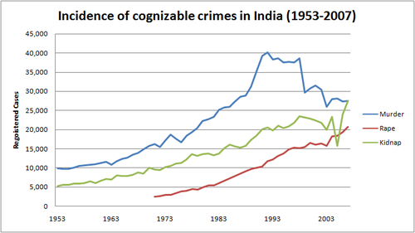
5. Results
The Count
The count of patients and types of disease as in a locality can be helpful in deciding in creating infrastructure of the health centers and medical camps, its staffing and medicine stock etc. If the data can be collected on daily basis or better, the resource utilization can be optimal. Judicious use of labor can be helpful in improving quality of medical services provided to the people and thereby help in reducing cost of operations. Inventory of medicines can also be appropriately managed to reduce wastage due to expiry and, if required, unutilized stock of medicines can be transferred to other centers of management.
References
Report on incidents in India 2016- Ministry of Law And Justice,
Government of India pp. 1-2
http://morth.nic.in/showfile.asp?lid=2904
[2] Connect with gocoder
https://www.wowza.com/docs/connect-wowza-gocoder-to-wowza-streaming-cloud
[3] content about django project
https://docs.djangoproject.com/en/1.8/intro/tutorial01/
[4] Android Studio
https://developer.android.com/docs

