Online Proctoring Examination System (OPES)

Online Proctoring Examination System (OPES)

Yash Kalamkar, Vedant Kapse , Nishant Ghutke , Sanket Ingale , Prajakta karwandikar

UG Engineering Students , Professor
Department of Computer Engineering, St. Vincent Pallotti College of Engineering & Technology,
Nagpur, Maharashtra, India.

yashkalamkar85@gmail.com

Received on: 5 May,2024 Revised on: 30 June,2024 Published on: 03 July ,2024

Abstract - Online Proctoring Examination System (OPES) is an occurrence of electronic learning and now distance education has prompted the creation of measures of assessment that are secure and reliable. Proctoring system based online exam are now known as effective means to meet problem of remote test situations, test security and cheating behaviors. By means of practical examples and cases, the article analyzes the efficiency of the platform to reduce cheating incidents, damage exam integrity and augment the testing conditions for lecturers and students at the same time.

- Introduction
Nowadays, under the digital environment the number of professionals and students seeking for remote education and online learning has risen dramatically, thus resulting in a need for effective and reliable evaluation methods. With the development of e-proctoring mechanisms, exams have now gained integrity even if the mode of examination is done remotely. This modern approach uses technology to continuously supervise each test taker during exams, hence prevents the students from committing any fraud and at the same time guaranteeing fairness in the tests.
- Overview
Online proctoring systems as a technological implementation undertaken to monitor and fulfill the supervisory obligations in online exams performed through the internet. They explore the use of computer tools and methods for online monitoring like webcam observation, screen capture inspection, and biometric checks aimed at safeguarding the academic honesty. To emulate the supervisory method of conventional face-to-face tests, online proctoring systems tend to detect and discourage acts leading to cheating, such as giving unauthorized assistance or

plagiarism. In addition to this, these systems prove to offer students and candidates the convenience they seek in terms of testing schedules.

The emergence of remote training and online proficiency
platforms has seen online proctoring become increasingly essential among institutions of learning and other organizations
as it offers an unfailing means to maintain the security and fair
examination conditions in virtual settings.

- Objective
- Conducting research on the technological properties and functionalities of online proctoring systems such as the range of tools used for surveillance and detecting fraud which will lead to identifying the tools.
- Assess the dependability and propriety of online invigilating tools in averting integrity breaches and safeguarding the actual standards of academic pursuits.
- Highlight the challenges of deploying internet based proctoring systems, e.g. inviolability problems, technical qualification and the difficulties faced by disabled people.
- Research possible strategies and solutions for risks that are associated with automated proctoring systems and work to maximize their impact and usability level.
- Analyze the future outlooks and prospects of online proctoring systems, taking into consideration how technology is advancing, as well as what regulation are being developed, not forgetting the way educational programs are evolving.

- Literature Review

The widespread availability of online proctoring systems has made them a popular choice for securing exams in online learning. While AI technology has been effective in detecting dishonest behavior, there are concerns about potential inaccuracies and biases in proctoring algorithms, as well as challenges related to system usability and user privacy. Ethical aspects of online proctoring, including students' privacy and information protection, also need to be carefully considered. Overall, it is important to carefully balance the ethical and technical considerations of these technologies to implement suitable systems that prioritize honesty, privacy, and ease of use in assessment settings.Methodology
The working which stands at the sight of the Construction from the Machine Learning-Based Online Proctoring System has overarching methodology that is divided into different stages such as System Design, Implementation, Testing and Performance evaluation.

1.1 System Design Phase
One of the key factors that we needed to do during the design stage was to come up with a list of the components of the system and the objectives to which the system will be applied to. This specific result can be accomplished as a part of a process, which gives the chance to describe features performance values. These can be used then by stakeholders, users and system size test. Design questions that often coincide with an appropriate criteria are frontend, backend, and DB issues.

1.2 Implementation Phase
The phase of putting the projects into action our team precisely assembled the system components by using most advanced technologies and programming languages at our disposal. The major works were UI (user interface) and usability of the product that we involved React JS and CSS to design a website that looks great without being complicated. This method helped us achieve not only the goal of simple interface operation but also to avoid various errors. The Node.js was veritably chosen for the back-end logic implementation, and the Python was used as a tool for the proctoring tasks that use machine learning. MongoDB, which is the database management system that facilitated the storage of test data, users' profile records, and reporting of the proctoring services.

1.3 Testing and Validation Phase
The testing analysed the afteroperative function, reliability and security of web proctoring system as a whole. Unit tests, parallel tests and end-to-end tests were developed in order to check each module as well as the brain of the system. Stage of user authentication and exam scheduling was dedicated to live proctoring and also of the database interaction. Furthermore, several mock exams were done by imitating the true picture of an exam, after which the algorithms developed for proctoring were examined.

1.4 Performance Evaluation Phase
We have have come to the performance evaluation and knows how much the system concerns the efficiency, accuracy,scaling and how our system works in different loading concurrents. The monitoring techniques provided include the number of seconds of response, throughput, resource usage and detection accuracy performances that are logged and the results analyzed. The parametric sweep was done through the stress testing process and the outcome showed the link-breaking and congestion point, as well as the expected performance of the system. We got the user feedback from some users and use A/B tests etc. for the data of further improvements.

1.5 Ethical Considerations
The question of ethics was given considerable attention both during and after the phase of design and testing. Privacy of the users, data security and regulation were a focus for us. It was ensured to maintain transparency in communication and consent with users, as far data collection, processing, and usage for proctoring purpose is concerned. In addition to that, the conscious effort was made to eliminate biases and maintain justice in the proctoring algorithms.

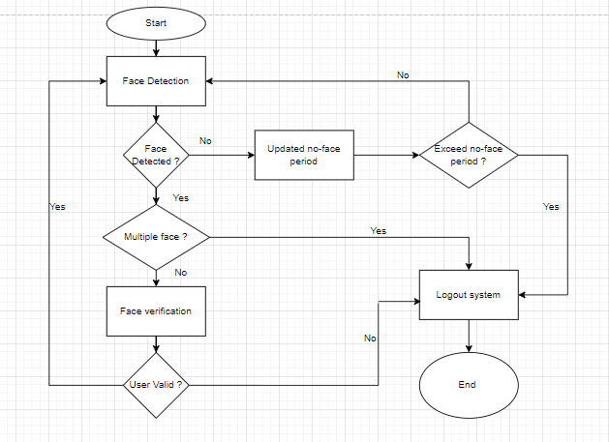
Figure 3.1. Methodology Flowchart

- System Design

The architecture of the Online Exam Proctoring System will serve as the backbone of the system and will be scaled, reliable, and secure. It consists of three main components: frontend, backend, and database that is associated with the expression of our online ideas. Every single component contributes to the smooth human conversation that includes the student and all sensors, as well as the underlying machine learning algorithms.

- Frontend Design :
The frontend of the system is constructed with React JS and CSS, which ensures a simple operation for the end user either a student or an administrator. The design of the website emphasize on user-friendliness, accessibility and the display to be useful on various gadgets.

Features of the Frontend:
- User Authentication: Safeguard the users’ privacy by ensuring logins and authentication.
- Exam Scheduling: Provides students the opportunity to view the available tests, select the best time break and sign for the exam.
- Live Proctoring Interface: Showing a real-time proctoring interface during tests ( live video tracking and monitoring alerts).
- Dashboard for Administrators: Gives the system administrators rights to check the exam in progress, review on proctoring reports, and user profile maintenance.

- Backend Implementation :
Backend of the system comprises its core ‘thinking’ and data processing centers, which function in Node.js and Python. It is a module that replies to user requests, manages the exam and in a standalone fashion AI-driven proctoring.

Components of the Backend:
- Server: Implements Node.js for HTTP requests and responses to maintain high-traffic workloads and speed.
- API Endpoints: It specifies the RESTful API’s to take part in the communication between the frontend and the backend which is the platform offering services such as user authentication and examination scheduling and proctoring tasks.
- Machine Learning Integration: Enables a Python script to conduct machine learning tasks, an activity that involves plagiarism detection, recognition of faces, behavior analysis.
- Database Communication: Communicates with MongoDB to record and restore exams data and user profiles and report on the exam proctoring.

- Database Management :
The point to be made here is MongoDB is used as the database management system so that structured data can be stored effectively. It supports flexibility, scalability, and Node.js availability for the data retrieval, processing, and conversion of the information required for the redevelopment of the dashboard.

Database Schema:
- Users Collection: Keeps user's profiles, i.e., students and administrators with login credentials and exam registration information.
- Exams Collection: It contains details about the exams, here name of the exam, duration time, and schedule slots with proctoring modes.
- Proctoring Reports Collection: All exam proctoring reports are generated tallied, dominated by detected anomalies, behavior analysis results, and plagiarism detection alerts.
- Logs Collection: A system that provides a record of user interactions, analytics and error messages which can be used to resolve problems as well as audit.

- Communication Flow:
The frontend-backend communication within the system uses the model of a client-server, where HTTP requests between the frontend and the backend are sent. When user perform specific requests like accessing or scheduling a test, or beginning a proctored session, the frontend transit the respective requests to the backend API endpoints. The backend, in essence, processes the requests and invokes business logic as necessary, communicates with the database or/and returns relevant responses to the front end. Machine learning agents will be evoked at these tasks as and when necessary and the many outcomes will serve as a reference to the backend's response to the frontend.

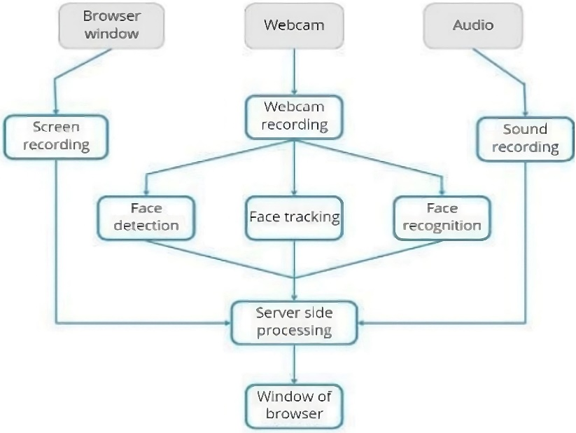
Figure 4.1. Proctoring system architecture

- Result and Conclusion
Among recent experiments, this research provides demonstrable proof of online proctoring test validity and its effectiveness in detecting cheating using. It also highlights the convenience and flexibility of online testing, while emphasizing the need to address privacy and accessibility issues. Online proctoring can be an invaluable asset for secure remote testing, with future improvements focusing on accuracy, privacy, and equal accessibility for all users.
Overall, our examination proctoring system has the potential to transform academic assessment by utilizing advanced technologies and monitoring methods. We have shown a practical solution to the ongoing issue of exam integrity in a digital educational setting. Moving forward, we are dedicated to improving our system to meet the changing demands of educators and students, guaranteeing the credibility of academic evaluations.

- Future Scope

- Technological Advances: AI, ML, and analytics advancements will improve cheating detection and anomaly identification.
- Enhanced Security: Modern biometric authentication systems, like fingerprint and facial recognition, will accurately verify exam candidates.
- Adaptive Proctoring: Tailored monitoring will consider exam nature, risk assessment, and personal history for smoother supervision.
- Integration with Learning Management Systems (LMS): Seamless integration into existing LMS platforms will simplify exam administration and reporting.
- Improved User Experience: User-friendly interfaces, real-time support, and optimization will reduce disruptions for instructors and test-takers.

References
- Kulkarni, A. R., Chavan, S. D., & Patil, P. S. (2018). "Online Examination Proctoring System Using Biometrics." International Journal of Innovative Research in Computer and Communication Engineering, 6(1), 100-105.
- Sharma, N., & Dubey, S. (2017). "Design and Implementation of Online Examination System Using Image Processing Techniques for Authentication." International Journal of Computer Applications, 164(6), 1-5.
- 3. Wang, Y., & Jia, J. (2020). "Design and Implementation of Online Examination System Based on Web." Journal of Physics: Conference Series, 1475(1), 012001.
- Liu, Y., Cai, Y., & Xiao, J. (2019). "Design and Implementation of Online Examination System Based on B/S Architecture." Journal of Physics: Conference Series, 1237(1), 012065.
- Khedkar, V., & Shinde, P. (2016). "An Online Examination System Using Data Mining Techniques." International Journal of Engineering Science and Computing, 6(11), 6040-6046.
- Idris, I. M., & Ahmad, S. (2017). "Secure Online Examination System Using Cloud Computing." International Journal of Emerging Trends & Technology in Computer Science, 6(3), 355-360.
- Mashood Mukhtar, "GPS based Advanced Vehicle Tracking and Vehicle Control System," Available: https://j.mecs-press.net/ijisa/ijisa-v7-n3/IJISA-V7-N3- 1.pdf, Published Online February 2015 in MECS
- Li, J., Chen, W., & Lin, Y. (2019). "Design and Implementation of Online Examination System Based on ASP.NET." Journal of Physics: Conference Series, 1237(1), 012055.
- Giri, A., & Mude, S. (2017). "Development of Online Examination System Using PHP and MySQL." International Journal of Science and Research, 6(12), 291-294.
- Saini, S., & Kaur, R. (2018). "Design and Implementation of Online Examination System Using Mobile Computing." International Journal of Computer Applications, 179(34), 25-28.
- Marathe, V., & Kokate, V. (2017). "Design and Implementation of Secure Online Examination System." International Journal of Innovative Research in Computer and Communication Engineering, 5(3), 5422-5428.
- Mittal, P., & Gupta, P. (2019). "Online Examination System Using Image Processing for Remote Proctoring." International Journal of Advanced Research in Computer Science, 10(3), 17-21.
- Doshi, P., & Patil, M. (2016). "Implementation of Online Examination System with Question Randomization." International Journal of Computer Applications, 135(3), 6-9.
- Yadav, A., & Agarwal, S. (2018). "Development of Secure Online Examination System Using AES Encryption." International Journal of Computer Applications, 181(19), 6-10.
- Kumar, R., & Singh, P. (2019). "Design and Implementation of Online Examination System with Adaptive Question Generation." International Journal of Computer Applications, 180(26), 38-42.
- Priyadharshini, R., & Arulmozhivarman, P. (2020). "Online Examination System Using Machine Learning for Cheating Detection." International Journal of Innovative Technology and Exploring Engineering, 9(3), 1400-1404.
- Jain, A., & Chourey, P. (2018). "Development of Online Examination System with Anti-Cheating Mechanism." International Journal of Computer Applications, 182(19), 1-4.
- Lohia, A., & Singh, S. (2017). "Secure Online Examination System Using Captcha and IP Spoofing Detection." International Journal of Advanced Research in Computer Science and Software Engineering, 7(7), 142-145.
- Roy, S., & Pramanik, P. (2019). "An Online Examination System with Biometric Authentication and Face Recognition." International Journal of Innovative Technology and Exploring Engineering, 9(3), 308-311.
- Sharma, A., & Jain, S. (2016). "Design and Implementation of Online Examination System with Automated Question Generation." International Journal of Computer Applications, 143(5), 34-39.

