Dynamic Pollution under Control by Using IoT

Dr. Umakant B. Gohatre¹, Afshad Asif Shaikh², Sham Rajkumar Zare³, FizzaRao Penugunda⁴, Giten Hemant Doshi ⁵

¹Assistant Professor, Department Electronics and Telecommunication Engineering,
Smt. Indira Gandhi College of Engineering,
Ghansoli, Navi Mumbai, Maharashtra, India 400701
umakantbhaskar@gmail.com
^{2,3,4,5} BE Student, Department Electronics and Telecommunication Engineering,
Smt. Indira Gandhi College of Engineering,
Ghansoli, Navi Mumbai, Maharashtra, India 400701
pfizzarao.2002@gmail.com

Received on: 29 March, 2023 Revised on: 16 April, 2023 Published on: 18 April, 2023

Abstract –According to the 2023 report of the world population review, India is the third-most polluted country in the world, with an average PM2.5 concentration of 51.90. Out of the 50 most polluted cities in the world, 39 of them are located in India. Also, according to a Switzerland firm known as IQAir recently released its report on world air quality 2022 where India is at the 8th spot out of the 10 most polluted countries in the world. In India, the transportation sector contributed almost 20-35 per cent of the PM2.5 pollution. Therefore, we can say one of the main sources of air pollution is transportation sector or fuel vehicles. Our project is mainly focused on measuring, displaying, monitoring and analyzing the harmful poisonous pollution causing gases that are carbon monoxide and hydrocarbons.
Keywords-IoT, NodeMCU, Dynamic, Sensor
INTRODUCTION
Clean air is every human being's right. Breathing polluted air affects health of not only human's but every living being, and it causes many diseases such as respiratory diseases, ischemic heart disease, lung cancers. Generally, air pollution occurs due to

contamination of natural air by chemical and physical agent. The global average carbon dioxide set a new high record of 414.72 parts per million in 2021. carbon dioxide, carbon monoxide nitrogen and Sulphur dioxideare the main gases that cause air pollution. Due to growing pollution, there is increase demand of more vehicles on the road and it was expected that vehicles grow up to 2.5 billion by 2023. Transportation or vehicles are the major sources of generation of the gases, such as CO, Hydrocarbons and CO2. Therefore, it is important to control the air pollutions by monitoring the individual vehicle that causes pollution. The goal of this paper is to identify, detect and monitor the pollution generated by the individual vehicles to the atmospheric air and show the status of its PUC dynamically on the website. therefore, the RTO/ traffic police can easily verify and check its PUC validity by just inputting vehicle registration number.

METHOLOGY
The block diagram is shown in Figure 1. It consists of the following IoT devices.
• Gas sensor
• GPS Module
• Node MCU (ESP32)
• internet connection
Exhaust gas is emitted from the combustion of petrol, diesel fuel and fuel oil of vehicles and from different industrial processes like burning gas flares. These pollution causing gases discharges into the atmosphere through the silencer pipe of a vehicle.

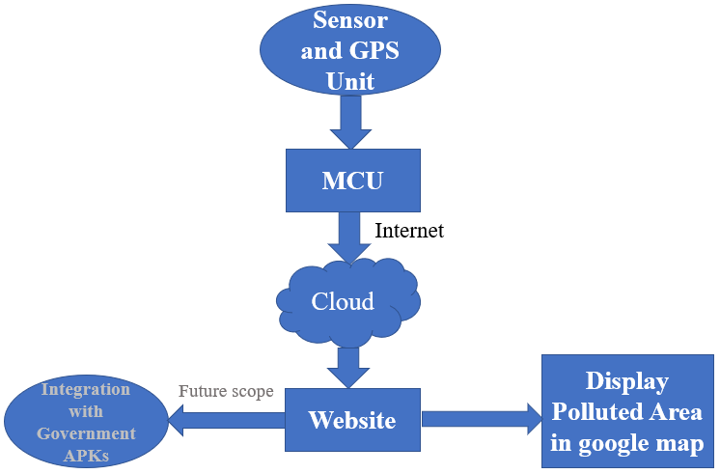Fig. 1- Block Diagram
Therefore, the air pollution sensor is connected near the silencer pipe of the vehicle for measuring the pollution generated by the individual vehicle. We are using Node MCU ESP32 microcontroller, which is a low-cost, low-power system with integrated Wi-Fi and Bluetooth. We are using MQ7 and MQ2 air quality gas sensors. They are low cost and suitable for detecting gases/smoke, ammonia, CO, CO2 and Hydrocarbons such as methane, butane and propane.NEO-6M GPS module for user location detection. The gas sensors, GPS module and NodeMCU are connected as shown in the figure 2.
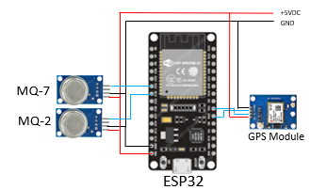
Fig. 2- Circuit Diagram
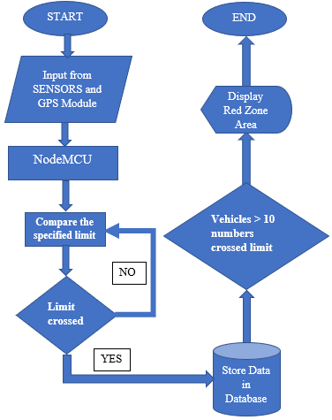
Fig. 3- Flow Chart
Pollution Detection:
The pollution sensor detects the air quality near the exhaust pipe in every 30 seconds and send the data to the ESP32. Then microcontroller compares this data with the standard specified limit. If limit is crossed, then this data along with current location of the vehicle will be sent to the cloud using Wi-Fi or Bluetooth then to the website. The microcontroller can also transfer the data to
any Wi-Fi device present in the Wi-Fi range.

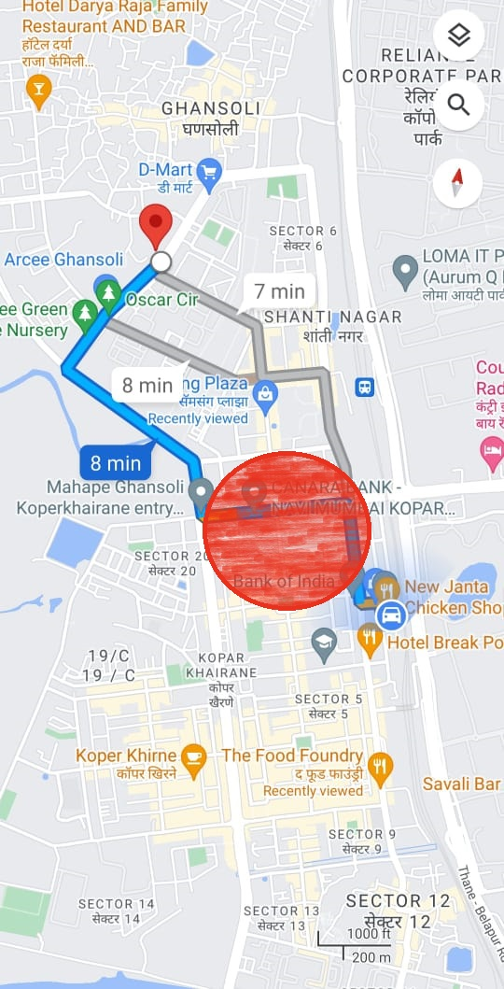
Fig. 4- Area marked as red zone

RESULT
After the real time experiment, we can see on the Google Maps, area is marked as red zone as shown in figure 4 and also the sensor value on the graph as shown in figure 5. The final website is shown in the figure 6.

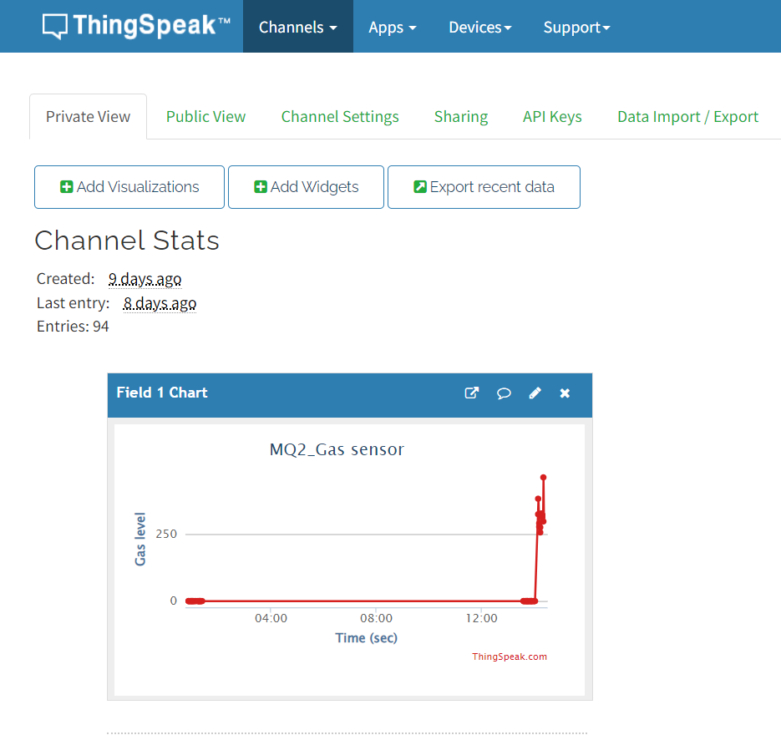
Fig 5- Sensor Readings

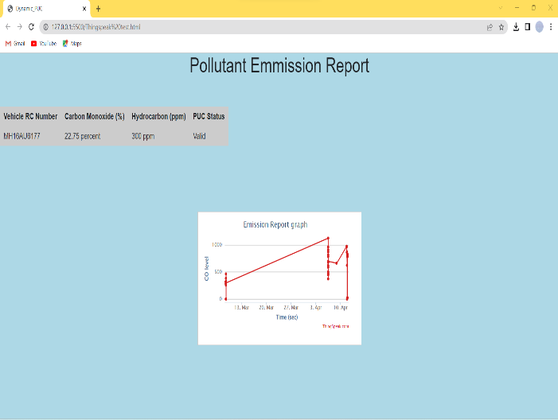
Fig. 6- Website

CONCLUSION
We have created an innovative way to measure pollution of vehicles and verifying PUC dynamically for ease of the government authority. We have also presented a new idea to measure pollution of the specific area.

ACKNOWLEDGMENT
I would like to express my heartfelt gratitude to Dr. Umakant Gohatre for his invaluable support and contribution to the completion of this project. His guidance was instrumental in the success of this project. His insights and feedback have greatly improved the quality of this research work.
I also want to thank Dr. V.P. Patil (HOD OF EXTC DEPT and Vice Principal) for their assistance and support.
Once again, thank you all the respected teachers of EXTC department for believing in this project and helping us see it through to completion.

REFERENCES
- Ramagiri Rushikesh, Chandra Mohan Reddy Sivappagari, Development of IoT based Vehicular Pollution Monitoring System, International Conference on Green Computing and Internet of Things (ICGCIoT) 2015.
- Sujata Pal, Anindo Ghosh, Vehicle Air Pollution Monitoring Using IoTs (IIT Ropar) 2018.
- Piyush Patil, Smart IoT Based System for Vehicle Noise and Pollution Monitoring (ICEI) 2017.
- Rebecca Lindsey, Ed DLUGOKENCKY, Climate Change: Atmospheric Carbon Dioxide (Climate.gov) 2022.

