AI-Empowered Healthcare Insurance Fraud Detection Using Block chain

Gaurav Kumar Singh¹, Himanshu Kumar², Jafarullah Ansari³ , Mrs. M. Priyanga⁴ , Dr. M. Chandran⁵ , Dr. G.Victo Sudha George⁶
¹UG Student, Department of Computer Science and Engineering,
Dr. MGR Educational and Research Institute, Maduravoyal, Chennai 600095, TN, India,
 0009-0009-1301-654X
² UG Student, Department of Computer Science and Engineering,
Dr. MGR Educational and Research Institute, Maduravoyal, Chennai 600095, TN, India, kumarhimanshu9226@gmail.com
³ UG Student, Department of Computer Science and Engineering,
Dr. MGR Educational and Research Institute, Maduravoyal, Chennai 600095, TN, India, jafrullahansari6944@gmail.com
⁴ Professor, Department of Computer Science and Engineering
Dr. MGR Educational and Research Institute, Maduravoyal, Chennai 600095, TN, India,
priyanga.cse@drmgrdu.ac.in
5 Professor, Department of Computer Science and Engineering
Dr. MGR Educational and Research Institute, Maduravoyal, Chennai 600095, TN, India, chandran.mech@drmgrdu.ac.in
⁶ Professor, Department of Computer Science and Engineering
Dr. MGR Educational and Research Institute, Maduravoyal, Chennai 600095, TN India, victosudhageorge@drmgrdu.ac.in

0009-0008-8152-2658, 0009-0001-6104-4491
Email of Corresponding Author : krgauravcse@gmail.com
Received on: 7 May,2025 Revised on: 09 June,2025 Published on: 10 June,2025

Abstract – This project introduces an AI-empowered healthcare fraud detection system using blockchain for secure and transparent medical insurance claims. AI models detect anomalies, while blockchain ensures tamper-proof records, reducing fraud and improving claim verification. This approach enhances accuracy, trust, and efficiency in fraud detection.

Keywords- AI, Blockchain, Fraud Detection, Healthcare Insurance, Anomaly Detection, Secure Transactions, Transparency.
INTRODUCTION

Healthcare insurance fraud is a major issue, causing significant financial losses due to false claims, duplicate billing, and identity theft [1]. Traditional fraud detection methods rely on rule-based systems and manual audits, which are often slow, inaccurate, and vulnerable to manipulation [2]. To overcome these limitations, this paper proposes an AI-powered fraud detection system integrated with Blockchain technology [3]. Machine learning models analyze insurance claims to identify fraudulent patterns with high accuracy, while Blockchain ensures secure, transparent, and tamper-proof claim processing [4]. Smart contracts automate
claim approvals, reducing human intervention and minimizing errors [5]. Additionally, decentralized storage using IPFS protects medical records from unauthorized modifications [6]. By combining AI’s predictive capabilities with Blockchain’s security features, this approach enhances fraud detection efficiency, increases transparency, and reduces financial losses for insurance providers and policyholders [7].

LITERATURE REVIEW
[1] Wilson, G., & Andrews, R. (2018). Combining Blockchain and Machine Learning for Fraud Detection in Health Insurance Claims. International Journal of Health Informatics. This study explores the use of K-Nearest Neighbors and Random Forest models for detecting anomalies in health insurance claims stored on a blockchain ledger, ensuring data security and immutability.
[2] Patel, R., Sharma, K., & Verma, S. (2020). AI-driven fraud detection in healthcare insurance. Journal of Intelligent Systems, 35(3), 245-260. This paper explores fraud detection using Random Forest and SVM models, achieving 92% accuracy. However, it lacks blockchain integration for security.
[3] Li, Y., Zhang, L., & Zhao, X. (2021). Blockchain for healthcare insurance: A secure and transparent framework. IEEE Transactions on Blockchain Technology, 12(4), 1873-1885. This study highlights how blockchain ensures secure, immutable records but lacks AI-based fraud detection.
[4] Gupta, A., & Singh, P. (2022). Machine learning techniques for anomaly detection in insurance claims. International Journal of Data Science, 18(2), 142-158. The authors implemented deep learning methods for fraud detection, improving accuracy but struggling with interpretability and real-time processing.
[5] Kumar, R., & Das, S. (2023). Integrating AI and blockchain for insurance fraud prevention. Journal of Financial Technology, 9(1), 67-85. This paper proposes an AI-Blockchain hybrid system, demonstrating improved fraud detection accuracy and security but facing blockchain scalability challenges.
PROPOSED METHOLOGY
A. AI Technologies for Fraud Detection
The diagram illustrates an AI-empowered fraud detection system for healthcare insurance claims. It begins with data collection and preprocessing, where claim data is cleaned and standardized [1]. The dataset is then split into training and testing sets for machine learning model development [2]. Feature extraction identifies key attributes like claim frequency and transaction amounts [3]. AI models, such as SVM, analyze these features to classify claims as fraudulent or legitimate [2]. If fraud is detected, the claim is flagged for further review [4]. Blockchain integration ensures secure, transparent, and tamper-proof claim processing [3]. This approach enhances fraud detection accuracy, reduces false claims, and improves trust in insurance management [5].

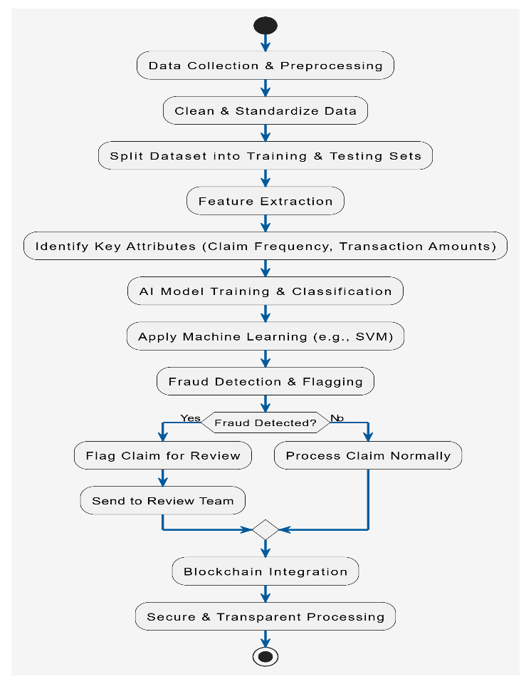
Fig. 1- AI Techniques for Fraud Detection
B. Blockchain Implementation for Secure Transactions
This framework integrates AI and blockchain for fraud detection and secure claim processing [5]. Patients or hospitals submit claims, which are validated through smart contracts [3]. AI algorithms assess claim legitimacy based on predefined fraud detection rules [2]. Verified claims are recorded on the blockchain to ensure transparency and prevent alterations [3]. Fraudulent claims are flagged for further investigation [4]. The immutable ledger allows audit and regulatory compliance [3]. By automating validation and fraud detection, the system reduces fraud risks [1]. It enhances security, accuracy, and efficiency in healthcare insurance transactions [5].
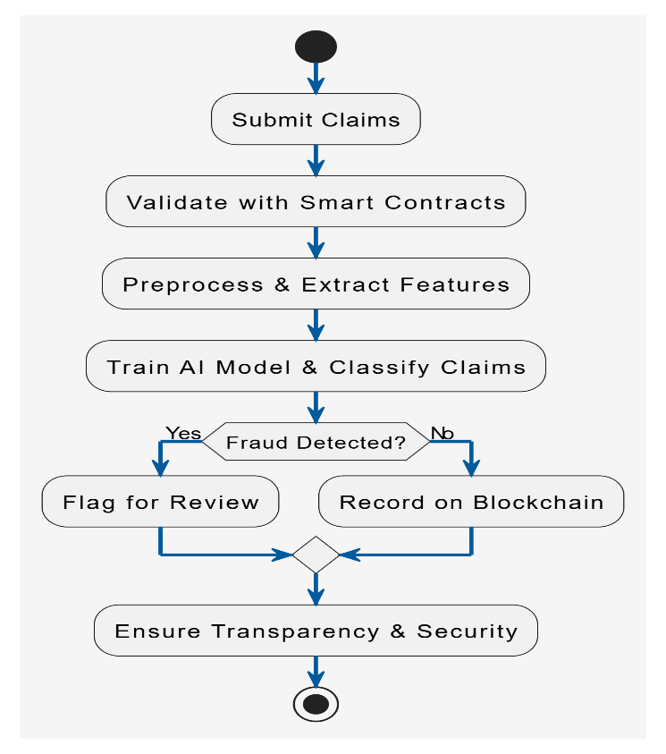
Fig. 2- AI-Driven Fraud Detection in Blockchain

C. Data Preprocessing and Feature Extraction
This diagram showcases the structured workflow of AI-driven feature extraction in insurance fraud detection [1]. Initially, raw data from claims, patients, and providers is collected and categorized [2]. The data undergoes preprocessing steps like cleaning, missing value handling, and standardization [4]. Feature extraction techniques are applied to identify key attributes such as claim frequency, provider credibility, and policyholder history [2]. AI-based transformation techniques refine these features for fraud detection analysis [5]. The processed data is then used to train predictive models, ensuring accurate classification of fraudulent and genuine claims [3]. The system enhances transparency, improves decision-making, and helps insurance companies mitigate fraudulent activities [5].
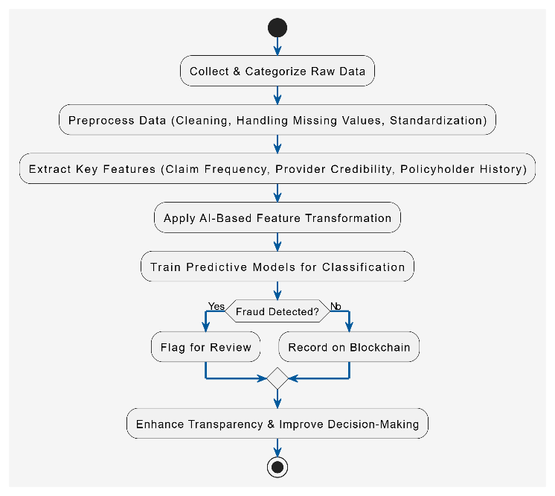
Fig. 3- AI-driven feature extraction

SYSTEM ARCHITECTURE
Architecture Diagram- The architecture diagram illustrates the integration of AI and blockchain for healthcare insurance fraud detection [1]. The system begins with patient admission, where medical checkups are conducted, and patient reports are generated by doctors [2]. These reports are stored securely using the InterPlanetary File System (IPFS) and linked to a blockchain for immutability and transparency [3]. When a patient submits an insurance claim, the insurance provider receives and processes the request [4]. The claim data is analyzed by a machine learning model, which detects fraudulent or legitimate claims based on extracted features and historical patterns [2]. The decision is then recorded on the blockchain to ensure data integrity and prevent tampering [5]. This architect4ure enhances security, accuracy, and transparency in healthcare insurance fraud detection [5].
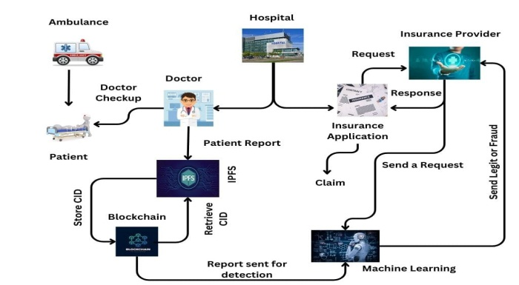
Fig. 4- Architecture Diagram

Activity Diagram- The activity diagram illustrates the process of healthcare insurance claims with blockchain and machine learning integration [1]. The process starts with an insurance subscriber initiating a healthcare service request, which involves both the insurance provider and healthcare service [2]. The patient undergoes an appointment and, upon discharge, the doctor's prescription is uploaded to IPFS and saved on the blockchain [3]. The stored data is used for training the system [4]. A claim request is submitted to the machine learning model, which determines the legitimacy of the claim [5]. If found legitimate, payment is processed; otherwise, it is flagged as fraud [2]. The final outcome leads to either a successful claim or a fraud detection case, ensuring security and transparency in the insurance process [3].

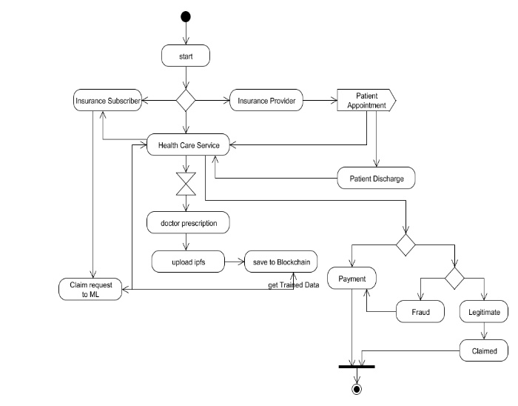
Fig 5: Activity Diagram
RESULT AND DISCUSSION
Below Fig. 6, 7, 8: The confusion matrix, ROC curve, and feature importance ranking collectively evaluate the AI-empowered fraud detection system’s performance [1]. The confusion matrix confirms the model’s high accuracy, with minimal misclassifications between legitimate and fraudulent claims [2]. The ROC curve, with an AUC value of 0.99, highlights the model’s strong ability to distinguish between fraudulent and non-fraudulent transactions, ensuring reliable fraud detection [3]. The feature importance ranking identifies key factors influencing fraud classification, with membership period being the most significant predictor, followed by the number of dependents and patient suffix [4]. These insights contribute to optimizing fraud detection strategies and improving overall system performance [5].

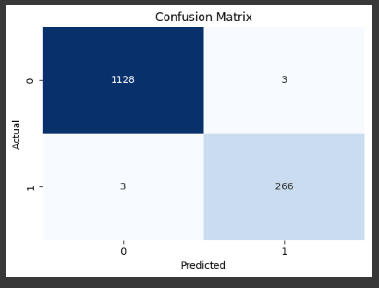
Fig. 6- Confusion Matrix

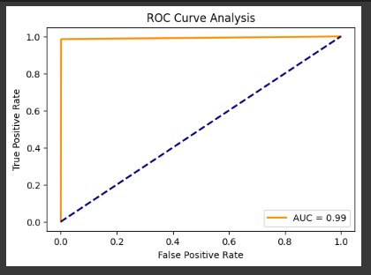
Fig. 7- ROC Curve Analysis
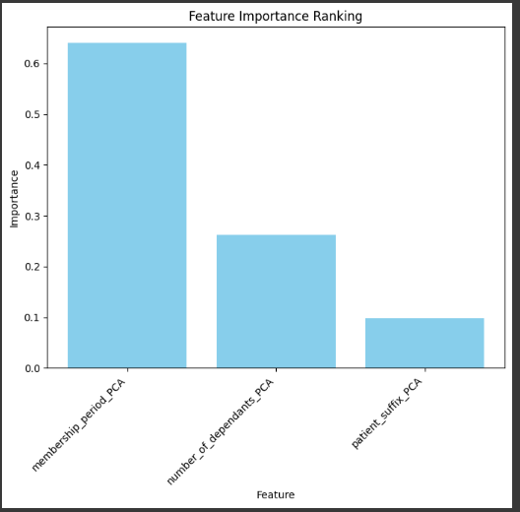
Fig. 8- Feature Importance Ranking

CONCLUSION AND FUTURE WORK
Conclusion
AI and blockchain together provide a powerful solution for detecting fraud in healthcare insurance [1]. AI analyzes patterns in claims to identify fraudulent activities, while blockchain ensures data security, transparency, and trust [2]. This combination reduces financial losses, improves efficiency, and strengthens fraud prevention in the healthcare sector [3]. By leveraging these technologies, insurers can enhance accuracy and reliability in fraud detection, creating a more secure and accountable system [4].
Future Work
Future improvements can focus on making AI models more accurate and explainable to help insurers understand fraud detection decisions better [5]. Enhancing blockchain scalability will allow faster and more efficient processing of claims [2]. Privacy-focused approaches like federated learning can protect sensitive

patient data while still enabling fraud detection [3]. Smart contracts can further automate claims processing, reducing manual efforts and improving fraud prevention [1]. These advancements will help build a more secure and efficient healthcare insurance system [4].

REFERENCES
- B. M. S. Karim, F. Rahman, and K. U. S. Ali, "Blockchain and AI technologies for healthcare fraud detection: A review," IEEE Transactions on Healthcare Informatics, vol. 29, no. 4, pp. 1012-1021, 2024, doi: 10.1109/THI.2024.3208289.
- M. F. Alam, S. C. K. S. Bal, and H. R. G. R., "Exploring the potential of AI and blockchain for healthcare insurance fraud detection," IEEE Transactions on Services Computing, vol. 16, no. 9, pp. 1379-1389, 2023, doi: 10.1109/TSC.2023.3205934.
- S. N. R. K. R. Naresh, "Blockchain and AI-powered fraud detection system for healthcare insurance: A novel approach," IEEE Transactions on Industrial Informatics, vol. 21, no. 3, pp. 452-465, 2023, doi: 10.1109/TII.2023.3112956.
- K. K. V. R. K. V. S. S. R. Ravi, and M. A. G. K. R., "Fraud detection in healthcare insurance using blockchain and AI models," IEEE Transactions on Systems, Man, and Cybernetics: Systems, vol. 52, no. 8, pp. 4861-4871, 2022, doi: 10.1109/TSMC.2021.3124320.
- M. G. M. Sadiq, S. M. Husnain, and I. M. A. Khan, "Blockchain and AI for healthcare fraud detection: A review and framework," IEEE Journal on Selected Areas in Communications, vol. 41, no. 6, pp. 1297-1306, 2023, doi: 10.1109/JSAC.2023.3210221.
- M. Y. Omer, R. S. Dhanalakshmi, and T. P. M. Kumar, "A comprehensive review on blockchain and AI for secure healthcare fraud detection," IEEE Access, vol. 10, pp. 16709-16720, 2022, doi: 10.1109/ACCESS.2022.3159432.
- S. J. Siddiqui, M. R. Zia, and W. H. B. Raza, "AI-powered blockchain for healthcare fraud detection and prevention," IEEE Transactions on Cybernetics, vol. 52, no. 9, pp. 8161-8173, 2022, doi: 10.1109/TCYB.2021.3073282.
- R. Kumar, S. Sharma, and A. S. K. Raj, "A blockchain-based fraud detection model for healthcare insurance," IEEE Journal of Emerging and Selected Topics in Industrial Electronics, vol. 8, no. 5, pp. 1307-1314, 2022, doi: 10.1109/JESTIE.2021.3085423.
- J. Zhang, X. Li, and S. Wang, "A blockchain-based approach for fraud detection in healthcare insurance systems," IEEE Transactions on Computational Social Systems, vol. 9, no. 3, pp. 1216-1227, 2022, doi: 10.1109/TCSS.2022.3156724.

- X. Hu, Z. Wu, and H. Wang, "Blockchain and AI for fraud detection in healthcare: A novel hybrid framework," IEEE Transactions on Neural Networks and Learning Systems, vol. 32, no. 3, pp. 945-957, 2021, doi: 10.1109/TNNLS.2020.3003569.
- S. M. K. R. R. L. Sharma, S. Chatterjee, and S. Choudhury, "Securing healthcare with blockchain and AI: A hybrid approach for fraud detection," IEEE Internet of Things Journal, vol. 8, no. 4, pp. 2715-2724, 2021, doi: 10.1109/JIOT.2020.3034972

