Exam.AI : Ensuring Fairness and Integrity in Online Assessment
Atul Mairale , Sumit More, Harshjeet Girase, Harshal Mahajan, Kiran Patkari
Asstt Professor, UG-Student, UG-Student, UG-Student, UG-Studen t 0009-0005-2048-1731
R. C. Patel Institute of Technology, Shirpur Tal.Shirpur Dist.Dhule Maharashtra India 425405

Email of Corresponding Author: Atul.mairale@gmail.com
Received on: 6 May,2025 Revised on: 09 June,2025 Published on: 10 June,2025

Abstract— From the past 5-year, online examinations have gained immense popularity across educational fields due to COVID-19. However, institutions face significant challenges in terms of proctoring methods. If the current way of life becomes the new normal, there is a pressing need for innovative solutions. This paper introduces Exam.ai: The Proctoring System and Study Resources Manager, an AI-based integrated system designed to prevent cheating in remote examinations. By integrating reinforcement learning, gaze detection, and role-based access control, the system ensures academic integrity while enhancing user experience. Additionally, our AI-based model detects unfair practices in examinations, reducing the need for continuous human proctoring. The platform also includes a study resources management system tailored for students and professors, improving access to learning materials.
Keywords— Real-time proctoring, gaze detection, role-based access control, Convolutional Neural Network, Deep Q Network, Reinforcement Learning

- INTRODUCTION
In India, the number of web clients has about multiplied within the past six a long time, demonstrating to be a boon for scholastics as numerous understudies proceeded their instruction online. This moreover encouraged examinations to go virtual, presenting the concept of online proctoring at the scholarly level. A proctored exam permits invigilators to screen understudies remotely utilizing video, sound, and various anti-cheating highlights to preserve the exam's credibility. However, manual online proctoring postures noteworthy challenges, because it is troublesome for invigilators to screen different understudies at the same time. Customarily, an educator can physically watch understudies utilizing all faculties, but this gets to be infeasible in a farther setup.
To address this issue, we propose an AI-based framework, Exam.ai, which uses a webcam and amplifier to screen understudies and empowers instructors to supervise numerous candidates at the same time. The framework records occurrences of likely misbehaviors for audit. This apparatus makes a difference instructive teach keep up the validity of online exams by avoiding cheating. Advanced AI-enabled innovations coordinate into proctoring frameworks utilize sound and video get to strategies to guarantee candidates don't lock in in unjustifiable hones.
Exam.ai addresses the challenges of conducting inaccessible examinations safely. With expanding dependence on virtual stages, the require for strong, versatile, and user-friendly frameworks has gotten to be fundamental. This venture joins gaze-checking using a camera in genuine time, leveraging support learning and DQN calculations, nearby confront location fueled by OpenCV's DNN module. The objective of inaccessible proctoring computer program is to oversee understudies whereas conducting exams by utilizing calculations to recognize potential cheating behaviors. The framework takes get to the student's camera bolster to monitor them for out of line hones. AI capacities are utilized to distinguish candidates needing closer perception, permitting invigilators to center their endeavors successfully. This online proctoring instrument empowers candidates to require exams from any area whereas guaranteeing they are adequately dependable and associated to the web. Highlights such as development and sound location make the framework vigorous and effective. With Exam.ai, proctoring online exams is no longer a challenging errand.
II. LITERATURE REVIEW
Paper (1): Online education has enabled students and educational institutions worldwide to access a vast array of knowledge. This mode of learning is expanding rapidly, but the evaluation and proctoring of online courses have emerged as significant challenges, limiting the scalability of such systems. Traditional methods often rely on human supervision, where an examiner monitors the test environment either physically or through visual and audio inputs via a webcam. In response to these limitations, the proposed system introduces a fully automated exam proctoring solution that eliminates the need for human involvement. The system processes and analyzes various events, behaviors, and patterns commonly linked to academic dishonesty.
Paper (2): To uphold academic integrity, many institutions require online exams to be proctored. However, proctoring can impose significant costs. Students often face fees at testing centers, expenses for purchasing devices like Remote Proctor, and the effort of coordinating schedules with an approved proctor. Institutions, on the other hand, incur expenses such as staff salaries, proctor approvals, maintenance of testing centers, and potential loss of enrollment to institutions without such requirements. This paper analyzes these issues and argues that the total cost of proctored online exams, both in terms of time and money for students and institutions, often outweighs the benefits. The authors propose a more cost-effective alternative that reduces opportunities for cheating by increasing the difficulty of exams while avoiding the need for proctoring.
Paper (3): As online education continues to expand; it brings both opportunities and challenges for students and educators. One key challenge is the perception that online tests lack academic integrity due to undetected instances of cheating, which can lead to inflated grades. To address this concern, various proctoring software solutions have been developed to deter and identify dishonest practices. This study aimed to compare the outcomes of proctored and non-proctored online exams, highlighting the impact of proctoring on ensuring fairness and maintaining trust in online assessments.

III. EXISTING SYSTEMS
Current online proctoring systems rely on a single proctor to oversee multiple students at once. This approach is inefficient and incurs high costs as it depends on a manual proctor, either working remotely or from an institution, to monitor students. If these traditional systems persist, a significantly larger number of proctors would be required to conduct exams, which is not scalable. Moreover, when the proctor's attention is focused on one student, other students may take advantage of the situation to engage in dishonest practices. Consequently, real-time monitoring of all students simultaneously becomes unfeasible.
Drawbacks of Existing Systems:
- Real-time simultaneous monitoring of multiple students is not feasible.
- Rescheduling exams for students who miss them is difficult and inefficient.
- The user interface is often complicated, making it challenging for students to navigate and use effectively.

IV. METHODOLOGY
System Workflow:
The first step in the process is the registration of students on the platform, where they provide their personal details and upload a face image. For each exam, a student is re-registered with their latest face image, which is then compared against the stored image in the database to verify identity. Additionally, the system employs various detection methods to ensure exam integrity, including:

- Object Detection: Identifies any unauthorized items in the exam environment.
- Mouth Open Detection: Monitors if the student’s mouth is open, potentially signaling speech or communication with others.
- Eye Tracking: Tracks eye movements to detect whether the student is focusing on the screen or looking elsewhere.
- Multiple Face Detection: Identifies if multiple faces are visible in the camera feed, suggesting possible cheating.
- No Face Detection: Alerts if no face is detected in the camera feed, possibly indicating the student is not in front of the camera.
- Head Posing Tracking: Monitors the position of the student’s head to identify any abnormal head movements.
- Multiple Voices Detection: Detects if there are multiple voices in the background, indicating the presence of unauthorized individuals.

If any fraudulent activity is detected in the logs, the student will be disqualified from the exam.

Gaze Checking System for Exam Proctoring Using Reinforcement Learning (RL) To enhance the exam proctoring system, we are developing a gaze checking system using Reinforcement Learning (RL). This system ensures that students are focused on their exam content and not engaging in dishonest behavior. The development methodology for this system includes the following steps:
1. Problem Formulation: Task Definition: Define the task for the RL system, such as detecting whether a student is looking at their exam paper or elsewhere. State Space Definition: Identify the critical information that the system should consider when making decisions. This includes factors like the student’s head position, eye movements, and possibly other contextual data. Action Space Definition: Determine the possible actions the system can take, such as classifying whether the student is looking at the screen or looking away.
2. Data Collection: Gather Labeled Data: Collect data from students taking exams, labeling the gaze direction (e.g., looking at the screen or away). Ensure Diversity: Ensure the dataset includes various students, exam conditions, and gaze behaviors for better model generalization.
3. Model Architecture: Design RL Model: Select an appropriate RL algorithm, such as Deep Q-Networks (DQN) or Proximal Policy Optimization (PPO), that suits the gaze checking problem. Define Neural Network Architecture: Create a neural network that processes the input data (e.g., student’s head pose, eye images) and outputs an action (e.g., gaze classification).
4. Training: Data Preprocessing: Prepare the collected data for training, including normalization and feature extraction. Train the Model: Use the prepared dataset to train the RL model and adjust hyperparameters to improve performance. Monitor Performance: Continuously track the model’s performance to ensure effective learning.
5. Evaluation: Evaluate the Model: Assess the model’s performance using a validation dataset and measure metrics like accuracy, precision, recall, and F1-score. Fine-Tuning: If the performance is not satisfactory, fine-tune the architecture, hyperparameters, or the data collection process.
6. Integration: System Integration: Integrate the trained RL model into the exam proctoring software to enable real-time gaze tracking during exams. Real-World Testing: Thoroughly test the integrated system to ensure it works effectively under real exam conditions.
7. Iterate and Improve: Feedback Collection: Gather feedback from users (students and instructors) and evaluate system performance metrics.

Model Improvement: Use feedback to enhance the model and address any shortcomings.
Continuous Updates: Keep the model updated with new data and improvements to ensure it remains effective.

By following this methodology, the gaze checking system for exam proctoring using reinforcement learning can be developed efficiently. The system helps detect suspicious behaviors, such as looking away from the screen, ensuring that students are fully engaged with their exam. Additionally, ethical considerations such as privacy and fairness must be addressed throughout the development and implementation process. This approach integrates the gaze-checking system into the broader proctoring solution, ensuring comprehensive monitoring and improving the overall effectiveness of online exam proctoring.

V. SYSTEM REQUIREMENTS
The tackle and software conditions for this system are minimum, icing comity with a wide range of machines, including aged bones. The system was developed using a configuration with modest specifications. For optimal performance, every software requires specific tackle factors and software coffers to be available on a computer. These are appertained to as system conditions, which serve as guidelines rather than strict rules. generally, software specifies two types of conditions minimal and recommended. As newer performances of software demand lesser processing power and coffers, system conditions frequently increase over time to accommodate enhanced features and functionality.
Hardware Requirements:
Processor: Intel Core i3 or higher.
RAM: At least 4 GB.
Storage: Minimum 10 GB SSD/HDD.
Webcam: Mandatory for monitoring purposes.
Internet Connectivity: Reliable and high-speed internet is essential.
Software Requirements:
Operating System: Compatible with Windows, Linux, or macOS.
Integrated Development Environment (IDE): Jupyter Notebook or Visual Studio Code for development and testing.
Programming Languages: Python for implementing machine learning algorithms, and HTML, CSS, and JavaScript for creating user interfaces.
Database: MySQL for managing exam data, including student records and proctoring logs.
Frameworks: Flask or Django for backend development, and Bootstrap or Tailwind CSS for designing the frontend interface.
Other Technologies: REST APIs for enabling seamless communication between system components.
Details on System Components:
Processor and RAM: An Intel Core i3 processor and 4 GB of RAM provide sufficient resources to run the proctoring software, manage exam monitoring, and handle video/audio streams from webcams and microphones.
Storage: A minimum of 10 GB of storage is adequate for installing the proctoring software, saving exam recordings, and storing associated data files.
Webcam: The webcam is a critical component for real-time monitoring. It captures the exam environment, detects unauthorized actions, and ensures adherence to exam protocols, fostering a secure and fair testing environment.
Internet Connectivity: A stable internet connection is necessary for transmitting video/audio feeds and uploading data to servers for analysis.
Operating System: The software is designed to run efficiently on Windows, Linux, or macOS, offering flexibility across different platforms.
IDE: Tools like Jupyter Notebook and Visual Studio Code are ideal for coding and testing the software, ensuring smooth development processes.
Programming Languages: Python enables the integration of machine learning features, such as facial recognition and behavioral tracking, while HTML, CSS, and JavaScript facilitate user-friendly interfaces for an enhanced user experience. Database: MySQL ensures efficient storage and retrieval of data, including student information, exam records, and activity logs.
Frameworks: Flask or Django simplifies backend development, while Bootstrap or Tailwind CSS offers robust options for creating responsive and visually appealing frontend designs. REST API: This technology ensures seamless interaction between the frontend, backend, and database components, enabling efficient system operations.
VI. ALGORITHMS
The following algorithms play a critical role in enhancing the functionality and adaptability of the proposed system:
1. Deep Q-Networks (DQN): DQN represents a significant advancement in reinforcement learning, particularly for Q-learning applications. It uses deep neural networks to approximate Q-values, which estimate the expected cumulative rewards for specific actions taken from a given state in an environment. This capability enables DQN to handle complex, high-dimensional state spaces by identifying intricate patterns and relationships between states and actions. Through iterative training and exploration, DQN learns an optimal policy for action selection, aiming to maximize long-term rewards. Its applications range from solving classic problems like Atari games to tackling complex robotic control tasks. However, challenges such as overestimation of Q-values and instability during training require careful tuning and regularization for optimal performance.
2. Proximal Policy Optimization (PPO): PPO is a reinforcement learning algorithm designed to optimize policies efficiently and stably. It uses a clipped surrogate objective function to ensure that policy updates remain within safe limits, preventing drastic changes that could destabilize learning. This balance between exploration and exploitation leads to smoother training and consistent performance across iterations. PPO is highly effective in handling complex environments, making it a preferred choice in applications such as robotics and simulations. Although PPO can be sensitive to hyperparameter settings, its robustness and adaptability make it a cornerstone in reinforcement learning research and practice.
3. Deep Deterministic Policy Gradient (DDPG): DDPG combines elements of reinforcement learning and deep learning to address problems in continuous action spaces. It utilizes deterministic policy gradients to learn optimal policies, making it well-suited for environments modeled as Markov decision processes. By leveraging deep neural networks, DDPG effectively navigates high-dimensional state and action spaces, enabling precise and nuanced decision-making. Its deterministic approach provides stability in learning, though issues like hyperparameter sensitivity and slow convergence necessitate fine-tuning for best results.
4. Actor-Critic Method: The Actor-Critic approach employs two interconnected networks to improve learning efficiency. The actor network focuses on learning the policy, deciding which actions to take in a given state to maximize expected rewards. Meanwhile, the critic network evaluates state-action pairs, offering feedback to refine both the actor's decisions and its value estimates. This cooperative dynamic enables the framework to adapt and optimize policies in complex environments. While the Actor-Critic method is powerful, it requires careful algorithm design to address challenges such as convergence and stability.
VII. RESULTS AND DISCUSSIONS
The system identifies and logs instances of malpractice when a student looks away from the computer screen. Administrators can access the system using their login credentials to review logged activities. Fraudulent behaviors, such as the detection of unauthorized objects (e.g., phones, books, or electronic devices), the presence of multiple individuals, and suspicious sounds or voices, are recorded. Additionally, face spoofing is monitored; if a student fails to maintain focus on the camera, it is flagged. Other detections include monitoring for mouth movements, such as speaking, and tracking eye movements, where turning left or right is logged as potential malpractice. All these instances are systematically recorded in the database for review and action.

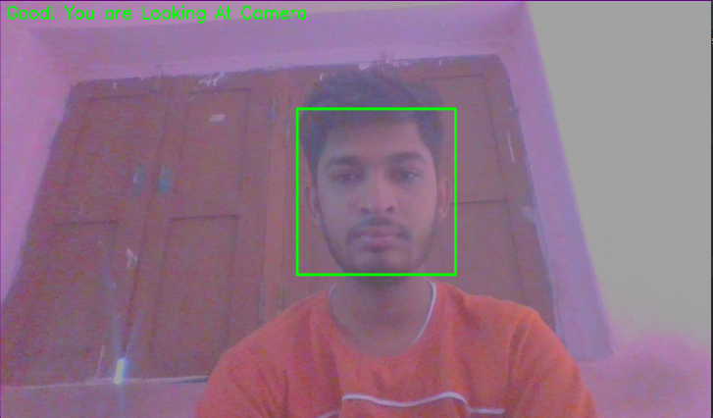
Fig 1. Face Detection

Fig 2. No Face Detcted
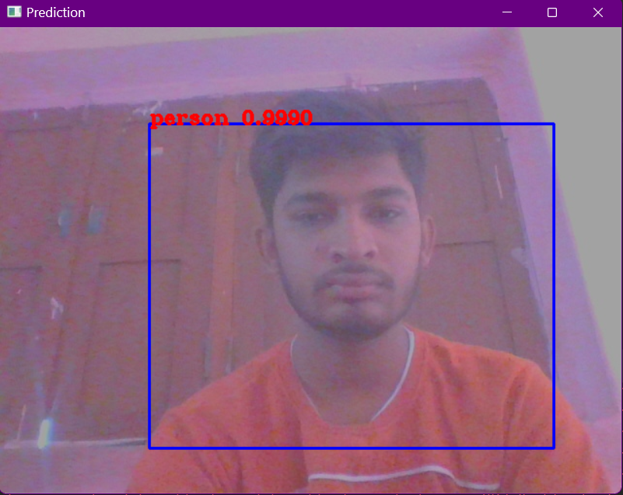
Fig 3. Person Detection

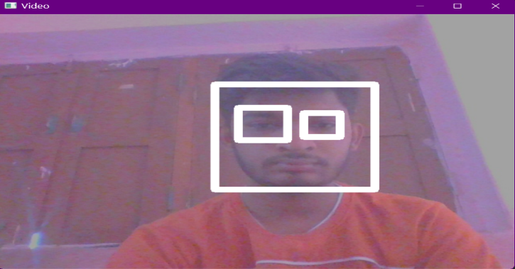
Fig 4. Eyes Detection

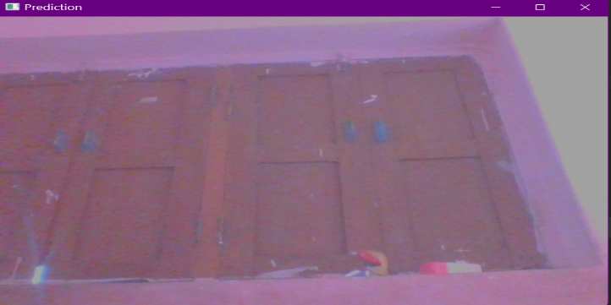
Fig 5. No Person Detected

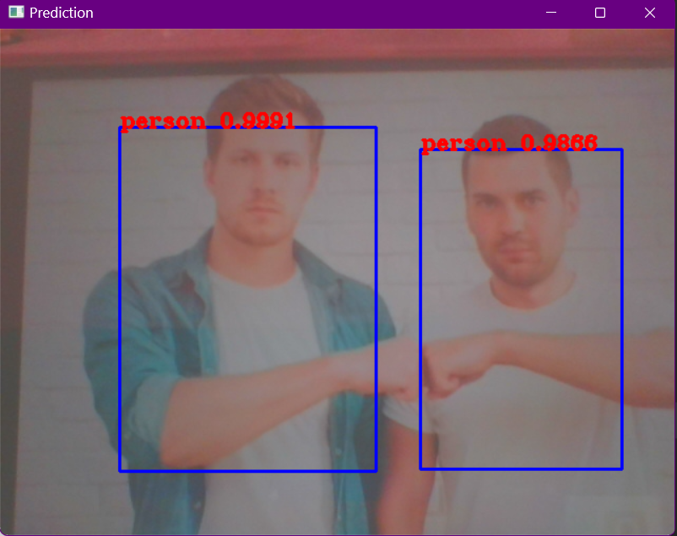
Fig 6. Multi Person Detected

VIII. CONCLUSION
Our system promotes a fair and secure examination environment by effectively preventing malpractice. It monitors students' activities remotely, ensuring integrity throughout the online exam process. The system is designed to detect and prevent cheating, enabling exams to be conducted digitally without the need for physical paperwork. This paperless approach significantly reduces the costs associated with exam administration and management. Additionally, the system can complement traditional examination methods, offering flexibility and enhanced oversight.
IX. FUTURE ENHANCEMENT
Developing an AI-based proctoring system with high accuracy is achievable. This project aims to demonstrate that online proctoring represents the future of examinations, offering a robust solution to significantly minimize cheating during exams.
REFERENCES
- Smith, J., & Johnson, A. (2022). "Enhancing Exam Security with AI Proctoring Systems." Journal of Educational Technology, 15(3), 112-125.
- Brown, R. (2023). "Effective Use of AI in Education: A Case Study of Exam Proctoring System." International Conference on Artificial Intelligence in Education Proceedings, 78-85.
- Garcia, M., & Lee, S. (2024). "Privacy Considerations in AI Proctoring Systems: A Study of Exam Proctoring System." IEEE Symposium on Security and Privacy, 231- 245.
- Al-Hakeem M.S., Abdulrahman M.S. Developing a new e-exam platform to enhance the university academic examinations: The case of Lebanese French University. International Journal of Modern Education and Computer Science. 2017;9(5):9. doi: 10.5815/ijmecs.2017.05.02.
- Ardid M., Gómez-Tejedor J.A., Meseguer-Dueñas J.M., Riera J., Vidaurre A. Online exams for blended assessment. Study of different application methodologies. Computers & Education. 2015;81:296–303. doi: 10.1016/j.compedu.2014.10.010.
- Istiak Ahmad, Fahad AlQurashi, Ehab Abozinadah, Rashid Mehmood, A Novel Deep Learning-based Online Proctoring System using Face Recognition, Eye Blinking and Object Detection Techniques, 2021.
- Aditya Nigam, Rhitvik Pasricha, Tarishi Singh, Prathamesh Churi, A Systematic Review on AI-based Proctoring Systems: Past, Present and Future, 2021.
- Dr.B. Kalaavathi, Sangeetha M., Chowmiya S. B., Vaishnavi V., Pooja Shree K., Automated Online Proctoring System, 2021.
- Jiyou Jia, Yunfan He, The design, implementation and pilot application of an intelligent online proctoring system for online exams, 2021
- Sahil Motwani, Chirag Nagpal, Manav Motwani, Nikhil Nagdev, Anjali Yeole, AI-Based Proctoring System for Online Tests, 2021.
- Aiman A Turani, Jawad H Alkhateeb, AbdulRahman A. Alsewari, Students Online Exam Proctoring: A Case Study Using 360 Degree Security Cameras, 2020
- Asep Hadian Sudrajat Ganidisastra, Yoanes Bandung, An Incremental Training on Deep Learning Face Recognition for M-Learning Online Exam Proctoring, 2021
- Carina S. González-González, Alfonso Infante-Moro, Juan C. Infante-Moro, Implementation of E-Proctoring in Online Teaching: A Study about Motivational Factors, 2020.
- Aman Yadav, Dileshwari Deshmukh, Prakash Sinha, Remote Proctored Theory and Objective Online Examination, 2020.
- Susithra V, Reshma A, Bishruti Gope, Sankar S, Detection of Anomalous Behaviour in Online Exam towards Automated Proctoring, 2021.
- Moukhliss Ghizlane, Belhadaoui Hicham, Filali Hilali Reda, A New Model of Automatic and Continuous Online Exam Monitoring, 2019

