A Review on Smart Electricity Board Android Application
Mrs. Snehal Golait , Samiksha R. Ghugare, Vikesh G. Juware, Manish M. Raut ,Aditi K. Radke
Prachi V.Ramteke
Mrs. Snehal Golait
Priyadarshini College of Engineering, Nagpur, India, 440019

Abstract – This paper is reviewed on Smart Electricity Board Android Application suggests a mobile based system to collect, process and notify consumers about consumption. This system will be reliable, efficient and accurate to suit the requirements of the providers. Meter reading, even though looks simple, is far from simple and involves processes which are not expedient. Calculation errors and delays in system updating are the major problems involved. Here we aim to eliminate the manual processes involved in the electricity meter reading system and eliminates the need of a user. It measures and monitors the electricity consumed by consumers in a locality and forwards the consumed power to the board which in turn notifies the power consumption with the help of GSM, GPS and Android. Our system reduces the cost of labor involved, increases the accuracy of meter reading and saves a large amount of time.
INTRODUCTION

Smart Electricity Board Android Application is basically a software for the electricity board which suggests a mobile based system to collect, process and notify consumers about their consumption. Electricity is one of the vital requirements for the sustainment of comforts of daily life. In our country, there are localities where we have surplus supply of electricity while many areas do not even have access to it. The current techniques for meter reading in India are not fully automated. The meter readings obtained from the energy meter are used to calculate electricity bill. The energy providers hire people who visit each house and record the meter readings manually. These meter readings are input to the system at the office by the back entry officer. The consumers are not pleased with the services of their providers. They have complaints regarding the statistical errors in their monthly readings.
Smart Electricity Board Android Application aims to receive monthly energy consumptions from remote locations to the board. It aims to minimize the technical errors and reduce human dependency at the same time. Our system helps to reduce the workload of the meter readers. Our project involves the use of a GPS which continuously monitors and records the energy meter readings. The system also makes use of a GSM modem for remote monitoring and control of energy meter. Short Messaging System (SMS) cell broadcasting feature to send the meter readings to the server.
Android is used as a means to notify the consumers about their monthly consumptions and perform monthly calculations at the electricity board. Thus the system is an effective way for collection of data. This reduces the need for a meter reader .It also provides consumer greater accuracy, improved billing, reduces cost etc. It offers better customer services, by sending alert of power cuts and consumption updates. It is very useful for remote areas or small villages which are not connected by any means of transport.
Further reading includes various sections describing the project work in detail. Section two gives an idea about the related work done and researches done in the area of automated meter reading. Section three gives an overview of the system which includes the study of the existing system and detailed discussion and design of the proposed system. Section four discusses about the implementation and the results obtained. It also deals with the various approaches taken to make the architecture ‘something better’. The last section finally concludes the research work and discusses the future scope of the research in relevance to the further study.

METHOLOGY
The hardware circuit produces an automated meter reading system. According to the load connected, the meter reading is send to the authorized user as SMS at specified time intervals and to the admin application. An android application is created each for the admin and the user. The android application for the electricity board personnel, is created with the facility to receive user readings which in turn directs the server for further processing, is created with the facility to receive user readings which in turn directs the server for further processing. The user application, with a friendly user interface provide a means for the consumers to retrieve their bill details and sending meter reading details, pay their bill, check their expected bill, provide feedback to the electricity board. Consumers also have the option to pay and to keep a copy of the bills for future reference. Fig. 1 shows the system architecture of (a) Admin (b) User modules.
Fig. 2 shows the message format obtained by (a) User and (b) Admin. At a time lapse of half the period of bill payment, a message is send to the user specifying his current status of his energy consumption and at the time of bill payment, a message is send to the device of the admin which provides information about the power consumption of the authorized consumer.
The User module is used to send the meter readings to the utility provider. (a) Login page (b) Home page (c) Notification page (d) Message page (e) Bill Notification page (f) Generate bill and payment page (g) Printable format for user application. The user application provides a friendly means for the consumers to retrieve their bill details, pay their bill, check their expected bill, and provide feedback to the electricity board.

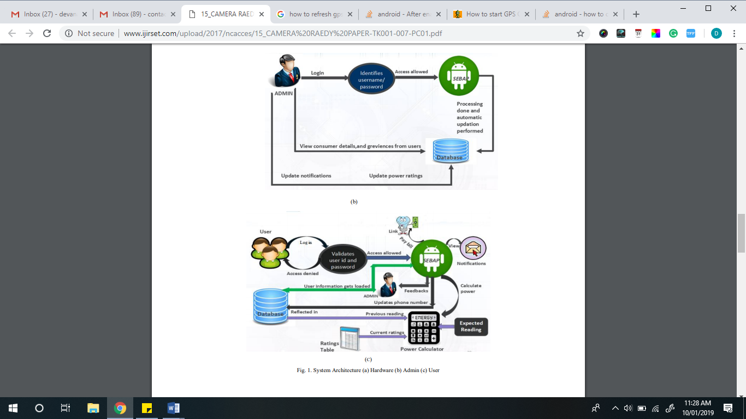
Fig. 1 Admin Module.
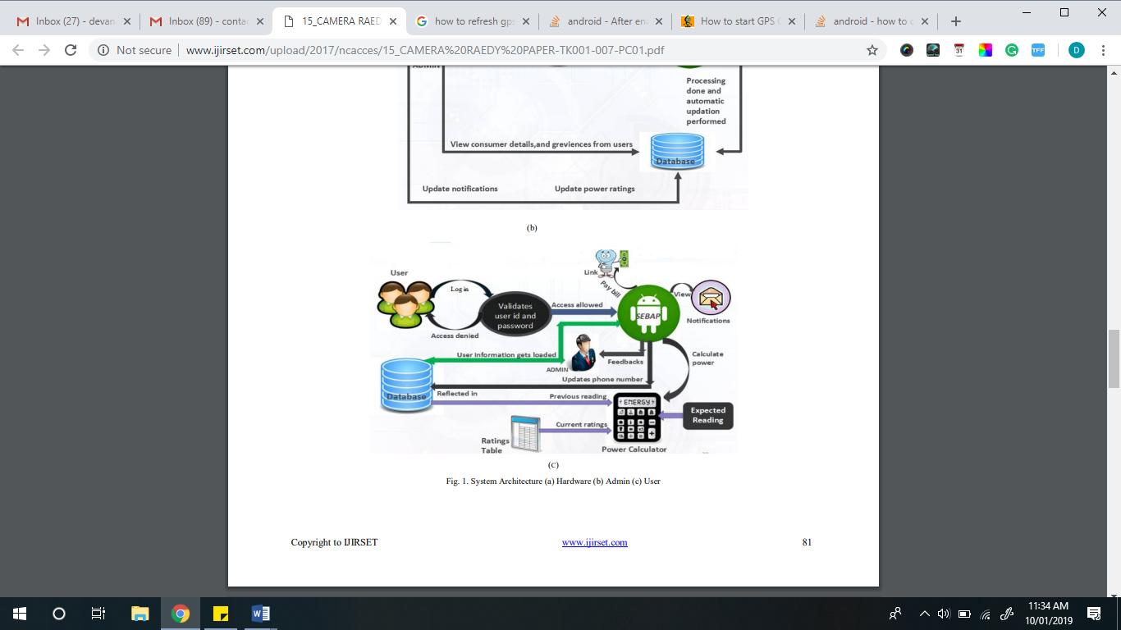

Fig. 2 User Module

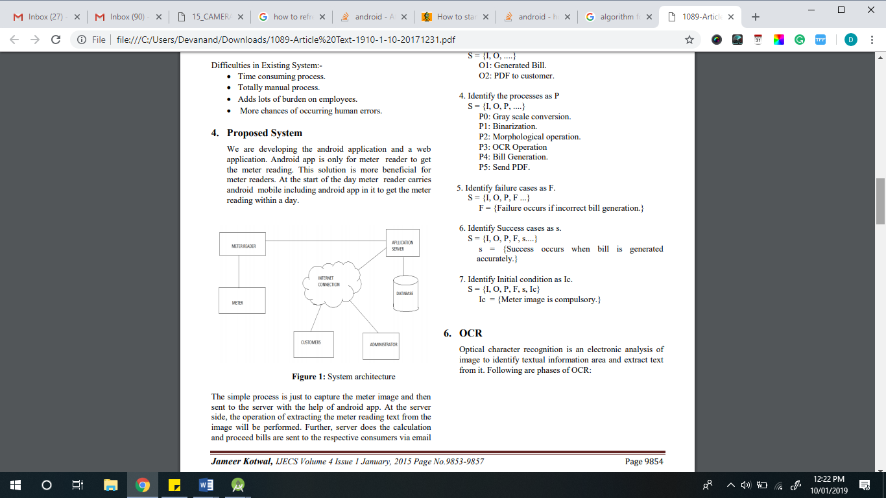

Fig. 3 System

DESIGN
Mathematical Model

- Let S be the system for meter reading
S = {...}
- Identify input as I
S = {I, ....}
I1: User or Meter reader Login.
I2: Captured image.
- Identify output O
S = {I, O, ....}
O1: Generated Bill.
O2: PDF to customer.
- Identify the processes as P
S = {I, O, P, ....}
P0: Gray scale conversion.
P1: Binarization.
P2: Bill Generation.
P3: Send PDF.
- Identify failure cases as F.
S = {I, O, P, F ...}
F = {Failure occurs if incorrect bill generation.}
- Identify Success cases as s.
S = {I, O, P, F, s....}
s = {Success occurs when bill is generated accurately.}
- Identify Initial condition as Ic.
S = {I, O, P, F, s, Ic}
Ic = {Meter image is compulsory.
CONCLUSION
Android application for meter reading using GPS suggests an easy solution that addresses the problems related to manual electricity billing process. The current method of billing process includes the manual process of meter reading, entering meter details at the server and billing to the customers. Our application is only for meter reader that reduces the workload on employees and to make the process of getting the meter reading, updating server and billing to customer via mail is made easy and accurate and also we have provided the facility for the customers that they can complaint about the incorrect bill to our web blog. Electricity and telecommunication devices are unavoidable agents for a convenient living. An effective method of metering, An effective method of metering, billing and payment system stimulates prudent electricity or mobile phone usage and compels consumers to pay their bills on time. Smart Electricity Board Android Application is expected to aid electricity companies in their policies, and also triggers future studies. The system eliminates most of the error prone manual calculations and manual data entering for electricity board. They can easily use the system for a faster, easy and error free environment to suit the comfort of customers. As part of future work, the system model can be implemented in other operating systems especially IOS and to integrate the admin application and the server side into a single system.
REFERENCES
[1] Prototype Extraction and Adaptive OCR Yihong Xu,, Member, IEEE, and George Nagy, Senior Member, IEEE,December 1999.
[2] L. Neumann and J. Matas. A method for text localization and recognition in real-world images. In ACCV, 2010.
[3] Y. Netzer, T. Wang, A. Coates, A. Bissacco, B. Wu, and A. Ng. Reading digits in natural images with unsupervised feature learning. In NIPS Workshop on Deep Learning and Unsupervised Feature Learning, 2011.
[4] K. Wang, B. Babenko, and S. Belongie. End-to-end scene text recognition. In ICCV, 2011.
[5] T. Wang, D. Wu, A. Coates, and A. Ng. End-to-end text recognition with convolutional neural denetworks. In ICPR, 2012.
[6] www.labbookpages.co.uk ++

[7] Link:tess4j.sourceforge.net

